|  |  |
| --- | --- |
| **NAME** | **DUE** |
| **Tomoki Koike** | **3/5/2019** |

**Every Boiler Engineering Code – Entry Level Programming**

**Week 2 – Programming Exercises**

1. **(Leap Year)** The month of February normally has 28 days. But if it is a leap year, February has 29 days. Write a Python program that asks the user to enter a year. The program should then display the number of days in February that year. Use the following criteria to identify leap years:
   1. Determine whether the year is divisible by 100. If it is, then it is a leap year if and only if it is also divisible by 400. For example, 2000 is a leap year, but 2100 is not.
   2. If the year is not divisible by 100, then it is a leap year if and only if it is divisible by 4. For example, 2004 is a leap year, but 2006 is not.

**(Use inputs 1988, 2016 and 2018 to test your program.)**

**Code:**

## PROBLEM #1

# NAME: Tomoki Koike

# DUE: 3/5/2019

# DESCRIPTION: This program is designed to figure out

# whether a certain is a leap year or not (with input validation)

# STAND: Class of 2020

##

# Accept user input (input validation included)

while True:

try:

year = int(input('Enter a specific year -> '))

except ValueError:

print('Sorry, cannot understand. Please enter again.')

continue

if year > 0:

# Valid input

break

else:

# Invlaid input

continue

# Using relational operators to figure out if the year is a leap year or not

# Is the selected year divisible with 100

if (year % 100) == 0:

# Is it divisible with 400

if (year % 400) == 0:

print('The year you have selected is a leap year.')

else:

print('Unfortunately, the year you have selected is not a leap year.')

# The year is not divisible with 100

else:

# Is it divisible with 4

if (year % 4) == 0:

print('The year you have selected is a leap year.')

else:

print('Unfortunately, the year you have selected is not a leap year.')

**Sample Execution:**

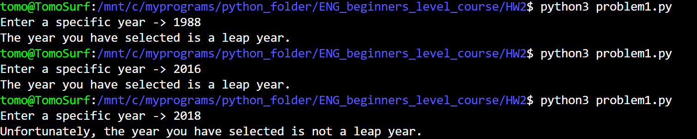

1. **(Software Sales)** A software company sells a package that retails for $99. Quantity discounts are given according to the following tables:

|  |  |
| --- | --- |
| **Quantity** | **Discount** |
| **10-19** | **10%** |
| **20-49** | **25%** |
| **50-99** | **35%** |
| **100 or more** | **45%** |

Write a Python program that asks the user to enter the number of packages purchased. The program should then display the amount of the discount (of any) and the total amount of the purchase after the discount. (**Note:** **the precision of output must be set to 2, the output must be formatted with comma separators and with the ‘$’ sign.**)

**(Use inputs 9, 45, 76 and 200 to test your program.)**

**Code:**

##PROBLEM #2

# NAME: Tomoki Koike

# DUE: 3/5/2019

# DESCRIPTION: This program is designed to compute the amount of discount

# and the final price for the package that is saled the software company

# (with input validation)

# STAND: Class of 2020

##

# List of the discounts

import array as arr

discountList = arr.array('d',[0, 0.1, 0.25, 0.35, 0.45])

# Function to calculate the discount and final pricing for proper number of orders

def discountTag(num):

num = num // 10

if num == 0:

tag = 0

elif num == 1:

tag = 1

elif 2 <= num and num <= 4:

tag = 2

elif 5 <= num and num <= 9:

tag = 3

else:

tag = 4

return tag

# Accept input (with input validation)

while True:

try:

num_pack = int(input('How many packages would you like to order? -> '))

except ValueError:

print('Sorry, cannot understand. Please enter again.')

continue

if isinstance(num_pack, int) == True and num_pack > 0:

# Valid input

break

else:

# Invalid input

print('Error. Please enter a again.')

continue

# The discount and the final price

discount = 99 * num_pack * discountList[discountTag(num_pack)]

price = 99 * num_pack - discount

# Output

print('The total discount will be ${0:.2f}'.format(discount))

print('The total price will be ${0:.2f}'.format(price))

**Sample Executions:**

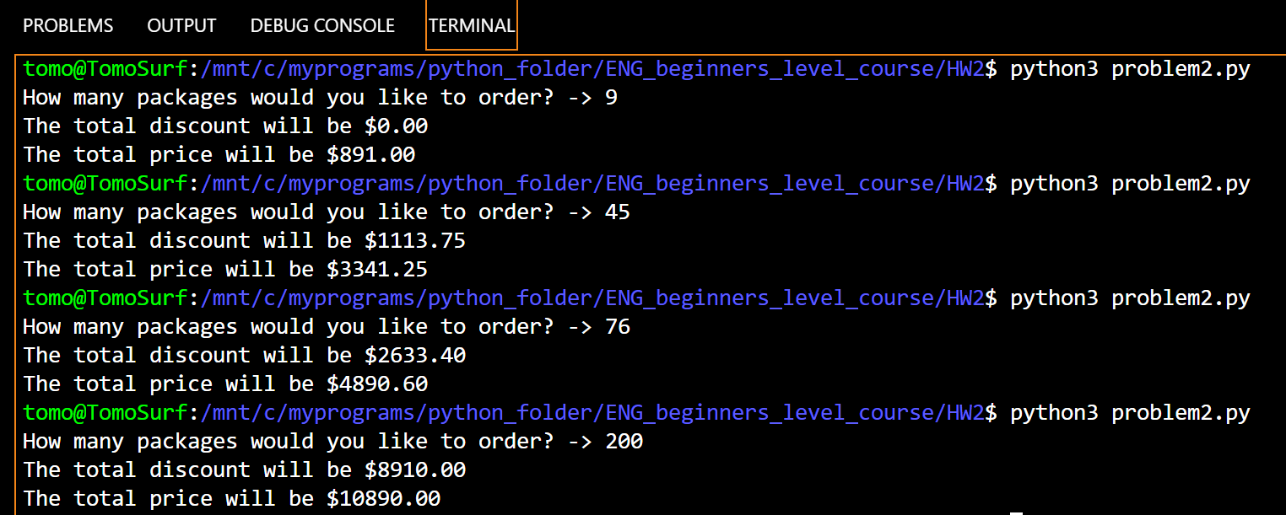

1. **(Fluid Mechanics)** A key parameter used to determine the type of fluid flow through a pipe is the Reynolds numbers. Which is given by this formula:

**Re = (V x *d*) /*v***

Re is the Reynolds number (a dimensionless value)

V is the velocity (m/s or ft/sec)

*d* is the diameter of the pipe (m or ft)

*v* is the kinematic viscosity of the fluid (m/s2 or ft/sec2)

The kinematic viscosity, *v*, is a measure of the fluid’s resistance to flow and stress. Except at extremely high pressures, a liquid fluid’s kinematic viscosity is dependent on temperature and independent of pressure. The following chart lists the kinematic viscosity of water at three different temperatures:

|  |  |
| --- | --- |
| **Temperature (0C)** | **Kinematic Viscosity (m/s2)** |
| 5 | 1.49 x 10-6 |
| 10 | 1.31 x 10-6 |
| 15 | 1.15 x 10-6 |

Using this information, write a Python program that requests the velocity of water flowing through a pipe (V), the pipe’s diameter (*d*), the water’s temperature (ask user select from 5, 10, and 15). Based the input values, your program should calculate the Reynolds number. (**Note: The output should be formatted in scientific notation. The precision of output must be set to 2.**)

**(Use V as .01, *d* as .01, temperature as 5; V as .04, *d* as .02, temperature as 10 to test your program.)**

**Code:**

## PROBLEM #3

# NAME: Tomoki Koike

# DUE: 3/5/2019

# DESCRIPTION: This program is designed to compute the Reynold's Number with

# the user input of velocity of fluid, diameter of pipe, and temperature of

# fluid (with input validation)

# STAND: Class of 2020

##

# Function for input validation

def getValid(prompt):

while True:

try:

this = float(input(prompt))

except ValueError:

print('Sorry, could not understand. Please enter again.')

continue

# Must be positive value

if this > 0:

# Valid input

break

else:

# Invalid input

print('Error. Enter a valid value.')

continue

return this

# Dictionary for temperature and corresponding kinematic viscosity (m/s^2)

temp_co_vis = {

5:1.49*10**(-6),

10:1.31*10**(-6),

15:1.15*10**(-6),

}

# Accept user input (with input validation)

vel = getValid('Please enter the velocity (m/s or ft/s) of fluid inside the pipe -> ')

diam = getValid('Please enter the diameter (m or ft) of the pipe -> ')

temp = getValid('Please enter the temperature (C) of the fluid -> ')

# Calculating Reynold's Number

Re = vel * diam / temp_co_vis[temp]

# Output

print('The Reynold''s number for the given parameters is {0:.2E}'.format(Re))

**Sample Execution:**

