AAE 334: Aerodynamics

HW 10: Shockwave Interactions

Dr. Blaisdell

School of Aeronautical and Astronautical

Purdue University

Tomoki Koike

Friday April 17th, 2020



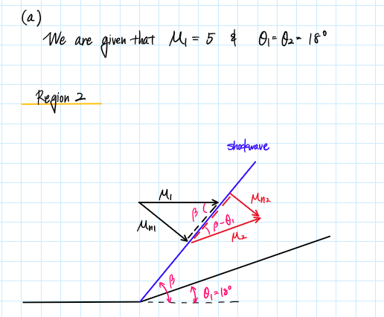

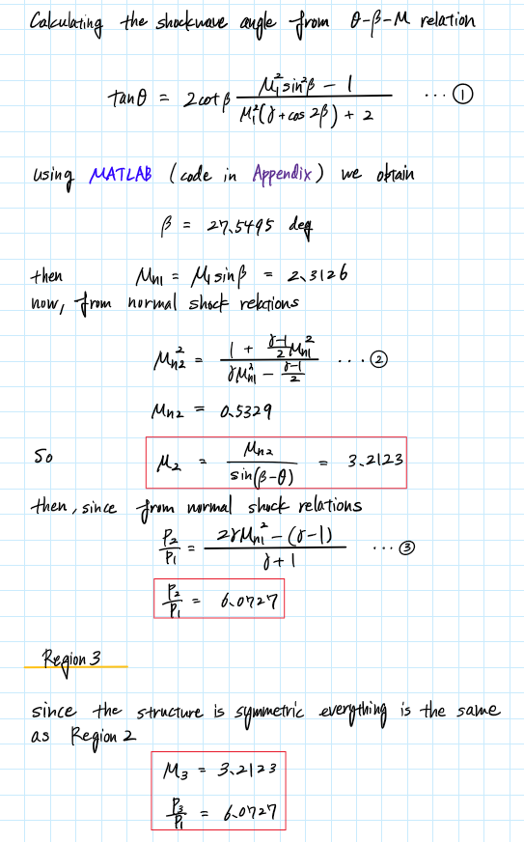

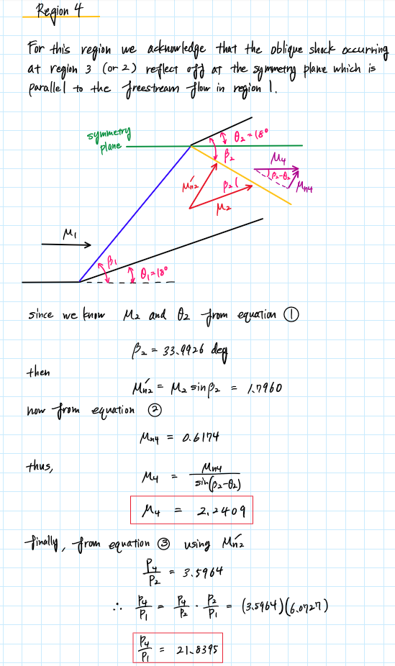

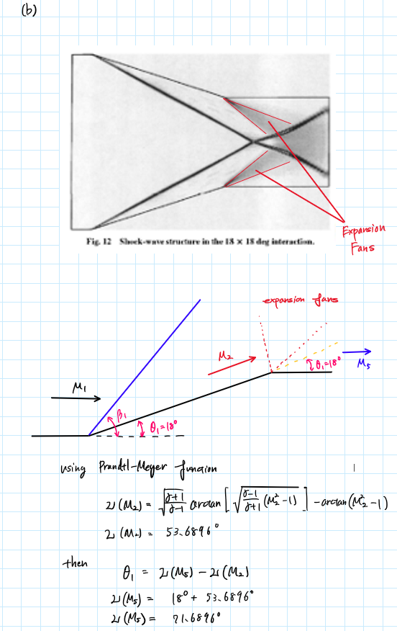

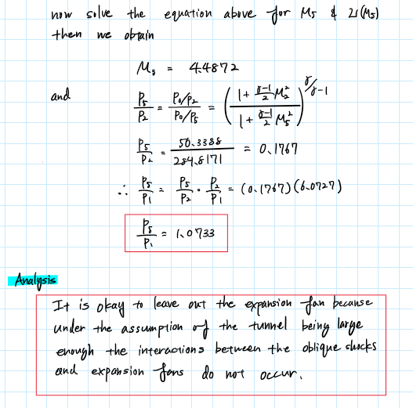



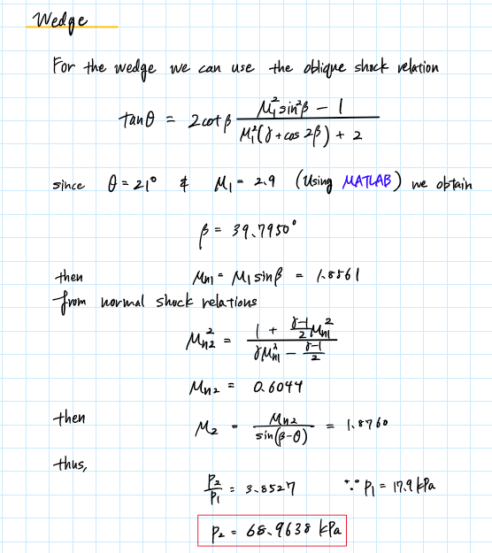

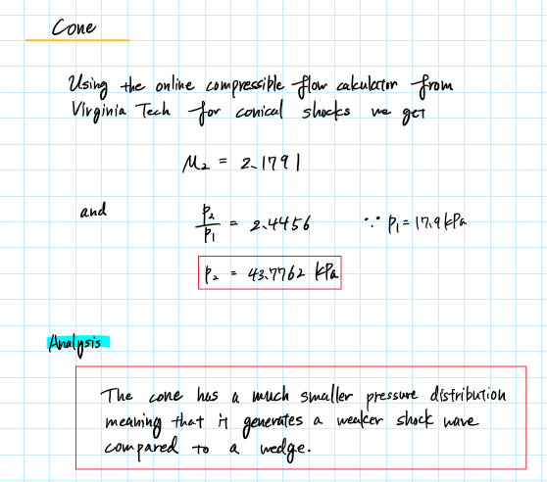



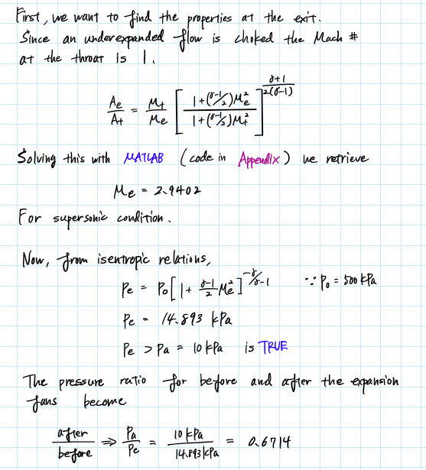

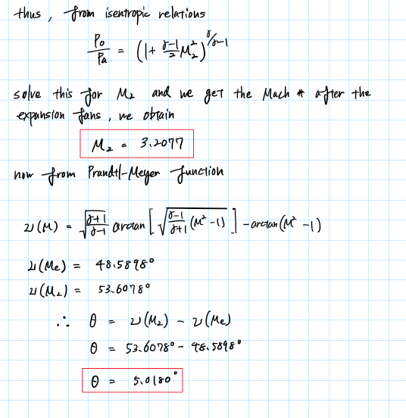





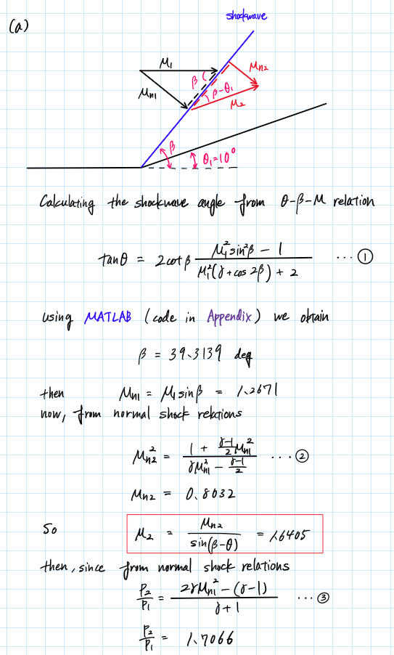

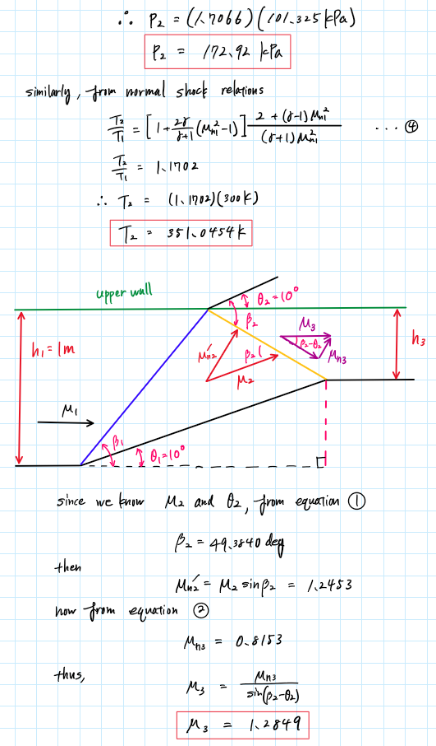

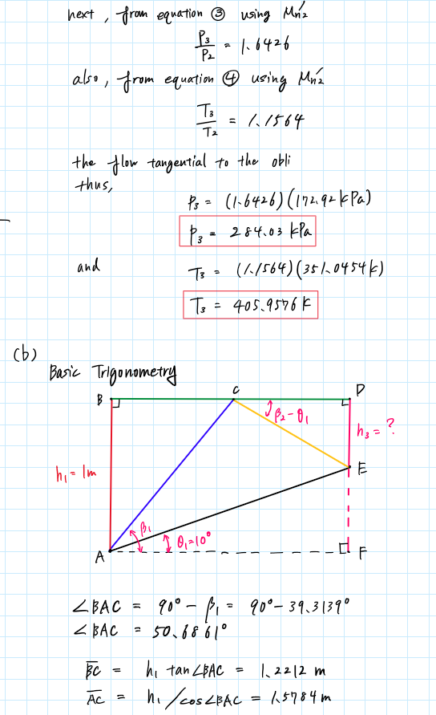

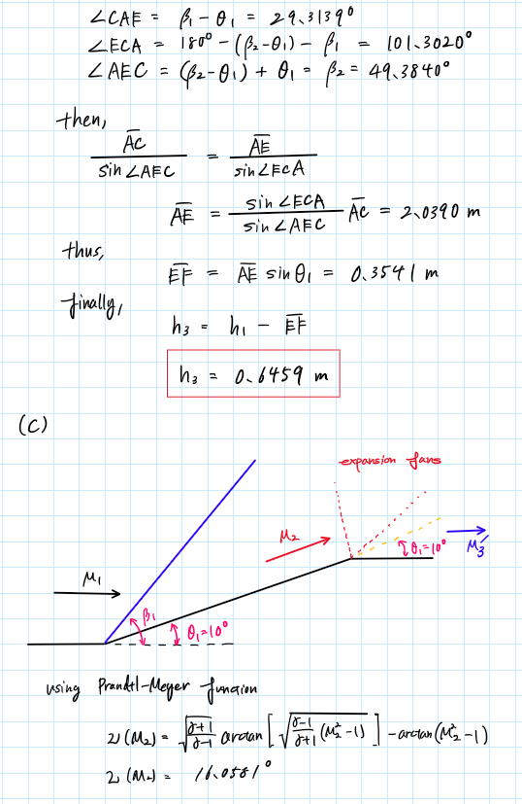

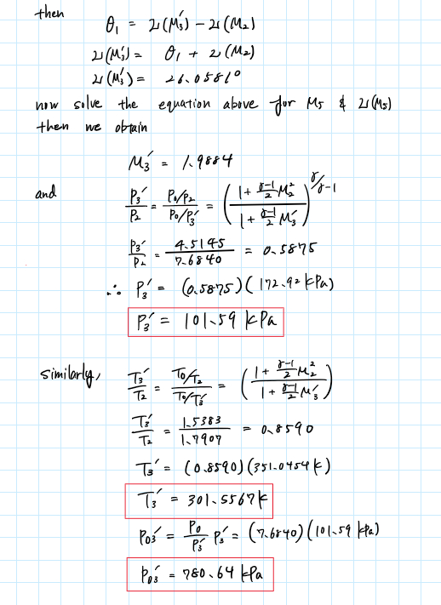

Appendix

## **AAE 334 HW10**

clear all; close all; clc;

### P1

% (a)

% Given Properties

M1 = 5;

theta = 18; % [deg]

gamma = 1.4;

% Region 2

beta = theta_beta_M_relation(theta,M1,gamma);

Mn1 = M1*sind(beta);

Mn2 = normalShock_jump_M(Mn1,gamma);

M2 = Mn2/sind(beta-theta);

P2_P1 = normalShock_jump_P_static(Mn1,gamma)

% Region 4

beta2 = theta_beta_M_relation(theta,M2,gamma);

Mn2_new = M2*sind(beta2);

Mn4 = normalShock_jump_M(Mn2_new,gamma);

M4 = Mn4/sind(beta2 - theta);

P4_P2 = normalShock_jump_P_static(Mn2_new,gamma);

P4_P1 = P4_P2*P2_P1;

% (b) Expansion fan

nu_M2 = Prandtl_Meyer_Expansion(M2,gamma);

nu_M5 = theta + nu_M2;

M5 = calc_M_from_PrantlMeyer(nu_M5,gamma);

P0_P2 = isentropic_relation_P_ratio(M2,gamma);

P0_P5 = isentropic_relation_P_ratio(M5,gamma);

P5_P2 = P0_P2/P0_P5;

P5_P1 = P5_P2*P2_P1;

### P2

% Given Properties

M1 = 2.9;

theta = 21; % [deg]

gamma = 1.4;

P1 = 17.9; % [kPa]

beta = theta_beta_M_relation(theta,M1,gamma)

Mn1 = M1*sind(beta)

Mn2 = normalShock_jump_M(Mn1,gamma)

M2 = Mn2/sind(beta-theta)

P2_P1 = normalShock_jump_P_static(Mn1,gamma)

P2 = P2_P1*P1

### P3

% Exit condtions

Ae_At = 4.0;

At = 1;

Ae = Ae_At*At;

Mt = 1;

gamma = 1.4;

P0 = 500e3; % [Pa]

Pa = 10e3; % [Pa]

[Me_sub, Me_sup] = M_for_area_ratio(At,Ae,Mt,gamma);

Me = Me_sup;

Pe = p_from_M_and_gamma(P0,Me,gamma,"static");

Pa_Pe = Pa/Pe;

M2 = M_from_P_ratio(P0,Pa,gamma)

% Expansion angles

nu_Me = Prandtl_Meyer_Expansion(Me,gamma)

nu_M2 = Prandtl_Meyer_Expansion(M2,gamma)

theta = nu_M2 - nu_Me

### P4

% Defining the given properties

M1 = 2;

P1 = 101325; % [Pa]

theta1 = 10; % [deg]

T1 = 300;

T0 = 1; % dummy

gamma = 1.4;

% Region 2

beta12 = theta_beta_M_relation(theta1,M1,gamma)

Mn1 = M1*sind(beta12)

Mn2 = normalShock_jump_M(Mn1,gamma)

M2 = Mn2/sind(beta12-theta1)

P2_P1 = normalShock_jump_P_static(Mn1,gamma)

P2 = P1*P2_P1

T2_T1 = normalShock_jump_T_static(Mn1,gamma)

T2 = T2_T1*T1

% Region 3'

theta2 = theta1;

beta23 = theta_beta_M_relation(theta2,M2,gamma)

Mn2p = M2*sind(beta23)

Mn3 = normalShock_jump_M(Mn2p,gamma)

M3 = Mn3/sind(beta23 - theta2)

P3_P2 = normalShock_jump_P_static(Mn2p,gamma)

T3_T2 = normalShock_jump_T_static(Mn2p,gamma)

P3 = P3_P2*P2

T3 = T3_T2*T2

P03 = p_from_M_and_gamma(P3,M3,gamma,"stagnation")

% (b)

h1 = 1;

ang_BAC = 90 - beta12;

BC = h1*tand(ang_BAC);

AC = h1/cosd(ang_BAC);

ang_CAE = beta12 - theta1;

ang_ECA = 180 - (beta23 - theta1) - beta12;

ang_AEC = beta23;

AE = sind(ang_ECA)/sind(ang_AEC)*AC;

EF = AE*sind(theta1);

h3 = h1 - EF;

% (c) Expansion fan

nu_M2 = Prandtl_Meyer_Expansion(M2,gamma)

nu_M3p = theta1 + nu_M2

M3p = calc_M_from_PrantlMeyer(nu_M3p,gamma)

P0_P2 = isentropic_relation_P_ratio(M2,gamma)

P0_P3p = isentropic_relation_P_ratio(M3p,gamma)

P3p_P2 = P0_P2/P0_P3p

P3p = P3p_P2*P2

T0_T2 = isentropic_relation_T_ratio(M2,gamma)

T0_T3p = isentropic_relation_T_ratio(M3p,gamma)

T3p_T2 = T0_T2/T0_T3p

T3p = T3p_T2*T2

P03p = P0_P3p*P3p

### Functions

function M = calc_M_from_PrantlMeyer(nu,gamma)

M = sym('M');

assume(M,["real","positive"]);

a1 = sqrt((gamma + 1)/(gamma - 1));

a2 = atand(a1^(-1)*sqrt(M^2 - 1));

a3 = atand(sqrt(M^2 - 1));

eqn = nu == a1*a2 - a3;

M = double(vpasolve(eqn,M));

if M < 0

M = -M;

end

end

function P_rat = isentropic_relation_P_ratio(M,gamma)

P_rat = (1 + (gamma - 1)/2*M^2)^(gamma/(gamma - 1));

end

function T_rat = isentropic_relation_T_ratio(M,gamma)

T_rat = (1 + (gamma - 1)/2*M^2);

end

function [M2_sub, M2_sup] = M_for_area_ratio(A1,A2,M1,gamma)

% Calculate the Mach number at the inlet

M2 = sym('M2');

assume(M2,["real","positive"])

a1 = 1 + (gamma - 1)/2*M2^2;

a2 = 1 + (gamma - 1)/2*M1^2;

a3 = (gamma + 1)/2/(gamma - 1);

eqn = A2/A1 == M1/M2 * (a1/a2)^(a3);

M2 = double(vpasolve(eqn,M2));

M2 = M2(M2 == real(M2));

M2_sub = min(M2);

M2_sup = max(M2);

end

function M = M_from_P_ratio(P0,P,gamma)

a1 = 2/(gamma - 1);

a2 = (P0/P)^((gamma - 1)/gamma);

M = sqrt(a1*(a2 - 1));

end

function T_rat = normalShock_jump_T_static(M1,gamma)

%{

Function: normalShock_jump_T_stati

Author: Tomoki Koike

Description: This function calculates the static pressure ratios

before and after a normal shockwave.

>>Inputs

M1: Mach number before shockwave

gamma: specific hear ratio

Outputs<<

T_rat: static temperature ratio

%}

a1 = 1 + 2*gamma*(M1^2 - 1)/(gamma + 1);

a2 = 2 + (gamma - 1)*M1^2;

a3 = (gamma + 1)*M1^2;

T_rat = (a1)*(a2)/(a3);

end

function P_rat = normalShock_jump_P_static(M1,gamma)

%{

Function: normalShock_jump_P_static

Author: Tomoki Koike

Description: This function calculates the static pressure ratios

before and after a normal shockwave.

>>Inputs

M1: Mach number before shockwave

gamma: specific hear ratio

Outputs<<

P_rat: static pressure ratio

%}

P_rat = (2*gamma*M1^2 - (gamma - 1))/(gamma + 1);

end

function M2 = normalShock_jump_M(M1,gamma)

%{

Function: normalShock_jump_M

Author: Tomoki Koike

Description: This function calculates the Mach number jump after a normal shockwave.

>>Inputs

M1: Mach number

gamma: specific hear ratio

Outputs<<

M2: Mach number after shock

%}

a1 = (gamma - 1)/2;

M2 = sqrt((1 + a1*M1^2)/(gamma*M1^2 - a1));

end

function nu = Prandtl_Meyer_Expansion(M,gamma)

%{

Function: Prandtl_Meyer_Expansion

Author: Tomoki Koike

Description: This function calculates the Prandtl-Meyer function results for

a given flow with given Mach number to find the

expansion fan relations

>>Inputs

M1: Mach number before expansion fan

gamma: specific hear ratio

Outputs<<

nu: Prandtl-Meyer function result [deg]

%}

a1 = sqrt((gamma + 1)/(gamma - 1));

a2 = atand(a1^(-1)*sqrt(M^2 - 1));

a3 = atand(sqrt(M^2 - 1));

nu = a1*a2 - a3;

end

function p2 = p_from_M_and_gamma(p1, M, gamma, type)

if type == "stagnation"

p2 = p1 * (1 + (gamma - 1) / 2 * M^2)^(gamma/(gamma - 1));

elseif type == "static"

p2 = p1 / (1 + (gamma - 1) / 2 * M^2)^(gamma/(gamma - 1));

else

disp("Error. Incorrect type. Type can only be 'stagnation' or 'static'.")

end

end