AAE 334: Aerodynamics

Homework 3: Flat Plate Theory and Effects of Flaps and Slats

Tomoki Koike

Friday February 7, 2020

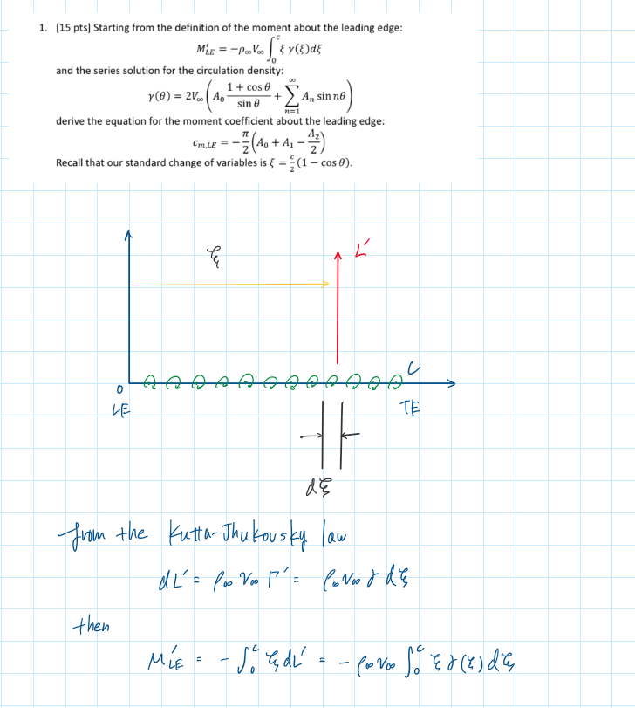

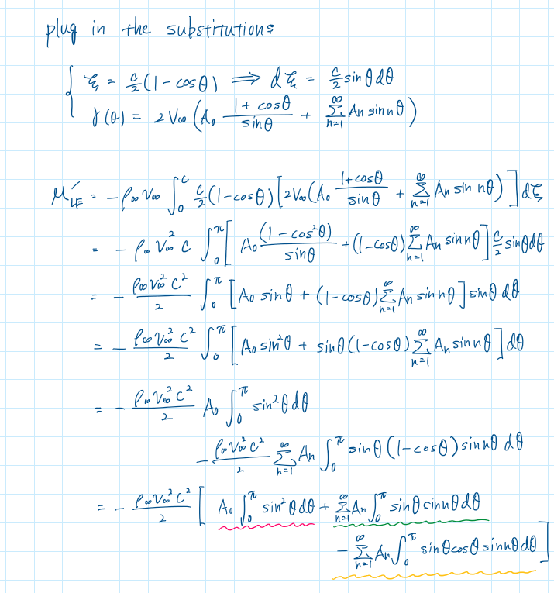

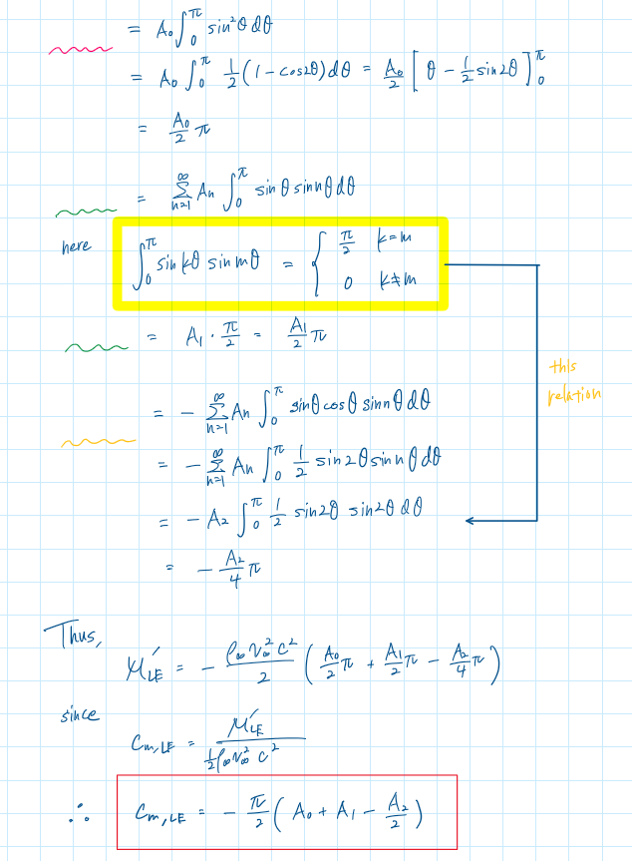

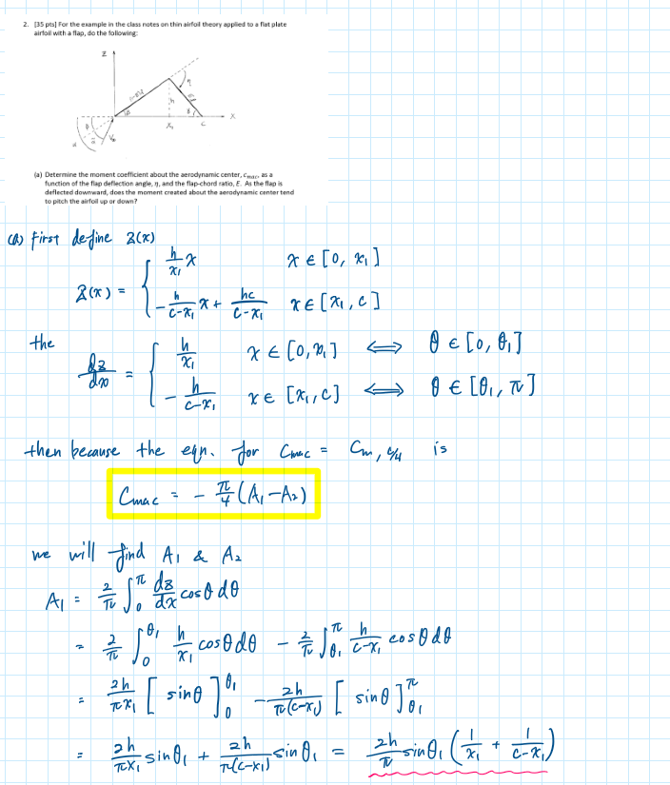

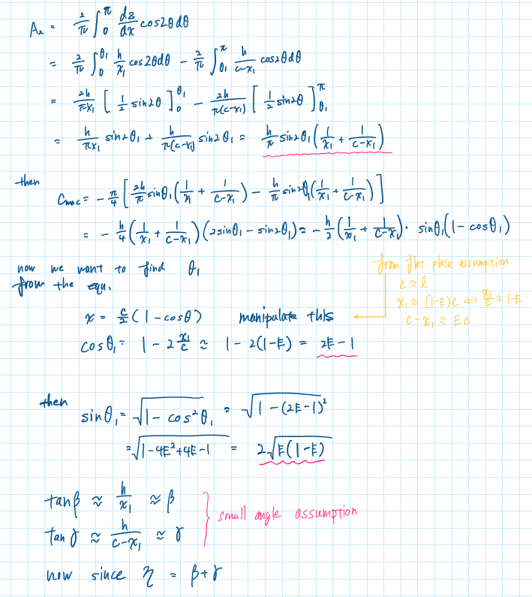

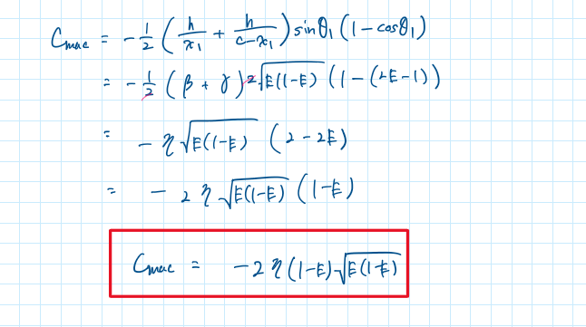

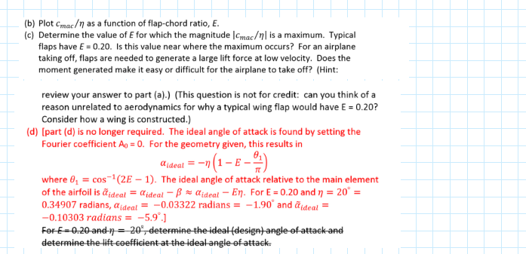



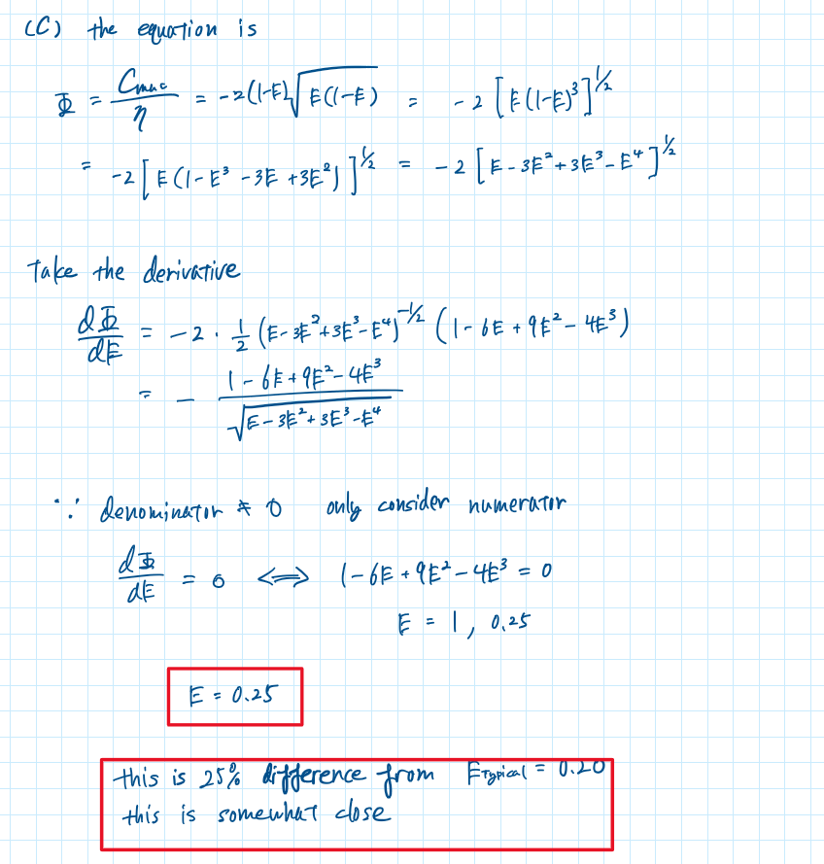

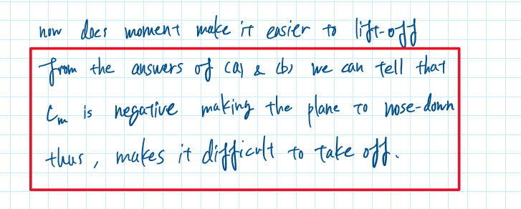

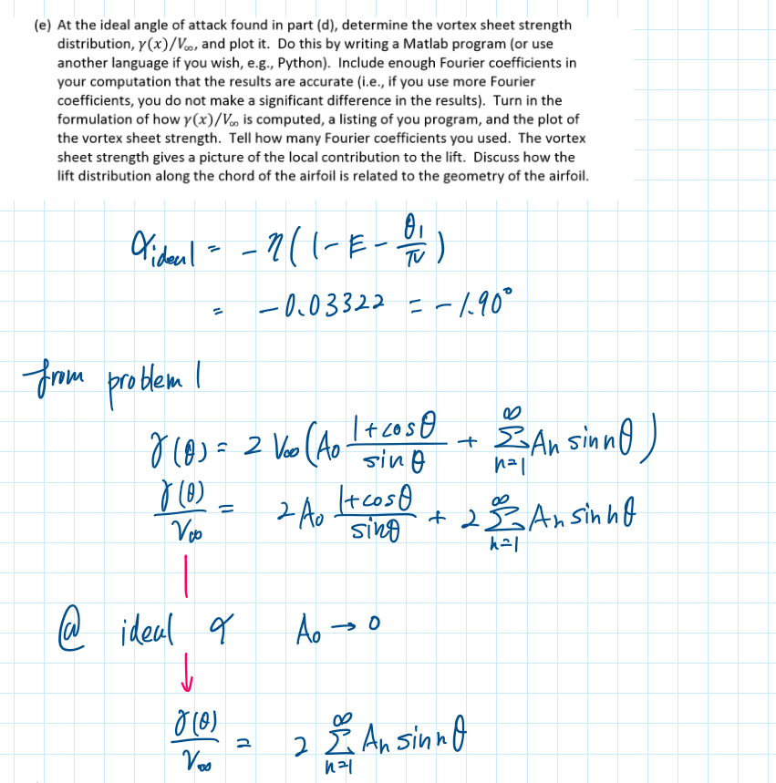

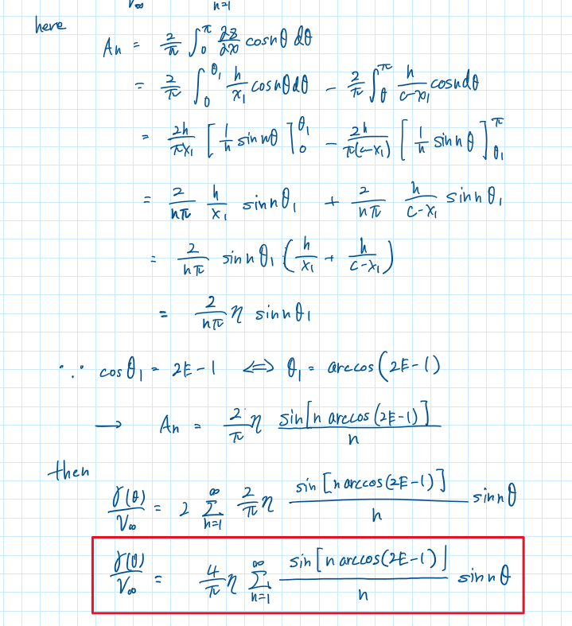

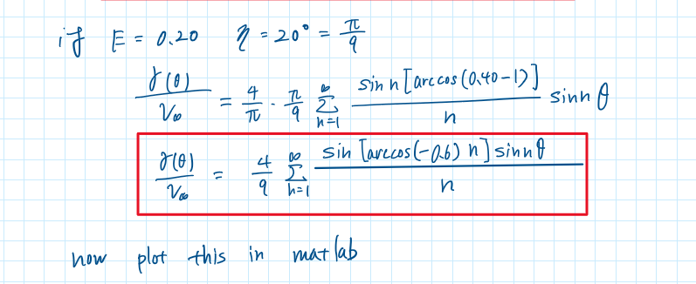

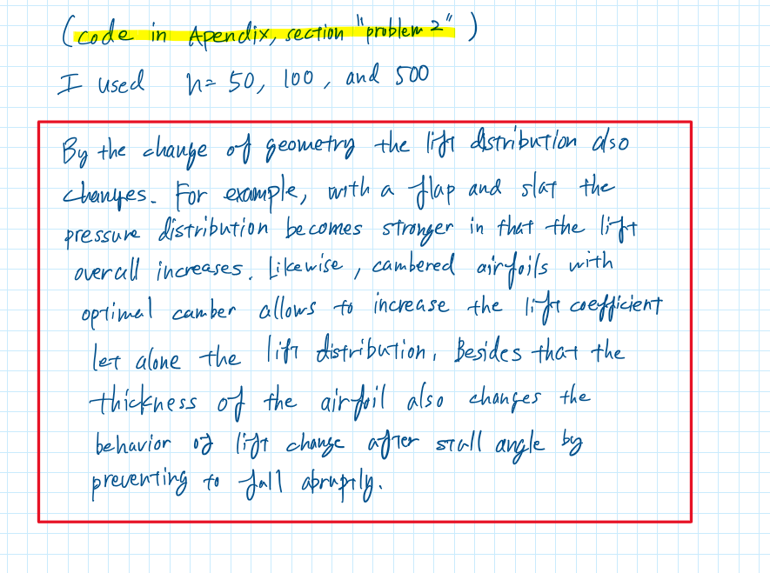

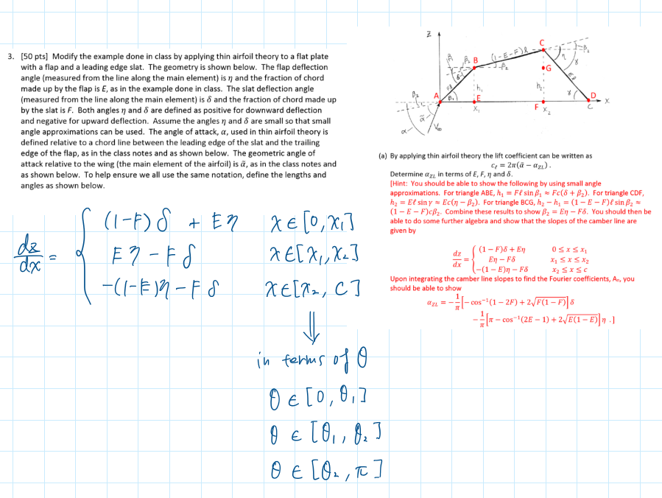

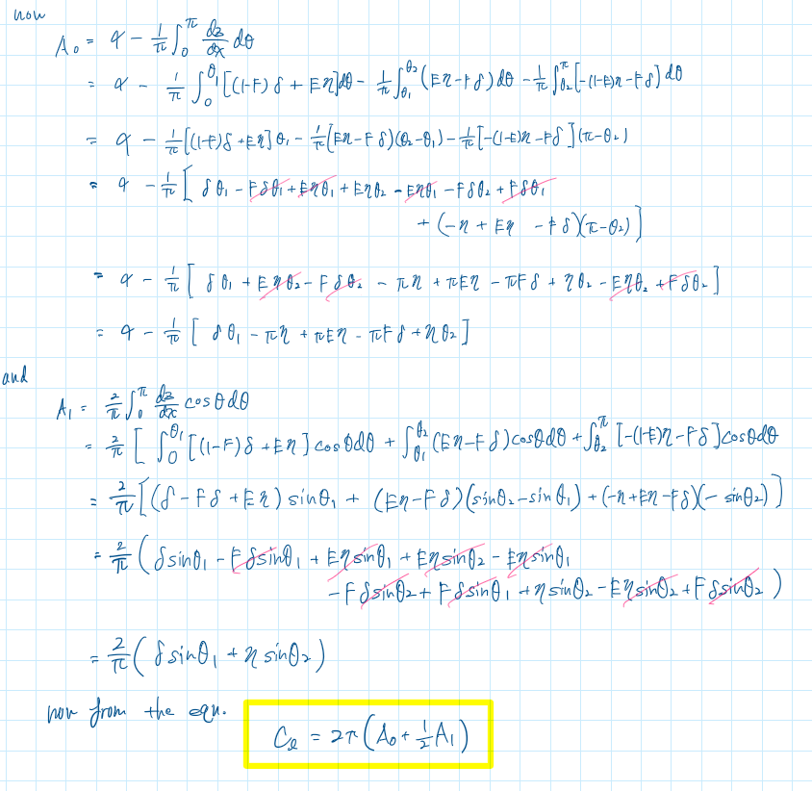

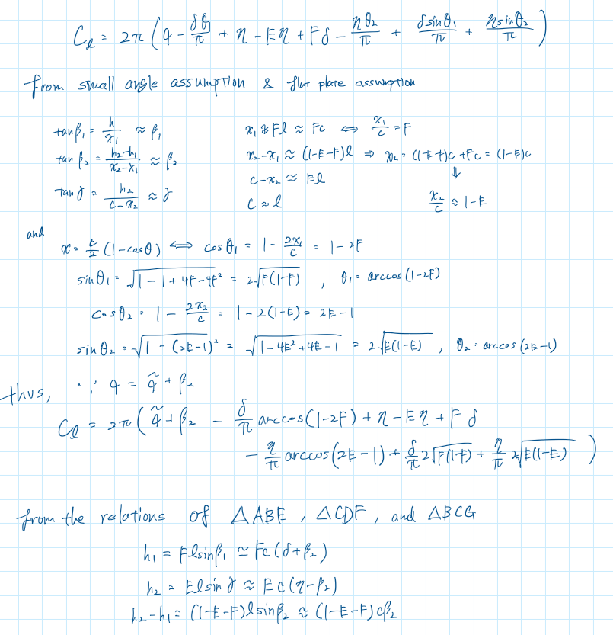

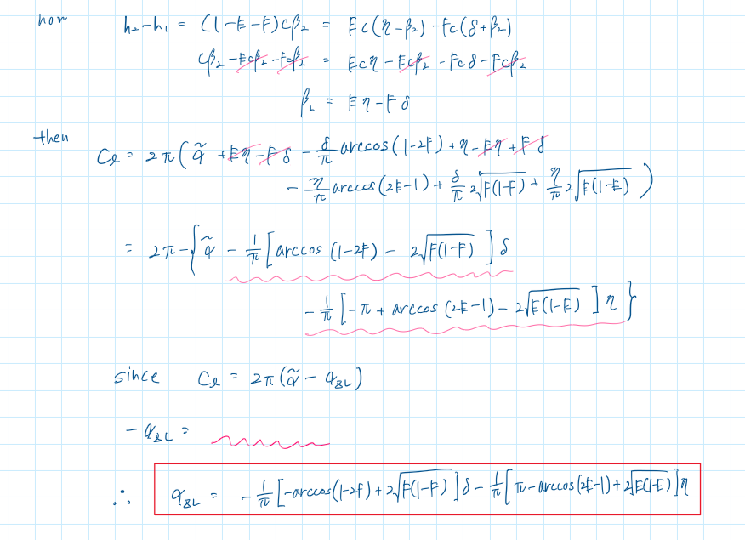

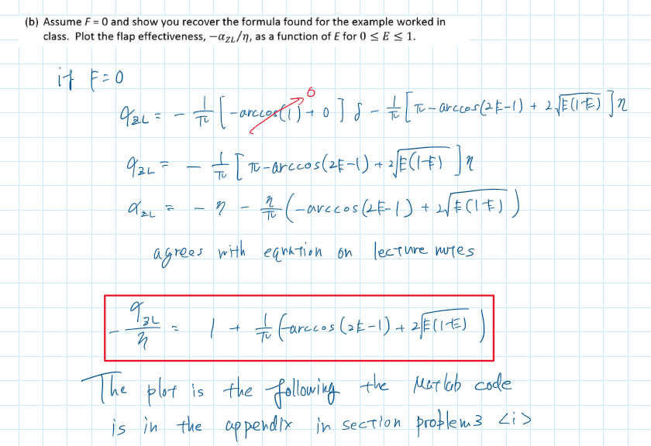

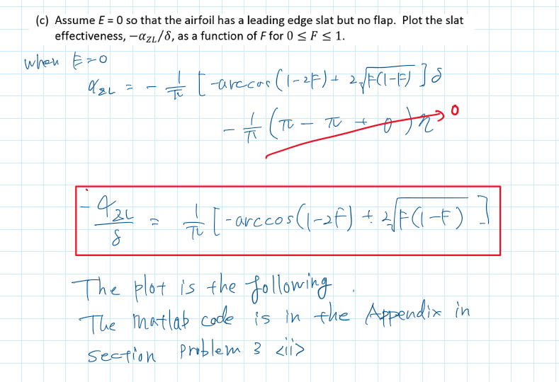

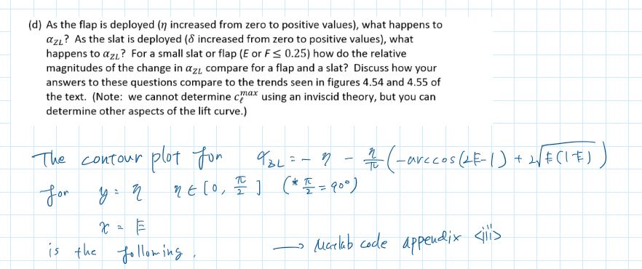

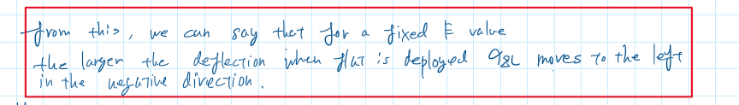

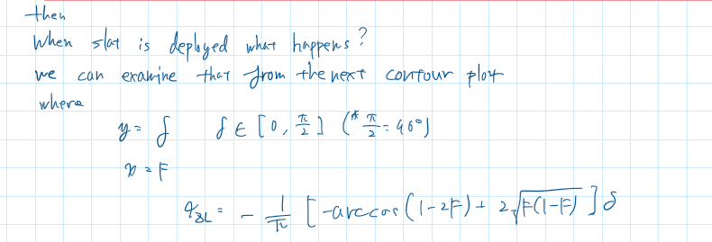

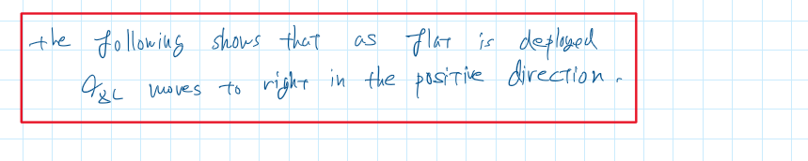

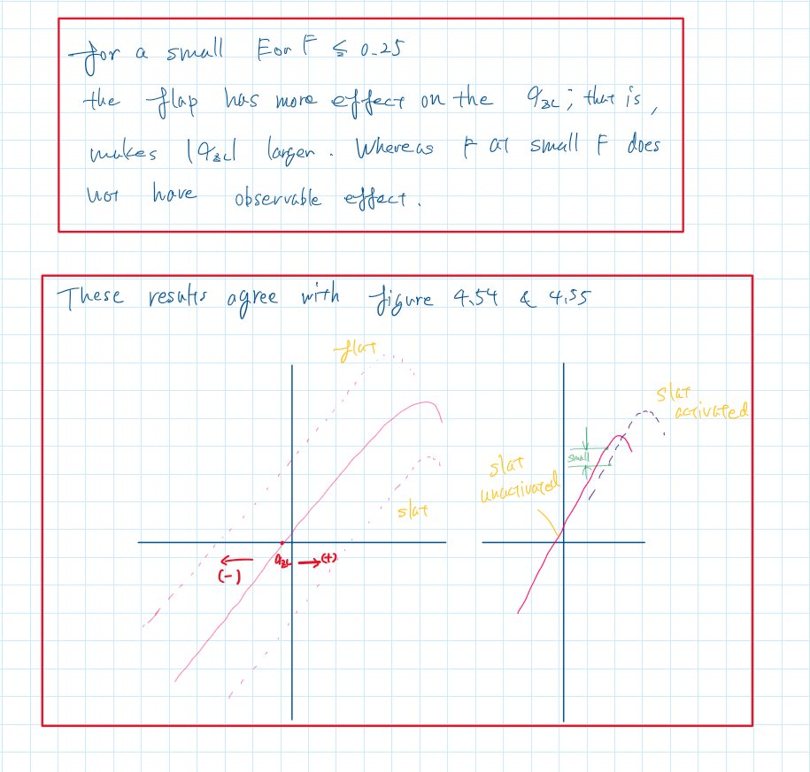

Appendix

HW 3 - matlab code

**problem 1**

clear all; close all; clc

% Plotting the moment coefficient about the aerodynamic center

E = linspace(0,1,100); % flap-chord ratio

C_mac_over_deflect = -2*(1-E).*sqrt(E.*(1-E)); % coefficient per deflection angle

fig1 = figure('Renderer', 'painters', 'Position', [10 10 900 600]);

plot(E, C_mac_over_deflect)

xlabel('flap-chord ratio, E')

ylabel('C_m_a_c per deflection angle')

title({'C_m_a_c per deflection angle VS flap-chord ratio', ...

'- By: Tomoki Koike'})

grid on

grid minor

box on

saveas(fig1, 'mmt_coeff.png')

**problem 2**

theta = linspace(0, pi, 2^10); % Define the angle theta

gamma_over_Vinf_50 = 0; % Initiate vortex sheet strength distribution

for n = 1:50

A_n = sin(n*acos(-0.6)).*sin(n.*theta)/n; % n-th Fourier coefficient

gamma_over_Vinf_50 = gamma_over_Vinf_50 + A_n; % Summation

end

gamma_over_Vinf_50 = 4/9 * gamma_over_Vinf_50;

gamma_over_Vinf_100 = 0; % Initiate vortex sheet strength distribution

for n = 1:100

A_n = sin(n*acos(-0.6)).*sin(n.*theta)/n; % n-th Fourier coefficient

gamma_over_Vinf_100 = gamma_over_Vinf_100 + A_n; % Summation

end

gamma_over_Vinf_100 = 4/9 * gamma_over_Vinf_100;

gamma_over_Vinf_500 = 0; % Initiate vortex sheet strength distribution

for n = 1:500

A_n = sin(n*acos(-0.6)).*sin(n.*theta)/n; % n-th Fourier coefficient

gamma_over_Vinf_500 = gamma_over_Vinf_500 + A_n; % Summation

end

gamma_over_Vinf_500 = 4/9 * gamma_over_Vinf_500;

% Plotting

fig2 = figure('Renderer', 'painters', 'Position', [10 10 900 600]);

plot(theta, gamma_over_Vinf_50)

xlabel('angle theta, [radians]')

ylabel('Vortex sheet strength distribution')

title({'Vortex Sheet Strength Dsitribution for Ideal Angle of Attack for a Flat Plate with Flaps', ...

'- By: Tomoki Koike'})

hold on

plot(theta, gamma_over_Vinf_100)

plot(theta, gamma_over_Vinf_500)

hold off

grid on

grid minor

box on

legend('n=50','n=100','n=500')

saveas(fig2, 'vortex_sheet_strength.png')

**problem 3 <i>**

E = linspace(0,1,2^11);

alpha_zl_E = 1 + (-acos(2.*E-1) + 2*sqrt(E.*(1-E)))/pi;

% Plotting

fig3 = figure('Renderer', 'painters', 'Position', [10 10 900 600]);

plot(E, alpha_zl_E)

xlabel('flap-chord ratio, E')

ylabel('flap effectiveness')

title({'Flap Effectiveness vs Flap-chord Ratio', ...

'- By: Tomoki Koike'})

grid on

grid minor

box on

saveas(fig3, 'flap_effectiveness.png')

**<ii>**

F = linspace(0,1,2^11);

alpha_zl_F = (-acos(1-2.*F) + 2*sqrt(F.*(1-F)))/pi;

% Plotting

fig3 = figure('Renderer', 'painters', 'Position', [10 10 900 600]);

plot(F, alpha_zl_F)

xlabel('slat-chord ratio, E')

ylabel('slat effectiveness')

title({'Slat Effectiveness vs Slat-chord Ratio', ...

'- By: Tomoki Koike'})

grid on

grid minor

box on

saveas(fig3, 'slat_effectiveness.png')

**<iii>**

eta = linspace(0,pi/2,2^8);

[X1, Y1] = meshgrid(E, eta);

alpha_zl_E = -Y1.*(1 + (-acos(2.*X1-1) + 2*sqrt(X1.*(1-X1)))/pi);

fig4 = figure('Renderer', 'painters', 'Position', [10 10 900 600]);

contour(X1,Y1, alpha_zl_E);

xlabel('flap-chord ratio, E')

ylabel('flap deflection')

title('When Flap is Deployed at some Flap-chord Ratio - By: Tomoki Koike')

colorbar

grid on

grid minor

box on

saveas(fig4, 'flap_deployed.png')

**<iv>**

delta = linspace(0,pi/2,2^8);

[X2, Y2] = meshgrid(F, delta);

alpha_zl_F = -Y2.*(-acos(1-2.*X2) + 2*sqrt(X2.*(1-X2)))/pi;

fig4 = figure('Renderer', 'painters', 'Position', [10 10 900 600]);

contour(X2,Y2, alpha_zl_F);

xlabel('slat-chord ratio, F')

ylabel('slat deflection')

title('When Slat is Deployed at some Slat-chord Ratio - By: Tomoki Koike')

colorbar

grid on

grid minor

box on

saveas(fig4, 'slat_deployed.png')