AAE 334: Aerodynamics

HW4: XFLR5 Analysis

Dr. Blaisdell

Tomoki Koike

Friday February 15, 2020

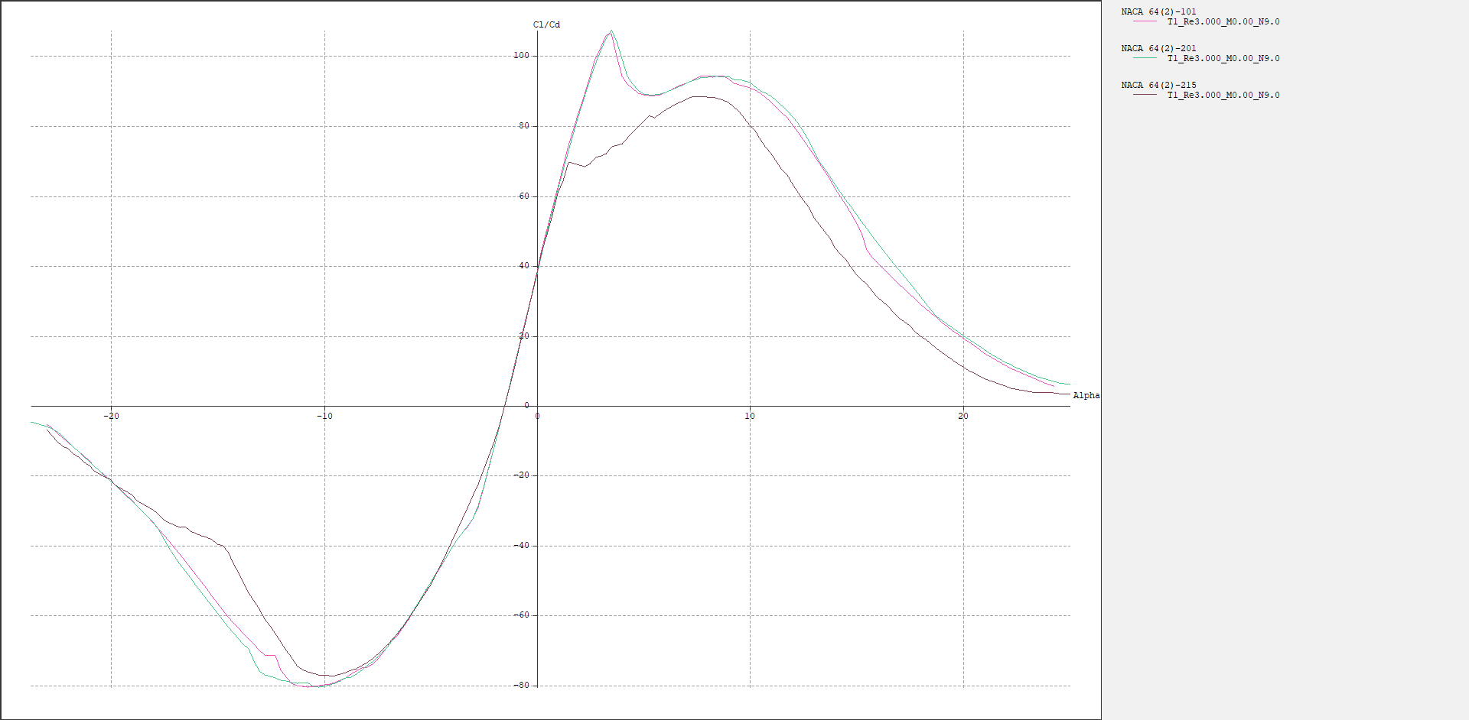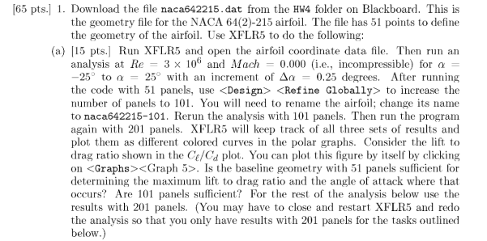a-1) The baseline geometry with 51 panels is not sufficient because from the plot above we can see that for small angle of attacks the 51 panels condition largely deviates from the ones where we have 101 and 201 panels. At these small angles, the 101 and 201 panel baselines reach their maximum Cl/Cd ratio.

a-2) Comparing the 101 and 201 panel conditions we can observe a small level of deviation between them but they are overall following the same path, and therefore, we can say that 101 panels yield a compromisable result. However, to assure the best quality of analysis using 201 panels would be better.



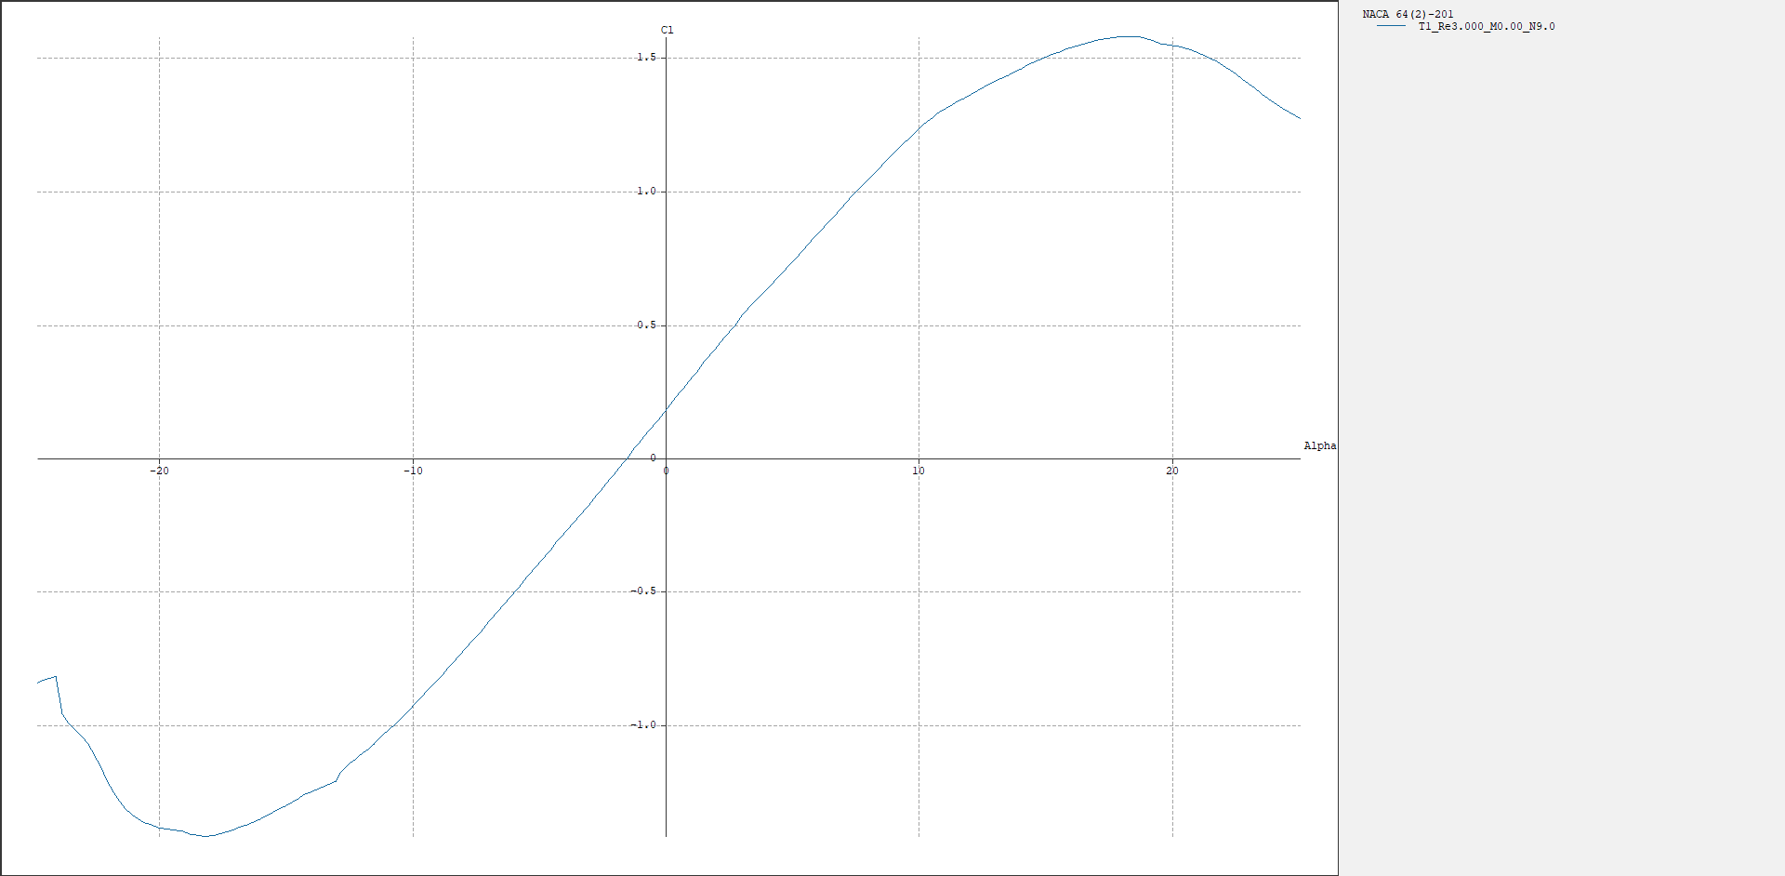

b-1) By exporting the graphical data in XFLR5, and then using the =MAX( ) command in excel we are able to find the maximum life coefficient,

Cl = 1.577676

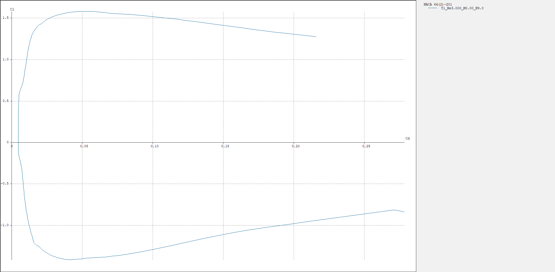

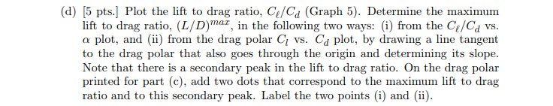

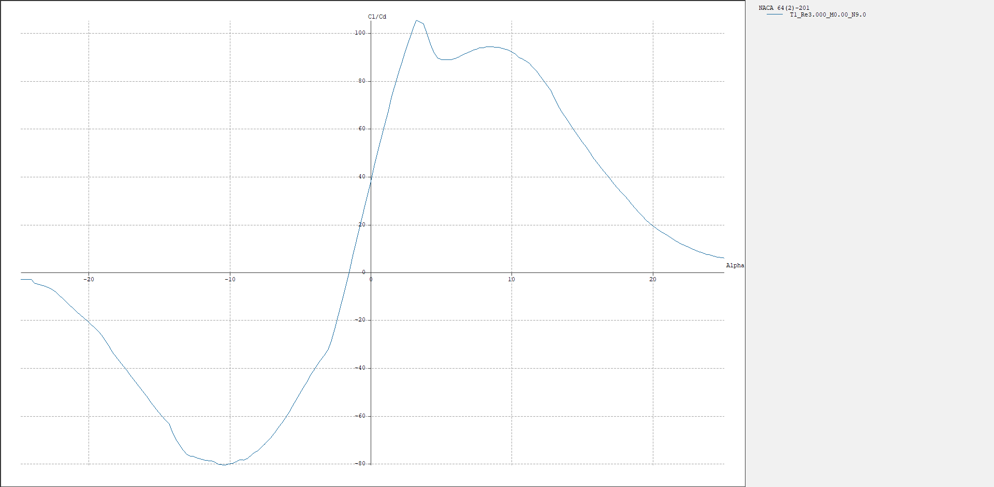

d-i) By exporting the data points and using Excel we find that the

First peak (max 1): 105.1151

Second peak (max 2): 94.22602

Since

The answer is 105.1151

d-ii) From the data points exported for the plot in problem c, we take the slope for each data points (x,y) (i.e. y/x) and find the maximum using Matlab (code is in appendix)

The plot looks like the following.

From this method the answer was 105.11509

d-iii) Find the second peak point with Excel and then plot the instructed line with matlab

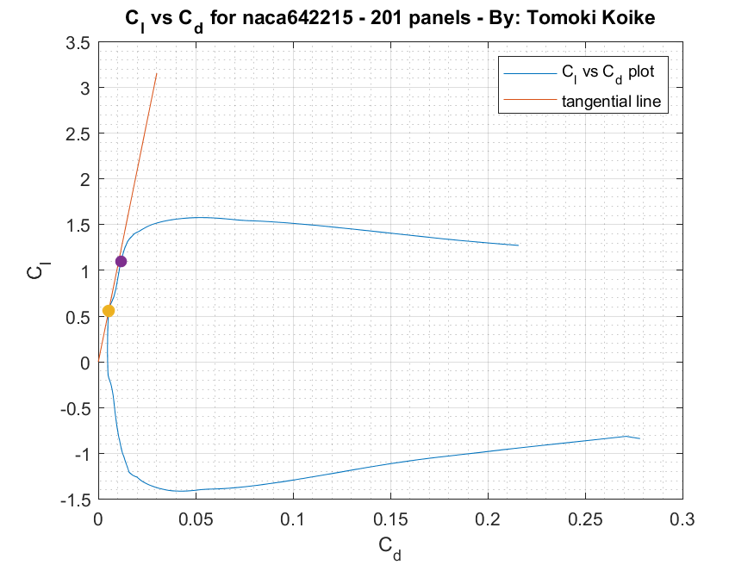

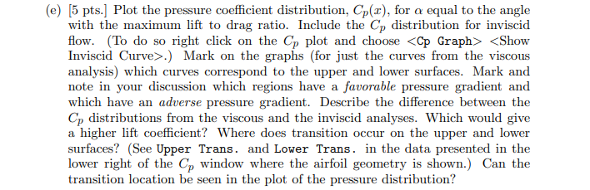

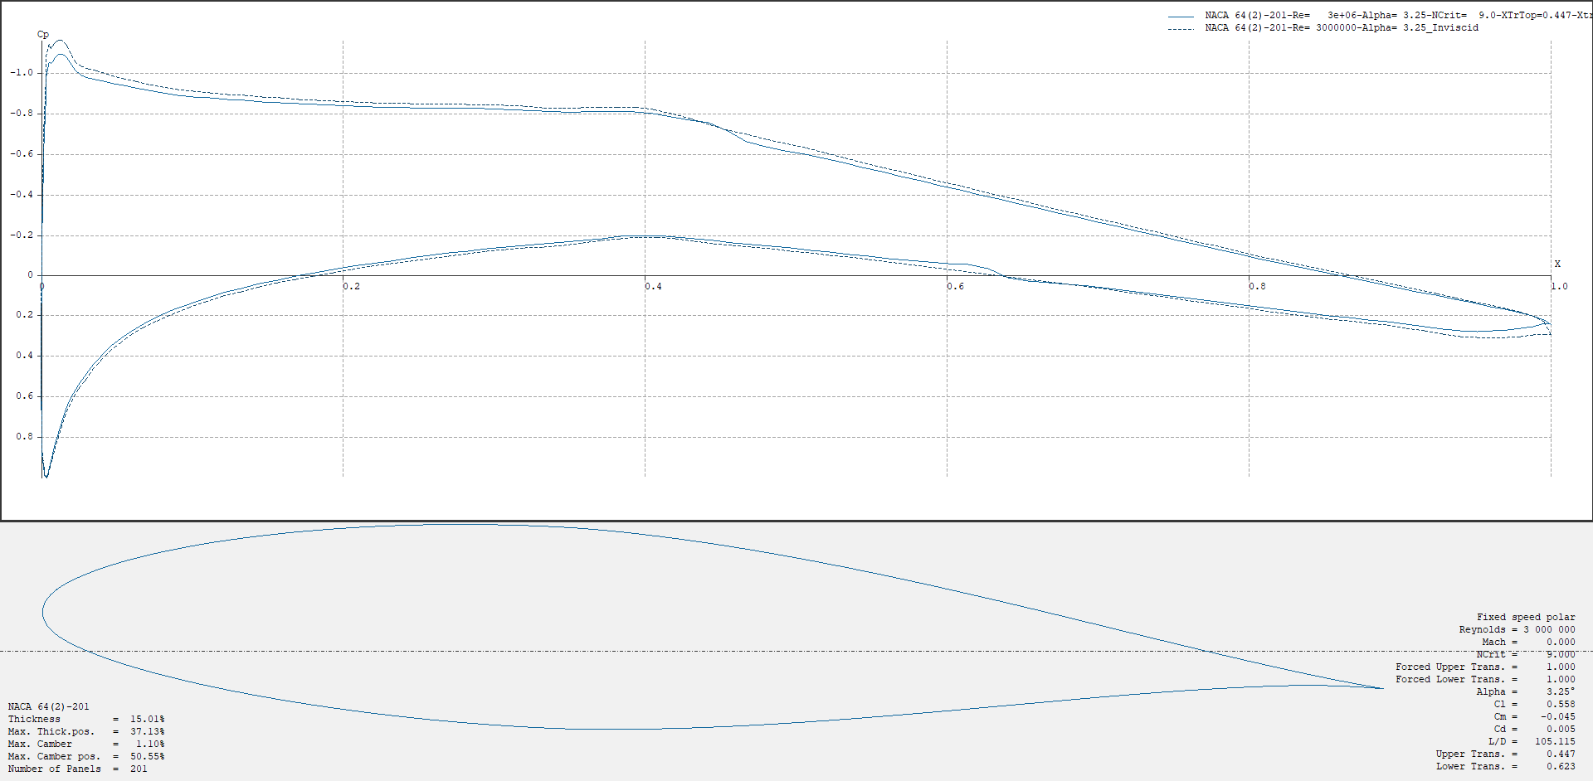e) From MATLAB we can find the local maxima and from that we can find the corresponding angle of attack value for the maximum Cl/Cd value with index searching (code provided in appendix). This angle of attack is 3.250.

Favorable

adverse

lower

Upper

From observing the plot above we can tell that the inviscid flow yields a pressure distribution with more regions of favorable pressure distributions. Therefore, since we know that the lift coefficient can be analytically calculated as a function of the pressure distribution we can say that the inviscid flow will have a higher lift coefficient than the viscous flow.

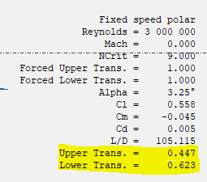

The lower transition can be observed in the pressure distribution plot as the point where the negative pressure distribution changes to positive at approximately 0.623. Whereas, we cannot see the upper transition point from the pressure distribution plot.

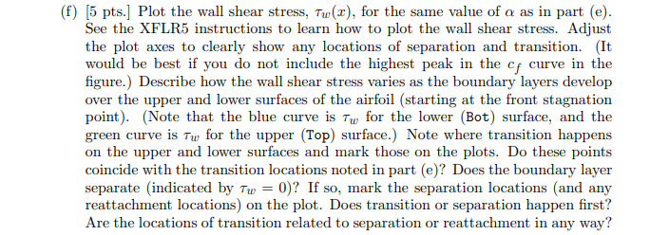

Transition point

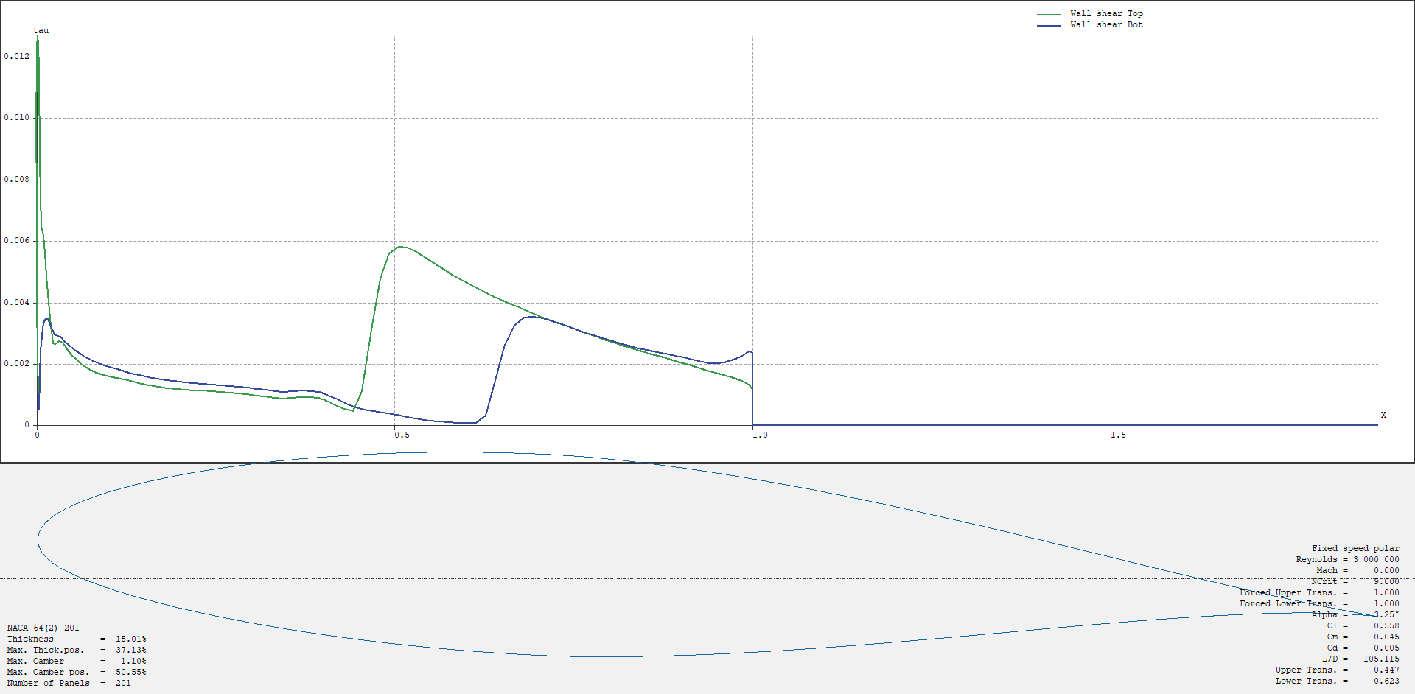

Turbulent

laminar

Transition point

Separation point

The plot above tells us that the upper shear goes up rapidly at the LE and increases at a closer location to the LE than the lower wall shear. The lower wall shear, in the other hand, does not go up rapidly at the LE and also increases its value at a farther point from the LE. Interestingly, the shear goes down abruptly zeros in the last half of the airfoil.

The transition points from the wall shear plot match the points in the plot in problem (c).

Theoretically the separation point is where the wall shear goes to zero, and therefore, the separation point should be at the 0.5 point. However, this is not actually the separation point because in the second half of the chord the flow is completely detached and does not correlate to the shear flow which automatically gives the value of zero. When you look at shear distribution we can see that the flow after the point where the shear shoots up is the turbulent flow and the nearly perpendicular region is the transition flow. Hence, the separation point is the point where the turbulent flow starts, and from this we know that the transition point is before the separation point for both upper and lower surfaces. After the separation point the shear distribution deceases smoothly and there is no reattachment occurring. We know this because if the flow were to reattach the shear distribution should become a negative value and once again increase to a positive value.

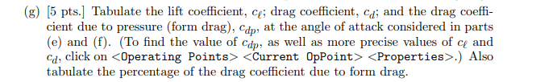

|  |  |  |  |  |
| --- | --- | --- | --- | --- |
| Alpha | Cl | Cd | Cdp | Cdp/Cd*100 (%) |
| 0. | 0.55781 | 0.00531 | 0.00113 | 21.2806 |



Using MATLAB we find that the angle of attack corresponding with the maximum lift coefficient is

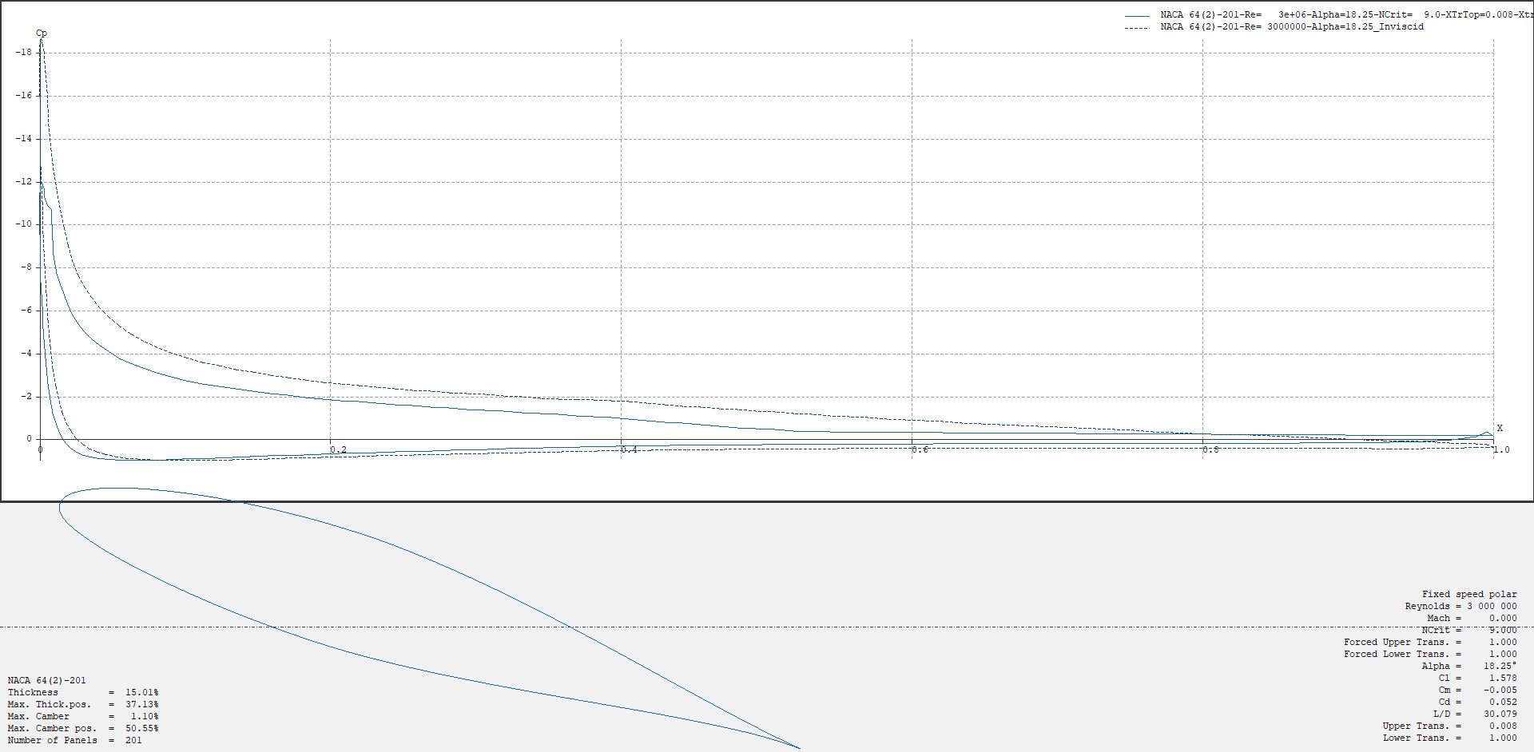Alpha = 18.250

lower

Upper

favorable

adverse

favorable

For this plot, the inviscid pressure distribution has a very higher pressure distribution at the LE for the upper surface. Besides this difference the inviscid agrees with the pressure distribution for the viscous flow. Since the pressure distribution for the inviscid flow is considerably larger than the viscous flow the inviscid flow will yield a higher life coefficient.

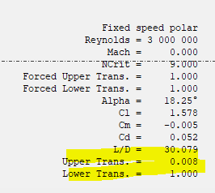

Since the transition point for the upper surface is too small it is hard to observe the exact point on the distribution plot. The lower bound seems to have an intersecting point near the LE edge but this seems to not be the transition point. However, we can tell that the TE is the transition point for the lower surface from the plot.

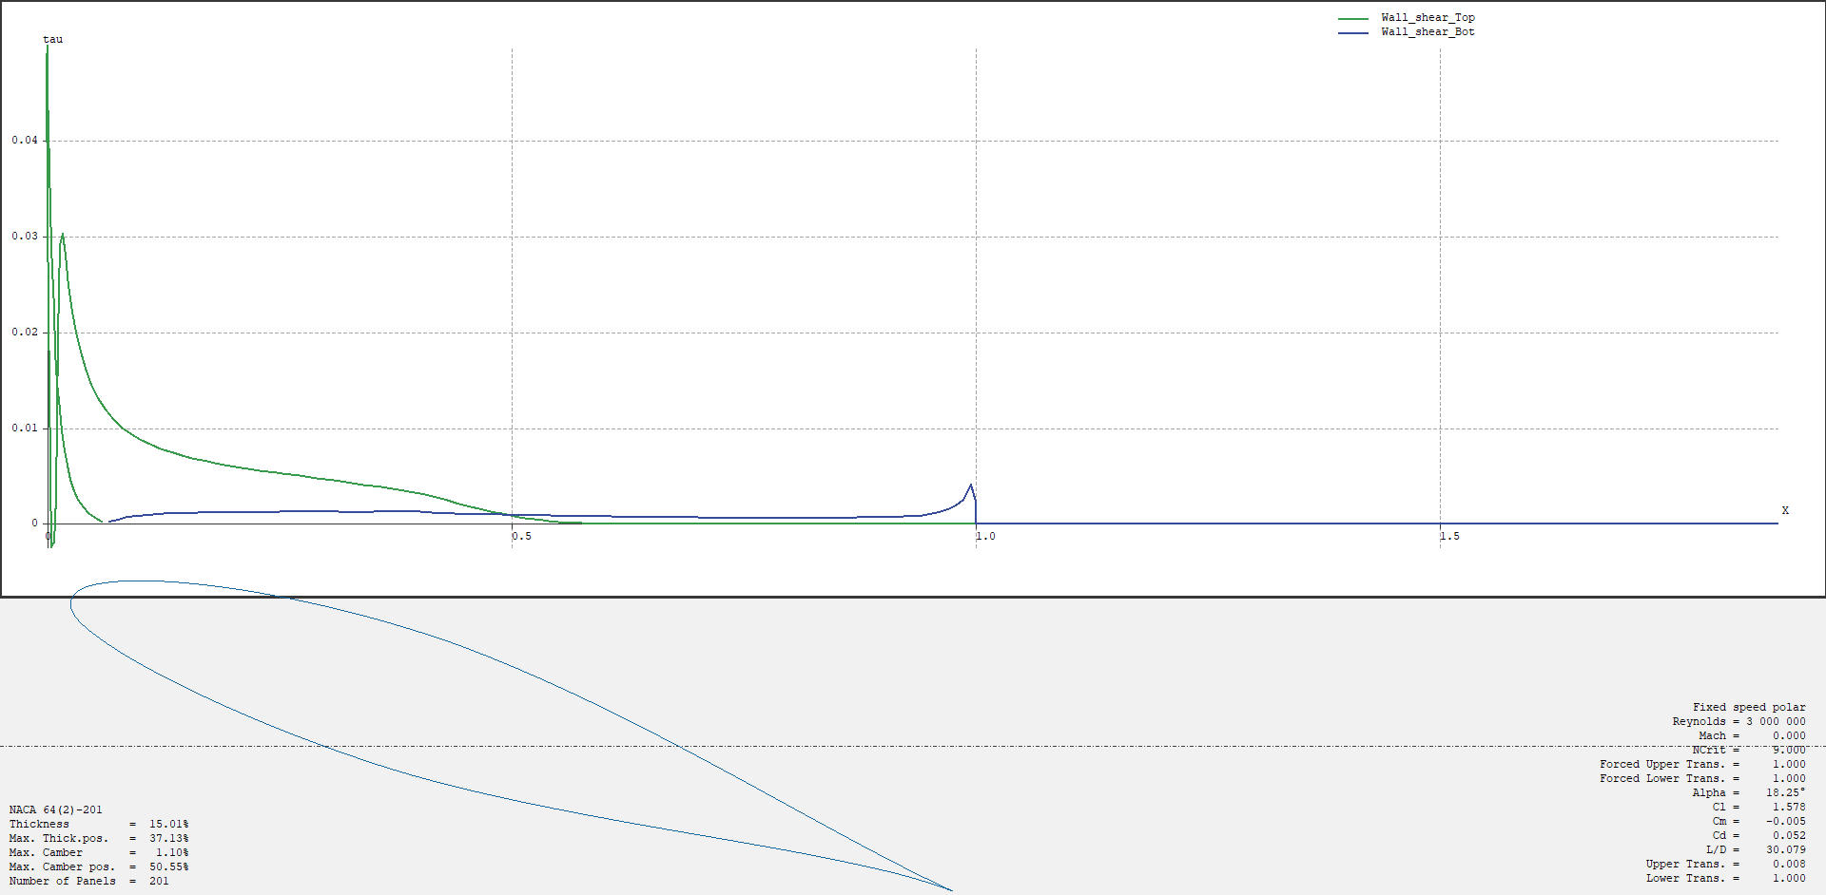

separation points

For this wall shear distribution on the upper surface fluctuates in the proximity of the LE because of the transition and separation points being very close to the LE. Whereas, the shear at the lower surface has overall a very small wall shear which has a curve with a small incremental gradient until the half chord length with a short and small transition process.

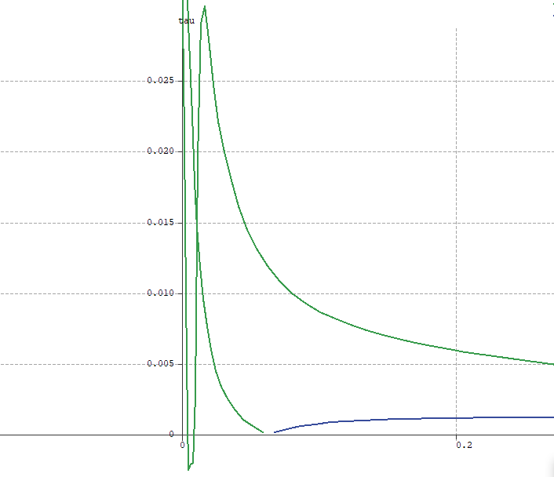

Reattachment

occurs

Transition points

For the upper surface the transition point coincides with that of the pressure distribution, however, the lower surface does not.

Yes, the boundary layer separates. And from the marks we can tell that the separation occurs before the transition. Also for the upper surface there is a point where the distribution dips to the negative side and reenters the positive side. This indicates the existence of a reattachment occurring for the upper surface.

|  |  |  |  |  |
| --- | --- | --- | --- | --- |
| Alpha | Cl | Cd | Cdp | Cdp/Cd*100 (%) |
| 18.25 | 1.57768 | 0.05245 | 0.04847 | 92.4118 |



From the tabulated data we know that at high angle of attacks the percentage of the form drag becomes substantially larger than when the angle of attack is small. This is depicted for the two angles we have analyzed: 0.325 and 18.25. When the angle of attack is small this means that the amount of skin friction accounts for most of the drag on the airfoil.

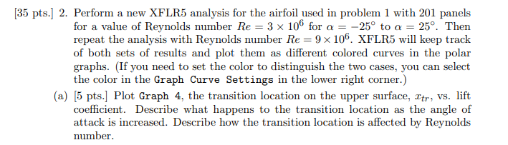

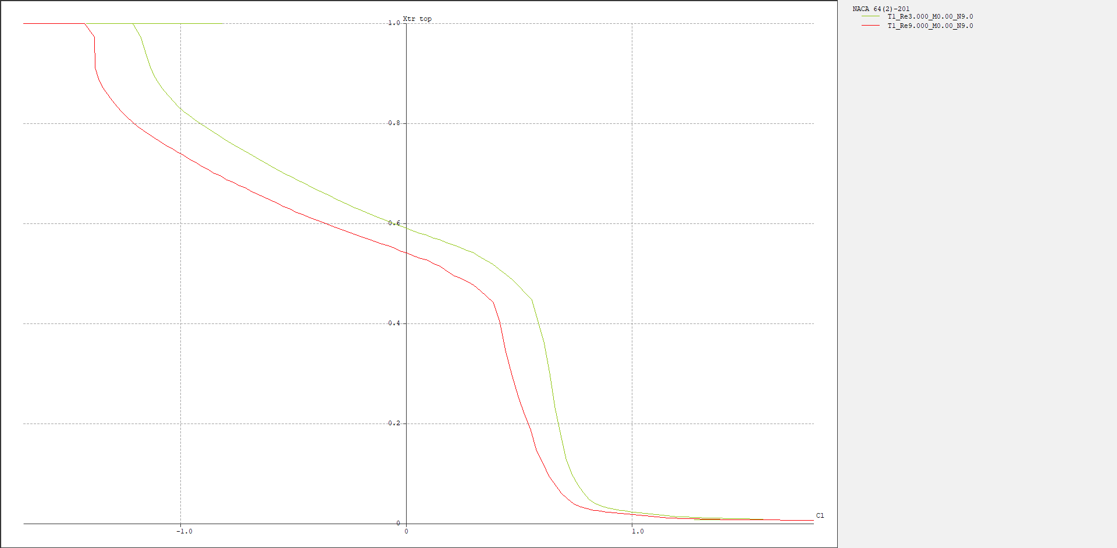

As the angle of attack increases the transition point on the upper surface decreases, and within the range of negative small angle of attacks the decrease rate is slower than the range of positive small angle of attacks.



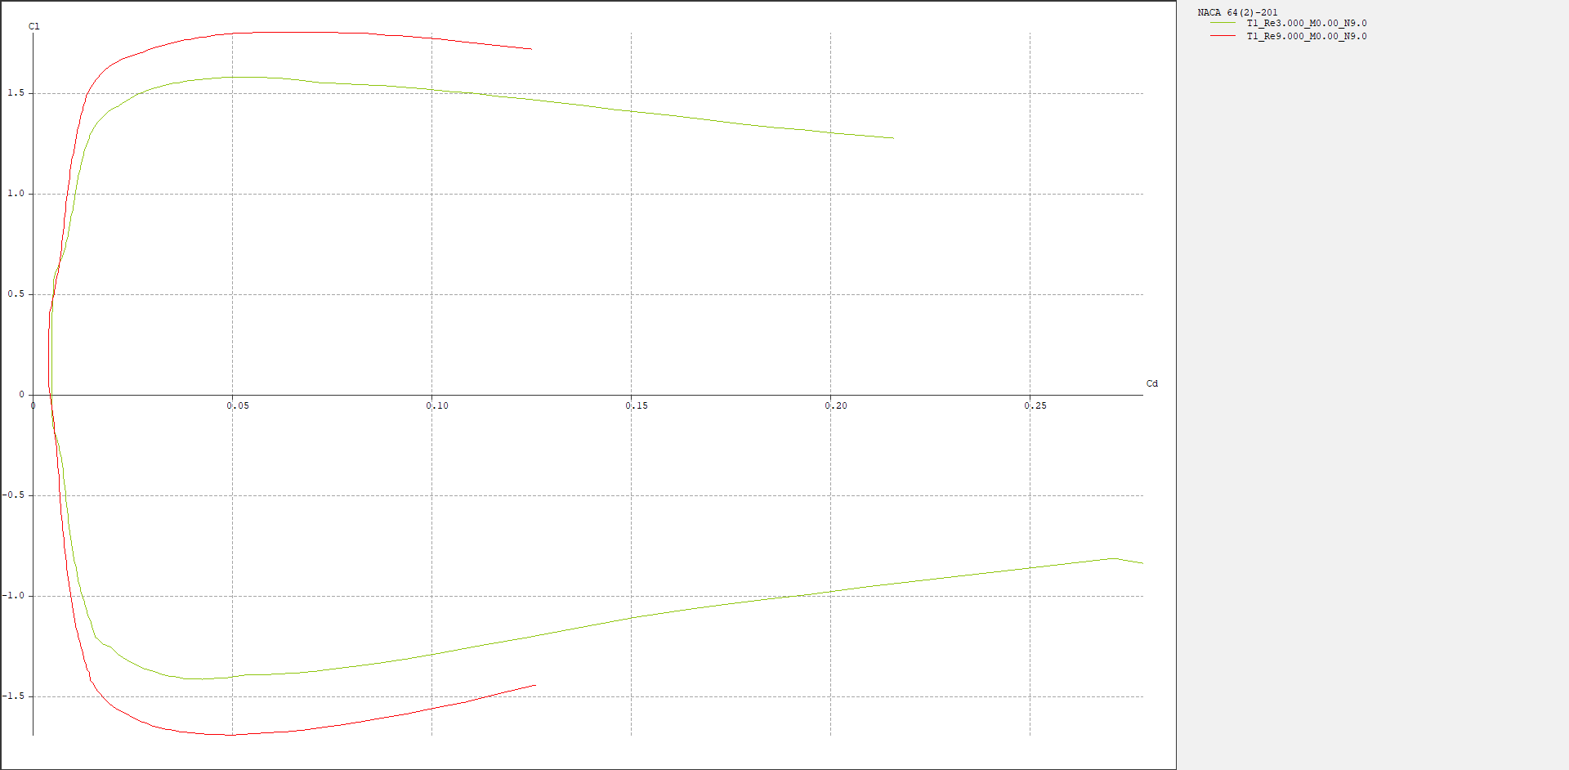

For this plot the Reynolds number equal to 9M (red) has a larger lift coefficient because of the increase in velocity and when the Reynolds number is higher the drag coefficient has a lower maximum value than the Reynolds number of 3M.

This is explainable because to make the Reynolds number larger the viscosity becomes smaller, the velocity becomes larger, or the object becomes larger. The former two reasons pander with the logic that to have lower drag the boundary layer has to remain attached to object. Thus, with higher Reynolds number the lift coefficient becomes overall larger and the drag coefficient becomes lower.



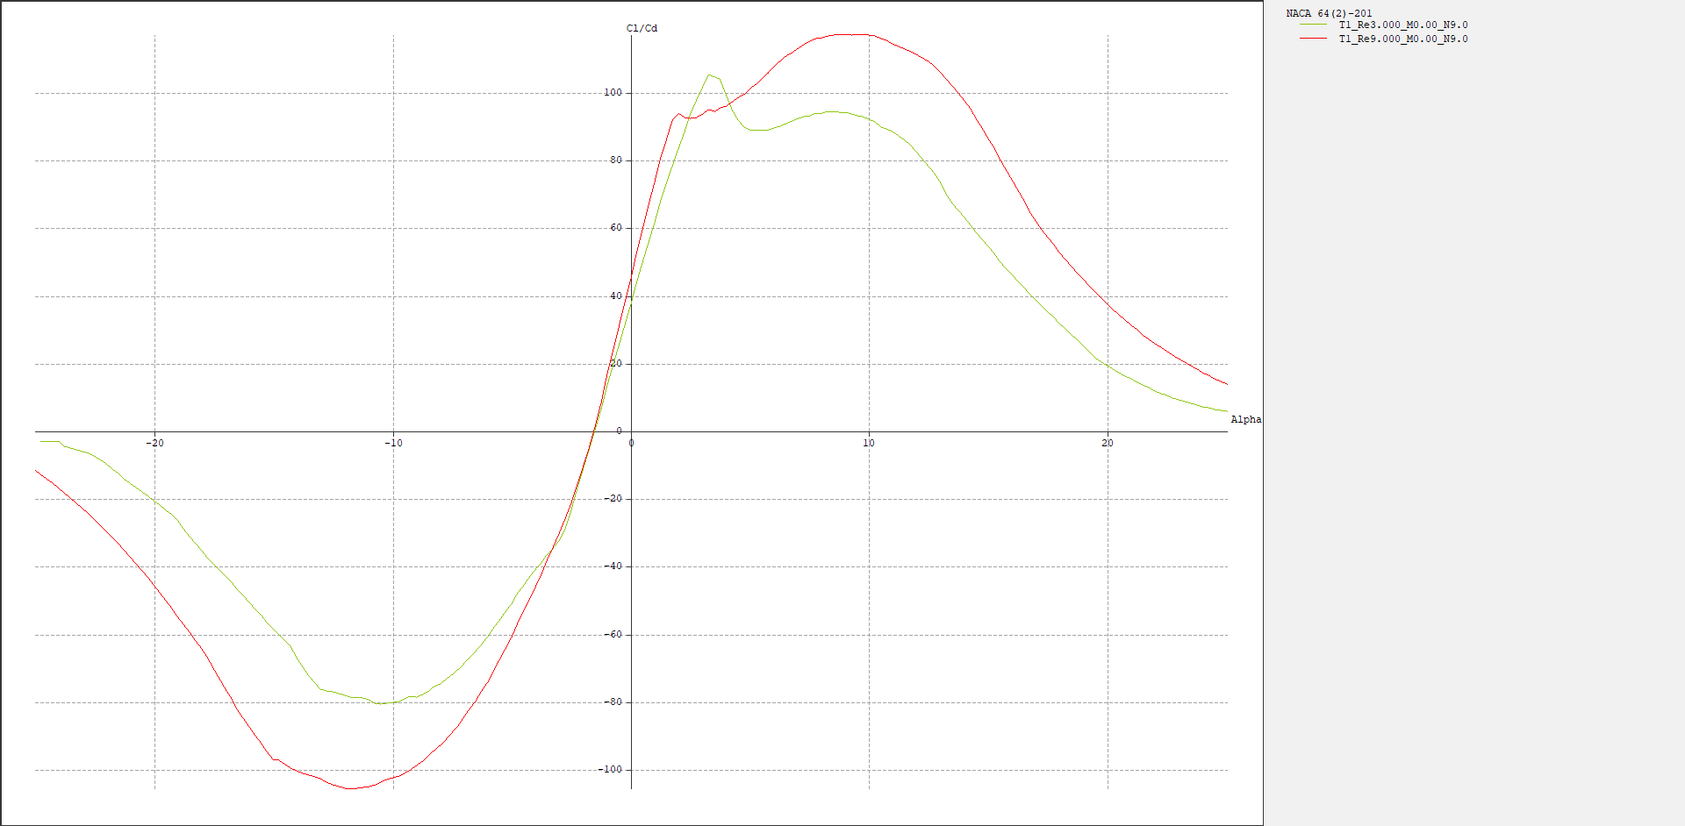

Using Excel from the exported data points from the plot above we get (for only 9M Reynolds number since 3M Reynolds number is the exact same analysis in problem 1)

peak (max): 116.9899

Since

The answer is 116.9899

Drawing a tangential line and calculating the L/D maximum ratio with MATLAB we get (for 9M Reynold number)

Maximum is 116.9898

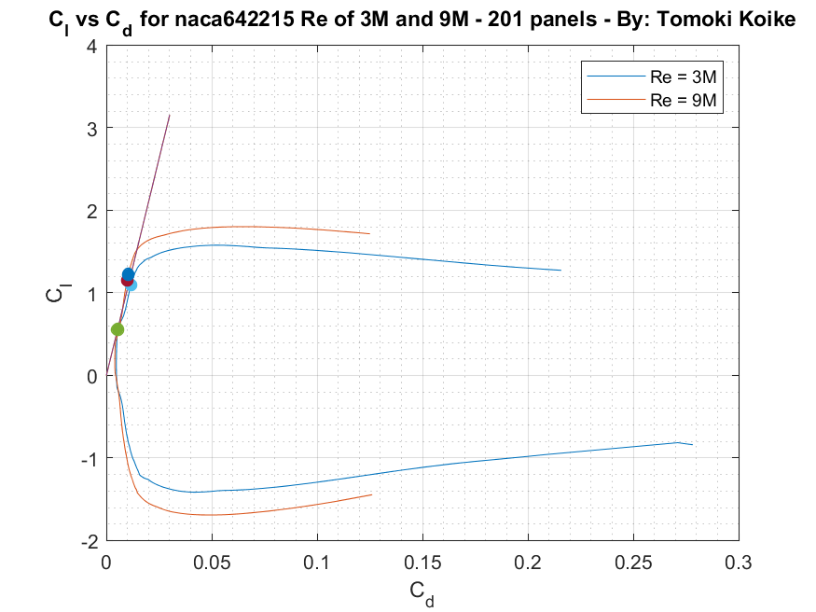

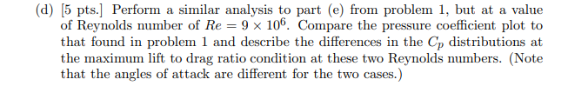

The angle of attack at maximum lift over drag ratio for Re = 9M is (calculated from MATLAB)

Alpha = 9.750

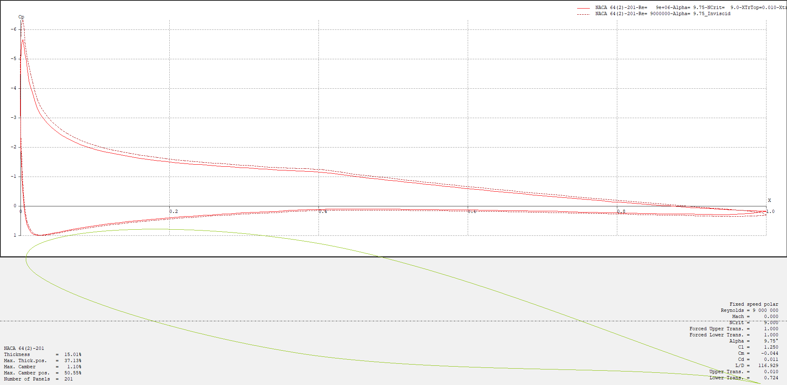

adverse

favorable

When the Reynolds number is 9M the lower surface is overall adverse. At the upper surface the pressure distribution is overall favorable but just at the proximity of the TE, the flow becomes adverse with a positive pressure gradient.

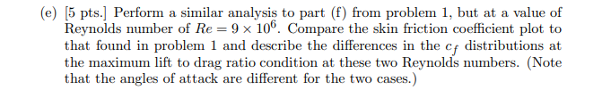

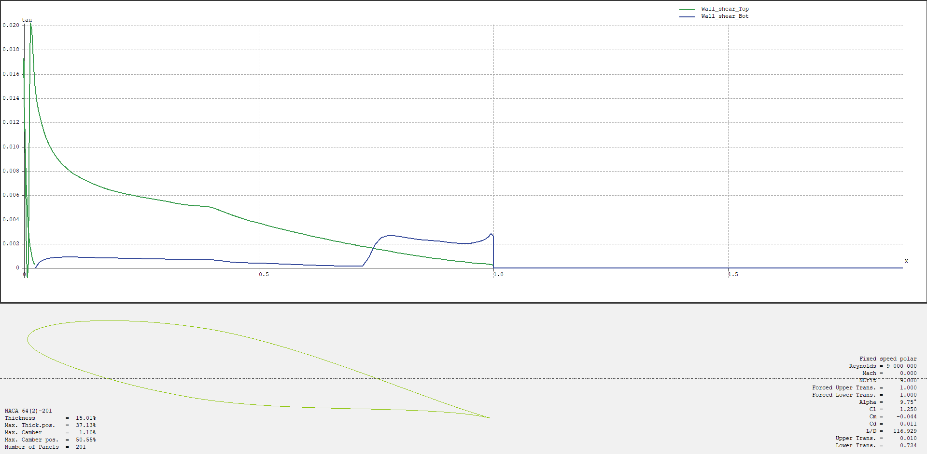

Transition points

Separation points

For the Reynolds number of 9M the shear distribution is very different from that of 6M and at the angle of maximum L/D. This is closer to when the angle of attack is high for Reynolds number of 6M. The upper surface undergoes transition and separation at a position very close to the LE and reattaches after it separates once. The lower surface has a trend similar to Reynolds number of 6M. The transition point is a 0.75 of the chord length and transitions smoothly to turbulent flow. Most importantly the deviation between the upper and lower surface is substantial compared to the plot in problem 1 (f).

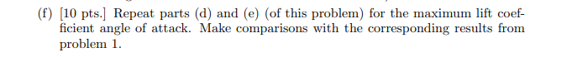

The angle with maximum angle of attack is computed in MATLAB as

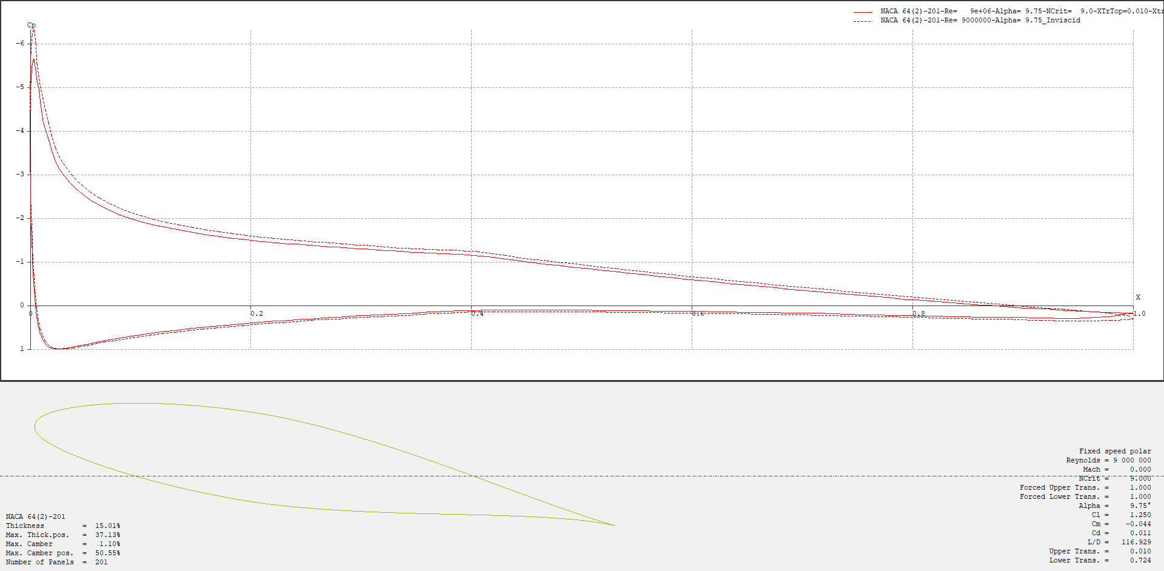Alpha = 21.75o

For this plot the deviation between the upper and lower surface is larger than that of Reynolds number of 3M. For the upper surface close to half-chord the pressure decrease rate goes down somewhat which was not observed in the previous observation in problem 1. Also, the distribution on the lower surface curves in a concave downwards manner which was something not seen as well. Besides those characteristics the pressure distribution is somewhat similar.



Interestingly for the Reynolds number 9M shear distribution the distribution is not so different from the angle of attack of 9.75 where the L/D is maximum. In the plot above the transition and separation points for the upper surface remains at a close location to the LE and the transition point for the lower surface also has not changed. This means that with the low viscosity or high velocity (which makes the Reynolds number high) the shear distribution does not change that much based on the angle of attack.

But compared to the 3M Reynolds number condition the shear in the range marked with an orange arrow remains higher.

Appendix

**problem 1**

clear all; close all; clc;

**(d)**

% Import data as matrix

Cl_vs_Cd = readtable('p1_c_Cl_vs_Cd.csv'); % Read file

Cl_vs_Cd = table2array(Cl_vs_Cd); % convert table to array

Cl = Cl_vs_Cd(:,2); % Assign Cl values

Cd = Cl_vs_Cd(:,1); % Assign Cd values

dydx = Cl./Cd; % Find the gradient of each points

[max_Cl_over_Cd, idx] = max(dydx)

Cd_idx = Cd(idx)

Cl_idx = Cl(idx)

% Tangential line

x = linspace(0,0.03);

y = Cl_idx/Cd_idx.*x;

% Finding local maximums

Cl_over_Cd_vs_AoA = csvread('p1_d_Cl_over_Cd_vs_AoA.csv');

Cl_over_Cd = Cl_over_Cd_vs_AoA(:,2);

AoA1 = Cl_over_Cd_vs_AoA(:,1);

local_max_idx = islocalmax(Cl_over_Cd);

local_max_Cl = Cl(local_max_idx);

local_max_Cd = Cd(local_max_idx);

local_max_AoA = AoA1(local_max_idx)

% Plotting

fig1 = figure('Renderer','painters');

plot(Cd, Cl)

title('C_l vs C_d for naca642215 - 201 panels - By: Tomoki Koike')

xlabel('C_d')

ylabel('C_l')

hold on

plot(x,y)

plot(local_max_Cd(3), local_max_Cl(3),'.','MarkerSize',20)

plot(local_max_Cd(4), local_max_Cl(4),'.','MarkerSize',20)

hold off

legend('C_l vs C_d plot', 'tangential line')

grid on

grid minor

box on

saveas(fig1, 'p1_d_tangential_line.png')

**<h>**

[max_Cl, idx2] = max(Cl)

AoA_maxCl = AoA1(idx2)

**problem 2**

% Import data as matrix

Cl_vs_Cd_new = readtable('p2_c_Cl_vs_Cd.csv'); % Read file

Cl_vs_Cd_new = table2array(Cl_vs_Cd_new); % convert table to array

Cl3 = Cl_vs_Cd_new(:,2); % Assign Cl values

Cd3 = Cl_vs_Cd_new(:,1); % Assign Cd values

dydx3 = Cl3./Cd3; % Find the gradient of each points

[max_Cl_over_Cd3, idx3] = max(dydx3)

Cd_idx3 = Cd3(idx3)

Cl_idx3 = Cl3(idx3)

% Tangential line

x3 = linspace(0,0.03);

y3 = Cl_idx3/Cd_idx3.*x3;

Cl9 = Cl_vs_Cd_new(:,4); % Assign Cl values

Cd9 = Cl_vs_Cd_new(:,3); % Assign Cd values

dydx9 = Cl9./Cd9; % Find the gradient of each points

[max_Cl_over_Cd9, idx9] = max(dydx9)

Cd_idx9 = Cd9(idx9)

Cl_idx9 = Cl9(idx9)

% Tangential line

x9 = linspace(0,0.03);

y9 = Cl_idx/Cd_idx.*x3;

% Finding local maximums

% 3M

Cl_over_Cd_vs_AoA_new = csvread('Polar_Graph_4.csv');

Cl_over_Cd3 = Cl_over_Cd_vs_AoA_new(:,2);

AoA3 = Cl_over_Cd_vs_AoA_new(:,1);

local_max_idx3 = islocalmax(Cl_over_Cd3)

local_max_Cl3 = Cl3(local_max_idx3)

local_max_Cd3 = Cd3(local_max_idx3)

local_max_AoA3 = AoA3(local_max_idx3)

% 9M

Cl_over_Cd9 = Cl_over_Cd_vs_AoA_new(:,4);

AoA9 = Cl_over_Cd_vs_AoA_new(:,3);

local_max_idx9 = islocalmax(Cl_over_Cd9)

local_max_Cl9 = Cl9(local_max_idx9)

local_max_Cd9 = Cd9(local_max_idx9)

local_max_AoA9 = AoA9(local_max_idx9)

% Plotting

fig2 = figure('Renderer','painters');

plot(Cd3, Cl3)

title('C_l vs C_d for naca642215 Re of 3M and 9M - 201 panels - By: Tomoki Koike')

xlabel('C_d')

ylabel('C_l')

hold on

plot(Cd9,Cl9)

plot(x9,y9)

plot(x3,y3)

plot(local_max_Cd3(3), local_max_Cl3(3),'.','MarkerSize',20)

plot(local_max_Cd3(4), local_max_Cl3(4),'.','MarkerSize',20)

plot(local_max_Cd9(3), local_max_Cl9(3),'.','MarkerSize',20)

plot(local_max_Cd9(4), local_max_Cl9(4),'.','MarkerSize',20)

hold off

legend('Re = 3M', 'Re = 9M')

grid on

grid minor

box on

saveas(fig2, 'p2_d_tangential_line.png')

[max_Cl9, idx_oho] = max(Cl9)

AoA_maxCl9999 = AoA9(idx_oho)