AAE 334: Aerodynamics

HW7: Wing Stability Analysis

Dr. Blaisdell

Purdue University

School of Aeronautical and Astronautical Engineering

Tomoki Koike

Friday March 13th 2020

Download the files in the HW7 folder on Blackboard. To review use of XFLR5 for stability analysis see the video ‘XFLR5 Demo for AAE 334 Stability Lecture’ by Professor Sullivan, which is available on the AAE 334 Course Content page on Blackboard. After performing the calculations or running the analyses described below, enter the results in the appropriate column in the Excel file “AAE334 Homework 7 Data and Answer Sheet”. Print a copy of the completed spreadsheet to turn in with your homework.

1. Problem #1
   1. [25 pts] Using the formulas in the notes, calculate the stability quantities on the “Homework sheet” tab of the Excel file “AAE334 Homework 7 Data and Answer Sheet”. Show your handwritten work on separate sheets of paper.
   2. [25 pts] Run XFLR5 using the file “AAE 334 telemaster stability Homework #7.xfl” and compare your answers (i.e., calculate the percent difference). (Note that the xfl file already has the geometry of the airplane included. In addition, the analysis of the wing alone has already been done. However, you will have to run the necessary analysis of the airplane.)
2. Problem #2 - Rerun xFLR5 with a velocity V=20 m/sec.
   1. [25 pts] Trim the aircraft by moving the CG so the aircraft is stable at the proper trim point.
   2. [25 pts] Trim the aircraft by changing the tail angle so the aircraft is stable at the proper trim point. (Use the original CG location.)

*The spreadsheet with the final answers is at the end

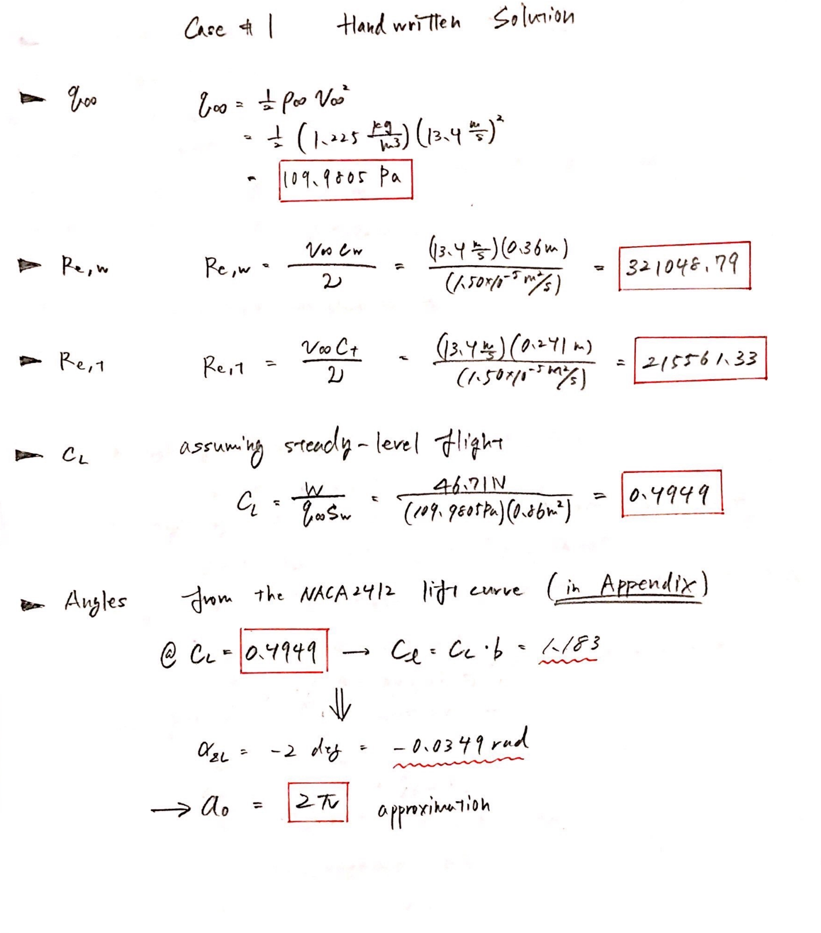

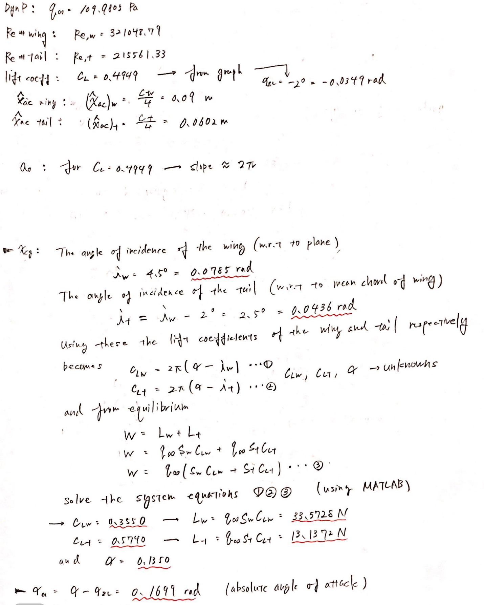

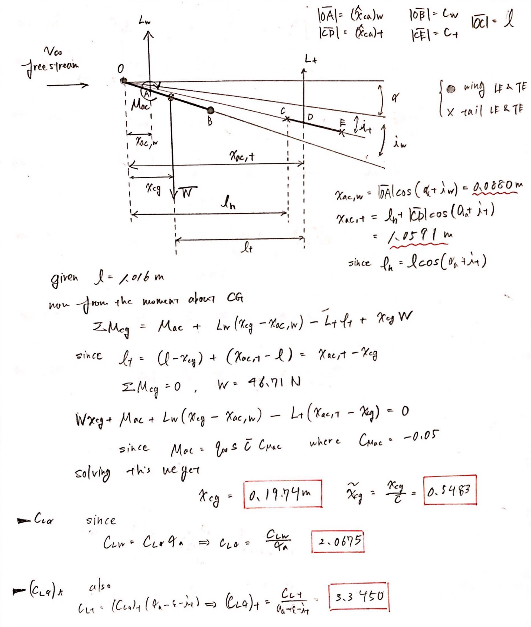

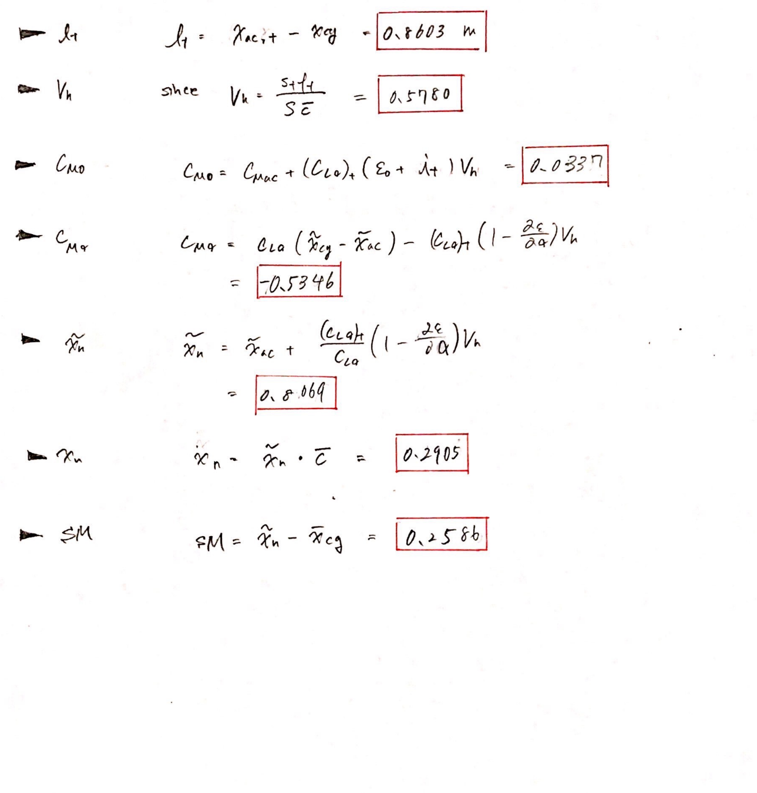

PLOT

MATLAB CODE

**AAE334 HW7 MATLAB CODE**

clear all; close all; clc;

fdir = 'C:\Users\Tomo\Desktop\studies\2020-Spring\AAE334\matlab\outputs\HW7';

set(groot, 'defaulttextinterpreter',"latex");

set(groot, 'defaultAxesTickLabelInterpreter',"latex");

set(groot, 'defaultLegendInterpreter',"latex");

**problem 1-a**

% Defining necessary properties

v_inf = 13.4; % freestream velocity [m/s]

rho_inf = 1.225; % freestream air density [kg/m3]

q_inf = 0.5*rho_inf*v_inf^2; % freestream dynamic pressure [Pa]

S_w = 0.86; % wing area [m2]

S_t = 0.208; % tail area [m2]

ch_w = 0.36; % chord length of wing [m]

ch_t = 0.241; % chord length of tail [m]

l = 1.016; % distance from the LE of the wing to the LE of the tail [m]

ch_mean = ch_w; % mean chord length of the wing [m]

epsilon = 0;

e_a = 0.4; % D(epsilon)/Da

W = 46.71; % weight of the plane [N]

% Calculating the x_cg (center of gravity of the plane)

% Necessary angles [rad]

a_zl = deg2rad(-2.1) % zero lift angle

i_w = deg2rad(4.5) % incident angle of the wing

i_t = i_w - deg2rad(2) % incident angle of the tail wrt the plane

% find a, C_Lw, and C_Lt

[C_Lw, C_Lt, a] = CLw_CLt_AoA(W, i_w, i_t, q_inf, S_w, S_t)

a_a = a - a_zl % absolute angle of attack

% the lifts for the wing and tail

L_w = q_inf*S_w*C_Lw % wing [N]

L_t = q_inf*S_t*C_Lt % tail [N]

% aerodynamic center positions (wrt the LE of the wing)

xhat_ac_w = ch_w/4 % wing [m]

xhat_ac_t = ch_t/4 % tail [m]

lh = l*cos(a_a + i_t);

x_ac_w = xhat_ac_w*cos(a_a + i_w)

x_ac_t = lh + xhat_ac_t*cos(a_a + i_t)

x_ac_til = 0.25;

% moment coefficient about the aerodynamic center of the wing

C_Mac_w = -0.05;

% moment about the aerodynamic center of the wing [N-m]

Mac_w = q_inf*S_w*ch_mean*C_Mac_w

% solve

syms var1

eqn1 = Mac_w + L_w*(var1 - x_ac_w) - L_t*(x_ac_t - var1) + W*var1 == 0;

x_cg = double(solve(eqn1, var1))

x_cg_til = x_cg/ch_mean

% C_La

C_La_w = C_Lw/a_a

% C_La_t

C_La_t = C_Lt/(a_a)

% l_t distance from the x_cg to the aerodynamic center of the tail

l_t = x_ac_t - x_cg

% Vh

Vh = S_t*l_t/S_w/ch_mean

% C_Mo

C_Mo = C_Mac_w + C_La_t*(epsilon + i_t)*Vh

% C_Ma

C_Ma = C_La_w*(x_cg_til - x_ac_til) - C_La_t*(1 - e_a)*Vh

% x_n

x_n_til = x_ac_til + C_La_t/C_La_w*(1 - e_a)*Vh

x_n = x_n_til*ch_mean

% SM

SM = x_n_til - x_cg_til

**problem 1-b**

% importing data

data_1b = readmatrix("inputs\hw7\hw7_Cm_vs_Cl_case1_2_2.csv");

% Calculating the static margin

SM_1b = calc_SM_from_xflr(data_1b)

% Importing another data

data_1b2 = readmatrix("inputs\hw7\hw7_Cm_vs_alpha_case1_2.csv");

% Calculating the C_M0 (*for the angle of attack add 2.1 degrees to adjust

% to the absolute angle of attack)

[C_Mo_1b, C_Ma_1b] = calc_CMo_and_CMa_from_xlfr(data_1b2, -2.1, rad2deg(i_w))

**problem 2-a**

% importing data

data_2a = readmatrix("inputs\hw7\hw7_Cm_vs_Cl_case2a.csv");

% Calculating the static margin

SM_2a = calc_SM_from_xflr(data_2a)

% Importing another data

data_2a2 = readmatrix("inputs\hw7\hw7_Cm_vs_alpha_case2a.csv");

% Calculating the C_M0 (*for the angle of attack add 2.1 degrees to adjust

% to the absolute angle of attack)

[C_Mo_2a, C_Ma_2a] = calc_CMo_and_CMa_from_xlfr(data_2a2, -2.1, rad2deg(i_w))

% find a, C_Lw, and C_Lt

q_inf_2a = 245;

[C_Lw_2a, C_Lt_2a, a_2a] = CLw_CLt_AoA(W, i_w, i_t, q_inf_2a, S_w, S_t)

a_a_2a = a_2a - a_zl % absolute angle of attack

% the lifts for the wing and tail

L_w = q_inf_2a*S_w*C_Lw_2a % wing [N]

L_t = q_inf_2a*S_t*C_Lt_2a % tail [N]

**problem 2-b**

% importing data

data_2b = readmatrix("inputs\hw7\hw7_Cm_vs_Cl_case2b.csv");

% Calculating the static margin

SM_2b = calc_SM_from_xflr(data_2b)

% Importing another data

data_2b2 = readmatrix("inputs\hw7\hw7_Cm_vs_alpha_case2b.csv");

% Calculating the C_M0 (*for the angle of attack add 2.1 degrees to adjust

% to the absolute angle of attack)

[C_Mo_2b, C_Ma_2b] = calc_CMo_and_CMa_from_xlfr(data_2b2, -2.1, rad2deg(i_w))

% find a, C_Lw, and C_Lt

q_inf_2b = 245;

[C_Lw_2b, C_Lt_2b, a_2b] = CLw_CLt_AoA(W, i_w, i_t, q_inf_2b, S_w, S_t)

a_a_2b = a_2b - a_zl % absolute angle of attack

% the lifts for the wing and tail

L_w = q_inf_2b*S_w*C_Lw_2b % wing [N]

L_t = q_inf_2b*S_t*C_Lt_2b % tail [N]

**Plotting**

fig1 = figure("Renderer","painters");

plot(data_1b(:,1),data_1b(:,2))

title({'$C_m$ vs $C_L$ Plots for All Cases - Tomoki Koike'})

xlabel('$C_L$')

ylabel('$C_m$')

hold on

plot(data_2a(:,1),data_2a(:,2))

plot(data_2b(:,1),data_2b(:,2))

plot(linspace(-0.2,0.7,100),zeros([1,length(linspace(-0.2,0.7,100))]),'--k',"LineWidth",1.0)

plot(zeros([1,length(linspace(-0.15,0.15,100))]),linspace(-0.15,0.15,100),'--k',"LineWidth",1.0)

hold off

grid on; grid minor; box on;

legend('Case 1','Case 2a','Case 2b')

saveas(fig1, fullfile(fdir,'Cm_vs_Cl.png'))

**FUNCTIONS**

function SM = calc_SM_from_xflr(data)

% data: data points

CL_1b = data(:,1);

Cm_1b = data(:,2);

% SM

if Cm_1b(CL_1b == min(abs(CL_1b)))

Cm_1b_0 = Cm_1b(CL_1b == min(abs(CL_1b)));

else

Cm_1b_0 = Cm_1b(CL_1b == -(min(abs(CL_1b))));

end

if CL_1b(Cm_1b == -(min(abs(Cm_1b))))

CL_1b_0 = CL_1b(Cm_1b == -(min(abs(Cm_1b))));

else

CL_1b_0 = CL_1b(Cm_1b == (min(abs(Cm_1b))));

end

SM = Cm_1b_0/CL_1b_0;

end

function [C_Mo, C_Ma] = calc_CMo_and_CMa_from_xlfr(data, a_zl, i_w)

% data: data points

% a_zl: zero lift angle of attack

% i_w: wing incidence angle

Cm = data(:,2);

a = data(:,1) - a_zl + i_w;

P = polyfit(a,Cm,1);

C_Ma = P(1);

C_Mo = P(2);

end

function [C_Lw, C_Lt, a] = CLw_CLt_AoA(W, i_w, i_t, q_inf, S_w, S_t)

% system equations to find a, C_Lw, and C_Lt

syms x1 x2 x3

eqn1 = x1 == 2*pi*(x3 - i_w);

eqn2 = x2 == 2*pi*(x3 - i_t);

eqn3 = W == q_inf*(S_w*x1 + S_t*x2);

res = solve([eqn1 eqn2 eqn3],[x1 x2 x3]);

% the lift coefficients for the wing and tail respectively

C_Lw = double(res.x1);

C_Lt = double(res.x2);

% angle of attack

a = double(res.x3);

end