AAE 334: Aerodynamics

HW8: Compressible Isentropic Relation & Pitot Tube

Dr. Blaisdell

School of Aeronautical & Astronautical Engineering

Purdue University

Tomoki Koike

Friday March 27th 2020

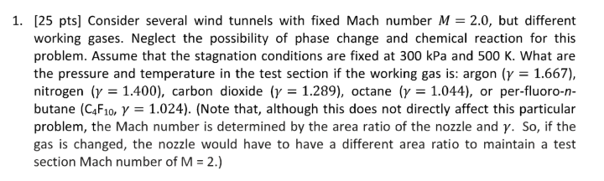

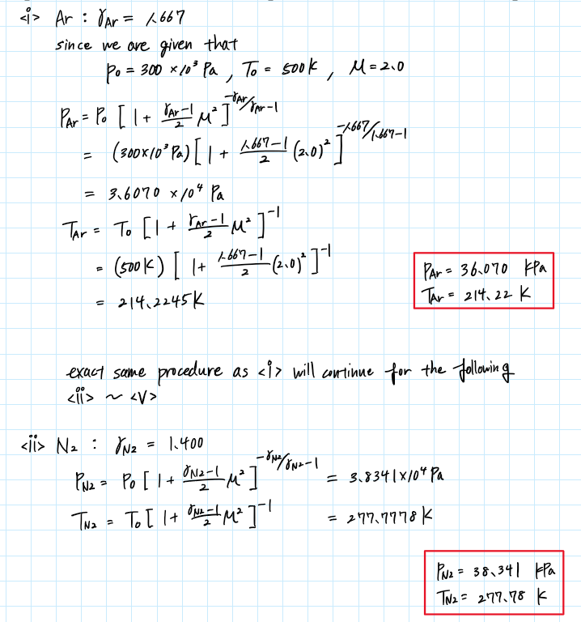

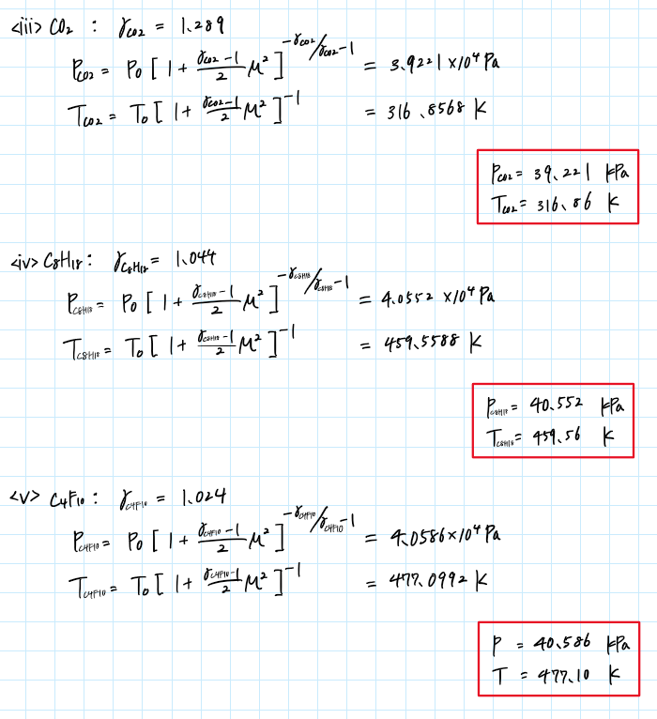

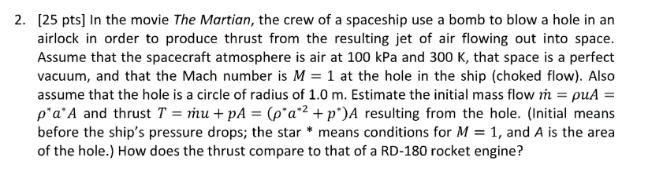

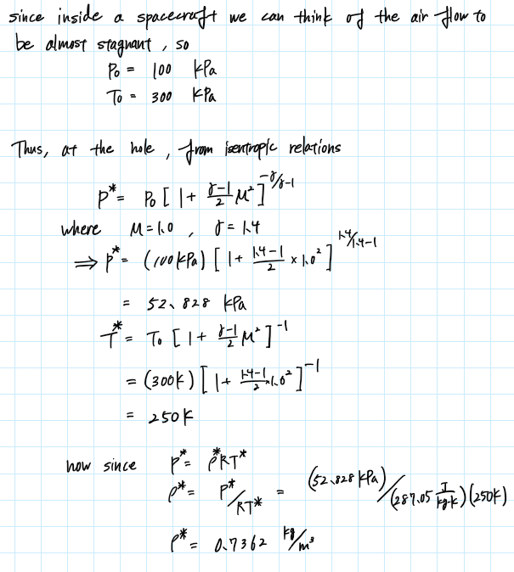

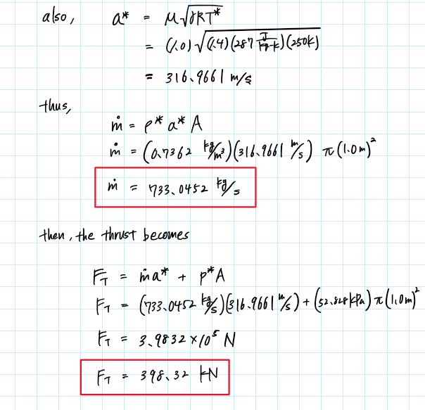

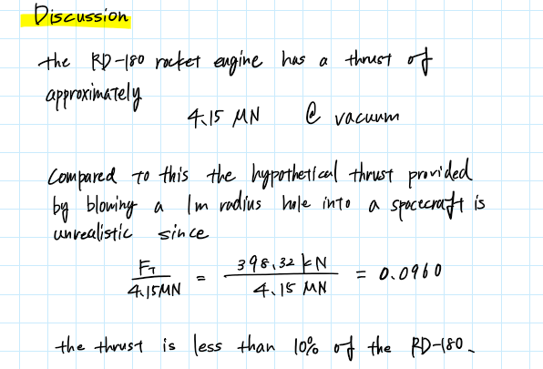

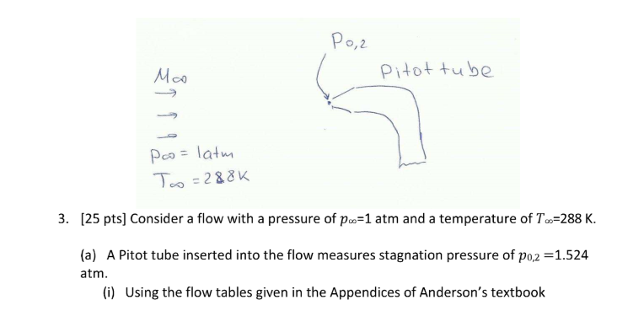 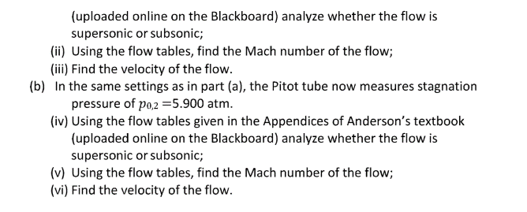

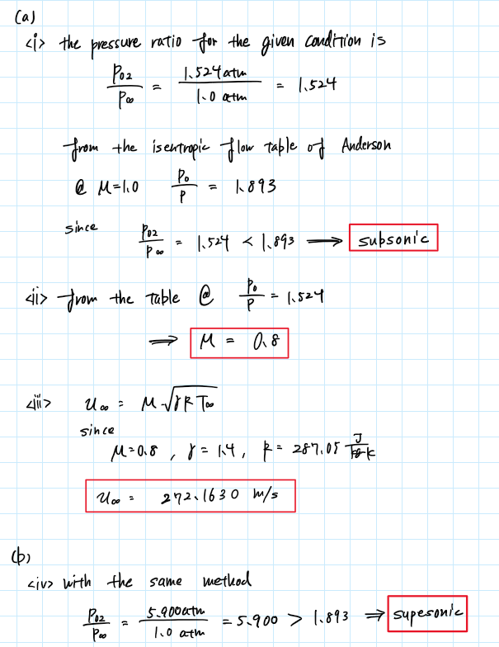

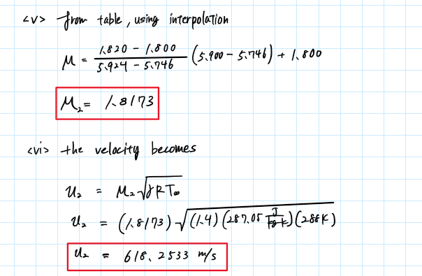

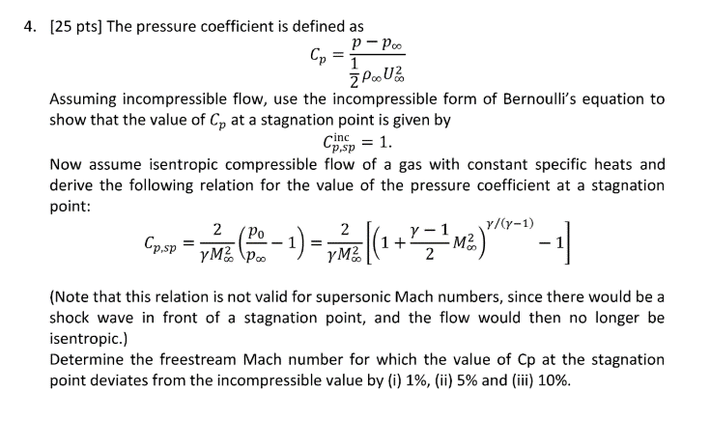

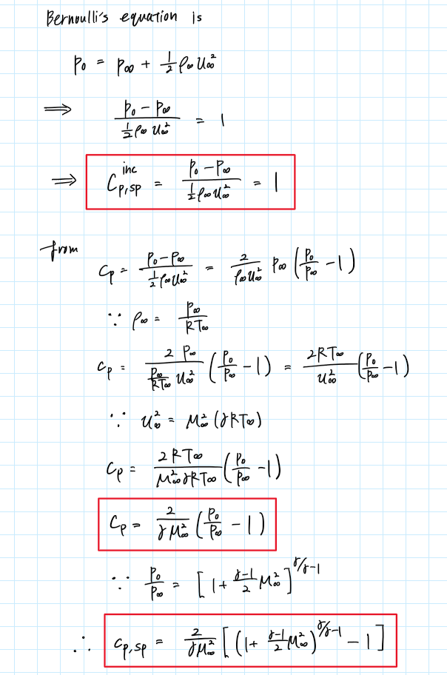

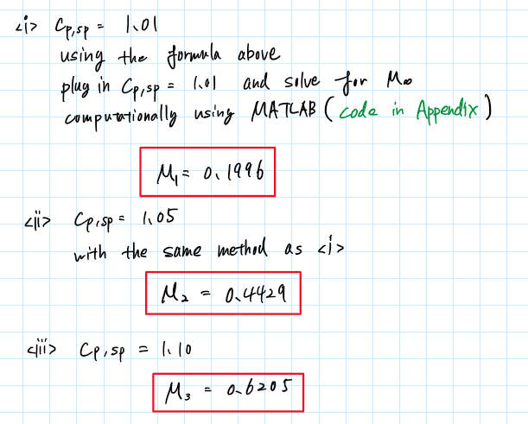

Appendix

**AAE334 HW8 MATLAB**

clear all; close all; clc;

**P1**

P0 = 300e3; % stagnation pressure [Pa]

T0 = 500; % stagnation temperature [K]

M = 2.0; % Mach number

% Argon

gamma_Ar = 1.667;

P_Ar = p_from_M_and_gamma(P0,M,gamma_Ar,'static')

T_Ar = T_from_M_and_gamma(T0,M,gamma_Ar,'static')

% Nitrogen

gamma_N2 = 1.400;

P_Ar = p_from_M_and_gamma(P0,M,gamma_N2,'static')

T_Ar = T_from_M_and_gamma(T0,M,gamma_N2,'static')

% Carbon Dioxide

gamma_CO2 = 1.289;

P_Ar = p_from_M_and_gamma(P0,M,gamma_CO2,'static')

T_Ar = T_from_M_and_gamma(T0,M,gamma_CO2,'static')

% Octane

gamma_C8H18 = 1.044;

P_Ar = p_from_M_and_gamma(P0,M,gamma_C8H18,'static')

T_Ar = T_from_M_and_gamma(T0,M,gamma_C8H18,'static')

% Per-fluoro-n-butane

gamma_C4F10 = 1.024;

P_Ar = p_from_M_and_gamma(P0,M,gamma_C4F10,'static')

T_Ar = T_from_M_and_gamma(T0,M,gamma_C4F10,'static')

**P2**

P0 = 100e3; % stagnation pressure [Pa]

T0 = 300; % stagnation temperature [K]

M = 1.0; % Mach number

gamma = 1.4; % heat capacity ratio

R = 287.05; % gas constant [J/kg/K]

A = pi*1.0^2; % hole area [m2]

P = p_from_M_and_gamma(P0,M,gamma,'static') % static pressure at hole

T = T_from_M_and_gamma(T0,M,gamma,'static') % static temperature at hole

rho = P/R/T % static density at hole

u = M*sqrt(gamma*R*T) % velocity at hole

m_dot = rho*u*A % mass flow at hole

Ft = m_dot*u + P*A % thrust at hole [N]

% Compare to RD-180 rocket engine

rat = Ft/4.15e6

**P3**

P02 = 1.524; % [atm]

P = 1; % [atm]

T = 288; % [K]

M = 0.8;

% <iii>

u = M*sqrt(gamma*R*T)

% <v>

M2 = two_point_interpolate(5.9,5.746,5.924,1.8,1.82)

% <vi>

u2 = M2*sqrt(gamma*R*T)

**P4**

% Cp = 1.01

M1 = calc_M_from_Cp(1.01)

% Cp = 1.05

M2 = calc_M_from_Cp(1.05)

% Cp = 1.10

M3 = calc_M_from_Cp(1.10)

**FUNCTION**

function M = calc_M_from_Cp(Cp)

gamma = 1.4;

syms M

a1 = 2/gamma/M^2;

a2 = (1 + (gamma - 1)/2*M^2)^(gamma/(gamma - 1));

eqn = Cp == a1*(a2 - 1);

M = double(solve(eqn,M));

M = M(M==real(M) & real(M)>0);

end

function y = two_point_interpolate(x,x_low,x_high,y_low,y_high)

slope = (y_high - y_low) / (x_high - x_low);

y = slope * (x - x_low) + y_low;

end

function T2 = T_from_M_and_gamma(T1, M, gamma, type)

if type == "stagnation"

T2 = T1 * (1 + (gamma - 1) / 2 * M^2);

elseif type == "static"

T2 = T1 / (1 + (gamma - 1) / 2 * M^2);

else

disp("Error. Incorrect type. Type can only be 'stagnation' or 'static'.")

end

end

function p2 = p_from_M_and_gamma(p1, M, gamma, type)

if type == "stagnation"

p2 = p1 * (1 + (gamma - 1) / 2 * M^2)^(gamma/(gamma - 1));

elseif type == "static"

p2 = p1 / (1 + (gamma - 1) / 2 * M^2)^(gamma/(gamma - 1));

else

disp("Error. Incorrect type. Type can only be 'stagnation' or 'static'.")

end

end