AAE 334: Aerodynamics

HW 9: Nozzle Flow Analysis

Dr. Blaisdell

School of Aeronautical and Astronautical

Purdue University

Tomoki Koike

Friday April 10th, 2020

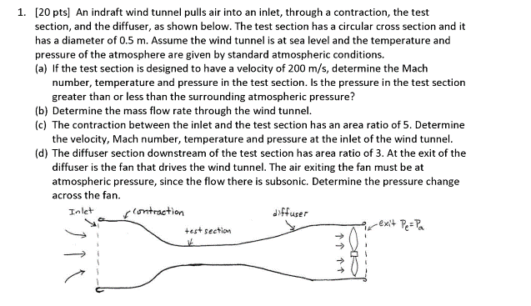

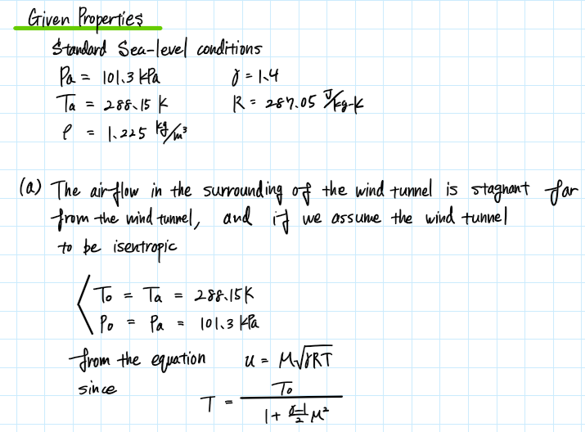

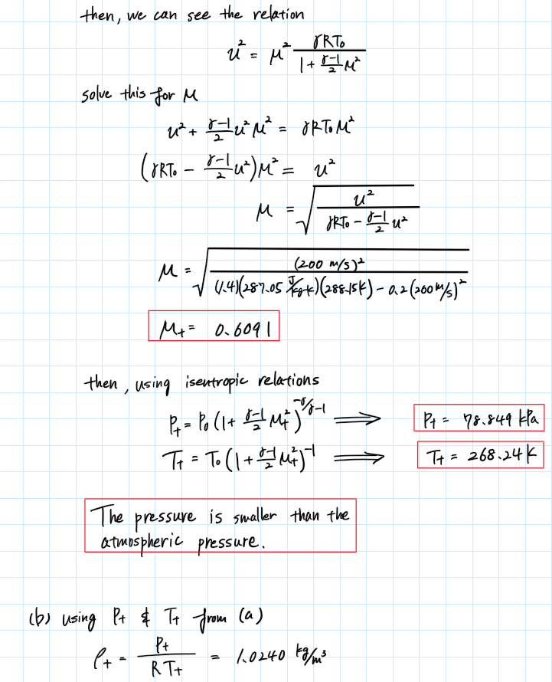

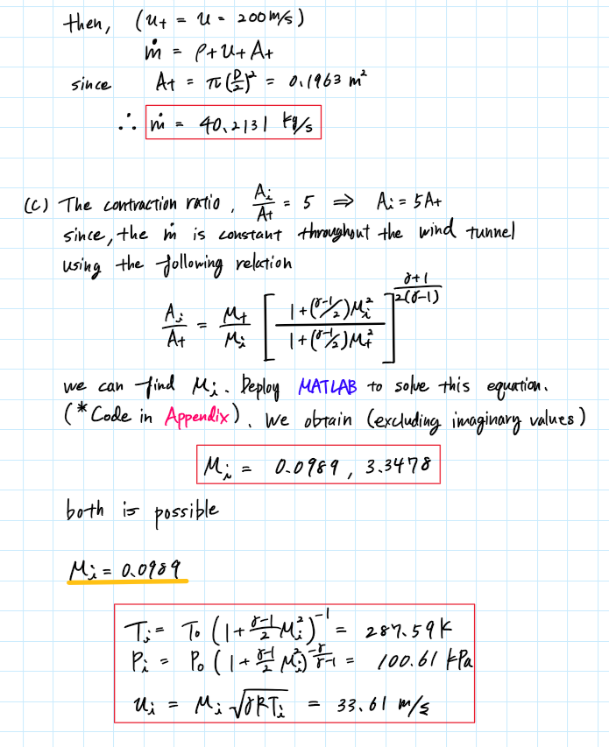

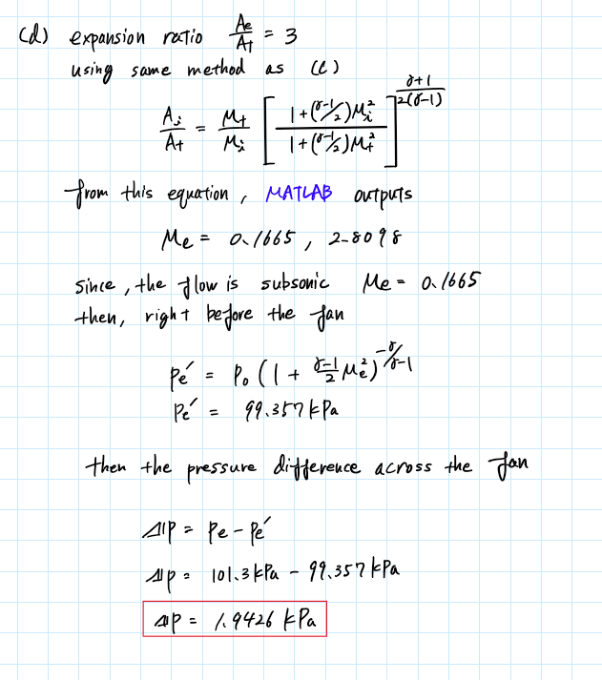

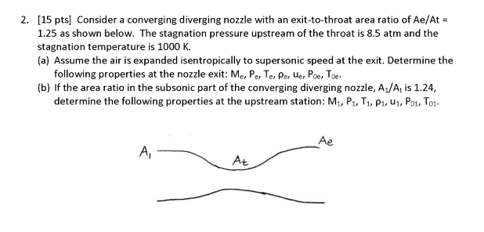

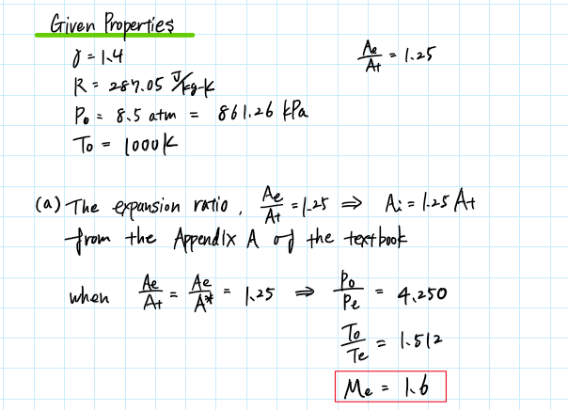

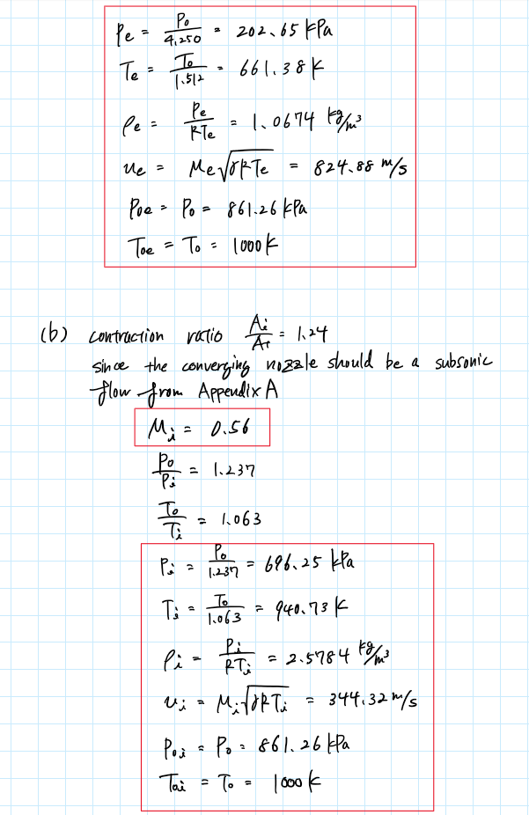

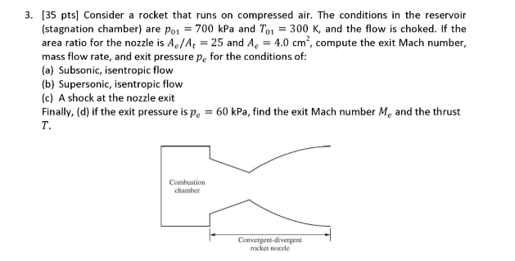

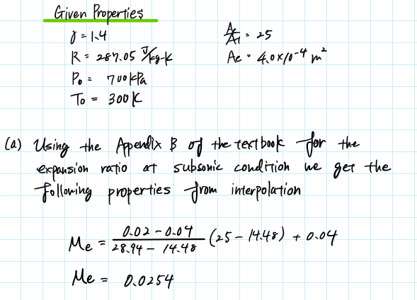

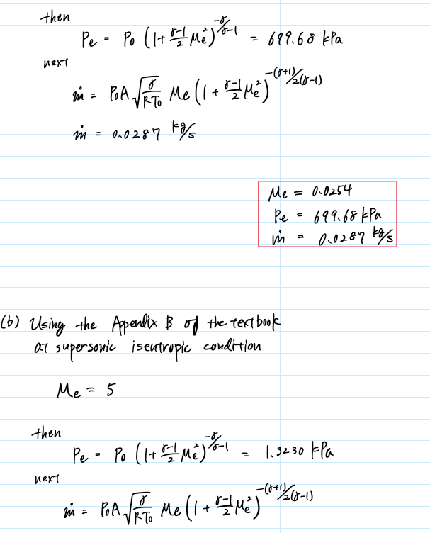

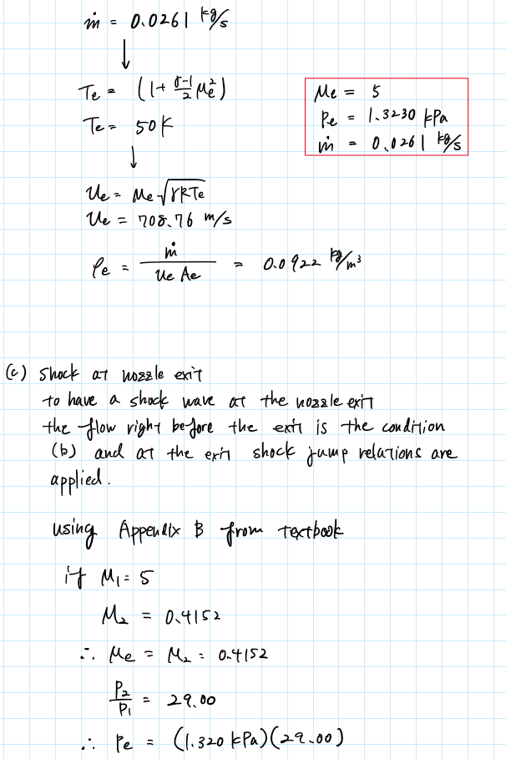

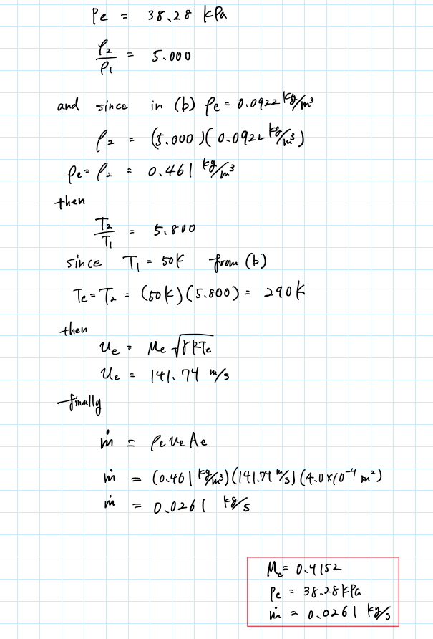

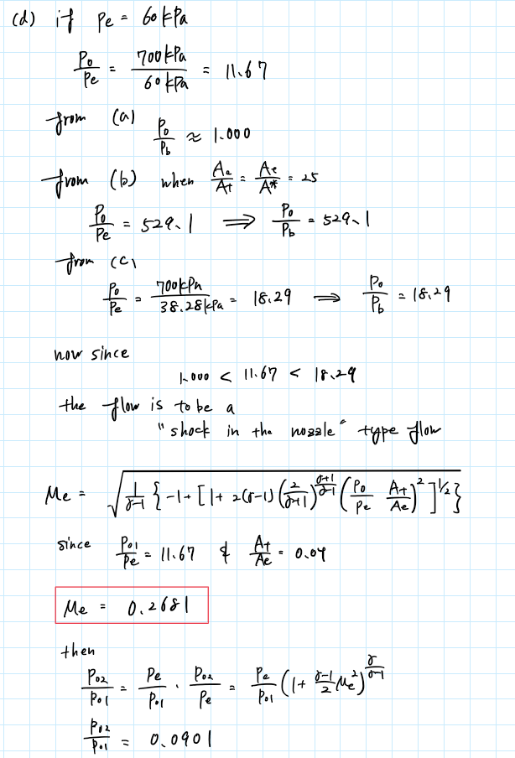

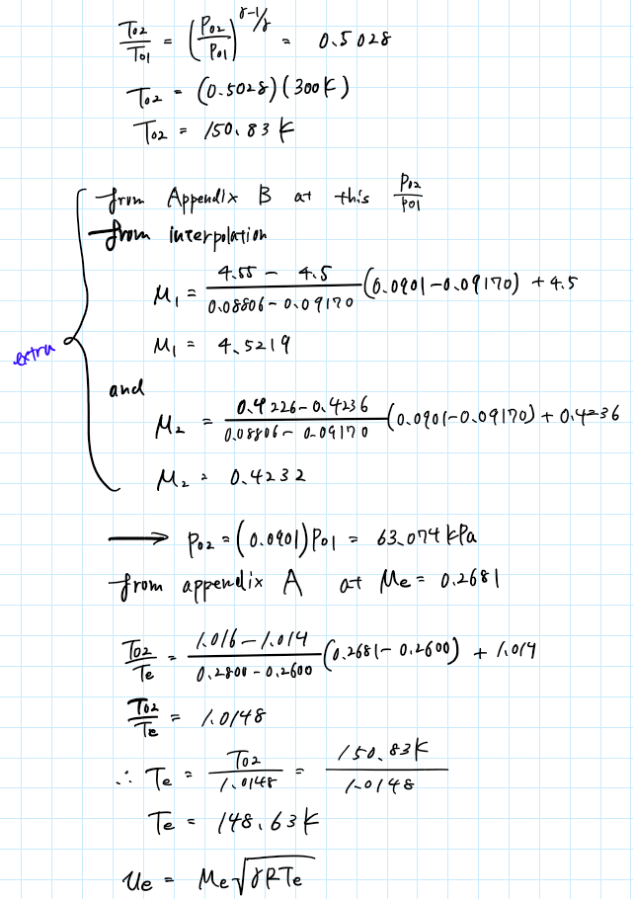

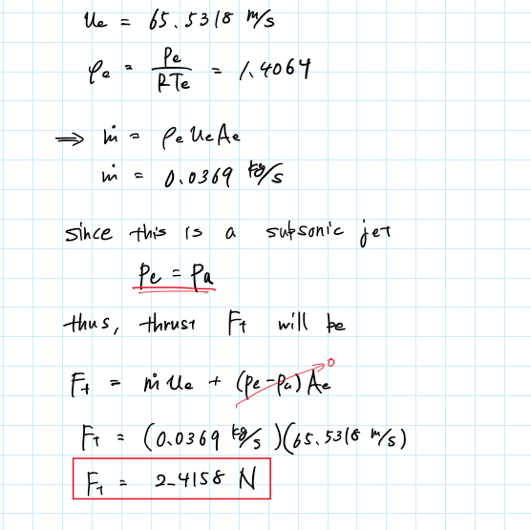

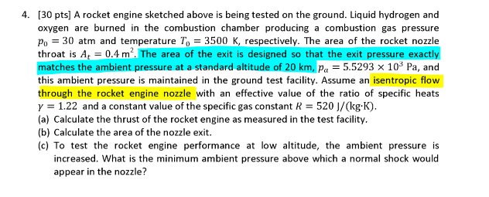

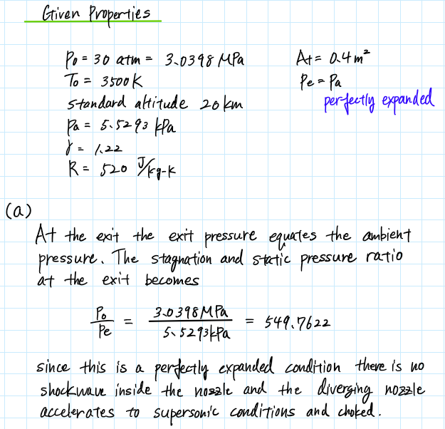

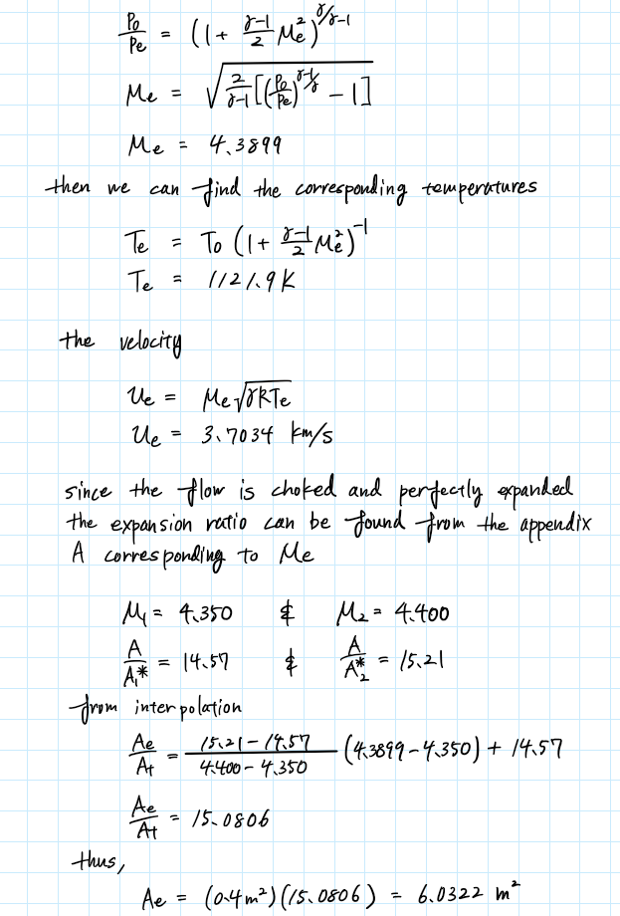

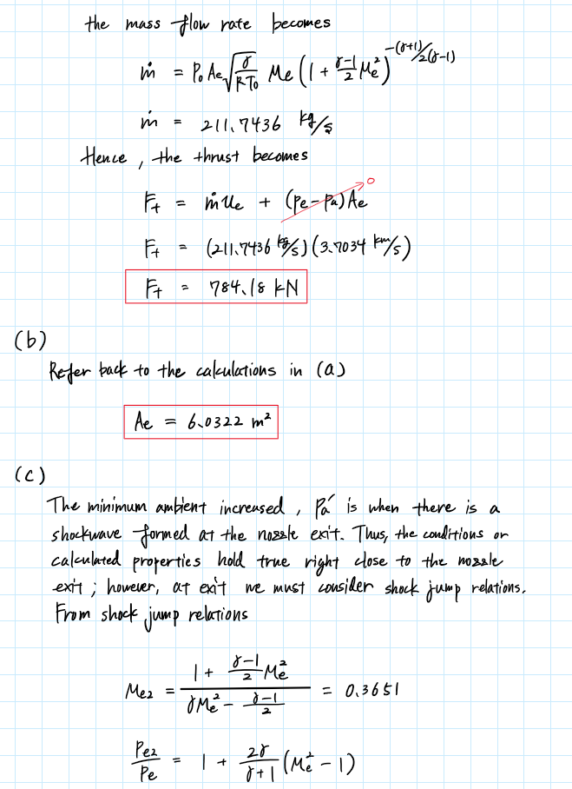

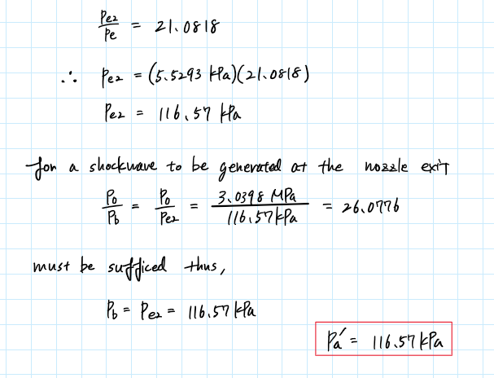

Appendix

## **AAE 334 HW9**

clear all; close all; clc;

### 1-a

% Given properties

Pa = 101.3e3;

Ta = 288.15;

rho_a = 1.225;

gamma = 1.4;

R = 287.05;

D = 0.5;

A_t = pi*(D/2)^2;

% Mach number

P0 = Pa; T0 = Ta;

u_t = 200;

den = u_t^2;

num = gamma*R*T0 - (gamma - 1)/2*u_t^2;

M_t = sqrt(den/num);

% Pressure

P_t = p_from_M_and_gamma(P0,M_t,gamma,"static")

% Temperature

T_t = T_from_M_and_gamma(T0,M_t,gamma,"static")

### 1-b

% Mass flow rate

rho_t = P_t/T_t/R;

m_dot = rho_t*u_t*A_t;

### 1-c

A_i = 5*A_t;

% Calculate the Mach number at the inlet

syms M_i

assume(M_i,["real","positive"])

a1 = 1 + (gamma - 1)/2*M_i^2;

a2 = 1 + (gamma - 1)/2*M_t^2;

a3 = (gamma + 1)/2/(gamma - 1);

eqn = A_i/A_t == M_t/M_i * (a1/a2)^(a3);

M_i = double(vpasolve(eqn,M_i));

M_i = M_i(M_i == real(M_i));

M_i_sub = min(M_i);

M_i_sup = max(M_i);

% If inlet subsonic

T_i_sub = T_from_M_and_gamma(T0,M_i_sub,gamma,"static");

P_i_sub = p_from_M_and_gamma(P0,M_i_sub,gamma,"static");

u_i_sub = M_i_sub*sqrt(gamma*R*T_i_sub);

% If inlet is supersonic

T_i_sup = T_from_M_and_gamma(T0,M_i_sup,gamma,"static");

P_i_sup = p_from_M_and_gamma(P0,M_i_sup,gamma,"static");

u_i_sup = M_i_sup*sqrt(gamma*R*T_i_sup);

### 1-d

A_e = 3*A_t;

% Calculate the Mach number at the inlet

syms M_e

assume(M_e,["real","positive"])

a1 = 1 + (gamma - 1)/2*M_e^2;

a2 = 1 + (gamma - 1)/2*M_t^2;

a3 = (gamma + 1)/2/(gamma - 1);

eqn = A_e/A_t == M_t/M_e * (a1/a2)^(a3);

M_e = double(vpasolve(eqn,M_e))

M_e = M_e(M_e == real(M_e))

M_e_sub = min(M_e)

M_e_sup = max(M_e)

Pe_b = p_from_M_and_gamma(P0,M_e_sub,gamma,"static")

delta_P = Pa - Pe_b

### 3-a

% Given properties

gamma = 1.4;

R = 287.05;

P0 = 700e3;

T0 = 300;

epsilon = 25;

Ae = 4e-4;

At = Ae/25;

Me = two_point_interpolate(25,14.48,28.94,0.04,0.02)

Pe = p_from_M_and_gamma(P0,Me,gamma,"static")

m_dot = mDot_from_M(Me,P0,T0,Ae,gamma,R)

### 3-b

Me = 5;

Pe = p_from_M_and_gamma(P0,Me,gamma,"static")

m_dot = mDot_from_M(Me,P0,T0,Ae,gamma,R)

Te = T_from_M_and_gamma(T0,Me,gamma,"static")

ue = Me*sqrt(gamma*R*Te)

rho_e = m_dot/ue/Ae

### 3-d

Pe = 60e3;

Me = shockInNozzle_M(P0,Pe,At,Ae,gamma)

P02_P01 = Pe/P0*(1 + (gamma - 1)/2*Me^2)^(gamma/(gamma - 1))

M1 = two_point_interpolate(P02_P01,0.0917,0.08806,4.5,4.55)

M2 = two_point_interpolate(P02_P01,0.0917,0.08806,0.4236,0.4226)

P02 = P02_P01*P0

T02_T01 = (P02_P01)^((gamma - 1)/gamma)

T02 = T02_T01*T0

T02_Te = two_point_interpolate(Me,0.26,0.28,1.014,1.016)

Te = T02/T02_Te

ue = Me*sqrt(gamma*R*Te)

rho_e = Pe/R/Te

m_dot = rho_e*ue*Ae

Ft = m_dot*ue

### 4-a

% Given properties

P0 = 3.0398e6;

T0 = 3500;

Pa = 5.5293e3;

gamma = 1.22;

R = 520;

At = 0.4;

Pe = Pa;

P0_Pe = P0/Pe

Me = M_from_P_ratio(P0,Pe,gamma)

Te = T_from_M_and_gamma(T0,Me,gamma,"static")

ue = Me*sqrt(gamma*R*Te)

Ae_At = two_point_interpolate(Me,4.35,4.4,14.57,15.21)

Ae = Ae_At*At

m_dot = mDot_from_M(Me,P0,T0,Ae,gamma,R)

Ft = m_dot*ue + (Pe - Pa)*Ae

### 4-c

% Shock jump relations

Me2 = shock_jump_M(Me,gamma)

Pe2_Pe = 1 + 2*gamma/(gamma + 1)*(Me^2 - 1)

Pe2 = Pe2_Pe*Pe

P0_Pb = P0/Pe2

### Function

function m_dot = mDot_from_M(M,P0,T0,A,gamma,R)

a1 = P0*A;

a2 = sqrt(gamma/R/T0);

a3 = (1 + (gamma - 1)/2*M^2);

a4 = -(gamma + 1)/2/(gamma - 1);

m_dot = a1*a2*M*a3^(a4);

end

function M = shockInNozzle_M(P0,Pe,At,Ae,gamma)

a1 = (gamma - 1);

a2 = (gamma + 1);

a3 = 2*a1*(2/a2)^(a2/a1);

a4 = (P0/Pe * At/Ae)^2;

a5 = 1 + a3*a4;

M = sqrt(1/a1 * (-1 + (a5)^(0.5)));

end

function M = M_from_P_ratio(P0,P,gamma)

a1 = 2/(gamma - 1);

a2 = (P0/P)^((gamma - 1)/gamma);

M = sqrt(a1*(a2 - 1));

end

function M2 = shock_jump_M(M1,gamma)

a1 = (gamma - 1)/2;

M2 = sqrt((1 + a1*M1^2)/(gamma*M1^2 - a1));

end

function T2 = T_from_M_and_gamma(T1, M, gamma, type)

if type == "stagnation"

T2 = T1 * (1 + (gamma - 1) / 2 * M^2);

elseif type == "static"

T2 = T1 / (1 + (gamma - 1) / 2 * M^2);

else

disp("Error. Incorrect type. Type can only be 'stagnation' or 'static'.")

end

end

function p2 = p_from_M_and_gamma(p1, M, gamma, type)

if type == "stagnation"

p2 = p1 * (1 + (gamma - 1) / 2 * M^2)^(gamma/(gamma - 1));

elseif type == "static"

p2 = p1 / (1 + (gamma - 1) / 2 * M^2)^(gamma/(gamma - 1));

else

disp("Error. Incorrect type. Type can only be 'stagnation' or 'static'.")

end

end