AAE 334L

Lab 1: Airfoil Characteristics

Post-Lab Assignment

Name: Tomoki Koike

Lab Section/Team Color: Gold

Contents

1. Lab Objectives (5) 3

2. Data Presentation and Analysis (15) 4

3. Error and Uncertainty (10) 7

4. Appendix 8

4.1 MATLAB CODE 8

4.2 RAW DATA 11

# Lab Objectives (5)

In this experiment, the first steps were to calibrate the LabView program for each lift, drag, and pitch. These procedures helped to remind us how the program worked. Thus, in the following steps our team were able to go through the measurements of the forces with no difficulties whatsoever. However, for the first airfoil with no flaps nor slats we did come across some problems with the micrometer to adjust the angle of attacks. Once we received assistance from the TA we were able to proceed smoothly by measuring each lift, drag, and pitch for the second and third airfoils. Therefore, we were able to satisfy the first objective of measuring each force components versus angle of attacks.

The second objectives were to acknowledge the influences made by the flaps and slats. Theoretically, the flaps and slats increase the total lift coefficient which is equivalent to increasing the total lift on the airfoil. During our measurements, we were able to recognize that the theory was congruent with empirical data. We were able to notice this because the first recorded value for the second airfoil with flaps had a higher lift value compared to the first airfoil and achieved a higher maximum lift while constantly showing higher numbers than the first airfoil measurements. Then the third airfoil with slats turned out to go above the second airfoil. These results demonstrated the theory and enabled us to have a deeper understanding of the effects of flaps and slats.

For this experiment we were instructed to measure the forces until the stall angle. To achieve this, we perceived this to measure the forces until the maximum lift and stop the measurement once the lift value decreased. During our measurements we were able to observe a drop in the lift value once the angles of the airfoils became relatively high for flight. Thus, we were also able to fulfill the third objective of defining the stall angles and find them through practice.

All in all, our team were able to satisfy all objectives and did not face any challenges for lab 1. Everyone in the team were able to find their role for the experiment and effectively and attentively contributed to the lab work. Thanks to this we were also able to end the lab with 30 plus more time left before the scheduled lab time ended. It was effective that all members read the procedures beforehand, and I hope this outstanding cooperation continues for the following labs.

# Data Presentation and Analysis (15)

1. (8 points) Plot the lift coefficient vs. angle of attack and the drag polar for the base airfoil (no flap or slat). Compare these results with the NACA 2415 data posted on Blackboard and discuss possible reasons for any significant differences. Use symbols (no connecting line!) for experimental data. Remember to label the axes and make the font sizes, line thicknesses, symbols, etc. sufficiently large so that the plot can be read easily.

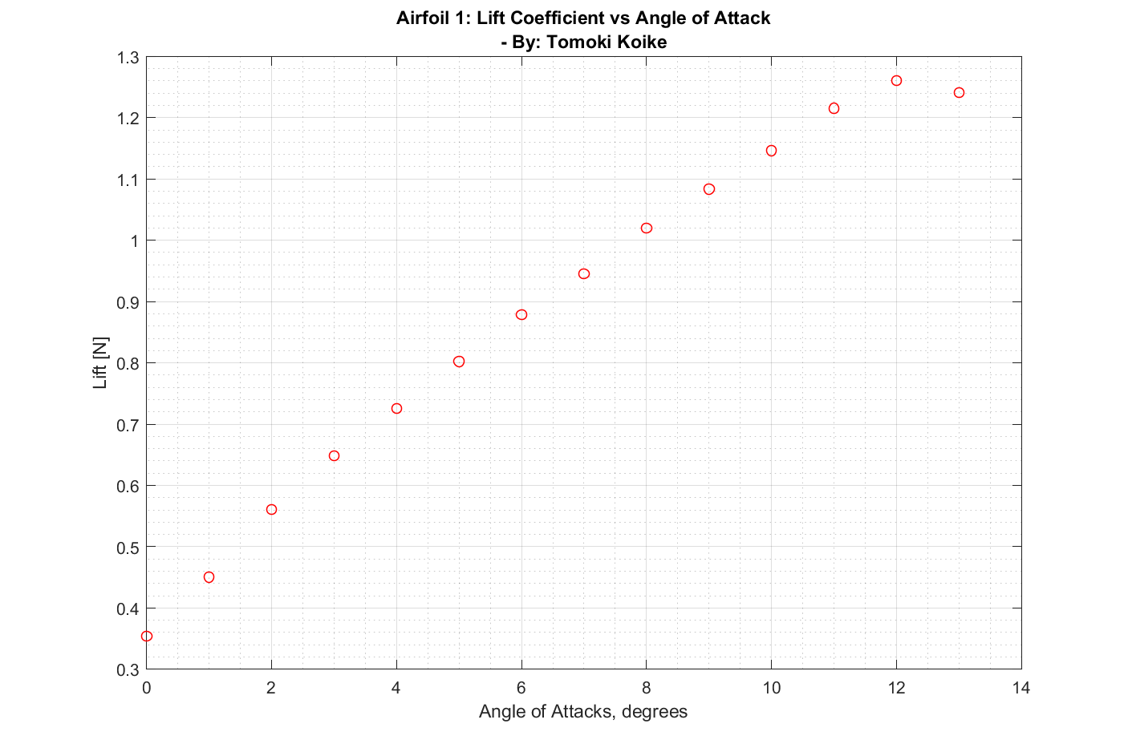

Figure 1: Lift curves for airfoil 1

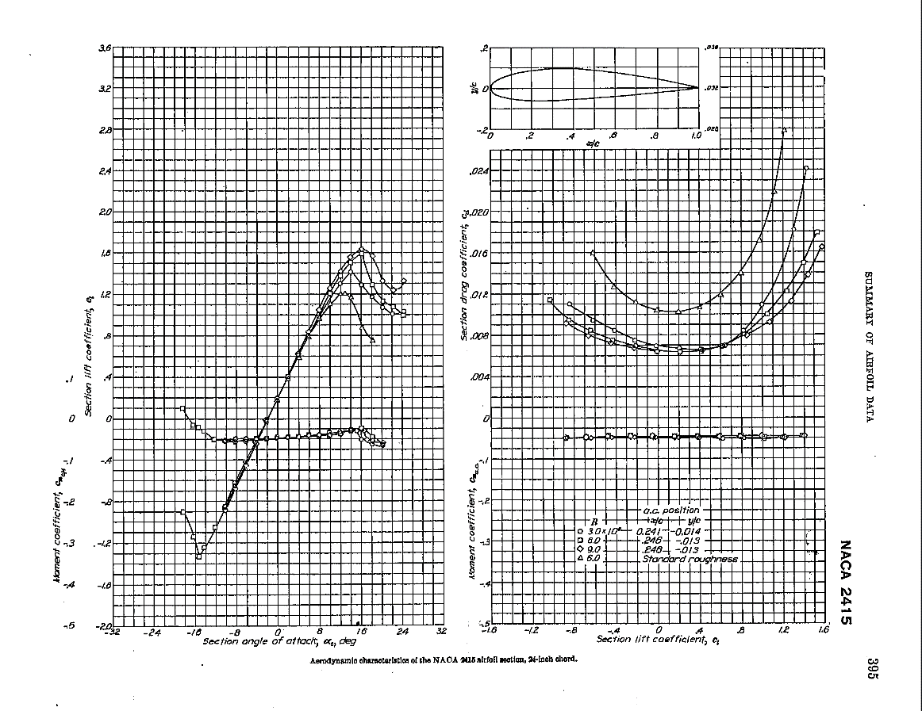

Figure 2: Official NACA 2415 airfoil lift coefficient curve

Comparing the two plots, we can say that the experimental data are close to the data from NACA. The maximum lift coefficient for the experiment is 1.26 and the stall angle is at 12 degrees which is consistent with the stall angles in figure 2, which range around 12-14 degrees. However, the lift coefficient on figure 1 at zero degrees is approximately twice of that in figure 2. Probable causes might be human errors of undetected angles at when measuring the angle using the micrometer.

1. (7 points) Plot the lift coefficient vs. angle of attack for all three airfoil configurations on the same plot. Are the results what you expected? Why or why not?

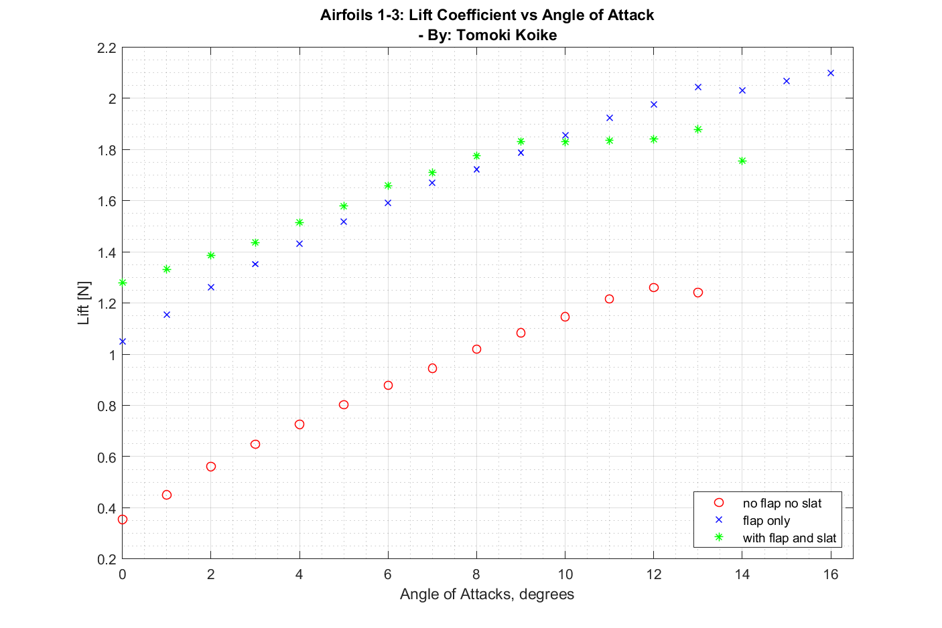

Figure 3: Lift coefficient curves for all airfoils

The lift coefficients for the 1st and 2nd airfoils are as expected. However, the 3rd one is unexpectedly low. By observing the plot below from the background document of lab 2 we can

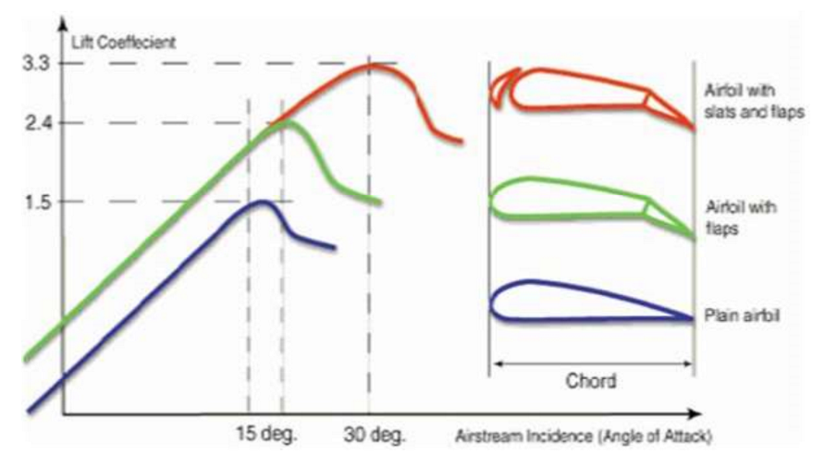

Figure 4: Expected lift coefficient curve

tell that we did not measure enough angles (up to approximately 30 degrees) for the airfoil with a flap and slat to reach its maximum lift coefficient. Because the lift value from the LabView went down in the middle of our data collection, we mistakenly thought that the airfoil has reached its stall angle.

# Error and Uncertainty (10)

1. (8 points) Discuss the sources of error and uncertainty in your results and how large they might be. Estimate the uncertainty of your calculated lift coefficient at a given angle of attack.

As aforementioned, one possible cause of error would be a human error of setting the angles of the airfoils using a micrometer. Moreover, we may have started the LabView program while someone was tampering with the airfoil which might have confounded the program to output unexpected numbers.

For the irregularly small lift coefficients of airfoil 3, the main cause would have been limitations due to the wind tunnel we have used for the experiment.

Sample Calculation of error for maximum lift coefficient for each airfoil 1-3:

Airfoil 1:

$$\%error_{1}= \frac{\left|1.2607-1.5\right|}{1.5}*100=15.95\%$$

Airfoil 2:

$$\%error_{2}= \frac{\left| 2.099-2.4 \right|}{2.4 }*100=12.54\%$$

Airfoil 3:

$$\%error_{3}= \frac{\left| 1.8785-3.3 \right|}{3.3 }*100=43.07\%$$

1. (2 points) What would you change to get better data next time?

If we were to repeat this experiment, we would measure the lift for more larger angles for airfoil 2 and 3 to achieve close results to the actual stall angles and maximum lift coefficients. Also, we should be more precise with measuring the angles by replacing the micrometer with an alternative method.

# Appendix

## MATLAB CODE

clear all; close all; clc

% Calibration

% Reading the calibration data file as a matrix

calib_data = readmatrix('calib.xlsx');

% Assigning variables to the data

lift_weights = lbs2newton(calib_data(6:9,2)); % weights for the lift [N]

lift_calib = -lbs2newton(calib_data(6:9,3)); % calibration lifts [N]

% Fitting data calibration data

[fitresult gof] = createFit(lift_weights, lift_calib);

disp(fitresult);

coeffs = coeffvalues(fitresult); % Obtaining the coefficients

% Assigning the coefficients for the fitted curve

c1 = coeffs(1);

c2 = coeffs(2);

c3 = coeffs(3);

% Defining a equation expression for lift scaling

syms lift

scale_lift = @(lift) c1*lift.^2 + c2*lift + c3;

% Reading the data for the airfoils

lift_data = readmatrix('airfoil_lifts.xlsx');

% Assigning the lift data for each airfoil (scaling simultaneously)

airfoil1 = scale_lift(lbs2newton(lift_data(1:14)));

airfoil2 = scale_lift(lbs2newton(lift_data(16:32)));

airfoil3 = scale_lift(lbs2newton(lift_data(34:48)));

% Creating vectors for each airfoils containing the angle of attacks

AoA_1 = 0:length(airfoil1)-1;

AoA_2 = 0:length(airfoil2)-1;

AoA_3 = 0:length(airfoil3)-1;

% Calculate lift coeffs

airfoil1 = cal_liftcoeff(airfoil1);

airfoil2 = cal_liftcoeff(airfoil2);

airfoil3 = cal_liftcoeff(airfoil3);

% Plotting

fig1 = figure('Renderer', 'painters', 'Position', [10 10 900 600]);

plot(AoA_1, airfoil1, 'or')

title({'Airfoil 1: Lift Coefficient vs Angle of Attack', ...

'- By: Tomoki Koike'})

xlabel('Angle of Attacks, degrees')

ylabel('Lift [N]')

xlim([0, 14])

grid on

grid minor

box on

saveas(fig1, 'lift_curve.png')

fig2 = figure('Renderer', 'painters', 'Position', [10 10 900 600]);

plot(AoA_1, airfoil1, 'or')

title({'Airfoils 1-3: Lift Coefficient vs Angle of Attack', ...

'- By: Tomoki Koike'})

xlabel('Angle of Attacks, degrees')

ylabel('Lift [N]')

hold on

plot(AoA_2, airfoil2, 'xb')

plot(AoA_3, airfoil3, '*g')

hold off

xlim([0, 16.5])

grid on

grid minor

box on

legend('no flap no slat', 'flap only', 'with flap and slat', ...

'location', 'southeast')

saveas(fig2, 'lift_curve_all.png')

function N = lbs2newton(w)

% Function that converts lbs to Newtons

N = w*4.44822;

end

function [fitresult, gof] = createFit(lift_weights, lift_calib)

%CREATEFIT(LIFT_WEIGHTS,LIFT_CALIB)

% Create a fit.

%

% Data for 'draf calib' fit:

% X Input : lift_weights

% Y Output: lift_calib

% Output:

% fitresult : a fit object representing the fit.

% gof : structure with goodness-of fit info.

%

% See also FIT, CFIT, SFIT.

%% Fit: 'draf calib'.

[xData, yData] = prepareCurveData( lift_weights, lift_calib );

% Set up fittype and options.

ft = fittype( 'poly2' );

opts = fitoptions( 'Method', 'LinearLeastSquares' );

opts.Robust = 'Bisquare';

% Fit model to data.

[fitresult, gof] = fit( xData, yData, ft, opts );

% Plot fit with data.

figure( 'Name', 'draf calib' );

h = plot( fitresult, xData, yData );

% Label axes

title('Lift Calibration Plot - By: Tomoki Koike')

xlabel( 'Calibration weigths [N]', 'Interpreter', 'none' );

ylabel( 'Calibration Lift [N]', 'Interpreter', 'none' );

legend('data points', 'line curve', 'Location', 'southeast')

grid on

grid minor

box on

end

function C_l = cal_liftcoeff(L)

rho = 1.225; % Desity of air at standard condition [kg/m^3]

vel = 19.6; % Velocity at 30Hz [m/s]

q = 0.5*rho*vel^2;

b = 0.2921; % wing span [m]

c = 3.75/39.37; % Chord length [m]

C_l = L / q / c / b;

end

## RAW DATA

