AAE 334L

Lab 2: Pressure Tap Airfoil

Post-Lab Assignment

Name: Tomoki Koike

Lab Section/Team Color: **Gold**

Contents

1. Lab Objective (5) 3

2. Data Presentation and Analysis (15) 4

3. Comparison with Theoretical Calculations (10) 7

4. Appendix 11

4.1 MATLAB CODE 11

4.2 RAW DATA 13

# Lab Objective (5)

In this experiment, similar to lab 1 we were required to use a software called PSI9016 in LabView to measure the pressure distribution over the provided airfoil. While using this software, we followed the instructions of how to start the measurements and recording the data. There were some few caveats while collecting data and we, as a team, helped each other out to avoid mistakes and mishaps to complete measuring data with the wind tunnel and the software successfully. For each angle of attack the pressure changed and we were able to physically and experimentally understand the change with the usage of the software. From this we are able to conclude that we have satisfied the first objective of this experiment.

The second objective of this experiment was to observe the transition point from laminar flow to turbulent flow, and how it changes accordingly with the angle of attack. From the recorded pressure distributions from LabView we were able to observe how the angle of attacks influenced the behavior of the flow. The transition points were indicated by the hump on the upper surface’s pressure distribution. Roughly, the beginning of the hump indicates the transition point and the location where the hump ends and gets back to the original curve, we know that the flow reattached to become laminar. From these analyses, we were able to satisfy the second objective of this lab.

The third objective of this lab is similar to the objective in lab 1, and it is to find the stall angle for the given airfoil. This is achieved from the post-calculations that we have done after collecting data of the pressure distributions for the angle of attacks. By integrating the pressure distribution analytically, we were able to obtain the lift coefficient for the airfoil at a given angle of attack; and, by doing this for each angle, at some point (or angle of attack) the lift coefficient will decrease. This decrease signifies that the angle of attack has reached the stall angle and increasing the angle furthermore will no longer increase the lift.

The fourth objective of this lab is to find the lift curve of the airfoil. This is the subsequent step for the third objective in that by finding the lift coefficient, since we have the density and velocity of the freestream, we were able to calculate the lift on the airfoil. Then managed to plot the lift versus the angle of attack – the lift curve. At the second half of this experiment we have successfully calculated the lift coefficient and the lift for an angle of attack of six degrees. Once you have calculated the lift for one angle the rest is the same process, and therefore, we can say that we have satisfied the third and fourth objectives from these calculations.

# Data Presentation and Analysis (15)

1. (5 points) Plot the Cp distributions for all angles of attack on the same plot. Briefly discuss how the pressure distribution changes with the angle of attack.

Figure : Pressure Distribution for all angle of attacks

The pressure distribution along the airfoil seems to be overall higher near the TE (trailing edge) and the lower surface has a larger magnitude than the upper surface. Also, as the angle of attack increases from zero the magnitude uniformly increases, although once it reaches the stall angle the pressure distribution decreases.

1. (10 points) Use your data to estimate Cl and Cd at each angle of attack. Plot the Cl vs. α curve and Cl vs. Cd (drag polar).

Using MATLAB we obtain the lift and drag coefficients listed in the following table and plot.

|  |  |  |
| --- | --- | --- |
| Angle of attack | Lift coeff. | Drag coeff. |
| -8 | -0.65735 | 0.08853 |
| -6 | -0.52078 | 0.051897 |
| -4 | -0.37167 | 0.024246 |
| -2 | -0.25332 | 0.008275 |
| 0 | 0.057916 | -5.03E-05 |
| 2 | 0.214211 | 0.007666 |
| 4 | 0.389421 | 0.027413 |
| 6 | 0.573253 | 0.060184 |
| 8 | 0.695983 | 0.097627 |
| 10 | 0.771997 | 0.135764 |
| 12 | 0.890392 | 0.188396 |
| 14 | 0.873366 | 0.217825 |
| 16 | 1.045343 | 0.302187 |
| 18 | 0.697514 | 0.231017 |
| 20 | 0.873495 | 0.323008 |

Table : lift coefficient and drag coefficient for each angle of attacks

Figure : lift coefficient for each angle of attack

*Figure 3: drag polar plot*

# Comparison with Theoretical Calculations (10)

1. (10 points) Compare your results with XFLR5 calculations and experimental results for the NACA 662-215 airfoil (from “Summary of Airfoil Data” by Abbot, von Doenhoff, and Stivers in NACA Report 824) uploaded on the class Blackboard page. Discuss the primary reasons for differences between your data, the XFLR5 calculations, and the historical data.

Now we have done the same analysis with XFLR5 with the following conditions

|  |  |
| --- | --- |
| Density | 1.225 kg/m^3 |
| Air Velocity | 19.17 m/s |
| Viscosity | 1.789*10^(-5) Pa-s |
| Chord length | 0.0889 m |
| Reynolds number | 116,694 |
| Mach number | 0.055395 |
| Angle of attacks | -8 to 20 |

The results were the following for the XFLR5 analysis

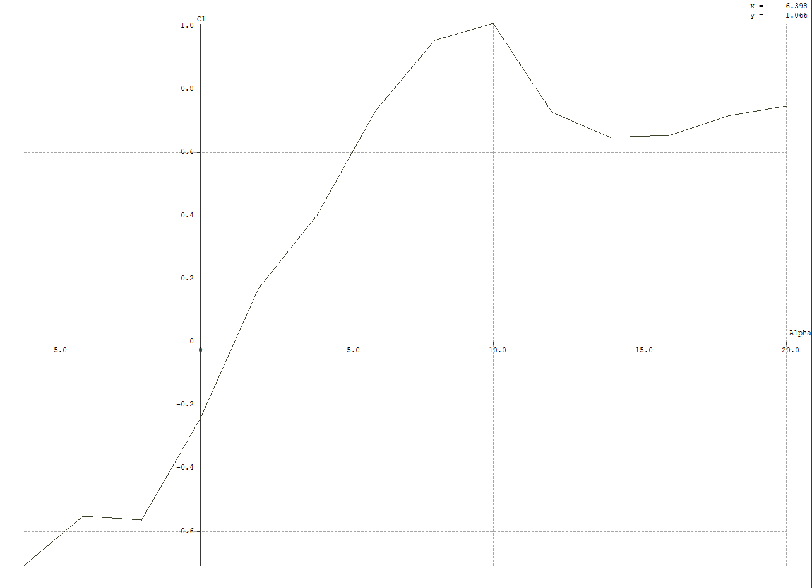

Figure : XFLR5 result for lift coefficient vs angle of attack

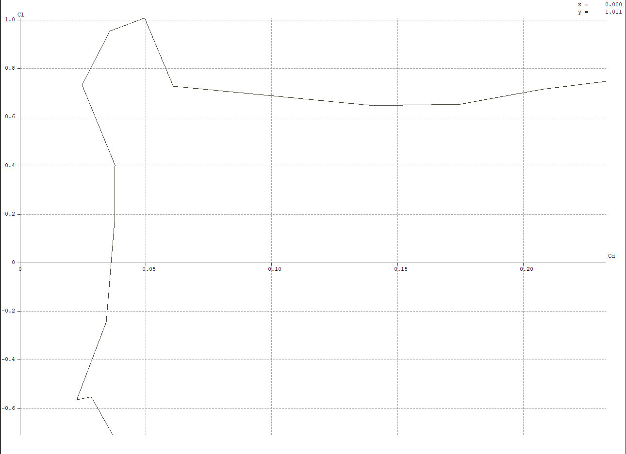

Figure : XFLR5 result for the drag polar

And, then the official data from NACA is the following

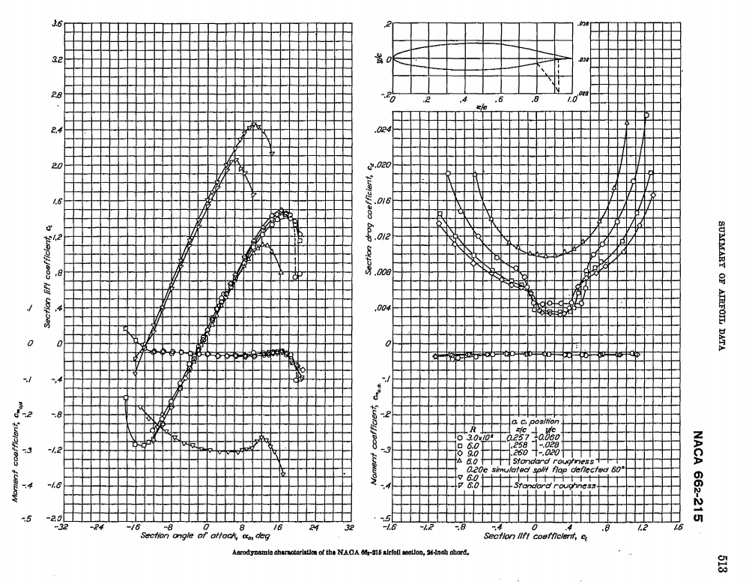

Figure : NACA data for airfoil

By looking at figures 2 through 5 we know that the results for the lift coefficient at each angle of attacks are very similar including the last increase after the stall angle around 15 degrees. However, by observing the drag polar plot, for our experimental data the drag coefficient seems to have an error at the angle of 20 degrees due to its radical decrease followed by an increase at an angle of attack of 20 degrees. But more importantly, our data does not have the bumpy behavior that the XFLR5 result displays in figure 5 for small drag coefficients. Possibly, errors might be the Reynolds number or other input mistakes for the XFLR5 analysis. Or perhaps we must address turbulent flows and other flow related errors during the measurement.

Now, comparing our experimental data with the official values from NACA we can tell that our stall angle match and overall the lift coefficients are identical. One observation we cannot make is for the angles more than 18 degrees because NACA does not have data points for those angles. For the drag polar the smooth concave up trend is alike except for the radical behavior of our experimental data at the high angles.

Ultimately, we can conclude that our experiment was successful while leaving some concerns with the data acquired for high angle of attacks.

# Appendix

## MATLAB CODE

clear all; close all; clc;

**2-1**

% Import the excel sheets

P_dist_data = readmatrix("pressure_dist_allAoAs.xlsx");

chord_len = P_dist_data(1,2:end);

P_dists = psi2pascal(P_dist_data(2:end,2:end)); % pascals

% Plotting

fig1 = figure("Renderer","painters");

plot(chord_len,P_dists(1,:),'.')

xlabel('chord length ratio')

ylabel('pressure distribution')

title('Pressure Distribution of the Airfoil for AoA from 0~20 - By: Tomoki Koike')

hold on

for i = 2:size(P_dists,1)

plot(chord_len, P_dists(i,1:end),'.')

end

hold off

grid on

grid minor

box on

saveas(fig1, 'pressure_dist.png')

**2-2**

% Creating matrix with pressure coefficients

rho = 1.225; % kg/m^3

v = 19.17; % m/s

Cp = P_dists./(0.5*rho*v^2);

Cp_u = Cp(:,1:19);

Cp_l = Cp(:,20:end);

% Import data of xy-coordinates

xy_coord = readmatrix("naca66215_xy_coord.xlsx");

xy_coord_u = xy_coord(1:71,:); % upper surface

xy_coord_l = xy_coord(72:end,:); % lower surface

x_u_interp = [0.0125 0.03125 0.0625 0.09375 0.125 0.1875 0.25 0.3125 0.375...

0.4375 0.5 0.5625 0.625 0.6875 0.71875 0.75 0.78125 0.8125 0.875];

x_l_interp = [0.0375 0.125 0.25 0.375 0.5 0.625 0.75];

y_u = xy_coord_u(:,2);

y_l = xy_coord_l(:,2);

x_u = xy_coord_u(:,1);

x_l = xy_coord_l(:,1);

% interpolate

y_u_interp = interp1(x_u,y_u,x_u_interp);

y_l_interp = interp1(x_l,y_l,x_l_interp);

% Calculating Cn, Ca, Cl, and Cd

alpha = -8:2:20;

Cn = zeros([1, length(alpha)]);

Ca = zeros([1, length(alpha)]);

Cl = zeros([1, length(alpha)]);

Cd = zeros([1, length(alpha)]);

ct = 1

x_u_interp = [x_u_interp 0.925];

dx_u = diff(x_u_interp);

x_l_interp = [x_l_interp 0.875];

dx_l = diff(x_l_interp);

for m = alpha

% for AoA of m degrees

Cn(ct) = sum(Cp_l(ct,:).*dx_l) - sum(Cp_u(ct,:).*dx_u);

Ca(ct) = sum(Cp_u(ct,:).*gradient(y_u_interp).*dx_u)...

- sum(Cp_l(ct,:).*gradient(y_l_interp).*dx_l);

Cl(ct) = Cn(ct)*cosd(m) - Ca(ct)*sind(m);

Cd(ct) = Cn(ct)*sind(m) + Ca(ct)*cosd(m);

ct = ct + 1;

end

% Plotting the results

fig2 = figure("Renderer","painters");

plot(alpha, Cl, 'o-', 'MarkerSize', 10)

xlabel('angle of attack')

ylabel('lift coefficient')

title('Lift Coefficient vs Angle of Attack for NACA66215 - By:Tomoki Koike')

grid on

grid minor

box on

saveas(fig2, 'Cl_vs_alpha.png');

fig3 = figure("Renderer","painters");

plot(Cd, Cl, '*-', 'MarkerSize', 10)

xlabel('draf coefficient')

ylabel('lift coefficient')

title('Drag polar for NACA66215 - By:Tomoki Koike')

grid on

grid minor

box on

saveas(fig3, 'drag_polar.png');

**Functions**

function p_new = psi2pascal(p)

p_new = p*6894.76;

end

## RAW DATA

Pressure Distributions



NACA 66215 x-y coordinates

|  |  |
| --- | --- |
| **Column1** | **Column2** |
| 1 | 0 |
| 0.993359 | 0.001014 |
| 0.982368 | 0.002802 |
| 0.969897 | 0.004996 |
| 0.955711 | 0.007707 |
| 0.939801 | 0.011019 |
| 0.922598 | 0.014866 |
| 0.904739 | 0.019047 |
| 0.886614 | 0.023373 |
| 0.868296 | 0.027778 |
| 0.849849 | 0.032225 |
| 0.831394 | 0.036664 |
| 0.813042 | 0.041041 |
| 0.794835 | 0.045322 |
| 0.776758 | 0.049485 |
| 0.758795 | 0.053512 |
| 0.740942 | 0.05738 |
| 0.723207 | 0.061065 |
| 0.705579 | 0.06455 |
| 0.688027 | 0.067819 |
| 0.670531 | 0.070857 |
| 0.653132 | 0.073641 |
| 0.635927 | 0.076136 |
| 0.618971 | 0.078307 |
| 0.602161 | 0.080134 |
| 0.585253 | 0.081615 |
| 0.567995 | 0.082808 |
| 0.550302 | 0.083776 |
| 0.53232 | 0.084567 |
| 0.514272 | 0.085177 |
| 0.496252 | 0.085604 |
| 0.478219 | 0.085851 |
| 0.460119 | 0.085929 |
| 0.441966 | 0.085845 |
| 0.423829 | 0.085602 |
| 0.405746 | 0.085192 |
| 0.3877 | 0.084607 |
| 0.369644 | 0.083846 |
| 0.351559 | 0.082915 |
| 0.333465 | 0.08182 |
| 0.315401 | 0.080559 |
| 0.297391 | 0.07913 |
| 0.279442 | 0.077529 |
| 0.261556 | 0.07575 |
| 0.243738 | 0.073785 |
| 0.225995 | 0.07163 |
| 0.208338 | 0.069278 |
| 0.190784 | 0.066724 |
| 0.173362 | 0.063959 |
| 0.156126 | 0.060971 |
| 0.139162 | 0.057759 |
| 0.122556 | 0.054319 |
| 0.106346 | 0.050636 |
| 0.090516 | 0.046688 |
| 0.075332 | 0.042547 |
| 0.061762 | 0.038516 |
| 0.050087 | 0.034671 |
| 0.03979 | 0.030875 |
| 0.030933 | 0.027296 |
| 0.023885 | 0.024252 |
| 0.018428 | 0.021736 |
| 0.014154 | 0.019493 |
| 0.010714 | 0.017364 |
| 0.007887 | 0.015289 |
| 0.005552 | 0.013257 |
| 0.003664 | 0.011195 |
| 0.00221 | 0.00905 |
| 0.001146 | 0.006896 |
| 0.000429 | 0.00477 |
| 0.000035 | 0.002683 |
| -0.000043 | 0.000635 |
| 0.000211 | -0.001385 |
| 0.000798 | -0.003398 |
| 0.001723 | -0.005419 |
| 0.00301 | -0.007452 |
| 0.004698 | -0.009476 |
| 0.00682 | -0.011424 |
| 0.009398 | -0.013257 |
| 0.012501 | -0.015052 |
| 0.01626 | -0.016832 |
| 0.020916 | -0.018644 |
| 0.02688 | -0.020637 |
| 0.03463 | -0.023061 |
| 0.044343 | -0.025898 |
| 0.055547 | -0.028844 |
| 0.06837 | -0.031811 |
| 0.083277 | -0.034918 |
| 0.099487 | -0.038013 |
| 0.116098 | -0.04088 |
| 0.133076 | -0.043524 |
| 0.150445 | -0.045974 |
| 0.168115 | -0.048244 |
| 0.185952 | -0.050332 |
| 0.203875 | -0.052241 |
| 0.221872 | -0.053983 |
| 0.239951 | -0.055567 |
| 0.258113 | -0.057004 |
| 0.276344 | -0.0583 |
| 0.294624 | -0.05946 |
| 0.312936 | -0.06049 |
| 0.331261 | -0.061389 |
| 0.349586 | -0.062157 |
| 0.367902 | -0.062792 |
| 0.386211 | -0.063293 |
| 0.404526 | -0.063659 |
| 0.422872 | -0.063892 |
| 0.441252 | -0.063995 |
| 0.459632 | -0.063974 |
| 0.477955 | -0.063827 |
| 0.496216 | -0.063546 |
| 0.514467 | -0.063121 |
| 0.532745 | -0.062548 |
| 0.550942 | -0.061829 |
| 0.568822 | -0.060962 |
| 0.586254 | -0.059893 |
| 0.603353 | -0.058553 |
| 0.620396 | -0.05689 |
| 0.637628 | -0.054913 |
| 0.655134 | -0.052649 |
| 0.672842 | -0.050137 |
| 0.69066 | -0.047409 |
| 0.708565 | -0.044491 |
| 0.726592 | -0.041401 |
| 0.744778 | -0.038161 |
| 0.763139 | -0.034796 |
| 0.781659 | -0.031333 |
| 0.80026 | -0.02781 |
| 0.818806 | -0.024282 |
| 0.8372 | -0.020809 |
| 0.855455 | -0.017432 |
| 0.873648 | -0.014164 |
| 0.891734 | -0.011022 |
| 0.909485 | -0.008053 |
| 0.926545 | -0.005413 |
| 0.942539 | -0.003293 |
| 0.957211 | -0.001775 |
| 0.97049 | -0.000802 |
| 0.982471 | -0.000252 |
| 0.993316 | -0.000019 |
| 1 | 0 |