# 

AAE 334L

Lab 3: The Finite Wing

**Post-Lab Assignment**

**Tomoki Koike**

**Team Gold**

Table of Contents

1. Lab Objectives (5) 3

2. Data Presentation and Analysis (25 points) 4

MATLAB CODE AUTHOR: TOMOKI KOIKE 12

Calibration 12

<a> 13

<b> 14

<c> 15

<d> 16

FUNCTIONS 16

# Lab Objectives (5)

In 500 words or less, discuss the objectives of this lab and how well they were met and to what extent they were not met. If applicable, discuss reasons why particular objectives were not met during your performance of the lab and how these challenges might be addressed in the future.

For this experiment there were two main objectives:

1. Be introduced to the effect of finite span on wing aerodynamics
2. Make measurements of finite-span effects for 3 span/chord ratios

The first objective was accomplished by being exposed to and by using the large wind tunnel for finite wings at the Purdue airport. For this experiment we were required to understand the aerodynamics that occurred for a 3D model of a wing. For a 3D finite wing there exists wing tip vortices and vortex filaments trailing downstream. This is generated by the spanwise pressure gradient occurring on both the upper and bottom surface of the wing which curves the streamlines flowing on the surfaces. This involvement of such vortices alters the aerodynamic properties such as lift coefficient, drag coefficient, and moment coefficient to some degree. Besides this there are multiple other theories such as downwash that distinguish the characteristics of an infinite wing and finite wing model. Additionally, we have experimented several different kinds of the wings by attaching devices which extend the wingspan or wingtip devices such as winglets. This was done to understand the effects of such practical devices on the wing’s aerodynamic performance. But there is one factor that is personally unsatisfactory. That is that we are not able to visually see the wing tip vortices and downwash. Hypothetically, if we have a condensed gas or vapor in the wing tunnel that visually displays the behavior of vortices for finite wings, it would be much more educative to understand how the aerodynamics work in actuality.

The second objective was satisfied by working out the usage of the LabView software. We were instructed to collect data of the lift and drag for each angle of attacks with an increment of two degrees. We were also able to make measurements for each specific attachment added to the wing. These attachments, aforementioned, changed the span/chord ratio to improve performance, and through the obtained data we were able to deepen our understanding for the effects that those devices cause.

This experiment was fairly straightforward, and our team were able to manage each task by dividing tasks evenly. Cooperation enable us to complete the experiment very smoothly in a prompt manner.

# Data Presentation and Analysis (25 points)

1. (10 points) For all three aspect ratios:

Calibrations

Figure 1: Lift Calibration

Linear model Poly2:

lift(x) = p1*x^2 + p2*x + p3

Coefficients (with 95% confidence bounds):

p1 = 6.763e-06 (-0.0002099, 0.0002234)

p2 = -1.01 (-1.02, -0.9999)

p3 = 0.2284 (0.1328, 0.3241)

Figure 2: Drag Calibration

Linear model Poly2:

drag(x) = p1*x^2 + p2*x + p3

Coefficients (with 95% confidence bounds):

p1 = 5.698e-05 (-0.0006717, 0.0007856)

p2 = 0.9975 (0.9638, 1.031)

p3 = -0.6245 (-0.9462, -0.3028)

* 1. (4 points) Plot your experimental data for CL vs. angle of attack ** for all 5 wing configurations on one graph.

Figure 3: Lift Coefficients vs AoA for All Wings (generated from MATLAB)

* 1. (2 points) On the graph from Part (b), plot CL vs. ** for a wing of the same airfoil section as the wing tested, but with infinite span. You can look up data for the NACA 0012 airfoil on the internet.

Calculating the average Reynolds number and Mach number from our data we get the following numbers

Table 1: Average Reynolds and Mach Number

|  |  |
| --- | --- |
| Average Reynolds Number | Average Mach Number |
| 160,150 | 0.0358 |

Using these numbers we define an analysis in XFLR5 with the airfoil NACA0012 for angle of attacks from 0 to 24 with increments of 2. And, from XFLR5 we get the following results for an infinite airfoil analysis.

Table 2: XFLR5 Results for NACA0012 Lift Coefficients over AoA

|  |  |
| --- | --- |
| Angle of Attack | Lift Coefficient |
| 0 | -2.53E-08 |
| 2 | 0.356045 |
| 4 | 0.536049 |
| 6 | 0.693497 |
| 8 | 0.846339 |
| 10 | 1.007681 |
| 12 | 1.082483 |
| 14 | 0.476771 |
| 16 | 0.482505 |
| 18 | 0.50604 |
| 20 | 0.531797 |
| 22 | 0.562831 |
| 24 | 0.591379 |

Plotting this with the plot we have in part (a), we obtain the following,

Figure 4: NACA0012 Lift Coefficients over AoA for Finite and Infinite Wings (generated from MATLAB)

* 1. (4 points) Plot the experimental drag polars (CD vs. CL) for all 5 wing configurations on one graph.

Figure 5: Drag Polar Plots for All 5 Wings (generated from MATLAB)

1. (8 points) Given your experimental results, how does the aspect ratio affect the lift and drag curves? What is the effect of the wing tip devices? How does your data compare with the NACA 0012 airfoil data?

Aspect Ratio:

To understand the effect of the aspect ratio on the lift and drag coefficients we will compare the small span and large span wing results. By observing figure 3, we can see that the “large span” datapoints with a larger aspect ratio have a higher maximum lift coefficient than the “small span” datapoints. However, the lift coefficient for the former start to decrease at a lower angle of attack than the latter. Also, from figure 5, we can see that when the aspect ratio is larger, L/D (gradients of the curve in figure 5) becomes larger as well.

Wing Tip Devices:

To understand the effect of wingtip devices we should concentrate on the datapoints labelled as “normal,” “small wingtip,” and “large wingtip.” From figure 4 we can see that the wingtip devices increase the maximum lift coefficients, and the size of the wingtip device does not alter the angle of attack where the lift coefficients starts to decrease and rather makes the stall angle higher compared to a normal wing with no wingtip device attached. Albeit, the larger wingtip device has a larger decrease rate than the small wingtip after the stall angle. From figure 5 we can see that the wingtip devices increases the lift-to-drag ratio but the larger the device is the larger the increase and decrease rate of L/D becomes.

1. (7 points) Using the experimental results for CL and CD find (for one wing span without wing tip devices):
   1. (3 points) The flight speed necessary to produce lift of 50 lbf at an angle of attack of 11.0 degrees. Assume STP.

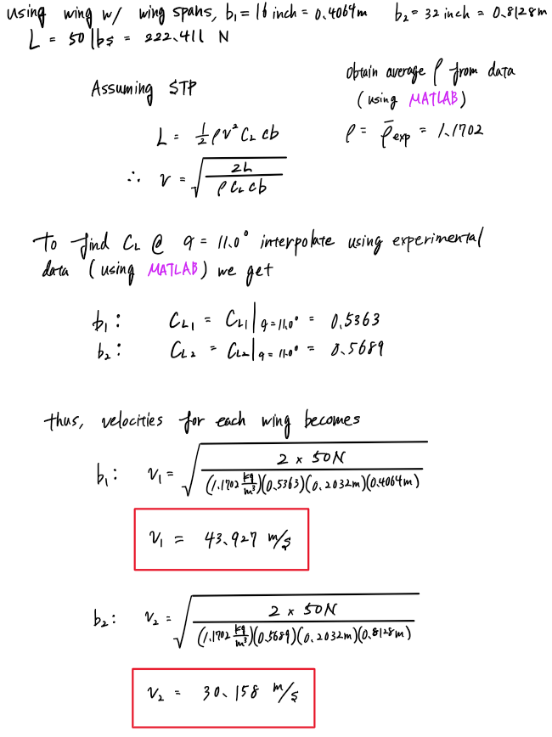

* 1. (2 points) The lift-to-drag ratio for the flight condition.

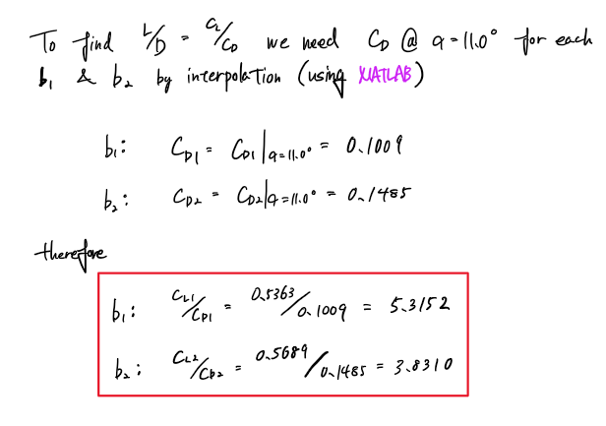

* 1. (2 points) Maximum L/D ratio and the angle of attack at which it occurs.

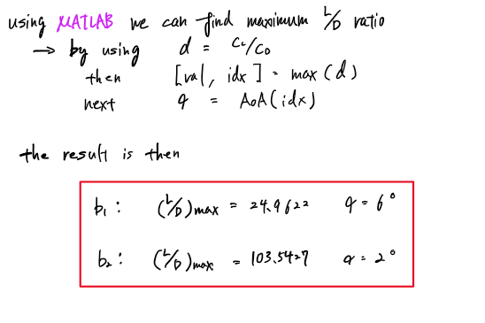

Appendix

# MATLAB CODE AUTHOR: TOMOKI KOIKE

close all; clear all; clc;

set(groot, 'defaulttextinterpreter',"latex");

set(groot, 'defaultAxesTickLabelInterpreter',"latex");

set(groot, 'defaultLegendInterpreter',"latex");

## Calibration

% Importing the calibration data file as a matrix

calib_data = rmmissing(readmatrix("calibration.xlsx"));

calib_data = [calib_data(1:11,:); calib_data(1,:); calib_data(11+1:end,:)];

calib_weights = lbs2newton(calib_data(1:11,1)); % the calibration weights [lbs]

calib_lifts = lbs2newton(calib_data(1:11,7)); % the calibrated lift [lbf]

calib_drags = lbs2newton(calib_data(12:end,6)); % the calibrated drag [lbf]

% calib_vel_L = calib_data(1:11,4); % calibartion velocity for lift [m/s]

% calib_vel_D = calib_data(12:end,4); % calibration velocity for drag [m/s]

% calib_pf_L = calib_data(1:11,2); % calibration reference pressure for lift

% calib_pf_D = calib_data(12:end,2); % calibration reference pressure for drag

% calib_rho_L = calc_density(calib_pf_L); % calibration density for lift [kg/m^3]

% calib_rho_D = calc_density(calib_pf_D); % calibration density for drag [kg/m^3]

% Fitting calibration data

% lift

[res_lift gof_lift] = createFit(calib_weights, calib_lifts, 'Lift');

disp(res_lift);

coeffs = coeffvalues(res_lift); % Obtaining the coefficients

% Assigning the coefficients for the fitted curve

c1_L = coeffs(1);

c2_L = coeffs(2);

c3_L = coeffs(3);

% Defining a equation expression for lift scaling

syms lift

scale_lift = @(lift) -(c1_L*lift.^2 + c2_L*lift + c3_L);

% drag

[res_drag gof_drag] = createFit(calib_weights, calib_drags, 'Drag');

disp(res_drag);

coeffs = coeffvalues(res_drag); % Obtaining the coefficients

% Assigning the coefficients for the fitted curve

c1_D = coeffs(1);

c2_D = coeffs(2);

c3_D = coeffs(3);

% Defining a equation expression for drag scaling

syms drag

scale_drag = @(drag) c1_D*drag.^2 + c2_D*drag + c3_D;

## <a>

Plot all the Cl vs AoA for all 5 different wings

Since the Pitot tube reading gives the pressure difference we know that

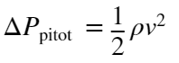

Thus,

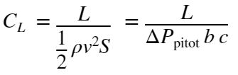

% Importing the data for all 5 different wings

default = readmatrix("default.xlsx");

small_span = readmatrix("small_span.xlsx");

large_span = readmatrix("large_span.xlsx");

small_wingtip = readmatrix("small_wingtip.xlsx");

large_wingtip = readmatrix("large_wingtip.xlsx");

% Extract the pressure, temperature, velocity, lift, and wing span values

% Default

p_a1 = inchwater2pascal(default(:,1)); % [Pa]

T_a1 = default(:,2); % [C]

v_a1 = default(:,3); % [m/s]

L_a1 = lbs2newton(default(:,6)); % [N]

b1 = inch2m(12); % [inch]

% Small span

p_a2 = inchwater2pascal(small_span(:,1));

T_a2 = small_span(:,2);

v_a2 = small_span(:,3);

L_a2 = lbs2newton(small_span(:,6));

b2 = inch2m(16);

% Large span

p_a3 = inchwater2pascal(large_span(:,1));

T_a3 = large_span(:,2);

v_a3 = large_span(:,3);

L_a3 = lbs2newton(large_span(:,6));

b3 = inch2m(32);

% Small wingtip

p_a4 = inchwater2pascal(small_wingtip(:,1));

T_a4 = small_wingtip(:,2);

v_a4 = small_wingtip(:,3);

L_a4 = lbs2newton(small_wingtip(:,6));

b4 = inch2m(16);

% Large wingtip

p_a5 = inchwater2pascal(large_wingtip(:,1));

T_a5 = large_wingtip(:,2);

v_a5 = large_wingtip(:,3);

L_a5 = lbs2newton(large_wingtip(:,6));

b5 = inch2m(15.5);

% Define angle of attack

alpha = 0:2:24;

% Define chord length

c = inch2m(8);

% Computing the lift coefficients for all 5 different wings

Cl_a1 = calc_lift_coeff(scale_lift(L_a1), p_a1, c, b1);

Cl_a2 = calc_lift_coeff(scale_lift(L_a2), p_a2, c, b2);

Cl_a3 = calc_lift_coeff(scale_lift(L_a3), p_a3, c, b3);

Cl_a4 = calc_lift_coeff(scale_lift(L_a4), p_a4, c, b4);

Cl_a5 = calc_lift_coeff(scale_lift(L_a5), p_a5, c, b5);

% Plotting

fig1 = figure("Renderer","painters");

plot(alpha, Cl_a1, '.', 'MarkerSize',10)

xlabel('angle of attack, $\alpha$ [deg]')

ylabel('$C_L$')

title({'Lift Coefficient Over Angle of Attack for 5 Different Wings',['' ...

'- By: Tomoki Koike']})

hold on

plot(alpha, Cl_a2, '.', 'MarkerSize', 10)

plot(alpha, Cl_a3, '.', 'MarkerSize', 10)

plot(alpha, Cl_a4, '.', 'MarkerSize', 10)

plot(alpha, Cl_a5, '.', 'MarkerSize', 10)

hold off

legend('normal', 'small span', 'large span', 'small wingtip', 'large wingtip',...

'Location','southeast')

grid on

grid minor

box on

saveas(fig1, 'cl_vs_alpha_all.png');

## <b>

% For XFLR5 calculate Reynolds number with average values

rho_avg1 = 2*mean(p_a1)./mean(v_a1.^2);

rho_avg2 = 2*mean(p_a2)./mean(v_a2.^2);

rho_avg3 = 2*mean(p_a3)./mean(v_a3.^2);

rho_avg4 = 2*mean(p_a4)./mean(v_a4.^2);

rho_avg5 = 2*mean(p_a5)./mean(v_a5.^2);

rho_avg = mean([rho_avg1,rho_avg2,rho_avg3,rho_avg4,rho_avg5])

v_avg = mean(mean([v_a1,v_a2,v_a3,v_a4,v_a5]))

myu = 1.81*10^(-5);

Re_avg = rho_avg*v_avg*c/myu

% Import XFLR results

xflr_res = readmatrix("Polar_Graph_3.csv");

xflr_alpha = xflr_res(:,1);

xflr_Cl = xflr_res(:,2);

% Plotting

fig2 = figure("Renderer","painters");

plot(alpha, Cl_a1, '.', 'MarkerSize',10)

xlabel('angle of attack, $\alpha$ [deg]')

ylabel('$C_L$')

title({'Lift Coefficient Over Angle of Attack for Finite and Infinite Wing', ['' ...

'5 Different Wings - By: Tomoki Koike']})

hold on

plot(alpha, Cl_a2, '.', 'MarkerSize', 10)

plot(alpha, Cl_a3, '.', 'MarkerSize', 10)

plot(alpha, Cl_a4, '.', 'MarkerSize', 10)

plot(alpha, Cl_a5, '.', 'MarkerSize', 10)

plot(xflr_alpha, xflr_Cl,'-')

hold off

legend('normal', 'small span', 'large span', 'small wingtip', 'large wingtip',...

'XFLR','Location','southeast')

grid on

grid minor

box on

saveas(fig2, 'cl_vs_alpha_inf_fin.png');

## <c>

% Drags

D_a1 = lbs2newton(default(:,5)); % [N]

D_a2 = lbs2newton(small_span(:,5));

D_a3 = lbs2newton(large_span(:,5));

D_a4 = lbs2newton(small_wingtip(:,5));

D_a5 = lbs2newton(large_wingtip(:,5));

% Computing the drag coefficients for all 5 cases

CD_a1 = calc_drag_coeff(scale_drag(D_a1), p_a1, c, b1);

CD_a2 = calc_drag_coeff(scale_drag(D_a2), p_a2, c, b2);

CD_a3 = calc_drag_coeff(scale_drag(D_a3), p_a3, c, b3);

CD_a4 = calc_drag_coeff(scale_drag(D_a4), p_a4, c, b4);

CD_a5 = calc_drag_coeff(scale_drag(D_a5), p_a5, c, b5);

% Plotting the drag polar for all 5 cases on one plot

fig3 = figure("Renderer","painters");

plot(CD_a1, Cl_a1,'.', 'MarkerSize',10)

title('Drag Polar for All 5 Cases - By: Tomoki Koike')

xlabel('$C_D$')

ylabel('$C_L$')

hold on

plot(CD_a2, Cl_a2,'.', 'MarkerSize',10)

plot(CD_a3, Cl_a3,'.', 'MarkerSize',10)

plot(CD_a4, Cl_a4,'.', 'MarkerSize',10)

plot(CD_a5, Cl_a5,'.', 'MarkerSize',10)

hold off

legend('normal', 'small span', 'large span', 'small wingtip', 'large wingtip',...

'Location','southeast')

grid on

grid minor

box on

saveas(fig3, 'drag_polar_all.png')

## <d>

Cl_a2_11 = interp1(alpha, Cl_a2, [11.0]);

Cl_a3_11 = interp1(alpha, Cl_a3, [11.0]);

CD_a2_11 = interp1(alpha, CD_a2, [11.0]);

CD_a3_11 = interp1(alpha, CD_a3, [11.0]);

L_D_a2 = Cl_a2./CD_a2;

[val1, idx1] = max(L_D_a2);

alpha1 = alpha(idx1);

L_D_a3 = Cl_a3./CD_a3;

[val2, idx2] = max(L_D_a3);

alpha2 = alpha(idx2);

## FUNCTIONS

function N = lbs2newton(w)

% Function that converts lbs to Newtons

N = w*4.44822;

end

function [fitresult, gof] = createFit(w, obj, obj_str)

[xData, yData] = prepareCurveData( w, obj );

% Set up fittype and options.

ft = fittype( 'poly2' );

opts = fitoptions( 'Method', 'LinearLeastSquares' );

opts.Robust = 'Bisquare';

% Fit model to data.

[fitresult, gof] = fit( xData, yData, ft, opts );

% Plot fit with data.

fig = figure("Renderer","painters");

plot( fitresult, xData, yData );

% Label axes

title(sprintf('%s Calibration Plot - By: Tomoki Koike',obj_str))

xlabel('Calibration weigths [N]');

ylabel(sprintf('Calibration %s [N]',obj_str));

legend('data points', 'line curve', 'Location', 'southeast')

grid on

grid minor

box on

saveas(fig, sprintf('%s_calib.png',obj_str))

end

function P = inchwater2pascal(pf)

P = pf * 248.82;

end

function Cl = calc_lift_coeff(L,p_diff,c,b)

Cl = L./p_diff/c/b;

end

function Cl = calc_drag_coeff(D,p_diff,c,b)

Cl = D./p_diff/c/b;

end

function d = inch2m(l)

d = l * 0.0254;

end