AAE 339: Aerospace Propulsion

HW 10: Gas Generator Cycles & Space Missions

Dr. Anderson

School of Aeronautical and Astronautical

Purdue University

Tomoki Koike

Friday April 24th, 2020

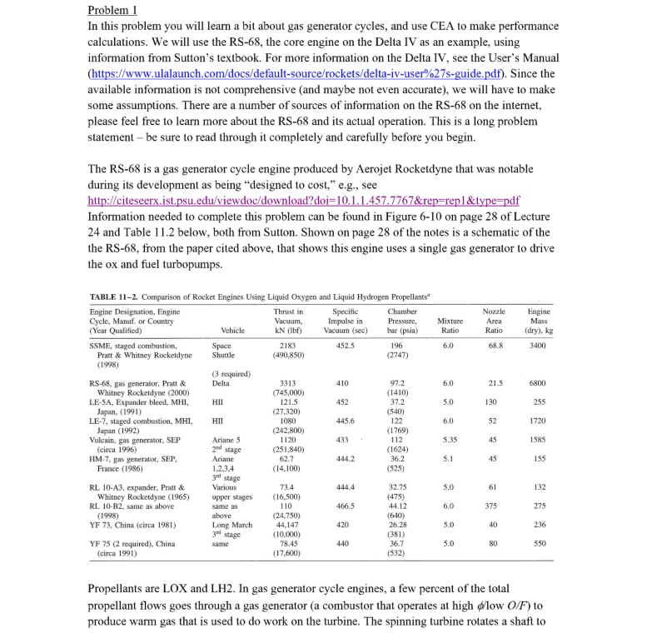

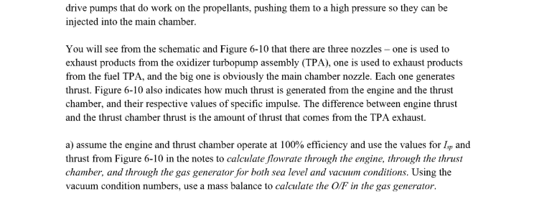

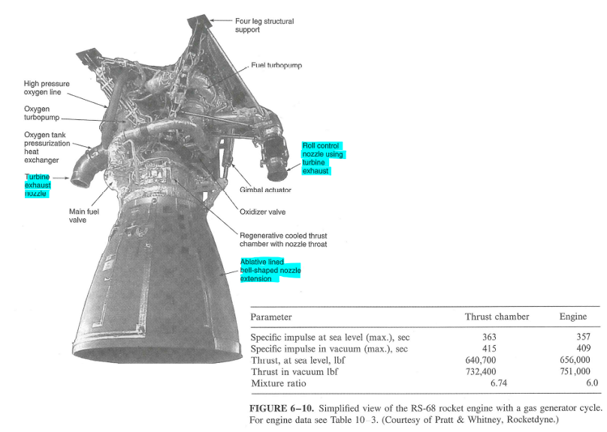

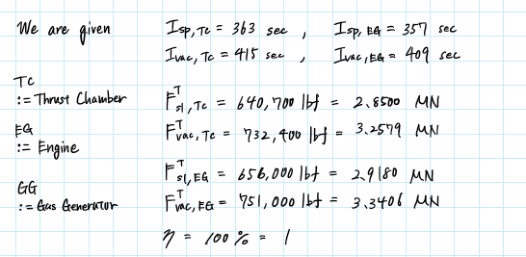

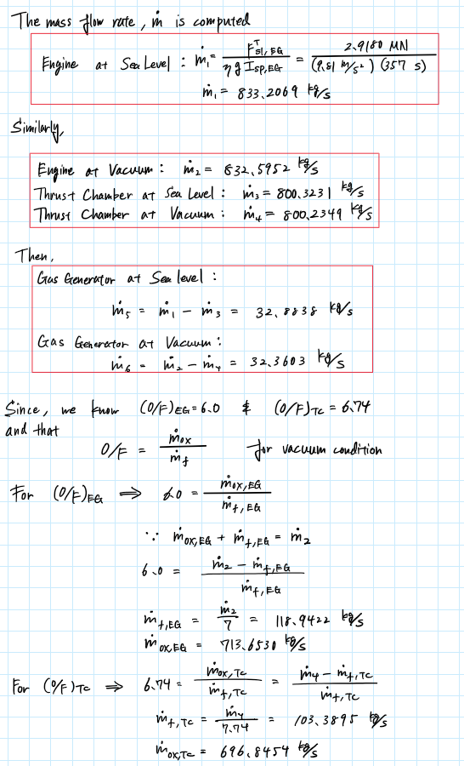

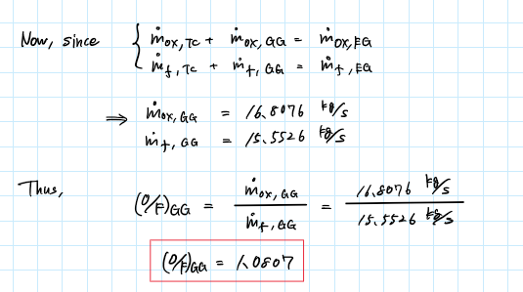

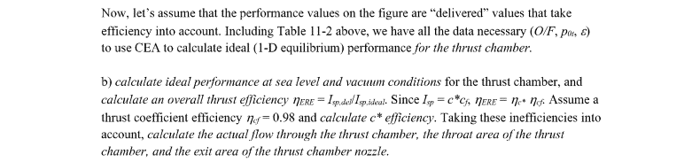

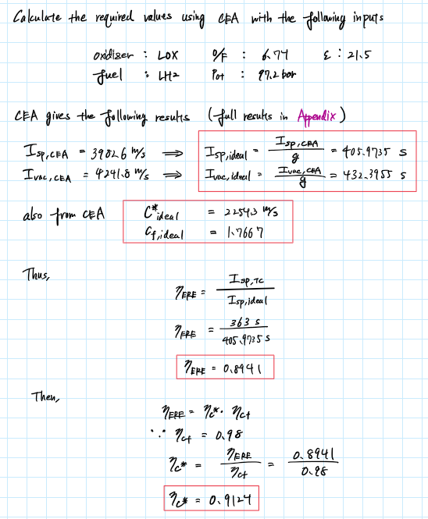

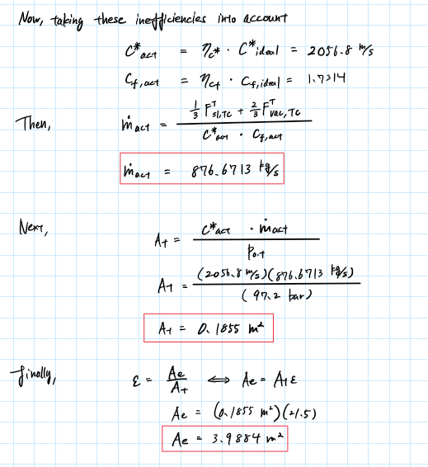

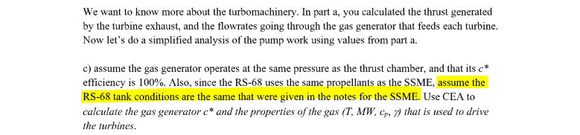

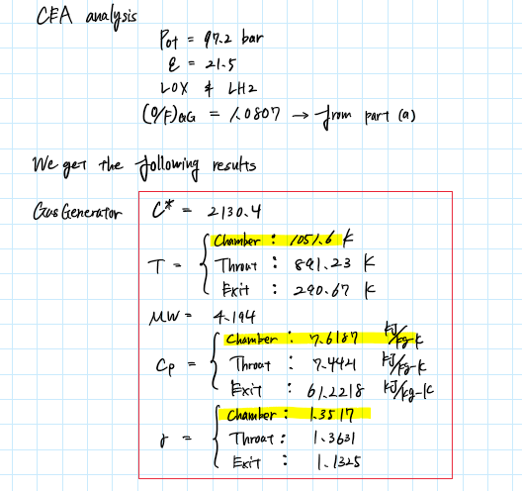

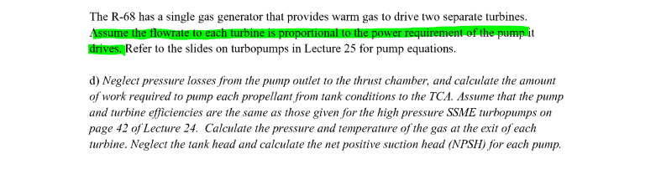

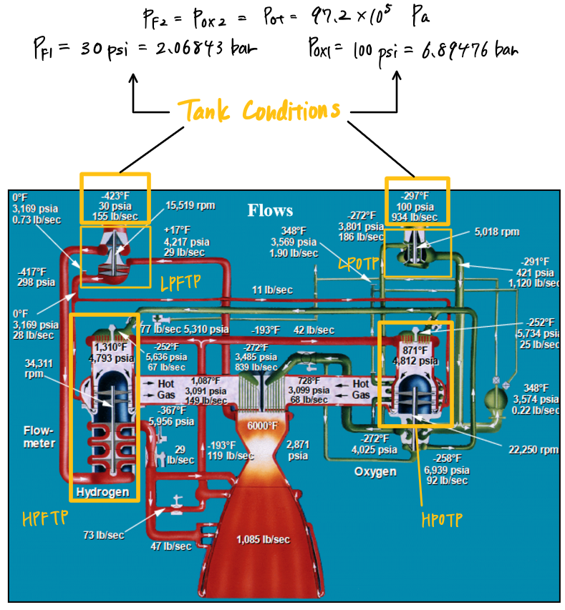

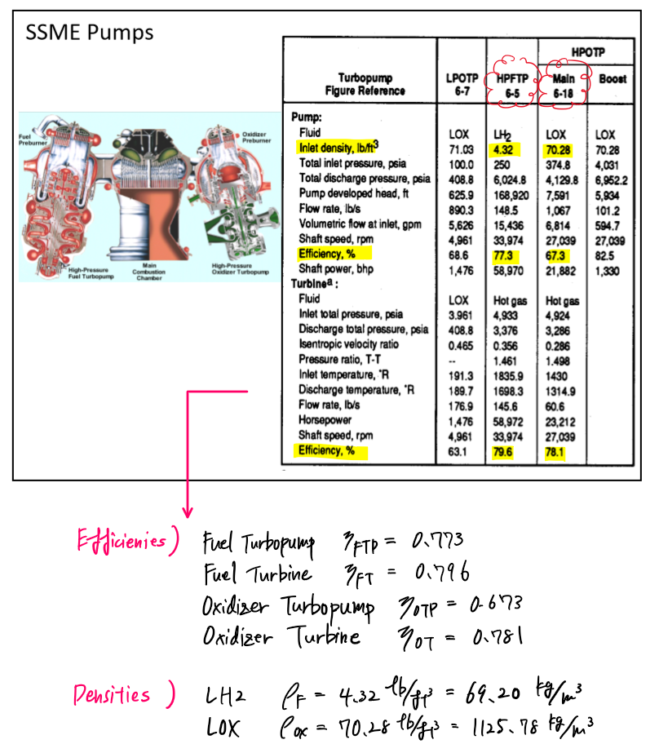

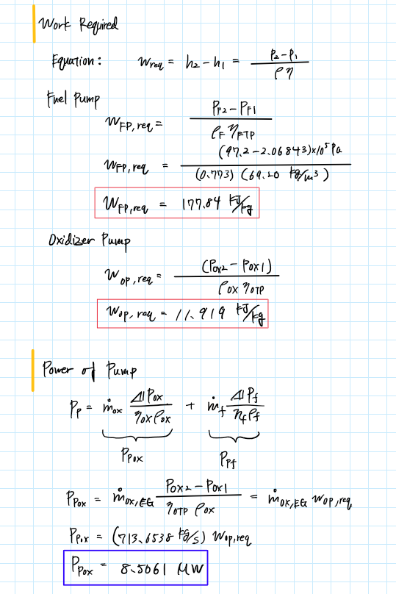

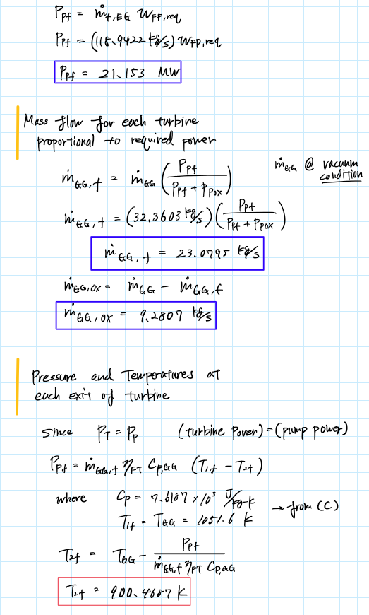

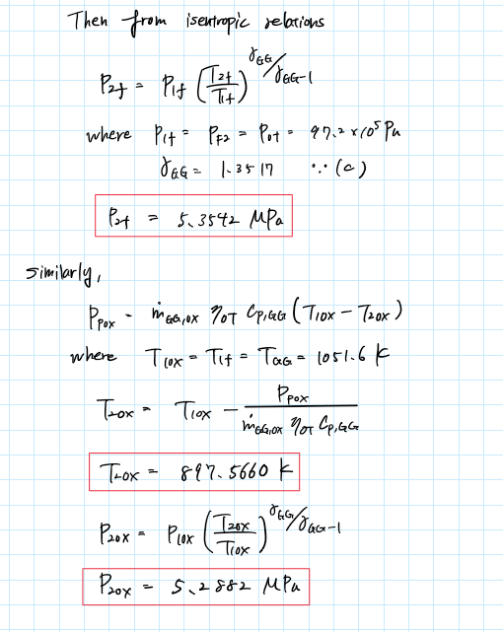

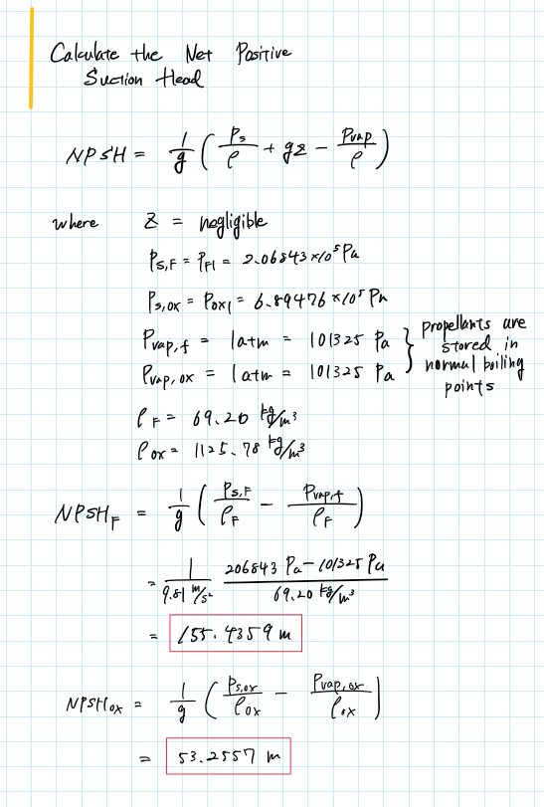

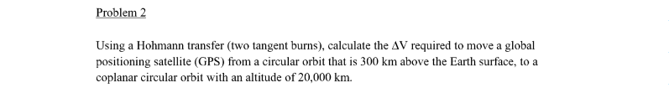

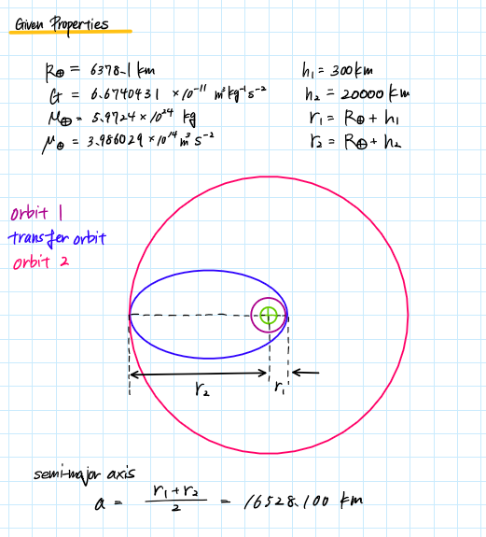

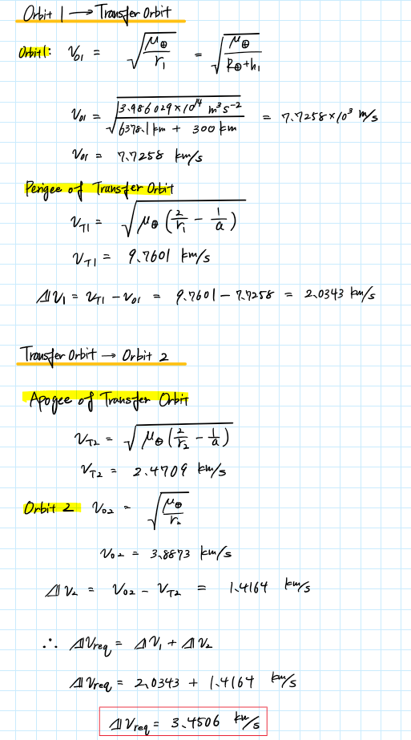

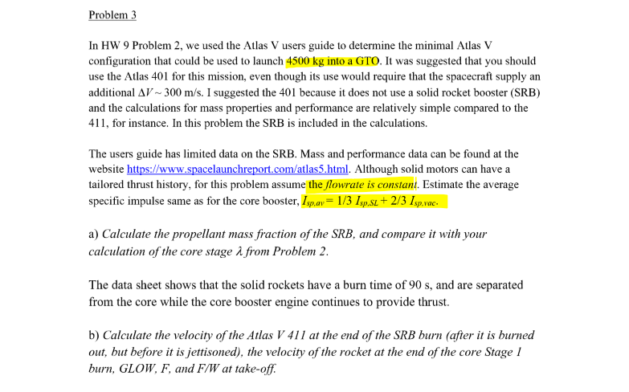

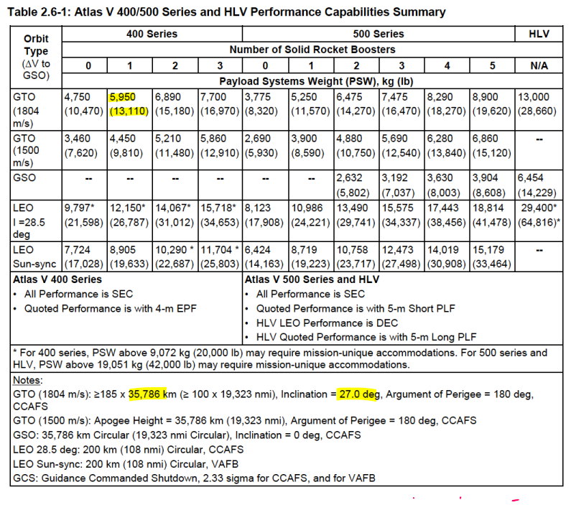

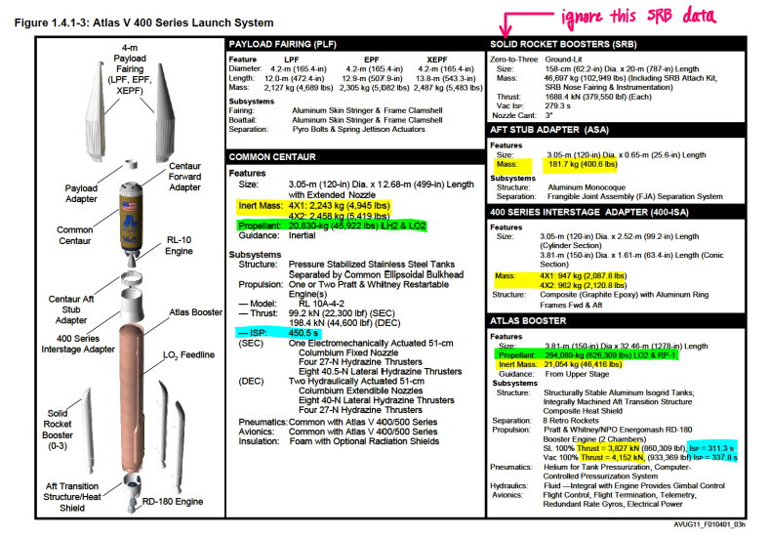



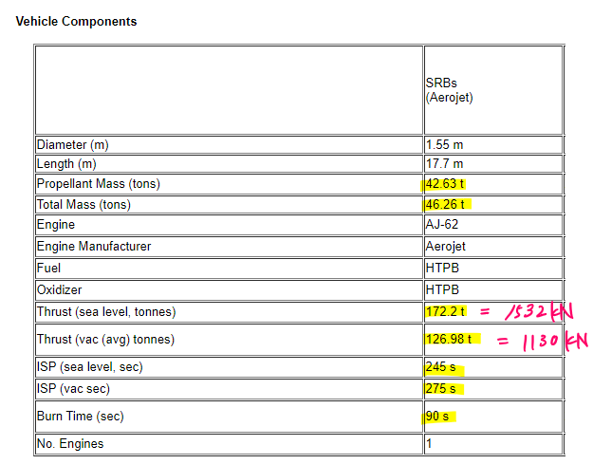

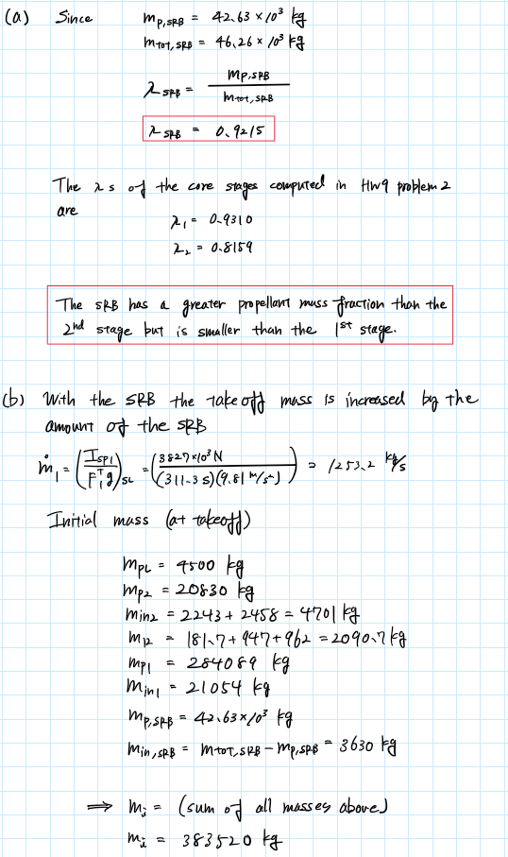

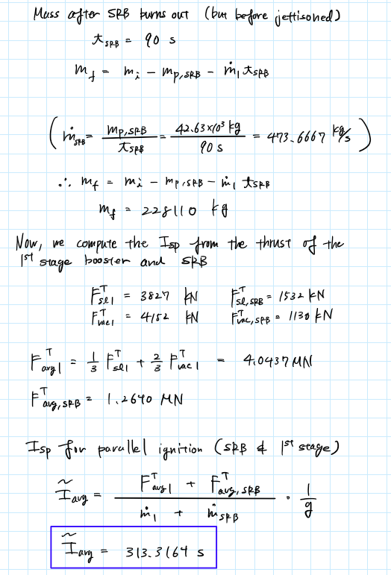

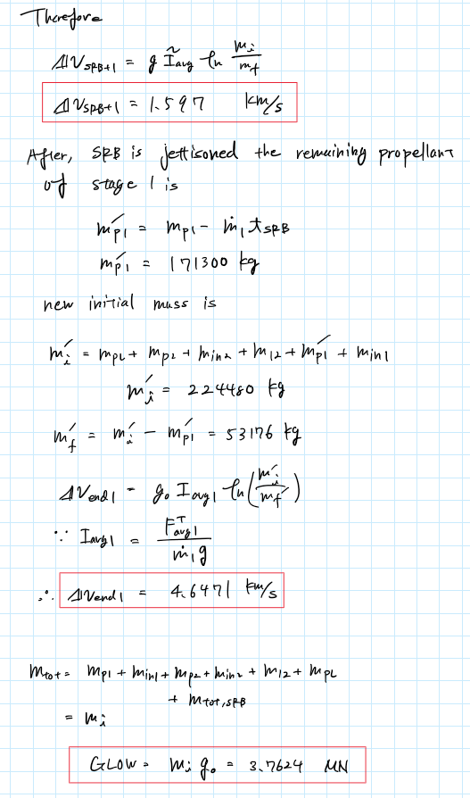

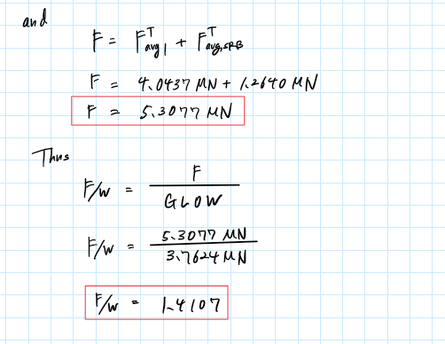

Appendix

MATLAB CODE

**AAE 339 HW 10**

clear all; close all; clc;

% Global constants

R_e = 6378.1e3; % [m]

G = 6.6740831e-11; % [m3kg-1s-2]

M_e = 5.9724e24; % [kg]

mu_e = G*M_e;

g = 9.81;

**P1 (a)**

% Specific impulse [s]

Isp_TC = 363;

Ivac_TC = 415;

Isp_EG = 357;

Ivac_EG = 409;

% Thrusts [N]

FT_sl_TC = lbf2newtons(640700);

FT_vac_TC = lbf2newtons(732400);

FT_sl_EG = lbf2newtons(656000);

FT_vac_EG = lbf2newtons(751000);

% Efficiency

eta = 1;

% Create array for convenience

arr = [Isp_EG, Ivac_EG, FT_sl_EG, FT_vac_EG;

Isp_TC, Ivac_TC, FT_sl_TC, FT_vac_TC];

T = array2table(arr,"RowNames",{'EG', 'TC'},"VariableNames",{'Isp','Ivac','slThrust','vacThrust'});

T.slMdot = T.slThrust./T.Isp/g/eta;

T.vacMdot = T.vacThrust./T.Ivac/g/eta;

T.slMdot("GG") = T.slMdot(1) - T.slMdot(2);

T.vacMdot("GG") = T.vacMdot(1) - T.vacMdot(2);

T.slThrust("GG") = T.slThrust(1) - T.slThrust(2);

T.vacThrust("GG") = T.vacThrust(1) - T.vacThrust(2);

mdot1 = T.slMdot("EG");

mdot2 = T.vacMdot("EG");

mdot3 = T.slMdot("TC");

mdot4 = T.vacMdot("TC");

mdot5 = T.slMdot("GG");

mdot6 = T.vacMdot("GG");

% Mixture ratio

phi_EG = 6.0;

phi_TC = 6.74;

mdot_f_EG = mdot2/(1 + phi_EG);

mdot_ox_EG = mdot_f_EG*phi_EG;

mdot_f_TC = mdot4/(1 + phi_TC);

mdot_ox_TC = mdot_f_TC*phi_TC;

mdot_ox_GG = mdot_ox_EG - mdot_ox_TC;

mdot_f_GG = mdot_f_EG - mdot_f_TC;

phi_GG = mdot_ox_GG/mdot_f_GG;

**(b)**

% CEA results

Isp_CEA = 3982.6;

Isp_ideal = Isp_CEA/g;

Ivac_CEA = 4241.8;

Ivac_ideal = Ivac_CEA/g;

cstar_ideal = 2254.3;

cf_ideal = 1.7667;

% Overall effficiency

eta_ERE = Isp_TC/Isp_ideal;

eta_cf = 0.98;

eta_cstar = eta_ERE/eta_cf;

% act values

cstar_act = eta_cstar*cstar_ideal;

cf_act = eta_cf*cf_ideal;

FT_act = 1/3*FT_sl_TC + 2/3*FT_vac_TC; % [N]

P0t = 97.2e5; % [Pa]

epsilon = 21.5;

mdot_act = FT_act/cstar_act/cf_act;

At = cstar_act*mdot_act/P0t;

Ae = At*epsilon;

**(c)**

Cp_GG = 7.6187e3; % [J/kg/K]

gamma_GG = 1.3517;

T_GG = 1051.6; %[K]

Cctar_GG = 2130.4;

**(d)**

% Pressures

P_f2 = P0t;

P_ox2 = P0t;

P_f1 = 2.06843e5;

P_ox1 = 6.89476e5;

% Efficiencies

eta_FTP = 0.773;

eta_FT = 0.796;

eta_OTP = 0.673;

eta_OT = 0.781;

% Densities

rho_F = 69.20;

rho_ox = 1125.78;

% Work required

w_FP_req = (P_f2 - P_f1)/rho_F/eta_FTP;

w_OP_req = (P_ox2 - P_ox1)/rho_ox/eta_OTP;

% Pump power

P_p_ox = mdot_ox_EG*w_OP_req;

P_p_f = mdot_f_EG*w_FP_req;

% Mass flow for each turbine

mdot_GG = mdot6;

mdot_GG_f = mdot_GG*P_p_f/(P_p_f + P_p_ox);

mdot_GG_ox = mdot_GG*P_p_ox/(P_p_f + P_p_ox);

% Pressure and temperatures

T2f = T_GG - P_p_f/mdot_GG_f/eta_FT/Cp_GG;

P2f = P_from_isentropic_relation(P0t,T2f,T_GG,gamma_GG,"num");

T2ox = T_GG - P_p_ox/mdot_GG_ox/eta_OT/Cp_GG

P2ox = P_from_isentropic_relation(P0t,T2ox,T_GG,gamma_GG,"num")

% NPSH

Pvap_f = 101325;

Pvap_ox = Pvap_f;

% fuel

NPSH_F = (P_f1 - Pvap_f)/g/rho_F

% oxidizer

NPSH_ox = (P_ox1 - Pvap_ox)/g/rho_ox

**P2**

% Given properties

h1 = 300e3;

h2 = 20000e3;

r1 = R_e + h1;

r2 = R_e + h2;

a = mean([r1 r2]);

% Anonymous function for circular velocity

circ_v = @(r) sqrt(mu_e/r);

% Anonymous function for elliptic velocity

ellip_v = @(r,a) sqrt(mu_e*(2/r - 1/a));

% Orbit 1 -> Transfer orbit

Vo1 = circ_v(r1);

Vt1 = ellip_v(r1,a);

dv1 = Vt1 - Vo1;

% Transfer orbit -> orbit 2

Vt2 = ellip_v(r2,a);

Vo2 = circ_v(r2);

dv2 = Vo2 - Vt2;

% Delta v required

dv_req = dv1 + dv2;

**P3 (a)**

% Given properties of the SRB

m_p_SRB = 42.63e3; % [kg]

m_tot_SRB = 46.26e3; % [kg]

m_in_SRB = m_tot_SRB - m_p_SRB; % [kg]

FT_sl_SRB = 1532e3; % [N]

FT_vac_SRB = 1130e3; % [N]

% Propellant mass fraction of SRB

lambda_SRB = m_p_SRB/m_tot_SRB;

**(b)**

% Atlas V 401 masses [kg]

m_p_2 = 20830;

m_p_1 = 284089;

m_in_2 = 4701;

m_in_1 = 21054;

m_mid = 2090.7;

m_pl = 4500;

% Isp

% First stage

Isp1 = 311.3;

Ivac1 = 337.8;

FT_SL_1 = 3827e3;

FT_vac_1 = 4152e3;

% Time for SRB to burn out

t_SRB = 90; % [s]

% Velocity after SRB burns out

% Mass and mass flow

m_i = m_pl + m_mid + m_in_1 + m_in_2 + m_p_1 + m_p_2 + m_tot_SRB

mdot_SRB = m_p_SRB/t_SRB;

mdot1 = FT_SL_1/Isp1/g

m_f = m_i - m_p_SRB - mdot1*t_SRB

% Isp

% First stage thrust

FT_sl_1 = 3827e3;

FT_vac_1 = 4152e3;

FT_avg_1 = 1/3*FT_sl_1 + 2/3*FT_vac_1

FT_avg_SRB = 1/3*FT_sl_SRB + 2/3*FT_vac_SRB

% Total thrust

FT_sl = FT_sl_1 + FT_sl_SRB

FT_vac = FT_vac_1 + FT_vac_SRB

Iavg_tilde = (FT_avg_1 + FT_avg_SRB)/(mdot1 + mdot_SRB)/g

dv_SRB_1 = rocket_eqn(Iavg_tilde,m_i,m_f)

m_p_1_new = m_p_1 - mdot1*t_SRB

m_i_new = m_pl + m_mid + m_in_1 + m_in_2 + m_p_1_new + m_p_2

m_f_new = m_i_new - m_p_1_new

Iavg1 = FT_avg_1/mdot1/g

dv_end1 = rocket_eqn(Iavg1,m_i_new,m_f_new)

GLOW = m_i*g

F = FT_avg_1 + FT_avg_SRB

F_W = F/GLOW

**Functions**

function dv = rocket_eqn(Isp,m1,m2)

g = 9.81;

dv = g*Isp*log(m1/m2);

end

function P2 = P_from_isentropic_relation(P1, T2, T1, gamma, type)

% type => type you want to find

if type == "num"

P2 = P1 * (T2 / T1)^(gamma / (gamma - 1));

elseif type == "den"

P2 = P1 * (T2 / T1)^(-gamma / (gamma - 1));

else

disp("You can only enter num or den for type.")

end

end

CEA RESULTS

Problem 1 (b)

*******************************************************************************

NASA-GLENN CHEMICAL EQUILIBRIUM PROGRAM CEA2, FEBRUARY 5, 2004

BY BONNIE MCBRIDE AND SANFORD GORDON

REFS: NASA RP-1311, PART I, 1994 AND NASA RP-1311, PART II, 1996

*******************************************************************************

### CEA analysis performed on Wed 22-Apr-2020 22:15:56

# Problem Type: "Rocket" (Infinite Area Combustor)

prob case=1111___________1727 ro equilibrium

# Pressure (1 value):

p,bar= 97.2

# Supersonic Area Ratio (1 value):

supar= 21.5

# Oxidizer/Fuel Wt. ratio (1 value):

o/f= 6.74

# You selected the following fuels and oxidizers:

reac

fuel H2(L) mole=100.0000

oxid O2(L) mole=100.0000

# You selected these options for output:

# short version of output

output short

# Proportions of any products will be expressed as Mole Fractions.

# Heat will be expressed as siunits

output siunits

# Input prepared by this script:prepareInputFile.cgi

### IMPORTANT: The following line is the end of your CEA input file!

end

THEORETICAL ROCKET PERFORMANCE ASSUMING EQUILIBRIUM

COMPOSITION DURING EXPANSION FROM INFINITE AREA COMBUSTOR

Pin = 1409.8 PSIA

CASE = 1111___________

REACTANT MOLES ENERGY TEMP

KJ/KG-MOL K

FUEL H2(L) 100.0000000 -9012.000 20.270

OXIDANT O2(L) 100.0000000 -12979.000 90.170

O/F= 6.74000 %FUEL= 12.919897 R,EQ.RATIO= 1.177549 PHI,EQ.RATIO= 1.177549

CHAMBER THROAT EXIT

Pinf/P 1.0000 1.7306 187.02

P, BAR 97.200 56.165 0.51972

T, K 3604.05 3418.64 1935.94

RHO, KG/CU M 4.7378 0 2.9211 0 5.0356-2

H, KJ/KG -930.79 -2020.24 -8861.46

U, KJ/KG -2982.36 -3942.99 -9893.54

G, KJ/KG -61190.1 -59179.6 -41230.2

S, KJ/(KG)(K) 16.7199 16.7199 16.7199

M, (1/n) 14.606 14.783 15.596

(dLV/dLP)t -1.03360 -1.02815 -1.00022

(dLV/dLT)p 1.5813 1.5142 1.0068

Cp, KJ/(KG)(K) 9.3254 8.8498 3.2335

GAMMAs 1.1351 1.1332 1.2003

SON VEL,M/SEC 1526.0 1476.1 1113.0

MACH NUMBER 0.000 1.000 3.578

PERFORMANCE PARAMETERS

Ae/At 1.0000 21.500

CSTAR, M/SEC 2254.3 2254.3

CF 0.6548 1.7667

Ivac, M/SEC 2778.7 4241.8

Isp, M/SEC 1476.1 3982.6

MOLE FRACTIONS

*H 0.03218 0.02737 0.00056

HO2 0.00009 0.00005 0.00000

*H2 0.18209 0.17545 0.15060

H2O 0.70545 0.73138 0.84853

H2O2 0.00002 0.00001 0.00000

*O 0.00617 0.00457 0.00000

*OH 0.06486 0.05381 0.00032

*O2 0.00914 0.00736 0.00000

* THERMODYNAMIC PROPERTIES FITTED TO 20000.K

Problem 1 (c)

*******************************************************************************

NASA-GLENN CHEMICAL EQUILIBRIUM PROGRAM CEA2, FEBRUARY 5, 2004

BY BONNIE MCBRIDE AND SANFORD GORDON

REFS: NASA RP-1311, PART I, 1994 AND NASA RP-1311, PART II, 1996

*******************************************************************************

### CEA analysis performed on Wed 22-Apr-2020 22:27:24

# Problem Type: "Rocket" (Infinite Area Combustor)

prob case=1111___________1727 ro equilibrium

# Pressure (1 value):

p,bar= 97.2

# Supersonic Area Ratio (1 value):

supar= 21.5

# Oxidizer/Fuel Wt. ratio (1 value):

o/f= 1.0807

# You selected the following fuels and oxidizers:

reac

fuel H2(L) mole=100.0000

oxid O2(L) mole=100.0000

# You selected these options for output:

# short version of output

output short

# Proportions of any products will be expressed as Mole Fractions.

# Heat will be expressed as siunits

output siunits

# Input prepared by this script:prepareInputFile.cgi

### IMPORTANT: The following line is the end of your CEA input file!

end

THEORETICAL ROCKET PERFORMANCE ASSUMING EQUILIBRIUM

COMPOSITION DURING EXPANSION FROM INFINITE AREA COMBUSTOR

Pin = 1409.8 PSIA

CASE = 1111___________

REACTANT MOLES ENERGY TEMP

KJ/KG-MOL K

FUEL H2(L) 100.0000000 -9012.000 20.270

OXIDANT O2(L) 100.0000000 -12979.000 90.170

O/F= 1.08070 %FUEL= 48.060749 R,EQ.RATIO= 7.344020 PHI,EQ.RATIO= 7.344020

CHAMBER THROAT EXIT

Pinf/P 1.0000 1.8713 290.67

P, BAR 97.200 51.944 0.33440

T, K 1051.16 891.23 295.75

RHO, KG/CU M 4.6648 0 2.9402 0 6.0615-2

H, KJ/KG -2359.23 -3563.22 -8487.57

U, KJ/KG -4442.91 -5329.88 -9039.25

G, KJ/KG -37975.1 -33760.2 -18508.4

S, KJ/(KG)(K) 33.8824 33.8824 33.8824

M, (1/n) 4.194 4.194 4.457

MW, MOL WT 4.194 4.194 4.194

(dLV/dLP)t -1.00000 -1.00000 -1.08934

(dLV/dLT)p 1.0000 1.0000 2.6024

Cp, KJ/(KG)(K) 7.6187 7.4421 61.2218

GAMMAs 1.3517 1.3631 1.1325

SON VEL,M/SEC 1678.2 1551.8 790.4

MACH NUMBER 0.000 1.000 4.429

PERFORMANCE PARAMETERS

Ae/At 1.0000 21.500

CSTAR, M/SEC 2130.4 2130.4

CF 0.7284 1.6433

Ivac, M/SEC 2690.2 3658.5

Isp, M/SEC 1551.8 3501.0

MOLE FRACTIONS

*H2 0.86383 0.86383 0.86383

H2O 0.13617 0.13617 0.07718

H2O(L) 0.00000 0.00000 0.05899

* THERMODYNAMIC PROPERTIES FITTED TO 20000.K