AAE339: Aerospace Propulsion

HW4: Propulsion Thermochemistry

Dr. Anderson

Tomoki Koike

February 12, 2020

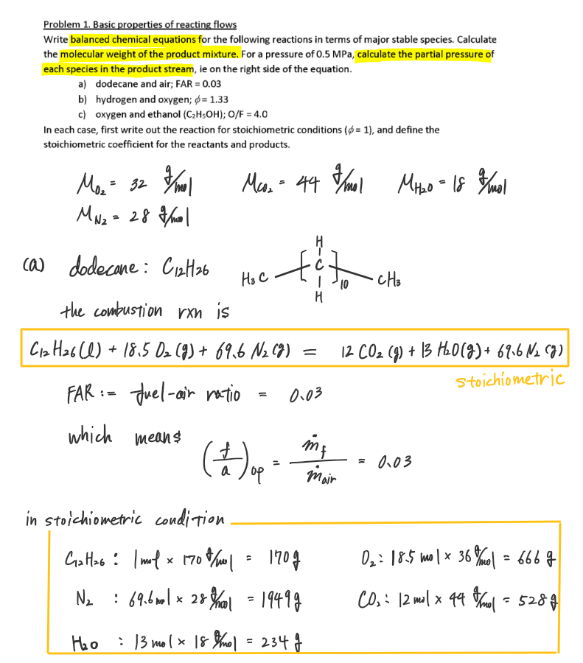

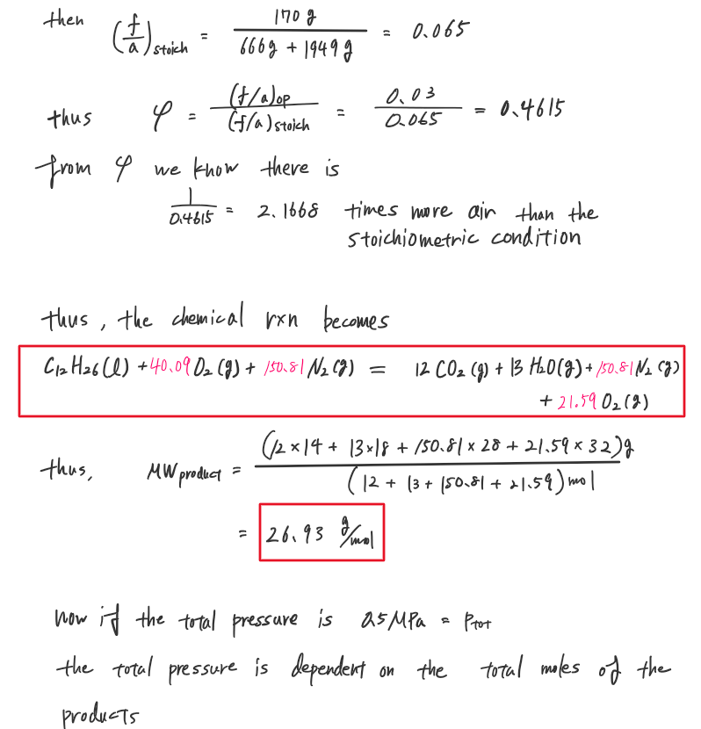

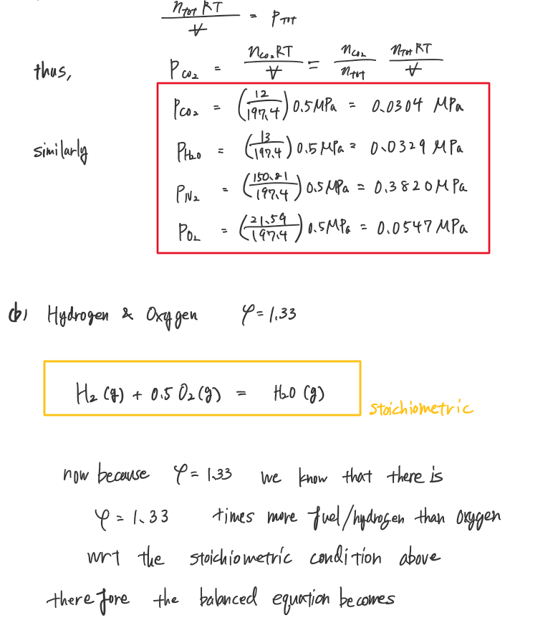

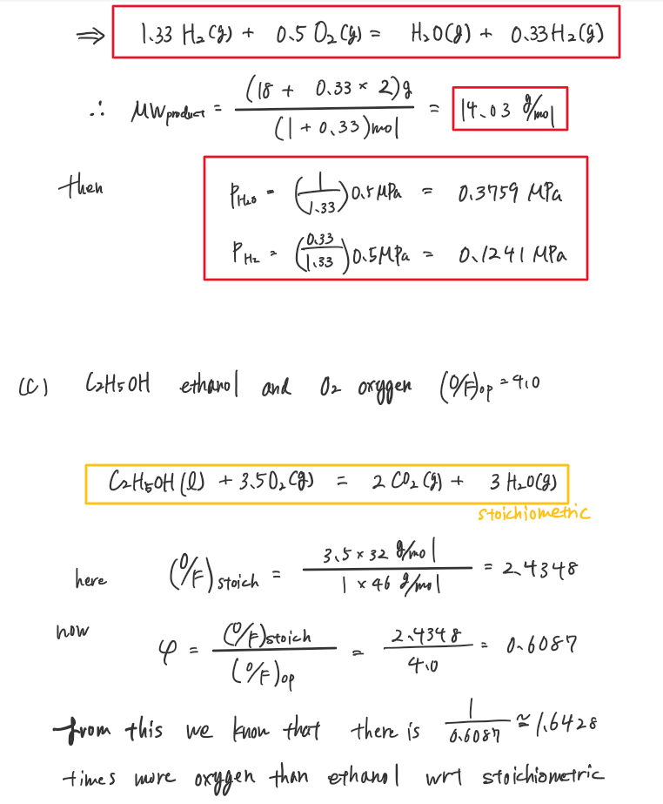

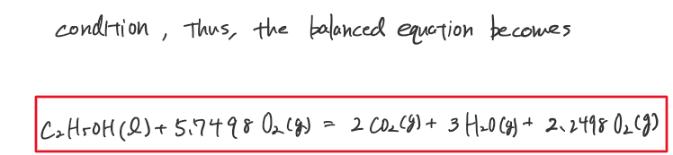

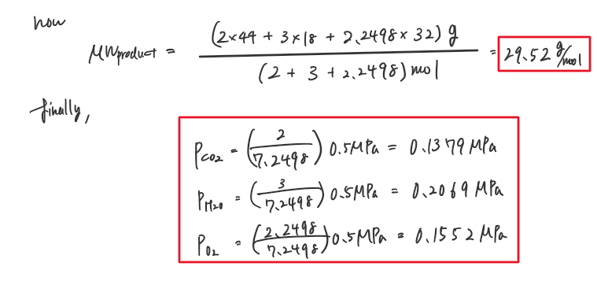

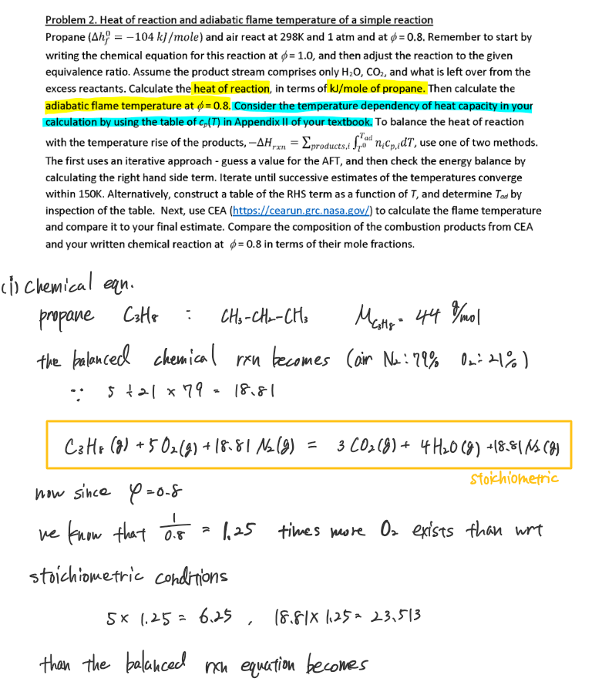

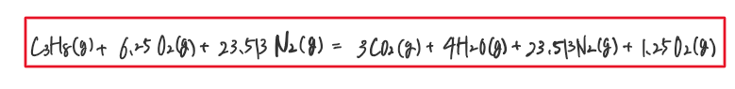

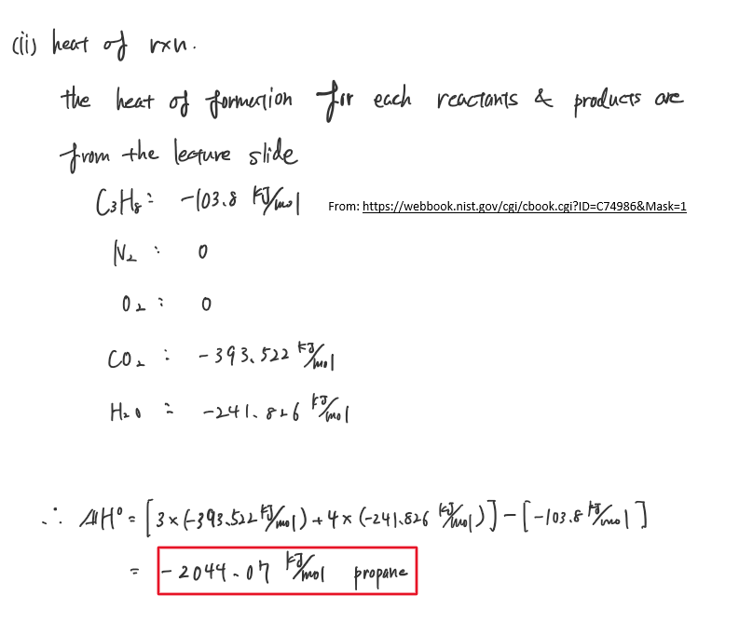

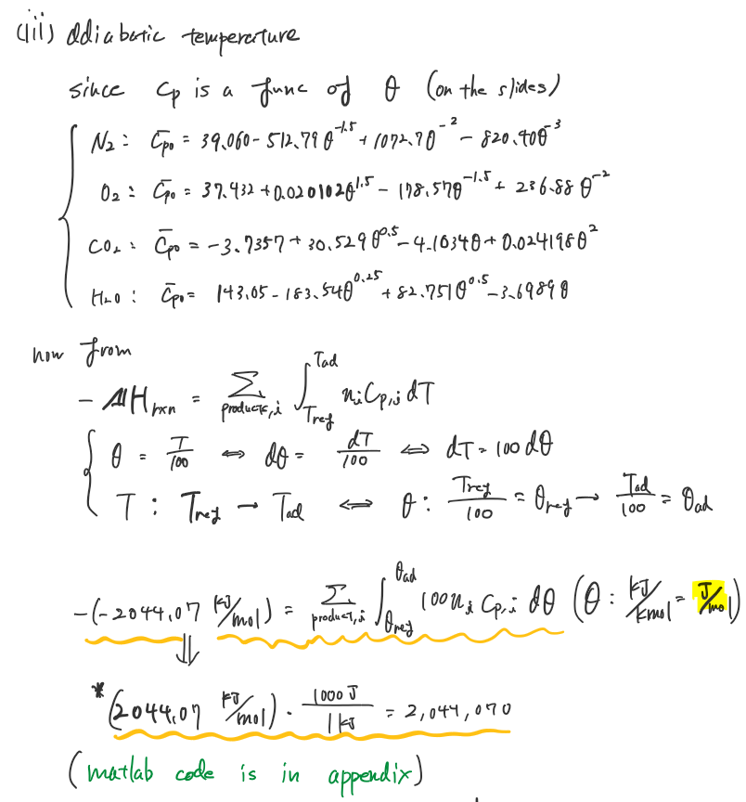

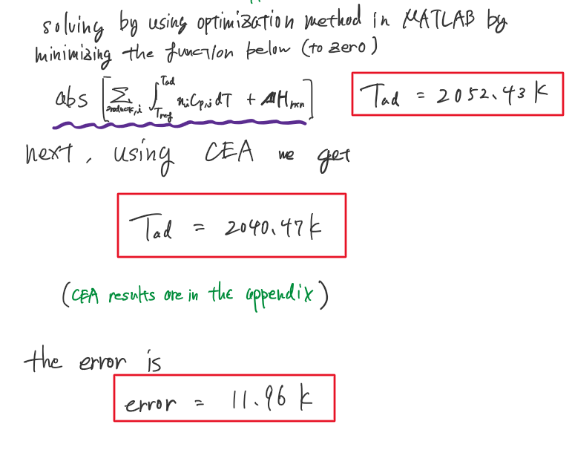

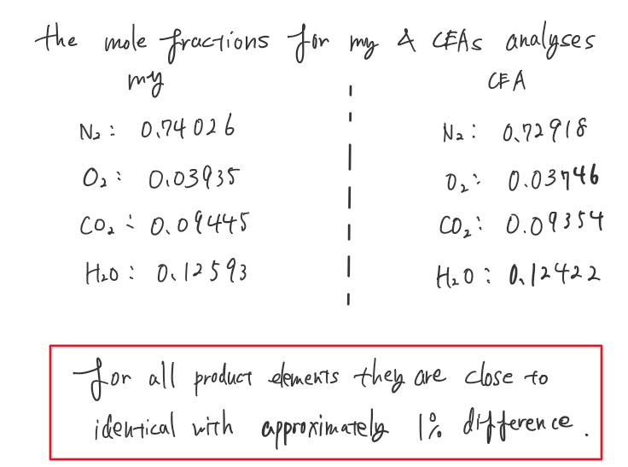

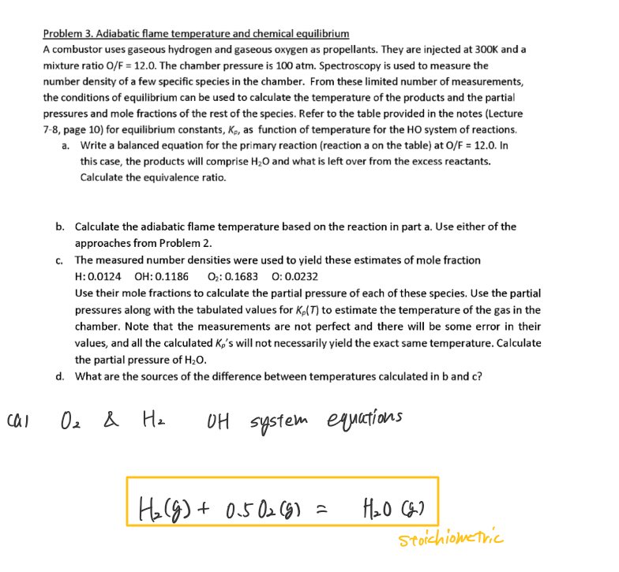

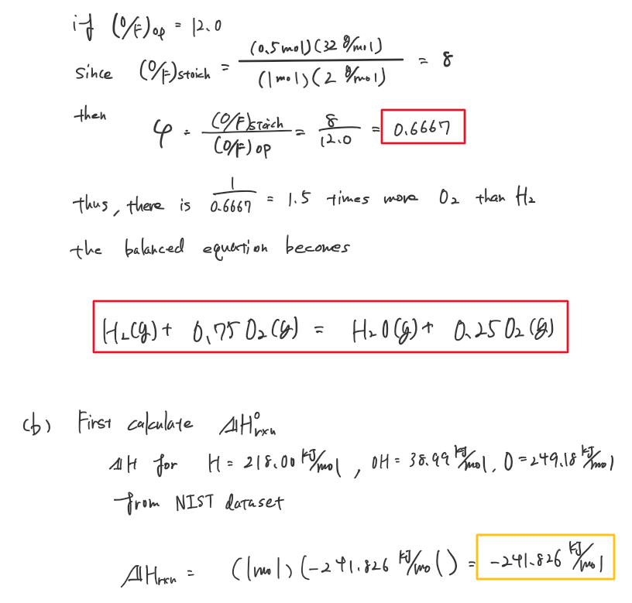

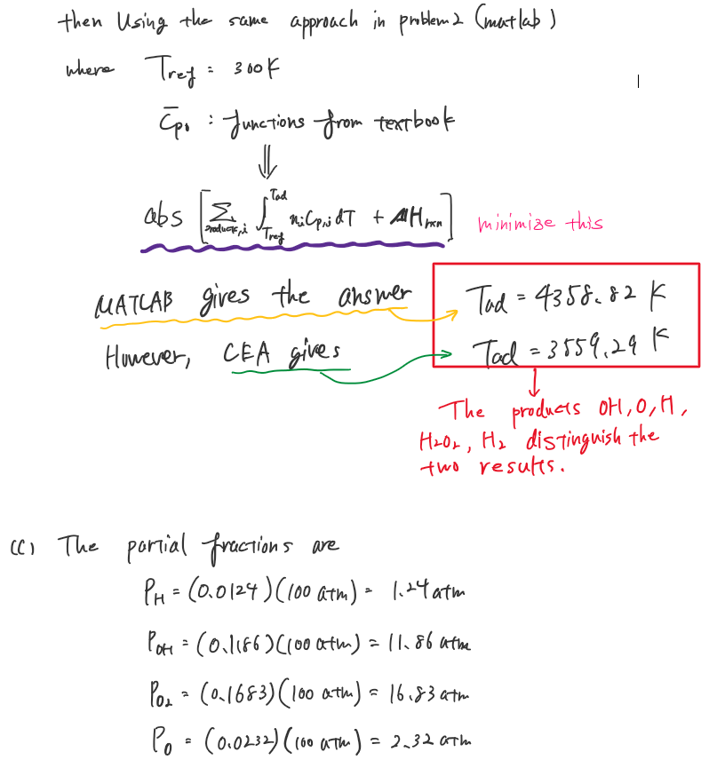

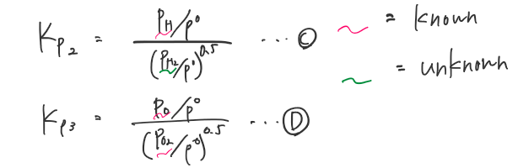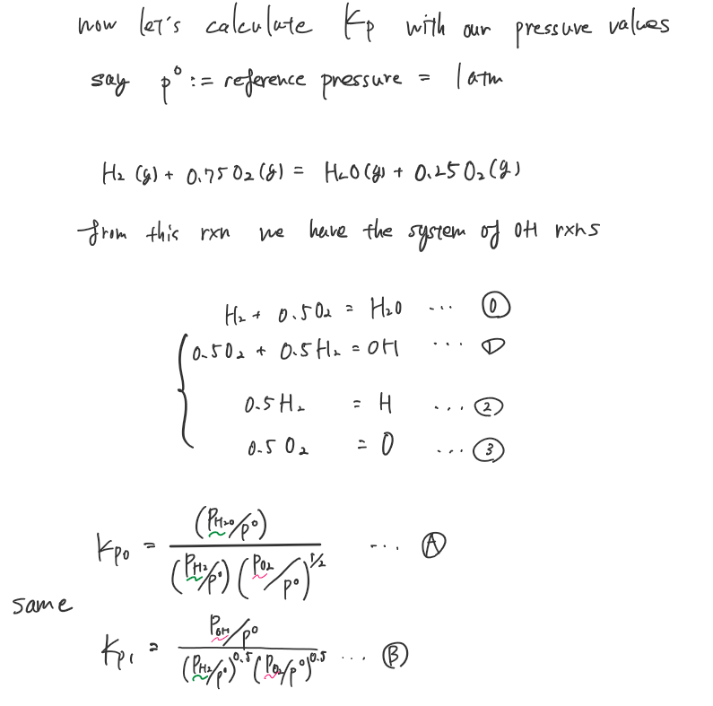

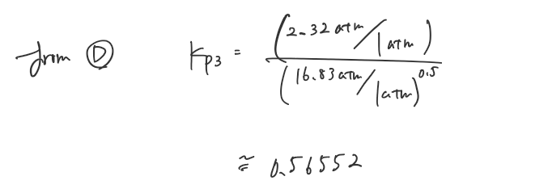

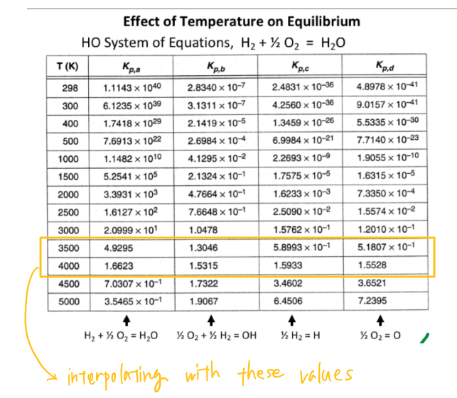

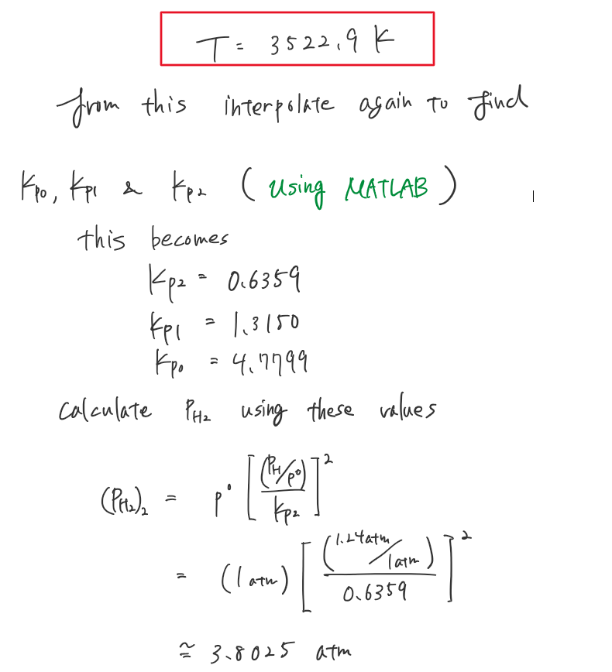

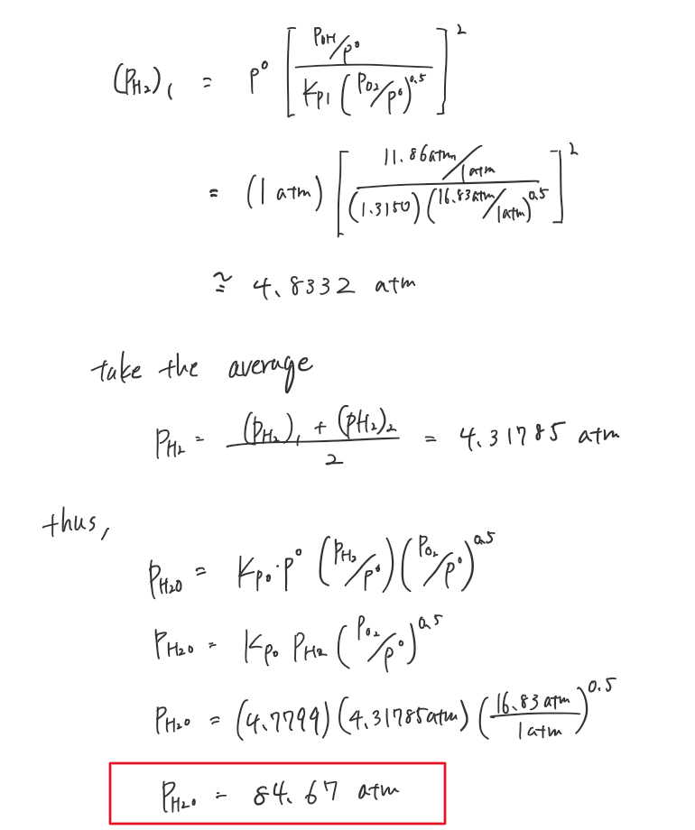

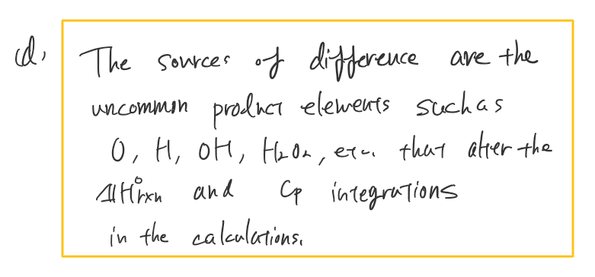

Appendix

>>Matlab Code

## **AAE339 matlab code**

clear all; close all; clc;

### problem 2

% Optimazation for the sum of integrals to equal the heat of reaction

[x,fval,exitflag,output,lambda,grad,hessian] = HW4_opt_T_ad_p2([301], [300], [3500]);

vpa(x, 10)

### problem 3

#### <b>

% Optimazation for the sum of integrals to equal the heat of reaction

[x2,fval2,exitflag2,output2,lambda2,grad2,hessian2] = HW4_opt_T_ad_p3([301], [300], [5000]);

vpa(x2, 10)

#### <c>

% interpolating

T_chamber = two_point_interpolate(0.56552,0.51807,1.5528,3500,4000);

Kp2 = two_point_interpolate(3522.9,3500,4000,0.58993,1.5933);

Kp1 = two_point_interpolate(3522.9,3500,4000,1.3046,1.5315);

Kp0 = two_point_interpolate(3522.9,3500,4000,4.9295,1.6623);

function obj = HW4_p2_objective(T_ad)

% Functions for the Cp for each element in the product

nitrogen_Cp = @(theta) 39.060-512.79*theta.^(-1.5)+1072.7*theta.^(-2)-820.40*theta.^(-3);

oxygen_Cp = @(theta) 37.432+0.020102*theta.^(1.5)-178.57*theta.^(-1.5)+236.88*theta.^(-2);

carbon_dioxide_Cp = @(theta) -3.7357+30.529*theta.^(0.5)-4.1034*theta+0.024198*theta.^2;

water_vapor_Cp = @(theta) 143.05-183.54*theta.^(0.25)+82.751*theta.^(0.5)-3.6989*theta;

% Moles

n_n2 = 23.513; %[moles]

n_o2 = 1.25;

n_co2 = 3;

n_h2o = 4;

T_ref = 278; %[K]

theta_ref = T_ref/100;

theta_ad = T_ad/100;

% Summations of integrations

H_rxn = (n_n2*integral(nitrogen_Cp,theta_ref,theta_ad) + n_o2*integral(oxygen_Cp,theta_ref,theta_ad) + ...

n_co2*integral(carbon_dioxide_Cp,theta_ref,theta_ad) + n_h2o*integral(water_vapor_Cp,theta_ref,theta_ad))*100;

obj = abs(H_rxn - 2.0447*10^6);

end

function [x,fval,exitflag,output,lambda,grad,hessian] = HW4_opt_T_ad_p2(x0,lb,ub)

%% Start with the default options

options = optimoptions('fmincon');

%% Modify options setting

options = optimoptions(options,'Display', 'off');

options = optimoptions(options,'PlotFcn', { @optimplotfunccount @optimplotfval });

options = optimoptions(options,'HessianApproximation', 'bfgs');

[x,fval,exitflag,output,lambda,grad,hessian] = ...

fmincon(@HW4_p2_objective,x0,[],[],[],[],lb,ub,[],options);

function obj = HW4_p3_objective(T_ad)

% Functions for the Cp for each element in the product

oxygen_Cp = @(theta) 37.432+0.020102*theta.^(1.5)-178.57*theta.^(-1.5)+236.88*theta.^(-2);

water_vapor_Cp = @(theta) 143.05-183.54*theta.^(0.25)+82.751*theta.^(0.5)-3.6989*theta;

%hydro_monoxide_Cp = @(theta) 81.546-59.350*theta.^(0.25)+17.329*theta.^(0.75)-4.266*theta;

%hydro_molecule_Cp = @(theta) 20.78603+4.850638*10.^(-10)*(theta/10)...

% -1.582916*10.^(-10)*(theta/10).^2+1.525102*10.^(-11)*(theta/10).^3+3.196347*10.^(-11)*(theta/10).^2;

% Moles

n_o2 = 0.25;

n_h2o = 1;

T_ref = 300; %[K]

theta_ref = T_ref/100;

theta_ad = T_ad/100;

% Summations of integrations

H_rxn = (n_o2*integral(oxygen_Cp,theta_ref,theta_ad) + n_h2o*integral(water_vapor_Cp,theta_ref,theta_ad))*100;

obj = abs(H_rxn - 241.826*10^3);

end

function [x,fval,exitflag,output,lambda,grad,hessian] = HW4_opt_T_ad_p3(x0,lb,ub)

%% Start with the default options

options = optimoptions('fmincon');

%% Modify options setting

options = optimoptions(options,'Display', 'off');

options = optimoptions(options,'PlotFcn', { @optimplotfunccount @optimplotfval });

options = optimoptions(options,'HessianApproximation', 'bfgs');

[x,fval,exitflag,output,lambda,grad,hessian] = ...

fmincon(@HW4_p3_objective,x0,[],[],[],[],lb,ub,[],options);

function y = two_point_interpolate(x,x_low,x_high,y_low,y_high)

slope = (y_high - y_low) / (x_high - x_low);

y = slope * (x - x_low) + y_low;

end

>>CEA results

For problem 2

*******************************************************************************

NASA-GLENN CHEMICAL EQUILIBRIUM PROGRAM CEA2, FEBRUARY 5, 2004

BY BONNIE MCBRIDE AND SANFORD GORDON

REFS: NASA RP-1311, PART I, 1994 AND NASA RP-1311, PART II, 1996

*******************************************************************************

### CEA analysis performed on Sun 09-Feb-2020 17:49:04

# Problem Type: "Rocket" (Infinite Area Combustor)

prob case=1111___________7282 ro equilibrium

# Pressure (1 value):

p,atm= 1

# Equivalence based on Fuel/Oxid. wt ratio (Eq 9.19*) (1 value):

phi= 0.8

# You selected the following fuels and oxidizers:

reac

fuel C3H8 mole=100.0000 t,k= 298.000

oxid Air mole=100.0000 t,k= 298.000

# You selected these options for output:

# short version of output

output short

# Proportions of any products will be expressed as Mole Fractions.

# Heat will be expressed as siunits

output siunits

# Input prepared by this script:prepareInputFile.cgi

### IMPORTANT: The following line is the end of your CEA input file!

end

THEORETICAL ROCKET PERFORMANCE ASSUMING EQUILIBRIUM

COMPOSITION DURING EXPANSION FROM INFINITE AREA COMBUSTOR

Pin = 14.7 PSIA

CASE = 1111___________

REACTANT MOLES ENERGY TEMP

KJ/KG-MOL K

FUEL C3H8 100.0000000 -104691.036 298.000

OXIDANT Air 100.0000000 -129.895 298.000

O/F= 19.59862 %FUEL= 4.854693 R,EQ.RATIO= 0.800304 PHI,EQ.RATIO= 0.800000

CHAMBER THROAT

Pinf/P 1.0000 1.8045

P, BAR 1.0132 0.56152

T, K 2040.47 1819.87

RHO, KG/CU M 1.7019-1 1.0584-1

H, KJ/KG -119.53 -451.65

U, KJ/KG -714.87 -982.18

G, KJ/KG -19273.5 -17534.9

S, KJ/(KG)(K) 9.3871 9.3871

M, (1/n) 28.497 28.521

(dLV/dLP)t -1.00047 -1.00011

(dLV/dLT)p 1.0156 1.0043

Cp, KJ/(KG)(K) 1.5938 1.4598

GAMMAs 1.2321 1.2521

SON VEL,M/SEC 856.4 815.0

MACH NUMBER 0.000 1.000

PERFORMANCE PARAMETERS

Ae/At 1.0000

CSTAR, M/SEC 1174.6

CF 0.6939

Ivac, M/SEC 1466.0

Isp, M/SEC 815.0

MOLE FRACTIONS

*Ar 0.00877 0.00877

*CO 0.00088 0.00016

*CO2 0.09354 0.09434

*H 0.00003 0.00000

*H2 0.00025 0.00006

H2O 0.12422 0.12517

*NO 0.00347 0.00183

*N2 0.72918 0.73064

*O 0.00017 0.00004

*OH 0.00203 0.00075

*O2 0.03746 0.03824

* THERMODYNAMIC PROPERTIES FITTED TO 20000.K

For problem 3

*******************************************************************************

NASA-GLENN CHEMICAL EQUILIBRIUM PROGRAM CEA2, FEBRUARY 5, 2004

BY BONNIE MCBRIDE AND SANFORD GORDON

REFS: NASA RP-1311, PART I, 1994 AND NASA RP-1311, PART II, 1996

*******************************************************************************

### CEA analysis performed on Tue 11-Feb-2020 13:09:56

# Problem Type: "Rocket" (Infinite Area Combustor)

prob case=1111___________1362 ro equilibrium

# Pressure (1 value):

p,atm= 100

# Oxidizer/Fuel Wt. ratio (1 value):

o/f= 12

# You selected the following fuels and oxidizers:

reac

fuel H2 mole=100.0000 t,k= 300.000

oxid O2 mole=100.0000 t,k= 300.000

# You selected these options for output:

# short version of output

output short

# Proportions of any products will be expressed as Mole Fractions.

# Heat will be expressed as siunits

output siunits

# Input prepared by this script:prepareInputFile.cgi

### IMPORTANT: The following line is the end of your CEA input file!

end

THEORETICAL ROCKET PERFORMANCE ASSUMING EQUILIBRIUM

COMPOSITION DURING EXPANSION FROM INFINITE AREA COMBUSTOR

Pin = 1469.6 PSIA

CASE = 1111___________

REACTANT MOLES ENERGY TEMP

KJ/KG-MOL K

FUEL H2 100.0000000 53.359 300.000

OXIDANT O2 100.0000000 54.358 300.000

O/F= 12.00000 %FUEL= 7.692308 R,EQ.RATIO= 0.661390 PHI,EQ.RATIO= 0.661390

CHAMBER THROAT

Pinf/P 1.0000 1.7311

P, BAR 101.33 58.531

T, K 3559.29 3372.16

RHO, KG/CU M 6.6625 0 4.1082 0

H, KJ/KG 3.6042 -804.29

U, KJ/KG -1517.22 -2229.03

G, KJ/KG -46860.1 -45204.2

S, KJ/(KG)(K) 13.1666 13.1666

M, (1/n) 19.459 19.679

(dLV/dLP)t -1.02763 -1.02307

(dLV/dLT)p 1.4934 1.4373

Cp, KJ/(KG)(K) 6.4682 6.1769

GAMMAs 1.1360 1.1341

SON VEL,M/SEC 1314.4 1271.1

MACH NUMBER 0.000 1.000

PERFORMANCE PARAMETERS

Ae/At 1.0000

CSTAR, M/SEC 1940.3

CF 0.6551

Ivac, M/SEC 2392.0

Isp, M/SEC 1271.1

MOLE FRACTIONS

*H 0.01237 0.00967

HO2 0.00070 0.00049

*H2 0.03406 0.02853

H2O 0.64249 0.66548

H2O2 0.00009 0.00006

*O 0.02327 0.01917

*OH 0.11870 0.10357

*O2 0.16832 0.17304

* THERMODYNAMIC PROPERTIES FITTED TO 20000.K