AAE 339

HW7: Compressor Stage Analysis

Dr. Anderson

School of Aeronautical and Astronautical Engineering

Tomoki Koike

Thursday March 12, 2020

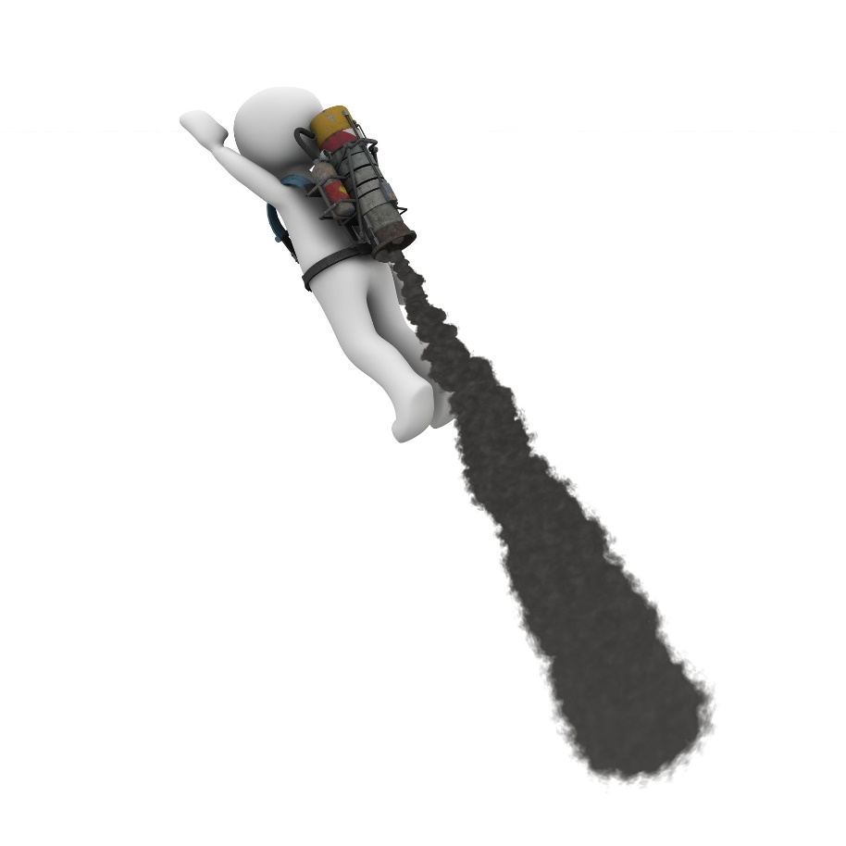

Problem 7.2

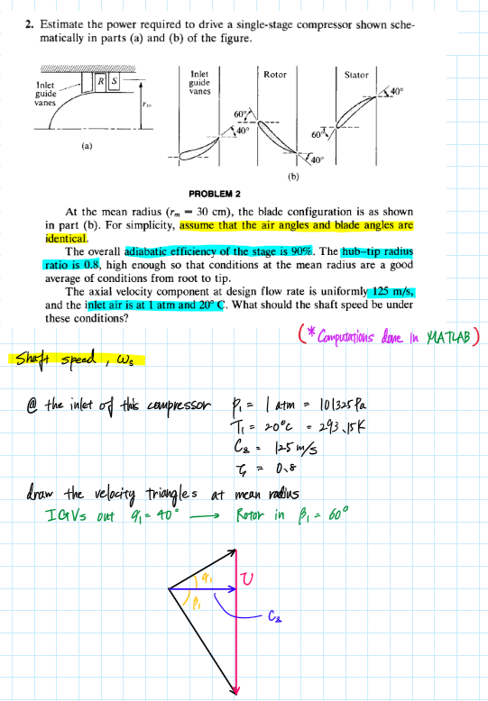

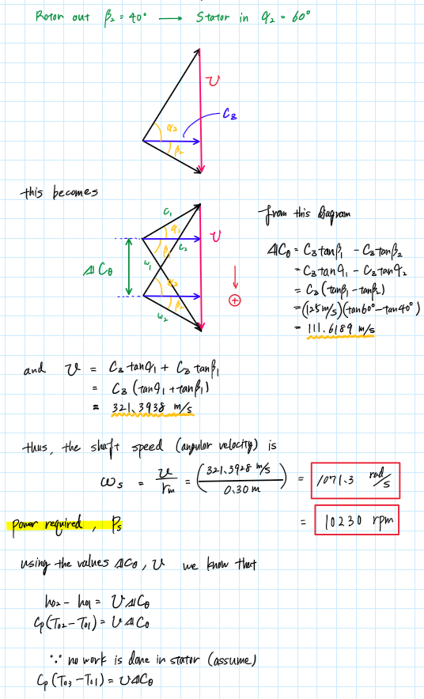

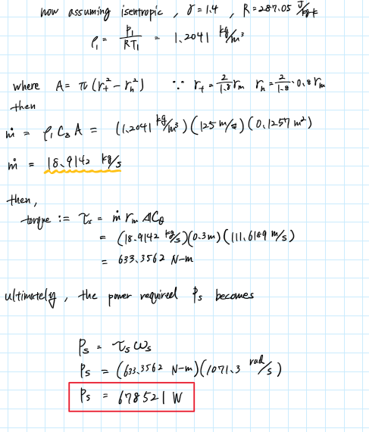

Problem 7.3

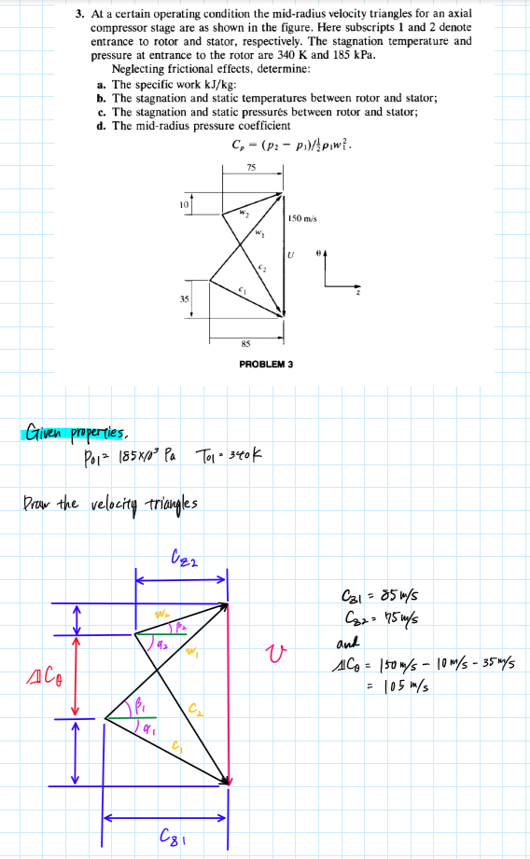

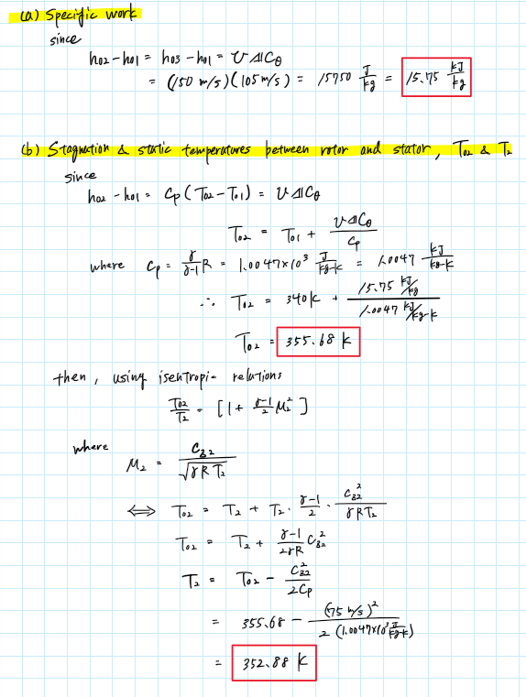

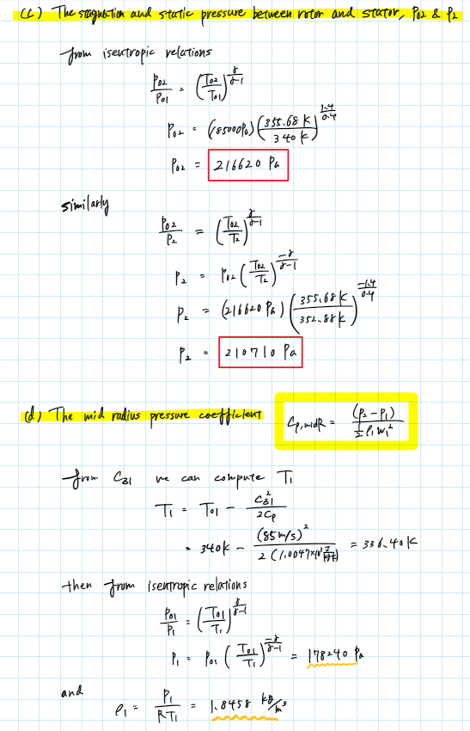

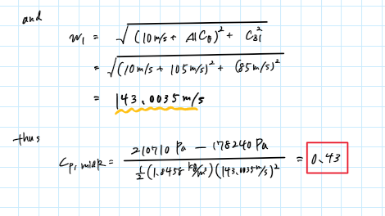

Problem 3

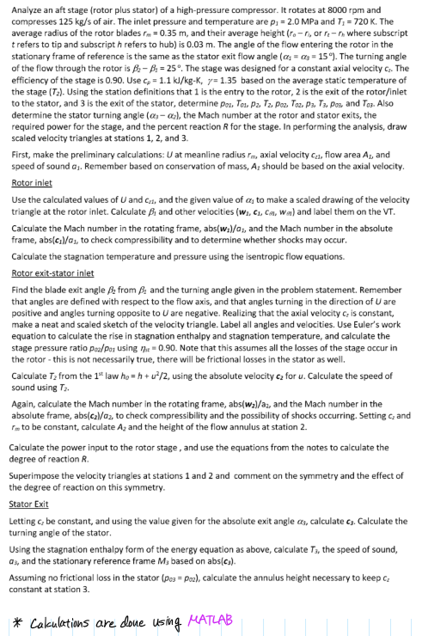

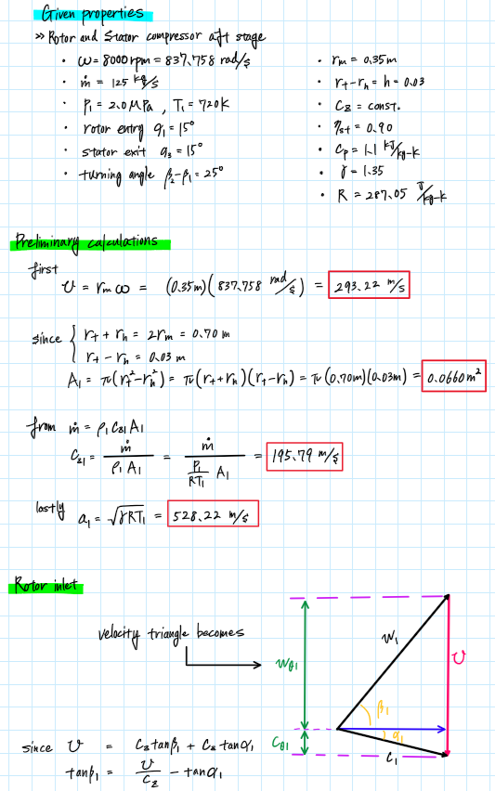

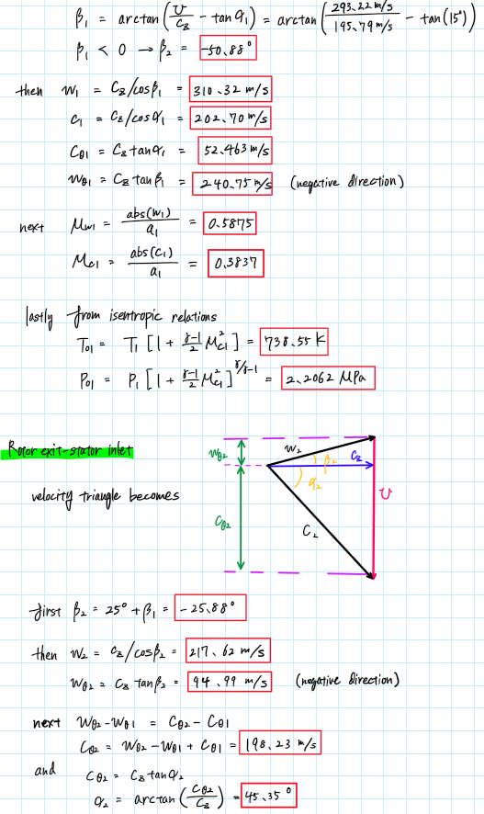



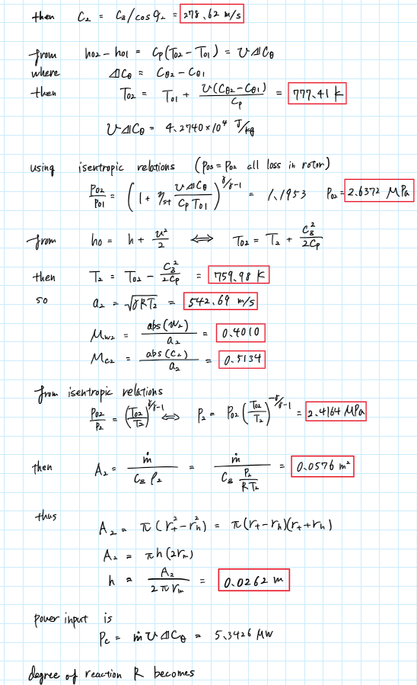

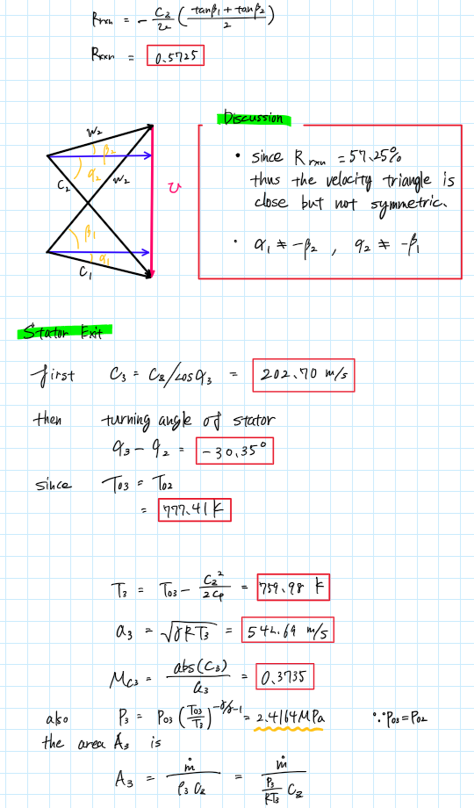



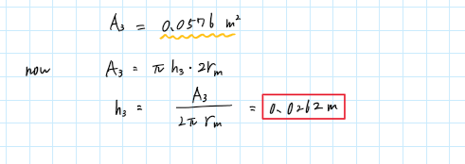

Appendix

**AAE 339 HW 7 MATLAB CODE**

close all; clear all; clc;

**p1.**

% Defining given properties

P1 = 101325; % [Pa]

T1 = 293.15; % [K]

c_z = 125; % [m/s]

r_m = 0.3; % [m]

zeta = 0.8;

alpha1 = 40; % [deg]

alpha2 = 60; % [deg]

beta1 = 60; % [deg]

beta2 = 40; % [deg]

gamma = 1.4;

R = 287.05;

delta_c_theta = c_z*(tand(beta1) - tand(beta2))

U = c_z*(tand(alpha1) + tand(beta1))

w_s = U/r_m

w_c = U*delta_c_theta

rho1 = P1/R/T1

% Calculate m_dot

r_t = 2/1.8*r_m;

r_h = r_t*0.8;

A = pi*(r_t^2 - r_h^2)

m_dot = rho1*A*c_z

tau_s = m_dot*r_m*delta_c_theta

Pow_s = tau_s*w_s

**p2.**

clear all; close all; clc;

% <a>

P01 = 185000; % [Pa]

T01 = 340; % [K]

delta_c_theta = 105; % [m/s]

U = 150; % [m/s]

c_z1 = 85; % [m/s]

c_z2 = 75; % [m/s]

Pow_s = U*delta_c_theta

% <b>

gamma = 1.4;

R = 287.05;

c_p = gamma/(gamma - 1)*R;

T02 = T01 + Pow_s/c_p

T2 = T02 - c_z2^2/c_p/2

% <c>

P02 = P_from_isentropic_relation(P01, T02, T01, gamma, "1")

P2 = P_from_isentropic_relation(P02, T02, T2, gamma, "2")

% <d>

T1 = T01 - c_z1^2/2/c_p

P1 = P_from_isentropic_relation(P01, T01, T1, gamma, "2")

rho1 = P1/R/T1

w1 = sqrt((10 + delta_c_theta)^2 + c_z1^2)

C_P_midR = (P2 - P1)/2/rho1/w1^2

**p3.**

clear all; close all; clc;

omega = 8000*2*pi/60; % [rad/s]

m_dot = 125; % [kg/s]

P1 = 2e6; % [Pa]

T1 = 720; % [K]

alpha1 = deg2rad(15);

alpha3 = alpha1;

turn_ang = deg2rad(25);

r_m = 0.35; % [m]

h = 0.03; % r_t - r_h

eta = 0.90;

cp = 1.1e3; % [kg/kg/K]

gamma = 1.35;

R = 287.05;

PRELIMINARY CALCULATIONS

U = r_m*omega

A1 = pi*2*r_m*h

c_z1 = m_dot/(P1/R/T1)/A1

a1 = sqrt(gamma*R*T1)

ROTOR INLET

c_z = c_z1

beta1 = -atan(U/c_z - tan(alpha1))

beta1_deg = rad2deg(beta1)

w1 = c_z/cos(beta1)

c1 = c_z/cos(alpha1)

c_theta1 = c_z*tan(alpha1)

w_theta1 = c_z*tan(beta1)

M_w1 = abs(w1)/a1

M_c1 = abs(c1)/a1

T01 = T_from_M_and_gamma(T1,M_c1,gamma,"stagnation")

P01 = p_from_M_and_gamma(P1,M_c1,gamma,"stagnation")

Rotor exit-stator inlet

beta2 = beta1 + turn_ang;

beta2_deg = rad2deg(beta2)

w2 = c_z/cos(beta2)

w_theta2 = c_z*tan(beta2)

c_theta2 = w_theta2 - w_theta1 + c_theta1

alpha2 = atan(c_theta2/c_z)

alpha2_deg = rad2deg(alpha2)

c2 = c_z/cos(alpha2)

T02 = T01 + U*(c_theta2-c_theta1)/cp

rise = U*(c_theta2-c_theta1)

P02_P01 = (1 + eta*rise/cp/T01)^(gamma/(gamma - 1))

P02 = P02_P01*P01

T2 = T02 - c_z^2/2/cp

a2 = sqrt(gamma*R*T2)

M_w2 = abs(w2)/a2

M_c2 = abs(c2)/a2

P2 = P02*(T02/T2)^(-gamma/(gamma - 1))

A2 = m_dot/c_z/(P2/R/T2)

h2 = A2/2/pi/r_m

Pc = m_dot*U*(c_theta2-c_theta1)

deg_rxn = -c_z/U*(tan(beta1) + tan(beta2))/2

Stator exit

c3 = c_z/cos(alpha3)

turning_stator = alpha3 - alpha2

turning_stator_deg = rad2deg(turning_stator)

T03 = T02

T3 = T03 - c_z^2/2/cp

a3 = sqrt(gamma*R*T3)

M_c3 = abs(c3)/a3

P03 = P02

P3 = P03*(T03/T3)^(-gamma/(gamma - 1))

A3 = m_dot/(P3/R/T3)/c_z

h3 = A3/2/pi/r_m

function P2 = P_from_isentropic_relation(P1, T2, T1, gamma, type)

if type == "1"

P2 = P1 * (T2 / T1)^(gamma / (gamma - 1));

elseif type == "2"

P2 = P1 * (T2 / T1)^(-gamma / (gamma - 1));

else

disp("You can only enter 1 or 2 for type.")

end

end

function T2 = T_from_M_and_gamma(T1, M, gamma, type)

if type == "stagnation"

T2 = T1 * (1 + (gamma - 1) / 2 * M^2);

elseif type == "static"

T2 = T1 / (1 + (gamma - 1) / 2 * M^2);

else

disp("Error. Incorrect type. Type can only be 'stagnation' or 'static'.")

end

end

function p2 = p_from_M_and_gamma(p1, M, gamma, type)

if type == "stagnation"

p2 = p1 * (1 + (gamma - 1) / 2 * M^2)^(gamma/(gamma - 1));

elseif type == "static"

p2 = p1 / (1 + (gamma - 1) / 2 * M^2)^(gamma/(gamma - 1));

else

disp("Error. Incorrect type. Type can only be 'stagnation' or 'static'.")

end

end