AAE 339: Aerospace Propulsion

HW 8: Introduction to Rocket Propulsion

Dr. Anderson

School of Aeronautical and Astronautical

Purdue University

Tomoki Koike

Friday April 10th, 2020

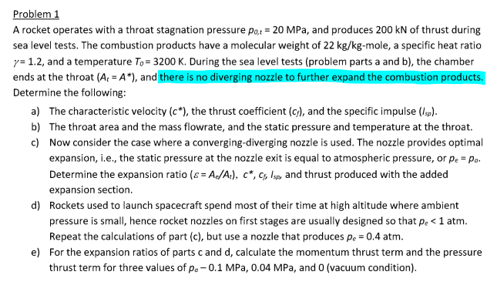

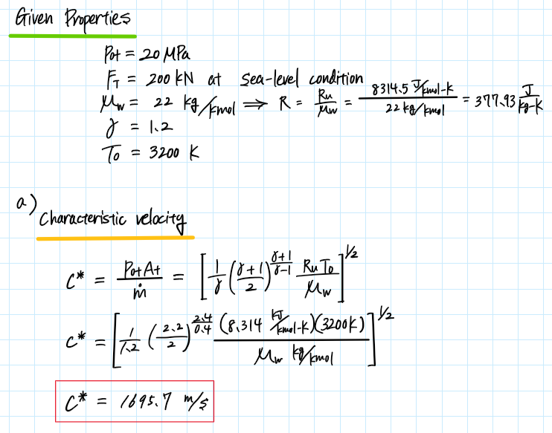

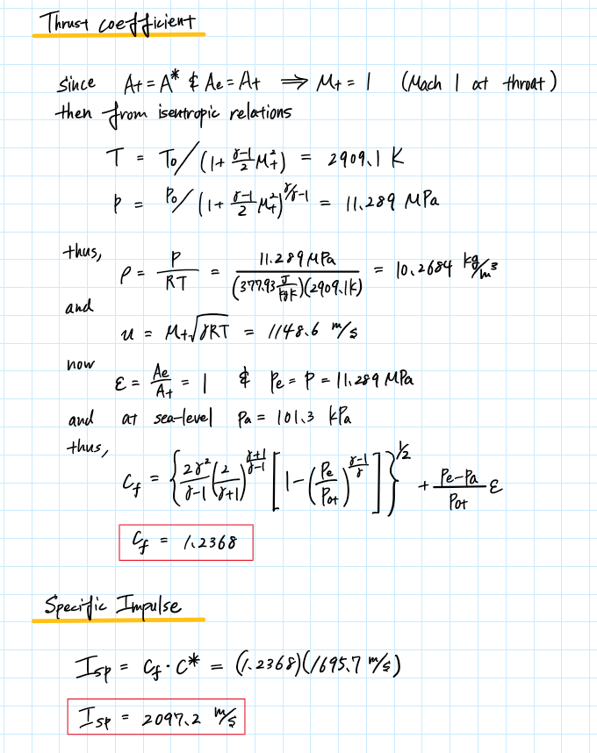

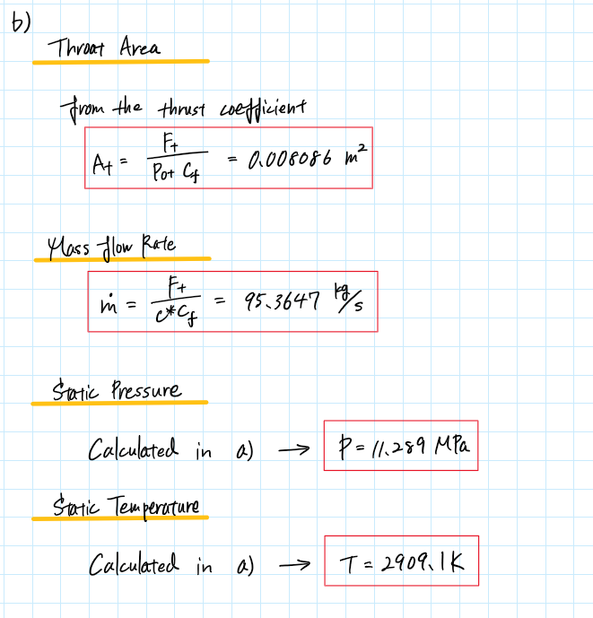

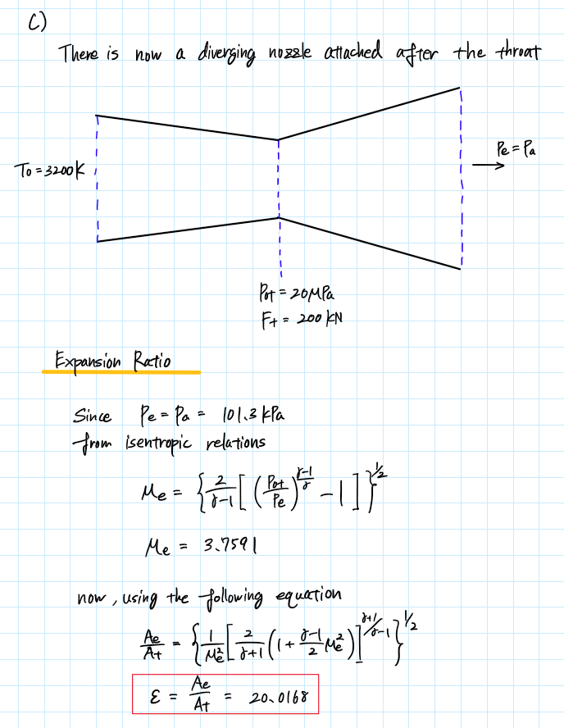

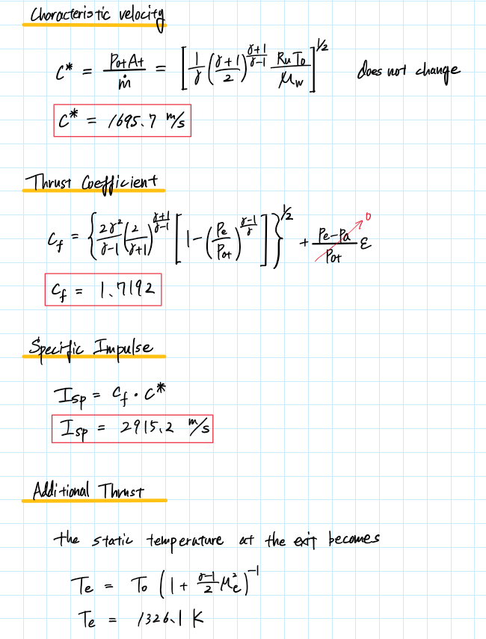

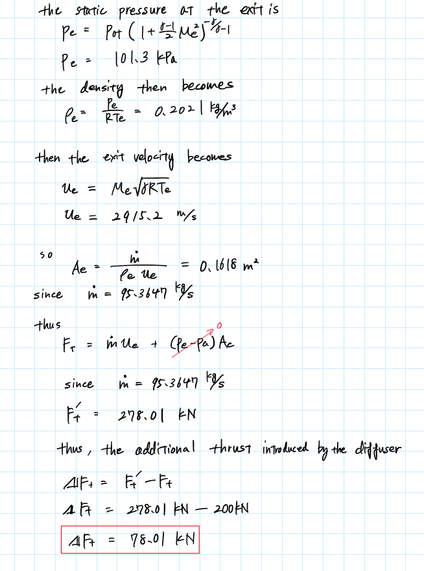

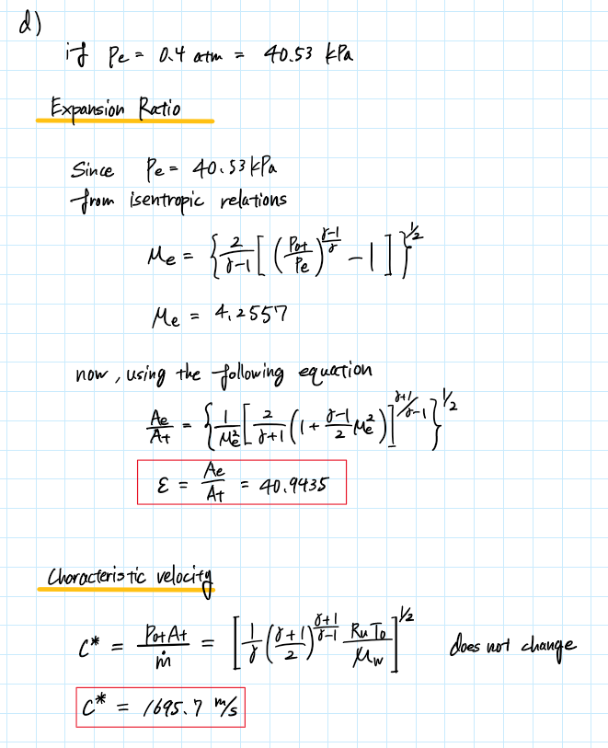

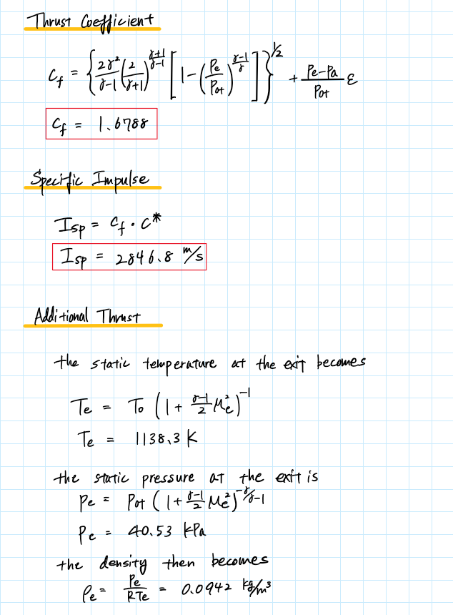

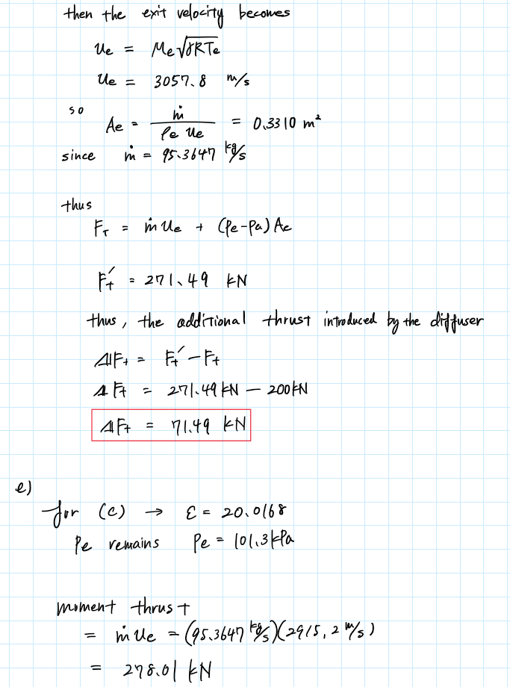

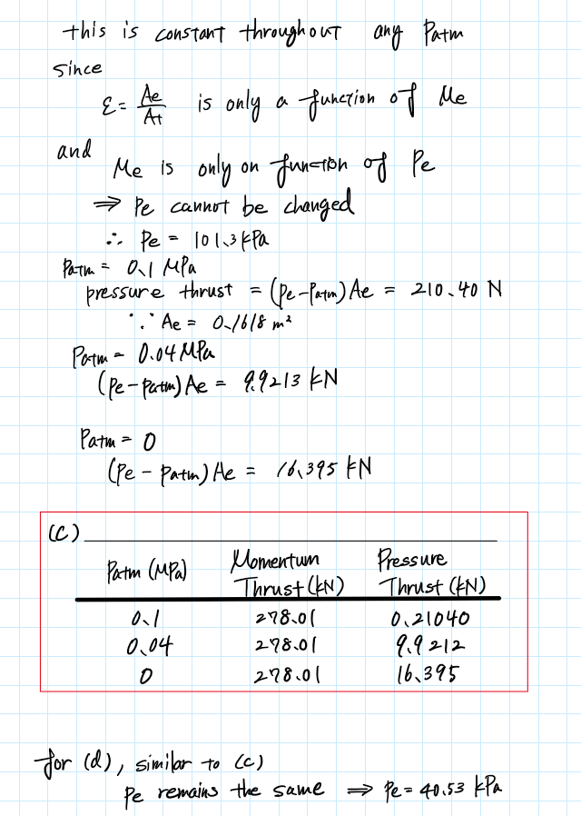

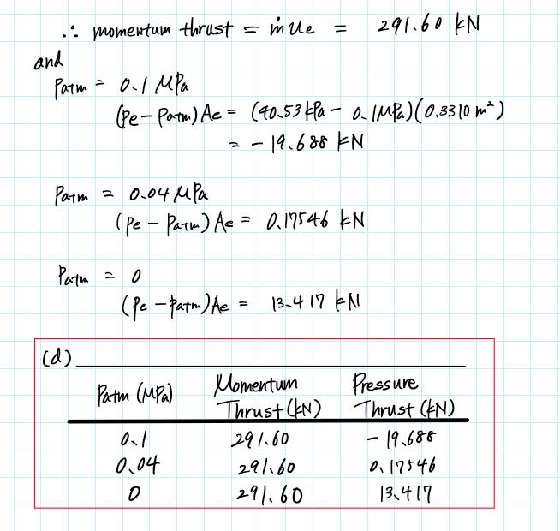

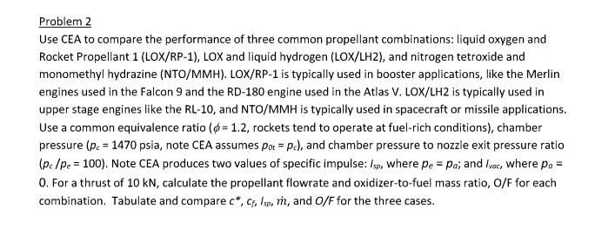

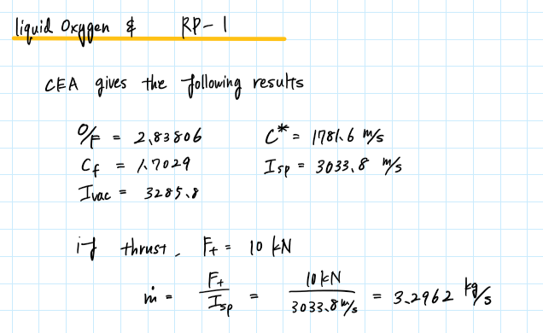

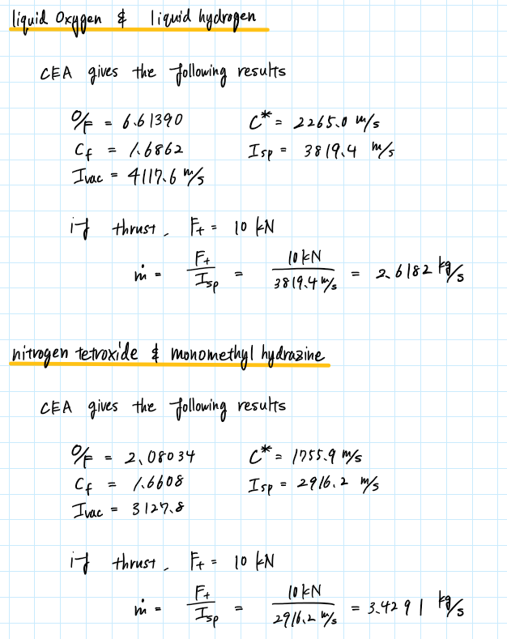

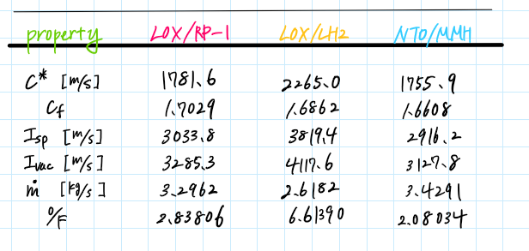

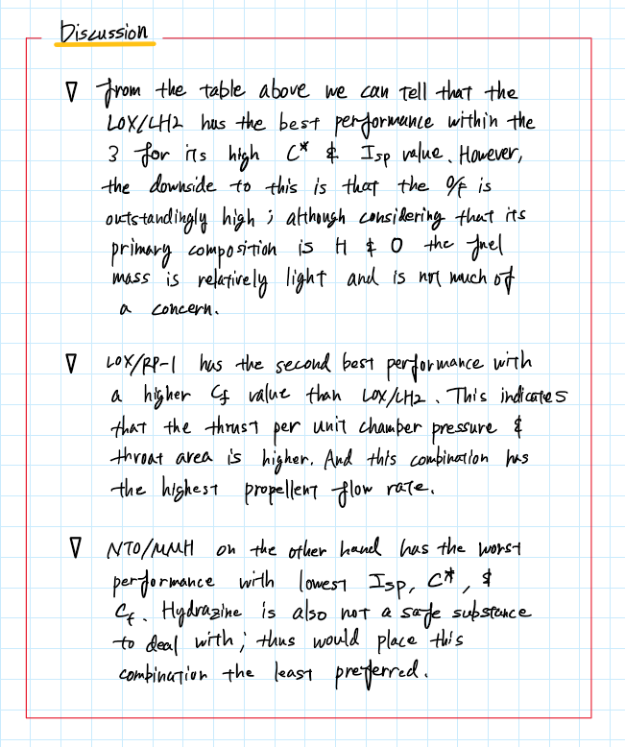

Appendix

## **AAE 339 HW 8**

close all; clear all; clc;

### P1

### a)

% Define the given properties

P0t = 20e6; % throat stagnation pressure [Pa]

Ft = 200e3; % thrust [N] @ sea-level conditions

Mw = 22; % molecular weight of the product gas [kg/kmol]

gamma = 1.2; % specific hear ratio

T0 = 3200; % temperature at the chamber [K]

Ru = 8314.5; % universal gas constant [J/kmol-K]

R = Ru/Mw; % specific gas constant [J/kg-K]

Patm = 101.3e3; % atmospheric pressure [Pa]

% Characteristic velocity

a1 = 1/gamma*((gamma + 1)/2)^((gamma + 1)/(gamma - 1)); % intermediate var 1

a2 = R*T0; % intermediate var 2

c_star = sqrt(a1*a2)

% Specific thrust

Mt = 1.0;

T = T_from_M_and_gamma(T0,Mt,gamma,"static")

P = p_from_M_and_gamma(P0t,Mt,gamma,"static")

rho = P/R/T

u = Mt*sqrt(gamma*R*T)

epsilon = 1.0;

a1 = 2*gamma^2/(gamma - 1); % intermediate var 1

a2 = (2/(gamma + 1))^((gamma + 1)/(gamma - 1)); % intermediate var 2

a3 = 1 - (P/P0t)^((gamma - 1)/gamma); % intermediate var 3

a4 = (P - Patm)/P0t*epsilon; % intermediate var 4

cf = sqrt(a1*a2*a3) + a4

% Specific impulse

Isp = cf*c_star

### b)

% Throat area

At = Ft/P0t/cf

% Mass flow rate

m_dot = Ft/c_star/cf

### c)

% Calculate the exit Mach number

Pe = Patm;

a1 = 2/(gamma - 1); % intermediate var 1

a2 = (P0t/Pe)^((gamma - 1)/gamma) - 1

Me = sqrt(a1*a2)

% Expansion ratio

a1 = 2/(gamma + 1); % intermediate var 1

a2 = (1 + (gamma - 1)/2*Me^2); % intermediate var 2

a3 = (gamma + 1)/(gamma - 1); % intermediate var 3

epsilon = sqrt(1/Me^2*(a1*a2)^(a3))

% Thrust coefficient

a1 = 2*gamma^2/(gamma - 1); % intermediate var 1

a2 = (2/(gamma + 1))^((gamma + 1)/(gamma - 1)); % intermediate var 2

a3 = 1 - (Pe/P0t)^((gamma - 1)/gamma); % intermediate var 3

a4 = (Pe - Patm)/P0t*epsilon; % intermediate var 4

cf = sqrt(a1*a2*a3) + a4

% Specific impulse

Isp = cf*c_star

% Additional thrust

Te = T_from_M_and_gamma(T0,Me,gamma,"static")

Pe = p_from_M_and_gamma(P0t,Me,gamma,"static")

rho_e = Pe/R/Te

ue = Me*sqrt(gamma*R*Te)

Ae = m_dot/rho_e/ue

Ft_new = m_dot*ue + (Pe - Patm)*Ae

delta_Ft = Ft_new - Ft

% PROBELM (e)

Patm = 0.1e6;

M_thrust = m_dot*ue

P_thrust = (Pe - Patm)*Ae

Patm = 0.04e6;

M_thrust = m_dot*ue

P_thrust = (Pe - Patm)*Ae

Patm = 0;

M_thrust = m_dot*ue

P_thrust = (Pe - Patm)*Ae

### d)

% Calculate the exit Mach number

Pe = 40.53e3;

a1 = 2/(gamma - 1); % intermediate var 1

a2 = (P0t/Pe)^((gamma - 1)/gamma) - 1; % intermediate var 2

Me = sqrt(a1*a2)

% Expansion ratio

a1 = 2/(gamma + 1); % intermediate var 1

a2 = (1 + (gamma - 1)/2*Me^2); % intermediate var 2

a3 = (gamma + 1)/(gamma - 1); % intermediate var 3

epsilon = sqrt(1/Me^2*(a1*a2)^(a3))

% Thrust coefficient

a1 = 2*gamma^2/(gamma - 1); % intermediate var 1

a2 = (2/(gamma + 1))^((gamma + 1)/(gamma - 1)); % intermediate var 2

a3 = 1 - (Pe/P0t)^((gamma - 1)/gamma); % intermediate var 3

a4 = (Pe - Patm)/P0t*epsilon; % intermediate var 4

cf = sqrt(a1*a2*a3) + a4

% Specific impulse

Isp = cf*c_star

% Additional thrust

Te = T_from_M_and_gamma(T0,Me,gamma,"static")

Pe = p_from_M_and_gamma(P0t,Me,gamma,"static")

rho_e = Pe/R/Te

ue = Me*sqrt(gamma*R*Te)

Ae = m_dot/rho_e/ue

Ft_new = m_dot*ue + (Pe - Patm)*Ae

delta_Ft = Ft_new - Ft

% PROBELM (e)

Patm = 0.1e6;

M_thrust = m_dot*ue

P_thrust = (Pe - Patm)*Ae

Patm = 0.04e6;

M_thrust = m_dot*ue

P_thrust = (Pe - Patm)*Ae

Patm = 0;

M_thrust = m_dot*ue

P_thrust = (Pe - Patm)*Ae

function T2 = T_from_M_and_gamma(T1, M, gamma, type)

if type == "stagnation"

T2 = T1 * (1 + (gamma - 1) / 2 * M^2);

elseif type == "static"

T2 = T1 / (1 + (gamma - 1) / 2 * M^2);

else

disp("Error. Incorrect type. Type can only be 'stagnation' or 'static'.")

end

end

function p2 = p_from_M_and_gamma(p1, M, gamma, type)

if type == "stagnation"

p2 = p1 * (1 + (gamma - 1) / 2 * M^2)^(gamma/(gamma - 1));

elseif type == "static"

p2 = p1 / (1 + (gamma - 1) / 2 * M^2)^(gamma/(gamma - 1));

else

disp("Error. Incorrect type. Type can only be 'stagnation' or 'static'.")

end

end