AAE 364: Control Systems Analysis

HW 11

Dr. Sun

School of Aeronautical and Astronautical

Purdue University

Tomoki Koike

Friday April 24th, 2020



Minimum Phase System

Bode Plot (from HW10)

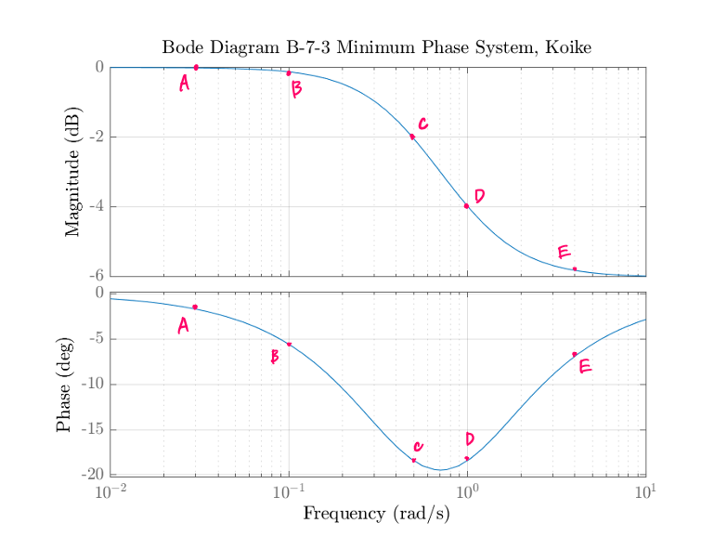

|  |  |  |  |  |
| --- | --- | --- | --- | --- |
| Point | [rad/s] | [deg] | [dB] | |G| |
| A | 0.02 | -1 | 0 | 1 |
| B | 0.1 | -6 | -0.15 | 0.9829 |
| C | 0.5 | -18 | -2 | 0.7943 |
| D | 1 | -19 | -4 | 0.6310 |
| E | 4 | -7 | -5.9 | 0.5129 |

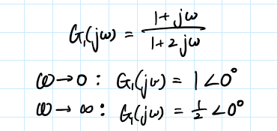

Nyquist Plot Sketch

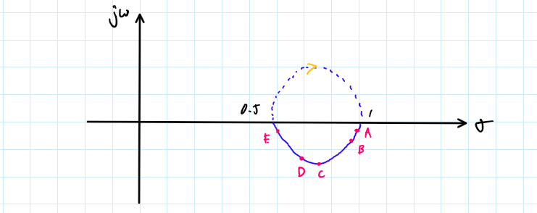

Nyquist Plot (MATLAB)

Non-Minimum Phase System

Bode Plot (from HW 10)

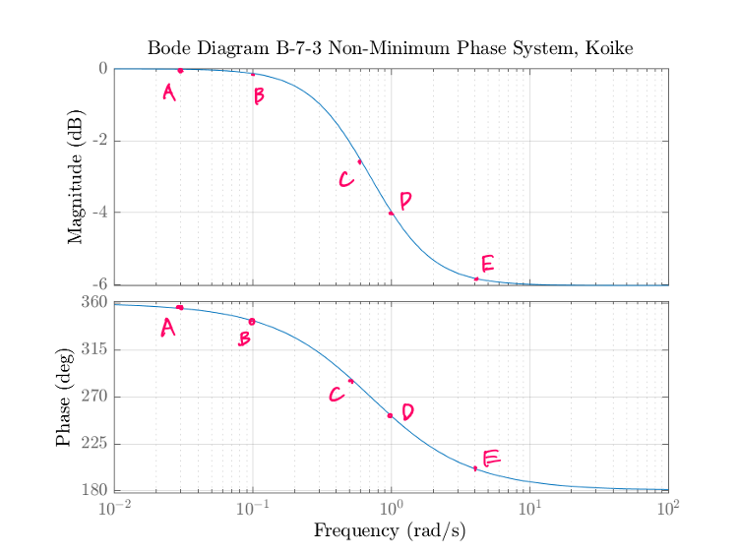

|  |  |  |  |  |
| --- | --- | --- | --- | --- |
| Point | [rad/s] | [deg] | [dB] | |G| |
| A | 0.02 | 352 | 0 | 1 |
| B | 0.1 | 343 | -0.02 | 0.9988 |
| C | 0.5 | 281 | -2.5 | 0.7480 |
| D | 1 | 255 | -4 | 0.6310 |
| E | 4 | 198 | -5.9 | 0.5070 |

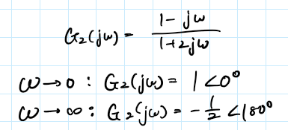

Nyquist Plot Sketch

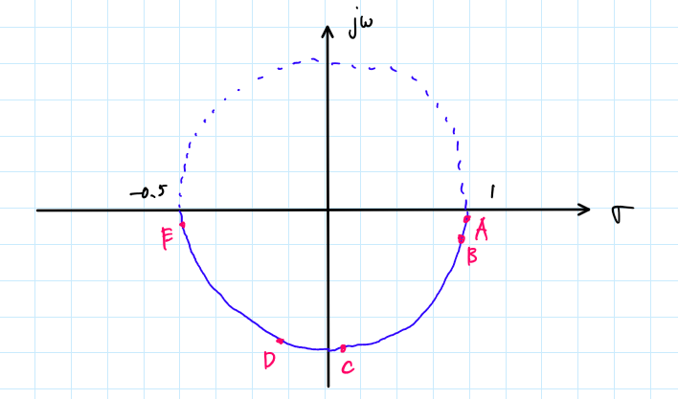



Nyquist Plot (MATLAB)

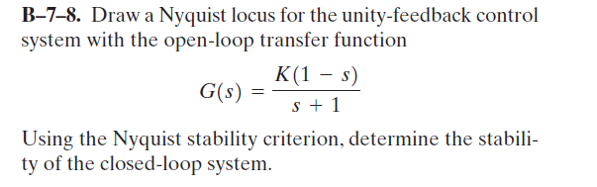

Bode Plot (from HW10)

Nyquist Plot Sketch

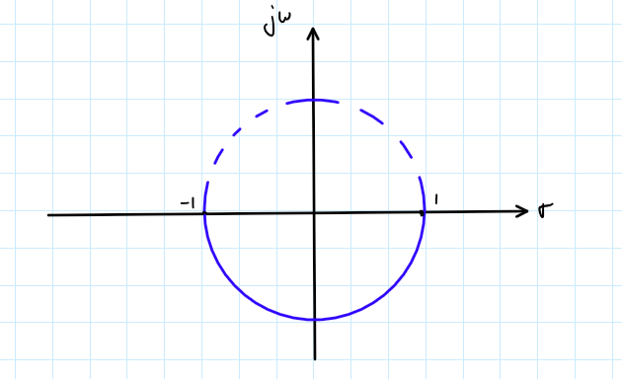



Nyquist Plot (MATLAB)

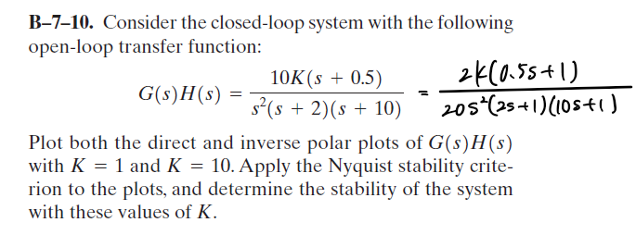

Bode Plot (from HW10)

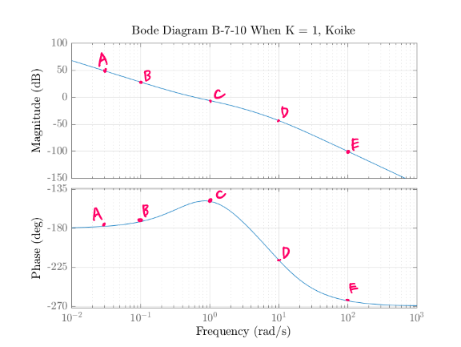

|  |  |  |  |  |
| --- | --- | --- | --- | --- |
| Point | [rad/s] | [deg] | [dB] | |G| |
| A | 0.02 | -178 | 55 | 562.3412 |
| B | 0.1 | -171 | 28 | 25.1189 |
| C | 1 | -150 | -7 | 0.4467 |
| D | 10 | -215 | -48 | 0.0004 |
| E | 100 | -261 | -100 | 0 |

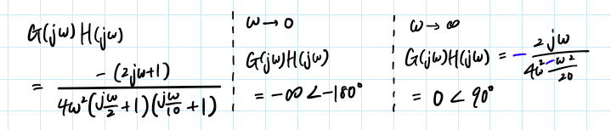

Nyquist Plot Sketch

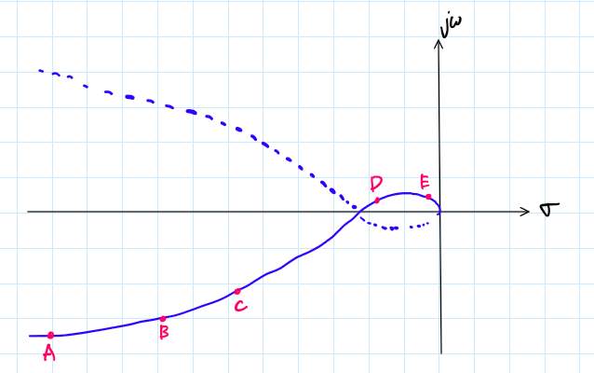



Nyquist Plot (MATLAB)

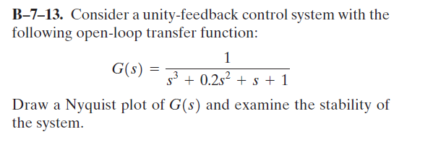

Bode Plot (from HW10)

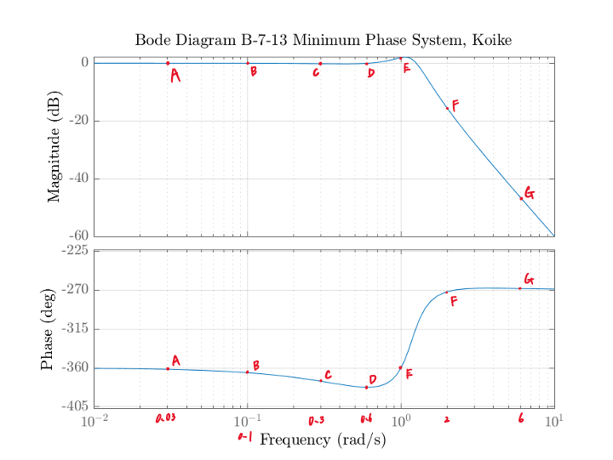

|  |  |  |  |  |
| --- | --- | --- | --- | --- |
| Point | [rad/s] | [deg] | [dB] | |G| |
| A | 0.03 | -360 | 0 | 1 |
| B | 0.1 | -364 | 0 | 1 |
| C | 0.3 | -375 | 0 | 1 |
| D | 0.6 | -382 | 0 | 1 |
| E | 1 | -360 | 2 | 1.2589 |
| F | 2 | -271 | -18 | 0.1259 |
| G | 6 | -270 | -46 | 0.00501 |

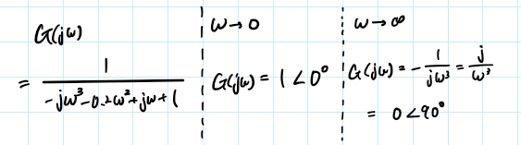

Nyquist Plot Sketch

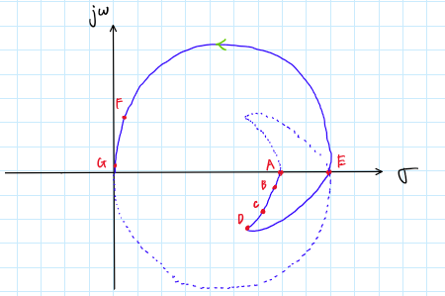

Nyquist Plot (MATLAB)

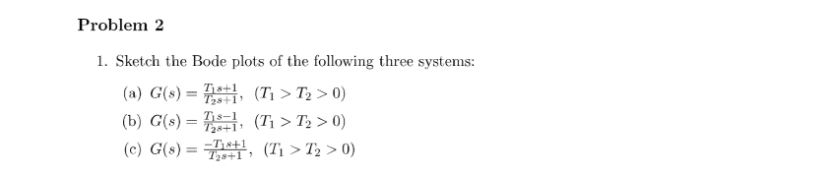

(a)

Bode Plot (from HW10)

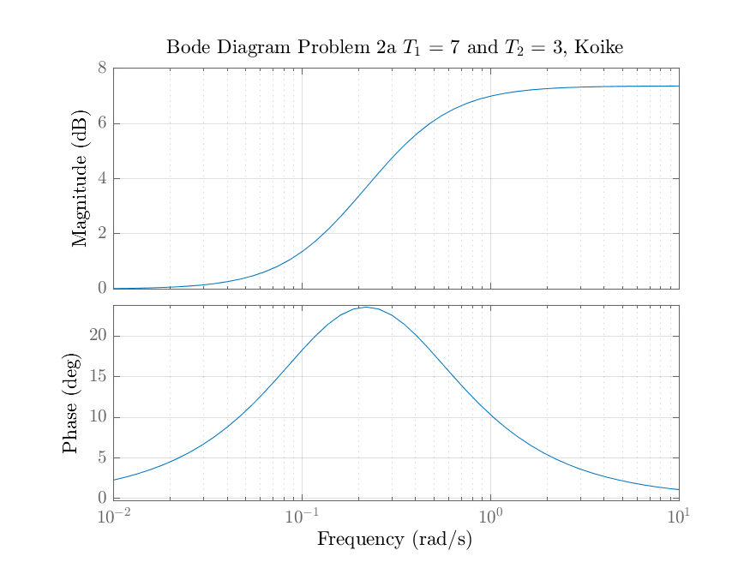

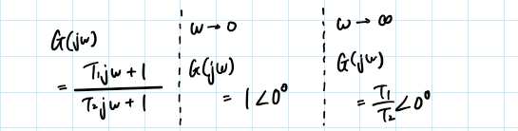

Nyquist Plot Sketch

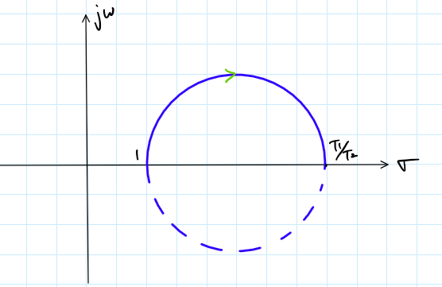

Nyquist Plot (MATLAB)

(b)

Bode Plot (from HW10)

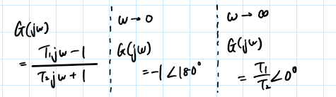

Nyquist Plot Sketch

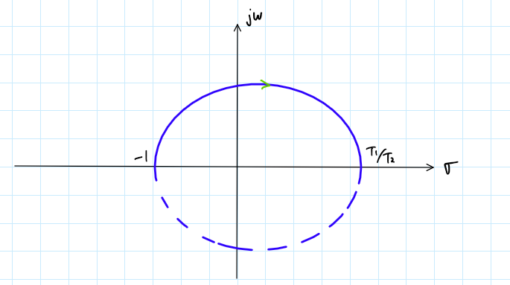

Nyquist Plot (MATLAB)

(c)

Bode Plot (from HW10)

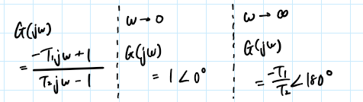

Nyquist Plot Sketch

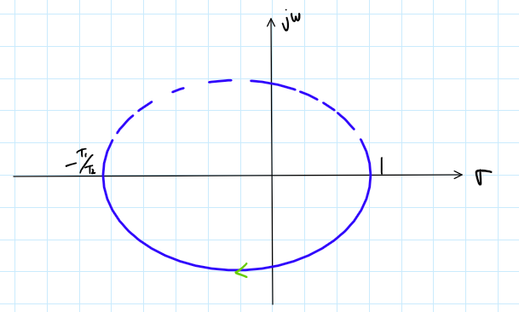

Nyquist Plot (MATLAB)

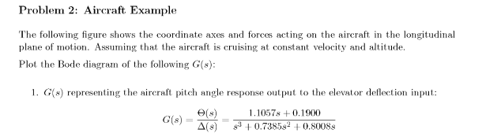

Poles and Zeros

|  |  |  |
| --- | --- | --- |
|  | Poles, | Zeros, |
| 1 | 0 + 0j | -0.1718 |
| 2 | -0.3693 + 0.8151j |  |
| 3 | -0.3693 - 0.8151j |  |

Corner Frequencies & Limits

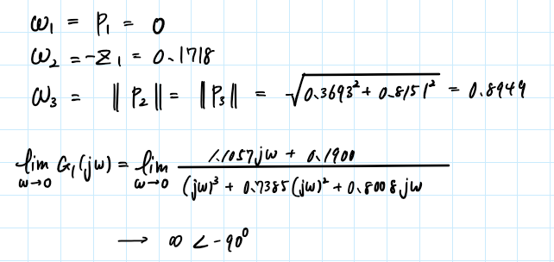

Bode Plot Sketch

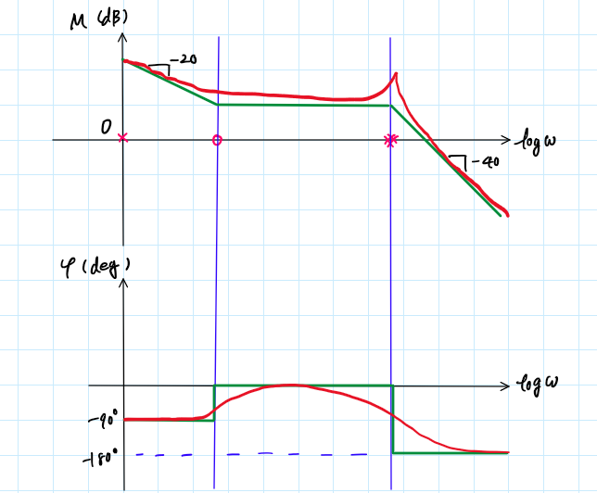

Bode Plot (MATLAB)

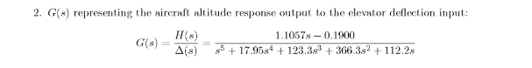

Poles and Zeros

|  |  |  |
| --- | --- | --- |
|  | Poles, | Zeros, |
| 1 | 0 + 0j | 0.1718 |
| 2 | -8.0992 |  |
| 3 | -4.7533 + 4.2012j |  |
| 4 | -4.7533 - 4.2012j |  |
| 5 | -0.3442 |  |

Corner Frequencies

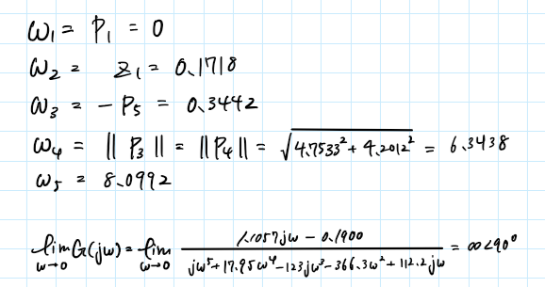

Bode Plot Sketch

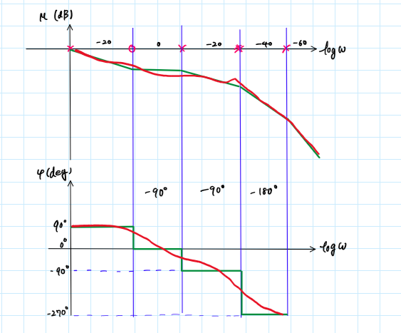

Bode Plot (MATLAB)

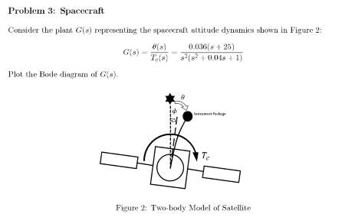

Poles and Zeros

|  |  |  |
| --- | --- | --- |
|  | Poles, | Zeros, |
| 1 | 0 + 0j | -25 |
| 2 | 0 + 0j |  |
| 3 | -0.02+0.9998j |  |
| 4 | -0.02-0.9998j |  |

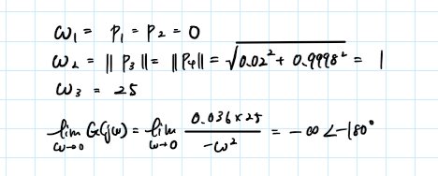

Bode Plot Sketch

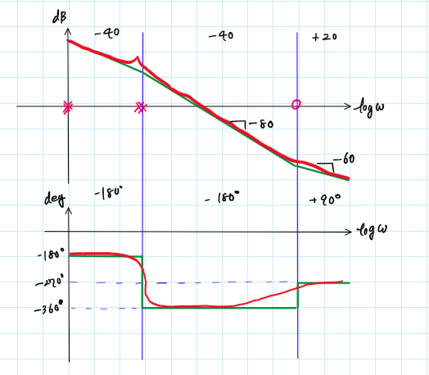

Bode Plot (MATLAB)

Appendix

MATLAB CODE

**AAE 364 HW11**

clear all; close all; clc;

fdir = 'C:\Users\Tomo\Desktop\studies\2020-Spring\AAE364\matlab\matlab_output\hw11';

set(groot, 'defaulttextinterpreter','latex');

set(groot, 'defaultAxesTickLabelInterpreter','latex');

set(groot, 'defaultLegendInterpreter','latex');

% Bode plot options

opts_bd = bodeoptions('cstprefs');

opts_bd.Title.Interpreter = "latex";

opts_bd.XLabel.Interpreter = "Latex";

opts_bd.YLabel.Interpreter = "Latex";

opts_bd.Grid = 'on';

% Nyquist plot options

opts_nq = nyquistoptions("cstprefs");

opts_nq.Title.Interpreter = 'latex';

opts_nq.XLabel.Interpreter = "Latex";

opts_nq.YLabel.Interpreter = "Latex";

opts_nq.Grid = 'on';

**B-7-3**

% Minimum Phase System

num = [1 1];

den = [2 1];

G = tf(num,den);

arr_log = [0 -0.15 -2 -4 -5.8];

arr = 10.^(arr_log/20);

% Nyquist Plot

fig = figure("Renderer","painters");

opts_nq.Title.String = "Nyquist Diagram B-7-3 Minimum Phase System, Koike";

nyquistplot(G,opts_nq);

axis equal;

saveas(fig,fullfile(fdir,"B-7-3_min_nyquist.png"));

% Non-minimum Phase System

num = [-1 1];

den = [2 1];

G = tf(num,den);

arr_log = [0 -0.01 -2.5 -4 -5.9];

arr = 10.^(arr_log/20);

% Nyquist Plot

fig = figure("Renderer","painters");

opts_nq.Title.String = "Nyquist Diagram B-7-3 Non-Minimum Phase System, Koike";

nyquistplot(G,opts_nq);

axis equal;

saveas(fig,fullfile(fdir,"B-7-3_nonmin_nyquist.png"));

**B-7-8**

K = 1;

num = K*[-1 1];

den = [1 1];

G = tf(num,den);

% Bode Plot

fig = figure("Renderer","painters");

opts_bd.Title.String = "Bode Diagram B-7-8 When K = 1, Koike";

bodeplot(G,opts_bd);

saveas(fig,fullfile(fdir,"B-7-8_bode_K=1.png"));

% Nyquist Plot

fig = figure("Renderer","painters");

opts_nq.Title.String = "Nyquist Diagram B-7-8 When K = 1, Koike";

nyquistplot(G,opts_nq);

axis equal;

saveas(fig,fullfile(fdir,"B-7-8_nyquist_K=1.png"));

**B-7-10**

% Define the OL transfer function

num = 5*[2 1];

den = conv(2*[0.5 1 0 0],10*[0.1 1]);

K = 1;

G = tf(K*num,den);

% Bode Plot

fig = figure("Renderer","painters");

opts_bd.Title.String = "Bode Diagram B-7-10 When K = 1, Koike";

bodeplot(G,opts_bd);

saveas(fig,fullfile(fdir,"B-7-10_bode_K=1.png"));

arr_log = [55 28 -7 -48 -100];

arr = 10.^(arr_log/20);

% Nyquist Plot

fig = figure("Renderer","painters");

title_txt = sprintf("Nyquist Diagram B-7-10 When K = 1, Koike");

opts_nq.Title.String = title_txt;

nyquistplot(G,opts_nq);

xlim([-5.5 0])

file_txt = sprintf("B-7-10_nyquist_K=1.png");

saveas(fig,fullfile(fdir,file_txt));

**B-7-13**

% Define the transfer function

num = [0 1];

den = [1 0.2 1 1];

G = tf(num,den);

% Bode Plot

fig = figure("Renderer","painters");

opts_bd.Title.String = "Bode Diagram B-7-13 Minimum Phase System, Koike";

bodeplot(G,opts_bd);

saveas(fig,fullfile(fdir,"B-7-13_bode.png"));

% Nyquist Plot

fig = figure("Renderer","painters");

opts_nq.Title.String = "Nyquist Diagram B-7-13, Koike";

nyquistplot(G,opts_nq);

saveas(fig,fullfile(fdir,"B-7-13_nyquist.png"));

**P2**

% (a)

num = [7 1];

den = [3 1];

G = tf(num,den);

% Bode Plot

fig = figure("Renderer","painters");

opts_bd.Title.String = "Bode Diagram Problem 2a $T_1$ = 7 and $T_2$ = 3, Koike";

bodeplot(G,opts_bd);

saveas(fig,fullfile(fdir,"P2-a_bode.png"));

% Nyquist Plot

fig = figure("Renderer","painters");

opts_nq.Title.String = "Nyquist Diagram Problem 2a $T_1$ = 7 and $T_2$ = 3, Koike";

nyquistplot(G,opts_nq);

saveas(fig,fullfile(fdir,"P2-a_nyquist.png"));

% (b)

num = [7 -1];

den = [3 1];

G = tf(num,den);

% Bode Plot

fig = figure("Renderer","painters");

opts_bd.Title.String = "Bode Diagram Problem 2b $T_1$ = 7 and $T_2$ = 3, Koike";

bodeplot(G,opts_bd);

saveas(fig,fullfile(fdir,"P2-b_bode.png"));

% Nyquist Plot

fig = figure("Renderer","painters");

opts_nq.Title.String = "Nyquist Diagram Problem 2a $T_1$ = 7 and $T_2$ = 3, Koike";

nyquistplot(G,opts_nq);

saveas(fig,fullfile(fdir,"P2-b_nyquist.png"));

% (c)

num = [-7 1];

den = [3 1];

G = tf(num,den);

% Bode Plot

fig = figure("Renderer","painters");

opts_bd.Title.String = "Bode Diagram Problem 2c $T_1$ = -7 and $T_2$ = 3, Koike";

bodeplot(G,opts_bd);

saveas(fig,fullfile(fdir,"P2-c_bode.png"));

% Nyquist Plot

fig = figure("Renderer","painters");

opts_nq.Title.String = "Nyquist Diagram Problem 2a $T_1$ = 7 and $T_2$ = 3, Koike";

nyquistplot(G,opts_nq);

saveas(fig,fullfile(fdir,"P2-c_nyquist.png"));

**P3 Aircraft Example**

% 1

num = [1.1057 0.19];

den = [1 0.7385 0.8008 0];

G = tf(num,den);

pls = roots(den)

zrs = roots(num)

cornFreq = corner_freq(num,den)

fig = figure("Renderer","painters");

opts_bd.Title.String = "Aircraft Example Bode Diagram 1, Koike";

bodeplot(G,opts_bd);

saveas(fig,fullfile(fdir,"P3-1_bode.png"));

% 2

num = [1.1057 -0.19];

den = [1 17.95 123.3 366.3 112.2 0];

pls = roots(den)

zrs = roots(num)

cornFreq = corner_freq(num,den)

G = tf(num,den);

fig = figure("Renderer","painters");

opts_bd.Title.String = "Aircraft Example Bode Diagram 2, Koike";

bodeplot(G,opts_bd);

saveas(fig,fullfile(fdir,"P3-2_bode.png"));

**P4 Spacecraft Example**

num = 0.036*[1 25];

den = [1 0.04 1 0 0];

pls = roots(den)

zrs = roots(num)

cornFreq = corner_freq(num,den)

G = tf(num,den);

fig = figure("Renderer","painters");

opts_bd.Title.String = "Spacecraft Example Bode Diagram 1, Koike";

bodeplot(G,opts_bd);

saveas(fig,fullfile(fdir,"P4_bode.png"));

function w_i = corner_freq(num,den)

%{

Function: corner_freq()

Author: Tomoki Koike

Description: Computes the corner frequencies for a Bode Plot.

>>Inputs

num: the numerator of the open-loop transfer function

den: the denominator of the open-loop transfer function

Outputs<<

w_i: the table with the corner frequencies for poles and zeros

%}

pls = roots(den);

zrs = roots(num);

cornP = unique(abs(pls));

cornZ = unique(abs(zrs));

if length(cornP) > length(cornZ)

cornZ = [cornZ; NaN([(length(cornP) - length(cornZ)), 1])];

else

cornP = [cornP; NaN([(length(cornZ) - length(cornP)), 1])];

end

w_i = array2table([cornP, cornZ],"VariableNames",{'Poles','Zeros'});

end