AAE364: Controls System Analysis

HW5: Stability and Error Analysis

Dr. Sun

Tomoki Koike

Friday, February 21, 2020

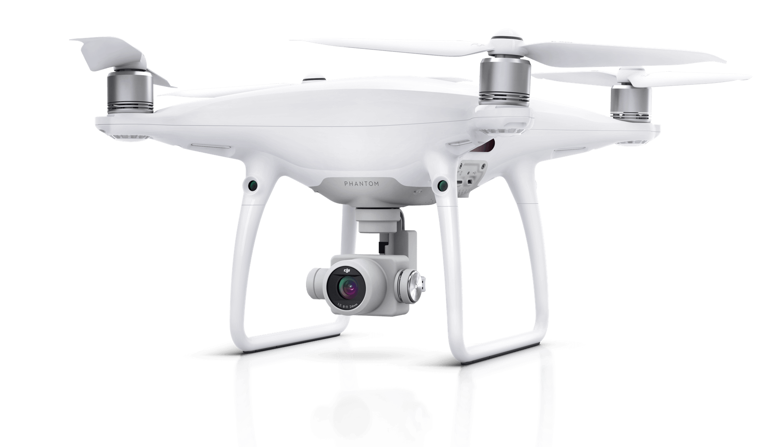

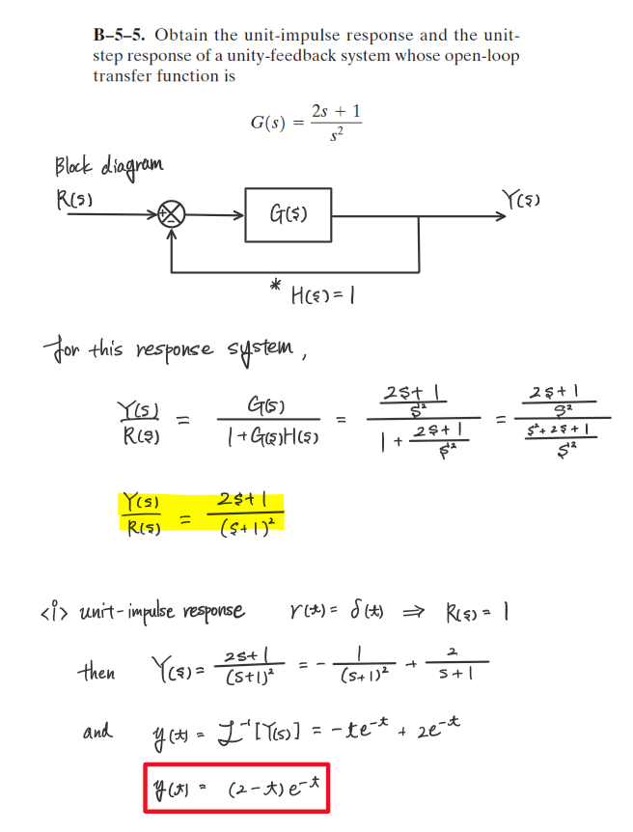

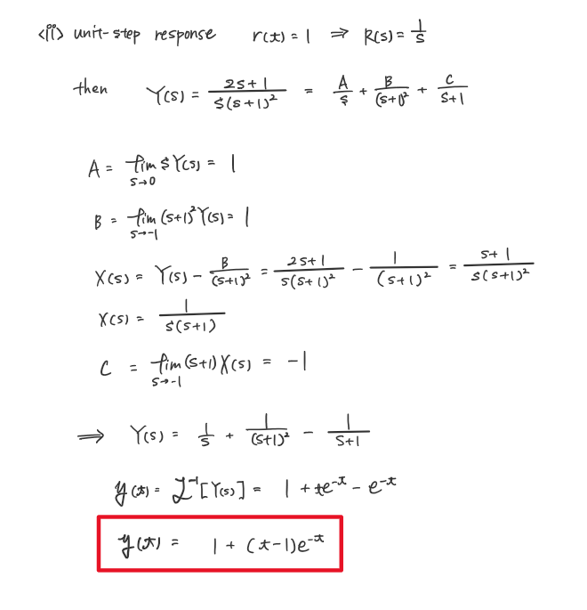

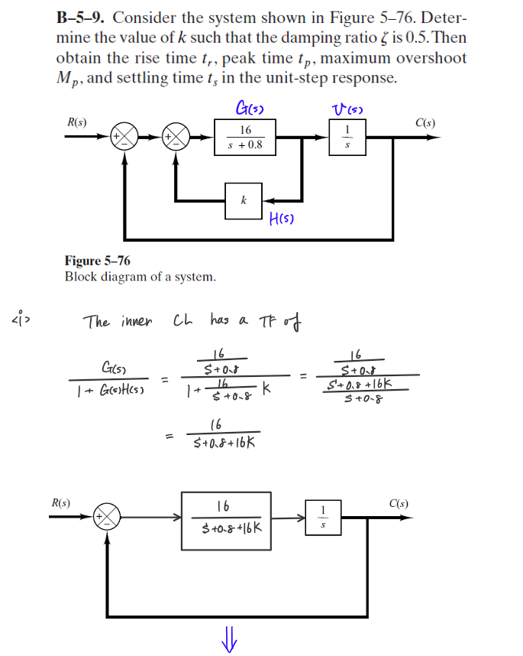

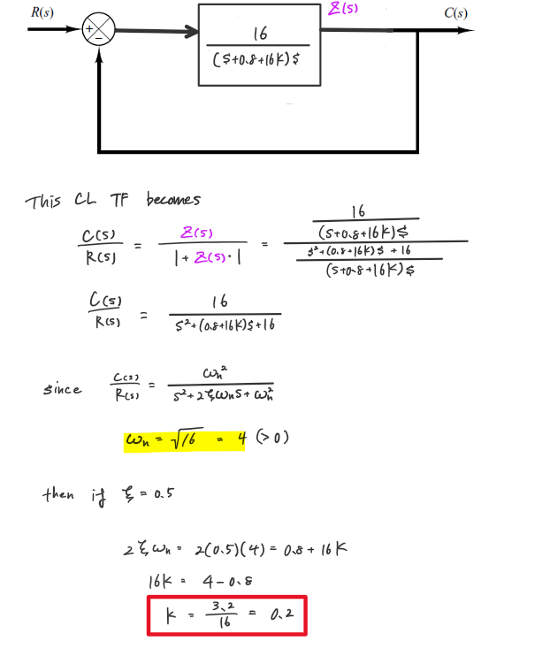

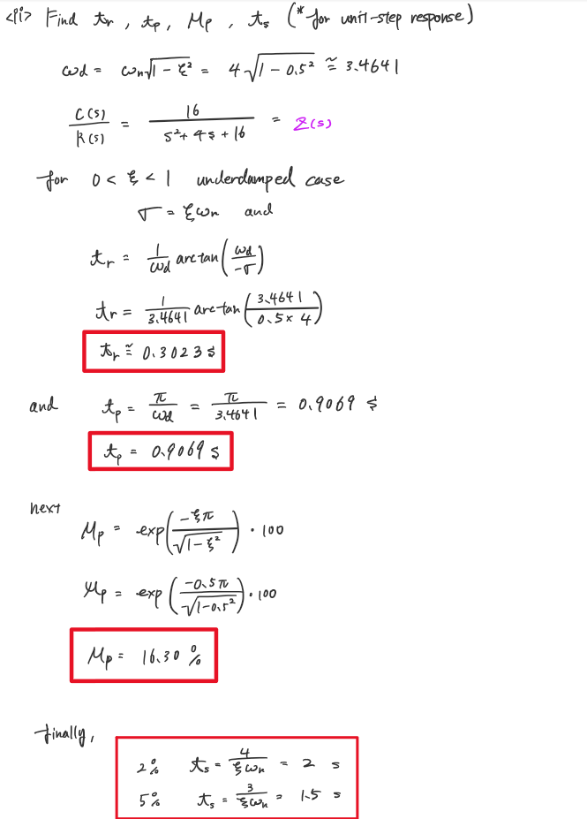

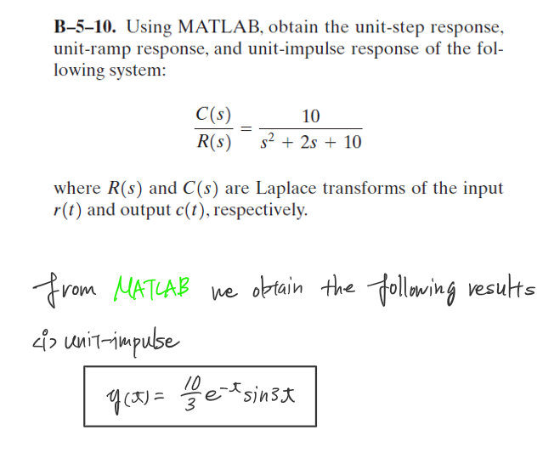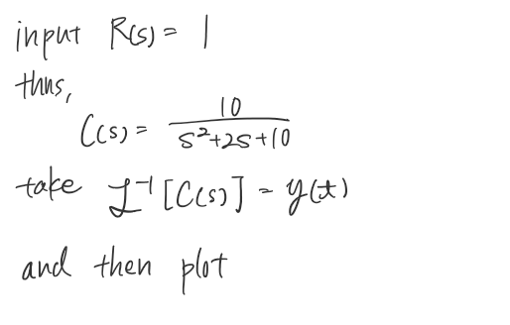

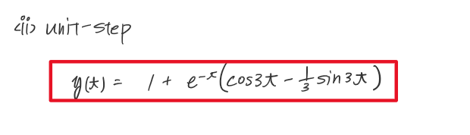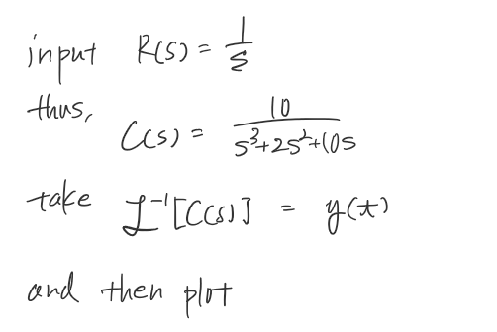

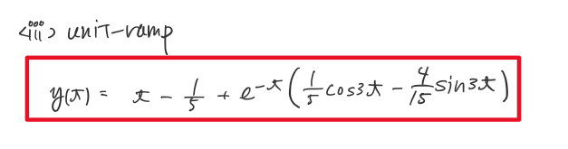

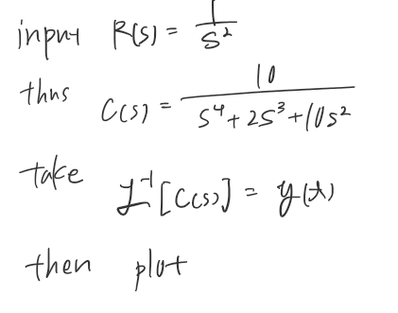

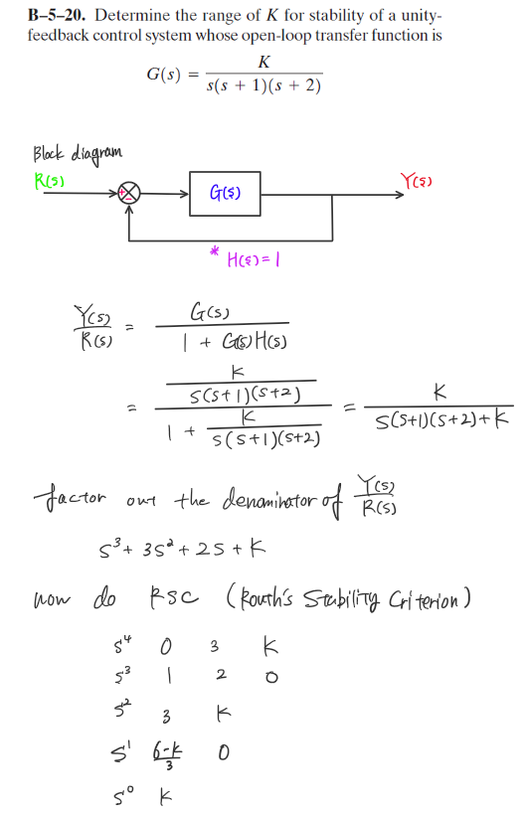

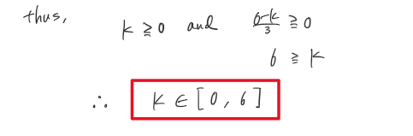

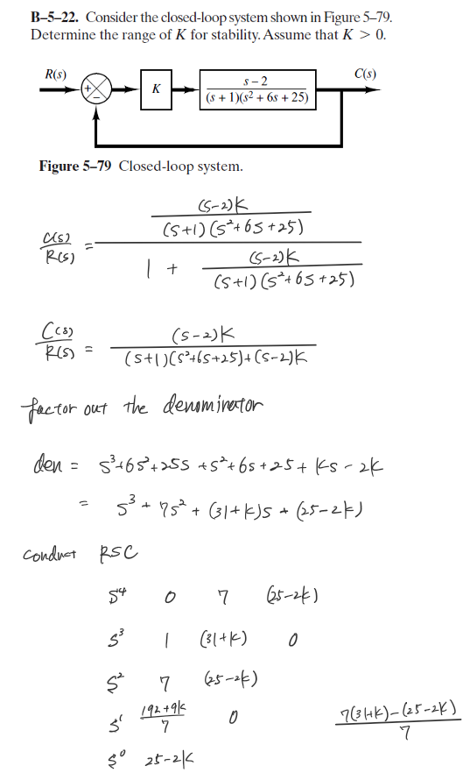

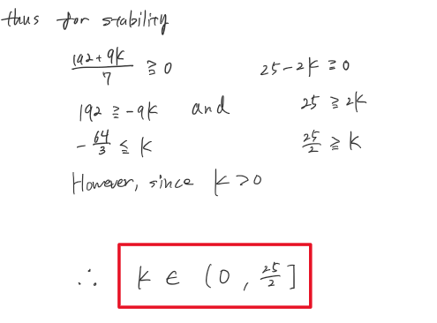

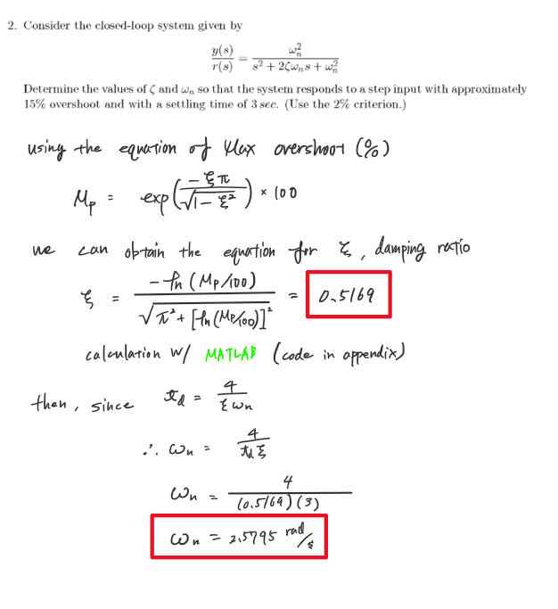

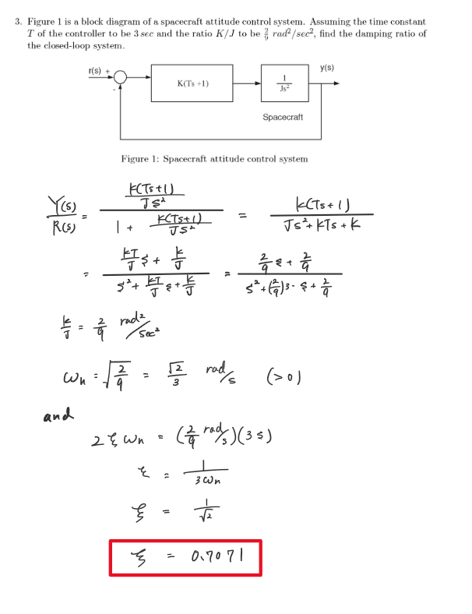

APPENDIX

**AAE364 HW5 MATLAB CODE**

**problem 1 >> B-5-10**

s = tf('s');

G = 10/(s^2+2*s+10);

fdir = 'C:\Users\Tomo\Desktop\studies\2020-Spring\AAE364\matlab\matlab_output';

% Impulse reponse

impF = 1;

[num_imp, den_imp] = tfdata(G*impF);

output_impulse = return_inverseLaplace_expression(num_imp, den_imp)

fig1 = figure("Renderer","painters");

impulse(G);

saveas(fig1, fullfile(fdir,'HW5_b_5_10_impulse.png'));

% Step Response

stepF = 1/s;

[num_step, den_step] = tfdata(G*stepF);

output_step = return_inverseLaplace_expression(num_step, den_step)

fig2 = figure("Renderer","painters");

step(G);

saveas(fig2, fullfile(fdir,'HW5_b_5_10_step.png'));

% Ramp Response

rampF = 1/s^2;

[num_ramp, den_ramp] = tfdata(G*rampF);

output_ramp = return_inverseLaplace_expression(num_ramp, den_ramp)

fig3 = figure("Renderer","painters");

step(G / s);

ylim([0, 10])

xlim([0, 10])

hold on

plot(linspace(0,10,20), linspace(0,10,20), '-r')

hold off

title('Ramp Response')

saveas(fig3, fullfile(fdir,'HW5_b_5_10_ramp.png'));

**problem 2**

MOS = 15; % percent

zeta = calc_zetaFromMOS_or_MOSFromzeta(MOS, "zeta")

function inverted_expr = return_inverseLaplace_expression(num, den)

%{

inputs: 1) num: numerator of the transfer function times input

function G(s)*R(s)

2) den: denominator of the transfer function times input

function G(s)*R(s)

outputs: 1) inverted_expr: returns the expression for the inverse

laplace equation of the output laplace equation

%}

syms s t % Invoke Symbolic Math Toolbox

snum = poly2sym(num, s); % Symbolic Numerator Polynomial

sden = poly2sym(den, s); % Symbolic Denominator Polynomial

G_time_domain = ilaplace(snum/sden); % Inverse Laplace Transform

G_time_domain = simplify(G_time_domain, 'Steps',10); % Simplify To Get Nice Result

inverted_expr = collect(G_time_domain, exp(-t)); % Optional Further Factorization

end

function output = calc_zetaFromMOS_or_MOSFromzeta(MOS_or_zeta, type)

%{

inputs: 1) MOS_or_zeta: maximum overshoot or zeta (damping ratio) input

the one of the two will be chosen depending on the second

input "type"

2) type: string "MOS" or "zeta" indicates what output the

user requires

outputs: 1) output: returns either the MOS or zeta

%}

if type == "MOS"

zeta = MOS_or_zeta;

output = exp(-zeta*pi/sqrt(1-zeta^2))*100;

elseif type == "zeta"

MOS = MOS_or_zeta;

output = -log(MOS/100)/sqrt(pi^2 + (log(MOS/100))^2);

end

end