AAE 364 Control Systems Analysis

Problem Set 7

Professor Inseok Hwang

School of Aeronautics and Astronautics, Purdue University

Spring 2020

Issued 3/6; Due 3/13

Reading Assignment:

Sections 1-3 in Chapter 6.

Paper \Bringing Root Locus to The Classroom: The story of Walter R. Evans and his textbook Control-System Dynamics".

Remarks: First, draw the root locus by hand and then use MATLAB to validate your solution. When you present results obtained with MATLAB as your solutions, you should explain your results clearly to get full credits. (Just giving gures and numbers is not enough for answers)

Problem 1

Consider the unity feedback system shown in Figure 1:

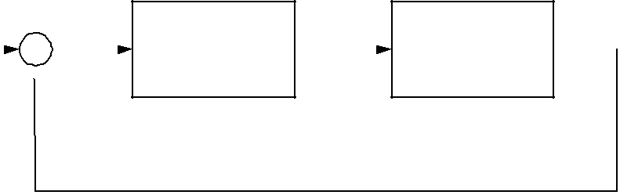

|  |  |  |  |  |  |  |  |
| --- | --- | --- | --- | --- | --- | --- | --- |
| R(S)+ | | E(S) | |  |  | Y(S) |  |
|  |  |  | K(S) |  | G(S) |  |  |
|  |  |  |  |  |  |



- 

Figure 1: A unity feedback system.

Plot the root locus for the system with

1.

1

K(s) = k; G(s) = s(s + 2)(s2 + 4s + 5)

2.

K(s) = k; G(s) =

s2 + 6s + 10

s2 + 2s + 10

1

3.

K(s) = k; G(s) =

s + 9

s(s2 + 4s + 11)

Problem 2

Solve B-6-8 and B-6-11 in Chapter 6.

Problem 3: Spacecraft

Consider the unity-feedback system in Figure 1 with the plant G(s) representing the spacecraft attitude dynamics shown in Figure 2:

|  |  |  |  |  |
| --- | --- | --- | --- | --- |
| (s) | = | 0:036(s + 25) | (1) |  |
|  |  |  |
| Tc(s) | s2(s2 + 0:04s + 1) |  |

Sketch the root loci of the unity-feedback system, with K(s) = K, as K varies from 0 to +1 (as accurately as you can)

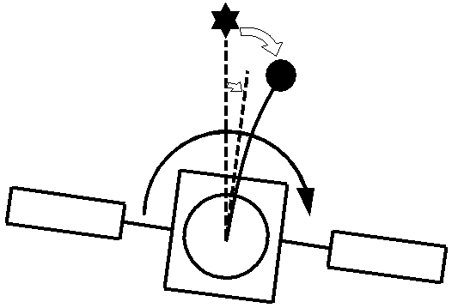

|  |  |  |
| --- | --- | --- |
|  | Instrument Package |  |
|  |  |

Figure 2: Two-body Model of Satellite

2