AAE 364: Controls System Analysis

HW9: Controller Design & Root Locus

Dr. Sun

School of Aeronautical and Astronautical

Purdue University

Tomoki Koike

Friday April 3, 2020

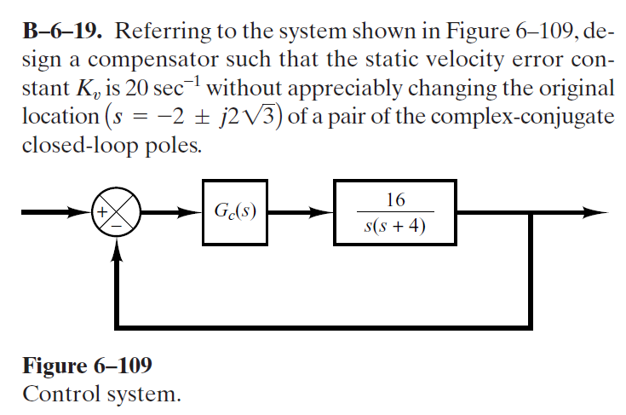

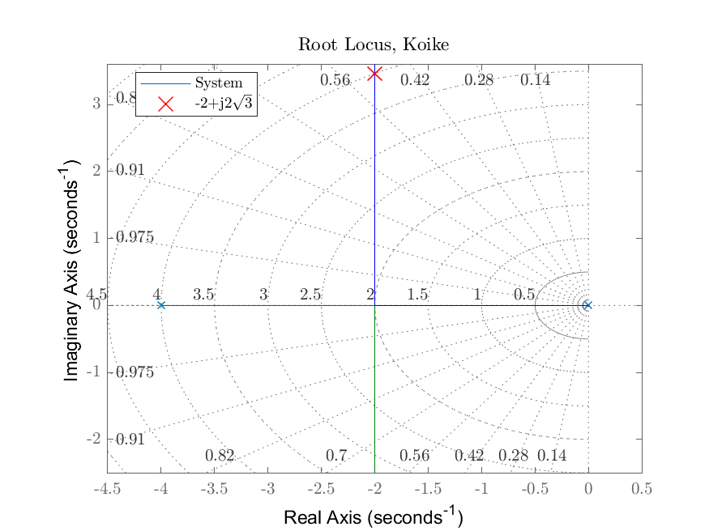

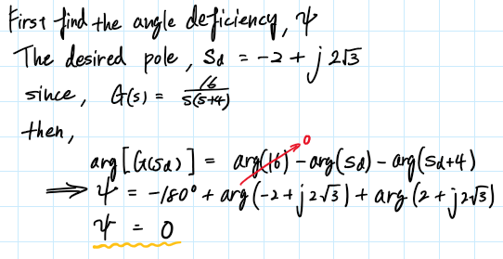

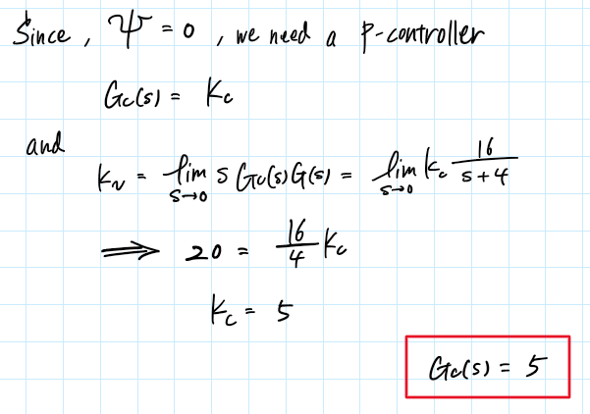

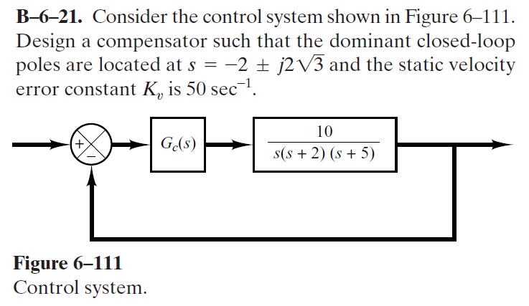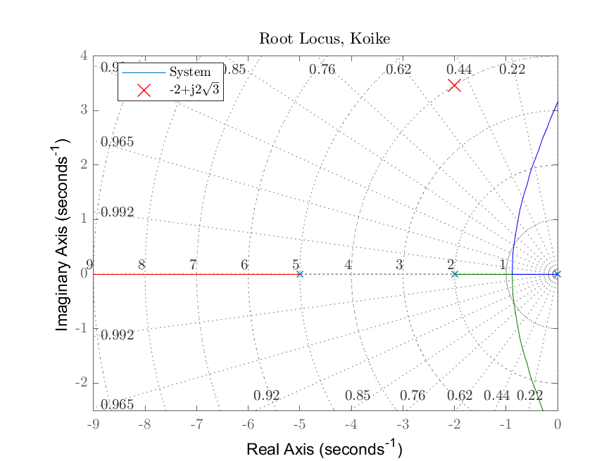

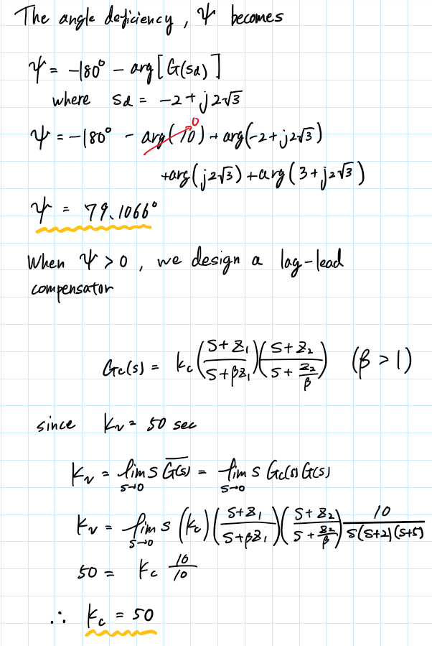

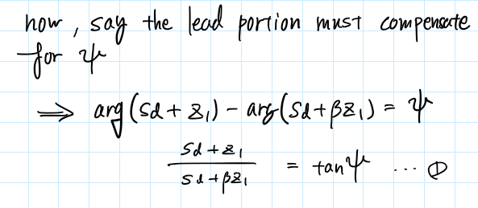



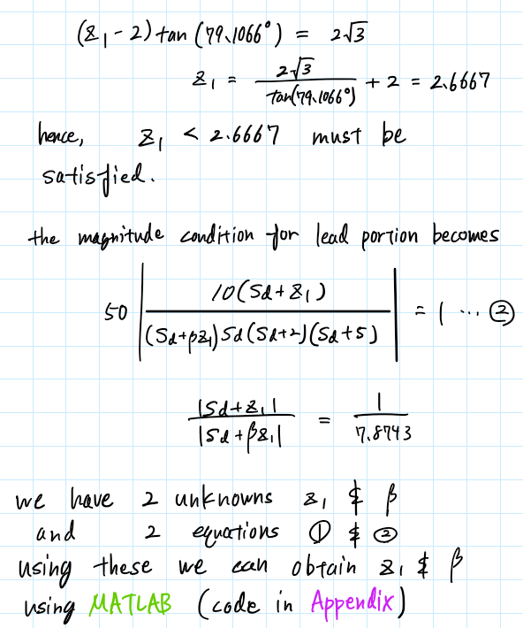

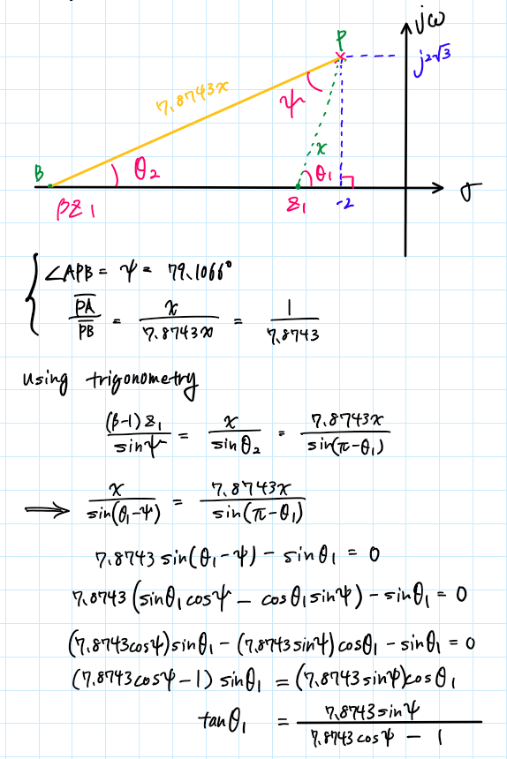

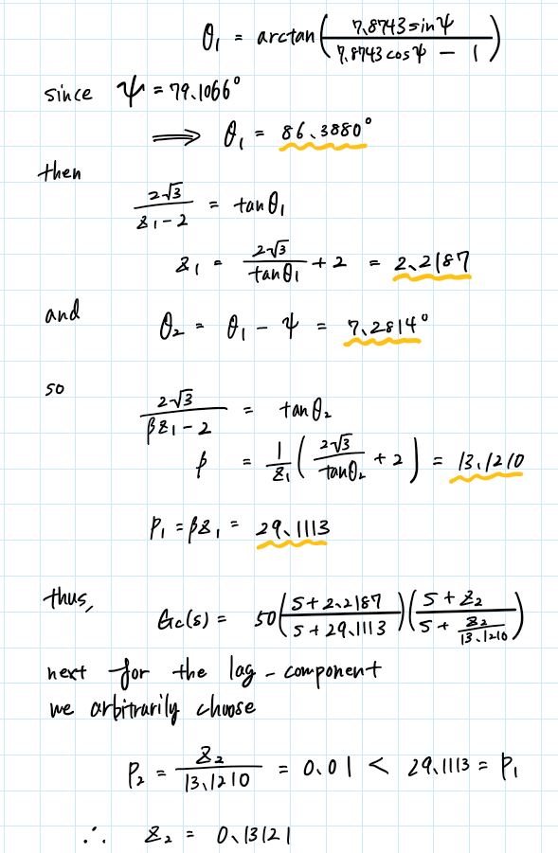

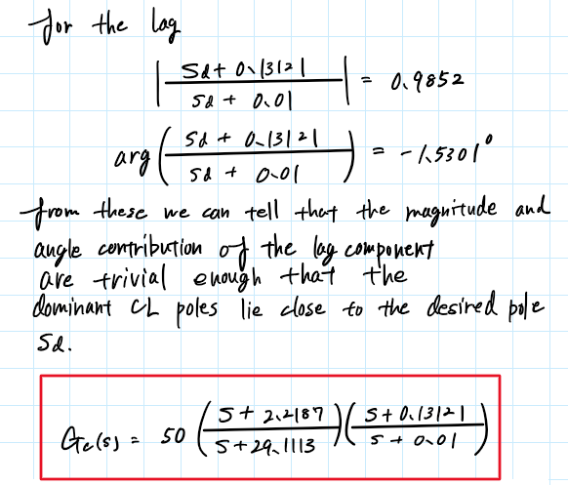

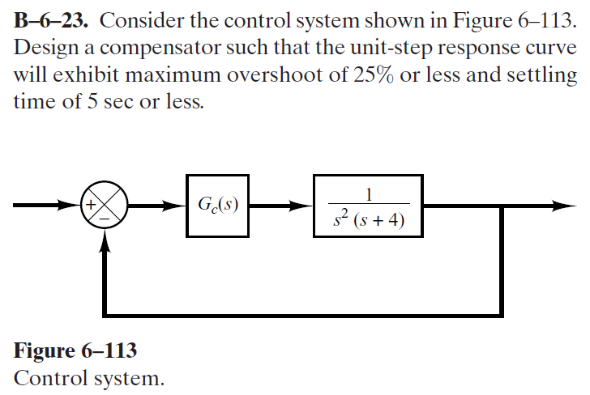

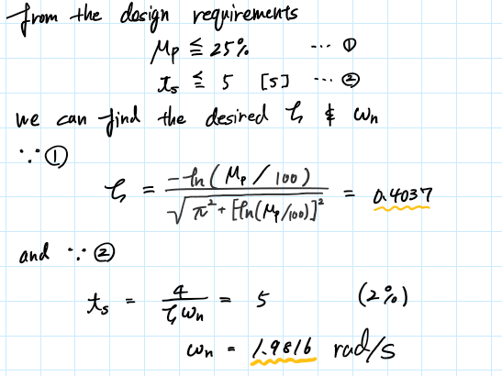

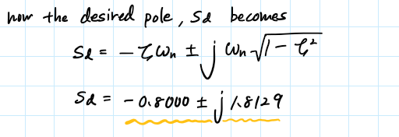

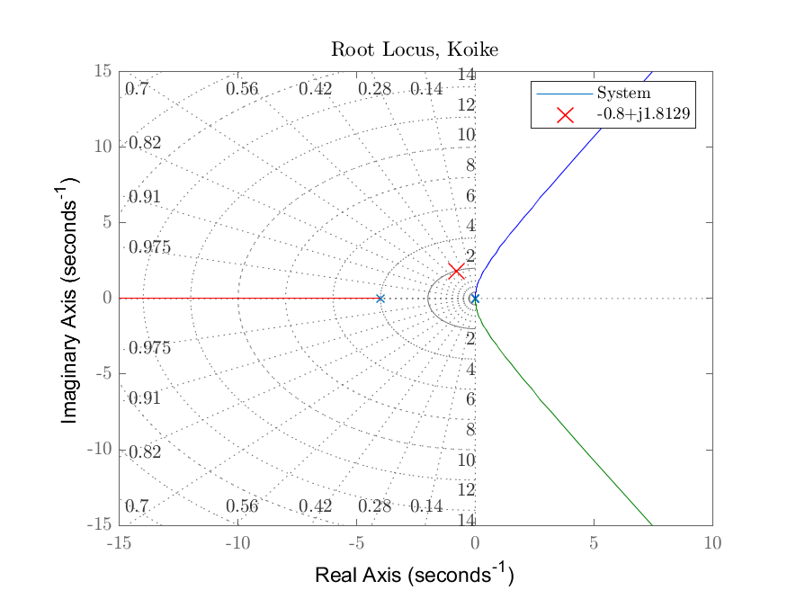

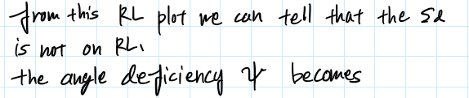

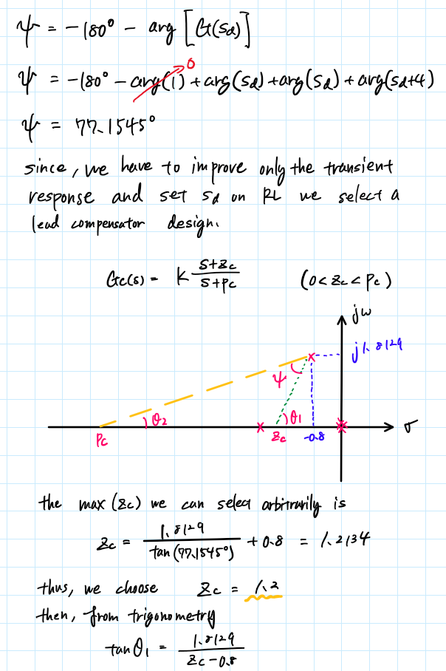

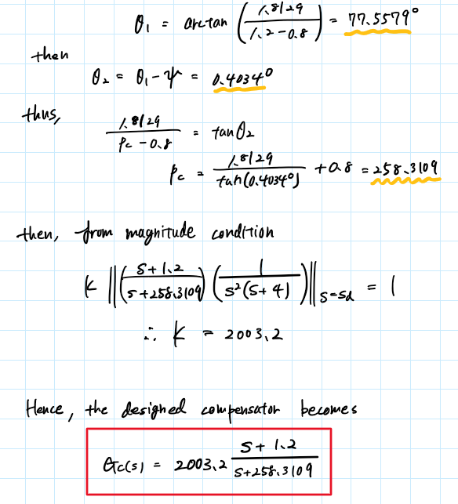

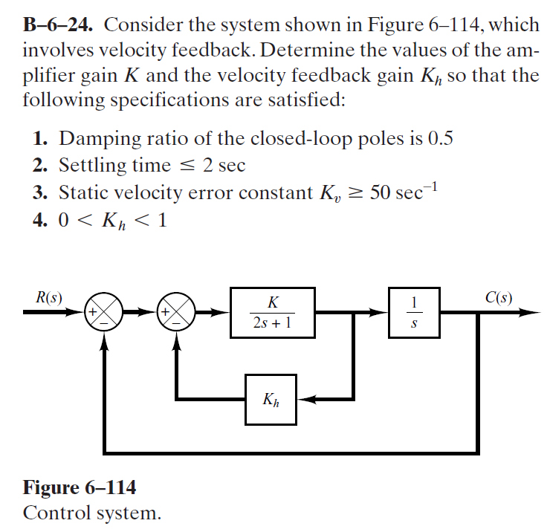

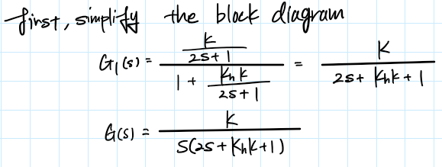

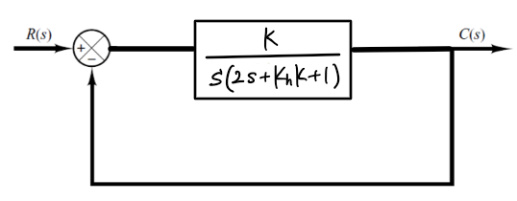

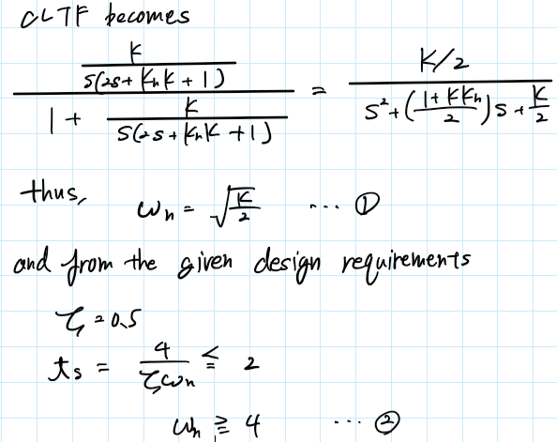

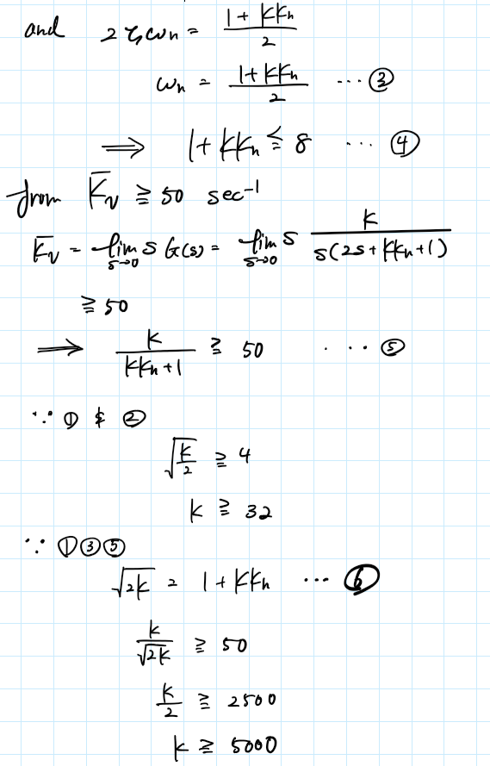

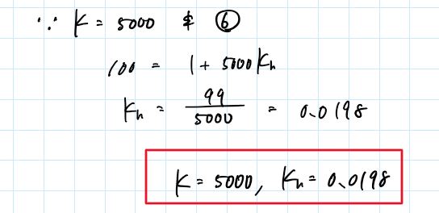

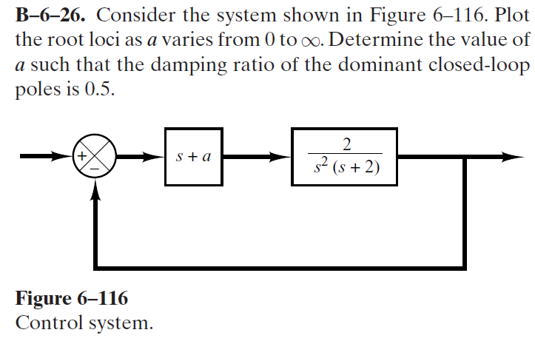

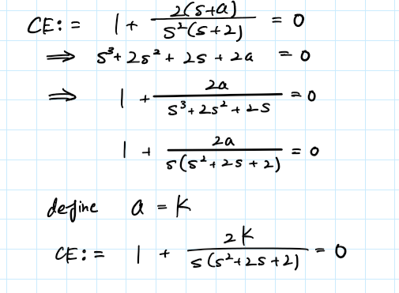

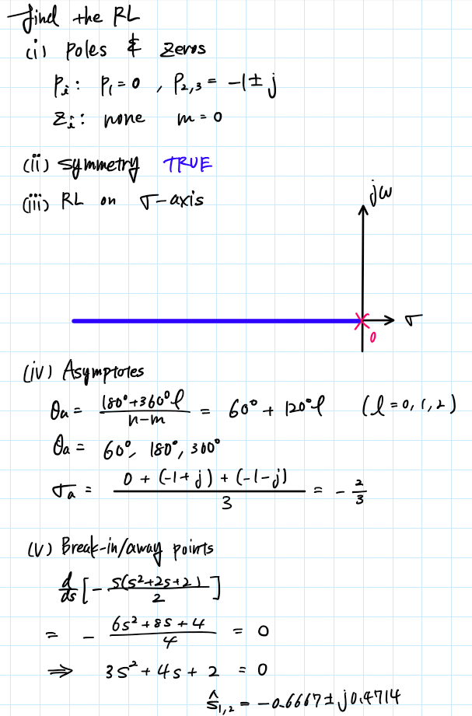

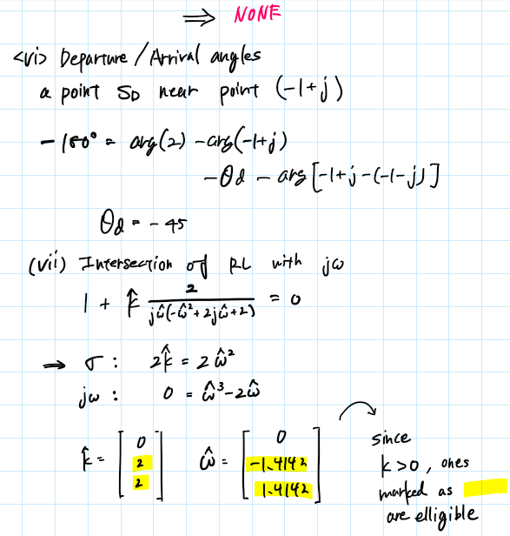

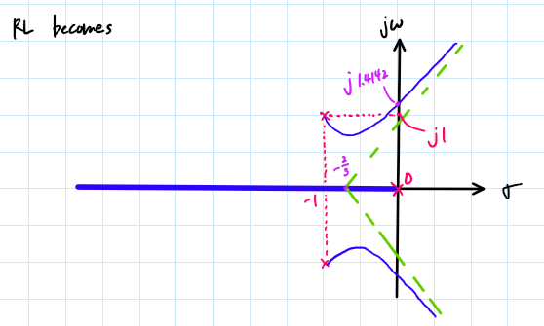

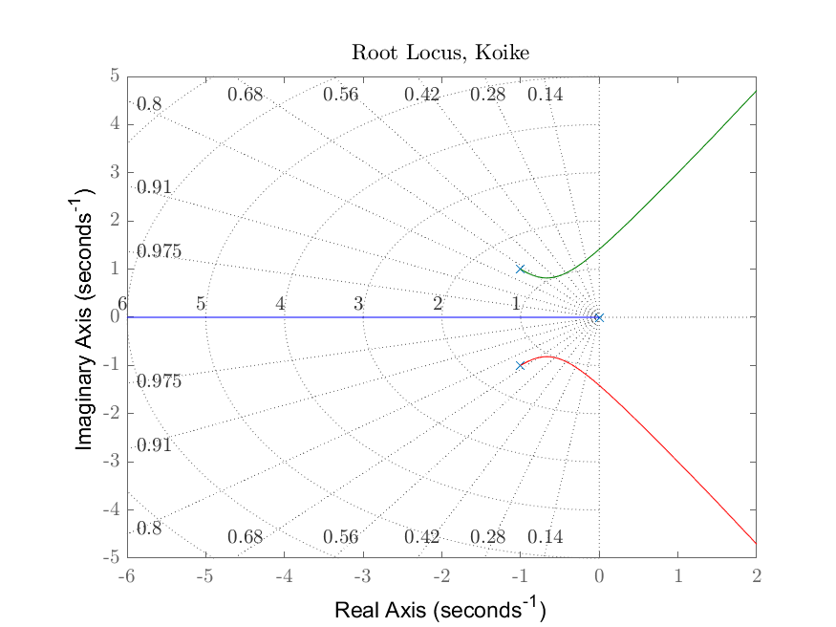

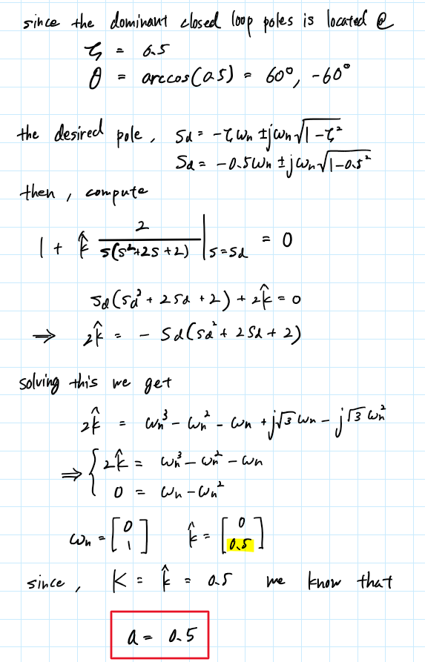

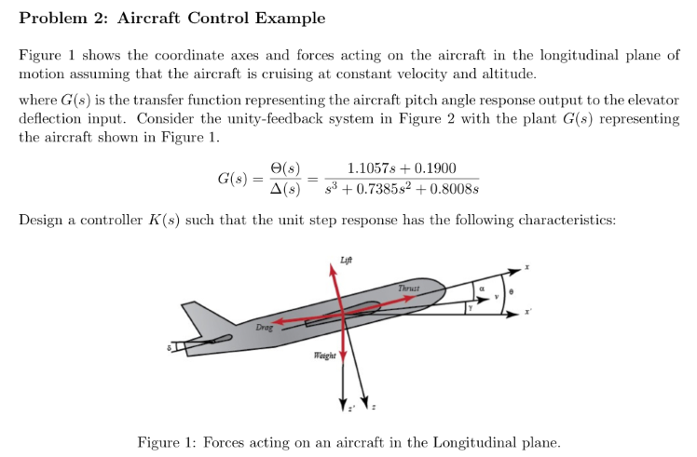

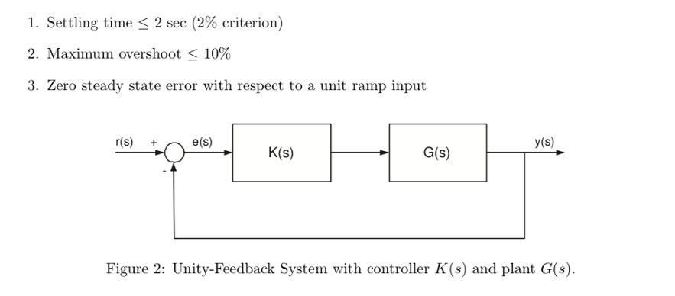

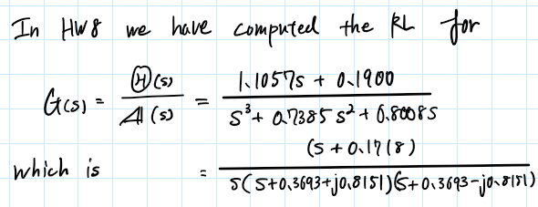

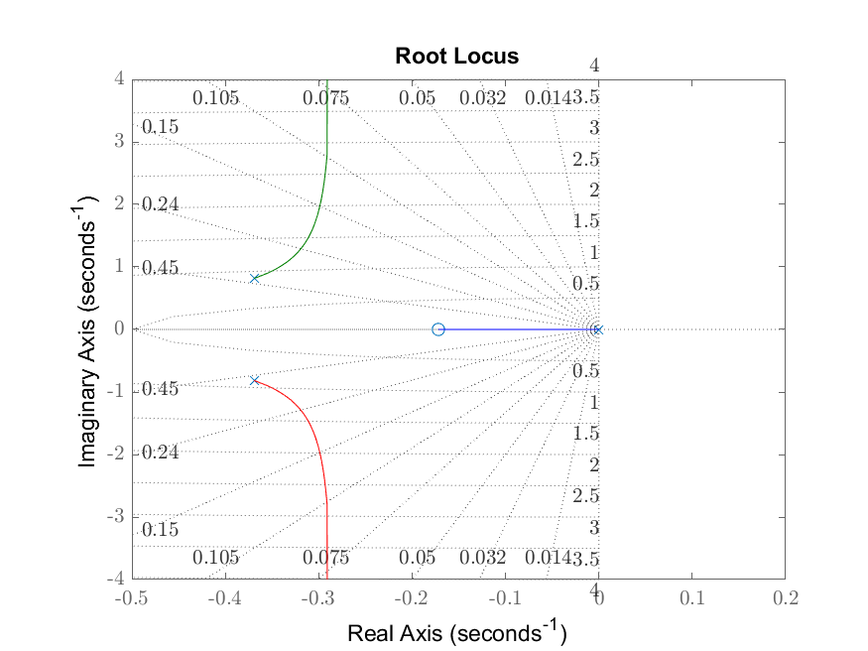

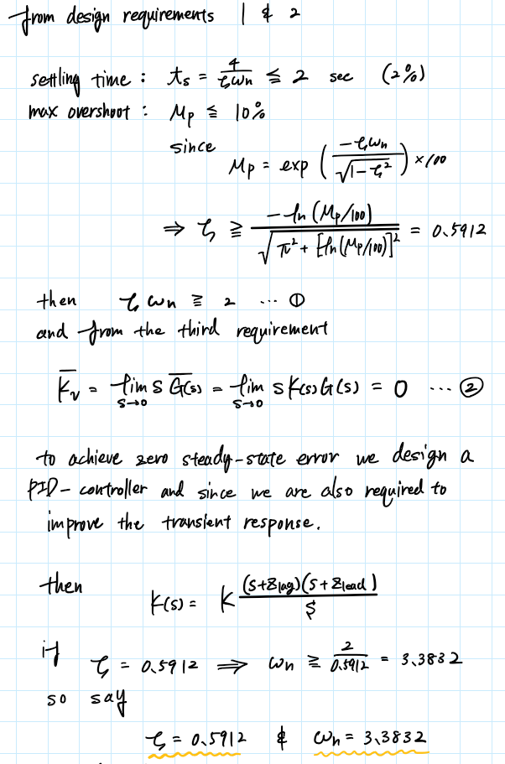

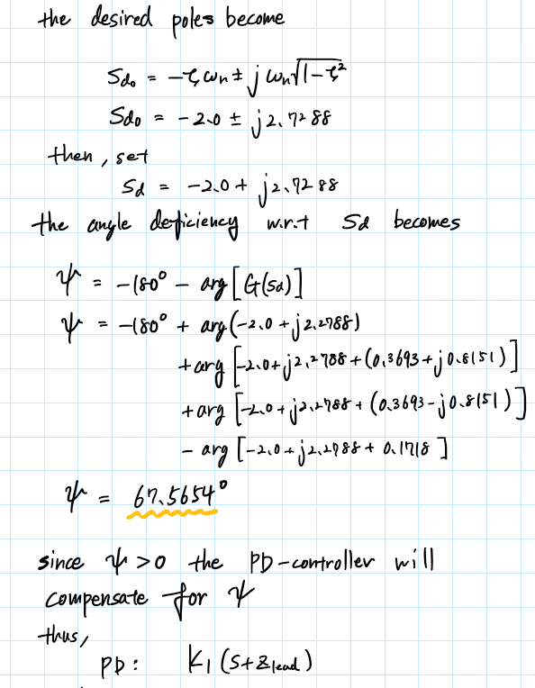

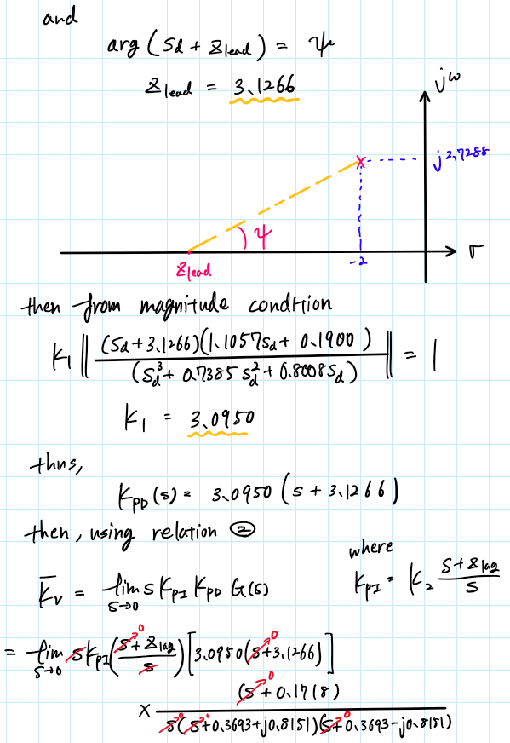

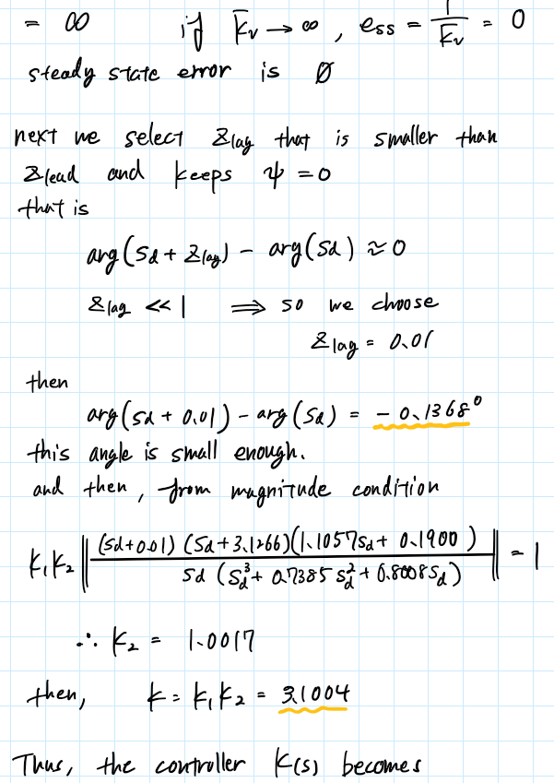

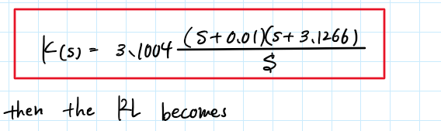

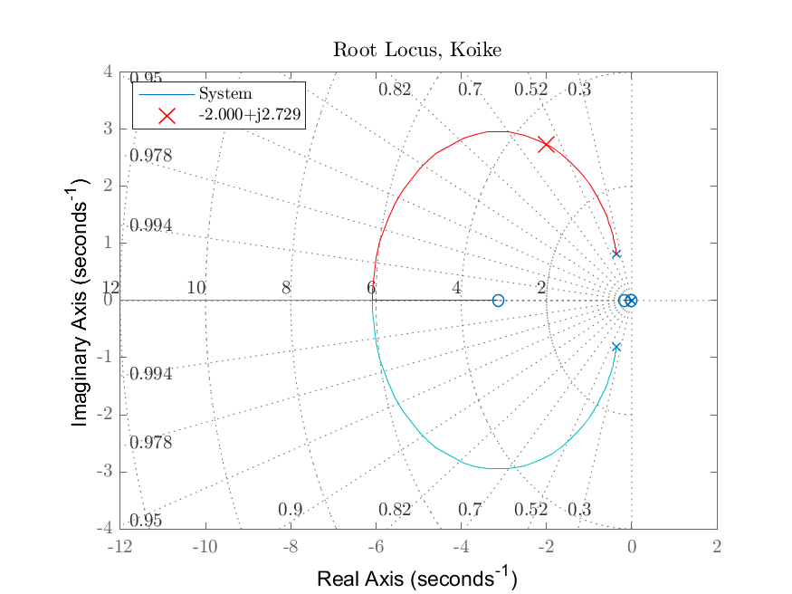

Appendix

## **AAE364 HW9 MATLAB CODE**

clear all; close all; clc;

fdir = 'C:\Users\Tomo\Desktop\studies\2020-Spring\AAE364\matlab\matlab_output\hw9';

set(groot, 'defaulttextinterpreter',"latex");

set(groot, 'defaultAxesTickLabelInterpreter',"latex");

set(groot, 'defaultLegendInterpreter',"latex");

### B-6-19

% Define OLTF G(s)

num = 16; % numerator

den = conv([1 0],[1 4]); % denominator

% Desired pole

sd = -2 + 2i*sqrt(3);

% Compute deficiency angle [deg]

psi = calc_ang_deficiency(num,den,sd);

% Plotting the RL (negative feedback)

fig1 = figure("Renderer","painters");

rlocusplot(tf(num,den)); sgrid;

title('Root Locus, Koike',"Interpreter","latex")

hold on

plot(real(sd),imag(sd),'xr','MarkerSize',12)

hold off

ylim([-2.5 3.6])

legend('System','-2+j2$\sqrt{3}$',"location","best")

saveas(fig1,fullfile(fdir,'B-6-19_RL.png'));

### B-6-21

% Define OLTF G(s)

num = [0 10]; % numerator

den = conv([1 0],[1 2]); % denominator

den = conv(den,[1 5]);

% Desired pole

Kv = 50; % [s-1]

sd = -2 + 2i*sqrt(3);

% Compute deficiency angle [deg]

psi = calc_ang_deficiency(num,den,sd)

% Plotting the RL (negative feedback)

fig2 = figure("Renderer","painters");

rlocusplot(tf(num,den)); sgrid;

title('Root Locus, Koike',"Interpreter","latex")

hold on

plot(real(sd),imag(sd),'xr','MarkerSize',12)

hold off

ylim([-2.5 4.0])

legend('System','-2+j2$\sqrt{3}$',"location","best")

saveas(fig2,fullfile(fdir,'B-6-21_RL.png'));

% Finding z1, p1 (beta*z1), and Kc

Kc = Kv;

z1_lim = imag(sd)/tand(psi) - real(sd); % condition for z1

theta1 = atan(7.8743*sind(psi)/(7.8743*cosd(psi) - 1));

theta1_deg = rad2deg(theta1);

z1 = imag(sd)/tan(theta1) + 2;

theta2_deg = theta1_deg - psi;

beta = (imag(sd)/tand(theta2_deg) + 2)/z1;

% lag component

p2 = 0.01;

mag_lag = abs((sd + p2*beta)/(sd + p2));

ang_lag = rad2deg(angle(sd + p2*beta) - angle(sd + p2));

### B-6-23

% Design requirements

Mp = 25; % [%]

ts = 5; % settling time

% Design parameters

zeta = calc_zetaFromMOS_or_MOSFromzeta(Mp,"zeta");

wn = 4/5/zeta;

% Desired pole (positive imag)

sd = -zeta*wn + wn*1i*sqrt(1 - zeta^2);

% OLTF

num = [0 1];

den = conv([1 0],[1 0]);

den = conv(den,[1 4]);

% Plotting the RL (negative feedback)

fig3 = figure("Renderer","painters");

rlocusplot(tf(num,den)); sgrid;

title('Root Locus, Koike',"Interpreter","latex")

hold on

plot(real(sd),imag(sd),'xr','MarkerSize',12)

hold off

sd_txt = sprintf("%0.3f+j%0.3f",real(sd),imag(sd));

legend('System',sd_txt,"location","best")

saveas(fig3,fullfile(fdir,'B-6-23_RL.png'));

% Angle deficiency

psi = calc_ang_deficiency(num,den,sd)

% Selecting zc, pc, and K

zc_lim = imag(sd)/tand(psi) - real(sd) % condition for zc

zc = 1.2;

theta1_deg = atand(imag(sd)/(zc + real(sd)));

theta2_deg = theta1_deg - psi;

pc = imag(sd)/tand(theta2_deg) - real(sd);

% Calculate K

syms K

Gc = (sd + zc)/(sd + pc);

G = 1/sd^2/(sd + 4);

eqn = K*abs(Gc*G) == 1

K = double(solve(eqn,K));

### B-6-24

% Design parameters

zeta = 0.5;

ts = 2;

wn = 4/ts/zeta

% Desired pole (positive imag)

sd = -zeta*wn + wn*1i*sqrt(1 - zeta^2)

Kh = 99/5000;

### B-6-26

% RL

num = [0 2];

den = [1 2 2 0];

[poles,zrs,angs,sigma,bi_pt,T_P,T_Z,k,w,fig1] = rootLocus_stepBystep_negFeedback(num,den)

saveas(fig1,fullfile(fdir,"B-6-26_RL.png"))

% Find gain, K when zeta = 0.5

zeta = 0.5;

syms K wn s

assume(K,'real');

assume(wn,'real');

p = -zeta*wn + wn*1j*sqrt(1 - zeta^2);

RHS = (s*(s^2 + 2*s + 2))

RHS = subs(RHS,s,p)

RHS = expand(RHS)

eqn1 = 2*K == -real(RHS)

eqn2 = 0 == -imag(RHS)

res = solve([eqn1 eqn2],[wn K]);

wn = double(res.wn)

Kh = double(res.K)

Kh = nonzeros(Kh)

### P2

% Define system

num = [1.1057 0.1900];

den = [1 0.7385 0.8008 0];

[poles,zrs,angs,sigma,bi_pt,T_P,T_Z,k,w,fig1] = rootLocus_stepBystep_negFeedback(num,den);

% Design parameters

zeta = calc_zetaFromMOS_or_MOSFromzeta(10,"zeta");

wn = 2/zeta;

% Desired pole (positive imag)

sd = -zeta*wn + wn*1i*sqrt(1 - zeta^2);

% Angle deficiency

psi = calc_ang_deficiency(num,den,sd)

% Find z_lead

syms z_lead

assume(z_lead,{'real','positive'})

eqn = angle(sd + z_lead) == deg2rad(psi);

z_lead = double(solve(eqn,z_lead))

% Find K1

syms K1

num2 = conv(num,[1 z_lead]);

G = create_TF_expression(num2,den); % Expression with "syms" of "s"

G_sd = subs(G,s,sd);

eqn = K1*abs(G_sd) == 1;

K1 = double(solve(eqn,K1))

% Find z_lag

z_lag = 0.01;

d_ang = rad2deg(angle(sd + z_lag) - angle(sd))

% Find K2

syms K2

num3 = conv(num2,[1 z_lag]);

den2 = conv(den,[1 0]);

G = create_TF_expression(num3,den2);

G_sd = subs(G,s,sd);

eqn = K1*K2*abs(G_sd) == 1;

K2 = double(solve(eqn,K2))

% Find K

K = K1*K2

% Plot RL

fig6 = figure("Renderer","painters")

rlocus(tf(K*num3,den2))

sgrid

title("Root Locus, Koike",'Interpreter',"latex")

hold on

plot(real(sd),imag(sd),'xr','MarkerSize',12)

hold off

sd_txt = sprintf("%0.3f+j%0.3f",real(sd),imag(sd));

legend('System',sd_txt,"location","best")

saveas(fig6,fullfile(fdir,'P2_RL_new.png'));

function [poles,zrs,angs,sigma,bi_pt,T_P,T_Z,k,w,fig1] = rootLocus_stepBystep_negFeedback(num,den)

%{

NAME: ROOTLOCUS_STEPBYSTEP_NEGFEEDBACK

AUTHOR: TOMOKI KOIKE

INPUTS: (1) num: THE NUMERATOR OF THE TRANSFER FUNCTION

(2) den: THE DENOMINATOR OF THE TRANSFER FUNCTION

OUTPUTS: (1) poles: POLES OF THE TRANSFER FUNCTION

(2) zrs: ZEROS OF THE TRANSFER FUNCTION

(3) angs: ANGLES OF THE ASYMPTOTES

(4) sigma: INTERSECTION OF THE ASYMPTOTES

(5) bi_pt: BREAK-IN/AWAY POINT

(6) T_P: TABLE WITH EACH POLE AND THEIR

DEPARTURE OR ARRIVAL ANGLES

(6) T_Z: TABLE WITH EACH ZERO AND THEIR

DEPARTURE OR ARRIVAL ANGLES

(7) k: VALUE K_HAT FOR INTERSECTION WITH IM AXIS

(8) w: INTERSECTION POINT WITH THE IM AXIS

(9) fig1: THE FIGURE WITH THE ROOT LOCUS PLOT

DESCRIPTION: CONDUCTS THE 7 STEP PROCEDURE OF THE ROOT LOCUS

ANALYSIS AND DISPLAYS THE RESULTS AS WELL AS THE PLOT FOR A NEGATIVE

FEEDBACK LOOP

%}

% STEP1 - POLES & ZEROS

poles = roots(den);

zrs = roots(num);

% STEP2 - SYMMETRY (*TAKEN FOR GRANTED)

% STEP3 - ROOT LOCUS ON REAL AXIS (*OMMITTED)

% STEP4 - ASYMPTOTES

[angs,sigma] = RL_asymptote(zrs,poles);

% STEP5 - BREAK-IN/AWAY POINTS

bi_pt = break_in_away_pt(num,den);

% STEP6 - ANGLE OF DEPARTURE

[T_P, T_Z] = departure_arrival_angle_calc(zrs, poles);

% STEP7 - INTERSECTION WITH IMAGINARY AXIS

[k,w] = intersection_IM_axis(num,den);

% DEFINE THE TRANSFER FUNCTION

L = tf(num, den);

% PLOTTING THE ROOT LOCUS

fig1 = figure(1);

rlocus(L)

title('Root Locus, Koike','interpreter','Latex')

sgrid

end

function psi = calc_ang_deficiency(num,den,s_d)

%{

Function: calc_ang_deficiency

Author: Tomoki Koike

Description: Computes the deficiency angle for a certain system from

its given open-loop transfer function and desired

pole.

>>Inputs

num: the numerator of the open-loop transfer function

den: the denominator of the open-loop transfer function

s_d: the desired pole

Outputs<<

psi: the angle deficiency

%}

% Get the length of each numerator and denominator

num_len = length(num);

den_len = length(den);

% Preset an array with the order of magnitudes (i.e. s^3, s^2, s^1, s^0)

% corresponding to the numerator and denominator

O_num = (num_len-1):-1:0;

O_den = (den_len-1):-1:0;

% Define a system equation of s to compute deficiency angle

syms s

N = factor(dot(num,s.^O_num),'FactorMode','complex');

D = factor(dot(den,s.^O_den),'FactorMode','complex');

N_angs = angle(subs(N,s,s_d));

D_angs = angle(subs(D,s,s_d));

psi = -pi - sum(N_angs) + sum(D_angs);

psi = double(rad2deg(psi));

end

function output = calc_zetaFromMOS_or_MOSFromzeta(MOS_or_zeta, type)

%{

inputs: 1) MOS_or_zeta: maximum overshoot or zeta (damping ratio) input

the one of the two will be chosen depending on the second

input "type"

2) type: string "MOS" or "zeta" indicates what output the

user requires

outputs: 1) output: returns either the MOS or zeta

%}

if type == "MOS"

zeta = MOS_or_zeta;

output = exp(-zeta*pi/sqrt(1-zeta^2))*100;

elseif type == "zeta"

MOS = MOS_or_zeta;

output = -log(MOS/100)/sqrt(pi^2 + (log(MOS/100))^2);

end

end

function [angs, sigma] = RL_asymptote(zrs, poles)

n = length(poles);

m = length(zrs);

angs = zeros([1,n-m]);

for i = 0:(n-m)-1

angs(i+1) = (180 + 360*i)/(n - m);

end

sigma = (sum(poles) - sum(zrs))/(n - m);

end

function [table_P, table_Z] = departure_arrival_angle_calc(zrs, poles)

%{

NAME: DEPARTURE_ARRIVAL_ANGLE_CALC

AUTHOR: TOMOKI KOIKE

INPUTS: (1) zrs: THE ZEROS OF THE TRANSFER FUNCTION

(2) poles: THE POLES OF THE TRANSFER FUNCTION

OUTPUTS: (1) TABLE_P : TABLE OF ALL THE POLES' DEPARTURE ANGLES

(2) TABLE_Z : TABLE OF ALL THE ZOLES' DEPARTURE ANGLES

DESCRIPTION: CALCULATES ALL THE DEPARTURE ANGLES AND ARRIVALS ANGLES

FOR THE PROVIDED ZEROS AND POLES OF A TRANSFER FUNCTION FOR NEGATIVE

FEEDBACK LOOP

%}

% PREALLOCATE ARRAY THETA TO STORE ALL ANGLES FOR THE POLES

theta_P = zeros([1,(length(poles))]);

% ANGLE FOR A FICTICIOUS POINT CLOSE TO EACH POLE

for n = 1:length(poles)

obj = poles(n);

% ANGLES FROM THE ZERO POINT TO A THE CURRENT POINT

if not(isempty(zrs))

for i = 1:length(zrs)

theta_P(n) = theta_P(n) + angle(obj - zrs(i));

end

end

% ANGLE FROM ANOTHER POLE TO THE CURRENT POLE

for i = 1:length(poles)

theta_P(n) = theta_P(n) - angle(obj - poles(i));

end

% THE ANGLE BECOMES

theta_P(n) = theta_P(n) + deg2rad(180); % [rad]

end

% CREATING TABLE

rad_P = reshape(theta_P,[length(theta_P),1]);

deg_P = rad2deg(rad_P);

table_P = table(reshape(poles,[length(poles),1]),rad_P,deg_P);

table_P.Properties.VariableNames = {'POLES','RADIUS','DEGREES'};

if not(isempty(zrs))

% PREALLOCATE ARRAY THETA TO STORE ALL ANGLES FOR THE POLES

theta_Z = zeros([1,(length(zrs))]);

% ANGLE FOR A FICTICIOUS POINT CLOSE TO EACH ZERO

for n = 1:length(zeros)

obj = zrs(n);

% ANGLES FROM THE ZERO POINT TO A THE CURRENT POINT

if not(isempty(zrs))

for i = 1:length(zrs)

theta_Z(n) = theta_Z(n) + angle(obj - zrs(i));

end

end

% ANGLE FROM A POLE TO THE CURRENT ZERO POINT

for i = 1:length(poles)

theta_Z(n) = theta_Z(n) - angle(obj - poles(i));

end

% THE ANGLE BECOMES

theta_Z(n) = -deg2rad(180) - theta_Z(n); % [rad]

end

% CREATING TABLE

rad_Z = reshape(theta_Z,[length(theta_Z),1]);

deg_Z = rad2deg(rad_Z);

table_Z = table(reshape(zrs,[length(zrs),1]),rad_Z,deg_Z);

table_Z.Properties.VariableNames = {'ZEROS','ANGLES','DEGREES'};

else

table_Z = [];

end

end

function rts = break_in_away_pt(num,den)

[q, d] = polyder(-den,num)

rts = roots(q)

rts = rts(rts==real(rts));

end

function [K, W] = intersection_IM_axis(num, den)

syms k w

n = length(den);

m = length(num);

f1 = 0; f2 = 0; p1 = 0; p2 = 0;

% RHS (denominator)

% when the largest order of s is even

if rem(n,2) == 1

% powers to the even numbers (real)

for i = 1:2:n

if rem(n-i,4) == 0

f1 = f1 + den(i)*w^(n-i);

else

f1 = f1 + den(i)*w^(n-i)*(-1);

end

end

% powers to the odd numbers (imaginary)

for i = 2:2:n-1

if rem(n-i,4) == 1

f2 = f2 + den(i)*w^(n-i);

else

f2 = f2 + den(i)*w^(n-i)*(-1);

end

end

% when the largest order of s is odd

elseif rem(n,2) == 0

% powers to the even numbers (real)

for i = 2:2:n

if rem(n-i,4) == 0

f1 = f1 + den(i)*w^(n-i);

else

f1 = f1 + den(i)*w^(n-i)*(-1);

end

end

% powers to the odd numbers (imaginary)

for i = 1:2:n-1

if rem(n-i,4) == 1

f2 = f2 + den(i)*w^(n-i);

else

f2 = f2 + den(i)*w^(n-i)*(-1);

end

end

end

% LHS

% when the largest order of s is even

if rem(m,2) == 1

% powers to the even numbers (real)

for i = 1:2:m

if rem(m-i,4) == 0

p1 = p1 + num(i)*w^(m-i);

else

p1 = p1 + num(i)*w^(m-i)*(-1);

end

end

% powers to the odd numbers (imaginary)

for i = 2:2:m-1

if rem(m-i,4) == 1

p2 = p2 + num(i)*w^(m-i);

else

p2 = p2 + num(i)*w^(m-i)*(-1);

end

end

% when the largest order of s is odd

elseif rem(m,2) == 0

% powers to the even numbers (real)

for i = 2:2:m

if rem(m-i,4) == 0

p1 = p1 + num(i)*w^(m-i);

else

p1 = p1 + num(i)*w^(m-i)*(-1);

end

end

% powers to the odd numbers (imaginary)

for i = 1:2:m-1

if rem(m-i,4) == 1

p2 = p2 + num(i)*w^(m-i);

else

p2 = p2 + num(i)*w^(m-i)*(-1);

end

end

end

% Solving the system equations

Re = k*p1 == -f1

Im = k*p2 == -f2

a = vpasolve([Re Im], [k w]);

K = double(a.k);

W = double(a.w);

end