AAE 440: Spacecraft Attitude Dynamics

PS11*

Dr. Howell

School of Aeronautical and Astronautical

Purdue University

Tomoki Koike

Wednesday May 6th, 2020

**Problem 1:** Given an unsymmetric rigid body, include the gravity torque. Define an uniform unsymmetric body such that the mass distribution are consistent with Exam 3, i.e.,

We will be able to orient the body in different ways on orbit so, for now, the principle axes are labeled , , .

1. A representative unsymmetric homogeneous rigid body model appears below. Recall that is does not matter if the vehicle is actually this shape – if it possesses the same inertias, the behavior is the same. Identify each moment of inertia with the appropriate axes in this unsymmetric body and label them , , .

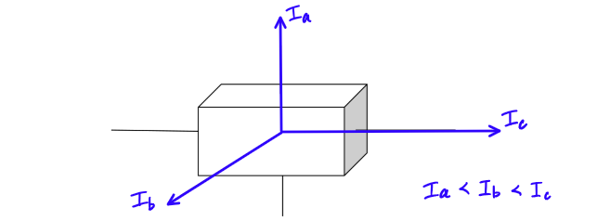

1. Assume the unsymmetric spacecraft is moving in a circular orbit with orbital angular velocity as summarized on the next page. (Note that as in previous problem sets, use as the orbital normal.) Consider the addition of a gravity moment and an assessment of the stability properties of a reference orientation. Some reference orientations align the principle directions , , , with different orbit axes , , .

[Here, is the orbital normal direction. When the Space Shuttle was operational, note that one equilibrium orientation of the Space Shuttle (nose oriented “down” or “up” along the radial direction; wings in the orbit plane) was defined such that . Which orientation of the ‘spacecraft’ sketched below represents the Space Shuttle equilibrium state?] (*, , do not correspond to , , but to the a-frame or orbital frame)

Orbital Diagram

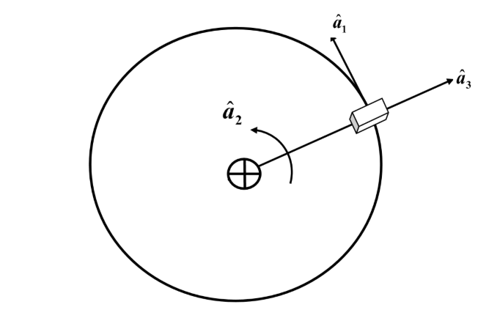

Equilibrium State (ii)

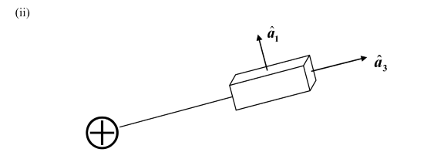

|  |
| --- |
| ⟹ *intermediate moment of inertia* = velocity direction |
| ⟹ *largest moment of inertia* = orbit normal |
| ⟹ *smallest moment of inertia* = radial direction |

NOT Equilibrium States (i), (iii), & (iv)

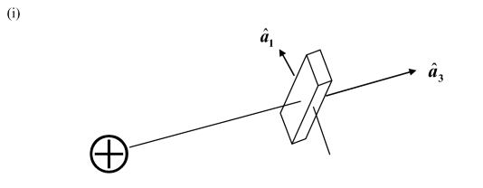

|  |
| --- |
| ⟹ *intermediate moment of inertia* = velocity direction |
| ⟹ *smallest moment of inertia* = orbit normal |
| ⟹ *largest moment of inertia* = radial direction |

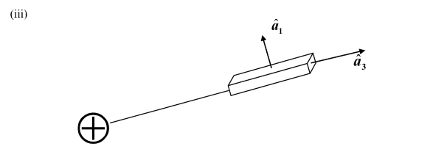

|  |
| --- |
| ⟹ *largest moment of inertia* = velocity direction |
| ⟹intermediate *moment of inertia* = orbit normal |
| ⟹ *smallest moment of inertia* = radial direction |

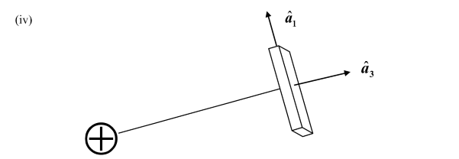

|  |
| --- |
| ⟹ *smallest moment of inertia* = velocity direction |
| ⟹ *intermediate moment of inertia* = orbit normal |
| ⟹ *largest moment of inertia* = radial direction |

Table of , ,

|  |  |
| --- | --- |
| Orientation (i)   * : = = 425 kg-m2 * = = 125 kg-m2 * : = = 500 kg-m2 | Orientation (ii)   * : = = 425 kg-m2 * = = 500 kg-m2 * : = = 125 kg-m2 |
| Orientation (iii)   * : = = 500 kg-m2 * = = 425 kg-m2 * : = = 125 kg-m2 | Orientation (iv)   * : = = 125 kg-m2 * = = 425 kg-m2 * : = = 500 kg-m2 |

From the relations,

By plugging in the corresponding moment of inertias for each orientation.

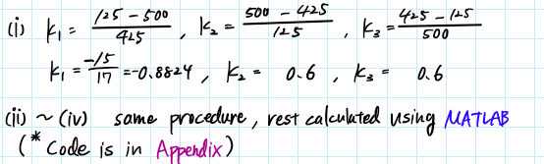

The tabulated results for the K-values is the following.

|  |  |  |  |
| --- | --- | --- | --- |
| Orientation |  |  |  |
| i | -0.882352941 | 0.6 | 0.6 |
| ii | 0.882352941 | -0.6 | -0.6 |
| iii | 0.6 | -0.882352941 | 0.6 |
| iv | -0.6 | 0.882352941 | -0.6 |

1. On Notes W page 12, there is a stability chart. For the formulation with as the orbit normal, a stability chart is appropriate (where bounds on each edge are -1 to +1). Add a point below that represents each orientation from part (b). There are at least 6 orientations of interest but only 4 are sketched in part (b). Which ones are missing? Sketch the orientations and add the K values to you table and stability chart.

All possible permutations/orientations of , , are

|  |  |  |  |  |  |
| --- | --- | --- | --- | --- | --- |
|  |  |  |  |  |  |
|  |  | (i) | a | c | b |
|  | | (ii) | a | b | c |
|  |  | (iii) | b | a | c |
|  |  | (iv) | c | a | b |
| Missing Orientation | | (v) | b | c | a |
| (vi) | c | b | a |

|  |  |
| --- | --- |
| Orientation (v)   * : = = 500 kg-m2 * = = 125 kg-m2 * : = = 425 kg-m2 | Orientation (vi)   * : = = 125 kg-m2 * = = 500 kg-m2 * : = = 425 kg-m2 |

Sketch of the missing orientations

(v)

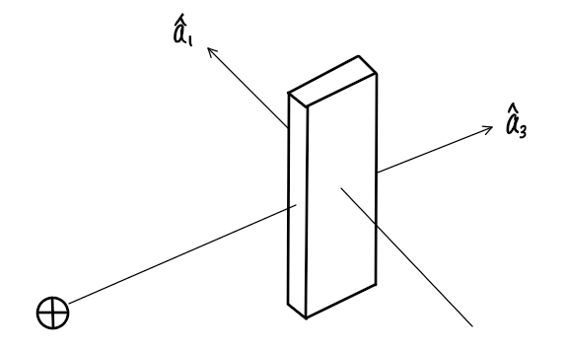

(vi)

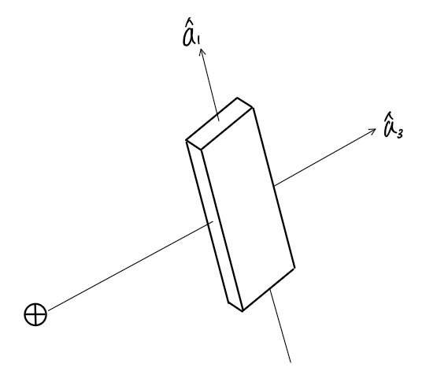

Table of K-values for all possible orientations

|  |  |  |  |
| --- | --- | --- | --- |
| Orientation |  |  |  |
| i | -0.882352941 | 0.6 | 0.6 |
| ii | 0.882352941 | -0.6 | -0.6 |
| iii | 0.6 | -0.882352941 | 0.6 |
| iv | -0.6 | 0.882352941 | -0.6 |
| v | -0.6 | -0.6 | 0.882352941 |
| vi | 0.6 | 0.6 | -0.882352941 |

Stability Chart with all orientations

**Problem 2:** Consider the addition of the gravity moment and an analytical assessment of the stability properties of a reference orientation.

1. Consider the differential equations (kinematic and dynamic) that govern the motion; you have already employed Euler parameters as the kinematic variables. In PS8*, you derived the differential equations to include the gravity torque for an axisymmetric rigid body. Return to the derivation and modify them to incorporate an unsymmetric body.

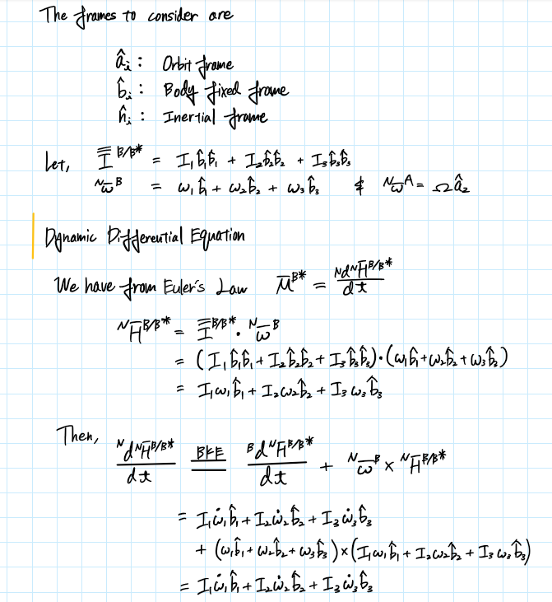

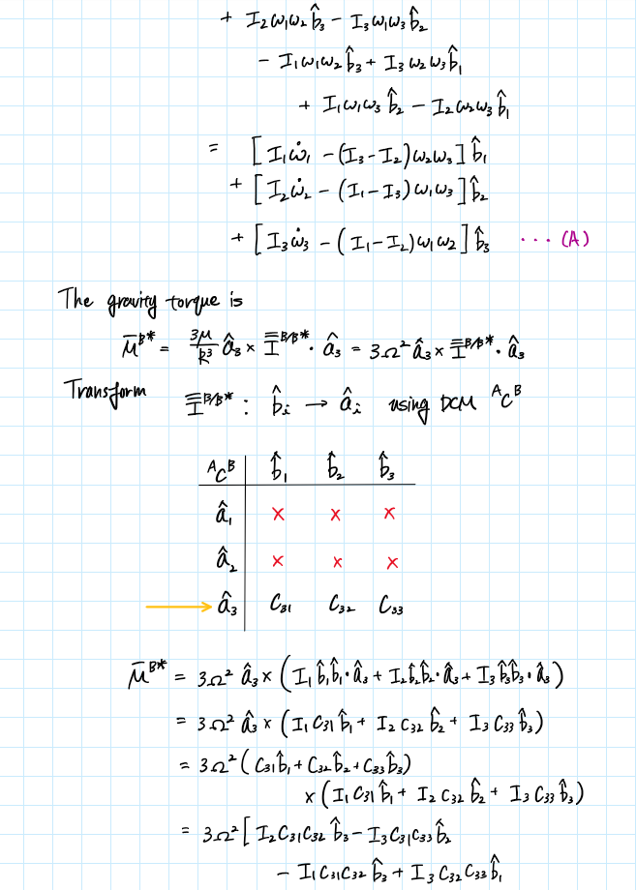

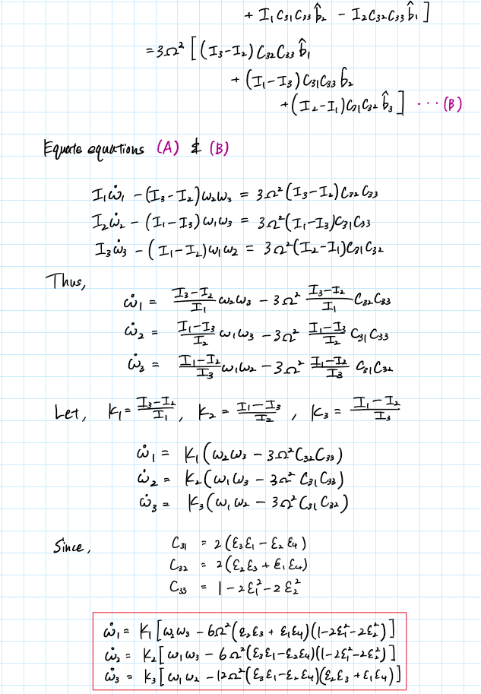

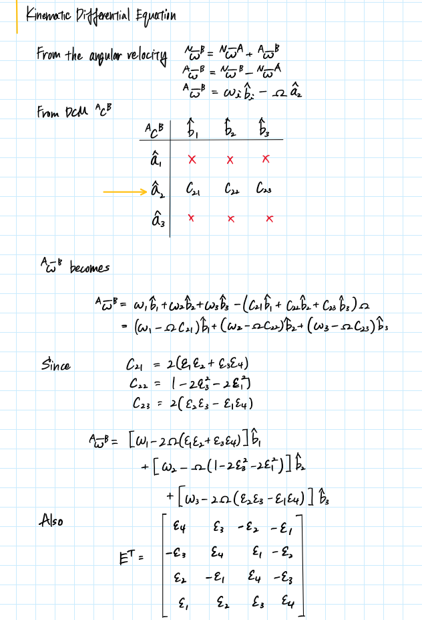

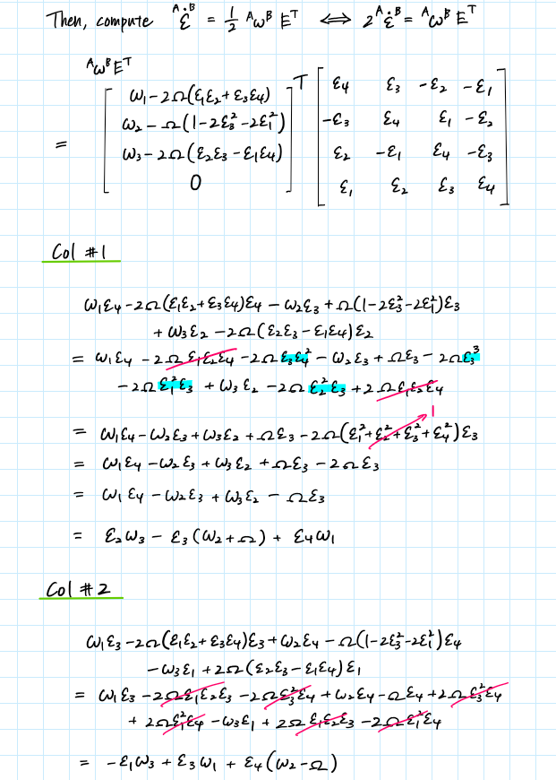

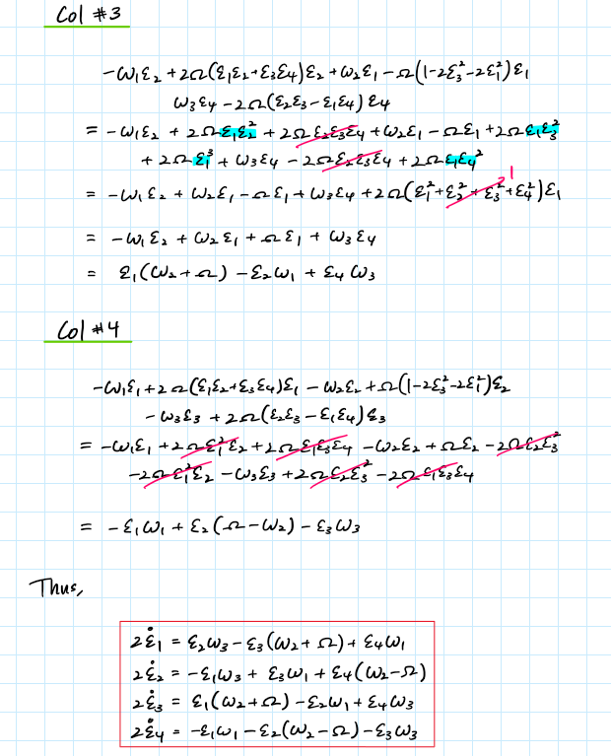

1. Identify the particular solution of interest that is employed in class. (Define the nominal motion in terms of the values of the dependent variables.) confirm that the particular solution is a solution is a solution of the corresponding nonlinear differential equations.

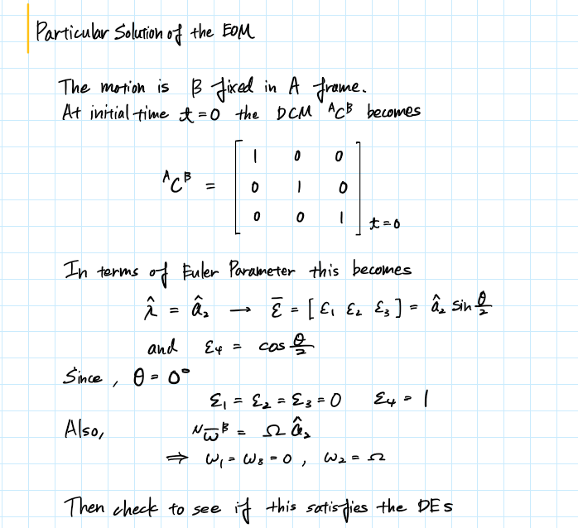

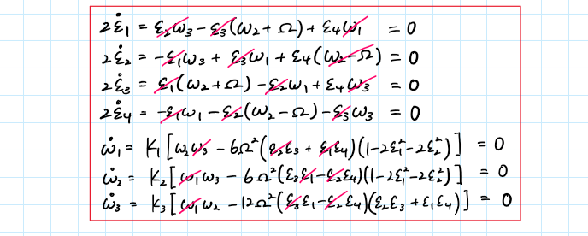

1. Perturb the particular (nominal) solution of interest in nonlinear differential equations. Derive the first-order variational equations (with Euler parameters as the kinematic variables). Find the characteristic equations and determine the eigenvalues. The characteristic equation should be EXACTLY the same as the one determined in class even though you are using different kinematic variables. Why is your characteristic equation the same?

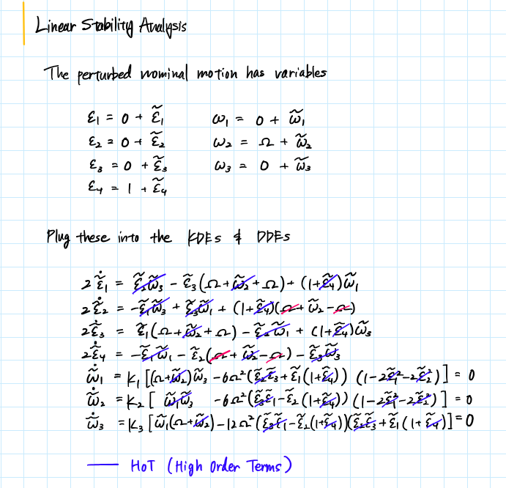

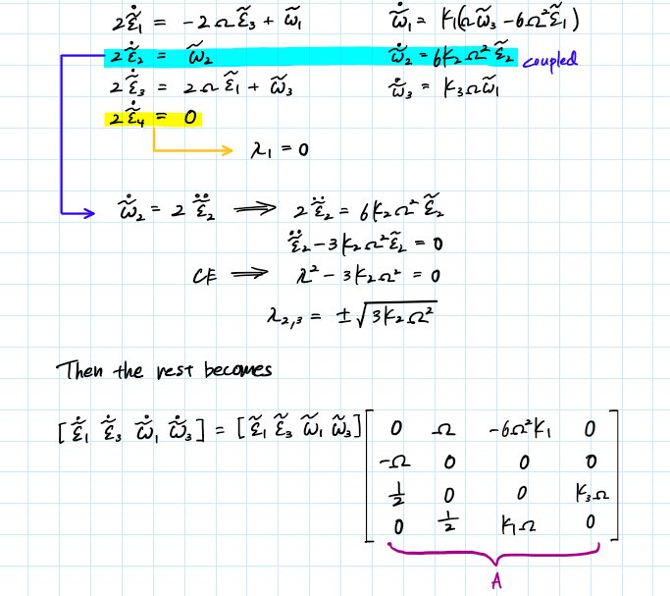

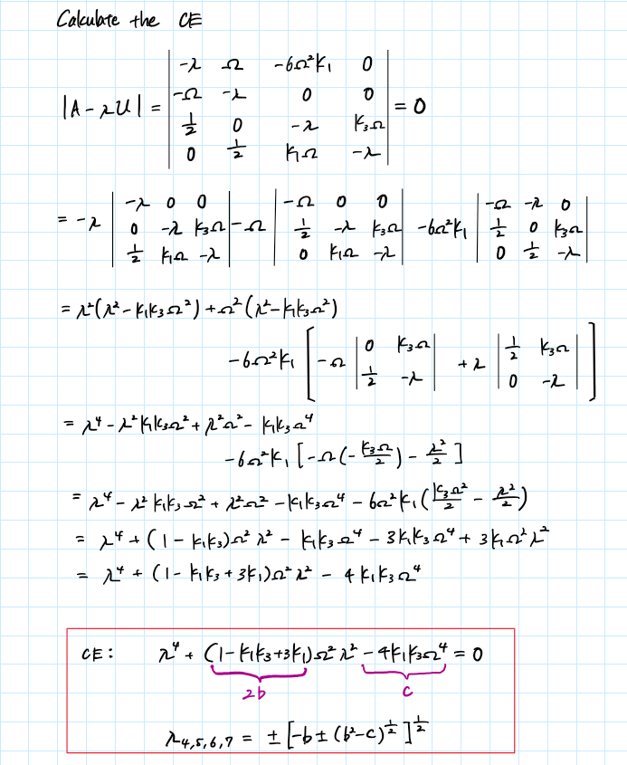

Discussion

* The CEs and eigenvalues in the class notes and this problem is the exact same. The only difference we can observe from the two are the frames and corresponding shape factor K-values.

|  |  |  |  |
| --- | --- | --- | --- |
|  | Class Notes |  | PS11* |
| Orbit Normal |  | ⟹ |  |
| Radial |  | ⟹ |  |
| Velocity |  | ⟹ |  |
| Shape Factor K |  | ⟹ |  |
|  | ⟹ |  |
|  | ⟹ |  |

* It does not matter whether you derive using the Euler parameters or the DCM since they are just a representation of an orientation of a physical body but defined with different methods.

1. As discussed in class, there are four conditions that can be used to identify unstable motion. However, you can simply determine the eigenvalues that correspond to each reference motion. For each of your points in the stability chart, determine the eigenvalues.

Eigenvalues are defined as for each orientation, and the tabulated results is the following.

|  |  |  |  |  |  |
| --- | --- | --- | --- | --- | --- |
| (i) | (ii) | (iii) | (iv) | (v) | (vi) |
| 0 | 0 | 0 | 0 | 0 | 0 |
| 1.3416 | 0+1.3416i | 0+1.627i | 1.627 | 0+1.3416i | 1.3416 |
| -1.3416 | 0-1.3416i | 0-1.627i | -1.627 | 0-1.3416i | -1.3416 |
| 1.0035+0.66947i | 0+0.76847i | 0.7009 | 1.383 | 0.89177+0.81238i | 0+0.92534i |
| -1.0035-0.66947i | 0-0.76847i | -0.7009 | -1.383 | -0.89177-0.81238i | 0-0.92534i |
| 1.0035-0.66947i | 0+1.8937i | 0+1.7121i | 0+0.86765i | 0.89177-0.81238i | 0+1.5726i |
| -1.0035+0.66947i | 0-1.8937i | 0-1.7121i | 0-0.86765i | -0.89177+0.81238i | 0-1.5726i |
| ⬇ | ⬇ | ⬇ | ⬇ | ⬇ | ⬇ |
| Unstable | Marginally Stable | Unstable | Unstable | Unstable | Unstable |

1. Identify the Region numbers in the stability chart. Note the curves that represent the stability boundaries. Note the regions where all your points or orientations appear in the stability chart. Do you have a point in Region 5? Region 7? Essentially, the stability chart yields analytical predictions of stability for the linear variational model. Do you expect each of the orientations to be stable or unstable in terms of the linear system? Nonlinear system?

The Regions are defined as the following

|  |  |
| --- | --- |
| Region 1: | *Stable* |
| Region 2: |  |
| Region 3: |  |
| Region 4: |  |
| Region 5: |  |
| Region 6: |  |
| Region 7: | *Unstable,* not from Lyapunov |
|  |  |

Stability Chart

Discussion

* Orientation (vi) is located in Region 5; however, there is no orientation in Region 7.
* For a linear system, orientation (ii) is the only orientation that is stable. All the others are unstable.
* For nonlinear system, orientation (ii) is possibly/potentially stable from this result. All the others are unstable.

**Problem 3.** Summarize the nondimensional version of the dynamic and kinematic differential equations in preparation for numerical integration. The independent variable is still 𝜈 (number of revs).

Summarize the nondimensional differential equations

1. Determine and justify the angle sequence to obtain the orientation of the vehicle relative to the orbit.

We will use the body two 2-1-2 angle sequence because the order of the rotation is the following:

Axis of Rotation:

Rotation Angles:

The body is unsymmetric which largely changes the motion of the body from our previous analysis we have done on different type of bodies in past problem sets, and therefore, we will not employ a fictitious frame like we did in the axisymmetric case. Our main focus will be on the precession and nutation angle histories for the subsequent analyses.

1. Recall the angles of importance:

|  |  |  |
| --- | --- | --- |
|  | - | Angle between and |
|  | - | Angle between a fixed reference line and the orbit radial direction |
|  | - | Angle between and plane P defined by and |
|  | - | Angle between plane P and the inertially fixed plane with which P coincides initially |

Identify the particular solution of interest that is employed in class. (Define the nominal motion in terms of the values of the dependent variables.) Confirm that the particular solution is a solution of the corresponding nonlinear differential equations. What are the values of the angles and that correspond to the particular solution? Why?

For this particular solution the principal direction of the rigid body is aligned with the orbit frame. The angle between and becomes 0 for the particular solution. the angle between and plane P defined by and depends on the precession about the axis.

For our particular solution the motion obeys the following presumptions for and

Since we know the differential equations from the previous problem (shown on the page 12 and 15), to obtain the particular solution we can plug in the initial conditions that we have for the angular velocities

= 0

= 0

= 0

= 0

2= 0

= 0

= 0

Thus, all the differentials equations become zero we know that this solution satisfies the nonlinear differential equations.

1. Consider the particular solution (the reference orientation) corresponding to Regions 1, 3, 4, and 6. Numerically integrate the equations that include the gravity torque for two revolutions and two sets of initial conditions.

*Initial Conditions 1:*

*Initial Conditions 2:*

Plot ; put the comparison solutions plus the curve for the nominal motion all on the same plot. Thus, there should be four plots, one for each region. Repeat for the angle . (Add additional comparison solutions if necessary.) Does a 10-revoltuion simulation add any additional insight?

Plots for 2-revolutions

Region 3

Region 1

Region 4

Region 6

Plots for 10-revolutions

Region 3

Region 1

Region 6

Region 4

Analysis

* For the case of 2 revolutions, the orientations 2 and 3 which corresponds to the Regions 1 and 6 respectively have a cyclic pattern while showing a stable trait of converging to a certain value within our simulation. Whereas, orientation 4 and 1 which is located in Region 3 and 4 respectively show a random behavior with some divergence.
* Plotting for 10 revolutions revealed that all orientations have somewhat same trait as 2 revolutions. The only thing peculiar is that for Region 6 the cyclic behavior became more evident
* The range of the inertial precession angle, is in a much larger scale than the precession angle, . Though the absolute difference between the particular solution and comparison solution of the two parameters are somewhat close as you may see from the plots the relative difference for is much smaller compared to .

1. Essentially the nominal motion is a body rotation about the orbit normal . For regions 1, 3, 4, and 6 is the nominal motion a rotation about an axis of smallest, largest, or intermediate inertia?

|  |  |
| --- | --- |
| Region | Nominal Motion |
| 1 | *Largest moment of inertia,* |
| 3 | *Intermediate moment of inertia,* |
| 4 | *Smallest moment of inertia,* |
| 6 | *Intermediate moment of inertia,* |

When the gravity torque is included, is the particular solution corresponding to Region 1 “stable”? Region 3? Region4? Region 6? Why or why not? Which eigenvalues correspond to each of the three regions? Is your numerical result consistent with the predicted results from the linear analysis (the eigenvalues)?

When the gravity torque is considered, the particular solution for all motion of interest and the rate of change for the kinematic and dynamic variables in the differential equations become zero, and therefore, the particular solutions for all 4 regions, region 1, 3, 4, and 6 are all stable. Although, for the comparison solutions the motion becomes unstable from what we know from the numerical investigations where the angular velocity measure numbers are not zero.

|  |  |  |  |  |
| --- | --- | --- | --- | --- |
|  | Region 4 | Region 1 | Region 6 | Region 3 |
|  | (i) | (ii) | (iii) | (iv) |
|  | 0 | 0 | 0 | 0 |
|  | 1.3416 | 0+1.3416i | 0+1.627i | 1.627 |
|  | -1.3416 | 0-1.3416i | 0-1.627i | -1.627 |
|  | 1.0035+0.66947i | 0+0.76847i | 0.7009 | 1.383 |
|  | -1.0035-0.66947i | 0-0.76847i | -0.7009 | -1.383 |
|  | 1.0035-0.66947i | 0+1.8937i | 0+1.7121i | 0+0.86765i |
|  | -1.0035+0.66947i | 0-1.8937i | 0-1.7121i | 0-0.86765i |
|  | ⬇ | ⬇ | ⬇ | ⬇ |
| Linear Prediction | Unstable | Marginally Stable | Unstable | Unstable |
| Numerical Investigation | Unstable | Unstable | Somewhat stable | Unstable |
| Consistency | Consistent | Consistent | Inconsistent | Consistent |

Just for further investigations we simulated for 50 revolutions for Region 6 since it was inconsistent for linear analysis and numerical analysis.

Region 6

For the precession plot on the left, the comparison solution 1 and comparison solution 2 diverge drastically at approximately the 32nd revolution. Thus, these plots for 50 revolutions show that for Region 6 the linear analysis and numerical investigation agree in that both indicate an unstable motion.

What is the difference between 𝜶 and 𝝈? Which one delivers information on orientation relative to the orbit? If nutation remains small, how does the vehicle respond in terms of 𝜶 and 𝝈? If the goal is a vehicle that remains fixed in the orbit, what is the desirable change in 𝝈?

The angle represent the precession with the body frame, on the other hand, the angle illustrates the angle between a fixed reference line and the radial direction of the orbit . Thus, in essence, is the angle that allows us to understand the orientation of the body relative to the orbit. The angle is directly proportional to the time and if the nutation of the body is maintained at a small angle, the angle is also maintained at a small magnitude. Whereas, from our numerical investigations we can see that the angle shows a tendency of changing erratically in the case the instability (which is for our numerical simulations). For the vehicle to remain in orbit, the angle should be proportional to the revolution and 360o, thereby have the relation of

Hence it is desirable for this relation to be sufficed in order to maintain stability.

1. Region 7 is unexplored. However, the current inertia values do not produce a vehicle orientation that represents Region 7. Modify the inertias to define a vehicle orientation in Region 7 and label the inertia dyadic. Sketch the orientation. The particular solution remains the same. Produce some simulations for at least two comparisons solutions and plot the results. Do your simulations offer some insight into operations in Region 7? What are your conclusions regarding stability?

The modified moment of inertia that has been selected

The orientation becomes

: = = 450 kg-m2

= = 385 kg-m2

: = = 410 kg-m2

Then the shape factors become

|  |  |  |
| --- | --- | --- |
|  |  |  |
| -0.05556 | -0.1039 | 0.1585 |

Stability Chart

Sketch of orientation

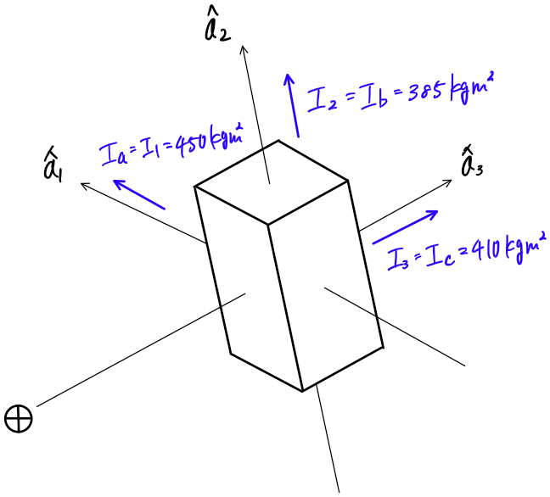

Region 7

Analysis

* Implementing the Lyapunov stability analysis only tells that Region 7 is marginally stable. However, with the numerical results, it is evident that the body is unstable with erratic behaviors observed in plots of precessions and inertial precession .

**Problem 4**: Discussion

1. Do you agree with outside sources that label the orientation in Region 1 as “stable”?

I do not agree with outside sources that label the orientation in Region 1 as “stable” because the stability chart in problem 1 only accounts for the linear analysis and does not extend to the nonlinear analyses done through numerical investigations.

Assume that the mission requires an orientation consistent with Regions 3, 4, 6 or 7. As the attitude control engineer, you are responsible for maintaining the orientation fixed relative to the orbit. Suggest some approaches you might employ to meet the requirements; justify your strategy (explain why it is useful to explore your concept).

Spin-stabilization

This approach makes the space vehicle itself to behave in a gyroscopic action because the rotating space vehicle’s mass is the key of the stabilizing mechanism. For this mechanism thrusters do exist to alter the spin rate depending on some occasions; however, the spinning in itself stabilizes the precession of the spacecraft to high precisions. The downside of this method is the continuous sweeping motion that may cause the complications of de-spinning some instruments that can only operate if it is directed correctly at the target and so forth.

3-axis stabilization

This is also a stabilizing system that is used in the real space missions. For this method, electrically powered reaction wheels/momentum wheels are mounted on the spacecraft. These wheels allows the distribution of angular momentum back in forth between the wheels and the vehicle. The wheels are rotatable to rotate the vehicle in the opposite direction with action/reaction law, but sometimes excessive momentum build up with this mechanism which requires the system to have a means to releasing or counteracting the torque on the vehicle.

1. Note: “Gravity gradient stabilization” is considered a passive technique to aid in attitude control. Gravity gradient stabilization of the original Space Shuttle, for example, employed the nominally Earth-pointing orientation without any interaction with the Reaction Control System (RCS). This orientation could be maintained over long periods of time in a quiet and contamination-free environment that can be highly desirable for observations, crew sleep periods, and similar activities. With which region was it likely to correspond? Could spin potentially aid gravity gradient stabilization?

It is likely that the space shuttle was within Region 1. For this region, the Lyapunov stability analysis tells us that it is the only Region that is marginally stable. For this case the orbital normal direction is aligned with the highest moment of inertia and the orbit radial direction is aligned with the smallest moment of inertia. The rotation, in theory, tries to end up spinning in the most efficient way in terms of energy, which means that the body’s rotation ends up spinning with the direction of the smallest moment of inertia. Thus, the spin applied to the vehicle can enable to keep the vehicle’s axis of rotation stay in the same principal moment direction.

How would your understanding of this problem influence your design of a spacecraft if it was desired to keep the vehicle fixed in the orbit frame? An early design for the Space Station included long massive booms that could be extended in the radial directions. What do you think was the purpose?

As aforementioned in the previous discussion above, it would be best to have the vehicle’s lowest moment of inertia direction be substantially smaller than the other two directions and aligned with the direction of the orbit radial. The moment of inertia is, in other words, the resistance to rotation and the orbit radial is in the direction that presumably has lowest torque applied, and therefore, it is best to have the lowest moment of inertia in this direction. What is more desirable is that, having the spacecraft face the earth with one face or be somewhat tidally locked with the Earth would indicate high stability and that is what I should be aiming for when designing a spacecraft.

The massive booms are possibly a means of increasing the moment of inertia in which the booms is aligned with directionally. This makes the moment of inertia in the orbit radial direction much smaller relative to the other two directions and aids stability.

1. The next step in this analysis would be to add the benefits of spin to our unsymmetric body that is required to be fixed in the orbit frame. Such is accomplished by adding a spinning rotor to the unsymmetric body. Reaction wheels, momentum wheels, and control moment gyros are all devices that leverage spin to maintain the orientation/attitude of unsymmetric bodies. Find a short definition of each of these types of spinning devices.

Reaction Wheel

It is a type of flywheel that is used to primarily used to rotate and provide another means of providing torque to the spacecraft in 2 directions. The mass of wheel is concentrated at the rim of the wheel to maximize the torque it can provide. It allows to the change the attitude of the spacecraft and the nominal rotation rate is zero. Thus, it is electrically powered to start and stop the rotation of the wheels.

Momentum Wheels

This is also a type of flywheel but rotates at a nominal fixed rate and rather at a high rate. This high rate of nominal rotation makes it immune to external torques compared to a vehicle with reaction wheels. However, this requires much more sophisticated motor systems and can have the risk of saturation.

Control Moment Gyros

It is a spinning rotor with gimbals that actuate with the tilting. It nominally rotates at a very high rate and takes advantage of the gyroscopic torque that is undesirable for the other two above. Abbreviated as CMG, this mechanism provides torque to the spacecraft by torqueing the CMG in the direction that is orthogonal to the CMG’s angular momentum vector and this results in a much more larger torque which is unobtainable with reaction wheels and momentum wheels. This adds more complexity to the system than momentum wheels and high rotation rates means more high precision controls. One more thing to note is that this device is very expensive.

Appendix

MATLAB CODE

## **AAE 440 PS11**

clear all; close all; clc;

fdir = 'C:\Users\Tomo\Desktop\studies\2020-Spring\AAE440\MATLAB\outputs\HW11';

set(groot, 'defaulttextinterpreter','latex');

set(groot, 'defaultAxesTickLabelInterpreter','latex');

set(groot, 'defaultLegendInterpreter','latex');

### 1b)

% Defining the object

Ia = 425; % [kg-m2]

Ib = 500; % [kg-m2]

Ic = 125; % [kg-m2]

% Orientation (i)

I1_i = Ia;

I2_i = Ic;

I3_i = Ib;

I_i = [I1_i I2_i I3_i];

% Orientation (ii)

I1_ii = Ia;

I2_ii = Ib;

I3_ii = Ic;

I_ii = [I1_ii I2_ii I3_ii];

% Orientation (iii)

I1_iii = Ib;

I2_iii = Ia;

I3_iii = Ic;

I_iii = [I1_iii I2_iii I3_iii];

% Orientation (iv)

I1_iv = Ic;

I2_iv = Ia;

I3_iv = Ib;

I_iv = [I1_iv I2_iv I3_iv];

% All orientations

Is = [I_i; I_ii; I_iii; I_iv];

% Compute K-values

Ks = zeros(size(Is));

for i = 1:size(Is,1)

Ks(i,:) = calc_Kvalues(Is(i,:));

end

Ks_T = array2table(Ks,"VariableNames",{'K1','K2','K3'});

writetable(Ks_T,fullfile(fdir,'Kvalues_table.xlsx'),"WriteMode","overwritesheet");

### 1c)

% All possible permutations/orientations

P_33 = perms(["a","b","c"]);

% Missing oreientations

% Orientation (v)

I1_v = Ib;

I2_v = Ic;

I3_v = Ia;

I_v= [I1_v I2_v I3_v];

% Orientation (vi)

I1_vi = Ic;

I2_vi = Ib;

I3_vi = Ia;

I_vi = [I1_vi I2_vi I3_vi];

% Add the missing orientations

Is_new = [Is; I_v; I_vi];

for i = 1:size(Is_new,1)

Ks_new(i,:) = calc_Kvalues(Is_new(i,:));

end

% Overwrite previous orientation table

Ks_T_new = array2table(Ks_new,"VariableNames",{'K1','K2','K3'});

writetable(Ks_T_new,fullfile(fdir,'Kvalues_table.xlsx'),"WriteMode","overwritesheet");

% K3-K1 stability chart

fig = figure("Renderer","painters");

for i = 1:size(Ks_new,1)

plot(Ks_new(i,3),Ks_new(i,1),'.',"MarkerSize",15)

if i == 1 hold on, end

end

v = [0 0; 1 0; 1 1; 0 1; 0 0; -1 0; -1 -1; 0 -1]; f = [1 2 3 4; 5 6 7 8];

patch("Faces",f,"Vertices",v,"FaceColor",'red','FaceAlpha',0.08);

A = linspace(-1,1); B = zeros(size(A));

plot(A,B,'--k',"LineWidth",0.8); plot(B,A,'--k',"LineWidth",0.8); hold off;

title('$K_3$-$K_1$ Stability Chart for All Orientations, Koike')

xlabel('$K_3$'); ylabel('$K_1$');

lgd = legend('i','ii','iii','iv','v','vi','unstable region',"Location","eastoutside");

lgd.FontSize = 6;

xlim([-1 1]); ylim([-1 1]); grid on; grid minor; box on;

saveas(fig,fullfile(fdir,"K3-K1_stability_chart.png"));

### 2d)

% Computing the eigenavlues for each orientation

lambda = zeros(7,length(Ks_new));

for i = 1:length(Ks_new)

lambda(:,i) = eigenvalues_unsymmBody(Ks_new(i,1), Ks_new(i,2), Ks_new(i,3));

end

lambda_arr = [lambda(:,1) lambda(:,2) lambda(:,3) ...

lambda(:,4) lambda(:,5) lambda(:,6)];

% Write array to excel sheet for convenience

b = arrayfun(@num2str,lambda_arr,'un',0);

xlswrite(fullfile(fdir,'eigenval_P2d.xlsx'),b);

### 2e)

% K3-K1 stability chart with stability constraints

fig = figure("Renderer","painters");

for i = 1:size(Ks_new,1)

plot(Ks_new(i,3),Ks_new(i,1),'.',"MarkerSize",15)

if i == 1 hold on, end

end

v = [0 0;1 0;1 1;0 1;0 0;-1 0;-1 -1;0 -1]; v2 = [-1 0;-1 1;0 0;0 0;0 -1;1 -1];

f = [1 2 3 4; 5 6 7 8]; f2 = [1 2 3; 4 5 6];

patch("Faces",f,"Vertices",v,"FaceColor",'red','FaceAlpha',0.08);

patch("Faces",f2,"Vertices",v2,"FaceColor",'red','FaceAlpha',0.08);

% Region 5

x = 0.1459:0.001:1;

roots = zeros(1,length(x));

for i = 1:length(x)

func = @(y) (1-x(i).*y+3.*y).^2 + 16.*x(i).*y;

roots(i) = fzero(func,0);

end

plot(x,roots, 'k-')

v3 = [0 0;1 0;1 -1]; f3 = [1 2 3];

patch("Faces",f3,"Vertices",v3,"FaceColor",'red','FaceAlpha',0.08);

A = linspace(-1,1); B = zeros(size(A));

plot(A,B,'--k',"LineWidth",0.8); plot(B,A,'--k',"LineWidth",0.8); hold off;

title('$K_3$-$K_1$ Stability Chart for All Orientations, Koike')

xlabel('$K_3$'); ylabel('$K_1$');

lgd = legend('i','ii','iii','iv','v','vi','unstable region',"Location","eastoutside");

lgd.FontSize = 6;

xlim([-1 1]); ylim([-1 1]); grid on; grid minor; box on;

% Add texts

text(-0.25,0.63,'1',"FontSize",20,"FontWeight","bold","Color",'m');

text(-0.71,0.21,'2',"FontSize",20,"FontWeight","bold","Color",'m');

text(-0.45,-0.42,'3',"FontSize",20,"FontWeight","bold","Color",'m');

text(0.25,-0.65,'4',"FontSize",20,"FontWeight","bold","Color",'m');

text(0.63,-0.41,'5',"FontSize",20,"FontWeight","bold","Color",'m');

text(0.25,0.65,'6',"FontSize",20,"FontWeight","bold","Color",'m');

text(0.15,-0.10,'7',"FontSize",20,"FontWeight","bold","Color",'m');

saveas(fig,fullfile(fdir,"K3-K1_stability_chart2.png"));

close all;

### 3c)

K1 = Ks_new(:,1).';

K2 = Ks_new(:,2).';

K3 = Ks_new(:,3).';

N = length(K1);

for k = 1:2

% Revolutions

v = [2 10];

rev = 0:0.003:v(k);

for j = 1:N % for different orientations

for i = 1:3 % for different intial w

w1 = [0 0.12 0.06]; w2 = [1 1 1]; w3 = [0 0.12 0.06];

w0 = [w1(i) w2(i) w3(i)]; % initial angular velocities

e0 = [0 0 0 1]; % initial euler parameters

y = [w0 e0 0]; % Initial Conditions

% Nutation and Precession History

[rev, Nut, Prec] = Nut_Prec_UnsymmBody(rev,y,K1(j),K2(j),K3(j));

% Plotting Precession Angle

figure(j)

hold on;

if i == 1

plot(rev, Prec,'-','DisplayName','particular sol')

else

plot(rev, Prec,'-','DisplayName',['comparison sol ',num2str(i-1)])

end

% Plotting Inertial Precession Angle

sigma = 360*rev;

beta = Prec+sigma;

figure(j+N)

hold on;

if i == 1

plot(rev, beta,'-','DisplayName','particular sol')

else

plot(rev, beta,'-','DisplayName',['comparison sol ',num2str(i-1)])

end

end

fig1 = figure(j);

xlabel('$\nu$ [revolutions]');

ylabel('Precession $\alpha$ [deg]')

grid on; grid minor; box on; legend;

str = sprintf('Precession for Orientation %d, Koike',j);

title(str)

str = sprintf('3.(c)Alpha_ori%d_rev%d.png',j,v(k));

saveas(fig1, fullfile(fdir, str));

fig2 = figure(j+N);

xlabel('$\nu$ [revolutions]');

ylabel('Inertial Precession $\beta$ [deg]')

grid on; grid minor; box on; legend;

str = sprintf('Inertial Precession for Orientation %d, Koike',j);

title(str)

str = sprintf('3.(c)Beta_ori%d_rev%d.png',j,v(k));

saveas(fig2, fullfile(fdir, str));

end

close all;

end

## **3e)**

% Modified Moment of Inertia [kg m2]

I_a = 450; I_b = 385; I_c = 410;

% Shape Factors for the Modified Vehicle in Region 7

[K1_reg7, K2_reg7, K3_reg7] = K_from_orientation(I_a, I_b, I_c);

% K3-K1 Stability Chart

fig = figure(1);

hold on

plot(K3_reg7,K1_reg7,'r.',"MarkerSize",30)

% Region 3 & 6

v = [0 0;1 0;1 1;0 1;0 0;-1 0;-1 -1;0 -1]; f = [1 2 3 4; 5 6 7 8];

patch("Faces",f,"Vertices",v,"FaceColor",'red','FaceAlpha',0.08);

% Region 2 & 4

v2 = [-1 0;-1 1;0 0;0 0;0 -1;1 -1]; f2 = [1 2 3; 4 5 6];

patch("Faces",f2,"Vertices",v2,"FaceColor",'red','FaceAlpha',0.08);

% Separating Region 5 & 7

x = 0.1459:0.001:1;

roots = zeros(1,length(x));

for i = 1:length(x)

func = @(y) (1-x(i).*y+3.*y).^2 + 16.*x(i).*y;

y0 = 0;

roots(i) = fzero(func,y0);

end

plot(x,roots, 'k-')

% Region 5 & 7

v3 = [0 0;1 0;1 -1]; f3 = [1 2 3];

patch("Faces",f3,"Vertices",v3,"FaceColor",'red','FaceAlpha',0.08);

% Figure Properties

title('$K_3$-$K_1$ Stability Chart with All Orientations, Koike')

xlabel('$K_3$'); ylabel('$K_1$');

lgd = legend('Modified Vehicle','Unstable Region',"Location","eastoutside");

lgd.FontSize = 6;

grid on; grid minor; axis equal; axis([-1 1 -1 1]);

% Region Numbers

text(-0.2,0.6,'1',"FontSize",20,"Color",'k');

text(-0.6,0.2,'2',"FontSize",20,"Color",'k');

text(-0.4,-0.4,'3',"FontSize",20,"Color",'k');

text(0.2,-0.6,'4',"FontSize",20,"Color",'k');

text(0.6,-0.2,'5',"FontSize",20,"Color",'k');

text(0.4,0.4,'6',"FontSize",20,"Color",'k');

text(0.3,-0.05,'7',"FontSize",15,"Color",'k');

saveas(fig,fullfile(fdir,"3.(e)K3-K1_stability_chart_region7.png"));

close all;

% Plotting Precessions for Modified Vehicle

rev = 0:0.001:10;

for i = 1:3 % for different intial w

w1 = [0 0.12 0.06]; w2 = [1 1 1]; w3 = [0 0.12 0.06];

w0 = [w1(i) w2(i) w3(i)]; % initial angular velocities

e0 = [0 0 0 1]; % initial euler parameters

y = [w0 e0 0]; % Initial Conditions

% Nutation and Precession History

[rev, Nut, Prec] = Nut_Prec_UnsymmBody(rev,y,K1_reg7,K2_reg7,K3_reg7);

% Plotting Precession Angle

figure(1)

hold on;

if i == 1

plot(rev, Prec,'-','DisplayName','particular sol')

else

plot(rev, Prec,'-','DisplayName',['comparison sol ',num2str(i-1)])

end

% Plotting Inertial Precession Angle

sigma = 360*rev;

beta = Prec+sigma;

figure(2)

hold on;

if i == 1

plot(rev, beta,'-','DisplayName','particular sol')

else

plot(rev, beta,'-','DisplayName',['comparison sol ',num2str(i-1)])

end

end

fig1 = figure(1);

xlabel('$\nu$ [revolutions]');

ylabel('Precession $\alpha$ [deg]')

grid on; grid minor; box on; legend;

str = sprintf('Precession for for the Modified Vehicle, Koike');

title(str)

str = sprintf('3.(e)Alpha_reg7.png');

saveas(fig1, fullfile(fdir, str));

fig2 = figure(2);

xlabel('$\nu$ [revolutions]');

ylabel('Inertial Precession $\beta$ [deg]')

grid on; grid minor; box on; legend;

str = sprintf('Inertial Precession for the Modified Vehicle, Koike');

title(str)

str = sprintf('3.(e)Beta_reg7.png');

saveas(fig2, fullfile(fdir, str));

### Functions

function Ks = calc_Kvalues(I)

I1 = I(1); I2 = I(2); I3 = I(3);

K1 = (I2 - I3)/I1;

K2 = (I3 - I1)/I2;

K3 = (I1 - I2)/I3;

Ks = [K1 K2 K3];

end

clear all; close all; clc;

fdir = 'C:\Users\Tomo\Desktop\studies\2020-Spring\AAE440\MATLAB\outputs\HW11';

set(groot, 'defaulttextinterpreter','latex');

set(groot, 'defaultAxesTickLabelInterpreter','latex');

set(groot, 'defaultLegendInterpreter','latex');

## **Extra for region 6**

% Define Moment of Inertia [kg m2]

I_1 = 500; I_2 = 425; I_3 = 125;

% Shape factors

[K1, K2, K3] = K_from_orientation(I_1, I_2, I_3); % (ii)

N = length(K1);

% K3 -K1 stability chart

f = 1; % scale factor

fig = figure(1);

hold on

plot(K3,K1,'r.',"MarkerSize",30)

% Region 3 & 6

v1 = [0 0;f 0;f f;0 f;0 0;-f 0;-f -f;0 -f]; f1 = [1 2 3 4; 5 6 7 8];

patch("Faces",f1,"Vertices",v1,"FaceColor",'blue','FaceAlpha',0.08);

% Region 2 & 4

v2 = [-f 0;-f f;0 0;0 0;0 -f;f -f]; f2 = [1 2 3; 4 5 6];

patch("Faces",f2,"Vertices",v2,"FaceColor",'blue','FaceAlpha',0.08);

% Separating Region 5 & 7

x = 0.1459:0.001:f;

roots = zeros(1,length(x));

for i = 1:length(x)

func = @(y) (1-x(i).*y+3.*y).^2 + 16.*x(i).*y;

y0 = 0;

roots(i) = fzero(func,y0);

end

plot(x,roots, 'k-')

% Region 5 & 7

v3 = [0 0;f 0;f -f]; f3 = [1 2 3];

patch("Faces",f3,"Vertices",v3,"FaceColor",'blue','FaceAlpha',0.08);

% Figure Properties

title('$K_3$-$K_1$ Stability Chart , Koike')

xlabel('$K_3$'); ylabel('$K_1$');

lgd = legend('Vehicle Orientation','Unstable Region',"Location","northeastoutside");

lgd.FontSize = 6;

grid on; grid minor; axis equal; axis([-f f -f f]);

% Region Numbers

text(-0.2*f,0.6*f,'1',"FontSize",20,"Color",'k');

text(-0.6*f,0.2*f,'2',"FontSize",20,"Color",'k');

text(-0.4*f,-0.4*f,'3',"FontSize",20,"Color",'k');

text(0.2*f,-0.6*f,'4',"FontSize",20,"Color",'k');

text(0.6*f,-0.2*f,'5',"FontSize",20,"Color",'k');

text(0.4*f,0.4*f,'6',"FontSize",20,"Color",'k');

text(0.3,-0.05,'7',"FontSize",15,"Color",'k');

str = sprintf("K3-K1_stability_chart_K1=%.2f_K2=%.2f_K3=%.2f.png",K1,K2,K3);

saveas(fig,fullfile(fdir,str));

close all;

% Revolutions

v = 50; revN = length(v);

gamma0 = 0;

for k = 1:revN

rev = 0:0.003:v(k);

for j = 1:N % for different orientations

for i = 1:3 % for different intial w

w1 = [0 0.12 0.06]; w2 = [0 1 1]; w3 = [0 0.12 0.06];

w0 = [w1(i) w2(i) w3(i)]; % initial angular velocities

e0 = [sind(gamma0/2) 0 0 cosd(gamma0/2)]; % initial euler parameters

y = [w0 e0 0]; % Initial Conditions

% Nutation and Precession History

[rev, Nut, Prec] = Nut_Prec_UnsymmBody(rev,y,K1(j),K2(j),K3(j));

% Plotting Precession Angle

figure(j)

hold on;

if i == 1

plot(rev, Prec,'-','DisplayName','particular sol')

else

plot(rev, Prec,'-','DisplayName',['comparison sol ',num2str(i-1)])

end

% Plotting Inertial Precession Angle

sigma = 360*rev;

beta = Prec+sigma;

figure(j+N)

hold on;

if i == 1

plot(rev, beta,'-','DisplayName','particular sol')

else

plot(rev, beta,'-','DisplayName',['comparison sol ',num2str(i-1)])

end

end

fig1 = figure(j);

xlabel('$\nu$ [revolutions]');

ylabel('Precession $\alpha$ [deg]')

grid on; grid minor; box on; lgd = legend;

lgd.Location = 'southwest';

str = sprintf('Precession for K1=%.2f K2=%.2f K3=%.2f',K1(j),K2(j),K3(j));

str = sprintf('Precession for Region 6, Koike');

title(str)

str = sprintf('SIM_Alpha_K1=%.2f_K2=%.2f_K3=%.2f_rev%d_nut=%d.png',K1(j),K2(j),K3(j),v(k),gamma0);

saveas(fig1, fullfile(fdir, str));

fig2 = figure(j+N);

xlabel('$\nu$ [revolutions]');

ylabel('Inertial Precession $\beta$ [deg]')

grid on; grid minor; box on; legend;

str = sprintf('Inertial Precession for K1=%.2f K2=%.2f K3=%.2f',K1(j),K2(j),K3(j));

str = sprintf('Inertial Precession for Region 6, Koike');

title(str)

str = sprintf('SIM_Beta_K1=%.2f_K2=%.2f_K3=%.2f_rev%d_nut=%d.png',K1(j),K2(j),K3(j),v(k),gamma0);

saveas(fig2, fullfile(fdir, str));

end

close all;

end

function [K_1, K_2, K_3] = K_from_orientation(I_1, I_2, I_3)

%{

Function: K_from_orientation()

Author: Tomoki Koike

Description: This function outputs shape factors based on user specified

orientation

>>Inputs

I1: Moment of Inertia 1

I2: Moment of Inertia 2

I3: Moment of Inertia 3

Outputs<<

K1: Shape factor 1

K2: Shape factor 2

K3: Shape factor 3

%}

K_1 = (I_2 - I_3)/I_1;

K_2 = (I_3 - I_1)/I_2;

K_3 = (I_1 - I_2)/I_3;

end

function lambdas = eigenvalues_unsymmBody(K_1, K_2, K_3)

%{

Function: eigenvalues_unsymmBody()

Author: Tomoki Koike

Description: This function outputs eigenvalues per omega for unsymmetric bodies

>>Inputs

K1: shape factor 1

K2: shape factor 2

K3: shape factor 3

Outputs<<

lambdas: eigenvalues

%}

% Simplification

b = (1 - K_1*K_3 + 3*K_1)/2;

c = -4*K_1*K_3;

% Eigenvalues

lambdas = [ 0 ;

sqrt(3*K_2) ;

-sqrt(3*K_2) ;

sqrt((-b + sqrt(b^2-c)));

-sqrt((-b + sqrt(b^2-c)));

sqrt((-b - sqrt(b^2-c)));

-sqrt((-b - sqrt(b^2-c)))];

end

function dy = EOM_nond_unsymmBody(v,y,K1,K2,K3)

%{

Function: EOM_nond_unsymmBody()

Author: Tomoki Koike

Description: Nondimensionalized EOM for an unsymmetric body

>>Inputs

v: number of revolutions

y: nond angular velocities, euler parameters

K1: shape factor 1

K2: shape factor 2

K3: shape factor 3

Outputs<<

dy: differential y

%}

dy = zeros(8,1);

% nond Dynamic EOMs

dy(1) = 2*pi*K1*(y(2)*y(3) - 6*(y(5)*y(6) + y(4)*y(7))*(1 - 2*y(4)^2 - 2*y(5)^2));

dy(2) = 2*pi*K2*(y(1)*y(3) - 6*(y(6)*y(4) - y(5)*y(7))*(1 - 2*y(4)^2 - 2*y(5)^2));

dy(3) = 2*pi*K3*(y(2)*y(1) - 12*(y(6)*y(4) - y(5)*y(7))*(y(5)*y(6) + y(4)*y(7)));

% nond Kinematical EOMs

dy(4) = pi*( y(1)*y(7) - (y(2) + 1)*y(6) + y(3)*y(5));

dy(5) = pi*( y(1)*y(6) + (y(2) - 1)*y(7) - y(3)*y(4));

dy(6) = pi*(-y(1)*y(5) + (y(2) + 1)*y(4) + y(3)*y(7));

dy(7) = pi*(-y(1)*y(4) - (y(2) - 1)*y(5) - y(3)*y(6));

% K - K0: Euler Constraint

dy(8) = EulerConstraint(y(4),y(5),y(6),y(7));

end

function [rev, Nut, Prec] = Nut_Prec_UnsymmBody(rev,y,K1,K2,K3)

%{

Function: Nut_Prec_UnsymmBody()

Author: Tomoki Koike

Descriptions: DE computing nutation and precession history of

unsymmertic body

>>Inputs

rev: number of revolutions

y: Initial conditions

K1: shape factor 1

K2: shape factor 2

K3: shape factor 3

Outputs<<

rev: revolutions

Nut: Nutation angle history

Prec: Culmulative Precession angle history

%}

% Numerical Integration

opt = odeset('RelTol', 1e-13, 'AbsTol', 1e-13);

[rev, data] = ode45(@(v,y) EOM_nond_unsymmBody(rev,y,K1,K2,K3),rev,y,opt);

% Calculating Nutation angle

Nut = acosd(1-2*data(:,6).^2-2*data(:,4).^2);

% Calculating Precession angle

C12 = 2.*(data(:,4).*data(:,5)-data(:,6).*data(:,7));

C32 = 2.*(data(:,5).*data(:,6)+data(:,4).*data(:,7));

Prec = zeros([length(rev),1]);

if y(1) ~= 0

for i = 1:length(rev)

if i == 1

continue

else

Prec1 = round([ acosd(C32(i)/sind(Nut(i))), ...

-acosd(C32(i)/sind(Nut(i))), ...

-acosd(C32(i)/sind(Nut(i)))],4);

Prec2 = round([ asind(C12(i)/sind(Nut(i))), ...

180-asind(C12(i)/sind(Nut(i))), ...

-180-asind(C12(i)/sind(Nut(i)))],4);

Prec(i) = intersect(Prec1, Prec2);

end

end

end

% Culmulative Precession

Prec = unwrap(Prec);

end