AAE 440: Spacecraft Attitude Dynamics

PS3: Successive Rotations and Orientational Angles

Tomoki Koike

Friday February 7, 2020

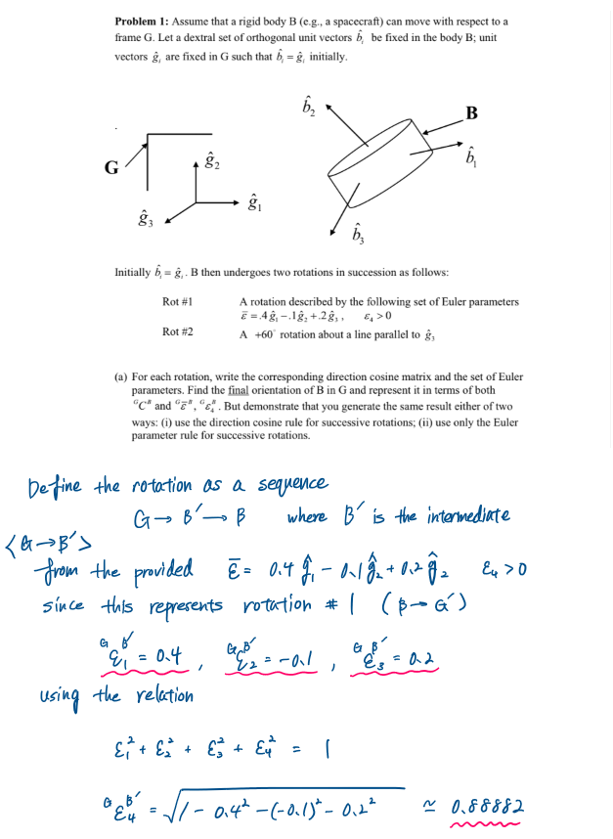

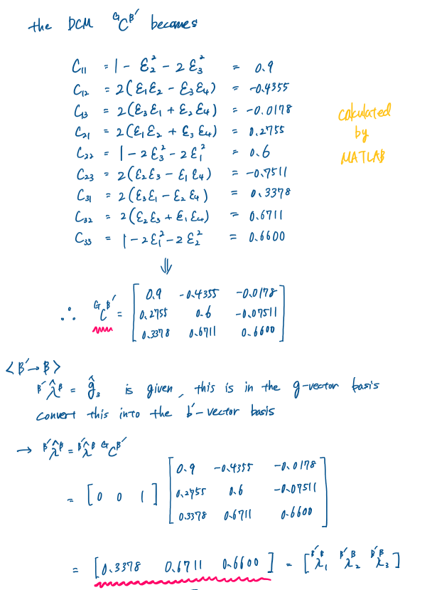

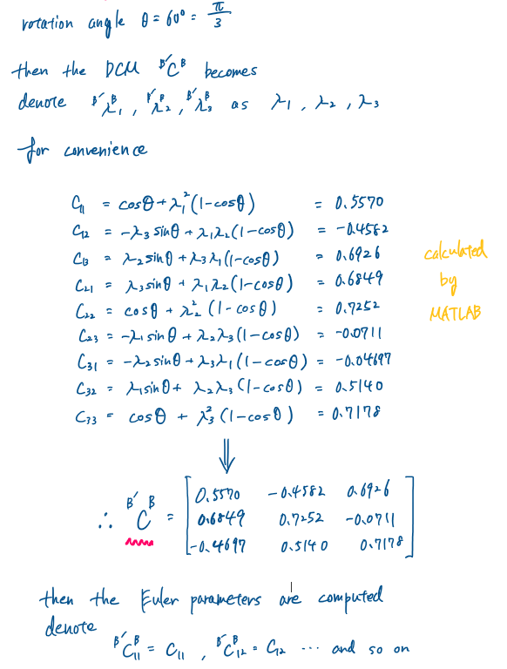

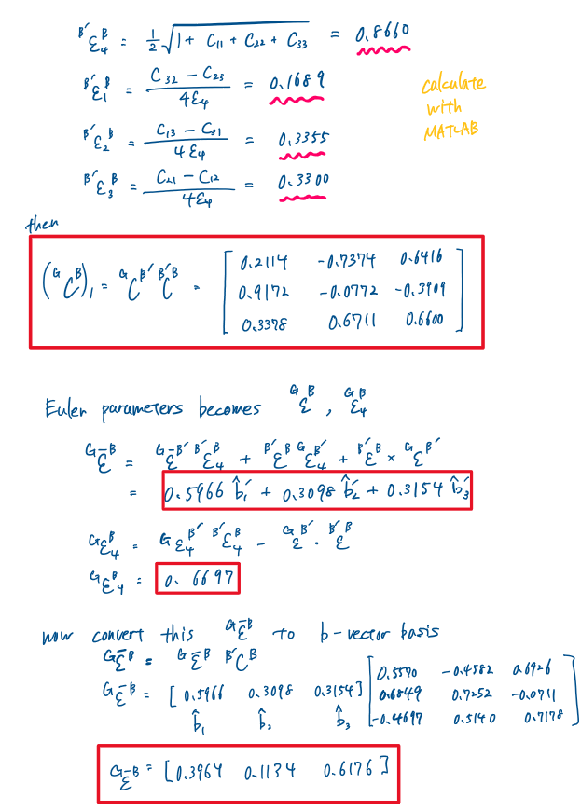

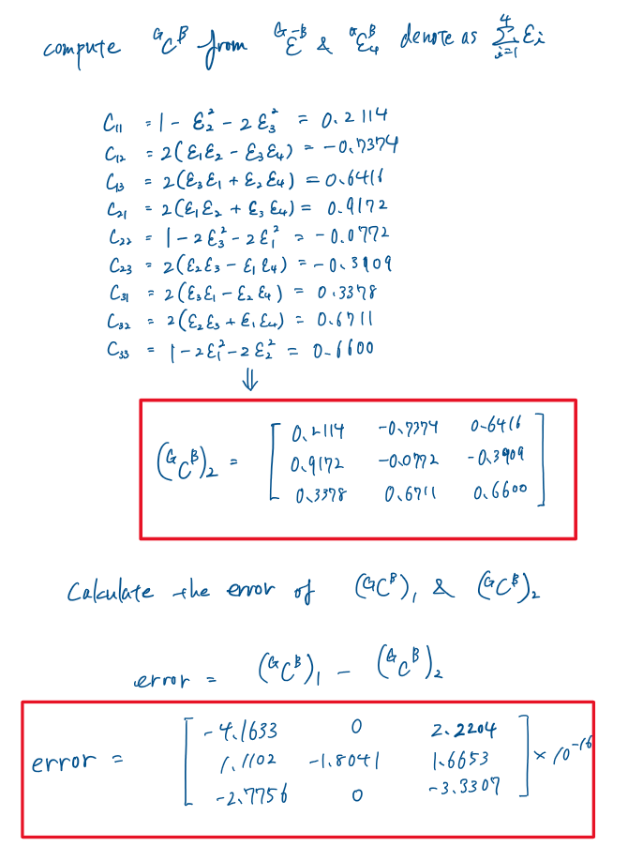

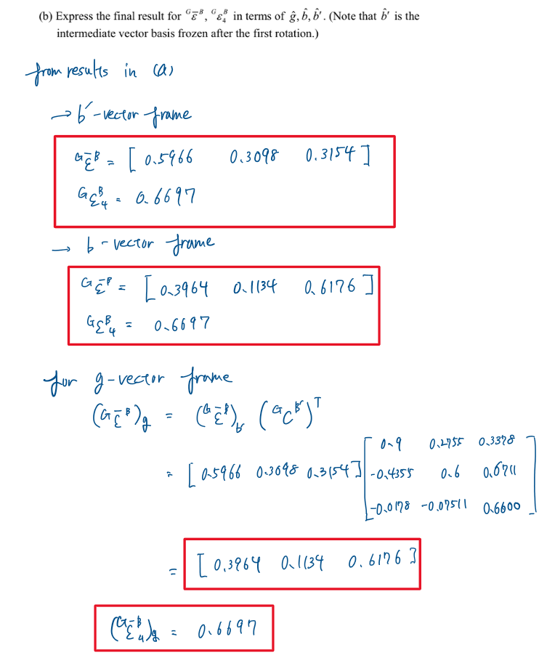

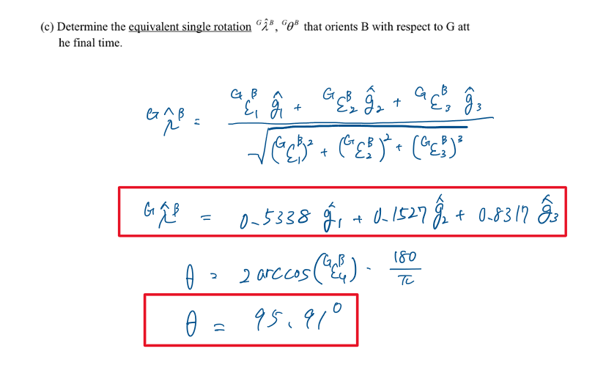

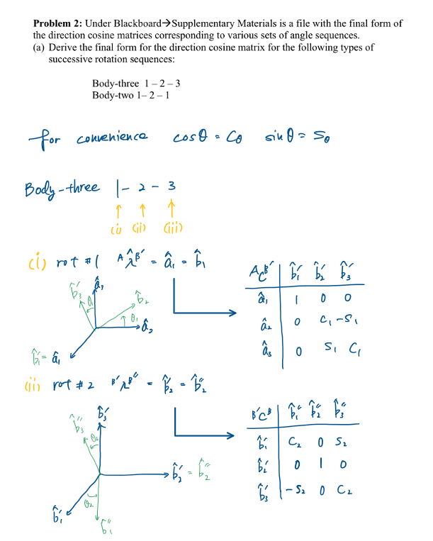

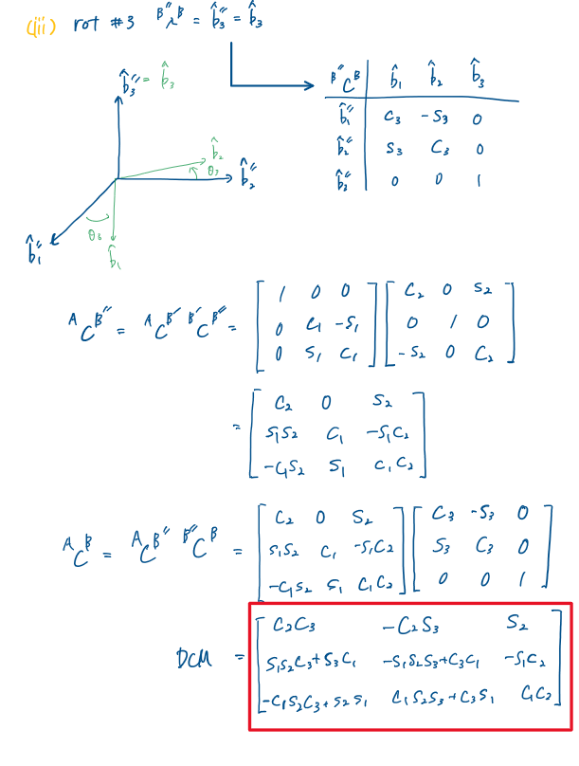

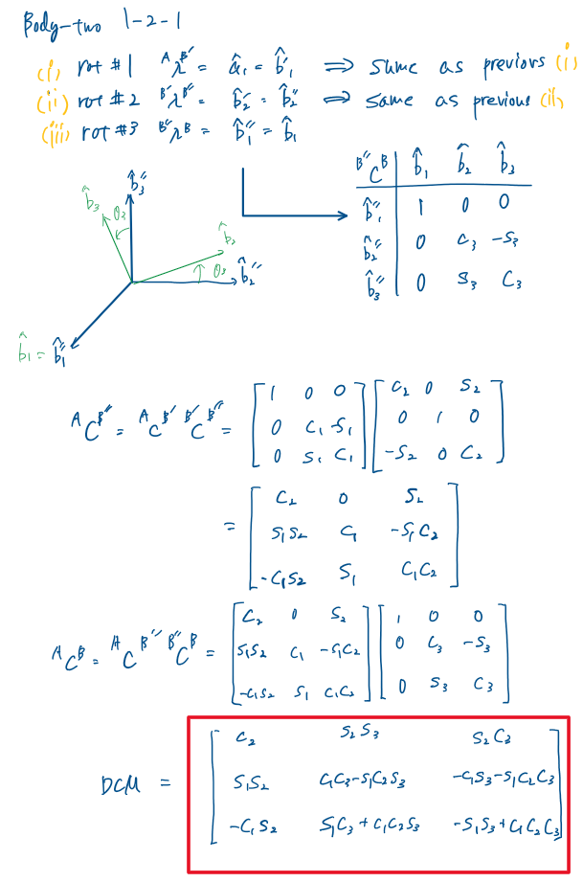

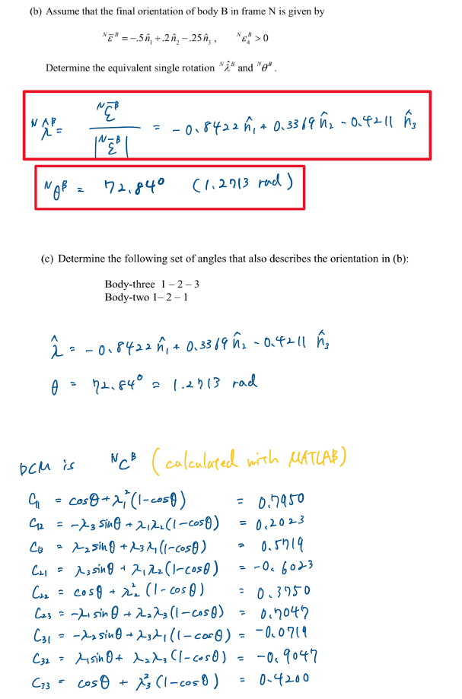

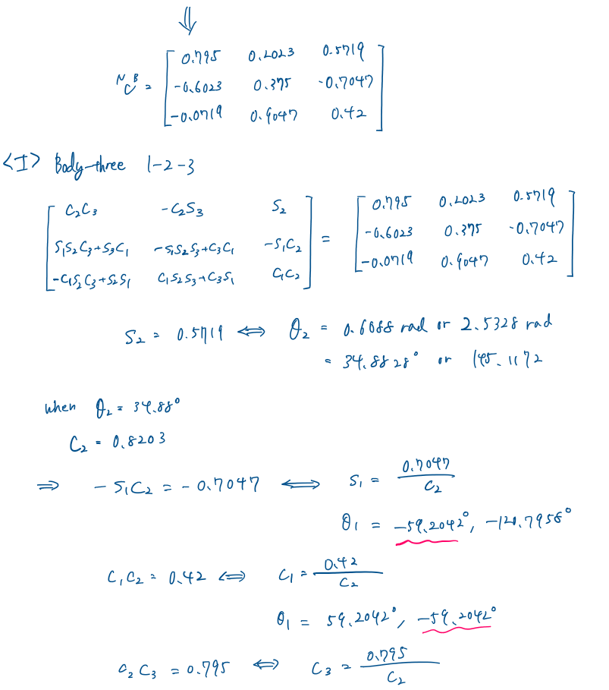

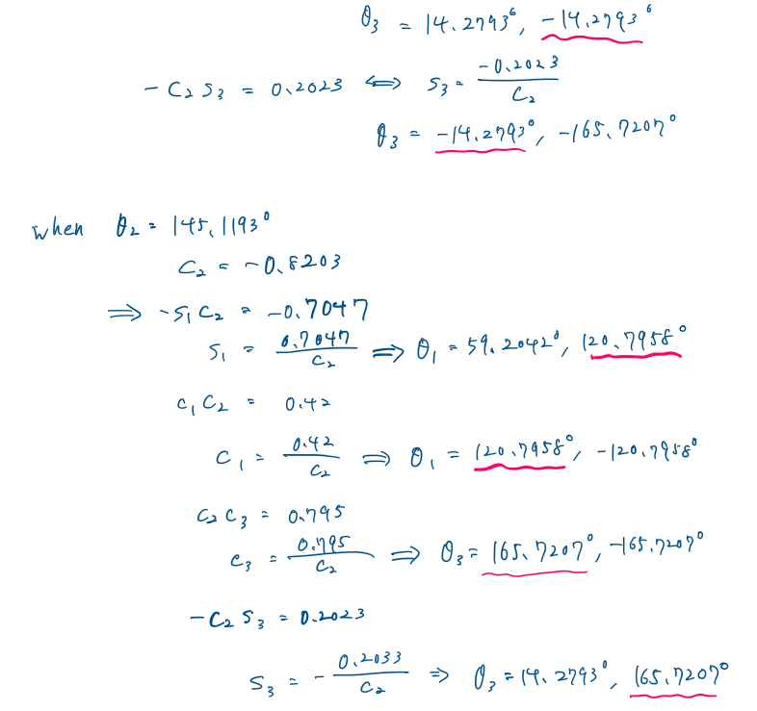

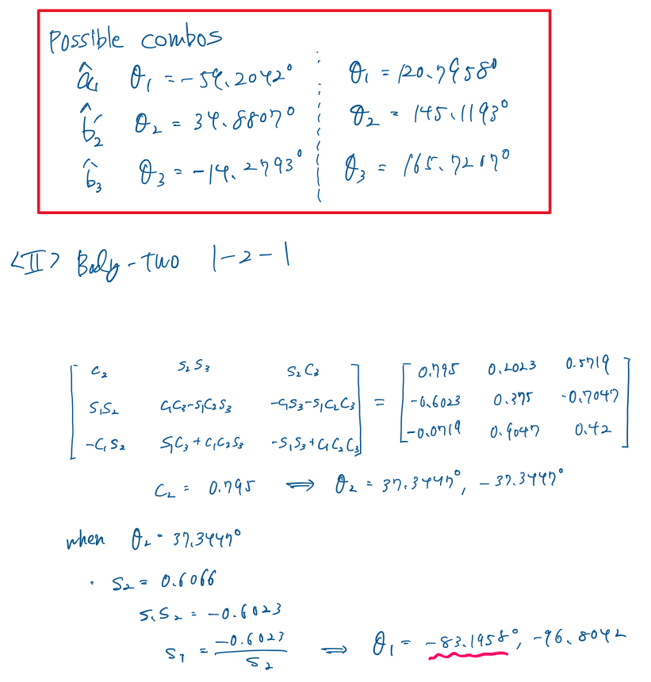

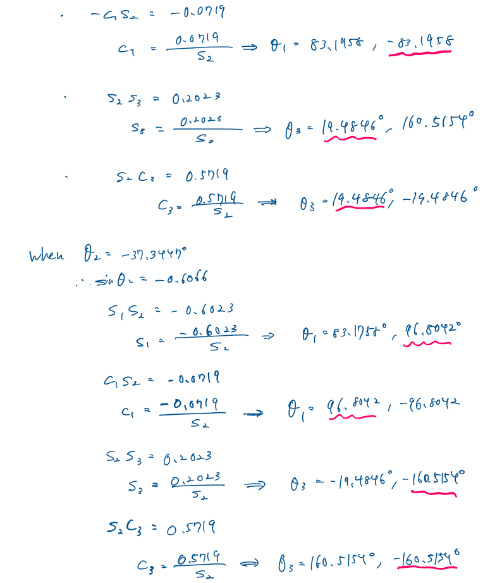

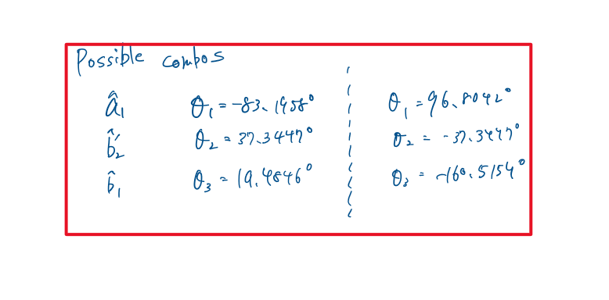

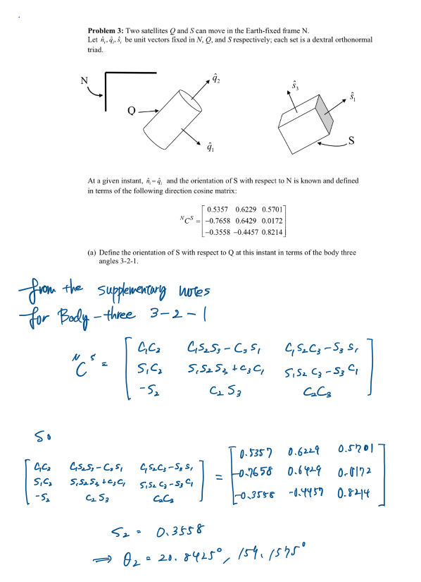

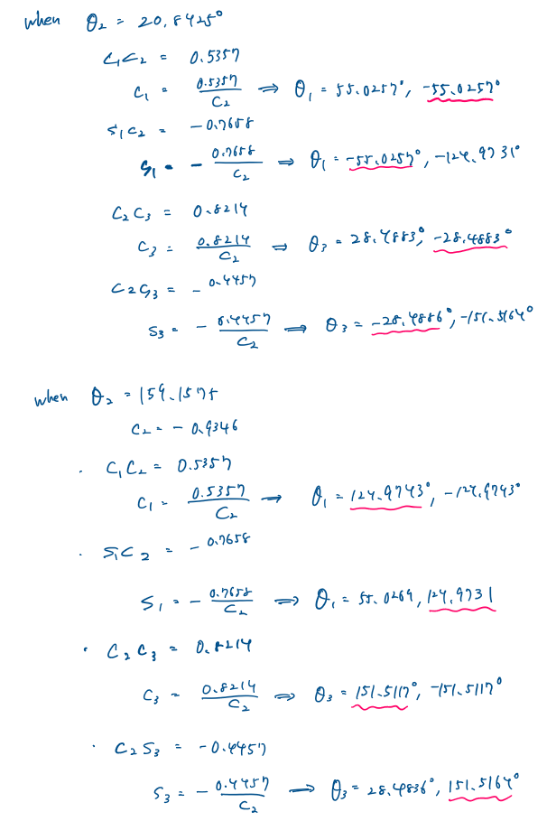

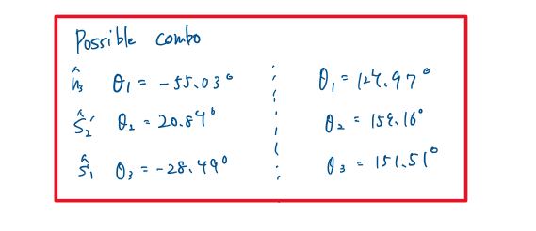

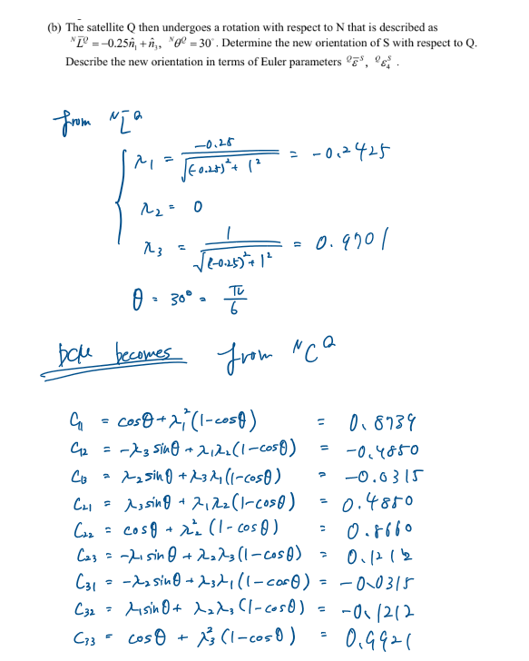

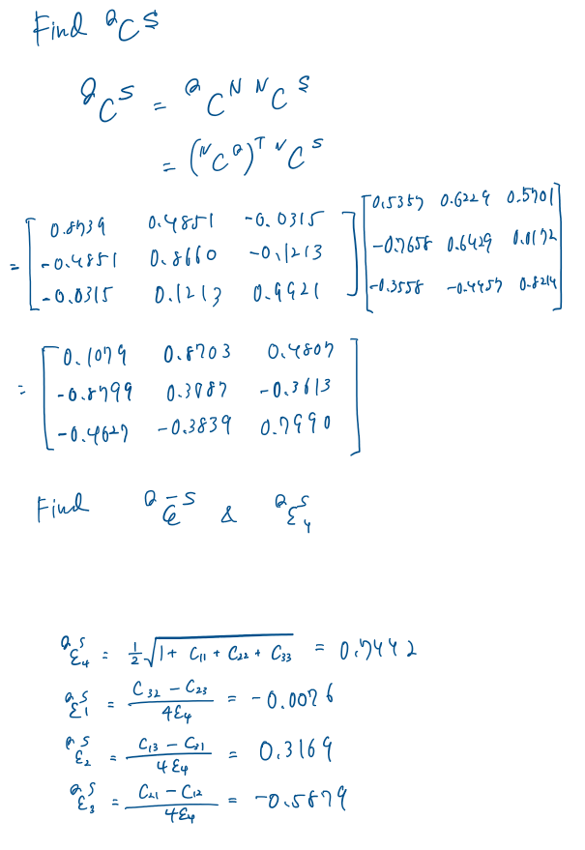

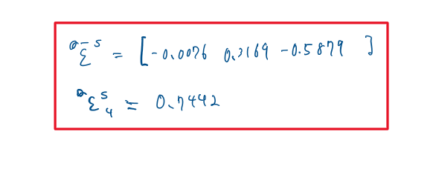

Appendix

AAE440 PS3 MATLAB CODE

**problem 1**

clear all; close all; clc;

**<a>**

% Rot#1 (G->B')

% Define the Euler Parameters/epsilons

e1_1 = 0.4;

e1_2 = -0.1;

e1_3 = 0.2;

e1_4 = sqrt(1-e1_1^2-e1_2^2-e1_3^2);

% Set as vector

e1 = [e1_1,e1_2,e1_3,e1_4];

% Compute the DCM

C_1 = DCM_euler_para(e1);

% Rot#2 (B'->B)

lambda_g = [0 0 1]; % in g vector basis

lambda_b_prime = lambda_g*C_1; % in b' vector basis

theta = pi/3; % rotation angle in radians

% Update DCM with next rotation

C_2 = DCM_lambda_theta(lambda_b_prime,theta);

% Compute the Euler parameters

e2 = epsilons_with_DCM(C_2);

% Compute the overall DCM

C = C_1*C_2;

% Compute the successive Euler parameter

e_new_Bprime = eulerPara_successive_rot(e1, e2);

% Convert this to b-vector basis

e_new_vec = e_new_Bprime(1:3)*C_2;

e_new_B = [e_new_vec e_new_Bprime(4)];

C_final = DCM_euler_para(e_new_B);

% Calculating the error

C_error = C - C_final;

**<b>**

% Epsilon in g frame

e_g = e_new_Bprime(1:3)*C_1.';

**<c>**

% Compute the lambda and theta for one single rotation

e_g = [e_g e_new_Bprime(4)];

[lambda_SRT, theta_SRT] = lambda_and_theta_fromEpsilon(e_g);

% Covnert radians to degrees

theta_SRT = theta_SRT/pi*180;

**problem 2**

clear all; close all; clc

**<b>**

e_NB = [-0.5 0.2 -0.25];

e_NB_4 = sqrt(1 - sum(e_NB.^2));

e_NB = [e_NB e_NB_4];

% Compute the lambda and theta for SRT

[lambda_NB theta_NB] = lambda_and_theta_fromEpsilon(e_NB);

% Convert lambda to degrees from radians

theta_NB_deg = theta_NB*180/pi;

**<b>**

% Calculating the DCM

C_NB = DCM_lambda_theta(lambda_NB, theta_NB);

**problem 3**

**<b>**

clear all; close all; clc;

L = [-0.25 0 1];

theta = pi/6;

lambdas = zeros([1 3]);

lambdas(1) = L(1)/sqrt(L(1)^2+L(2)^2+L(3)^2);

lambdas(2) = L(2)/sqrt(L(1)^2+L(2)^2+L(3)^2);

lambdas(3) = L(3)/sqrt(L(1)^2+L(2)^2+L(3)^2);

% DCM from N basis to Q basis

C_NQ = DCM_lambda_theta(lambdas, theta);

% DCM from N basis to S basis

C11 = 0.5357;

C12 = 0.6229;

C13 = 0.5701;

C21 = -0.7658;

C22 = 0.6429;

C23 = 0.0172;

C31 = -0.3558;

C32 = -0.4457;

C33 = 0.8214;

C_NS = [C11 C12 C13; C21 C22 C23; C31 C32 C33];

% Compute the DCM from Q to S

C_QS = C_NQ.'*C_NS

% Compute epsilons for Q to S basis

epsilon = epsilons_with_DCM(C_QS);

function C_mat = DCM_euler_para(epsilons)

% Epsilon vector

epsilon1 = epsilons(1);

epsilon2 = epsilons(2);

epsilon3 = epsilons(3);

epsilon4 = epsilons(4);

% Calculating DCM with Euler parameters

C11 = 1 - 2*epsilon2^2 - 2*epsilon3^2;

C12 = 2*(epsilon1*epsilon2 - epsilon3*epsilon4);

C13 = 2*(epsilon3*epsilon1 + epsilon2*epsilon4);

C21 = 2*(epsilon1*epsilon2 + epsilon3*epsilon4);

C22 = 1 - 2*epsilon3^2 - 2*epsilon1^2;

C23 = 2*(epsilon2*epsilon3 - epsilon1*epsilon4);

C31 = 2*(epsilon3*epsilon1 - epsilon2*epsilon4);

C32 = 2*(epsilon2*epsilon3 + epsilon1*epsilon4);

C33 = 1 - 2*epsilon1^2 - 2*epsilon2^2;

C_mat = [C11 C12 C13; C21 C22 C23; C31 C32 C33];

end

function C_mat = DCM_lambda_theta(lambdas, theta)

% Lambda vector

lambda1 = lambdas(1);

lambda2 = lambdas(2);

lambda3 = lambdas(3);

% Calculating DCM with lambdas and theta

C11 = cos(theta) + lambda1^2*(1-cos(theta));

C12 = -lambda3*sin(theta) + lambda1*lambda2*(1-cos(theta));

C13 = lambda2*sin(theta) + lambda3*lambda1*(1-cos(theta));

C21 = lambda3*sin(theta) + lambda1*lambda2*(1-cos(theta));

C22 = cos(theta) + lambda2^2*(1-cos(theta));

C23 = -lambda1*sin(theta) + lambda2*lambda3*(1-cos(theta));

C31 = -lambda2*sin(theta) + lambda3*lambda1*(1-cos(theta));

C32 = lambda1*sin(theta) + lambda2*lambda3*(1-cos(theta));

C33 = cos(theta) + lambda3^2*(1-cos(theta));

C_mat = [C11 C12 C13; C21 C22 C23; C31 C32 C33];

end

function epsilons = epsilons_with_DCM(C_mat)

epsilon4 = 0.5*sqrt(1+C_mat(1,1)+C_mat(2,2)+C_mat(3,3));

epsilon1 = (C_mat(3,2)-C_mat(2,3))/4/epsilon4;

epsilon2 = (C_mat(1,3)-C_mat(3,1))/4/epsilon4;

epsilon3 = (C_mat(2,1)-C_mat(1,2))/4/epsilon4;

epsilons = [epsilon1 epsilon2 epsilon3 epsilon4];

end

function e_new = eulerPara_successive_rot(e1, e2)

e1_v = e1(1:3);

e1_4 = e1(4);

e2_v = e2(1:3);

e2_4 = e2(4);

% Calculate the successive epsilon

e_v_new = e1_v*e2_4 + e2_v*e1_4 + cross(e2_v, e1_v);

e4_new = e1_4 * e2_4 - dot(e1_v,e2_v);

e_new = [e_v_new e4_new];

end

function [lambda, theta] = lambda_and_theta_fromEpsilon(epsilons)

% Calculating the lambda unit vector and the angle theta for a simple

% rotation using the epsilon values

e_vec = epsilons(1:3);

e4 = epsilons(4);

% compute lambda

lambda = e_vec / sqrt(sum(e_vec.^2));

theta = 2*acos(e4);

end