AAE440: Space Attitude Dynamics

HW4: Kinematical Differentials & Orientations

Dr. Howell

Tomoki Koike

Friday February 14, 2020

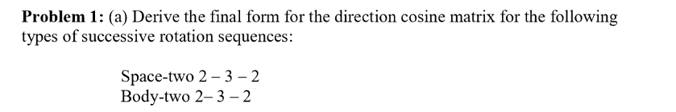

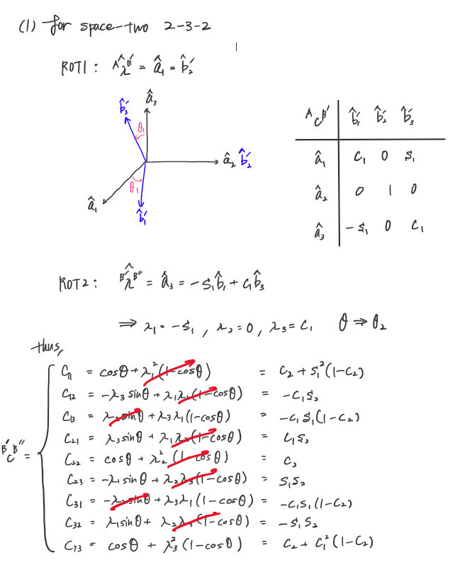

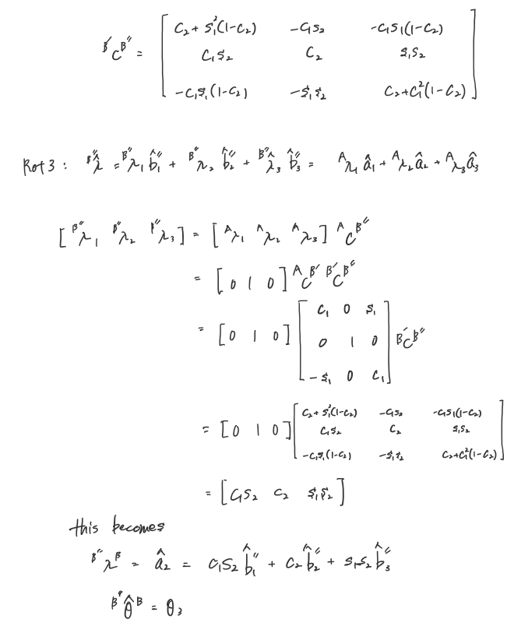

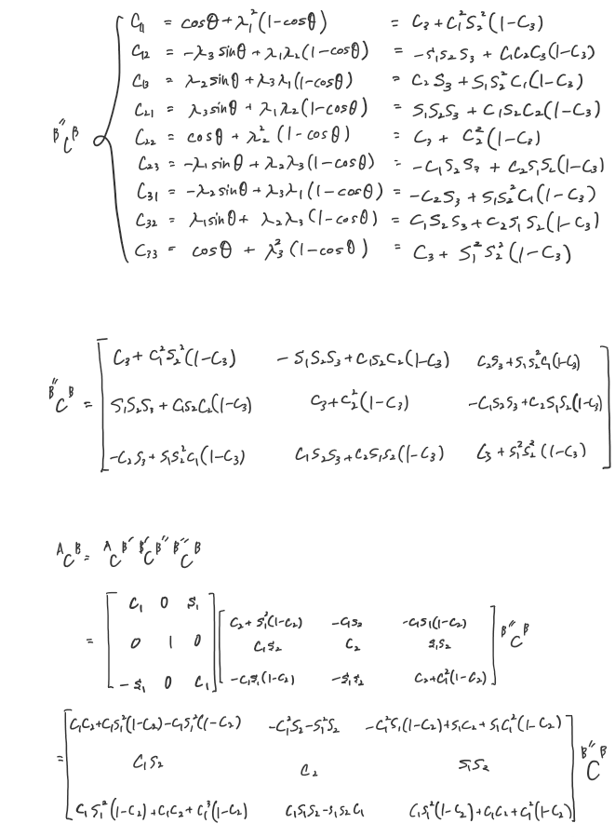

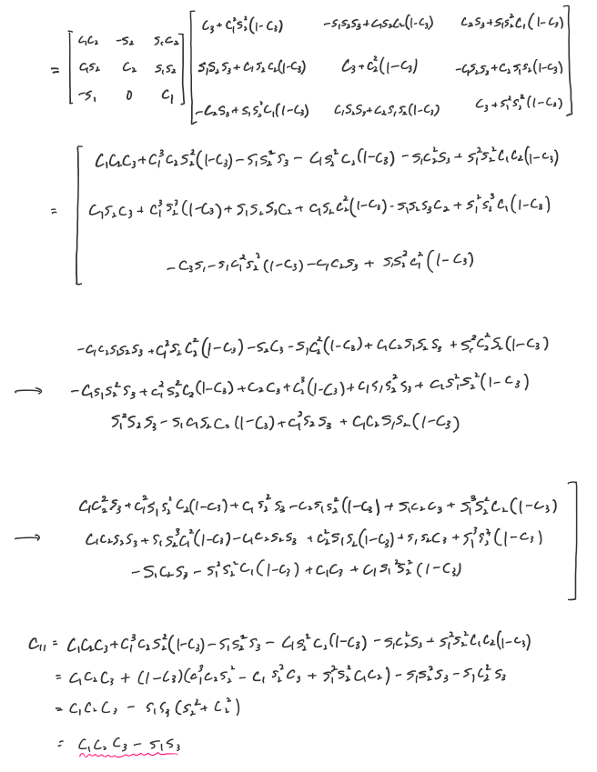

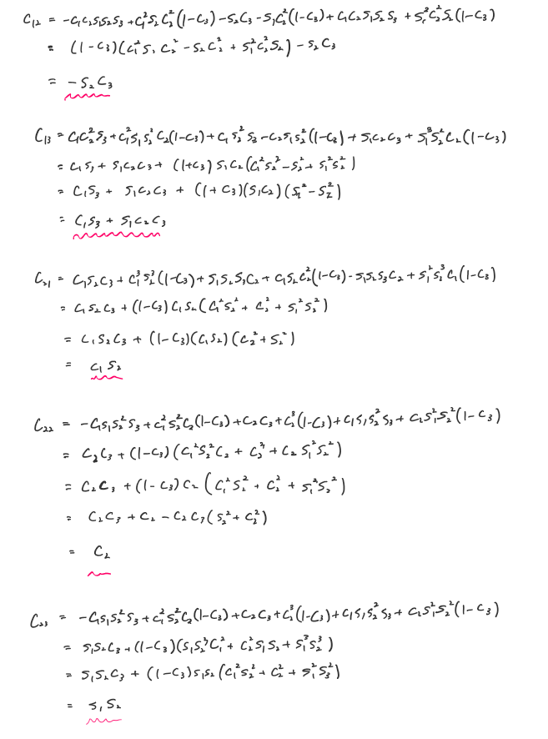

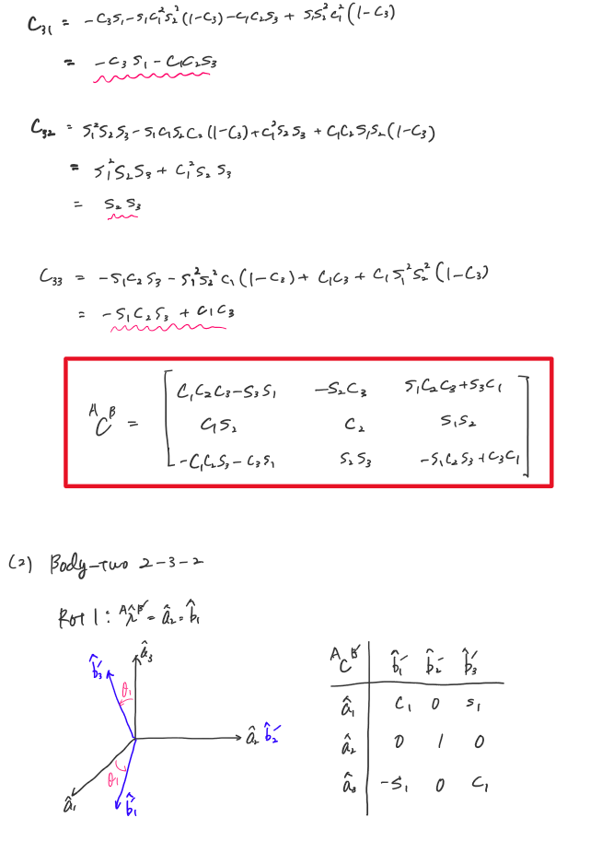

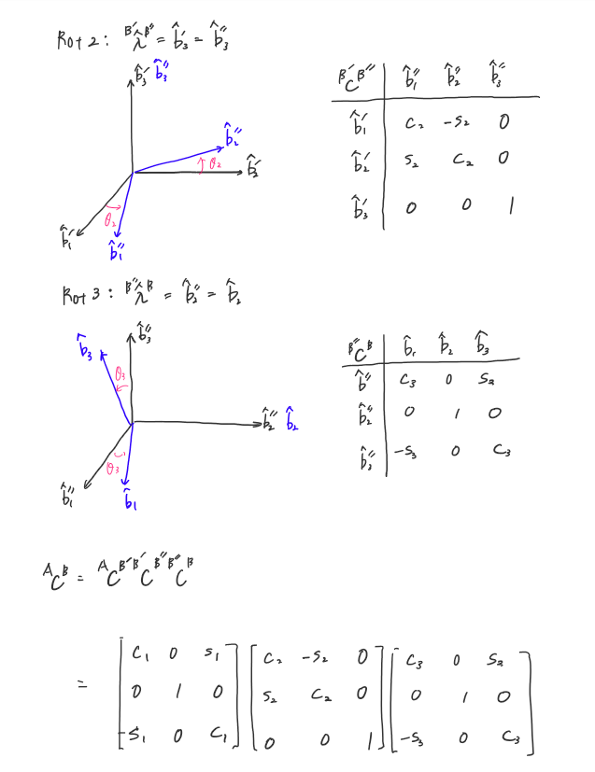

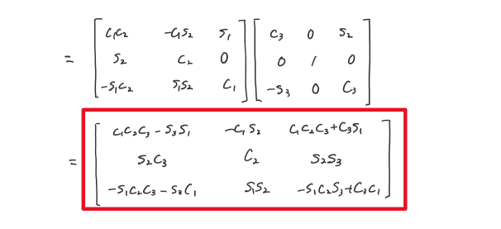

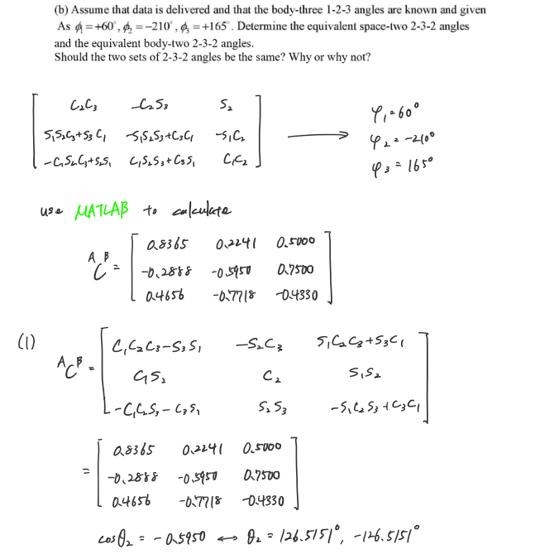

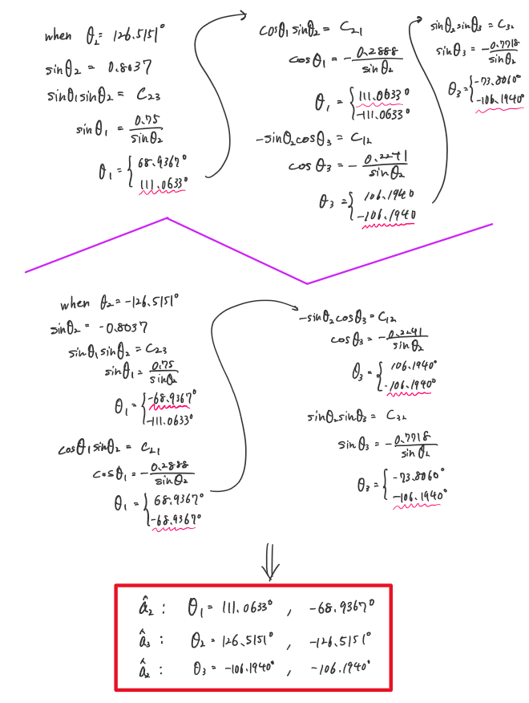

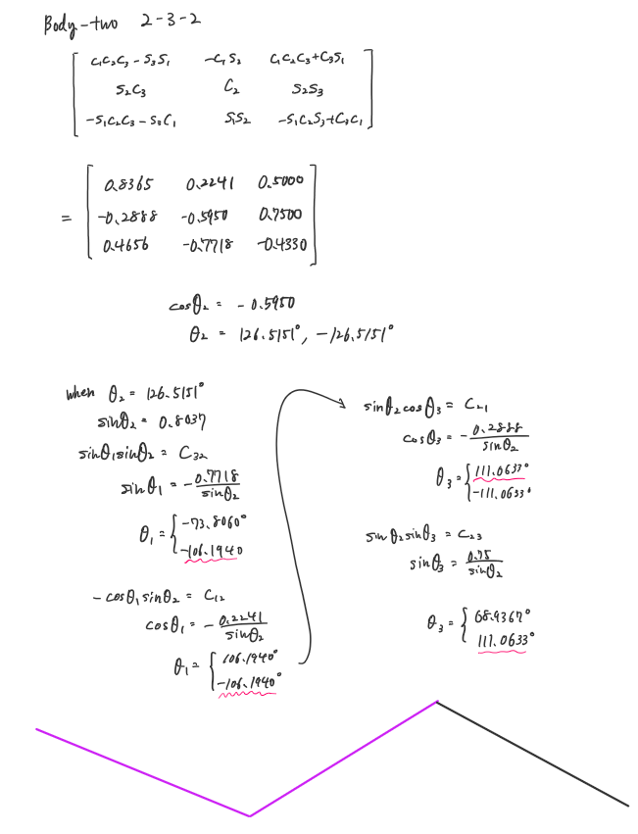

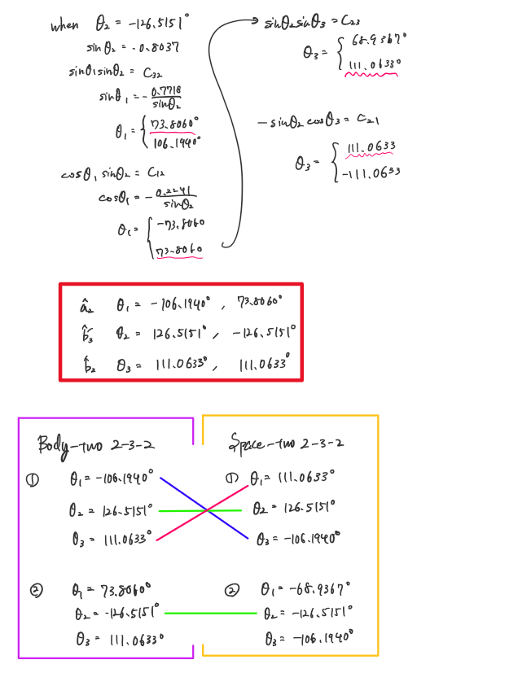

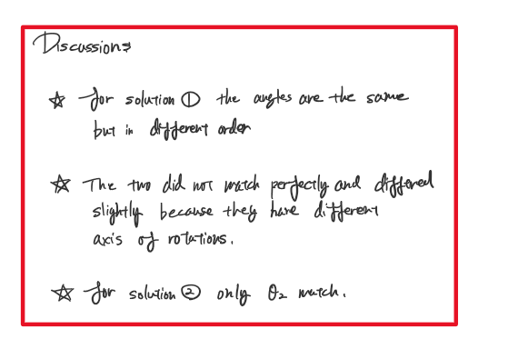

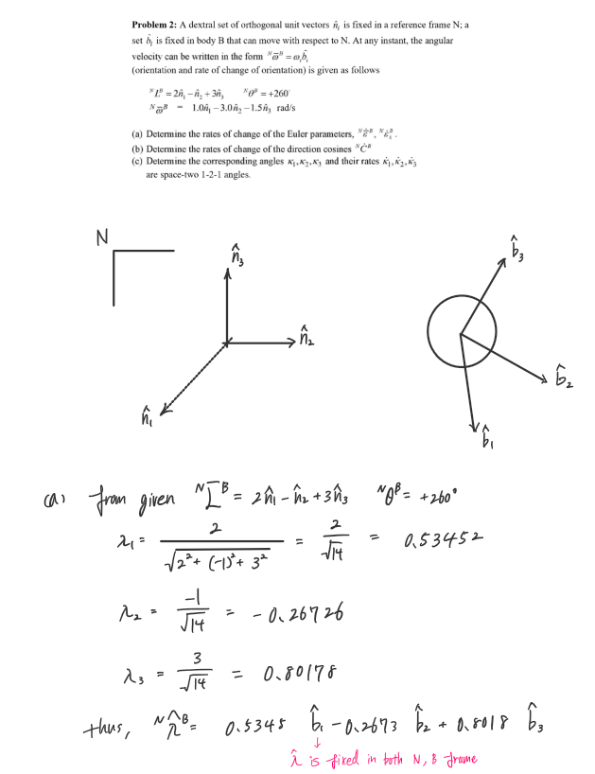

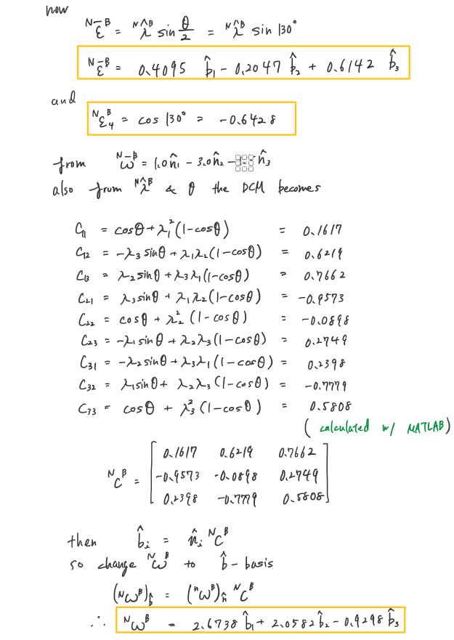

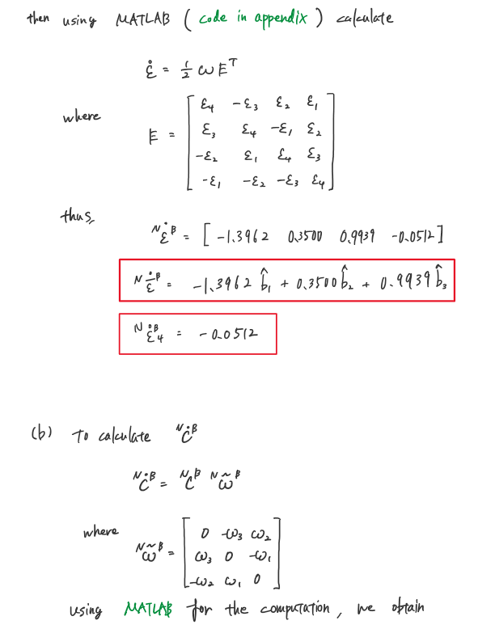

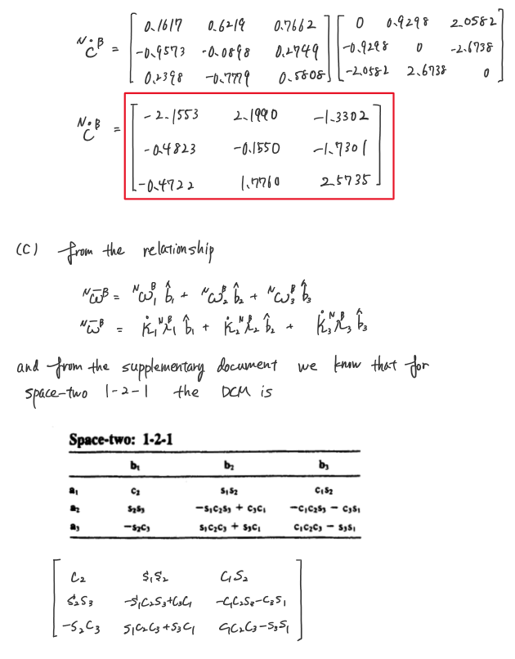

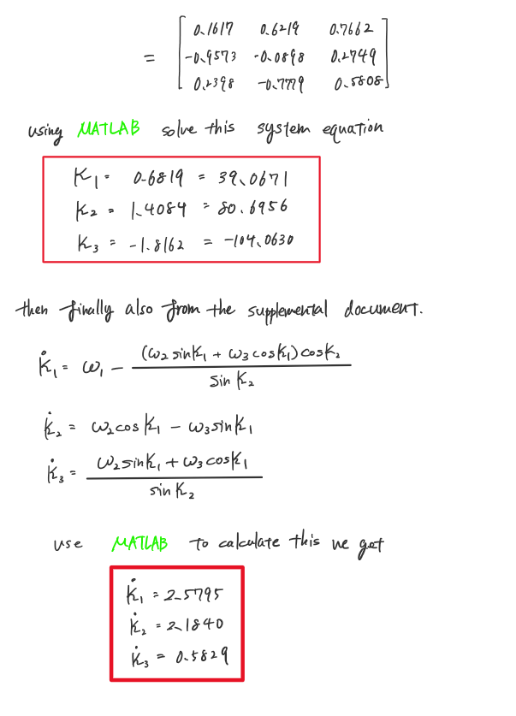

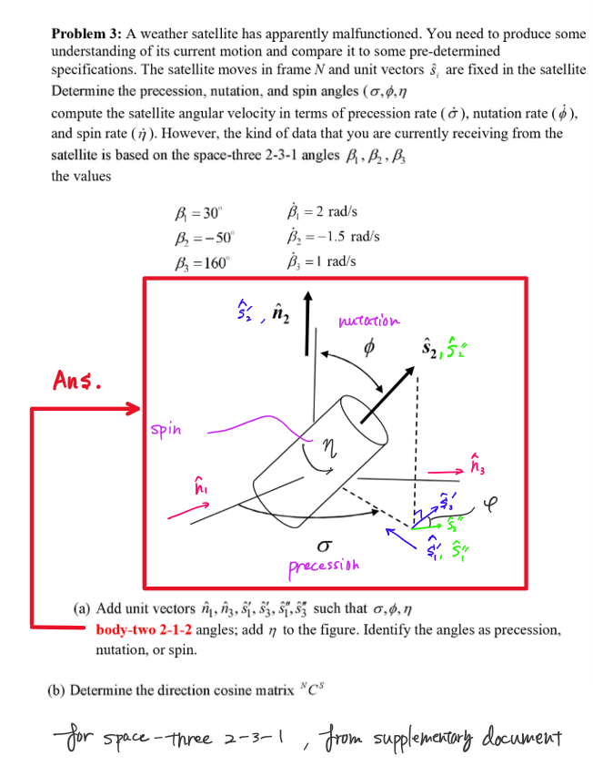

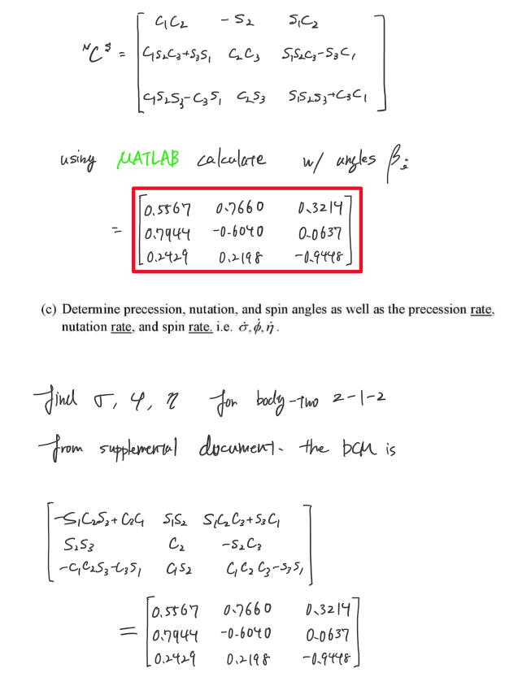

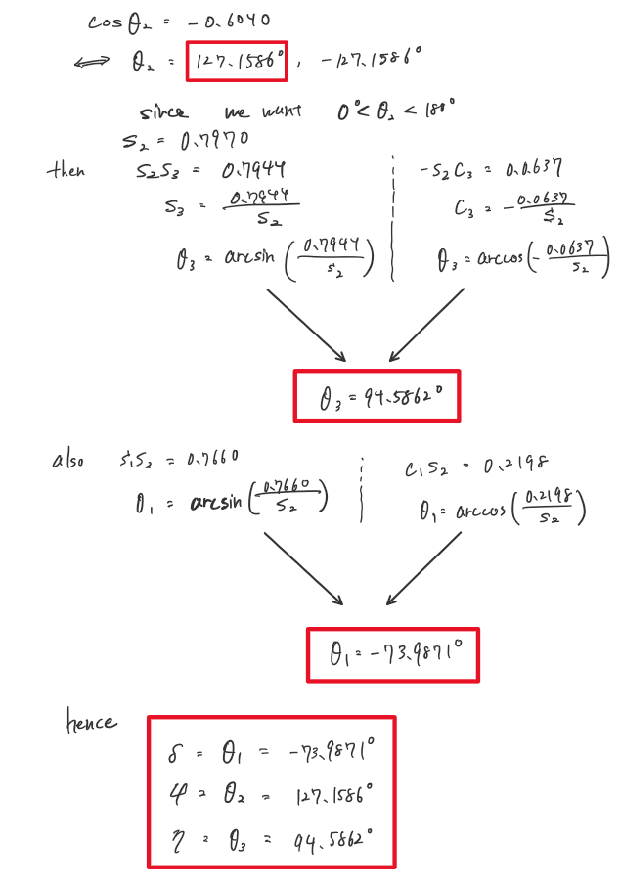

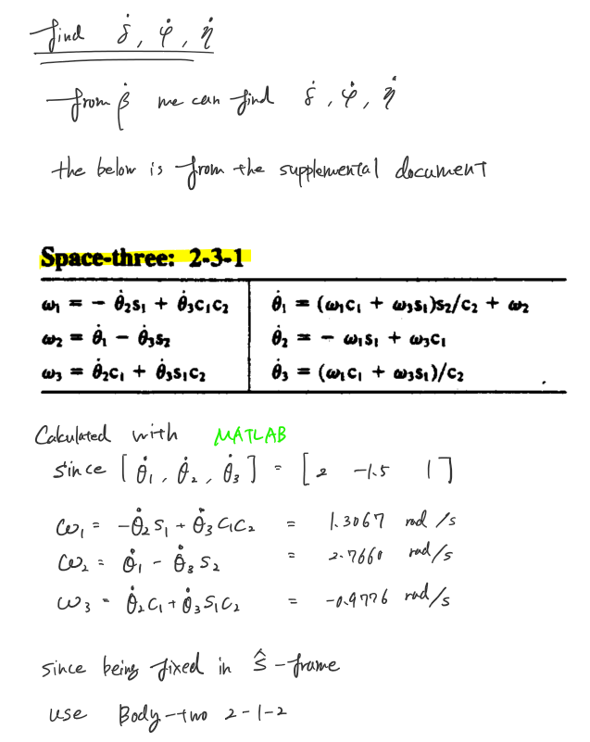

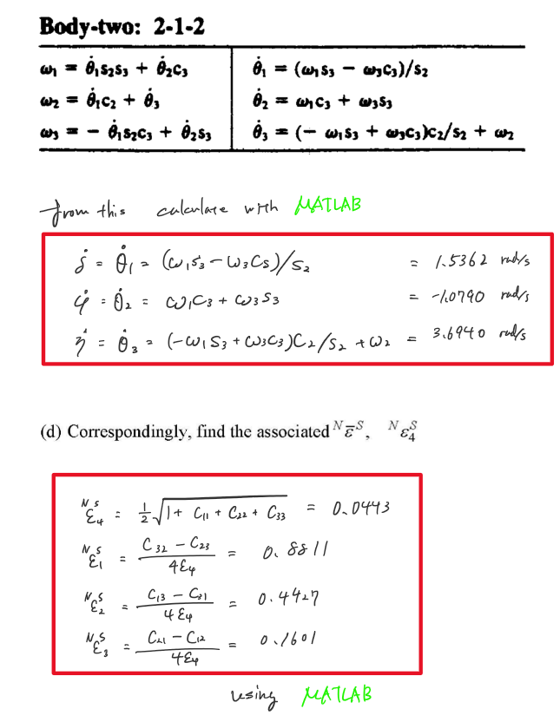

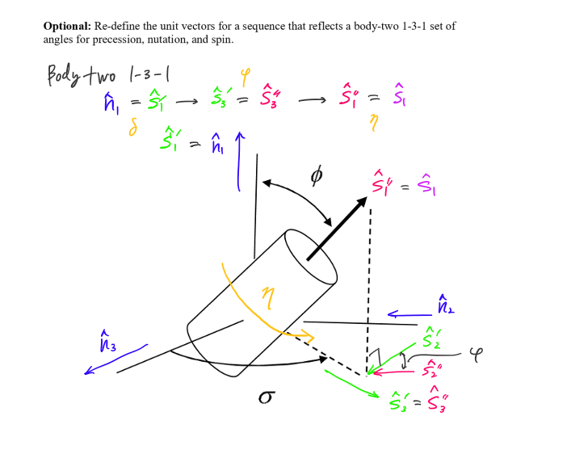

Appendix

## **AAE440 HW4 MATLAB CODE problem 1**

clear all; close all; clc;

% Defining body-three 1-2-3 system

theta_d = [60 -210 165];

theta = deg2rad(theta_d); % convert the thetas to radians

% Function that calculates DCM in Body System from angles and rotational axes

C_body_123 = DCM_Body(1, 2, 3, theta(1), theta(2), theta(3));

function C_body = DCM_Body(Rot1, Rot2, Rot3, theta1, theta2, theta3)

Rot = [Rot1, Rot2, Rot3];

theta = [theta1, theta2, theta3]; % radians

C_body = zeros([3,3]);

C = zeros([3,3,3]);

for i=1:3

if Rot(i) == 1

% DCM for rotation about axis 1

C(:,:,i) = [ 1 0 0;

0 cos(theta(i)) -sin(theta(i));

0 sin(theta(i)) cos(theta(i))];

elseif Rot(i) == 2

% DCM for rotation about axis 2

C(:,:,i) = [ cos(theta(i)) 0 sin(theta(i));

0 1 0;

-sin(theta(i)) 0 cos(theta(i))];

else

% DCM for rotation about axis 3

C(:,:,i) = [ cos(theta(i)) -sin(theta(i)) 0;

sin(theta(i)) cos(theta(i)) 0;

0 0 1];

end

end

C_body = C(:,:,1)*C(:,:,2)*C(:,:,3);

end

## **AAE440 HW4 MATLAB CODE problem 2**

clear all; close all; clc;

#### <a>

% Given

L_NB_vec = [2 -1 3]; % n-hat

theta = 260/180*pi;

% Calculate lambda

lambda_NB = L_NB_vec/sqrt(sum(L_NB_vec.^2)); % b-hat

% Calculate epsilons

e_NB_vec = lambda_NB*sin(theta/2); % b-hat

e_NB_4 = cos(theta/2);

% Angular velocity

omega_NB_n = [1 -3 -1.5]; % n-hat

% Find the DCM

C_NB = DCM_from_EulerAxisAng(lambda_NB,theta);

% Change basis of omega from n-hat to b-hat

omega_NB_b = omega_NB_n*C_NB;

e_NB_dot = EulerParaDot_from_AngVel([e_NB_vec, e_NB_4], [omega_NB_b, 0]);

#### <b>

% Calculating the rate of change of DCM

C_dot = DCM_Dot_from_PoissonKineEq(C_NB, omega_NB_b);

#### <c>

% Angles

kappa2 = acos(C_NB(1,1)); % Neglecting the second solution (Class Convention)

kappa1 = asin(C_NB(1,2)/sin(kappa2));

kappa1 = acos(C_NB(1,3)/sin(kappa2)); % Check if it satisfies condition

kappa3 = -(pi+asin(C_NB(2,1)/sin(kappa2)));

kappa3 = -acos(-C_NB(3,1)/sin(kappa2));

% Angles in degrees

kappa1_d = rad2deg(kappa1);

kappa2_d = rad2deg(kappa2);

kappa3_d = rad2deg(kappa3);

% Angular velocities

omega = omega_NB_b;

kappa1_dot = omega(1) - (omega(2)*sin(kappa1) + omega(3)*cos(kappa1))*cos(kappa2)/sin(kappa2);

kappa2_dot = omega(2)*cos(kappa1) - omega(3)*sin(kappa1);

kappa3_dot = (omega(2)*sin(kappa1) + omega(3)*cos(kappa1))/sin(kappa2);

function C_mat = DCM_from_EulerAxisAng(lambdas, theta)

% Euler Axis

lambda1 = lambdas(1);

lambda2 = lambdas(2);

lambda3 = lambdas(3);

% Calculating DCM from Euler Axis and Euler Angle

C11 = cos(theta) + lambda1^2*(1-cos(theta));

C12 = -lambda3*sin(theta) + lambda1*lambda2*(1-cos(theta));

C13 = lambda2*sin(theta) + lambda3*lambda1*(1-cos(theta));

C21 = lambda3*sin(theta) + lambda1*lambda2*(1-cos(theta));

C22 = cos(theta) + lambda2^2*(1-cos(theta));

C23 = -lambda1*sin(theta) + lambda2*lambda3*(1-cos(theta));

C31 = -lambda2*sin(theta) + lambda3*lambda1*(1-cos(theta));

C32 = lambda1*sin(theta) + lambda2*lambda3*(1-cos(theta));

C33 = cos(theta) + lambda3^2*(1-cos(theta));

C_mat = [C11 C12 C13; C21 C22 C23; C31 C32 C33];

end

function e_dot = EulerParaDot_from_AngVel(epsilons, omega)

%{

epsilons: 1x4 row vector with 3 vector elements and the 4th being a

scalar element

omega: 1x4 row vector with 4th element equal to 0

%}

e1 = epsilons(1);

e2 = epsilons(2);

e3 = epsilons(3);

e4 = epsilons(4);

% E matrix

E = [e4 -e3 e2 e1; e3 e4 -e1 e2; -e2 e1 e4 e3; -e1 -e2 -e3 e4];

% Output

e_dot = 0.5*omega*E.';

end

function C_dot = DCM_Dot_from_PoissonKineEq(C_mat, omegas)

omega1 = omegas(1);

omega2 = omegas(2);

omega3 = omegas(3);

omega_wave = [0 -omega3 omega2; omega3 0 -omega1; -omega2 omega1 0];

C_dot = C_mat*omega_wave;

end

## **AAE440 HW4 MATLAB CODE problem 3**

clear all; close all; clc;

% Angles and angular velocities

Beta = deg2rad([30 -50 160]); % rad

Beta_dot = [2 -1.5 1]; % rad s-1

% Creating DCM for space three 2-3-1 (N_C_S)

C_NS_space_231 = DCM_Space(2, 3, 1, Beta(1), Beta(2), Beta(3));

delta = 1.291318577654501; % Precession

phi = 2.219335441889180; % Nutation

eta = 1.650841195002049; % Spin

theta1 = delta;

theta2 = phi;

theta3 = eta;

% Calculating omega

omega1 = -Beta_dot(2)*sin(Beta(1)) + Beta_dot(3)*cos(Beta(1))*cos(Beta(2));

omega2 = Beta_dot(1) - Beta_dot(3)*sin(Beta(2));

omega3 = Beta_dot(2)*cos(Beta(1)) + Beta_dot(3)*sin(Beta(1))*cos(Beta(2));

% Rates

delta_dot = (omega1*sin(theta3) - omega3*cos(theta3))/sin(theta2);

phi_dot = omega1*cos(theta3) + omega3*sin(theta3);

eta_dot = (-omega1*sin(theta3) + omega3*cos(theta3))*cos(theta2)/sin(theta2) + omega2;

% Calcuate the euler parameters

epsilons = EulerPara_from_DCM(C_NS_space_231);

function epsilons = EulerPara_from_DCM(C_mat)

epsilon4 = 0.5*sqrt(1+C_mat(1,1)+C_mat(2,2)+C_mat(3,3));

epsilon1 = (C_mat(3,2)-C_mat(2,3))/4/epsilon4;

epsilon2 = (C_mat(1,3)-C_mat(3,1))/4/epsilon4;

epsilon3 = (C_mat(2,1)-C_mat(1,2))/4/epsilon4;

epsilons = [epsilon1 epsilon2 epsilon3 epsilon4];

end