AAE 440: Spacecraft Attitude Dynamics

PS7

Dr. Howell

School of Aeronautical and Astronautical

Purdue University

Tomoki Koike

March 13, 2020

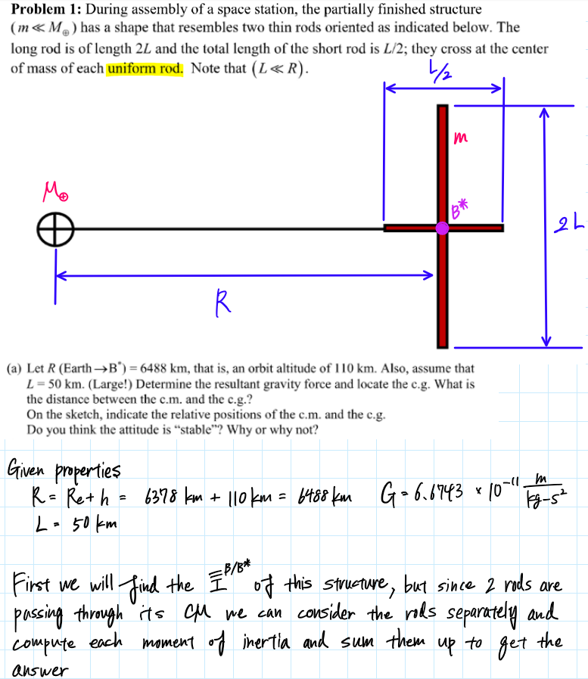

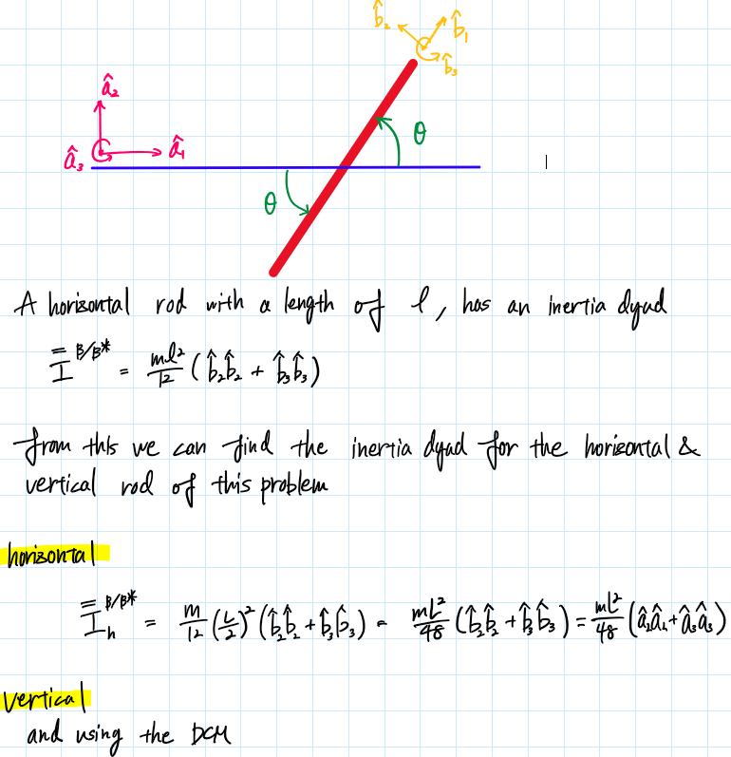

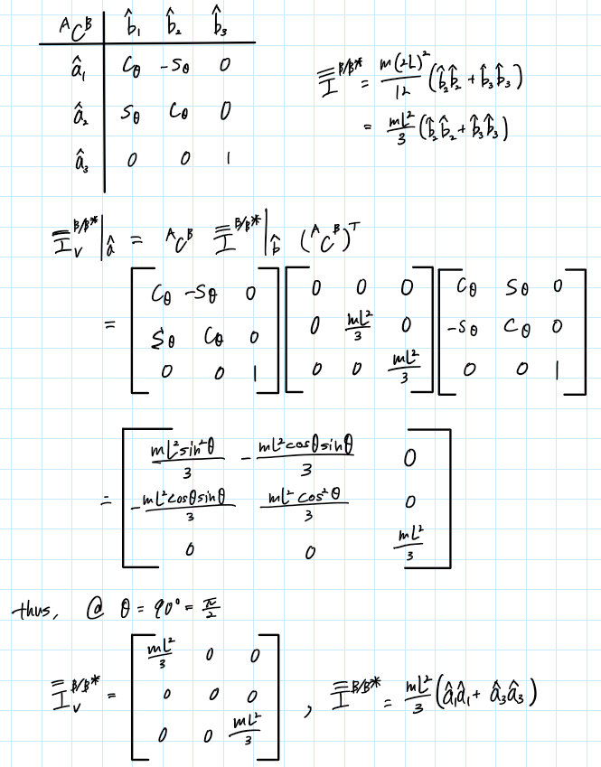

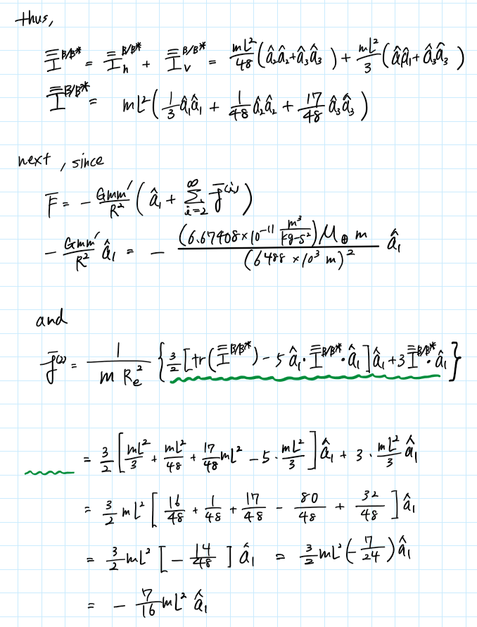

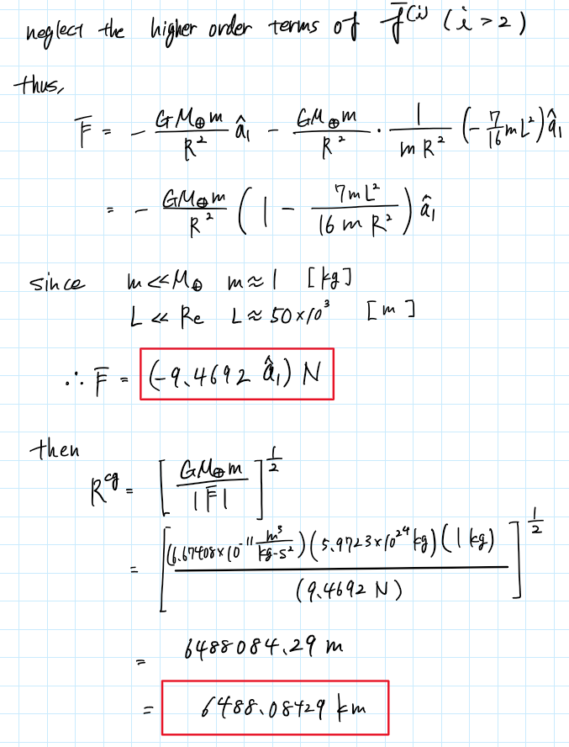

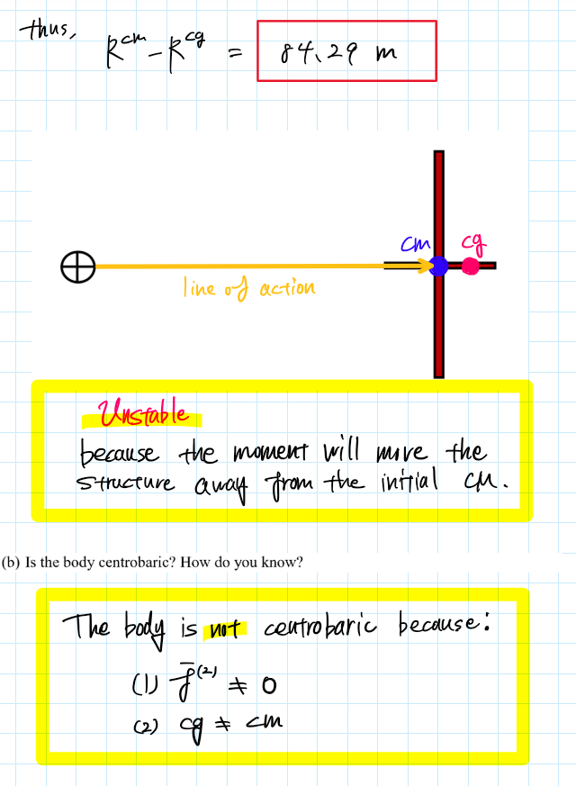

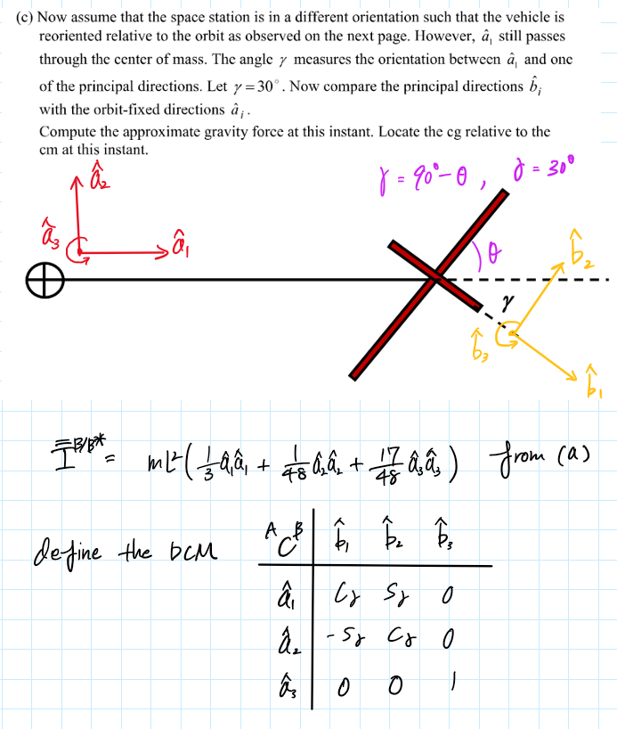

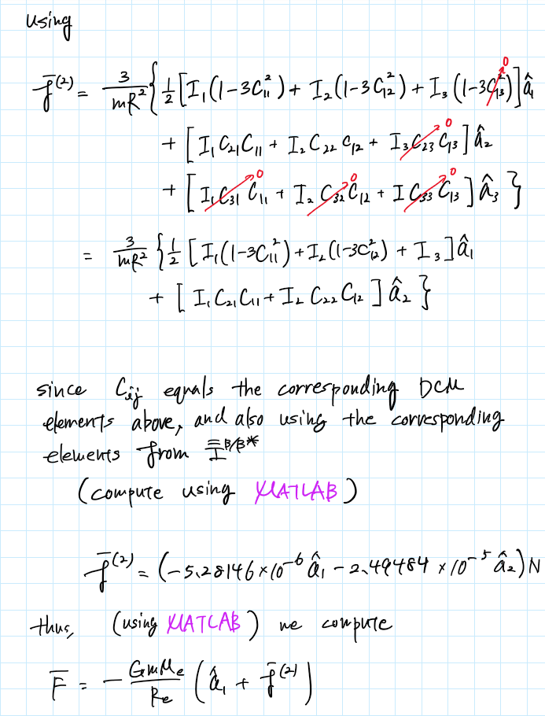

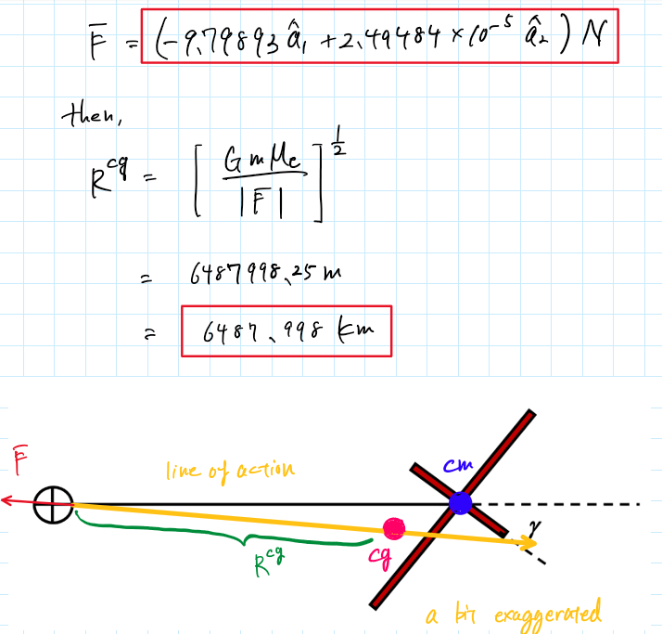

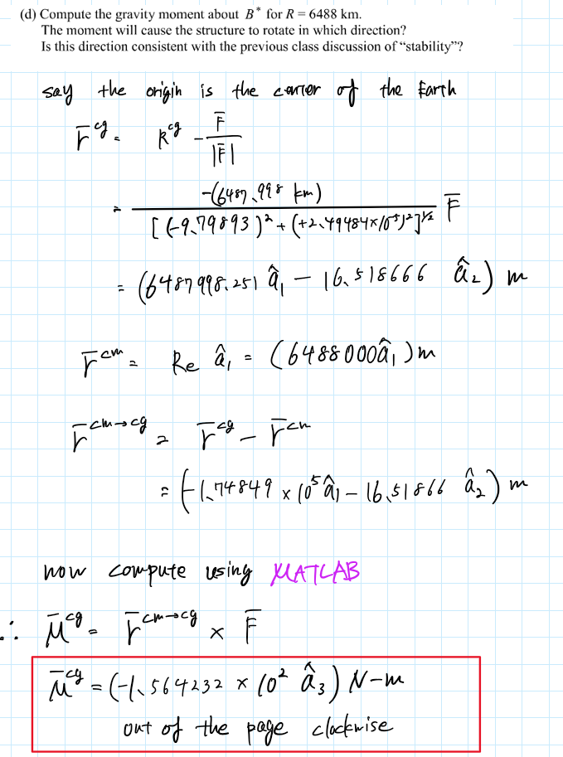

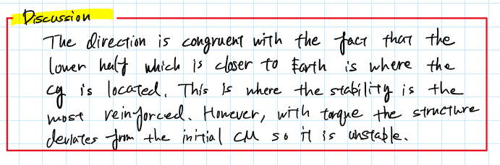

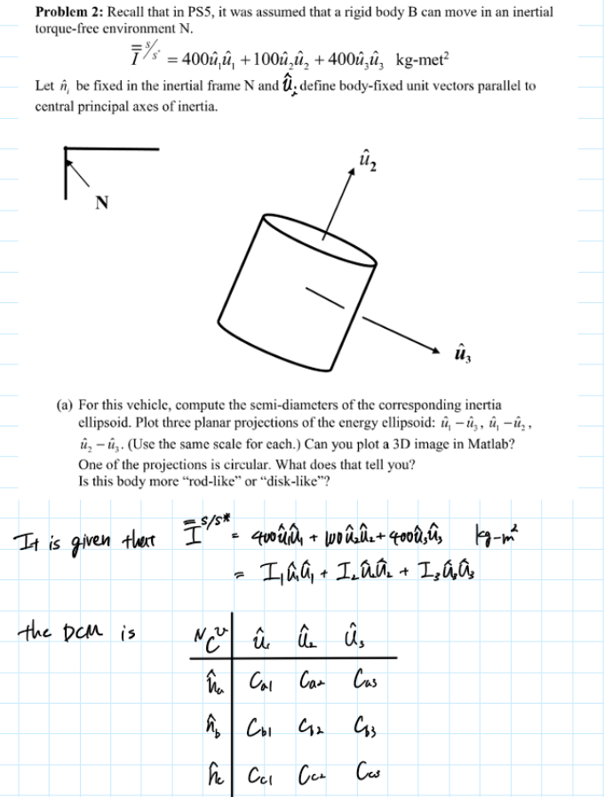

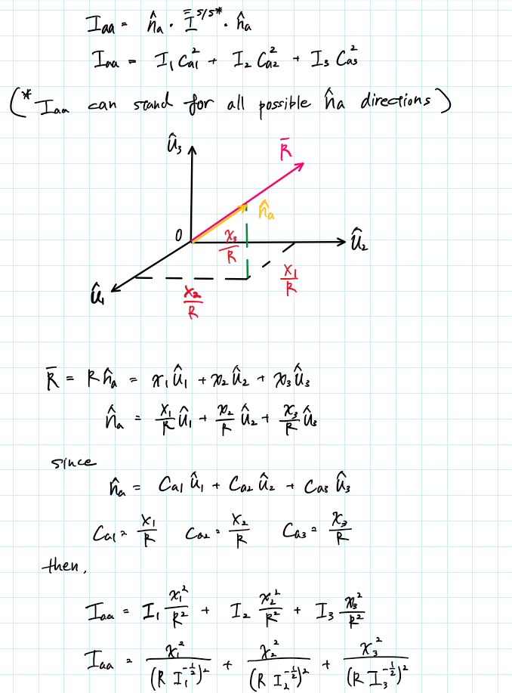

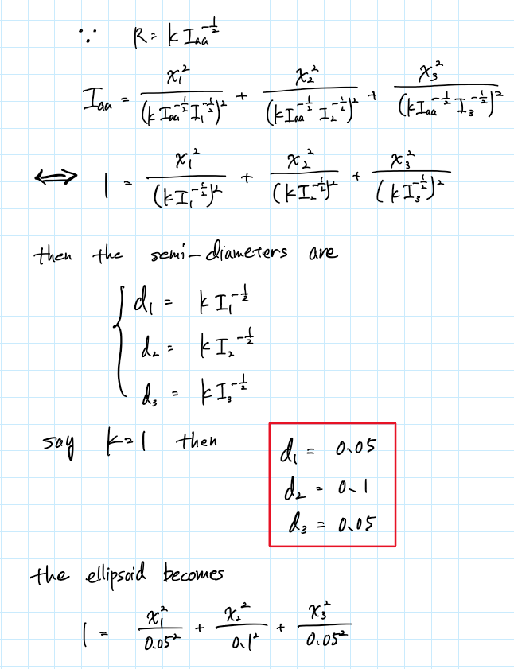

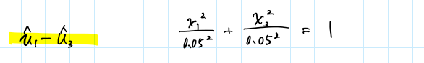

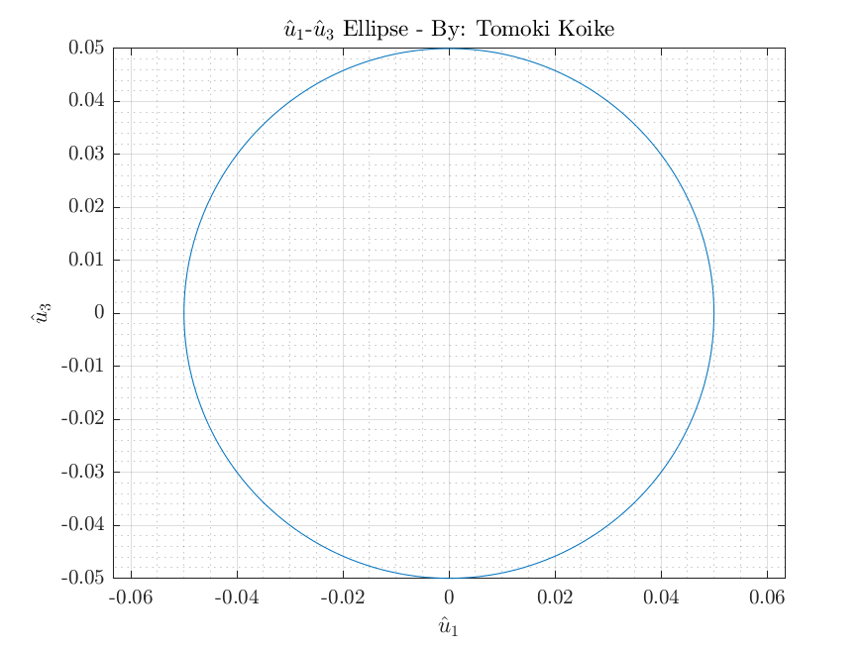

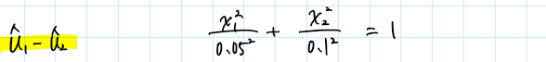

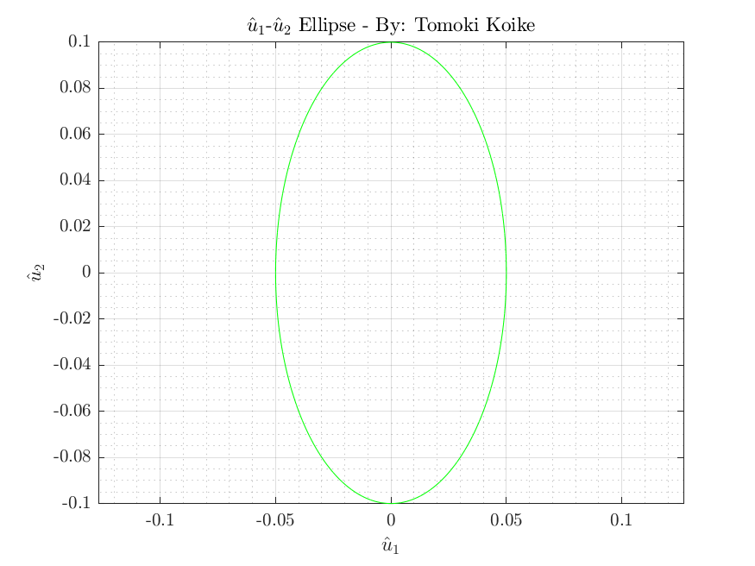

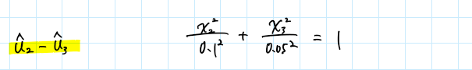

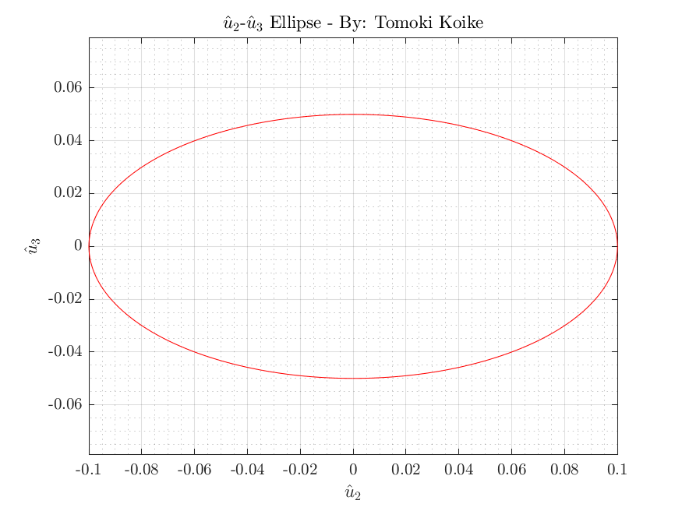



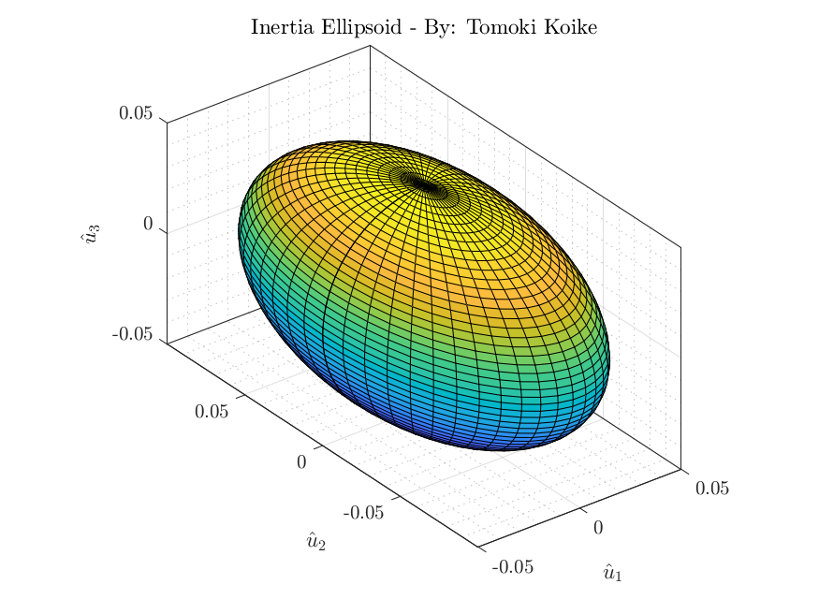

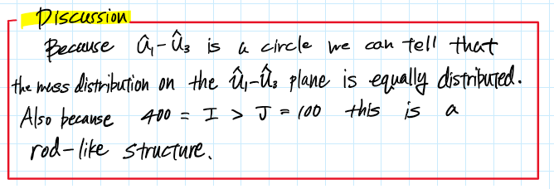

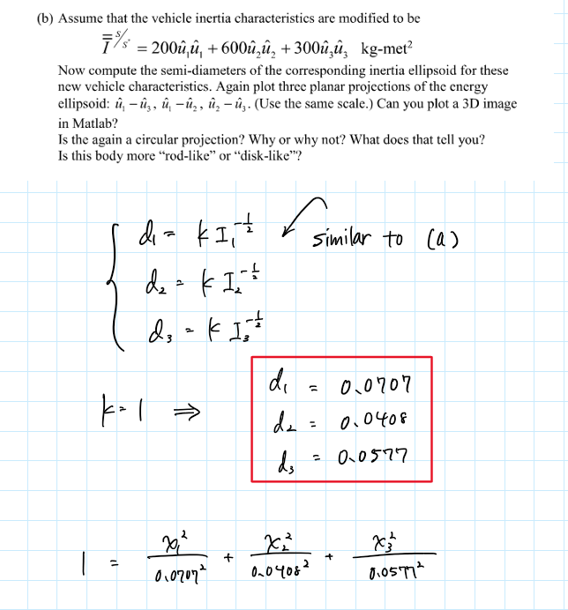



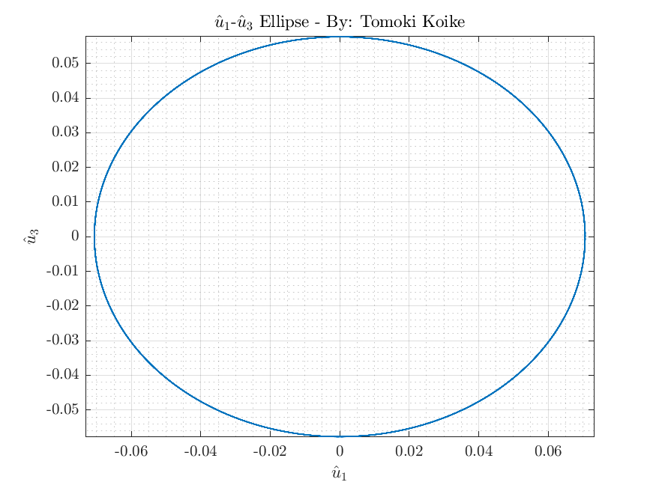



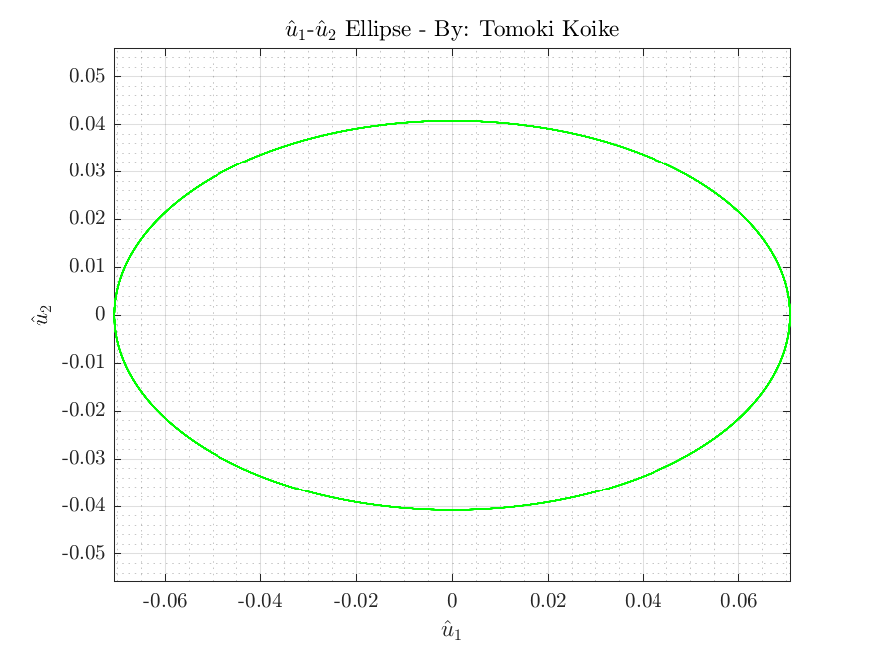



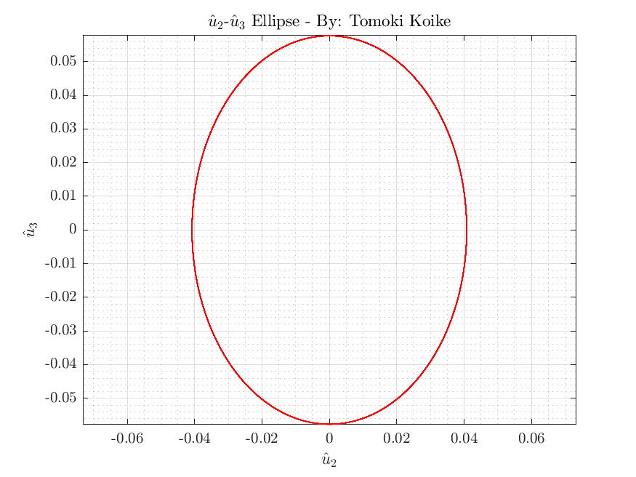



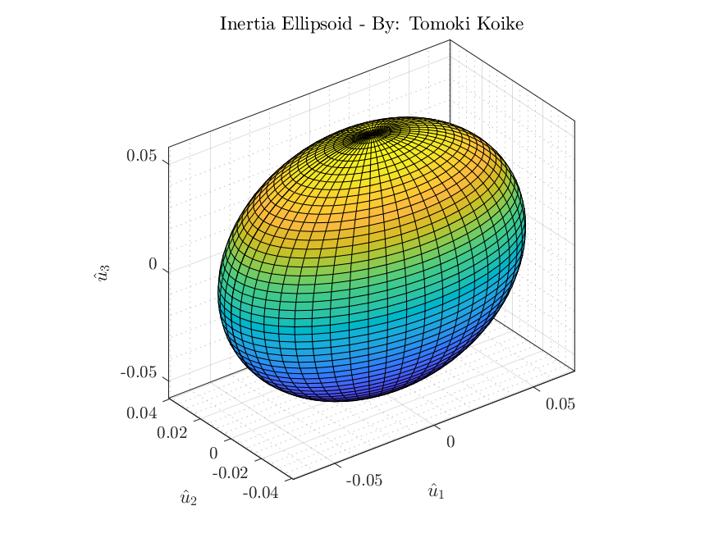

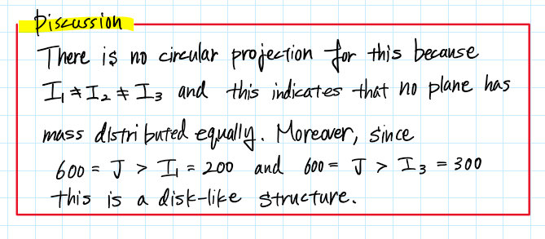

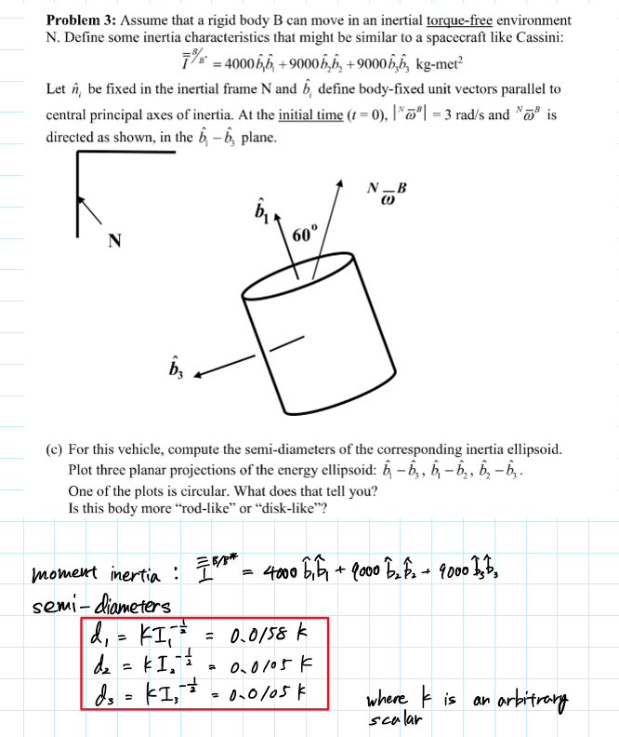



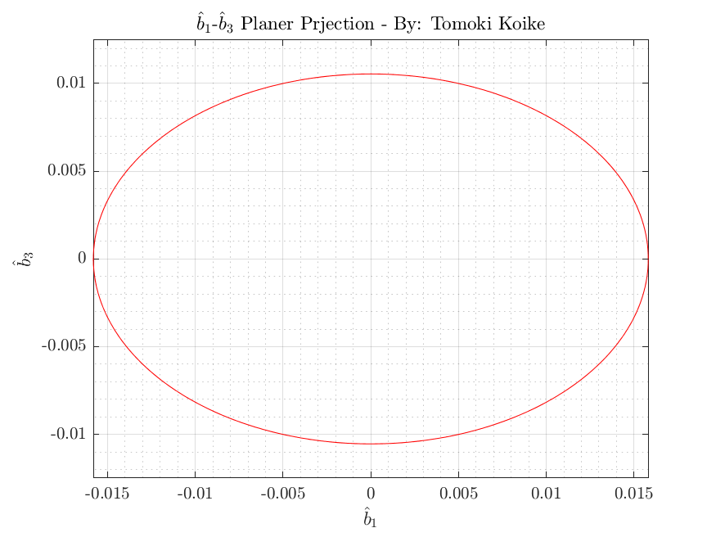

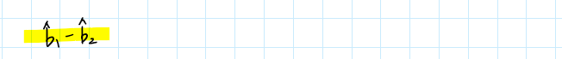

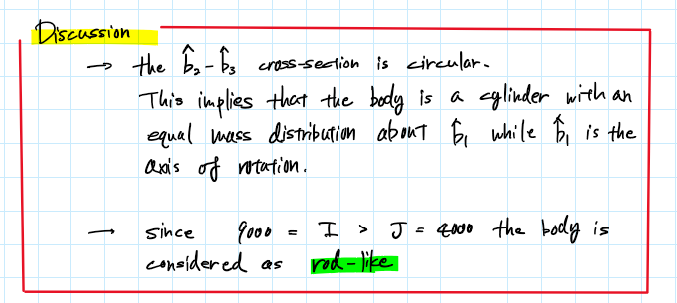

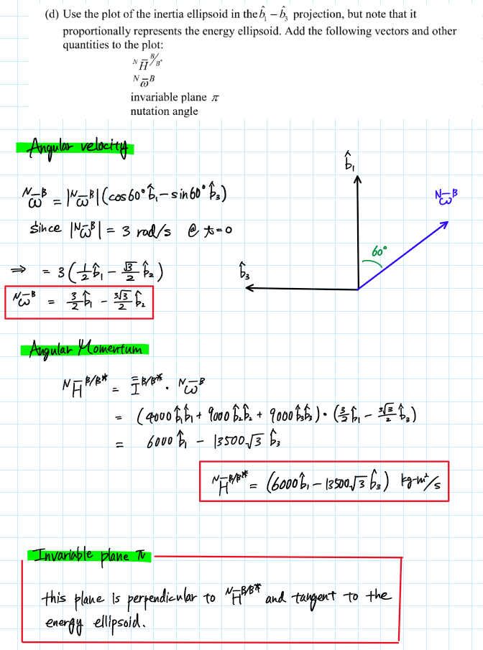

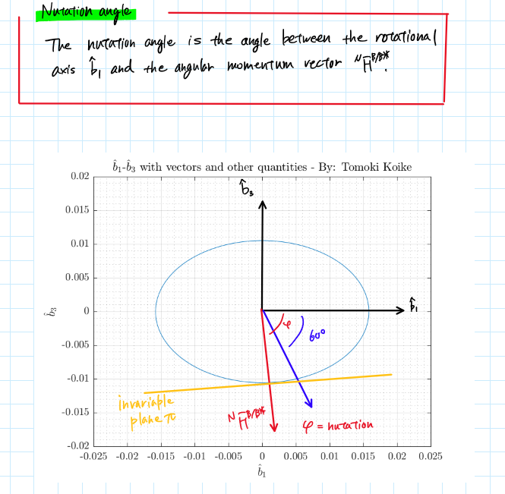

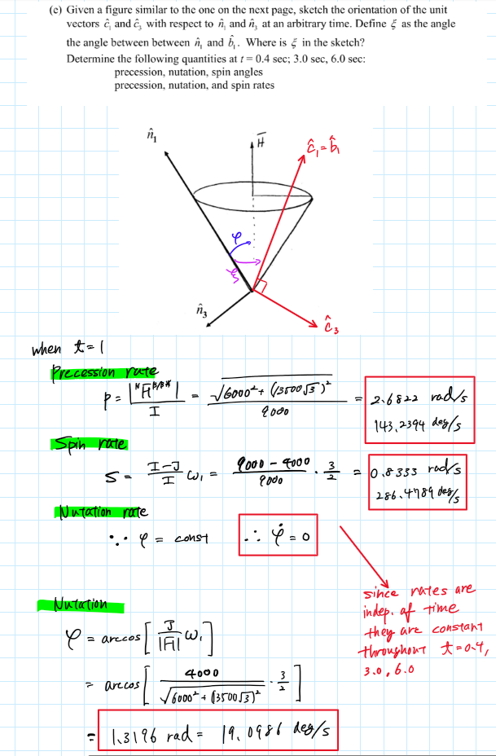

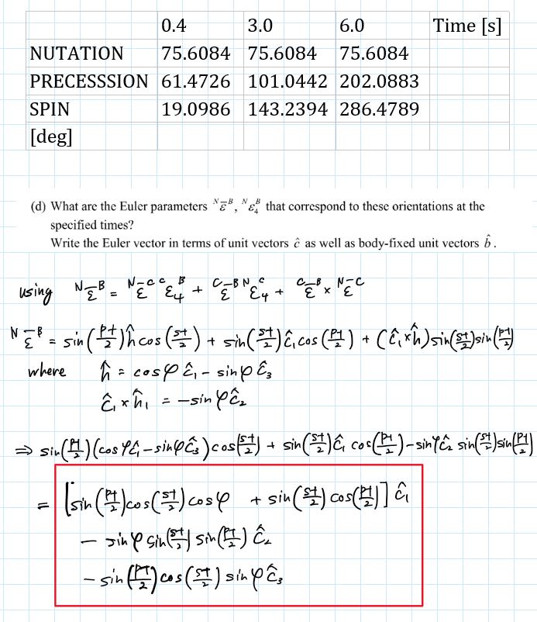

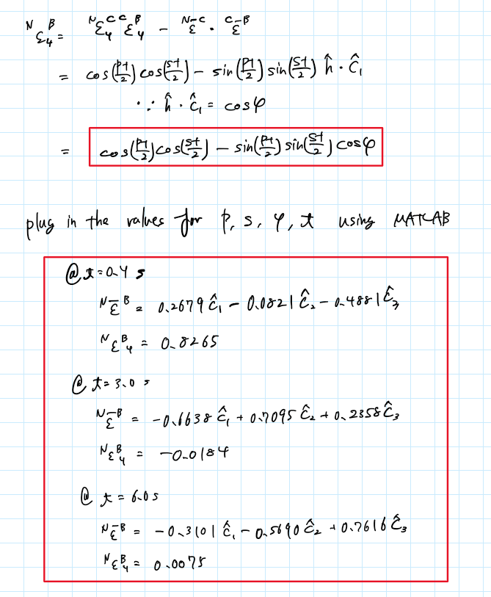

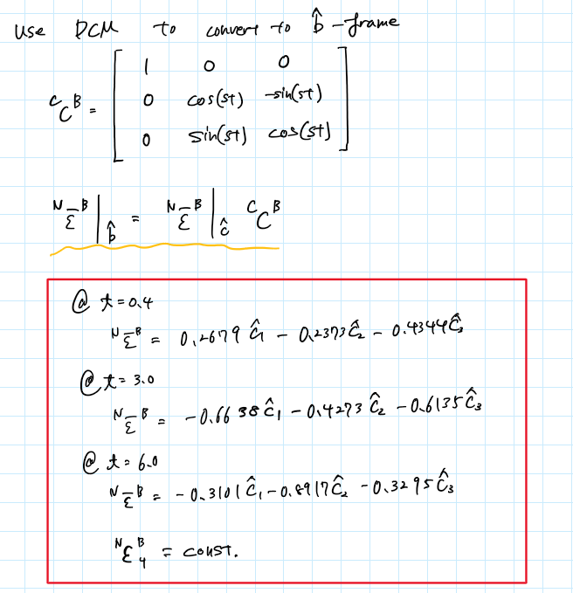

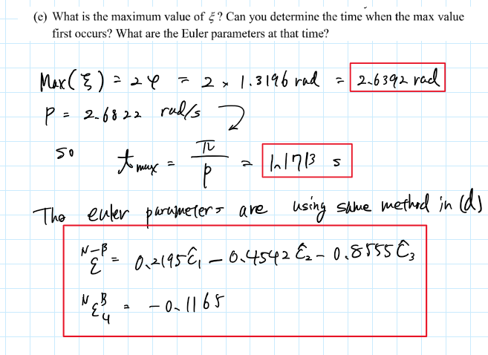

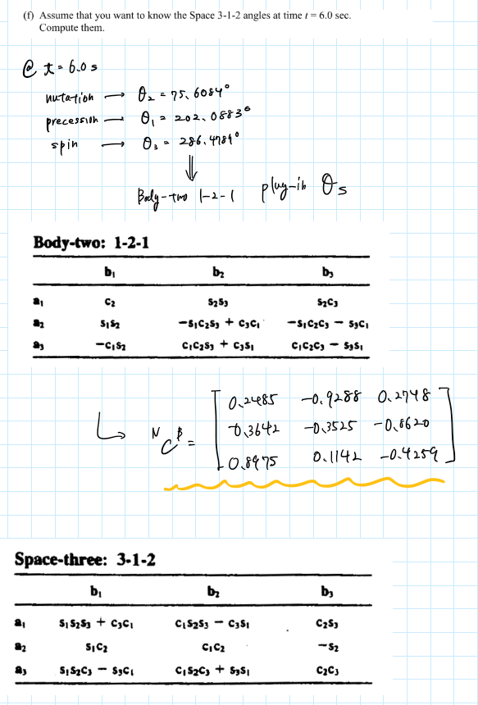

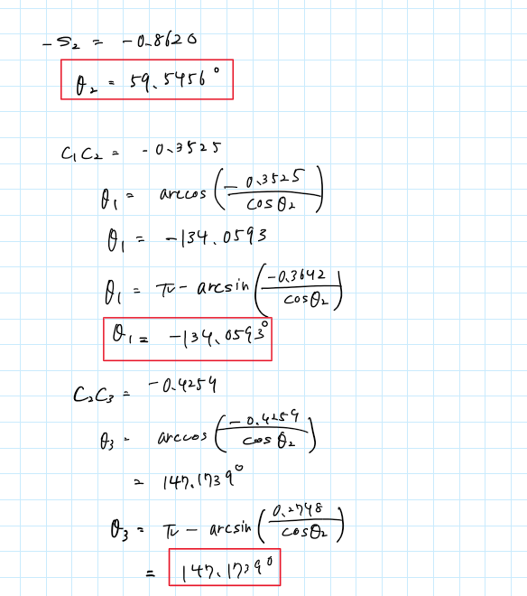

Appendix

**AAE440 PS7 Problem 1**

clear all; close all; clc;

format long e

digits(100)

syms m L theta

I_rod = [0 0 0; 0 m*L^2/3 0; 0 0 m*L^2/3];

C_AB = [cos(theta) -sin(theta) 0; sin(theta) cos(theta) 0; 0 0 1];

I_h = C_AB*I_rod*transpose(C_AB)

I_h = subs(I_h, theta, pi/2)

I_v = subs(I_rod, theta, pi/2)

clear all;

**(a) & (b)**

% Define given properties

M_e = 5.9723e24; % [kg]

R_e = 6378e3; % [m]

R = R_e + 110e3

G = 6.6743015e-11; % [m3kg-1s-2]

m = 1;

L = 50e3;

% Resultant gravity force

m_horz = m;

m_vert = m;

l_horz = L/2;

l_vert = 2*L;

I_horz = m_horz*l_horz^2/12*[0 0 0; 0 1 0; 0 0 1];

I_vert = m_vert*l_vert^2/12*[1 0 0; 0 0 0; 0 0 1];

I_body = (I_horz + I_vert);

F_g = resultant_Gforce(M_e,m,R,I_body)

R_cg = distance2cg(M_e,m,F_g)

delta_cm_cg = R - R_cg

**(c)**

gamma = -30; % [deg]

C_AB = [ cosd(gamma) sind(gamma) 0;

-sind(gamma) cosd(gamma) 0;

0 0 1];

F_g_new = resultant_Gforce_with_DCM(M_e,m,R,I_body,C_AB)

R_cg_new = distance2cg(M_e,m,F_g_new)

**(d)**

r_cg = -F_g_new/norm(F_g_new)*R_cg_new

r_cm = [R 0 0]

r_cm_cg = r_cg - r_cm

Mmt_cg = cross(r_cm_cg,F_g_new)

**AAE440 PS7 Problem 2**

clear all; close all; clc;

fdir = 'C:\Users\Tomo\Desktop\studies\2020-Spring\AAE440\MATLAB\outputs\HW7';

set(groot, 'defaulttextinterpreter',"latex");

set(groot, 'defaultAxesTickLabelInterpreter',"latex");

set(groot, 'defaultLegendInterpreter',"latex");

% ellipsoid

I_body = [400 0 0; 0 100 0; 0 0 400];

k = 1;

d1 = k*I_body(1,1)^(-0.5)

d2 = k*I_body(2,2)^(-0.5)

d3 = k*I_body(3,3)^(-0.5)

% Plotting

theta = 0:0.1:360;

theta = deg2rad(theta);

% u1-u3

fig1 = figure("Renderer","painters");

plot(d1*cos(theta), d3*sin(theta))

title('$\hat{u}_1$-$\hat{u}_3$ Ellipse - By: Tomoki Koike')

xlabel('$\hat{u}_1$')

ylabel('$\hat{u}_3$')

grid on; grid minor; box on; axis equal;

saveas(fig1, fullfile(fdir,'u1_u3_ellipse.png'));

% u1-u2

fig2 = figure("Renderer","painters");

plot(d1*cos(theta), d2*sin(theta), 'g')

title('$\hat{u}_1$-$\hat{u}_2$ Ellipse - By: Tomoki Koike')

xlabel('$\hat{u}_1$')

ylabel('$\hat{u}_2$')

grid on; grid minor; box on; axis equal;

saveas(fig2, fullfile(fdir,'u1_u2_ellipse.png'));

% u1-u2

fig3 = figure("Renderer","painters");

plot(d2*cos(theta), d3*sin(theta), 'r')

title('$\hat{u}_2$-$\hat{u}_3$ Ellipse - By: Tomoki Koike')

xlabel('$\hat{u}_2$')

ylabel('$\hat{u}_3$')

grid on; grid minor; box on; axis equal;

saveas(fig3, fullfile(fdir,'u2_u3_ellipse.png'));

% Ellipsoid

fig4 = figure("Renderer","painters");

ellipsoid(0,0,0,d1,d2,d3,50)

title('Inertia Ellipsoid - By: Tomoki Koike')

xlabel('$\hat{u}_1$')

ylabel('$\hat{u}_2$')

zlabel('$\hat{u}_3$')

grid on; grid minor; box on; axis equal;

saveas(fig4, fullfile(fdir,'ellipsoid.png'));

clear all; close all;

fdir = 'C:\Users\Tomo\Desktop\studies\2020-Spring\AAE440\MATLAB\outputs\HW7';

set(groot, 'defaulttextinterpreter',"latex");

set(groot, 'defaultAxesTickLabelInterpreter',"latex");

set(groot, 'defaultLegendInterpreter',"latex");

% ellipsoid

I_body = [200 0 0; 0 600 0; 0 0 300];

k = 1;

d1 = k*I_body(1,1)^(-0.5)

d2 = k*I_body(2,2)^(-0.5)

d3 = k*I_body(3,3)^(-0.5)

% Plotting

theta = 0:0.1:360;

% u1-u3

fig5 = figure("Renderer","painters");

plot(d1*cos(theta), d3*sin(theta))

title('$\hat{u}_1$-$\hat{u}_3$ Ellipse - By: Tomoki Koike')

xlabel('$\hat{u}_1$')

ylabel('$\hat{u}_3$')

grid on; grid minor; box on; axis equal;

saveas(fig5, fullfile(fdir,'u1_u3_ellipse2.png'));

% u1-u2

fig6 = figure("Renderer","painters");

plot(d1*cos(theta), d2*sin(theta), 'g')

title('$\hat{u}_1$-$\hat{u}_2$ Ellipse - By: Tomoki Koike')

xlabel('$\hat{u}_1$')

ylabel('$\hat{u}_2$')

grid on; grid minor; box on; axis equal;

saveas(fig6, fullfile(fdir,'u1_u2_ellipse2.png'));

% u1-u2

fig7 = figure("Renderer","painters");

plot(d2*cos(theta), d3*sin(theta), 'r')

title('$\hat{u}_2$-$\hat{u}_3$ Ellipse - By: Tomoki Koike')

xlabel('$\hat{u}_2$')

ylabel('$\hat{u}_3$')

grid on; grid minor; box on; axis equal;

saveas(fig7, fullfile(fdir,'u2_u3_ellipse2.png'));

% Ellipsoid

fig8 = figure("Renderer","painters");

ellipsoid(0,0,0,d1,d2,d3,50)

title('Inertia Ellipsoid - By: Tomoki Koike')

xlabel('$\hat{u}_1$')

ylabel('$\hat{u}_2$')

zlabel('$\hat{u}_3$')

grid on; grid minor; box on; axis equal;

saveas(fig8, fullfile(fdir,'ellipsoid2.png'));

**AAE 440 PS7 p3**

clear all; close all; clc;

fdir = 'C:\Users\Tomo\Desktop\studies\2020-Spring\AAE440\MATLAB\outputs\HW7';

set(groot, 'defaulttextinterpreter',"latex");

set(groot, 'defaultAxesTickLabelInterpreter',"latex");

set(groot, 'defaultLegendInterpreter',"latex");

% Draw Arrow Function

drawArrow = @(x,y,varargin) quiver( x(1),y(1),x(2)-x(1),y(2)-y(1),0, varargin{:});

% Setting given properties

I_body = [4000 0 0; 0 9000 0; 0 0 9000];

k = 1;

d_1 = k*I_body(1,1)^(-0.5);

d_2 = k*I_body(2,2)^(-0.5);

d_3 = k*I_body(3,3)^(-0.5);

theta = 0:0.01:2*pi;

**<a>**

% Plotting

% b1-b3

fig1 = figure("Renderer","painters");

plot(d_1*cos(theta), d_3*sin(theta), 'r')

title('$\hat{b}_1$-$\hat{b}_3$ Planer Prjection - By: Tomoki Koike')

xlabel('$\hat{b}_1$')

ylabel('$\hat{b}_3$')

grid on; grid minor; box on; axis equal;

saveas(fig1, fullfile(fdir,'b1_b3_ellipse3.png'));

% b1-b2

fig2 = figure("Renderer","painters");

plot(d_1*cos(theta), d_2*sin(theta), 'b')

title('$\hat{b}_1$-$\hat{b}_2$ Planer Prjection - By: Tomoki Koike')

xlabel('$\hat{b}_1$')

ylabel('$\hat{b}_2$')

grid on; grid minor; box on; axis equal;

saveas(fig2, fullfile(fdir,'b1_b2_ellipse3.png'));

% b2-b3

fig3 = figure("Renderer","painters");

plot(d_2*cos(theta), d_3*sin(theta), 'g')

title('$\hat{b}_2$-$\hat{b}_3$ Planer Prjection - By: Tomoki Koike')

xlabel('$\hat{b}_2$')

ylabel('$\hat{b}_3$')

grid on; grid minor; box on; axis equal;

saveas(fig3, fullfile(fdir,'b2_b3_ellipse3.png'));

% Ellipsoid

fig4 = figure("Renderer","painters");

ellipsoid(0,0,0,d_1,d_2,d_3,100)

title('Inertia Ellipsoid - By: Tomoki Koike')

xlabel('$\hat{b}_1$')

ylabel('$\hat{b}_2$')

zlabel('$\hat{b}_3$')

grid on; grid minor; box on; axis equal;

saveas(fig4, fullfile(fdir,'ellipsoid3.png'));

**<b>**

% Defining properties

T = 0; % Torque [N-m]

I_cm = [4000 0 0; 0 9000 0; 0 0 9000]; % Inertia Dyadic [kg-m2]

I = 9000;

J = 4000;

% Defining the angular velocity

w_mag = 3; % Magnitude of angular velocity

ang = deg2rad(60); % [rad]

w_NB = [w_mag*cos(ang) 0 -w_mag*sin(ang)];

% Angular Momentum

H_NB = I_cm*w_NB';

% Replotting b1-b3 and adding vectors and quantities

fig5 = figure("Renderer","painters");

plot(d_1*cos(theta), d_3*sin(theta))

title('$\hat{b}_1$-$\hat{b}_3$ with vectors and other quantities - By: Tomoki Koike')

xlabel('$\hat{b}_1$')

ylabel('$\hat{b}_3$')

hold on; grid on; grid minor; box on; axis equal;

xlim([-0.025, 0.025]); ylim([-0.020, 0.020]);

saveas(fig5, fullfile(fdir,'b1_b3_ellipse_new.png'));

**<c>**

% angles @ t = 1

p = norm(H_NB)/I; % precession rate

s = (I-J)/I*w_NB(1); % spin rate

phi = acos(J/norm(H_NB)*w_NB(1)); % nutation angle = constant

% t = 0.4, 3.0, 6.0

t = [0.4 3.0 6.0];

p_rad = p.*t;

s_rad = s.*t;

phi_deg = rad2deg(phi)

p_deg = rad2deg(p_rad)

s_deg = rad2deg(s_rad)

**<d>**

% Euler Parameters

e_04_c = EulerPara_from_OrientAngs(0.4,p,s,phi);

e_30_c = EulerPara_from_OrientAngs(3.0,p,s,phi);

e_60_c = EulerPara_from_OrientAngs(6.0,p,s,phi);

% t = 0.4s

t = 0.4;

e_04_c = [e_04_c(1) e_04_c(2) e_04_c(3)];

C_CB_04 = [1 0 0; 0 cos(s*t) -sin(s*t); 0 sin(s*t) cos(s*t)];

e_04_b = e_04_c*C_CB_04

% t = 3.0s

t = 3.0;

e_30_c = [e_30_c(1) e_30_c(2) e_30_c(3)];

C_CB_30 = [1 0 0; 0 cos(s*t) -sin(s*t); 0 sin(s*t) cos(s*t)];

e_30_b = e_30_c*C_CB_30

% t = 6.0s

t = 6.0;

e_60_c = [e_60_c(1) e_60_c(2) e_60_c(3)];

C_CB_60 = [1 0 0; 0 cos(s*t) -sin(s*t); 0 sin(s*t) cos(s*t)];

e_60_b = e_60_c*C_CB_60

**<e>**

% maximum of zeta

zeta = 2*phi;

% time corresponding to the maximum zeta

t_maxzeta = pi/p;

% Euler parameters corresponding

e_maxzeta = EulerPara_from_OrientAngs(t_maxzeta,p,s,phi)

**<f>**

% t = 6.0 s

C = DCM_Body(1, 2, 1, p_rad(3), phi, s_rad(3));

theta2 = asin(-C(2,3))

theta1 = -acos(C(2,2)/cos(theta2))

theta1 = -pi-asin(C(2,1)/cos(theta2))

theta3 = pi-asin(C(1,3)/cos(theta2))

theta3 = acos(C(3,3)/cos(theta2))

theta1 = rad2deg(theta1)

theta2 = rad2deg(theta2)

theta3 = rad2deg(theta3)

function epsilons = EulerPara_from_OrientAngs(t,p,s,phi)

e1 = cos(phi)*sin(p*t/2)*cos(s*t/2)+cos(p*t/2)*sin(s*t/2);

e2 = -sin(phi)*sin(s*t/2)*sin(p*t/2);

e3 = -sin(phi)*sin(p*t/2)*cos(s*t/2);

e4 = cos(p*t/2)*cos(s*t/2)-cos(phi)*sin(p*t/2)*sin(s*t/2);

epsilons = [e1 e2 e3 e4];

end