AAE 440: Spacecraft Attitude Dynamics

PS8*

Dr. Howell

School of Aeronautical and Astronautical

Purdue University

Tomoki Koike

Friday April 3, 2020

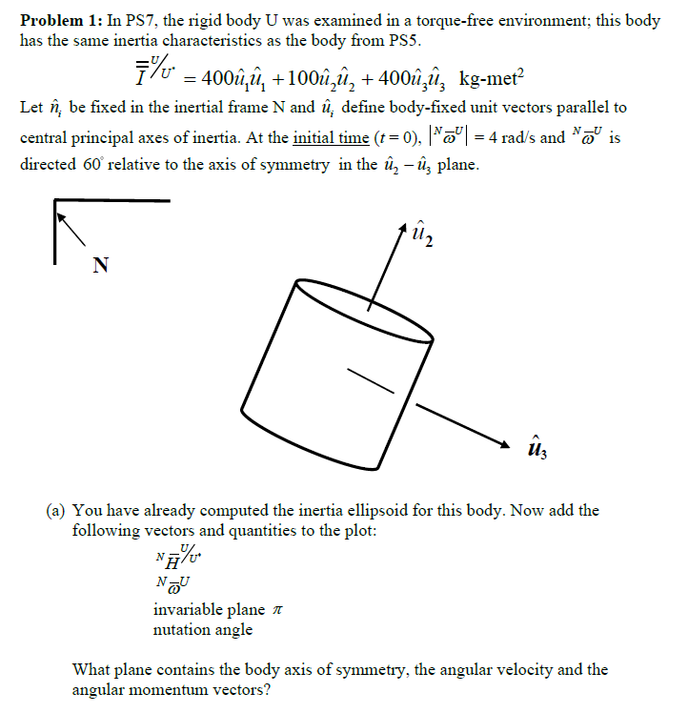

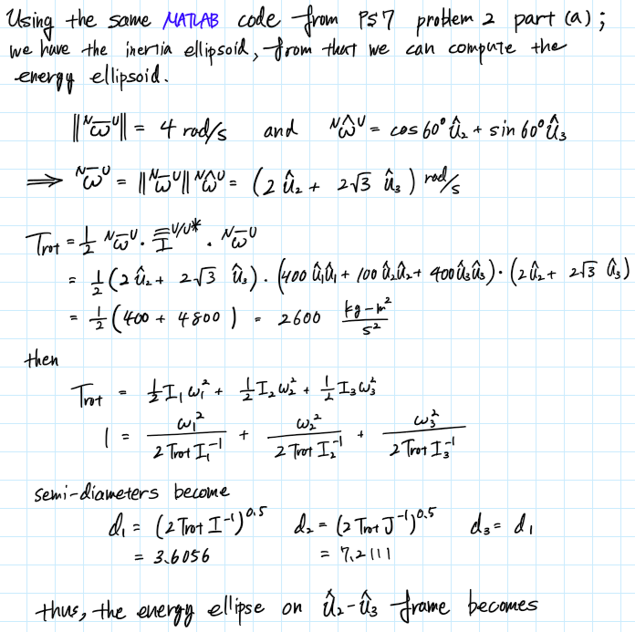

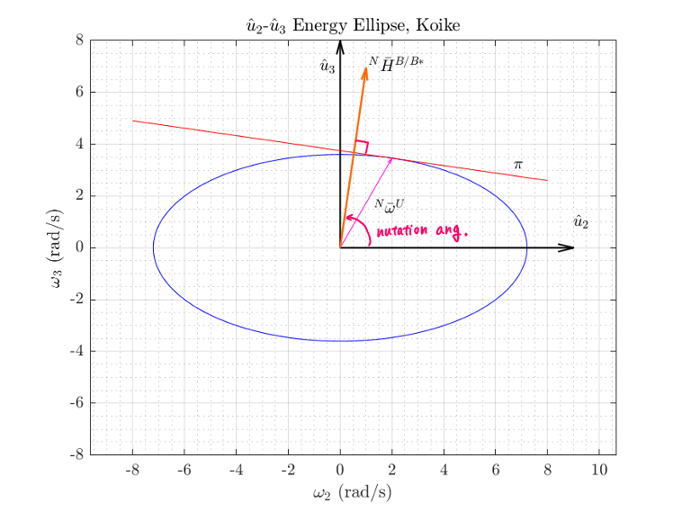

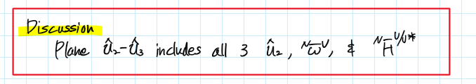

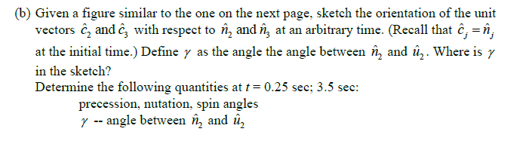

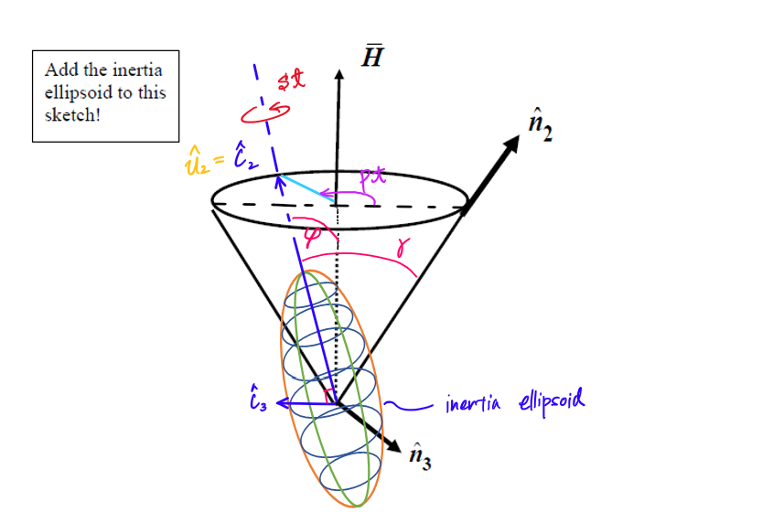

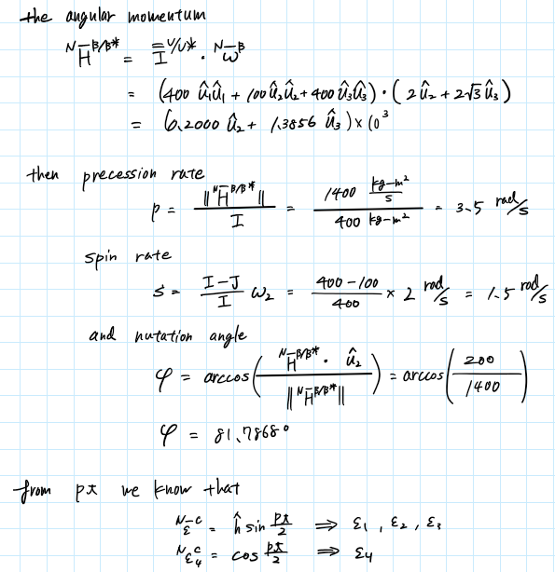

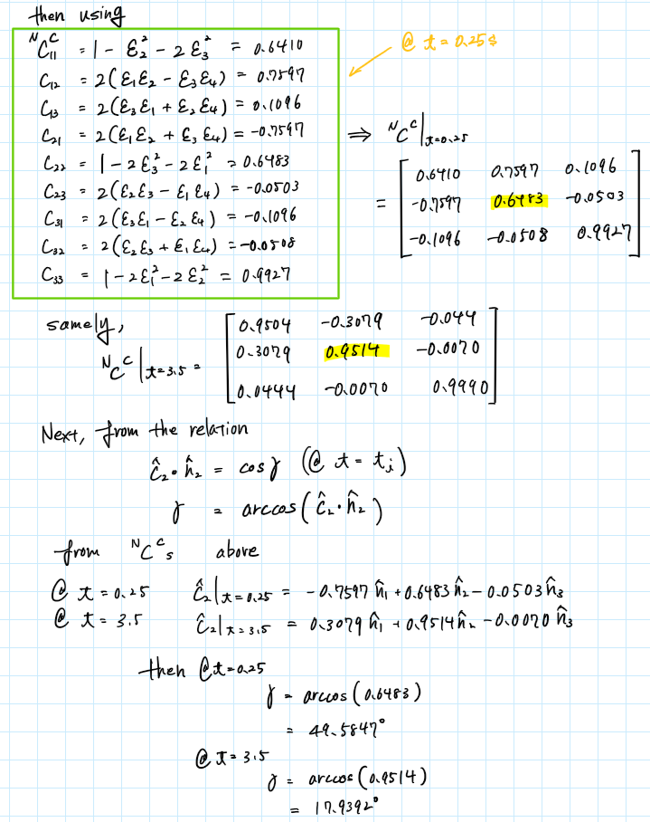

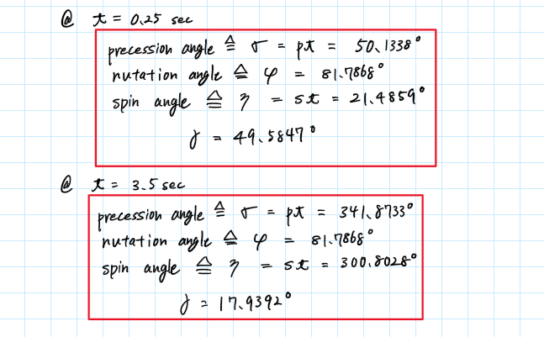

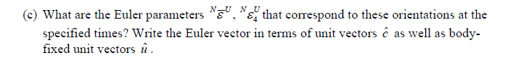

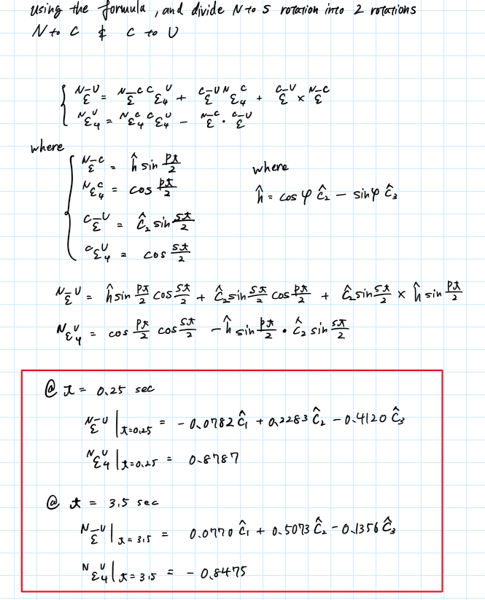

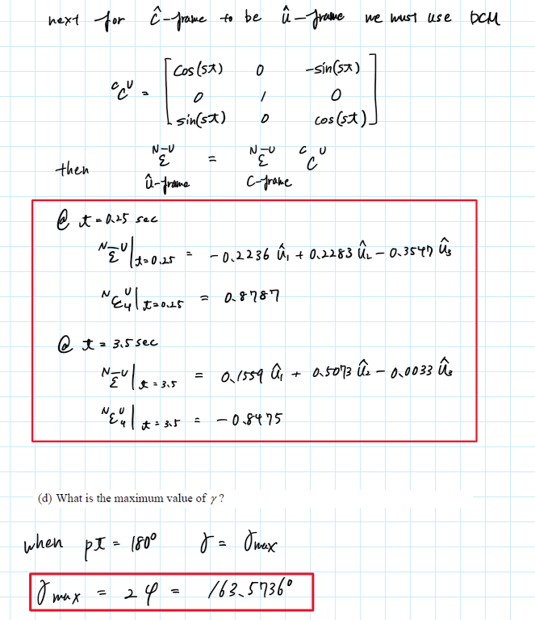

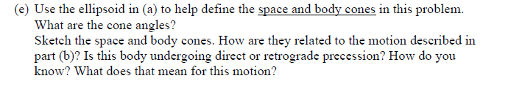

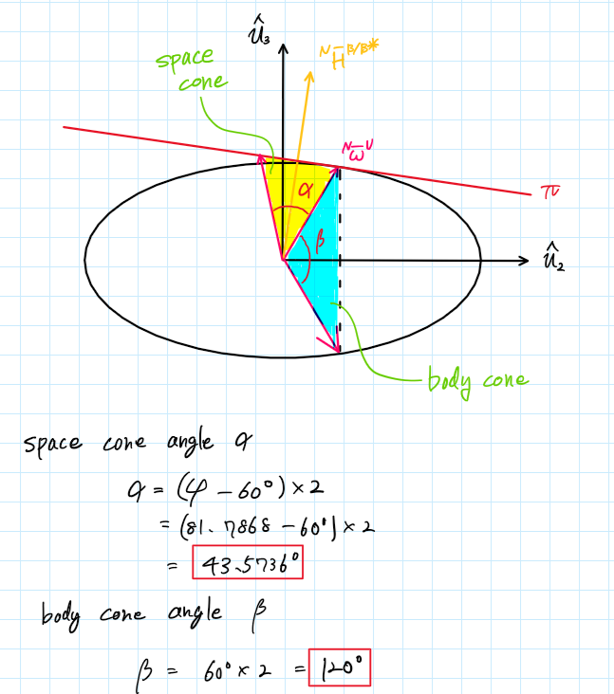

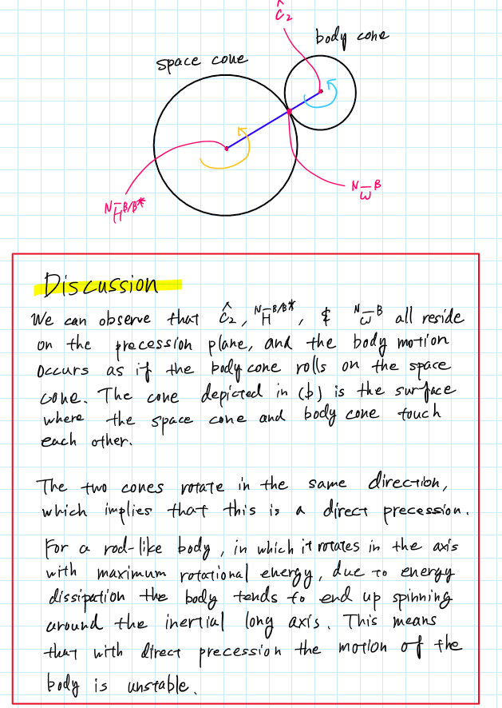

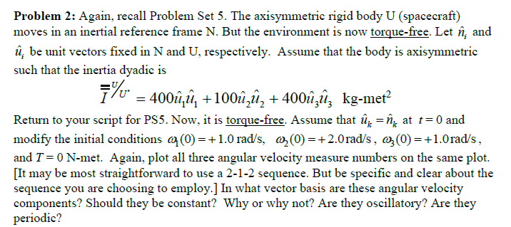



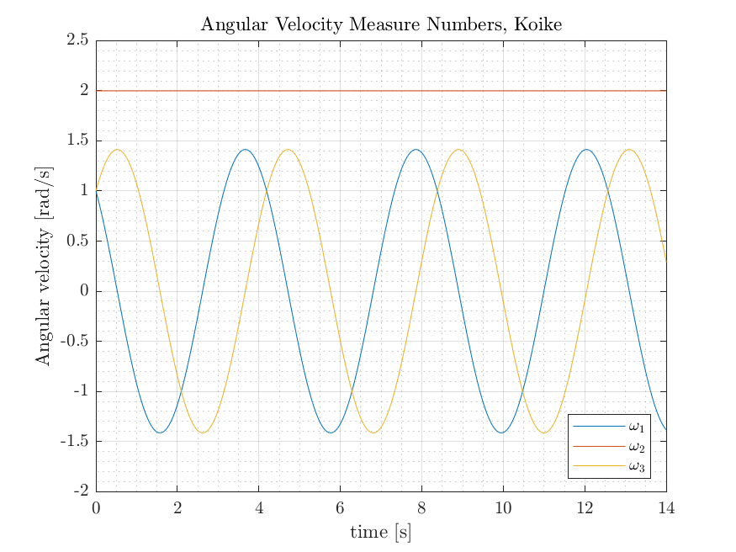

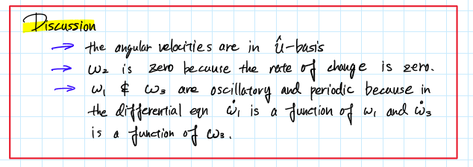

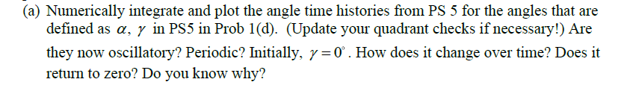

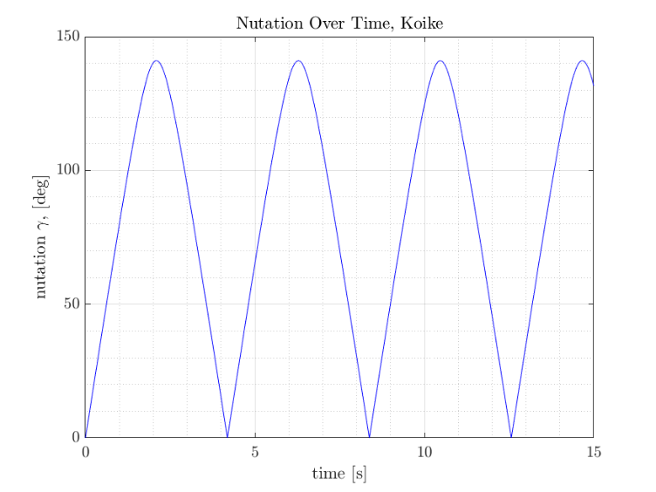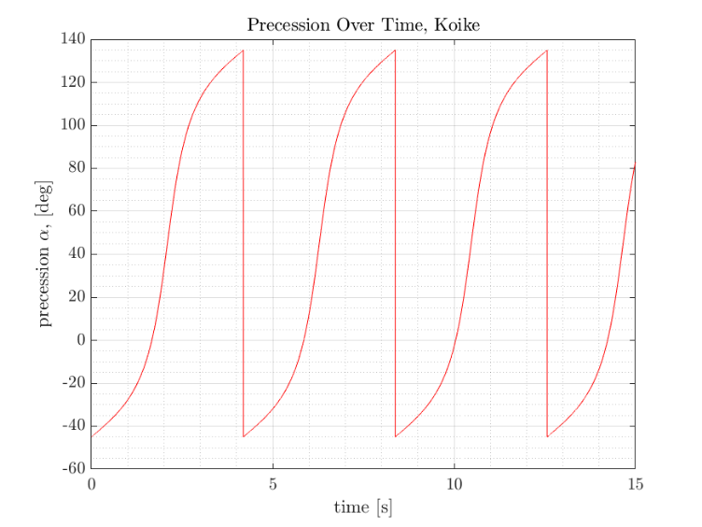

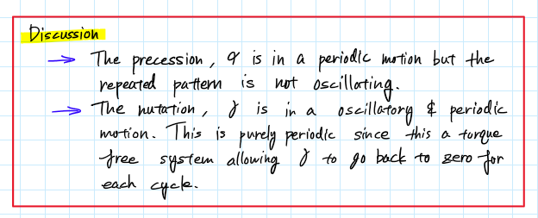

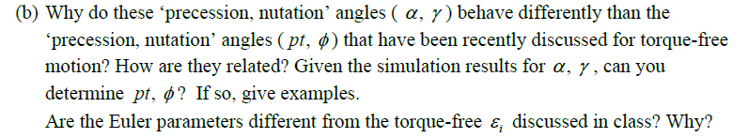

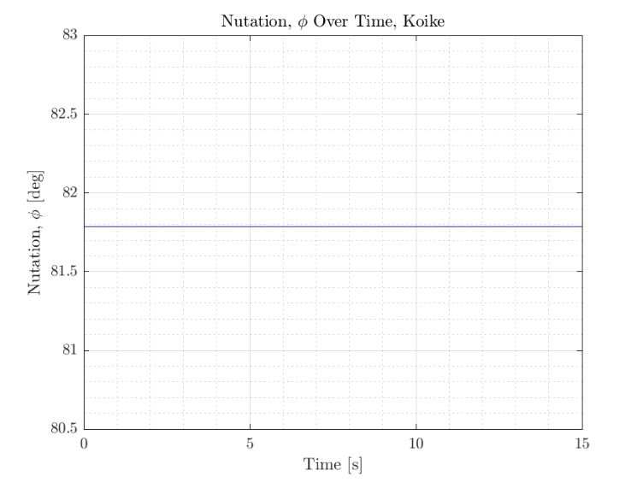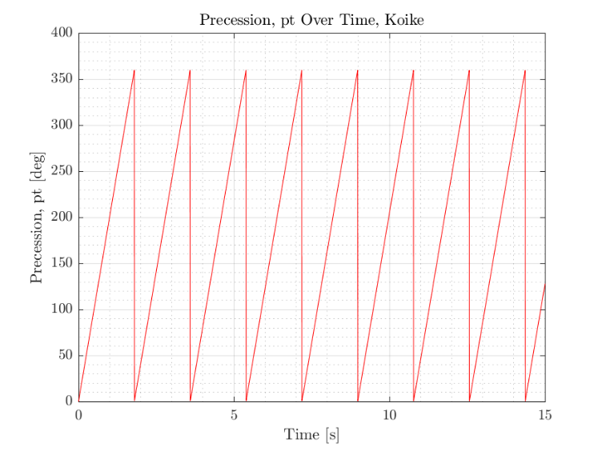

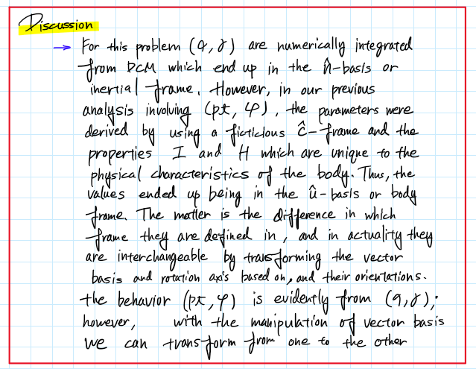

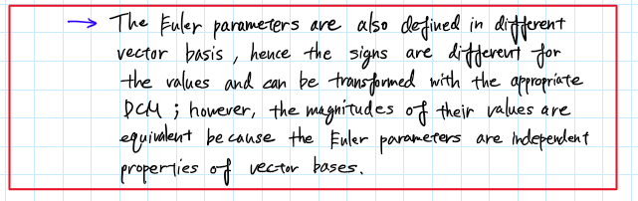

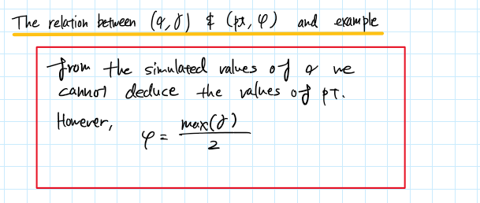

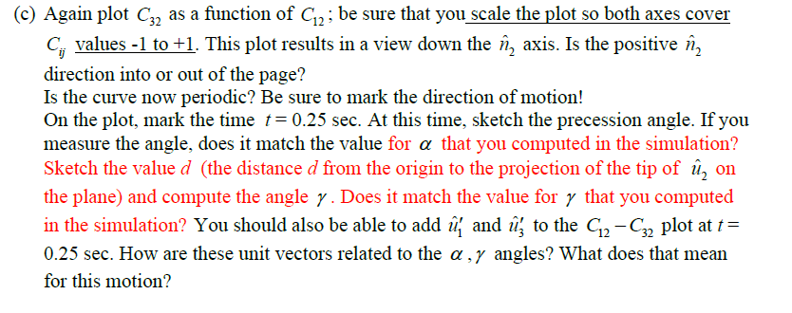

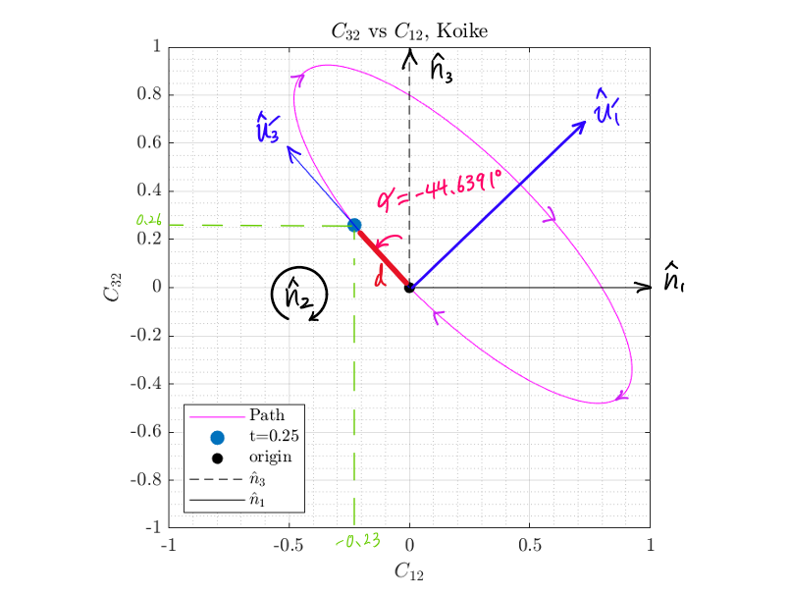

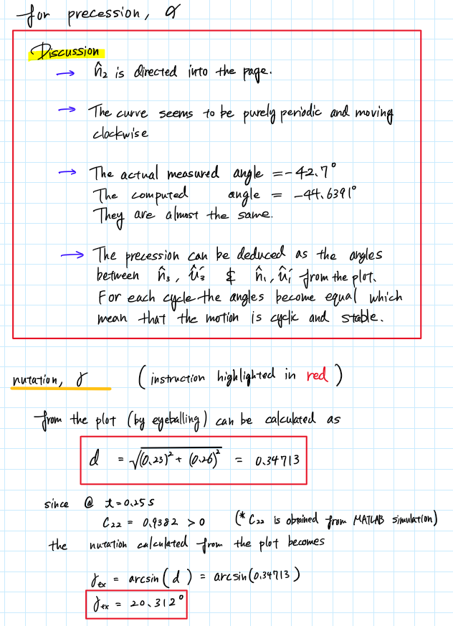

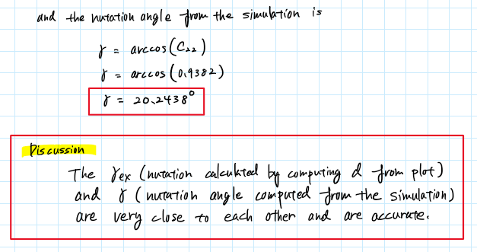

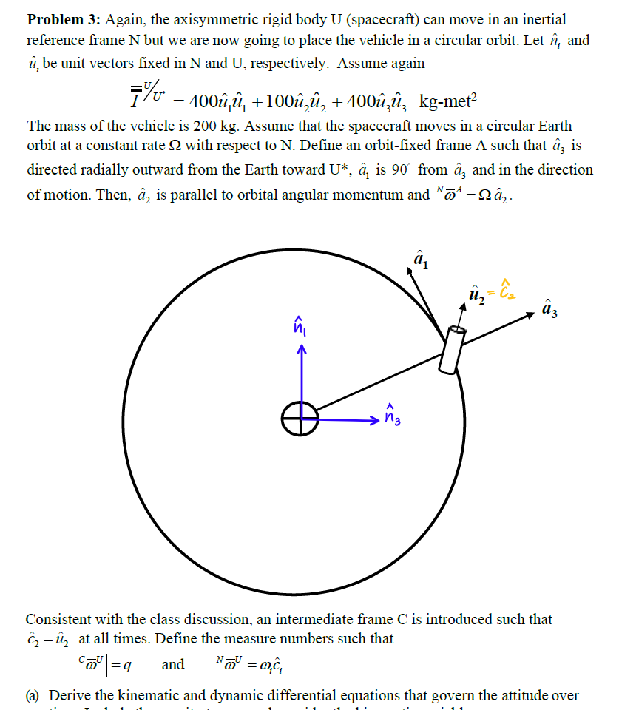  


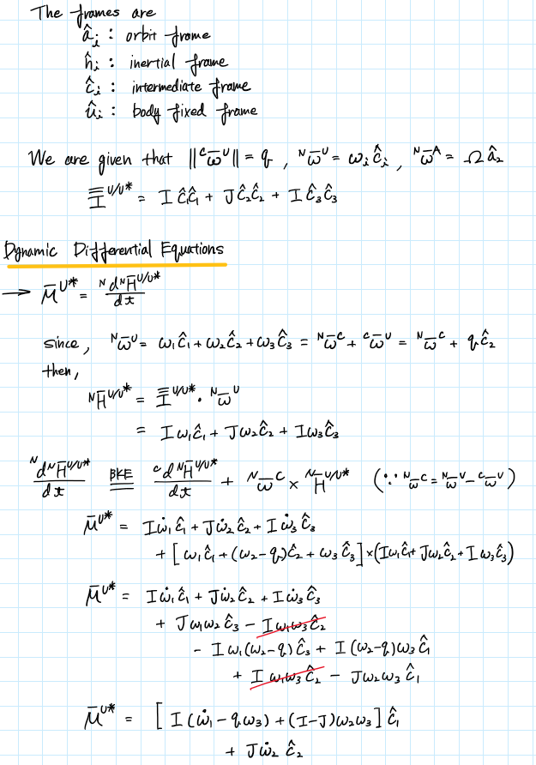

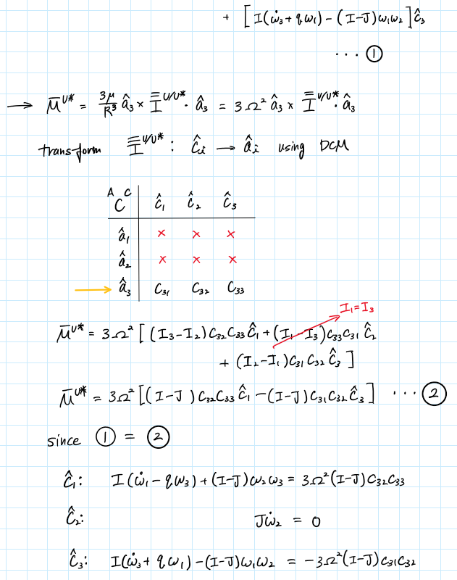

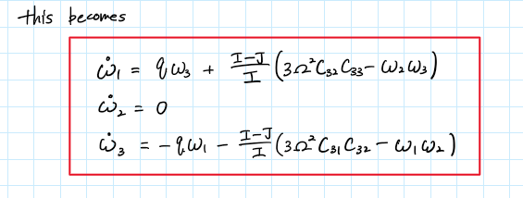

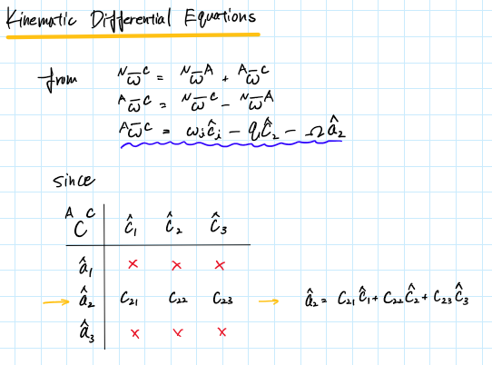

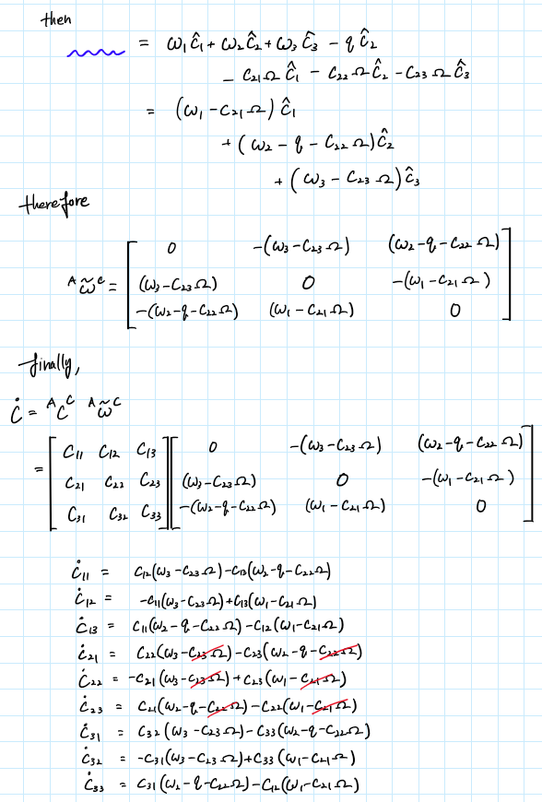

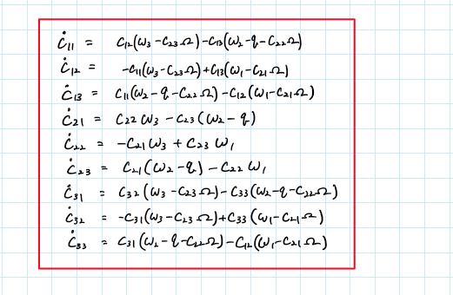



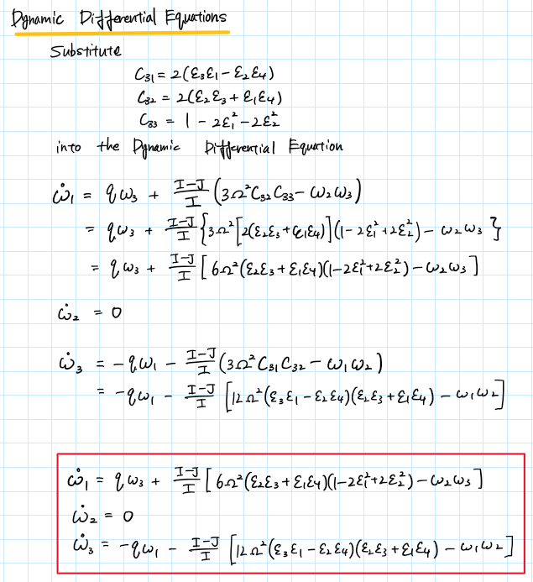

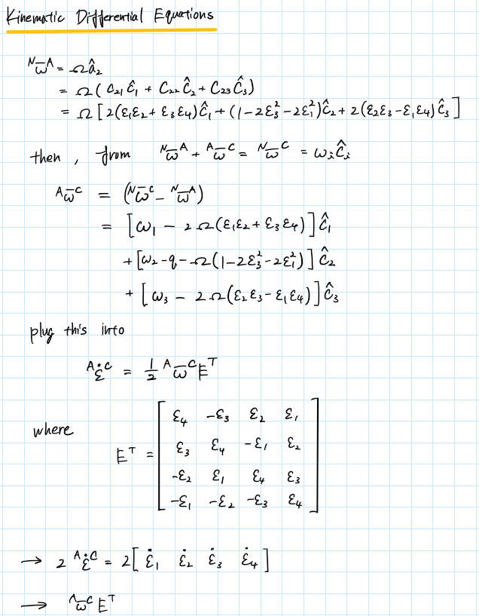

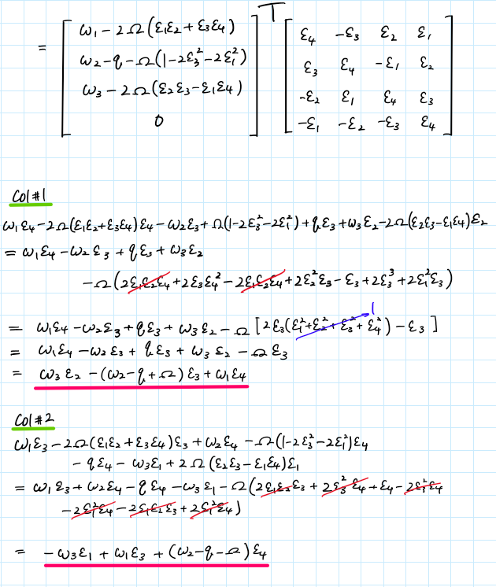

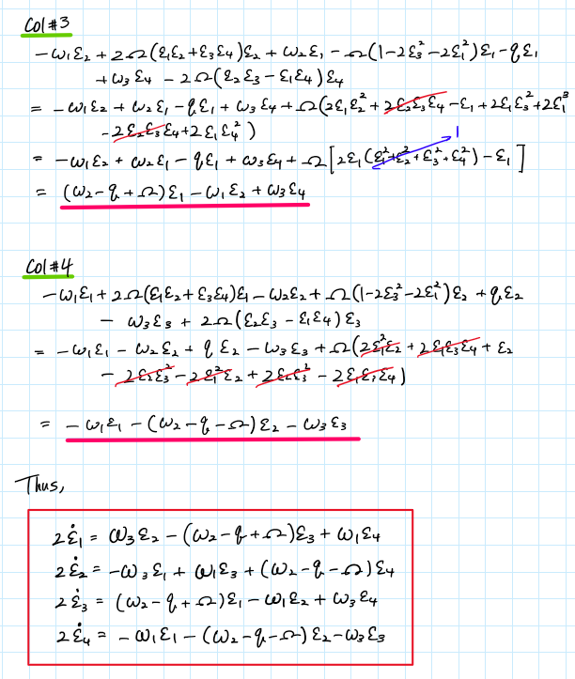

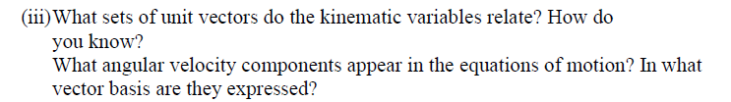

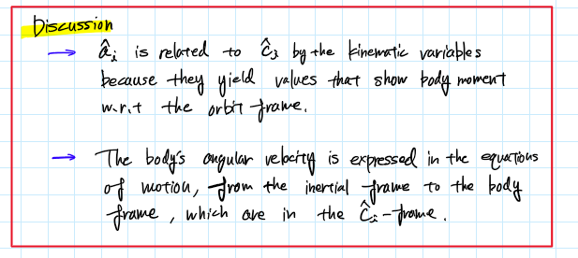

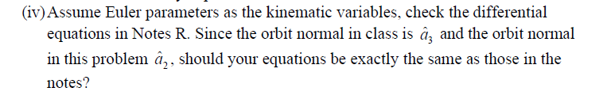

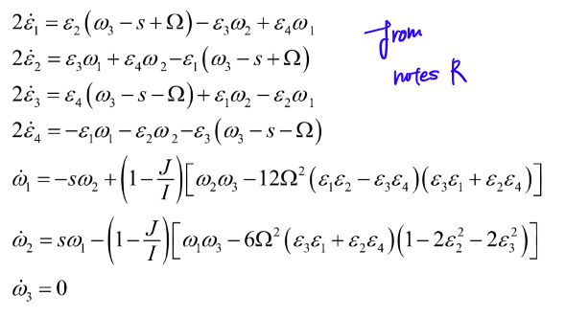

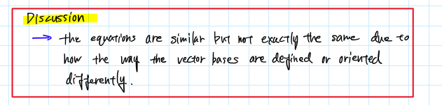

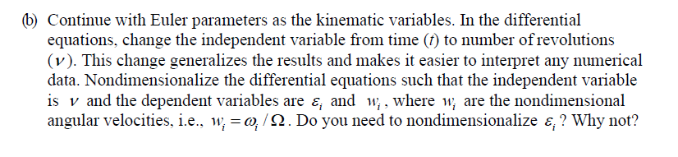

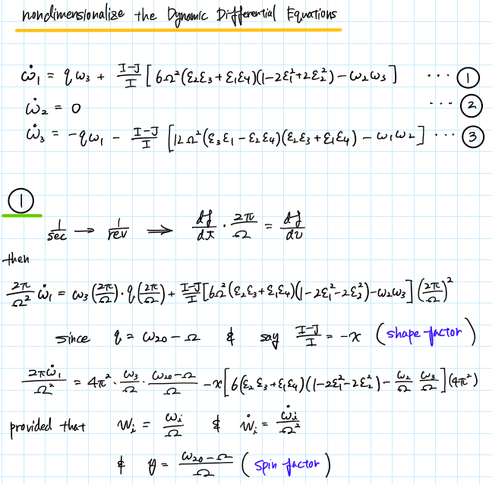

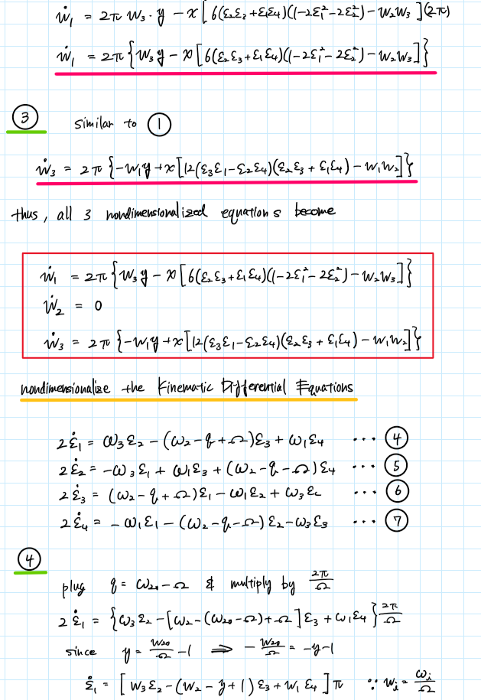

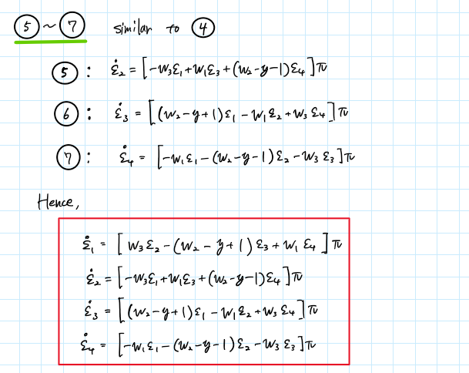

Appendix

## **AAE440 HW8 PROBLEM 1 MATLAB**

clear all; close all; clc;

fdir = 'C:\Users\Tomo\Desktop\studies\2020-Spring\AAE440\MATLAB\outputs\HW8';

set(groot, 'defaulttextinterpreter',"latex");

set(groot, 'defaultAxesTickLabelInterpreter',"latex");

set(groot, 'defaultLegendInterpreter',"latex");

% Arrow drawing function

drawArrow = @(x,y,varargin) quiver( x(1),y(1),x(2)-x(1),y(2)-y(1),0, varargin{:} );

#### (a)

% Given properties

I_body = [400 0 0; 0 100 0; 0 0 400]; % [kg-m2]

I = I_body(1,1); J = I_body(2,2);

w_NU_mag = 4; % magnitude of angular velocity [rad/s]

w_NU_hat = [0 cosd(60) sind(60)]; % angle of w_NU relative to u_2 [deg]

w_NU = w_NU_mag*w_NU_hat;

% Kinetic rotational energy

Trot = 0.5*w_NU*I_body*w_NU.'

% Semi-diameters of energy ellipsoid

d1 = sqrt(2*Trot*I^(-1))

d2 = sqrt(2*Trot*J^(-1))

d3 = d1

% Plotting the inertial ellipsoid

theta = 0:0.01:2*pi;

u_str = ["$\hat{u}_1$","$\hat{u}_2$","$\hat{u}_3$"];

% u2-u3

fig1 = figure("Renderer","painters");

plot(d2*cos(theta), d3*sin(theta), 'b')

title('$\hat{u}_2$-$\hat{u}_3$ Energy Ellipse, Koike')

xlabel('$\omega_2$ (rad/s)')

ylabel('$\omega_3$ (rad/s)')

hold on

drawArrow([0 9], [0 0],'k','linewidth',1); text(9,1,u_str(2),"Interpreter","Latex");

drawArrow([0 0], [0 8],'k','linewidth',1); text(-0.8,7,u_str(3),"Interpreter","Latex");

% Angular velocity

drawArrow([0 w_NU(2)], [0 w_NU(3)],'color','#FD07EA');

text(1.3,1.5,'${}^N\bar{\omega}^U$','Interpreter','Latex');

% Invariable plane PI

[a, b] = line_tangent2ellipse(w_NU(2),w_NU(3),d2,d3);

x = -8:0.1:8;

y = a*x + b;

plot(x,y,'-r'); text(6.7,3.2,'$\pi$','Interpreter',"latex");

% H_body

drawArrow([0 1.0],[0 1.0*(-1/a)],'color','#FF6800','linewidth',1.2)

text(1.1,7,'${}^N\bar{H}^{B/B*}$')

hold off

xlim([-9 9]); ylim([-8 8]);

grid on; grid minor; box on; axis equal;

saveas(fig1, fullfile(fdir,'P1-a-u2_u3_EN-ellipse.png'));

### (b)

% Angular momentum

H_NU = I_body*w_NU.';

H_NU_mag = norm(H_NU);

% Computing p, s, and phi

p = H_NU_mag/I;

s = (I - J)/I*w_NU(2);

phi = acos(H_NU(2)/H_NU_mag)

phi_deg = rad2deg(phi)

% Computing the precession, nutation, and spin angles

% @ t = 0.25

t = 0.25;

sigma = p*t

sigma_deg = rad2deg(sigma)

eta = s*t

eta_deg = rad2deg(eta)

% @ t = 3.5

t = 3.5;

sigma = mod(p*t,2*pi)

sigma_deg = rad2deg(sigma)

eta = mod(s*t,2*pi)

eta_deg = rad2deg(eta)

h_hat_U = H_NU/H_NU_mag;

h_hat_C = [0 cos(phi) -sin(phi)];

% gamma

syms t1

e_NC = h_hat_C*sin(p*t1/2);

e4_NC = cos(p*t1/2);

% DCM

% @ t= 0.25

e_NC_025 = double(subs(e_NC,t1,0.25));

e4_NC_025 = double(subs(e4_NC,t1,0.25));

C_NC_025 = DCM_from_EulerPara([e_NC_025 e4_NC_025])

% @ t= 3.5

e_NC_35 = double(subs(e_NC,t1,3.5));

e4_NC_35 = double(subs(e4_NC,t1,3.5));

C_NC_35 = DCM_from_EulerPara([e_NC_35 e4_NC_35])

gamma_025 = acosd(C_NC_025(2,2))

gamma_35 = acosd(C_NC_35(2,2))

### (c)

% Euler parameters

c2_hat = [0 1 0];

syms t

e_NC = h_hat_C*sin(p*t/2);

e4_NC = cos(p*t/2);

e_CU = c2_hat*sin(s*t/2);

e4_CU = cos(s*t/2);

e_NU = e_NC*e4_CU + e_CU*e4_NC + cross(e_CU,e_NC);

e4_NU = e4_NC*e4_CU - dot(e_NC,e_CU);

% C-frame

% @ t = 0.25

e_NU_025_C = double(subs(e_NU,t,0.25))

e4_NU_025 = double(subs(e4_NU,t,0.25))

% @ t = 3.5

e_NU_35_C = double(subs(e_NU,t,3.5))

e4_NU_35 = double(subs(e4_NU,t,3.5))

% U-frame

syms t2

C_CU = [cos(s*t2) 0 -sin(s*t2);

0 1 0;

sin(s*t2) 0 cos(s*t2)];

% @ t = 0.25

e_NU_025_U = double(e_NU_025_C*subs(C_CU,t2,0.25))

C_NU_025_1 = double(C_NC_025*subs(C_CU,t2,0.25))

C_NU_025_2C = DCM_from_EulerPara([e_NU_025_C e4_NU_025])

C_NU_025_2U = DCM_from_EulerPara([e_NU_025_U e4_NU_025])

% @ t = 3.5

e_NU_35_U = double(e_NU_35_C*subs(C_CU,t2,3.5))

### (d)

gamma_max = 2*phi_deg;

### (e)

alpha = 2*(phi_deg - 60)

### ADDITIONAL (FOR PROBLEM 2)

tspan = 0:0.005:15;

fig2 = figure("Renderer","painters")

plot(tspan,rad2deg(mod(p*tspan,2*pi)),'r')

title("Precession, pt Over Time, Koike")

ylabel('Precession, pt [deg]')

xlabel('Time [s]')

grid on; grid minor; box on;

saveas(fig2,fullfile(fdir,"pt_precession.png"))

fig3 = figure("Renderer","painters")

plot(tspan,rad2deg(phi).*ones(size(tspan)),'b')

title("Nutation, $\phi$ Over Time, Koike")

ylabel('Nutation, $\phi$ [deg]')

xlabel('Time [s]')

grid on; grid minor; box on;

saveas(fig3,fullfile(fdir,"phi_nutation.png"))

### FUNCTION

function [slope, y_intercept] = line_tangent2ellipse(x1,y1,a,b)

slope = -x1/y1*b^2/a^2;

y_intercept = y1 - x1*slope;

end

## **AAE440 HW8 PROBLEM 2 MATLAB**

clear all; close all; clc;

fdir = 'C:\Users\Tomo\Desktop\studies\2020-Spring\AAE440\MATLAB\outputs\HW8';

set(groot, 'defaulttextinterpreter',"latex");

set(groot, 'defaultAxesTickLabelInterpreter',"latex");

set(groot, 'defaultLegendInterpreter',"latex");

% Defining System Properties

T = 0; % Torque [N m]

I_cm = [400 0 0;

0 100 0;

0 0 400]; % Inertia Dyadic [kg m2]

I = 400;

J = 100;

% Given Initial Conditions

w0 = [1 2 1]; % Initial AngVel [rad s-1]

e0 = [0 0 0 1]; % Initial Euler Parameters

C0 = [1 0 0 0 1 0 0 0 1]; % Initial DCM

% Numerically integrating dynamic and kinematic EOMs

tspan = [0 14]; % Integration time

y0 = [w0 e0 0 C0]; % Initial conditions

opt = odeset('RelTol', 1e-13, 'AbsTol', 1e-13); % Integration Tolerance

[t1, res1] = ode45(@(t,y) EOM(t,y,I,J,T), tspan, y0, opt);

% Plotting three angular velocity measure numbers over time

fig1 = figure("Renderer","painters");

plot(t1, res1(:,1:3))

ylabel('Angular velocity [rad/s]')

xlabel('time [s]')

title({'Angular Velocity Measure Numbers, Koike'})

axis([tspan -2 2.5])

legend('$\omega_1$', '$\omega_2$', '$\omega_3$','Location',"best")

grid on; grid minor; box on;

saveas(fig1, fullfile(fdir, 'angVel_measure_nums.png'));

### (a)

% Plotting precession and nutation angles

tspan_a = 0:0.001:15;

[t_a, res_a] = ode45(@(t,y) EOM(t,y,I,J,T), tspan_a, y0, opt);

% Assigning computed C12, C22, and C32 to a variable

C_a = res_a(:,9:end);

[alpha_a, gamma_a] = ang_calc_body212(C_a);

fig2 = figure(2);

plot(t_a, alpha_a, 'r')

xlabel('time [s]')

ylabel('precession $\alpha$, [deg]')

title('Precession Over Time, Koike')

grid on; grid minor; box on;

saveas(fig2, fullfile(fdir,'alpha.png'));

fig3 = figure(3);

plot(t_a, gamma_a, 'b')

xlabel('time [s]')

ylabel('nutation $\gamma$, [deg]')

title('Nutation Over Time, Koike')

grid on; grid minor; box on

saveas(fig3, fullfile(fdir,'gamma.png'));

### (c)

% Integration with smaller time step

tspan_c = 0:0.05:15;

[t_c, res_c] = ode45(@(t,y) EOM(t,y,I,J,T), tspan_c, y0, opt);

% C_new = res_c(:,9:17);

% Assigning computed C12, C22, and C32 to a variable

C11s_c = res_c(:,9);

C12s_c = res_c(:,10);

C13s_c = res_c(:,11);

C21s_c = res_c(:,12);

C22s_c = res_c(:,13);

C23s_c = res_c(:,14);

C31s_c = res_c(:,15);

C32s_c = res_c(:,16);

C33s_c = res_c(:,17);

% Finding the index when t=0.2 and t=1.5 and corresponding C12 C22 C32

index_t0p25 = find(t_c==0.25);

C11_t025 = C11s_c(index_t0p25);

C12_t025 = C12s_c(index_t0p25);

C13_t025 = C13s_c(index_t0p25);

C21_t025 = C21s_c(index_t0p25);

C22_t025 = C22s_c(index_t0p25);

C23_t025 = C23s_c(index_t0p25);

C31_t025 = C31s_c(index_t0p25);

C32_t025 = C32s_c(index_t0p25);

C33_t025 = C33s_c(index_t0p25);

C_025 = [C11_t025 C12_t025 C13_t025;

C21_t025 C22_t025 C23_t025;

C31_t025 C32_t025 C33_t025]

% Computing gamma

gamma = acosd(C22_t025)

% Plotting at t = 0.2 and 1.5

fig4 = figure(4);

plot(C12s_c, C32s_c,'-m','MarkerSize',15)

title('$C_{32}$ vs $C_{12}$, Koike')

xlabel('$C_{12}$')

ylabel('$C_{32}$')

hold on

plot(C12_t025, C32_t025, '.','MarkerSize',26)

plot(0,0,'.k','MarkerSize',20)

plot([0 0],[0 1],'--k')

plot([0 1],[0 0],'-k')

d = linspace(0,-0.5,100);

plot(d,d.*(C32_t025/C12_t025),'-b')

hold off

legend('Path','t=0.25','origin','$\hat{n}_3$','$\hat{n}_1$',"location",'southwest')

grid on; grid minor; axis equal; box on;

xlim([-1 1]); ylim([-1 1]);

saveas(fig4, fullfile(fdir, 'C12_vs_C32.png'));

### FUNCTION

function [alphas, gammas] = ang_calc_body212(DCM)

%{

This function calculates the precession, nutation, and spin angle

from the provided DCM

%}

% DCM is 1 by 9 matrix with each column being C_ij

C12s = DCM(:,2);

C21s = DCM(:,4);

C22s = DCM(:,5);

C23s = DCM(:,6);

C32s = DCM(:,8);

% Preallocating alpha and gamma arrays

alphas = zeros([length(C12s),1]);

gammas = zeros([length(C12s),1]);

% For loop to construct alpha and gamma arrays interatively

for i = 1:length(alphas)

% calculating gamma

gammas(i) = acos(C22s(i));

% calculating and verfying alpha

alpha1 = round([acos(C32s(i)/sin(gammas(i))), ...

-acos(C32s(i)/sin(gammas(i))), ...

-acos(C32s(i)/sin(gammas(i)))+2*pi],4);

alpha2 = round([asin(C12s(i)/sin(gammas(i))), ...

pi-asin(C12s(i)/sin(gammas(i))), ...

pi-asin(C12s(i)/sin(gammas(i)))],4);

if i == 1

alphas(i) = deg2rad(-44.9829164957209);

else

alphas(i) = intersect(alpha1, alpha2);

end

gammas(i) = rad2deg(gammas(i));

alphas(i) = rad2deg(alphas(i));

end

end

function dwdt = EOM(t,y,I,J,T)

%{

inputs: 1) t: time lapse

2) y: angular velocities, euler parameters, initial

euler constraint constant, DCM

3) I: moment of inertia about the non-rotating axis

4) J: moment of inertia about the rotating axis

5) T: torque

outputs: 1) dwdt: differential y

%}

dwdt = zeros(17,1);

% Dynamics EOMs

dwdt(1) = T/I - (I-J)/I*y(3)*y(2);

dwdt(2) = 0;

dwdt(3) = (I-J)/I*y(1)*y(2);

% Kinematic EOM of angular velocities and Euler parameters

dedt1 = 0.5*( y(1)*y(7)-y(2)*y(6)+y(3)*y(5));

dedt2 = 0.5*( y(1)*y(6)+y(2)*y(7)-y(3)*y(4));

dedt3 = 0.5*(-y(1)*y(5)+y(2)*y(4)+y(3)*y(7));

dedt4 = -0.5*( y(1)*y(4)+y(2)*y(5)+y(3)*y(6));

dwdt(4) = dedt1;

dwdt(5) = dedt2;

dwdt(6) = dedt3;

dwdt(7) = dedt4;

dwdt(8) = y(4)^2 + y(5)^2 + y(6)^2 + y(7)^2 - 1; % Euler Constraint

e = [y(4) y(5) y(6) y(7)];

C = DCM_from_EulerPara(e); % DCM

% Kinematic EOM of angular velocities and direction cosines

dwdt(9) = C(1,2)*y(3)-C(1,3)*y(2);

dwdt(10) = C(1,3)*y(1)-C(1,1)*y(3);

dwdt(11) = C(1,1)*y(2)-C(1,2)*y(1);

dwdt(12) = C(2,2)*y(3)-C(2,3)*y(2);

dwdt(13) = C(2,3)*y(1)-C(2,1)*y(3);

dwdt(14) = C(2,1)*y(2)-C(2,2)*y(1);

dwdt(15) = C(3,2)*y(3)-C(3,3)*y(2);

dwdt(16) = C(3,3)*y(1)-C(3,1)*y(3);

dwdt(17) = C(3,1)*y(2)-C(3,2)*y(1);

end

function C_mat = DCM_from_EulerPara(epsilons)

% Euler Parameters

epsilon1 = epsilons(1);

epsilon2 = epsilons(2);

epsilon3 = epsilons(3);

epsilon4 = epsilons(4);

% Calculating DCM from Euler Parameters

C11 = 1 - 2*epsilon2^2 - 2*epsilon3^2;

C12 = 2*(epsilon1*epsilon2 - epsilon3*epsilon4);

C13 = 2*(epsilon3*epsilon1 + epsilon2*epsilon4);

C21 = 2*(epsilon1*epsilon2 + epsilon3*epsilon4);

C22 = 1 - 2*epsilon3^2 - 2*epsilon1^2;

C23 = 2*(epsilon2*epsilon3 - epsilon1*epsilon4);

C31 = 2*(epsilon3*epsilon1 - epsilon2*epsilon4);

C32 = 2*(epsilon2*epsilon3 + epsilon1*epsilon4);

C33 = 1 - 2*epsilon1^2 - 2*epsilon2^2;

C_mat = [C11 C12 C13; C21 C22 C23; C31 C32 C33];

end