

College of Engineering
School of Aeronautics and Astronautics

AAE 532
Orbital Mechanics

PS 2
N-Body Problem and Gravitational Equation of Motion

Author:
Tomoki Koike
Supervisor:
K. C. Howell

September 11th, 2020 Friday
Purdue University
West Lafayette, Indiana
Problem 1: After a complex route to the vicinity of the Moon, the two identical – the original – ARTEMIS spacecraft (P1 and P2) arrived in the lunar vicinity on August 23 and October 22, 2010, respectively. The trajectories in the lunar vicinity prior to lunar orbit insertion were influenced significantly by the gravity fields of other bodies, particularly the Earth and the Sun. The P1 path from arrival in the Moon vicinity to the lunar insertion point appears in the images below. Note that it is from a familiar elliptical orbit.
Define a system that is comprised of five particles. The law of gravity between each pair is the familiar inverse square law. Obviously, the planets are not truly aligned simultaneously, but assume that the Sun, spacecraft (s/c), and other bodies are colinear and positioned as indicated below.
Earth – Moon – s/c – Sun – Jupiter
Assume that a single spacecraft is instantaneously located along the transfer path such that the distance between the s/c and the Moon is 140,000 km. The total mass of each ARTEMIS spacecraft is about 130 kg. The distances of the other planets from the Sun are assumed to be equal to the semi-major axis as listed in the Table of Constants located under Supplementary Documents on BrightSpace.

- Locate the center of mass of the 5-particle system. Identify it on a sketch. Add unit vectors and appropriate position vectors.
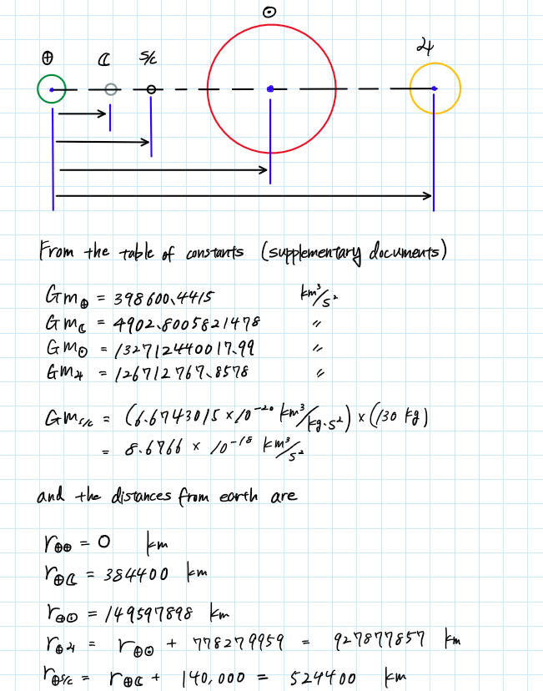
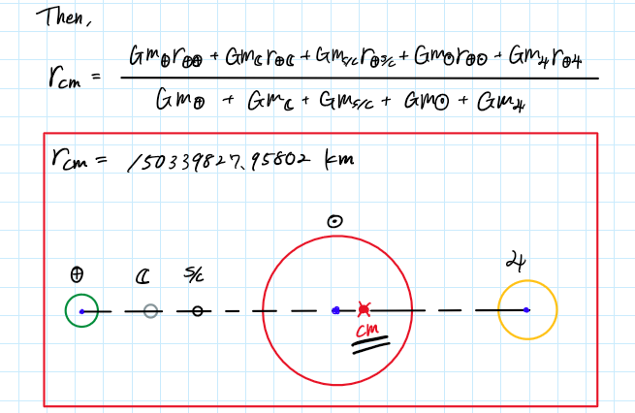

- Write the vector differential equation for motion of the s/c with respect to the center of mass, i.e., $\overline{r_{i}}={\overline{r}}_{s/c}$. You should obtain an expression for the accelerations on the s/c, i.e. ${\ddot{\overline{r}}}_{s/c} =$ (sum of 4 terms). Assuming the alignment above, compute the accelerations on the s/c due to each of the other bodies. Include the directions. Which body produces the largest acceleration on the s/c? smallest? What is the descending order? Net acceleration in km/sec²? [Did you use a consistent number of significant digits in your computations?]
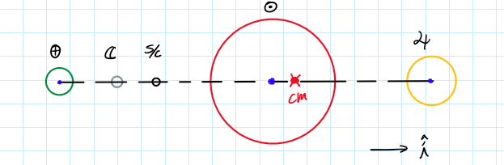

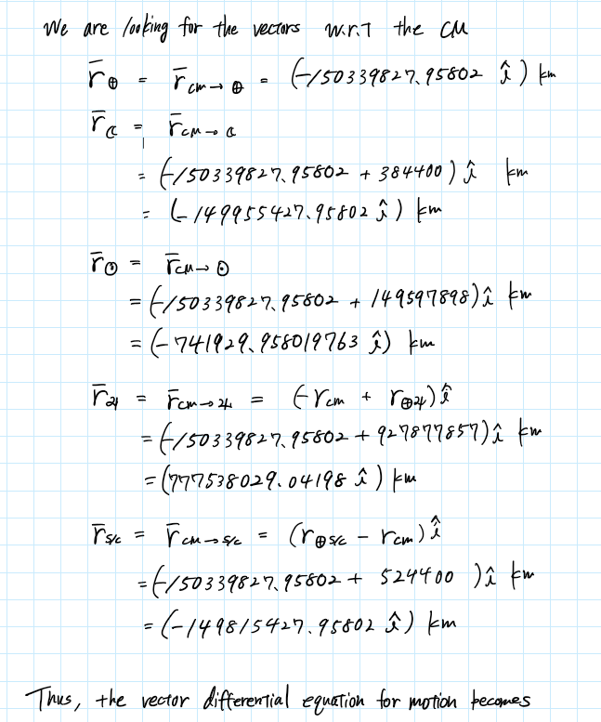

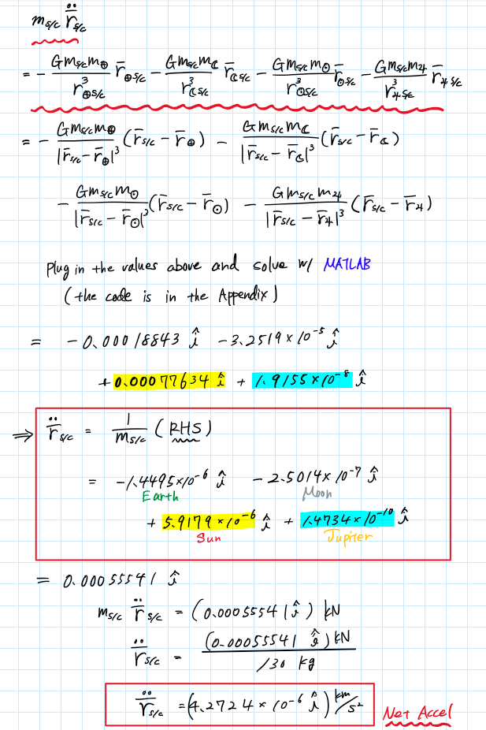
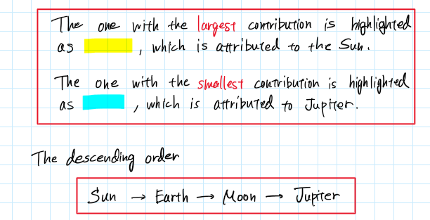
- Compare the relative size of the acceleration terms (gravitational forces) and their directions on the s/c. Is the order of influence what you expected? Which gravity term dominates? Do the acceleration terms seem consistent with your expectations?

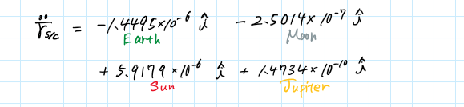

body | Magnitude of Acc. Term | Direction
Earth | $$1.4495×{10}^{-6}$$ | negative (left)
Moon | $$2.5014×{10}^{-7}$$ | negative (left)
Sun | $$5.9179×{10}^{-6}$$ | positive (right)
Jupiter | $$1.4734×{10}^{-10}$$ | positive (right)

The order of influence of all the bodies were relatively close to what I have been expecting. For the Sun, considering the close distance of the CM (Center of Mass) and spacecraft to the Sun, it was straightforward to tell that the Sun was going to have the largest order of influence on the system. Similarly, Jupiter, which was significantly far away from the CM and spacecraft compared to the other bodies was also anticipated to have the smallest influence. The other two, Earth and Moon, though the moon is located closer the spacecraft, it is possible to predict that the Earth would have a larger influence considering its larger mass and size.
The results indicate that the Sun dominates the gravity terms.
Since the spacecraft has a significantly smaller mass than the planets, it is likely that we have assumed the acceleration term to be small. The direction would also be expected to go right due to the Sun. The results satisfy these predictions, and therefore, we can say that the acceleration term is congruent with our expectations.

Problem 2: Return to the system in Problem 1
- Write the expression for the acceleration of the spacecraft relative to the Moon due to the gravity of the Earth, Moon, Sun, and Jupiter. Write this expression in the form ${\ddot{\overline{r}}}_{☾→s/c}$ = (sum of terms). Label each of the following terms in this expression: dominant term, direct perturbing terms, indirect perturbing terms, net perturbing term.
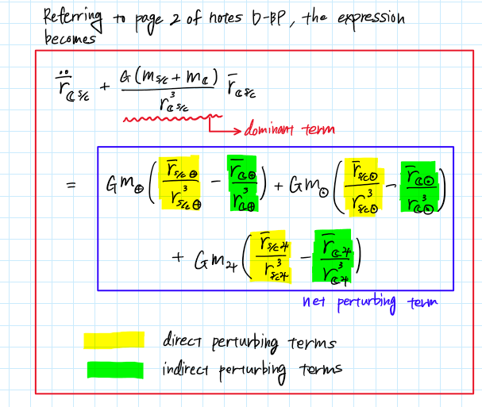

- Compute the magnitude and direction of each of the terms in your expression for ${\ddot{\overline{r}}}_{☾→s/c}$ , as well as the net perturbing accelerations for each body and the total net acceleration. Include the directions. Does the ‘dominant’ Moon term also possess the largest magnitude? If not, which body contributes the largest individual magnitude terms? Is the largest magnitude term a direct or indirect term? Compare the magnitude and direction of the dominant acceleration and the net perturbing acceleration from each ‘perturbing’ body. Which ‘perturbing’ body has the largest impact? If the indirect perturbing acceleration terms are neglected, compare the magnitude of the dominant and the direct perturbing accelerations. Which body would have the largest impact? Do the indirect perturbing term matter?

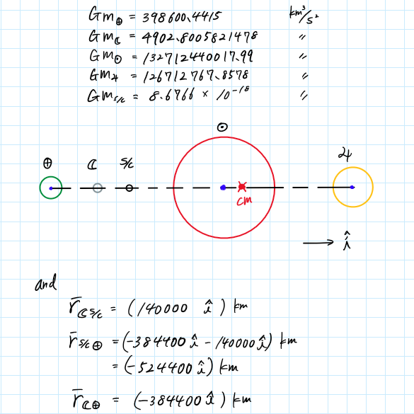

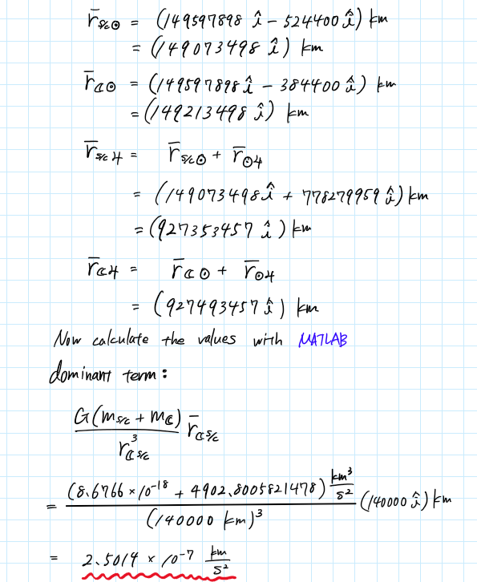

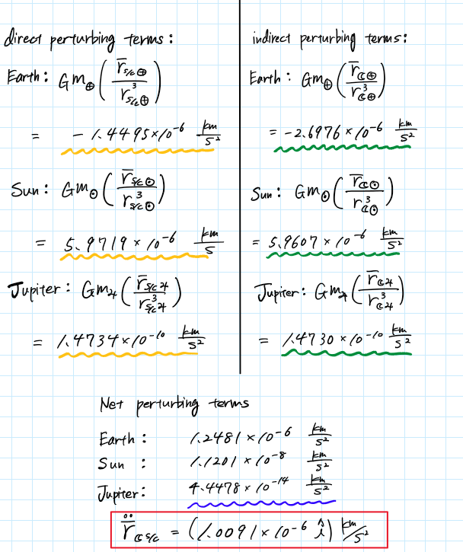
Body | term type | magnitude [km/s³] | direction | rank of all | rank of dominant and net | rank of dominant and direct
Moon | dominant | $$2.5014×{10}^{-7}$$ | + | 6 | 2 | 3
Earth | direct perturbing | $$1.4495×{10}^{-6}$$ | - | 4 |  | 2
 | indirect perturbing | $$2.6976×{10}^{-6}$$ | - | 3
 | net perturbing | $$1.2481×{10}^{-6}$$ | + | 5 | 1
Sun | direct perturbing | $$5.9719×{10}^{-6}$$ | + | 1 |  | 1
 | indirect perturbing | $$5.9607×{10}^{-6}$$ | + | 2
 | net perturbing | $$1.1201×{10}^{-8}$$ | + | 7 | 3
Jupiter | direct perturbing | $$1.4734×{10}^{-10}$$ | + | 8 |  | 4
 | indirect perturbing | $$1.4730×{10}^{-10}$$ | + | 9
 | net perturbing | $$4.4478×{10}^{-14}$$ | + | 10 | 4

The dominant Moon term does not have the largest magnitude; instead the direct perturbating term of the Sun has the largest magnitude within all terms.
All net perturbing terms have a positive direction (to the right of the spacecraft). The dominant term also has a positive in our derivation; however, considering that we left the term in the LHS, we can say that the dominant term has a negative direction when moved to the RHS. The largest net perturbing term is the Earth’s as we can see in column ‘rank of dominant and net’ of the table above. Thus, we can say that the Earth has the largest perturbing impact on the spacecraft.
When the indirect perturbing terms are neglected, the direct perturbing term of the Sun is again the body with the largest magnitude. However, when we include the indirect perturbing term, the Sun’s net perturbing term becomes smaller than that of the Earth’s. Hence, we can say that the indirect perturbing term does have a large influence and should not be neglected.

- Assume that all the perturbing bodies are neglected. Given the values of the acceleration terms at this instant along the path, is it reasonable to model the motion of the spacecraft using a two-body problem (i.e., only Moon and s/c)? If a two-body model is not adequate, is there a three-body system that may provide a more reasonable model for the spacecraft motion, e.g., Moon/spacecraft/Earth or Moon/spacecraft/Sun? Would you rather use a four-body model? Which bodies? Why?

From what we have discussed earlier in part (b) of this problem it is unreasonable to neglect all the perturbing bodies and assume the system to be a two-body problem. In part (b), we have seen that the dominant Moon term is smaller in magnitude than the net perturbing term of the Earth and is also smaller than the magnitude of the direct perturbing term of the Sun. Both the direct and indirect perturbing term of Jupiter has a magnitude smaller with an order of 2 to 3, and its net perturbing term is significantly smaller than the other perturbing bodies. That being said, we cannot model this as a three-body problem, and the system at least has to include the Earth and the Sun as perturbing bodies. Ultimately, we should model this system as a four-body problem with the bodies Moon/spacecraft/Earth/Sun.

- Recast the problem and write the expression for the acceleration of the spacecraft relative to the Earth due to the gravity of the Earth, Moon, Sun and Jupiter. Now, evaluate the dominant acceleration and each perturbing acceleration term. Is this model equally valid? Observing the terms, compare the values of the dominant acceleration and the net perturbing acceleration from each additional body. Given the assessment in (b), will any of your conclusions change with this formation? Which model for the spacecraft motion is correct (a) or (d)? Why?
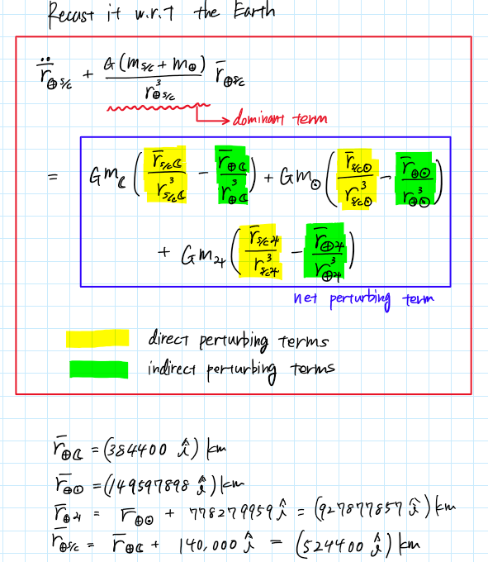

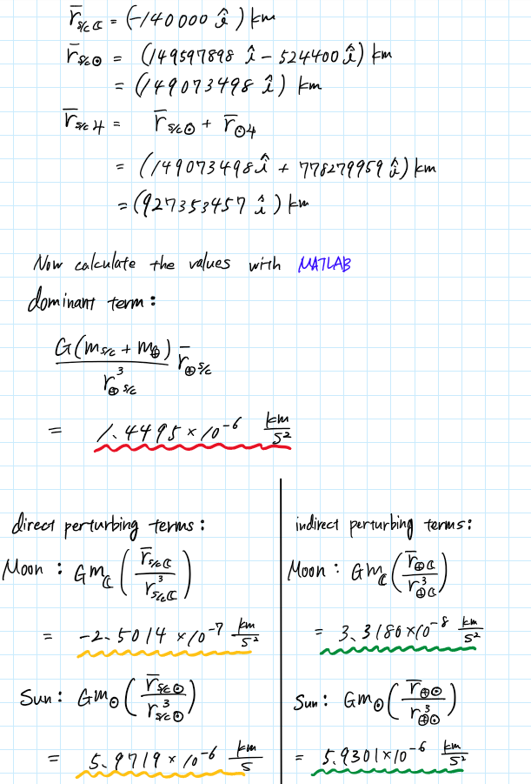
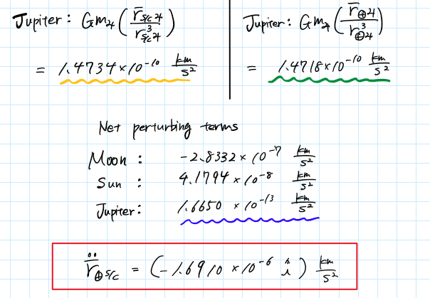
Body | term type | magnitude [km/s³] | direction | rank of all | rank of dominant and net | rank of dominant and direct
Earth | dominant | $$1.4495×{10}^{-6}$$ | + | 3 | 1 | 2
Moon | direct perturbing | $$2.5014×{10}^{-7}$$ | - | 5 |  | 3
 | indirect perturbing | $$3.3180×{10}^{-8}$$ | + | 7
 | net perturbing | $$2.8332×{10}^{-7}$$ | - | 4 | 2
Sun | direct perturbing | $$5.9719×{10}^{-6}$$ | + | 1 |  | 1
 | indirect perturbing | $$5.9301×{10}^{-6}$$ | + | 2
 | net perturbing | $$4.1794×{10}^{-8}$$ | + | 6 | 3
Jupiter | direct perturbing | $$1.4734×{10}^{-10}$$ | + | 8 |  | 4
 | indirect perturbing | $$1.4718×{10}^{-10}$$ | + | 9
 | net perturbing | $$1.6650×{10}^{-13}$$ | + | 10 | 4

This model is equally valid to compute the acceleration of the spacecraft since it has many similarities to the model with respect to the Moon.
The dominant term has become the third largest in magnitude (you can see from the column ‘rank of all’) but still the direct perturbing term of the Sun has the largest impact on the spacecraft’s acceleration. When looking at the column ‘rank of dominant and net’, you can see that the dominant term has the largest magnitude; however, the column on the right of that shows that Moon’s direct perturbing term also has a large influence with the third largest magnitude that is just about one order of magnitude smaller. From this we can say that the conclusion drawn in part (c) of implementing a four-body model will not change from the results obtained in part (d).
The overall acceleration for the model in part (b) has a positive direction but the model acquired in part (d) gives an overall acceleration in the negative direction. In Problem 1 (b), we have computed the net acceleration from the vector differential equation of motion to have a positive direction. The acceleration direction for the Moon model is coherent with the results obtained in Problem 1 and has a somewhat similar magnitude. Hence, we can conclude that the spacecraft motion model of part (b) is the correct one.
Problem 3: The dwarf planet Pluto has 5 known moons. The largest moon, Charon, is nearly half the size of Pluto and is the largest known moon in comparison to its parent body. Assume the Pluto-Charon system is modeled as an isolated two-body problem for the motion of Charon relative to Pluto due to the mutual gravity. Ignore all other forces.

 | Pluto | Charon
Gm [km³/s²] | 981.601 | 119.480
Diameter [km] | 1162 | 606
Semi-major axis of orbit for Charon relative to Pluto = 19596 km
*https://nssdc.gsfc.nasa.gov/planetary/factsheet/plutofact.html

- Sketch the system and define appropriate unit vectors; let $\hat{i}, \hat{j}, \hat{k}$ be an inertial set of unit vectors such that $\hat{i}$ is parallel to ${\overline{r}}_{PC}$ at the initial time. Locate the center of mass and define position vectors for each object with respect to the fixed center of mass. Is the cm outside the radius of Pluto?

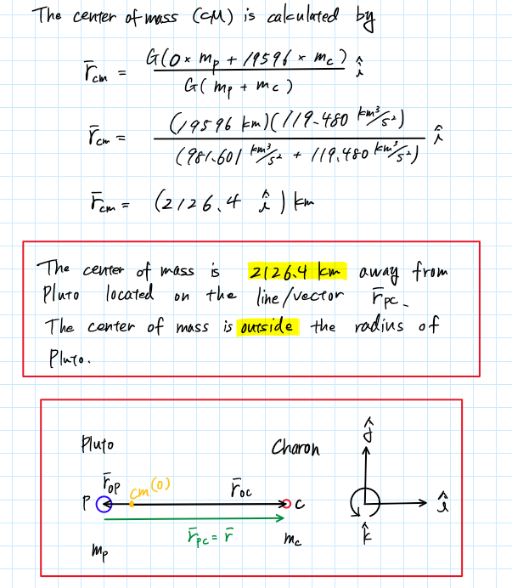
- Let ${\overline{r}}_{PC}=\overline{r}$ be the relative position of Charon with respect to Pluto. Write the kinematic expressions for the relative position and velocity for the motion of Charon relative to Pluto, that is, $\overline{r}$, $\overline{v}$ in terms of rotating unit vectors $\hat{r}$, $\hat{θ}$. At t = 0, the inertial velocities are known such that ${\dot{\overline{r}}}_{C}=0.211319\frac{km}{s}\hat{j}$ and ${\dot{\overline{r}}}_{P}=-0.025717\frac{km}{s}\hat{j}$. Determine angular velocity for the motion of Charon relative to Pluto.
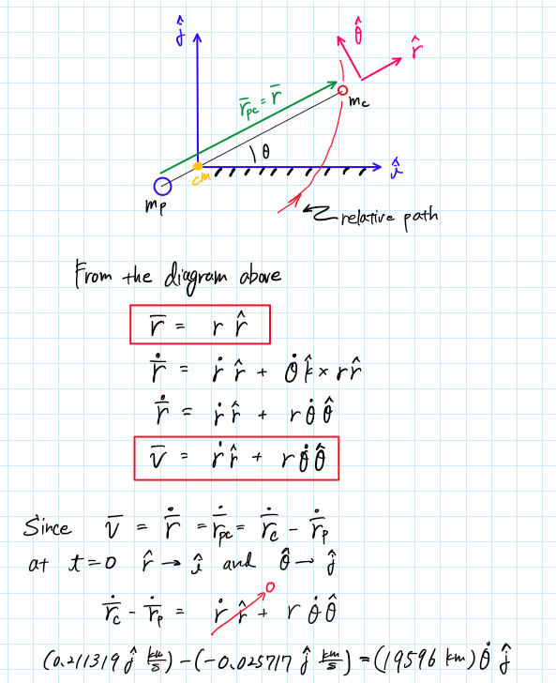
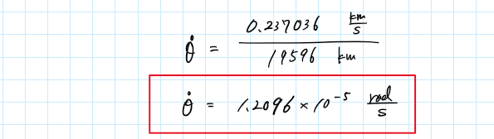

- Determine the system linear momentum; use this result to compute the velocity of the system center of mass. Does this result make sense?
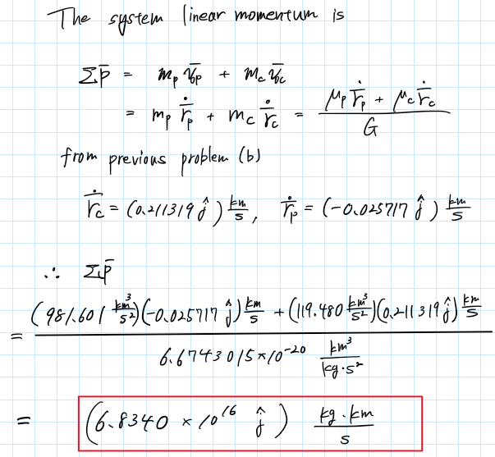

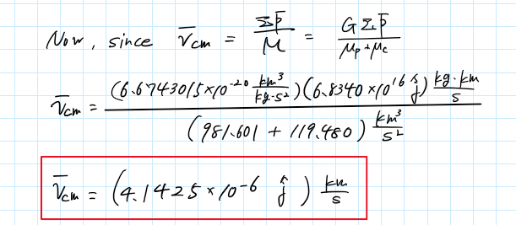
Since the center of mass is much closer to Pluto, the result of the center of mass having a very small velocity is understandable. This, in a sense, shows how we can consider the center of mass to be almost stationary in the system, in contrast with the significantly larger distance between Pluto and Charon.

- Determine the constant ${\overline{C}}_{3}$ for this system. What are the correct units?
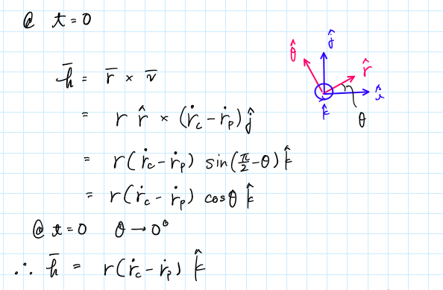
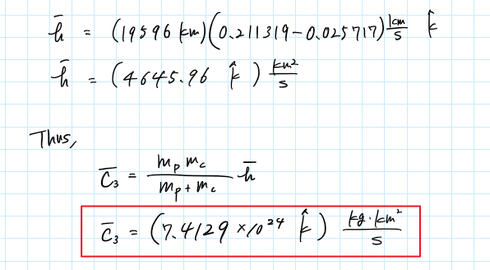

- Evaluate the energy constant $C_{4}$; of course, include the units.

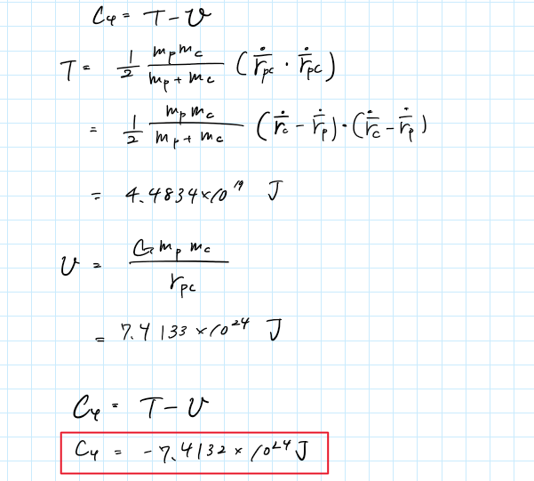

Appendix

Problem 1 MATLAB Code
%% AAE 532 HW 2 Problem 1
% Tomoki Koike
close all; clear all; clc;
fdir = 'C:\Users\Tomo\Desktop\studies\2020-Fall\AAE532\matlab\outputs\hw2';
set(groot, 'defaulttextinterpreter','latex');
set(groot, 'defaultAxesTickLabelInterpreter','latex');
set(groot, 'defaultLegendInterpreter','latex');
format longG;
% Set constants
planet_consts = setup_planetary_constants(); % Function that sets up all the constants in the table
sun = planet_consts.sun; % structure of sun
moon = planet_consts.moon; % structure of moon
earth = planet_consts.earth; % structure of earth
jupiter = planet_consts.jupiter; % structure of jupiter
G = 6.6743015e-20; % Gravitational constant [km^3/kg/s^2]
% (a)

% Define the necessary constants
m_sc = 130; % spacecraft mass [kg]
dist_moon2sc = 140000; % distance between the moon and the spacecraft
sc.gp = G * m_sc; % gravitational parameter of spacecraft
gp_5 = [earth.gp, moon.gp, sc.gp, sun.gp, jupiter.gp]; % gravitational parameters of the 5
dist_from_earth = [0, moon.smao, (moon.smao + dist_moon2sc), earth.smao, (earth.smao + jupiter.smao)];
r_cm = dot(gp_5, dist_from_earth) / sum(gp_5); % the center of mass from the earth
% (b)

% position vectors with respect to the center of mass
r_earth = -r_cm;
r_moon = -r_cm + moon.smao;
r_sun = -r_cm + earth.smao;
r_jupiter = -r_cm + (earth.smao + jupiter.smao);
r_sc = -r_cm + (moon.smao + dist_moon2sc)
% Calculate the coefficients in the vector differential equation for motion
c1 = -earth.gp*m_sc*(r_sc - r_earth)/abs(r_sc - r_earth)^3;
c2 = -moon.gp*m_sc*(r_sc - r_moon)/abs(r_sc - r_moon)^3;
c3 = -sun.gp*m_sc*(r_sc - r_sun)/abs(r_sc - r_sun)^3;
c4 = -jupiter.gp*m_sc*(r_sc - r_jupiter)/abs(r_sc - r_jupiter)^3;
c1/m_sc
c2/m_sc
c3/m_sc
c4/m_sc
C = c1 + c2 + c3 + c4
Problem 2 MATLAB Code
%% AAE 532 HW 2 Problem 2
% Tomoki Koike
close all; clear all; clc;
fdir = 'C:\Users\Tomo\Desktop\studies\2020-Fall\AAE532\matlab\outputs\hw2';
set(groot, 'defaulttextinterpreter','latex');
set(groot, 'defaultAxesTickLabelInterpreter','latex');
set(groot, 'defaultLegendInterpreter','latex');
format longG;
% Set constants
planet_consts = setup_planetary_constants(); % Function that sets up all the constants in the table
sun = planet_consts.sun; % structure of sun
moon = planet_consts.moon; % structure of moon
earth = planet_consts.earth; % structure of earth
jupiter = planet_consts.jupiter; % structure of jupiter
G = 6.6743015e-20; % Gravitational constant [km^3/kg/s^2]
% (a) (b)

% Define the necessary constants
m_sc = 130; % spacecraft mass [kg]
dist_moon2sc = 140000; % distance between the moon and the spacecraft
sc.gp = G * m_sc; % gravitational parameter of spacecraft

% Position vectors
r_moon_sc = 140000;
r_sc_earth = -moon.smao - dist_moon2sc;
r_moon_earth = -moon.smao;
r_sc_sun = earth.smao - abs(r_sc_earth);
r_moon_sun = earth.smao - moon.smao;
r_sc_jupiter = r_sc_sun + jupiter.smao;
r_moon_jupiter = r_moon_sun + jupiter.smao;
% Dominant term
dom_term = (sc.gp + moon.gp) * r_moon_sc / abs(r_moon_sc)^3;

% Direct, indirect, and net perturbating terms
% Earth
dir_term_earth = earth.gp * r_sc_earth / abs(r_sc_earth)^3;
indir_term_earth = earth.gp * r_moon_earth / abs(r_moon_earth)^3;
net_term_earth = dir_term_earth - indir_term_earth;

% Sun
dir_term_sun = sun.gp * r_sc_sun / abs(r_sc_sun)^3;
indir_term_sun = sun.gp * r_moon_sun / abs(r_moon_sun)^3;
net_term_sun = dir_term_sun - indir_term_sun;

% Jupiter
dir_term_jupiter = jupiter.gp * r_sc_jupiter / abs(r_sc_jupiter)^3;
indir_term_jupiter = jupiter.gp * r_moon_jupiter / abs(r_moon_jupiter)^3;
net_term_jupiter = dir_term_jupiter - indir_term_jupiter;

% Acceleration
acc = net_term_earth + net_term_sun + net_term_jupiter - dom_term;
% Recast it with respect to the Earth

r_earth_moon = -r_moon_earth;
r_earth_sun = earth.smao;
r_earth_jupiter = r_earth_sun + jupiter.smao;
r_earth_sc = -r_sc_earth;
r_sc_moon = -r_moon_sc;
% Dominant term
dom_term = (sc.gp + earth.gp) * r_earth_sc / abs(r_earth_sc)^3;

% Direct, indirect, and net perturbating terms
% Moon
dir_term_moon = moon.gp * r_sc_moon / abs(r_sc_moon)^3;
indir_term_moon = moon.gp * r_earth_moon / abs(r_earth_moon)^3;
net_term_moon = dir_term_moon - indir_term_moon;

% Sun
dir_term_sun = sun.gp * r_sc_sun / abs(r_sc_sun)^3;
indir_term_sun = sun.gp * r_earth_sun / abs(r_earth_sun)^3;
net_term_sun = dir_term_sun - indir_term_sun;

% Jupiter
dir_term_jupiter = jupiter.gp * r_sc_jupiter / abs(r_sc_jupiter)^3;
indir_term_jupiter = jupiter.gp * r_earth_jupiter / abs(r_earth_jupiter)^3;
net_term_jupiter = dir_term_jupiter - indir_term_jupiter;

% Acceleration
acc = net_term_moon + net_term_sun + net_term_jupiter - dom_term;

Problem 3 MATLAB Code
%% AAE 532 HW 2 Problem 3
% Tomoki Koike
close all; clear all; clc;
fdir = 'C:\Users\Tomo\Desktop\studies\2020-Fall\AAE532\matlab\outputs\hw2';
set(groot, 'defaulttextinterpreter','latex');
set(groot, 'defaultAxesTickLabelInterpreter','latex');
set(groot, 'defaultLegendInterpreter','latex');
format longG;
% Define necessary constants
pluto.gp = 981.601; % gravitational parameter [km3/s2]
charon.gp = 119.480;
pluto.d = 1162; % diameter [km]
charon.d = 606;
d_pluto_charon = 19596; % semi-major axis of charon relative to Pluto [km]
G = 6.6743015e-20; % Gravitational constant [km^3/kg/s^2]
% (a)
% Center of mass
r_cm = (0 * pluto.gp + d_pluto_charon * charon.gp) / (pluto.gp + charon.gp);
% (b)
% Find the angular velocity
rdot_c = 0.211319; % [km/s]
rdot_p = -0.025717;
rdot_pc = rdot_c - rdot_p;
thetadot = rdot_pc / d_pluto_charon;
% (c)
lin_mmt = (pluto.gp*rdot_p + charon.gp*rdot_c) / G;
v_cm = G * lin_mmt / (pluto.gp + charon.gp);
% (d)
h = d_pluto_charon * (rdot_c - rdot_p);
pluto.m = pluto.gp / G;
charon.m = charon.gp / G;
C3 = pluto.m * charon.m * h / (pluto.m + charon.m);
% (e)
T = 0.5 * (pluto.m * charon.m) * dot(rdot_pc, rdot_pc) / (pluto.m + charon.m);
U = G * pluto.m * charon.m / abs(rdot_pc);
C4 = T - U;

Table of Constant Setup MATLAB File
%% Table of Constants

function planets = setup_planetary_constants()

%{
arp : Axial Rotational Period (Rev / Day)
mer : Mean Equatorial Radius (km)
gp : Gravitational Parameter, mu (km^3 / s^2)
smao : Semi-Major Axis of Orbit (km)
op : Orbital Period (s)
eo : Eccentricity of Orbit
ioe : Inclination of Orbit to Ecliptic (deg)
%}

% Sun
sun.arp = 0.0394011;
sun.mer = 695990;
sun.gp = 132712440017.99;
sun.smao = NaN;
sun.op = NaN;
sun.eo = NaN;
sun.ioe = NaN;

% Moon
moon.arp = 0.0366004;
moon.mer = 1738.2;
moon.gp = 4902.8005821478;
moon.smao = 384400;
moon.op = 2360592;
moon.eo = 0.0554;
moon.ioe = 5.16;

% Mercury
mercury.arp = 0.0170514;
mercury.mer = 2439.7;
mercury.gp = 22032.080486418;
mercury.smao = 57909101;
mercury.op = 7600537;
mercury.eo = 0.20563661;
mercury.ioe = 7.00497902;

% Venus
venus.arp = 0.0041149; % retrograde
venus.mer = 6051.9;
venus.gp = 324858.59882646;
venus.smao = 108207284;
venus.op = 19413722;
venus.eo = 0.00676399;
venus.ioe = 3.39465605;

% Earth
earth.arp = 1.0027378;
earth.mer = 6378.1363;
earth.gp = 398600.4415;
earth.smao = 149597898;
earth.op = 31558205;
earth.eo = 0.01673163;
earth.ioe = 0.00001531;

% Mars
mars.arp = 0.9747000;
mars.mer = 3397;
mars.gp = 42828.314258067;
mars.smao = 227944135;
mars.op = 59356281;
mars.eo = 0.09336511;
mars.ioe = 1.84969142;

% Jupiter
jupiter.arp = 2.4181573;
jupiter.mer = 71492;
jupiter.gp = 126712767.8578;
jupiter.smao = 778279959;
jupiter.op = 374479305;
jupiter.eo = 0.04853590;
jupiter.ioe = 1.30439695;

% Saturn
saturn.arp = 2.2522053;
saturn.mer = 60268;
saturn.gp = 37940626.061137;
saturn.smao = 1427387908;
saturn.op = 930115906;
saturn.eo = 0.05550825;
saturn.ioe = 2.48599187;

% Uranus
uranus.arp = 1.3921114; % retrograde
uranus.mer = 25559;
uranus.gp = 5794549.0070719;
uranus.smao = 2870480873;
uranus.op = 2652503938;
uranus.eo = 0.04685740;
uranus.ioe = 0.77263783;

% Neptune
neptune.arp = 1.4897579;
neptune.mer = 25269;
neptune.gp = 6836534.0638793;
neptune.smao = 4498337290;
neptune.op = 5203578080;
neptune.eo = 0.00895439;
neptune.ioe = 1.77004347;

% Pluto
pluto.arp = -0.1565620; % retrograde
pluto.mer = 1162;
pluto.gp = 981.600887707;
pluto.smao = 5907150229;
pluto.op = 7830528509;
pluto.eo = 0.24885238;
pluto.ioe = 17.14001206;

% Return
planets.sun = sun;
planets.moon = moon;
planets.mercury = mercury;
planets.venus = venus;
planets.earth = earth;
planets.mars = mars;
planets.jupiter = jupiter;
planets.saturn = saturn;
planets.uranus = uranus;
planets.neptune = neptune;
planets.pluto = pluto;
end

