CSci 365: Organizations of Programming Languages

Name: Kenneth Jahnke

**Assignment 2: Lexical Analyzer (100 + 10 (optional))**

**– Read the submission instructions.**

Q1. [10] Design/draw a state transition diagram to recognize one form of the comments of the C-based programming languages, those that begin with /* and end with */. At the end, the transition will return ‘COMMENT’ if it’s in the correct form; otherwise, it’ll return an error message of ‘SLASH CODE’. For the labels of the states, use q0, q1, q2, …, etc.

Assume that a comment is given in the same line and ends with a hidden ‘EOL’ symbol to indicate the end of the line. e.g.) /* a comment */EOL

Note: Do **not** include the utility functions ‘getChar’ and ‘addChar’ in the transition.

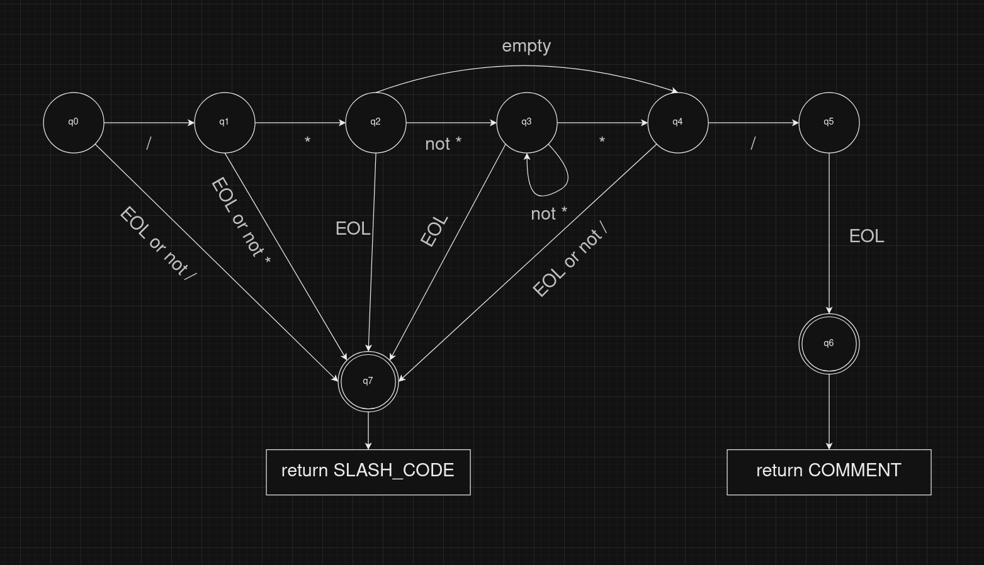

Q2. [10, optional] Design/draw a state diagram to recognize a float number, e.g.) \*\***.**\*\*… *. It returns ‘float’.

e.g.) float number: 2.0, 20.0101, 0.0, etc.

Q3. [20] Programming

Write a Python program to test the code to implement the state diagram of Q1.

Test your program with the following inputs and give the outputs.

Correct Input:

Input 1: /* this is a comment */

Incorrect inputs:

Input 2: // this is a comment //

Input 3: // this is a comment */

Input 4: /* this is a comment /*

Input 5: */ this is a comment */

Input 6: */ this is a comment */

Input 7: /* this is a */ comment */

Hin

Note: Refer to the codes in ‘front.c’ that identify the identifiers and integer literals.

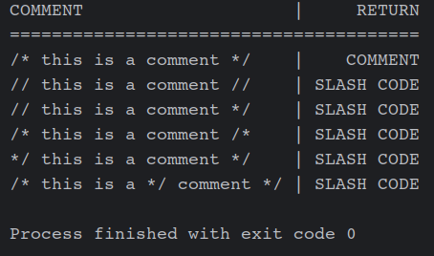

Q4. [70] Programming

Implement the lexical analyzer to handle the short program below. Write it in Python or in Java – **not in C** because its codes are available in the textbook.

Input **file**: a program below.

input(a)

input(b)

input(c)

total = a + b + c /* get a sum of three inputs */

average = total / 3 /* compute an average */

print(total)

print(average)

Output display on the **screen**:

A list of (type of a token, ‘,’, lexeme)s. Each list of (token, lexeme) will be printed in the new line.

e.g.) (<ADD_op>, +)

(<ID>, sum)

etc.

e.g.) For the above input program:

<input>, input

<lparen>, (

<id>, a

…

Lookup Table of the Token, special characters and words:

|  |  |  |  |
| --- | --- | --- | --- |
| **Token** | **Value/lexeme** | **Token** | **Value/lexeme** |
| <input> | input | <output> | print |
| <id> | identifier | <number> | integer, float |
| <lparen> | ( | <rparen> | ) |
| <add_op> | +, - | <mult_op> | *, /, //, % |
| <rel_op> | <, >, <=, >=, ==, != | <assign_op> | = |
| <comment> | comment | <error> | error |
| **reserved words** | input, output, if, else, begin, end, while, for | | |
| <input> | **input** | <output> | **print** |
| <if> | **if** | <else> | **else** |
| <begin> | **begin** | <end> | **end** |
| <while> | **while** | <for> | **for** |

Separator:

whitespace, line_feed.

<id> token: use the state diagram in the textbook

– starting with upper/lower letter, followed by any of upper/lower letter/digit

<number> token:

If integer, starting with a non-zero digit, followed by digit(s)

If float, starting with a non-zero digit, followed by digit(s), a decimal point(.), followed by digit(s).

* *at least one* digit before and after a decimal point

<error> token:

If it detects any non-valid token which is not in the lookup table, write an <error> token

and the invalid message with the value.

e.g.) && in the program → <error>, ‘Invalid token’ for &&

