***COM109 Interactive Web Authoring - Assessment One Report***

***Niall Morrissey (B00787301)***

**Soaring Aviation Website Report**

1. **Initial Wireframe Designs** *(used wireframe.cc to design layouts)*

I prepared a wireframe diagram to help develop the layout I planned to use on my website. The use of wireframe diagram allowed me to plan the layout of the website. I have included two wireframe diagrams, one for the index page layout which will also be used on the majority of web pages following to ensure the website has an overall consistent look and feel.

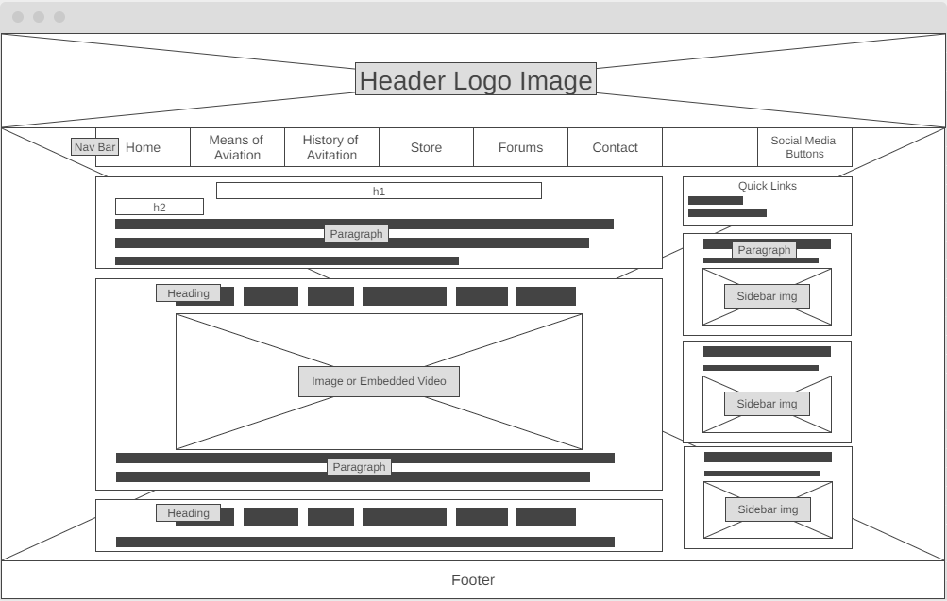index.html wireframe design

The second wireframe diagram was for the contacts page on which the layout was amended to reflect the contact information content being requested from the user. As this was different from the main index page, I considered it would be useful to set out the fields to be included.

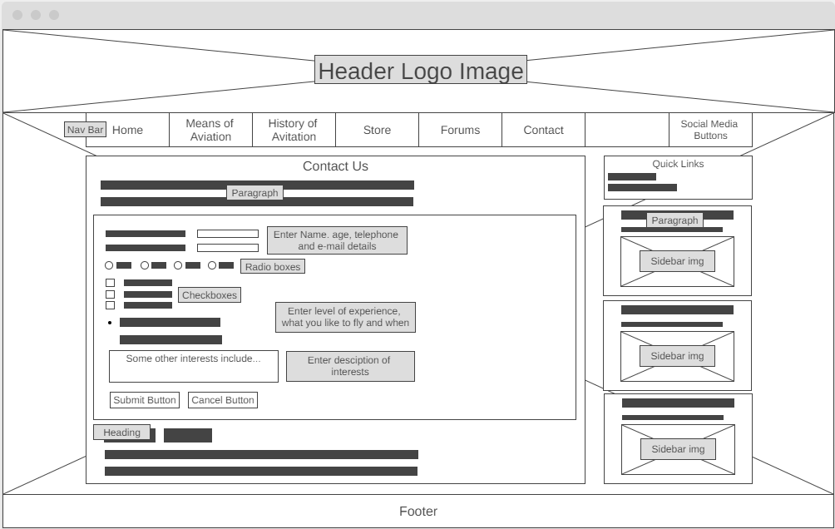contact.html wireframe design

1. **Colour Scheme Selection**

In deciding the layout and colour scheme of my website, I used blue as the primary colour. This looks well and reflects the sky etc therefore helping reinforce the theme and subject matter of the website. I liked the blue colour chosen, although not the colour of the sky enhances and complements the background image of the airfield.

For my menus I used a beige colour which contrasts well with the background colour and stands out without being too “loud” and making it unpleasant for the user to view.

Overall, the background colours and designs should enhance the content and not distract the reader from the information on the website. My background image is of an airfield/runway from a scenic location which reinforces the aeronautic theme. I reduced the opacity some of the div elements located in the centre of the web pages so that the background image is more visible. You will see the effect on the website as I have not reduced the opacity of the header and footer allowing the effect to be compared, whereas the middle div elements have been.

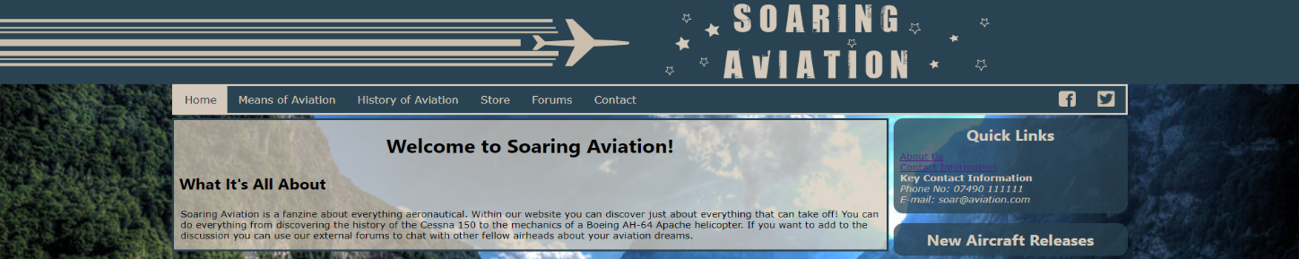As seen in the attached screenshot below, reducing the opacity has added impact to the div elements containing content.

1. **Web Site Design Process**

I used the following steps when designing and building my website.

1. **Planning Stage**

In this stage thought about the theme of my website. I am interested in aviation and decided to produce a website that would provide information about the different forms of aviation and link to content videos YouTube to provide more information. I prepared the index wireframe diagram to help plan the general layout.

1. **Gathering Content**

I started to research the content and look for appropriate text content and images online. I also reviewed videos on YouTube, that I could link to in my website.

1. **Design and build**

Using the wireframe diagram, I annotated the bare diagram with colour schemes and effects that I intended to include in my website. I have attached in the screenshot below a photo of the wireframe diagram used for this phase of the design and build. Once I had the index page prepared, I replicated the design for the other pages. I have written my CSS to allow scaling of the webpage so when the user changes the size of their window or decided to access it on a smaller device i.e. a mobile device, the website should scale to fit.

*Plan Structure*

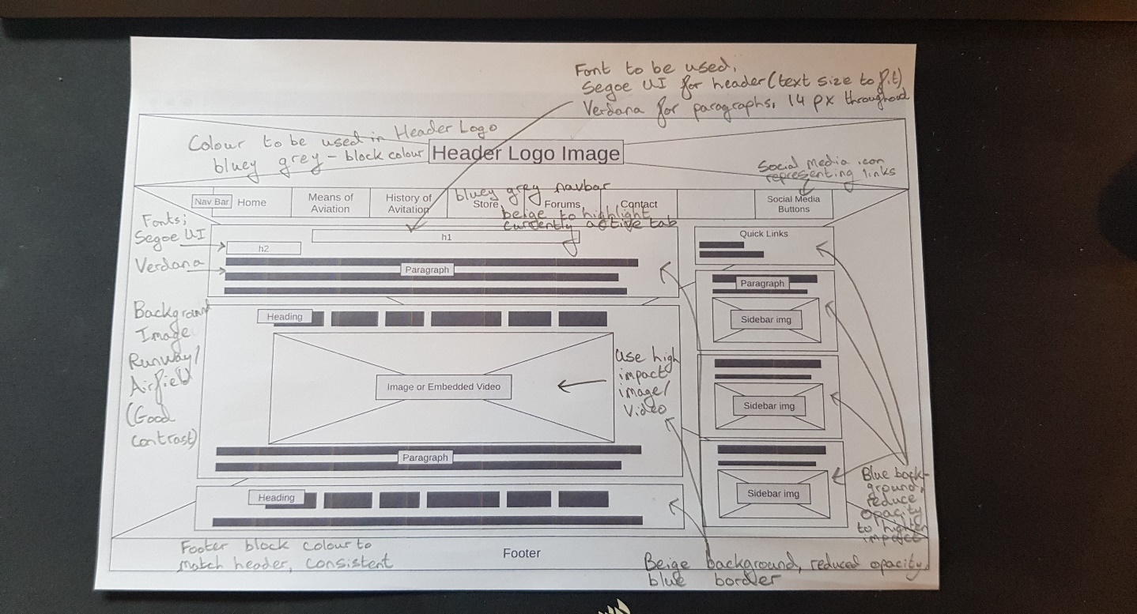

1. **Testing - Checking for Validation and Compliance**

I tested the website to ensure all was working properly and in particular the validation on the contents page. I tested all the features in my javascript function used in the contact form, all information was gathered correctly and the client-side validation was working as expected.

In the attached Annex 1 below, I have attached screenshots of the produced validation reports after checking with https://validator.w3.org/#validate_by_input. I checked the StyleSheet.css, index.html and contact.html webpages. Each validation report returned with no errors or warning to show.

1. **References**

Website Development

Webs Wireframe.cc. n.d. *Log in - Wireframe.cc Premium*. [online] Available at: <https://wireframe.cc/pro/> [Accessed 10 March 2021].

W3schools.com. n.d. *W3Schools Online Web Tutorials*. [online] Available at: <https://www.w3schools.com/> [Accessed 10 March 2021].

W3schools.com. n.d. *CSS Navigation Bar*. [online] Available at: <https://www.w3schools.com/css/css_navbar.asp> [Accessed 12 March 2021].

Rifki, N., 2020. *The ultimate guide to iframes - LogRocket Blog*. [online] LogRocket Blog. Available at: <https://blog.logrocket.com/the-ultimate-guide-to-iframes/> [Accessed 14 March 2021].

Sehl, K., 2018. *Free Social Media Icons (The Ones You're Actually Allowed to Use)*. [online] Social Media Marketing & Management Dashboard. Available at: <https://blog.hootsuite.com/social-media-icons/> [Accessed 15 March 2021].

W3schools.com. n.d. *JavaScript Form Validation*. [online] Available at: <https://www.w3schools.com/js/js_validation.asp> [Accessed 16 March 2021].

w3resource. 2020. *JavaScript : phone number validation - w3resource*. [online] Available at: <https://www.w3resource.com/javascript/form/phone-no-validation.php> [Accessed 17 March 2021].

w3resource. 2020. *JavaScript : email validation - w3resource*. [online] Available at: <https://www.w3resource.com/javascript/form/email-validation.php> [Accessed 17 March 2021].

Validator.w3.org. n.d. *The W3C Markup Validation Service*. [online] Available at: <https://validator.w3.org/> [Accessed 18 March 2021].

Website Content (Text and Images)

Icons8.com. n.d. *Airplane favicon Icons - Free Download, PNG and SVG*. [online] Available at: <https://icons8.com/icons/set/airplane-favicon> [Accessed 15 March 2021].

Facebook. n.d. *Facebook*. [online] Available at: <https://www.facebook.com/avweek/> [Accessed 15 March 2021].

n.d. [online] Available at: <https://twitter.com/AINonline> [Accessed 15 March 2021].

En.wikipedia.org. n.d. *Airplane*. [online] Available at: <https://en.wikipedia.org/wiki/Airplane> [Accessed 14 March 2021].

En.wikipedia.org. n.d. *History of aviation*. [online] Available at: <https://en.wikipedia.org/wiki/History_of_aviation> [Accessed 15 March 2021].

En.wikipedia.org. n.d. *Red Arrows*. [online] Available at: <https://en.wikipedia.org/wiki/Red_Arrows> [Accessed 15 March 2021].

Gallay, A., 2018. [online] Papercitymag.com. Available at: <https://www.papercitymag.com/culture/centurion-lounge-dfw-airport-dallas-forth-worth-upgrade-perks-luxe-travel/> [Accessed 15 March 2021].

All-free-download.com. n.d. *Su 35 Flanker E Wallpaper Military Aircrafts Planes Wallpapers in jpg format for free download*. [online] Available at: <https://all-free-download.com/wallpapers/download/ su_35_flanker_e_wallpaper_military_aircrafts_planes_wallpaper_291.html> [Accessed 16 March 2021].

Quevedo, J., 2017. *Cabina Ancha – Mexicoaeroespacial*. [online] Mexicoaeroespacial.com.mx. Available at: <https://mexicoaeroespacial.com.mx/tag/cabina-ancha/> [Accessed 16 March 2021].

Kratochvil, V., 2015. *File:Police-helicopter-8712919948643Mk.jpg - Wikimedia Commons*. [online] Commons.wikimedia.org. Available at: <https://commons.wikimedia.org/wiki/File:Police-helicopter-8712919948643Mk.jpg> [Accessed 16 March 2021].

Falcus, M., 2016. *airBaltic CS300 First Flight Report - Airport Spotting*. [online] Airport Spotting. Available at: <http://www.airportspotting.com/airbaltic-cs300-flight-trip-report/> [Accessed 16 March 2021].

Wikiwand. n.d. *Wingsuit flying | Wikiwand*. [online] Available at: <https://www.wikiwand.com/en/Wingsuit_flying> [Accessed 17 March 2021].

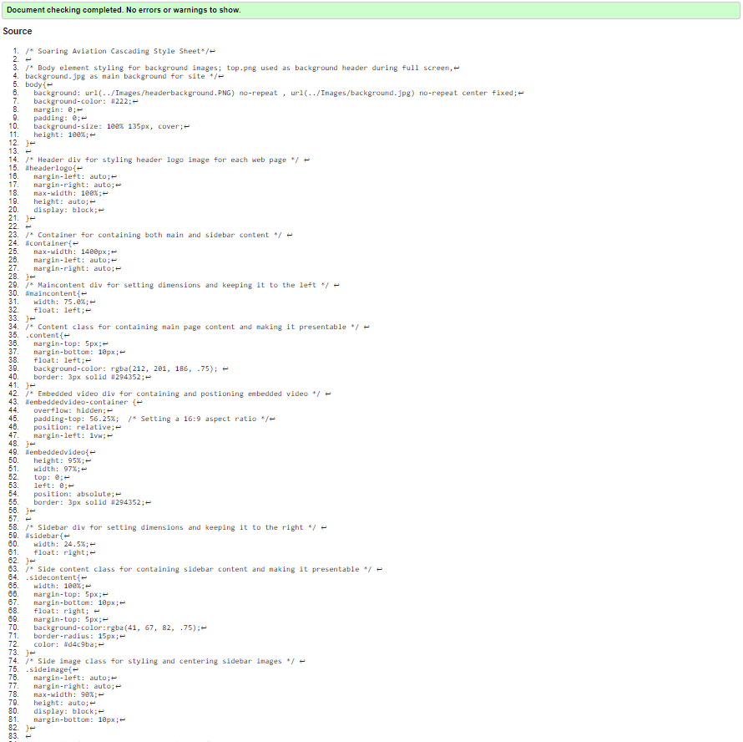**Annex 1 - Screenshots of Validation Reports**

*‘StyleSheet.css’ Validation Report Screenshots*

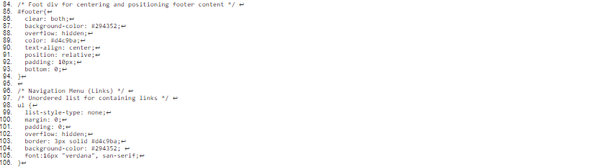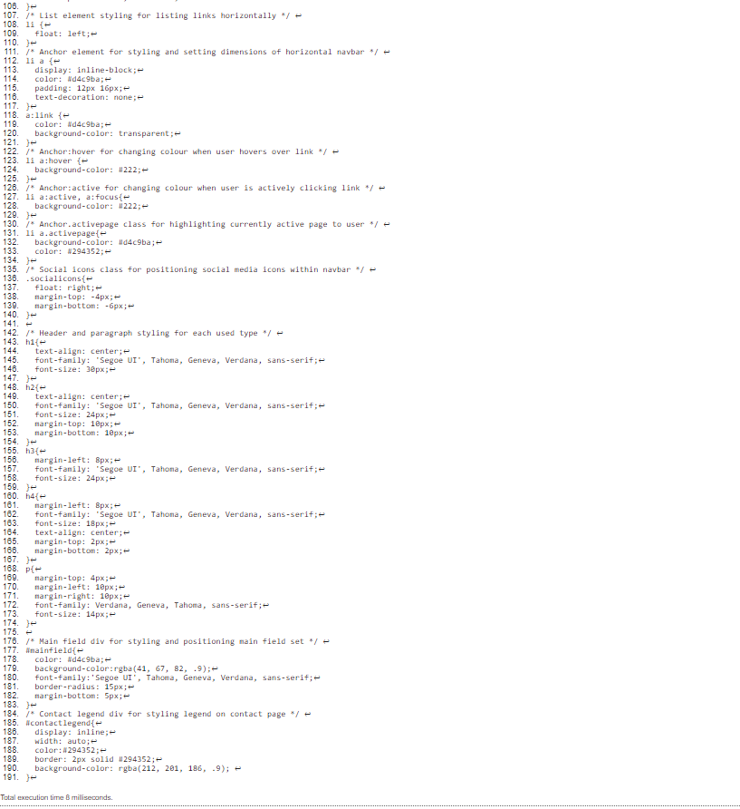

*‘index.html’ Validation Report Screenshots*

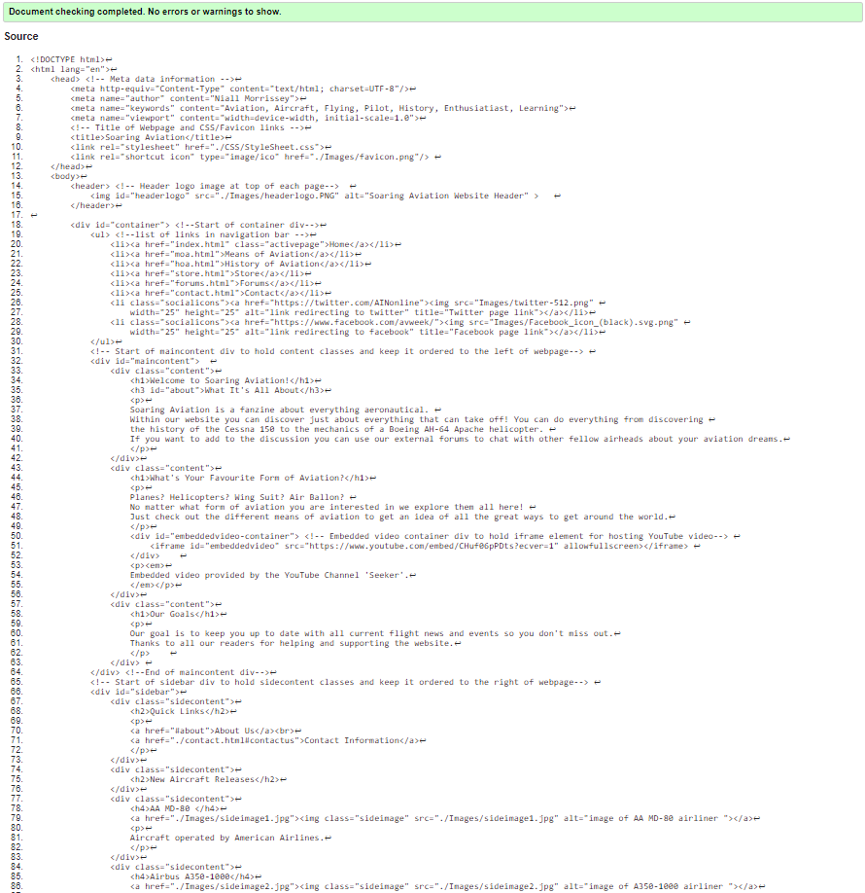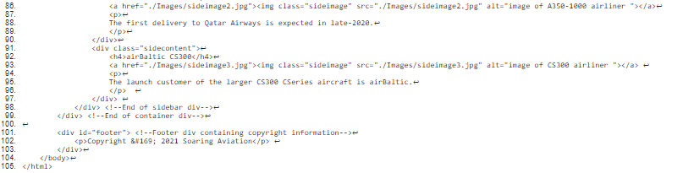

*‘contact.html’ Validation Report Screenshots*

