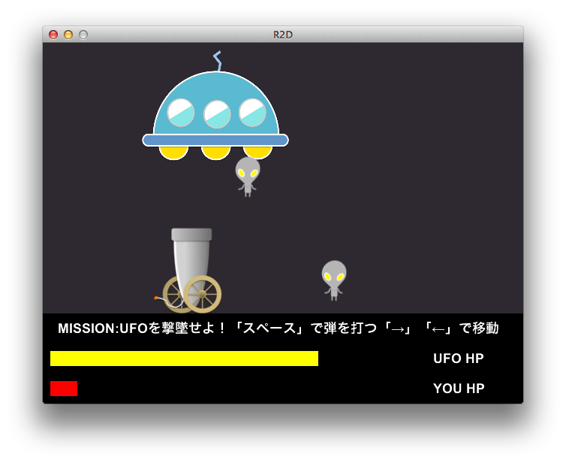
課題３：シューティングゲーム
シューティングゲームを作ってみましょう。
自機を操作してUFOから出てくるエイリアンをよけながら弾をUFOに当てましょう。

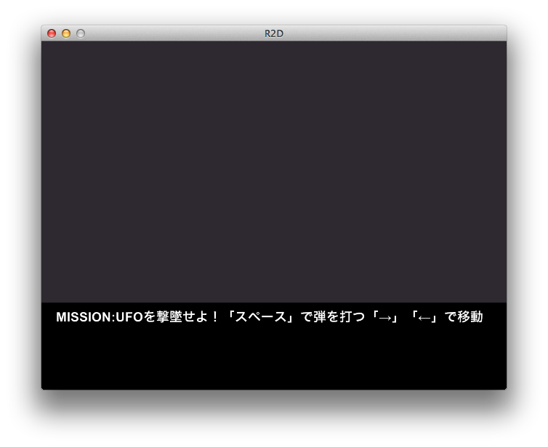
プログラムリスト1(no3-1.rb)：背景
001: # coding: utf-8
002:
003: require 'r2d'
004:
005: w = window
006:
007: MAX_HP = 500
008: BOTTOM = 360
009:
010: Rectangle.new(0, 0, w.w, BOTTOM, [46, 41, 48, 255])
011: Text.new(20, BOTTOM + 10, 20,
012: 'MISSION:UFOを撃墜せよ！「スペース」で弾を打つ「→」「←」で移動')
013:
014: window :show

プログラムリスト2(no3-2.rb)：キャラ表示（まだ動かない）
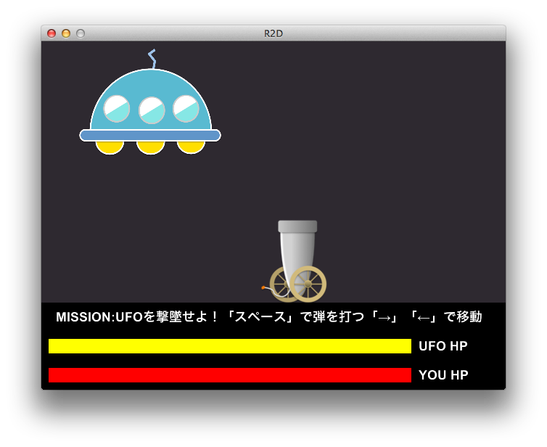
001: # coding: utf-8
002:
003: require 'r2d'
004:
005: w = window
006:
007: MAX_HP = 500
008: BOTTOM = 360
009:
010: Rectangle.new(0, 0, w.w, BOTTOM, [46, 41, 48, 255])
011: Text.new(20, BOTTOM + 10, 20,
012: 'MISSION:UFOを撃墜せよ！「スペース」で弾を打つ「→」「←」で移動')
013:
014: ufo_hp = MAX_HP
015: ufo_gage = Rectangle.new(10, 410, MAX_HP, 20, 'yellow')
016: Text.new(520, 410, 20, 'UFO HP')
017:
018: my_hp = MAX_HP
019: my_gage = Rectangle.new(10, 450, MAX_HP, 20, 'red')
020: Text.new(520, 450, 20, 'YOU HP')
021:
022: ufo = Image.new(50, 10, 'ufo.png')
023: ufo.width = 200
024: ufo.height = 150
025:
026: gun = Image.new(300, BOTTOM - 115, 'gun.png')
027:
028: window :show

プログラムリスト3(no3-3.rb)：自機の移動と弾の表示
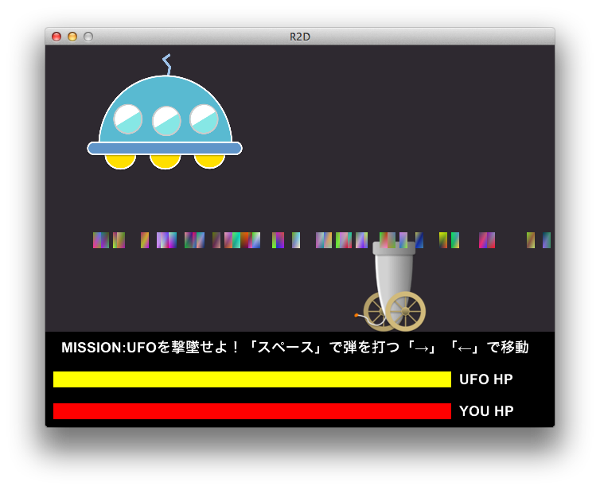
001: # coding: utf-8
002:
003: require 'r2d'
004:
005: w = window
006:
007: MAX_HP = 500
008: BOTTOM = 360
009:
010: Rectangle.new(0, 0, w.w, BOTTOM, [46, 41, 48, 255])
011: Text.new(20, BOTTOM + 10, 20,
012: 'MISSION:UFOを撃墜せよ！「スペース」で弾を打つ「→」「←」で移動')
013:
014: ufo_hp = MAX_HP
015: ufo_gage = Rectangle.new(10, 410, MAX_HP, 20, 'yellow')
016: Text.new(520, 410, 20, 'UFO HP')
017:
018: my_hp = MAX_HP
019: my_gage = Rectangle.new(10, 450, MAX_HP, 20, 'red')
020: Text.new(520, 450, 20, 'YOU HP')
021:
022: ufo = Image.new(50, 10, 'ufo.png')
023: ufo.width = 200
024: ufo.height = 150
025:
026: gun = Image.new(300, BOTTOM - 115, 'gun.png')
027:
028: bomb = []
029: playing = true
030:
031: on_key 'space' do
032: if playing
033: bomb << Rectangle.new(gun.x + 50, BOTTOM - 125, 10, 20, 'random')
034: end
035: end
036:
037: key_down 'left' do
038: gun.x = (gun.x - 5) % w.w
039: end
040:
041: key_down 'right' do
042: gun.x = (gun.x + 5) % w.w
043: end
044:
045: window :show

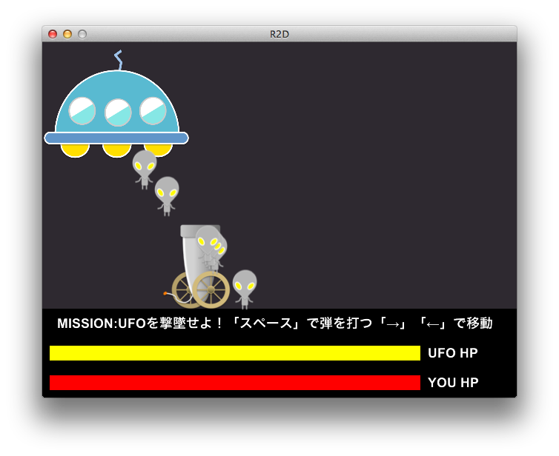
プログラムリスト4(no3-4.rb)：エイリアンと弾のアニメーション
001: # coding: utf-8
002:
003: require 'r2d'
004:
005: w = window
006:
007: MAX_HP = 500
008: BOTTOM = 360
009:
010: Rectangle.new(0, 0, w.w, BOTTOM, [46, 41, 48, 255])
011: Text.new(20, BOTTOM + 10, 20,
012: 'MISSION:UFOを撃墜せよ！「スペース」で弾を打つ「→」「←」で移動')
013:
014: ufo_hp = MAX_HP
015: ufo_gage = Rectangle.new(10, 410, MAX_HP, 20, 'yellow')
016: Text.new(520, 410, 20, 'UFO HP')
017:
018: my_hp = MAX_HP
019: my_gage = Rectangle.new(10, 450, MAX_HP, 20, 'red')
020: Text.new(520, 450, 20, 'YOU HP')
021:
022: ufo = Image.new(50, 10, 'ufo.png')
023: ufo.width = 200
024: ufo.height = 150
025:
026: gun = Image.new(300, BOTTOM - 115, 'gun.png')
027:
028: bomb = []
029: enemy = []
030: playing = true
031:
032: on_key 'space' do
033: if playing
034: bomb << Rectangle.new(gun.x + 50, BOTTOM - 125, 10, 20, 'random')
035: end
036: end
037:
038: key_down 'left' do
039: gun.x = (gun.x - 5) % w.w
040: end
041:
042: key_down 'right' do
043: gun.x = (gun.x + 5) % w.w
044: end
045:
046: switch = true
047:
048: update do
049: if !playing
050: next
051: end
052: if rand(30) == 0
053: enemy << Image.new(ufo.x + 100, 120, 'enemy.png')
054: end
055:
056: bomb.each do |b|
057: b.y -= 6
058: end
059:
060: enemy.each do |e|
061: e.y += 6
062: end
063:
064: if switch
065: ufo.x += 5
066: if ufo.x > (w.w - 200)
067: switch = false
068: end
069: else
070: ufo.x -= 5
071: if ufo.x <= 0
072: switch = true
073: end
074: end
075: end
076:
077: window :show

プログラムリスト5(no3-5.rb)：弾とエイリアンのあたり判定
001: # coding: utf-8
002:
003: require 'r2d'
004:
005: w = window
006:
007: MAX_HP = 500
008: BOTTOM = 360
009:
010: Rectangle.new(0, 0, w.w, BOTTOM, [46, 41, 48, 255])
011: Text.new(20, BOTTOM + 10, 20,
012: 'MISSION:UFOを撃墜せよ！「スペース」で弾を打つ「→」「←」で移動')
013:
014: ufo_hp = MAX_HP
015: ufo_gage = Rectangle.new(10, 410, MAX_HP, 20, 'yellow')
016: Text.new(520, 410, 20, 'UFO HP')
017:
018: my_hp = MAX_HP
019: my_gage = Rectangle.new(10, 450, MAX_HP, 20, 'red')
020: Text.new(520, 450, 20, 'YOU HP')
021:
022: ufo = Image.new(50, 10, 'ufo.png')
023: ufo.width = 200
024: ufo.height = 150
025:
026: gun = Image.new(300, BOTTOM - 115, 'gun.png')
027:
028: bomb = []
029: enemy = []
030: playing = true
031:
032: on_key 'space' do
033: if playing
034: bomb << Rectangle.new(gun.x + 50, BOTTOM - 125, 10, 20, 'random')
035: end
036: end
037:
038: key_down 'left' do
039: gun.x = (gun.x - 5) % w.w
040: end
041:
042: key_down 'right' do
043: gun.x = (gun.x + 5) % w.w
044: end
045:
046: def hit_check(e, m)
047: r = e.x + e.width > m.x && e.x < m.x + m.width &&
048: e.y + e.height > m.y && e.y < m.y + m.height
049: if r || m.y < 0 || m.y > (BOTTOM - 50)
050: m.remove
051: end
052: return r
053: end
054:
055: switch = true
056:
057: update do
058: if !playing
059: next
060: end
061: if rand(30) == 0
062: enemy << Image.new(ufo.x + 100, 120, 'enemy.png')
063: end
064:
065: bomb.each do |b|
066: b.y -= 6
067: if hit_check(ufo, b)
068: end
069: end
070:
071: enemy.each do |e|
072: e.y += 6
073: if hit_check(gun, e)
074: end
075: end
076:
077: if switch
078: ufo.x += 5
079: if ufo.x > (w.w - 200)
080: switch = false
081: end
082: else
083: ufo.x -= 5
084: if ufo.x <= 0
085: switch = true
086: end
087: end
088: end
089:
090: window :show

プログラムリスト6(no3-6.rb)：残りエネルギー（HP）の変化
001: # coding: utf-8
002:
003: require 'r2d'
004:
005: w = window
006:
007: MAX_HP = 500
008: BOTTOM = 360
009:
010: Rectangle.new(0, 0, w.w, BOTTOM, [46, 41, 48, 255])
011: Text.new(20, BOTTOM + 10, 20,
012: 'MISSION:UFOを撃墜せよ！「スペース」で弾を打つ「→」「←」で移動')
013:
014: ufo_hp = MAX_HP
015: ufo_gage = Rectangle.new(10, 410, MAX_HP, 20, 'yellow')
016: Text.new(520, 410, 20, 'UFO HP')
017:
018: my_hp = MAX_HP
019: my_gage = Rectangle.new(10, 450, MAX_HP, 20, 'red')
020: Text.new(520, 450, 20, 'YOU HP')
021:
022: ufo = Image.new(50, 10, 'ufo.png')
023: ufo.width = 200
024: ufo.height = 150
025:
026: gun = Image.new(300, BOTTOM - 115, 'gun.png')
027:
028: bomb = []
029: enemy = []
030: playing = true
031:
032: on_key 'space' do
033: if playing
034: bomb << Rectangle.new(gun.x + 50, BOTTOM - 125, 10, 20, 'random')
035: end
036: end
037:
038: key_down 'left' do
039: gun.x = (gun.x - 5) % w.w
040: end
041:
042: key_down 'right' do
043: gun.x = (gun.x + 5) % w.w
044: end
045:
046: def hit_check(e, m)
047: r = e.x + e.width > m.x && e.x < m.x + m.width &&
048: e.y + e.height > m.y && e.y < m.y + m.height
049: if r || m.y < 0 || m.y > (BOTTOM - 50)
050: m.remove
051: end
052: return r
053: end
054:
055: def gage_mgt(gage, hp, max_hp)
056: gage.width = (max_hp.to_f * hp / max_hp).to_i
057: end
058:
059: switch = true
060:
061: update do
062: if !playing
063: next
064: end
065: if rand(30) == 0
066: enemy << Image.new(ufo.x + 100, 120, 'enemy.png')
067: end
068:
069: bomb.each do |b|
070: b.y -= 6
071: if hit_check(ufo, b)
072: ufo_hp -= 1
073: gage_mgt(ufo_gage, ufo_hp, MAX_HP)
074: end
075: end
076:
077: enemy.each do |e|
078: e.y += 6
079: if hit_check(gun, e)
080: my_hp -= 1
081: gage_mgt(my_gage, my_hp, MAX_HP)
082: end
083: end
084:
085: if switch
086: ufo.x += 5
087: if ufo.x > (w.w - 200)
088: switch = false
089: end
090: else
091: ufo.x -= 5
092: if ufo.x <= 0
093: switch = true
094: end
095: end
096: end
097:
098: window :show

プログラムリスト7(no3.rb)：完成
001: # coding: utf-8
002:
003: require 'r2d'
004:
005: w = window
006:
007: MAX_HP = 500
008: BOTTOM = 360
009:
010: Rectangle.new(0, 0, w.w, BOTTOM, [46, 41, 48, 255])
011: Text.new(20, BOTTOM + 10, 20,
012: 'MISSION:UFOを撃墜せよ！「スペース」で弾を打つ「→」「←」で移動')
013:
014: ufo_hp = MAX_HP
015: ufo_gage = Rectangle.new(10, 410, MAX_HP, 20, 'yellow')
016: Text.new(520, 410, 20, 'UFO HP')
017:
018: my_hp = MAX_HP
019: my_gage = Rectangle.new(10, 450, MAX_HP, 20, 'red')
020: Text.new(520, 450, 20, 'YOU HP')
021:
022: ufo = Image.new(50, 10, 'ufo.png')
023: ufo.width = 200
024: ufo.height = 150
025:
026: gun = Image.new(300, BOTTOM - 115, 'gun.png')
027:
028: bomb = []
029: enemy = []
030: playing = true
031:
032: on_key 'space' do
033: if playing
034: bomb << Rectangle.new(gun.x + 50, BOTTOM - 125, 10, 20, 'random')
035: end
036: end
037:
038: key_down 'left' do
039: gun.x = (gun.x - 5) % w.w
040: end
041:
042: key_down 'right' do
043: gun.x = (gun.x + 5) % w.w
044: end
045:
046: def hit_check(e, m)
047: r = e.x + e.width > m.x && e.x < m.x + m.width &&
048: e.y + e.height > m.y && e.y < m.y + m.height
049: if r || m.y < 0 || m.y > (BOTTOM - 50)
050: m.remove
051: end
052: return r
053: end
054:
055: def gage_mgt(gage, hp, max_hp)
056: gage.width = (max_hp.to_f * hp / max_hp).to_i
057: end
058:
059: def final_message(msg, gage)
060: Rectangle.new(100, 100, 440, 150, 'red')
061: Text.new(150, 150, 50, msg)
062: gage.width = 0
063: end
064:
065: switch = true
066:
067: update do
068: if !playing
069: next
070: end
071: if rand(30) == 0
072: enemy << Image.new(ufo.x + 100, 120, 'enemy.png')
073: end
074:
075: bomb.each do |b|
076: b.y -= 6
077: if hit_check(ufo, b)
078: ufo_hp -= 1
079: gage_mgt(ufo_gage, ufo_hp, MAX_HP)
080: end
081: end
082:
083: enemy.each do |e|
084: e.y += 6
085: if hit_check(gun, e)
086: my_hp -= 1
087: gage_mgt(my_gage, my_hp, MAX_HP)
088: end
089: end
090:
091: if switch
092: ufo.x += 5
093: if ufo.x > (w.w - 200)
094: switch = false
095: end
096: else
097: ufo.x -= 5
098: if ufo.x <= 0
099: switch = true
100: end
101: end
102:
103: if ufo_hp <= 0 && my_hp > 0
104: final_message('GAME CLEAR !!', ufo_gage)
105: playing = false
106: end
107:
108: if ufo_hp > 0 && my_hp <= 0
109: final_message('GAME ORVER...', my_gage)
110: playing = false
111: end
112: end
113:
114: window :show

