Assignment 1 — Frame Your Project and Prepare Your Corpus
Team of 3 · Milestone 1 of 4 · Type your answers directly in the blank cells — they grow as you type.
Strict compliance: your submission ZIP must exactly match the folder/file structure on the Submission page (near the end). Automated grading rejects anything that doesn't — check it before you submit.

Project name  the short name of your project — the same name all four assignments will use | Home Health Assistant
Team members
In 'Worked sections', list the sections each member led (e.g. 1, 5, 7.1–7.3). Every section must be owned by someone; each member submits the AI-chat behind their own sections (Section 8).
Team member | Full name | Student number | Worked sections
Student 1 | K. M. Mehemud Azad | 2105014 | Section 1, 2, 4
Student 2 | Shah Mohammad Abdul Mannan | 2105056 | Section 5, 6, 7.1, 7.2
Student 3 | Jonayed Mohiuddin Shanto | 2105060 | Section 3, 7.3, 7.4, 7.5

What this assignment is: Everyone builds the same kind of system — an agent that answers questions from scanned book pages: it takes a page image, reads it, finds the relevant text, and gives an answer grounded in that text, with a human in the loop for risky steps. What makes your project unique is your three choices (Section 1). In this milestone you pin down those choices, source and clean your scanned corpus, and design your agent on paper.
What to hand in: One ZIP with the filled form, your configs/task.yaml, your eda.ipynb (runs top-to-bottom), your corpus or a script that recreates it, a short provenance/licence note, and one AI-chat transcript per team member. Exact names are on the Submission page.

Section 1 — Our Problem & Our Three Choices
The task is fixed for everyone: “Given a scanned page image from our corpus, answer a question grounded in the page's text.” You do not choose the problem type. You make it your project through the three choices below — these drive every later design decision and make your work different from every other group. (Two qualities — being faithful and accurate — are required of EVERYONE, so they are not choices; see your NFR below.)
① Domain  your practical, real-user subject and the person who'd use the tool (health worker, farmer, legal-aid worker, …). See Domains-And-Natural-Fit. No two groups share one. | A home-health reference assistant for a general household or caregiver without immediate access to a physician (e.g., after-hours, rural, or simply wanting a quick, sourced answer before deciding whether to seek care) — helping them understand a symptom, injury, or anatomical question against a documented historical medical reference.
② Data speciality  the ONE hard property of the corpus you're handed — e.g. Bangla · Arabic · code-switching · degraded scans · multi-column · handwritten · old orthography · math notation · dirty-OCR (see Data-Speciality Catalog). English is not a speciality; an English corpus takes a data condition. | Old orthography and degraded 1890s scans with dirty OCR: archaic typography (long-s ligatures, "œ"/"æ" ligatures), lots of images containing info, foxing/staining on early pages, and OCR misreads from period fonts (e.g. "Smart-weed"→"8mart-weed", "Life-root"→"Iiife-root").
③ Primary NFR + target  the ONE quality you optimise ABOVE baseline, with a concrete target (see the NFR sheet) — e.g. low-latency ≤300ms · memory ≤2GB · calibrated ECE ≤0.05 · private (PII recall ≥0.98) · explainable · auditable · secure · robust · accessible. Faithful & accurate are baseline, NOT choices.  Agentic behaviour (mandatory for everyone, no choice): your agent must do evidence-gated re-search — if the top retrieval score is weak, widen k and retrieve again; abstain once k hits k_max. You build and prove it in A3; nothing to declare here. | Explainable — every answer must show which passage and page it came from, and the reasoning chain  (symptom → matched passage, relevant images → conclusion),  mirroring the book's own "Medical Diagnosis" method.  Target: 100% of answers cite a specific page; a human can verify the citation supports the claim in <30 seconds.
Justify each of the three choices
A one-liner is not enough here — give reasoning a marker can test against your actual corpus.
Why this DOMAIN  the real decision this tool helps and the person who makes it — not “it is useful”. Why a document-reading agent (not a web search) is the right fit. | A document-reading agent fits better than web search because the value is a traceable answer from one documented, fixed source — the real decision is "can I address this at home with what's in this reference, or does this look serious enough to see a doctor now?" A web search can't offer that same page-level accountability.
Why this DATA SPECIALITY  evidence it is genuinely in YOUR corpus — point to a specific page or feature — and the one pipeline stage it will force you to build. | Examples: Real in our corpus — page 12 ("ſome") and page 341 ("8mart-weed") show OCR breaking on period typography and long-s; this forces a dedicated post-OCR cleanup/normalization stage before chunking, or retrieval on garbled tokens will silently fail.  Also we would like to test if small ocr models can perform ocr on blurred out old pages.  The book contains a lot of images and we would like to store the images alongside the text to reference any claim.  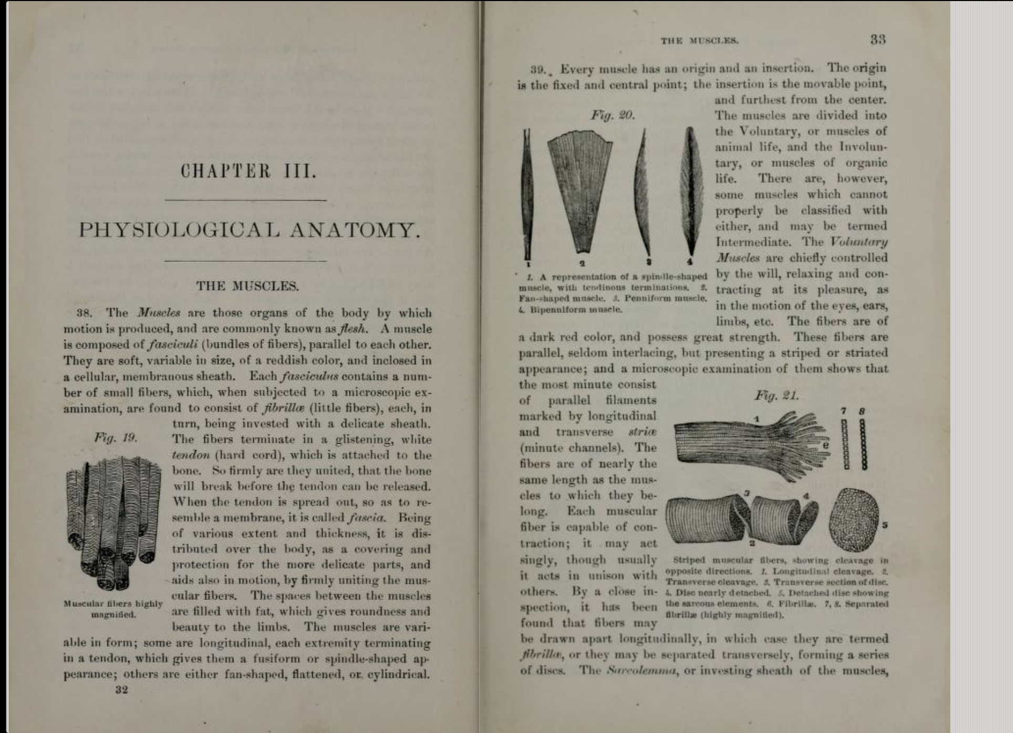
Why this NFR + target  why this quality matters for your user, why THAT number is the right target (not a round guess), and the one thing you would trade to hit it. | Users need to trust why an 1890s source says X, especially since some of its guidance is medically outdated — an unexplained answer risks being followed uncritically.  100% citation coverage is achievable since every answer must trace to one page; the trade-off is we sacrifice some fluency (answers read more like "per page 412..." than natural prose).
The rest of the framing
Who would use this  the real person/role who'd use the finished tool and the decision it helps. Not “data scientists” or “the marker”. | A householder or family caregiver without same-day doctor access, deciding whether a symptom needs home care or professional attention.
How we measure success  pick ONE headline number for answer quality and state your target (e.g. groundedness ≥ 0.9; answer-F1 ≥ 0.7). | Groundedness ≥ 0.9 — at least 90% of answers are fully supported by the cited page.
Score we want to beat  the laziest baseline, so you can prove value (e.g. “return the top-1 retrieved chunk verbatim = 0.4 answer-F1”). | "Return the top-1 retrieved chunk verbatim" ≈ 0.4 answer-F1 — our agent must beat that by reasoning across chunks and citing precisely.  Furthermore,  https://www.kaggle.com/datasets/thedevastator/comprehensive-medical-q-a-dataset  We don’t have a score generally but we can test our system on this common q/a questions and see how many have been answered correctly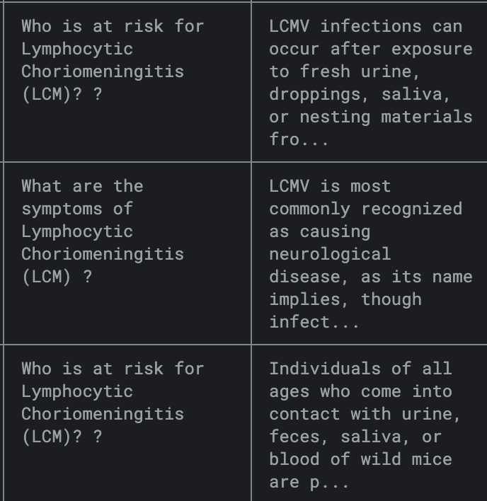

Section 2 — Our Corpus
Your knowledge base is scanned book pages — images before they are text. Sourcing and documenting them is graded here.
Corpus name and link  the public source and a working link (e.g. Internet Archive, HathiTrust, Qatar Digital Library). Must be scanned page-images, not pre-typed text, and freely usable. | The People's Common Sense Medical Adviser (R.V. Pierce, 1890) — Internet Archive, https://drive.google.com/file/d/1M5K4DtM2aHMJOSdUgvBxwth20P5wQ7vA/view
Licence, and may we share it  the licence (public-domain / CC-BY / “research only”) and whether you may re-share. If not, write “link only” and hand in a download script. | Public domain (US, pre-1926 publication) — free to re-share, with source credited.
How big is it  must be ≥ 300 pages AND ≥ 60,000 words of usable text (huge-corpus profile: ≥ 100k pages). State pages, words, and MB on disk. | 1034 pages, 354367 words, 65.3 MB
Scan & script difficulty  what makes these scans hard to read: script (Bangla conjuncts/matras, Arabic ligatures), fonts, faded/skewed pages, mixed scripts, old orthography. | 1890s typeface with long-s and ligature artifacts, foxing/staining on early pages, faded ink in places — causing OCR misreads (see examples above).
How we split it (no leakage)  train/val/test as percentages, split by DOCUMENT (never by page), so no book appears in two splits. | Split by chapter/section as document units (e.g., Physiology, Diagnosis, Diseases-by-organ-system), never by page — e.g., 70% train / 15% val / 15% test.
The one way data could leak, and how we checked  the single most likely leak (e.g. same book in train and test) and how you confirmed it didn't happen. | Risk: the same disease chapter's intro and its "Report of Cases Treated" appendix ending up in different splits, since they discuss the same content. Checked by keeping each full chapter as one atomic unit assigned to only one split.
Preparing the scans — answer each for your corpus
Say what you did and its effect. Last 3 rows are blank for anything not listed. Example: “Deskew pages? | rotated by detected angle | OCR word-error 31%→22%”.
Preparation question | What we did about it | Effect on the data
Deskew / rotate crooked pages? | Measured skew angle on a systematic sample (1 page per 50-page chunk, 18 pages total) using OpenCV's minAreaRect on binarized text regions | Most pages near 0° (clean scans); 2/18 (11%) exceeded 1° skew, max observed 2.72°. Not severe enough to require deskewing as a blanket step — will spot-check flagged pages individually rather than rotate the whole corpus.
Denoise / remove speckle & stains? | Visually confirmed foxing (brown age-spotting) concentrated in front-matter pages (pp.1-20) | Not yet corpus-quantified — planned before A2. Confirmed qualitatively present; deferred systematic measurement since it's concentrated in a small known region.
Binarize / boost contrast? | Tested grayscale + autocontrast + fixed-threshold binarization on a 5-page sample spread across the corpus (pp.20, 34, 15, 20, 20 in different chunks), Tesseract OCR before/after | Net word count changed 1432→1429 (−0.21%) — essentially neutral to slightly negative. Fixed-threshold binarization isn't a clear win; not adopting it as a blanket default.
Remove blank or non-content pages? | Scanned embedded text length across all 918 page-splits in the corpus; flagged pages with <20 characters | 33 pages (3.6%) flagged as near-empty (mostly foxed front-matter). These will be auto-excluded from chunking.
Normalise the extracted text (Unicode, digits)? | Searched all ~311,000 extracted tokens corpus-wide for digit-substituted-into-word errors (our confirmed error class, e.g. "8mart-weed") | Found 45 confirmed instances (0.014% of tokens) — e.g. "COM3HON" (Common), "CEBEBJ8AL" (Cerebral), "TEMPERA3IENTS" (Temperaments). This is a conservative lower bound — it only catches digit-substitution, not other OCR error types (like the "Buffalo"→"Bttwpa-LO" letter-garbling we found earlier). Confirms normalization/re-OCR is needed, not optional.

Section 3 — Corpus Description & Findings (from the notebook)
Data schema — every field you store per page/chunk
List each field: name, type, meaning, and a typical value. E.g. “page_id | string | which scanned page | g07_bk1_p045”.
Field / column | Type | What it means | Typical value
page_id | string | unique id for one scanned page (book + page number) | g07_bk1_p341
chapter | string | chapter/section title this page belongs to — our leak-proof split unit | Emmenagogues
raw_ocr_text | string | reader output for the page before any cleanup — fine-tuned Qwen3-VL at serving; the embedded Internet-Archive layer and a 300-DPI Tesseract pass are kept as A1 baselines to compare against | “…Extract of 8mart-weed…”
cleaned_text | string | normalised/corrected text used for chunking & retrieval | “…Extract of Smart-weed…”
image_description | string | null | VLM-generated caption for pages that carry a figure/plate; null otherwise | “Wood-cut of the human skeleton, anterior view, labelled”
passage_regions | list[bbox] | layout-stage boxes for each text block on the page, so a citation can be rendered as a cropped image of the exact passage (Section 5, Design/Problem statement) | [[112, 884, 690, 951], …]
image_id | string | null | stable id of the figure on this page — what cite attaches when an answer draws on a plate rather than on text (Section 7.2) | g07_bk1_p341_fig1
quality_flags | list[string] | per-page flags emitted by Stage 1 (near-empty, foxed, skew >1°, low reader confidence) — what routes a page to enhance_page or to human review | [“low_conf”, “foxed”]
ingest_run_id | string | which ingest run produced this row (input hash + reader version + enhancement params), so any indexed text traces back to its run (Section 5, MLOps) | ing_2026-07-25_qwen3vl-lora-v2
Findings
Three things the exploration showed  e.g. page-length spread, dominant vs rare topics, worst scan-quality band, script/font variety. | (1) Page length is tight, not wide: across 1,034 pages the middle 80% falls between 207 and 474 words (median 368, mean 350, max 784), and 21 pages extract zero words at all — near-empty front-matter and full-page plates. (2) The largest single structural block is the Appendix (66 pages, printed pp.907–978); “DISEASES OF THE …” chapter headers carry 51 pages; genuinely rare are the “Cases Treated” reports (5 pages, scattered pp.510–862) and the reproductive-health chapters (Spermatorrhea 9 pages, Impotency 11). (3) OCR failure is token-local, not page-local: printed p.342 is a clean, well-lit scan yet renders the same product name three different ways on the one page — “l^uiart-weed”, “8mart-weed”, and correctly “Smart-weed”.
What this means for our build  how a finding changes a downstream choice (e.g. “many faded pages → enhancement matters”). | Two consequences. First, because the errors are token-local on otherwise-clean pages (finding 3), a page-level confidence gate cannot catch them — the page looks fine by every image-quality measure we have. That is why our fallback is a reader fine-tuned on this book's own typeface (Sections 4 and 5) plus token-level confidence, rather than more image enhancement. Second, because page length is tight and unimodal (finding 1), fixed-size chunking is defensible and we do not need aggressive sub-splitting; the 21 zero-word pages are dropped before chunking instead of being sent to the reader at all.
Three example pages
Show three real pages so a reader sees what one looks like: the page id, a note on scan quality, and the text your pipeline extracted from it.
Page id | Scan-quality note | Extracted text (short excerpt)
g07_bk1_p341 | Clean scan, correct period typeface — but OCR still garbles a plant name. | “Iiif<B-root (Senecio Gracilis.) Life-root exerts a peculiar...” (Tesseract misreads “Life-root”)  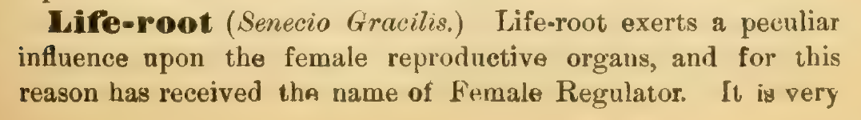
g07_bk1_p342 | Clean scan; long-s-era typeface trips OCR on a compound remedy name. | “Extract of 8mart-weed” (should read “Smart-weed”)  
g07_bk1_pPreface | Worst band in the corpus — foxed/faded unnumbered preface leaf; both embedded and fresh OCR fail. | “Bttwpa-LO, N. Y., July, 1875.” (should read “Buffalo, N.Y., July, 1875.”)  

Section 4 — Risks
Answer each honestly — write “N/A” only if it truly doesn't apply (rare for historical books).
Personal data (PII)  do the books name living or identifiable people (letters, records, biographies)? How will you detect and redact it? | The physiology/anatomy chapters name no living individuals.  The "Cases Treated" sections (from p.500+) describe real historical patients by initials/description only (e.g. "a lady, aged 30"), not full names — low PII risk  But we'll still run a name/PII-pattern scan across all "Cases Treated" sections before release, since some editions of this genre do include patient names.
Licensing / copyright  are all pages genuinely public-domain or openly licensed? What's your evidence? | Public domain — published 1890, U.S., pre-1926 → confirmed public domain under U.S. copyright law. Evidence: title page states publisher/date; no renewal record exists for works this old. Free to re-share with source credited.  link : https://archive.org/details/peoplescommonsen00pierrich
OCR failure  where will reading fail worst (script, fonts, damage)? What's your fallback (re-OCR, enhance, abstain)? | (1) embedded OCR misreads period typography ("Smart-weed"→"8mart-weed"), fixed by re-OCR at 300 DPI; (2) some degraded pages defeat even fresh OCR (the 1875 preface page: "Buffalo"→"Bttwpa-LO"/"Bnrrao"). Since these failures are font-specific (long-s, ligatures), not random noise, our primary fallback is to fine-tune our OCR model on this book's exact typeface, using ground truth aligned from an existing proofread edition (Project Gutenberg #18467) rather than hand-transcribing. We'll also evaluate a vision-language model (e.g.qwen3.5-9b) as a candidate reader for our worst-case pages, since VLMs can use contextual/semantic understanding to resolve ambiguous characters that pure pixel-matching OCR cannot. Pages still low-confidence after both attempts escalate to human review.
Hallucination  how could the agent answer things not in the text, and how will you stop it (grounding, abstention)? | Since some passages promote the author's own commercial products ("Dr. Pierce's Compound Extract of Smart-weed") as if clinically neutral, and other passages reflect stigmatizing/inaccurate Victorian framing (e.g. attributing "Spermatorrhea" to "self-abuse"), the agent must ground every claim to a specific page and abstain rather than repeat these as established fact. Grounding + citation-per-claim + an explicit "historical claim, not modern consensus" flag prevents this.  We might also add extra modern data from web scrapping if needed.
Bias across your corpus  which fonts/regions/subgroups might the system read worse, given your data speciality and NFR? | Two concrete, corpus-specific biases:  (1) commercial bias — the author repeatedly recommends his own named products throughout the remedy chapters;  (2) social/moral bias — reproductive-health chapters (pp.700-900: menstrual disorders, "Spermatorrhea and Impotency," venereal disease) reflect period stigma rather than clinical neutrality. Both need explicit disclaimers rather than being surfaced as plain fact.

Section 5 — Design Choices & Justification (the corpus/ingest stage)
State your choice across the eight facets for the stages you touch in A1 (Stage 0 framing, Stage 1 ingest/enhance). You'll extend this table each milestone — it's the graded design artifact (configs/design_choices.md).
Facet | Our choice (this stage) | Why — fits our corpus · what it costs · what would change it
Problem statement | Our knowledge base is the full book, The People's Common Sense Medical Adviser (Pierce, 1890), indexed once. A user asks an arbitrary health question; the agent retrieves the relevant page(s), reads them, and answers grounded in that page's text, returned with a page citation. The citation shows a segmented crop of the source passage, plus the relevant figure where one applies. Success metric: groundedness ≥ 0.9 (≥90% of answers fully supported by the cited page), with every answer carrying a page citation (our Explainable NFR). | This framing maps the fixed course task onto our single public-domain corpus and our Explainable NFR, so success is one measurable criterion rather than an informal judgement. The segmented crop makes each citation independently verifiable, which is what an explainable system owes the reader. It costs scope discipline, since the system stays on page-grounded retrieval instead of open-ended medical advice, and it adds a passage-segmentation stage plus an optional vision-language pass for figures. We would revise it if the corpus proved too thin for realistic questions (it does not, at 1,034 pages and 354,367 words, §2), or if segmentation proved too unreliable to trust, in which case we fall back to a plain page-number citation.
Data | Public-domain 1890 scan (Internet Archive), 1,034 pages, one book. Split by chapter as document units, never by page; all pages indexed once, and the split governs labels only. Ground-truth transcriptions built LLM-assisted, then hand-checked on degraded regions. | Chapters are natural leak-proof units (a disease chapter's intro and its "Cases Treated" close must stay together) · cost is coarser splits plus manual labelling · would change if one chapter is disproportionately long and needs sub-splitting.
Model | Open-weight Qwen VLM (Qwen3-VL, 9B) as the OCR/reader, fine-tuned on our corpus (tentative; we will benchmark other open-source options first, then retrain/fine-tune the best). Ground truth generated offline with Gemini (proprietary, label-time only, never at inference) and hand-checked, which gives us data to both fine-tune and evaluate Qwen. | Open-weight keeps inference sovereign and benchmarkable (proprietary touches only offline label generation, per the OCR ruling) · cost is fine-tuning compute plus a GPU at serving · would change to a smaller reader if Qwen's accuracy-per-cost doesn't justify 9B on our labelled block.
Methods | Light classical cleanup (grayscale + adaptive contrast; blank pages flagged by near-zero text), then supervised fine-tuning (LoRA) of the Qwen reader on our ground-truth transcriptions, with token-level cross-entropy loss. Key knobs: LoRA rank, learning rate, epochs; no global binarization. | Adaptive beats fixed-threshold binarization, which crushed faint ink on a test page ("carminative"→"earminative") · LoRA over full fine-tune keeps the 9B trainable on a modest GPU · cost is per-page tuning plus label-hungry fine-tuning · would drop fine-tuning if base Qwen already hits target CER on our labelled block.
Design | Ingest+Enhance sits before Layout/OCR (Stage 1 → feeds 2–3). Interface: raw page-image in → cleaned image + page_id + quality flags out. Layout segmentation yields the passage-region boxes our citations crop from; a VLM pass writes a stored image_description for figure pages. | Isolating cleanup before reading lets us swap readers without touching enhancement · pre-computed region boxes and figure descriptions let citation and retrieval work at query time without re-processing · cost is an extra pass per figure page · would drop the figure pass to text-only if VLM captions prove unreliable.
Development | eda.ipynb logs page/word/blank counts and OCR error examples; configs/task.yaml records the three choices; each fine-tune run logs CER on the val block. Every number in the form traces to a re-runnable cell. | Keeps each claim checkable against a cell (the grading gate) · cost is upkeep discipline as the corpus grows · would add output caching if top-to-bottom re-runs get slow.
Deployment | Ingest/enhance runs as a one-shot offline batch job on our own machine (GPU for the Qwen reader), not a live service. Its output feeds later stages. Full serving stack (API + UI, container) planned for A4. | Ingest is preprocessing, done once and never in the user's request path, so batch/offline is correct and keeps the latency budget clean · no cost to batching · would move to incremental ingest only if the corpus grew large enough to need it.
MLOps | Version each ingest run (input hash + OCR-model version + enhancement params) so any indexed text traces to the run that produced it. CER on the labelled block is the acceptance gate for a run: a new run ships only if its CER matches or beats the previous version. Retrain / re-ingest trigger: a new edition or book is added, or a re-run regresses CER against the last version. | The corpus is static and indexed once, so there is no live drift to watch; the useful MLOps signal is reproducibility and catching a regression when we change the reader or add data · cost is hand-building the versioning and gate (no dashboard) · would grow into live monitoring only once the system serves real traffic in A4.
One decision where we chose one option over another  show one place you picked one option and rejected another, and why (e.g. “diffusion enhancement over classical denoise — because our scans are badly faded”). | We re-OCR every page ourselves rather than trust the PDF's bundled OCR text layer. Confirmed on real pages that the embedded layer misreads period typography ("Smart-weed"→"8mart-weed") which our own pass corrects · cost is extra compute per page and giving up the free text already in the source files.

Section 6 — Our Pipeline & Scope
Everyone builds the same 9-stage pipeline. Mark which tier each stage is for your group: ⭐ core (all groups) · ▲ gated (required only if your NFR/data-speciality triggers it — see codebase-guide.md) · ➕ bonus. Then name the one model/tool you expect to use per stage.
Stage | What it does | Tier for us (⭐/▲/➕) | Our planned model/tool
0 Frame | the three choices + success metric | ⭐ | N/A (planning only, no model)
1 Ingest + Enhance | load, clean, (VAE/diffusion) repair scans | ⭐ | OpenCV/PIL adaptive-contrast cleanup + blank-page flagging by near-zero text. Bonus: a Qwen VLM generates a figure caption (image_description) per figure page.
2 Layout | find text/table/figure regions | ⭐ | Document layout / region detection (e.g. a layout model such as PP-DocLayout or docTR, or the VLM's own region grounding) to separate text blocks, figures, and plates before reading.
3 OCR / HTR | read the text (pretrained, fine-tuned) | ⭐ | Open-weight Qwen VLM (Qwen3-VL, 9B), fine-tuned on our corpus; ground truth built offline with Gemini and hand-checked.
4 Index | chunk, embed, store vectors | ⭐ | Sentence-embedding model + FAISS flat index. Bonus: semantic chunking (split on topic shifts, not fixed word-count), and the ingest-time figure captions embedded alongside text so figure questions retrieve.
5 Retrieval | find relevant chunks (+rerank) | ⭐ | Dense retrieval (embedding similarity), top-k with a rerank step if time allows
6 Agent | reason, use tools, answer grounded | ⭐ | An LLM as the agent "brain" over the 9 fixed tools
7 RL / RLVR | train tool-choice + verifiable reward | ➕ | Not attempted in core scope; a stretch goal if time allows
8 Serve | API + UI (+ adapt/quantize) | ⭐ | FastAPI backend + lightweight web UI (deferred to A4, but scoped as core since every team must eventually ship)
9 Evaluate | metrics, fairness, calibration, explain | ⭐ | Custom groundedness/citation-accuracy harness, built on our labeled example pages
Beyond the tiers above, these are bonus opportunities (extra credit): handwriting/HTR, a real-world messy corpus, an actual external client, agent-policy training (RL/RLVR), and multi-agent. Aim for the core build first; attempt bonuses if you have room.

Section 7 — The Agent Layer (on paper)
The agent is the heart of the system. Design it here against the fixed repo interface; you'll implement it in A3.
7.1 The agent and its brain
The brain(s)  which trained/pretrained models power perception and answering (OCR reader, embedder, LLM). | Three models split perception from reasoning. (1) An open-weight Qwen VLM (Qwen3-VL, fine-tuned) reads page text as our OCR/reader. (2) A sentence-embedding model turns pages and chunks into vectors for retrieval. (3) An LLM is the reasoning brain that picks tools, judges retrieval confidence, and composes the final cited answer. The same VLM also generates the stored image_description for figure-bearing pages at ingest time, so the LLM brain can read those descriptions like any other retrieved text at query time.
What one step looks like  one loop: perceive the query → decide a tool → act → observe → (stop or repeat). | Perceive the question → call retrieve with an initial k → observe the top retrieval score → if the score is below our confidence threshold, widen k and retrieve again (our required evidence-gated re-search behavior) → once evidence is strong enough, read_page the best candidate(s) → extract the specific supporting span → cite the page → answer. If confidence is still weak after k reaches k_max, stop and escalate_to_human rather than guess.
7.2 Its tools (fixed interface)
The tool set is fixed in the repo. For each, say how your project uses it, and mark read-only vs. acts.
Tool (fixed) | How our project uses it | Reads / Acts
retrieve | Searches the indexed corpus (dense embeddings over page/chunk text and stored image descriptions) for candidate pages. Called first each turn, and re-called with a widened k if the top score is weak. This is our declared evidence-gated re-search behaviour. | Reads
rerank | Re-scores the top-k candidates, since vocabulary overlaps across chapters (e.g. a symptom mentioned in both a fever chapter and a skin chapter) need finer disambiguation before committing to one page. | Reads
read_page | Opens both the cleaned OCR text and the stored image_description (if any) of a candidate page, so the agent checks the passage genuinely supports the question before extracting. | Reads
enhance_page | Re-runs adaptive-contrast cleanup and/or re-OCR on a page flagged low-confidence (e.g. our EDA-identified foxed pages), and can trigger a fresh VLM description pass if the stored one looks weak. | Acts
extract | Pulls the precise sentence or phrase that answers the question (e.g. an exact dose or symptom description), so the final answer quotes narrowly rather than summarising loosely. | Reads
aggregate | Combines information across multiple pages when a question spans chapters, e.g. a remedy named in the Materia Medica section and its actual use noted again in a disease chapter. | Reads
cite | Attaches the exact page id (and image id, if the answer drew on a figure) to the final answer. This is what makes our Explainable NFR checkable. | Reads
calculator | Does exact arithmetic on quantities stated in the text (e.g. summing or unit-converting a dose the page itself gives), so numeric answers stay grounded in the page rather than estimated. | Reads
escalate_to_human | Fires when retrieval confidence stays weak even at k_max (abstain and escalate), or when a question lands in a content area we've flagged as needing extra care (e.g. the reproductive-health chapters with stigmatising period framing). Hands off rather than answering uncritically. | Acts
7.3 Autonomy, humans, and budget
Autonomy level  read-only · act-with-approval · act-then-log. Which, and why for your NFR? | Act-then-log, with the acting surface deliberately narrow. Only two tools act: enhance_page (re-cleanup / re-read of a page) and escalate_to_human. Both touch our own derived artefacts only — never the source scans, never anything outside the system — so no approval step is needed before the fact. Every acting call is logged with the page_id, the ingest_run_id and reader version it ran against, and the confidence that triggered it (Section 5, MLOps). That log is what makes our Explainable NFR auditable after the fact: for any answer, a marker can replay which pages were re-read and why. With respect to the user and the corpus the agent stays read-only — it never edits source data or takes real-world action.
Human-in-the-loop  which cases escalate to a human (via escalate_to_human), and what they decide. | Escalates when: (1) the grounding gate fails after k reaches k_max — no retrieved passage entails the answer; (2) reader confidence stays low after the escalation ladder in Section 4 is exhausted (re-read with the fine-tuned Qwen reader, then a second-opinion VLM pass); (3) the answer would rest only on a model-generated image_description rather than on page text (see 7.5); (4) the matched passage falls in a flagged bias or PII-risk area from Section 4 — the commercial-product passages, or the reproductive-health chapters carrying period stigma. The human confirms or corrects the citation, supplies a redaction, or attaches the “historical claim, not modern consensus” flag before the answer is released.
Budget  max steps and cost per query (agent.max_steps, budget). What happens at the limit? | agent.max_steps = 8. A worst-case grounded run is retrieve → widen-and-retrieve ×2 (to k_max) → rerank → read_page → extract → cite = 7 calls, which leaves exactly one spare for a single enhance_page. enhance_page is separately capped at 1 call per query, because it re-runs the 9B VLM reader and is by far the most expensive step (Section 5 puts a GPU in the serving path); a second low-confidence page escalates instead of being re-read. k widens at most twice. On hitting either cap without a grounded, cited answer the agent abstains and calls escalate_to_human — it never spends its last step guessing.
7.4 How we'll test it, and how it improves
Our eval questions  how you'll build tasks.jsonl for YOUR domain — the questions your real user would ask. Include enough checkable (verifiable) items and abstention cases so grading stays objective. | tasks.jsonl is hand-written from real corpus content and mixes three item types. (a) Verifiable page-cited questions — e.g. “What does the book recommend applying to the chest for whooping-cough?” → printed p.523, which names the Compound Extract of Smart-weed and hot fomentations; each item stores the expected page id, so scoring is exact rather than judged. (b) Abstention items the corpus cannot answer, drawn from the modern Kaggle Medical Q&A set named in Section 1 — because that set is contemporary medicine, most of its items should trigger a correct refusal, which makes it a ready-made abstention benchmark rather than an accuracy benchmark. (c) Figure items answerable only from a plate, to test that image_id citation works. Separately, grading_kit/heldout_pages/labels.jsonl holds our three hand-checked pages with ground-truth transcriptions; those score the reader (CER), not the agent.
How it improves  rule-based policy first; if you attempt RL (bonus), the reward is RLVR on your verifiable questions (checkable answers), which sharpens a GENERAL system. | Two loops, deliberately separated. The reader improves by supervised fine-tuning (LoRA on Qwen3-VL, Section 5 Methods) against our hand-checked ground truth, gated on CER over the labelled block — a new ingest run ships only if its CER matches or beats the previous version (Section 5, MLOps). The agent policy improves rule-based first: we tune the re-search confidence threshold and k_max from the A1/A2 measurements, with no learning involved. If we attempt the RL bonus, the reward is RLVR over the verifiable items in (a) and the abstention items in (b), scoring both a correct page citation and a correct refusal — so the policy is rewarded for knowing when to stop, not for answering more often.
7.5 Agent-specific risks
These exist because the agent ACTS over many steps — they don't apply to a plain model.
Prompt injection from documents  a scanned page could contain “ignore your instructions”. How do you isolate content from commands? | Two entry points, because our reader is a VLM. First, page text: retrieved text is always passed to the LLM inside a delimited, labelled source-content field, never concatenated into the system prompt, and the system prompt states that anything inside that field is data to quote and cite, never an instruction — so an “ignore your instructions” string scanned off a page is quoted back, not obeyed. Second, and specific to our design: image_description is model-generated text produced at ingest by the VLM from pixels we do not control, so text drawn inside a figure can be transcribed into it. We therefore treat image_description as untrusted data on exactly the same footing as OCR text — same delimited field, never merged into instructions — rather than trusting it because our own model wrote it. An 1890 book will not contain a deliberate injection; we build the isolation now because the same pipeline is meant to take a messier corpus later.
Wrong tool / runaway loop  how budgets and guardrails stop it. | Three bounds, all from 7.3: agent.max_steps = 8 caps total tool calls; k widens at most twice before k_max; and enhance_page is capped at 1 call per query, so the agent cannot sit in a re-read loop burning GPU on a page that will never resolve. Because only enhance_page and escalate_to_human act, a wrong tool choice at worst wastes a read — it cannot corrupt the index or the source scans. Hitting any cap without a grounded answer routes to escalate_to_human rather than to another attempt.
Ungrounded answer  how the grounding gate forces abstention when evidence is missing. | Before answering, the agent checks that the cited passage actually entails the claim; if nothing passes that gate even after k_max, it abstains and escalates rather than filling the gap from the model's own medical knowledge — the failure mode that matters most here, since the LLM brain knows far more modern medicine than this book contains. One case needs a stricter rule: an answer resting on image_description is grounded in a caption our VLM wrote, not in the page itself, so a figure-based claim stands only if cite can resolve it to the stored image_id and passage crop; if it cannot, the claim is dropped or escalated. This is also what keeps the Explainable target honest — a citation a human can verify in under 30 seconds has to point at the page, not at another model's output.

Section 8 — How We Worked With AI
One transcript per team member. Each member submits one plain-text file named exactly <their student number>.txt, containing the full AI conversation behind the sections they led.
Each .txt file must contain | In this order
Header | member name, student number, sections led
The full conversation | every prompt and every AI reply, unedited
A short reflection | what you accepted, changed, or rejected from the AI, and why

Submission — Required Folder Structure
The autograder enforces this exactly. ZIP named A1_<your team id>.zip, containing:
Path | What it is
A1_form.docx | this filled form
configs/task.yaml | your three choices, filled in
notebooks/eda.ipynb | corpus exploration; runs top-to-bottom (a stub is in the repo — you edit it)
scripts/get_data.sh | fills data/raw/ with your corpus (edit the stub)
data/provenance.md | source, licence, page/word counts (edit the stub)
grading_kit/manifest.yaml | declares your three axes + points to corpus/heldout/build (edit the stub)
grading_kit/heldout_pages/ + labels.jsonl | a few set-aside pages + their ground-truth transcriptions
transcripts/<student number>.txt ×3 | one AI-chat transcript per member

How You'll Be Graded (100 points)
Grounding gate: every answer in the form must match your own corpus, notebook, and configs. Unsupported or generic answers score zero for that item.
What we assess | Points
Section 1 — the three choices are specific, valid, and distinct | 20
Section 2 — corpus sourced, licensed, ≥300 pages/≥60k words, split without leakage | 20
Section 3 — schema, findings, and three real example pages | 15
Section 4 — risks answered honestly (PII, licence, OCR, hallucination, bias) | 10
Section 5 — eight-facet design table + one real trade-off | 15
Section 6 — pipeline scope and tiers correct for your profile | 5
Section 7 — agent designed against the fixed tool interface | 10
Section 8 + submission structure correct | 5

