
Koneru Lakshmaiah Education Foundation
(Deemed to be University estd. u/s. 3 of the UGC Act, 1956)
Off-Campus: Bachupally-Gandimaisamma Road, Bowrampet, Hyderabad, Telangana - 500 043.
Phone No: 7815926816, www.klh.edu.in
STUDENT CASE STUDY EXECUTION REPORT
Department | FED
Subject | DSA-2
Academic Year | I-III Semester (2025-26)
Faculty Name | BALAIAH GUDIPUDI
Student Name | M. MANASA
Roll Number | 2520030500
Branch | CSE
Course Outcome
Case Study Topic: Trees & Balanced Search Structures – Smart Tourism & Travel Itinerary Optimization System
Work Done Summary:
In this case study, we implemented tree-based data structures to design a smart tourism and travel itinerary optimization system. The system leverages Binary Search Trees and AVL Trees to index travel routes, maintain balanced itinerary records, and generate sorted travel schedules. AVL Trees were particularly effective in ensuring that the database remained balanced during continuous insertions and deletions, with rotations such as LL, RR, LR, and RL performed whenever the balance factor exceeded the limit. Tree traversals were used to produce itineraries sorted by departure time or priority, while efficient insertion and deletion operations supported dynamic updates to travel plans. By comparing AVL Trees with a Sorted ArrayList, we concluded that AVL Trees provide superior performance for large-scale tourism workloads, especially when frequent updates and queries are required. This approach ensures that travelers can quickly access optimized itineraries even when plans change dynamically.
Implementation Details:
- Route Indexing:
- Each travel route was assigned a unique RouteID and stored in a BST.
- Searching for a route is efficient with O(log n) complexity.
- Balanced Itinerary Database:
- AVL Trees maintained balanced structures for itinerary records.
- Rotations (LL, RR, LR, RL) were performed when balance factors exceeded limits.
- Sorted Travel Schedules:
- In-order traversal generated itineraries sorted by departure time.
- Pre-order traversal supported priority-based route planning.
- Dynamic Updates:
- Insertions and deletions allowed travelers to add/remove destinations.
Result: Screenshots / Output
Code Screenshot:
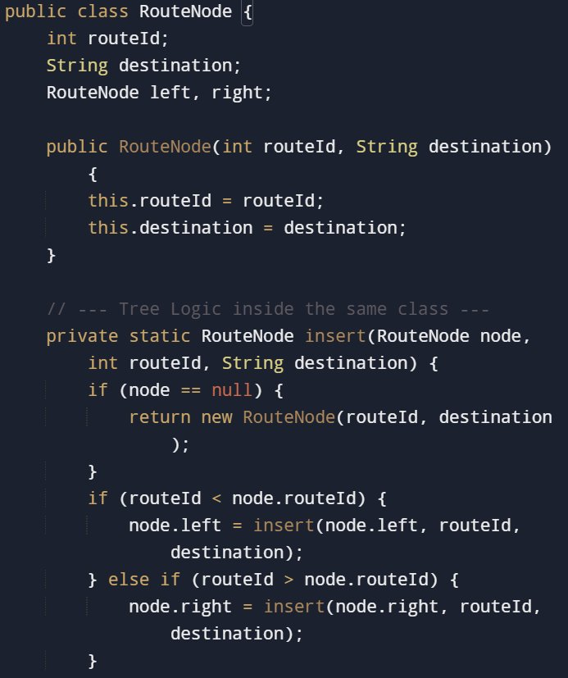
Program Output:
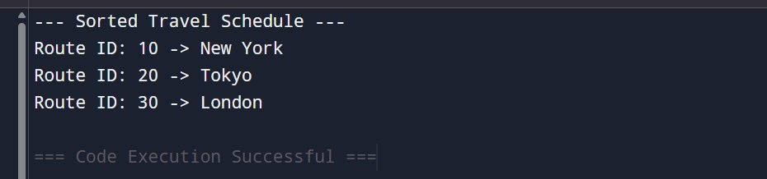
GitHub Link:

Student Signature | Faculty Signature

