
Koneru Lakshmaiah Education Foundation
(Deemed to be University estd. u/s. 3 of the UGC Act, 1956)
Off-Campus: Bachupally-Gandimaisamma Road, Bowrampet, Hyderabad, Telangana - 500 043.
Phone No: 7815926816, www.klh.edu.in
STUDENT CASE STUDY EXECUTION REPORT
Department | FED
Subject | DSA-2
Academic Year | I-III Semester (2025-26)
Faculty Name | BALAIAH GUDIPUDI
Student Name | M. MANASA
Roll Number | 2520030500
Branch | CSE
Course Outcome
Case Study Topic: Multiway Trees & Range Query Structures – Travel Booking & Analytics
Work Done Summary:
In this case study, we implemented multiway trees and range query structures to improve the efficiency of travel booking and analytics systems. B‑Trees were used to index large booking databases, ensuring fast insertion and retrieval of passenger and trip records. B+ Trees supported range queries on travel dates and ticket prices, enabling quick filtering of bookings within specific timeframes or price ranges. Segment Trees were applied to monitor seat availability across multiple trips, allowing real‑time updates and queries on occupancy. Fenwick Trees (Binary Indexed Trees) were integrated to maintain cumulative booking statistics, such as total tickets sold over time, providing fast prefix sum queries. Together, these structures demonstrate how balanced indexing and efficient query mechanisms can significantly enhance smart tourism and travel itinerary optimization systems.
Implementation Details:
- B‑Tree: Indexes passenger and booking records for efficient search.
- B+ Tree: Enables range queries (e.g., tickets between ₹2000–₹5000, trips between June 1–June 15).
- Segment Tree: Tracks seat availability across trips, supporting fast updates and queries.
- Fenwick Tree: Maintains cumulative booking statistics, allowing quick prefix queries for analytics.
Result: Screenshots / Output
Code Screenshot:
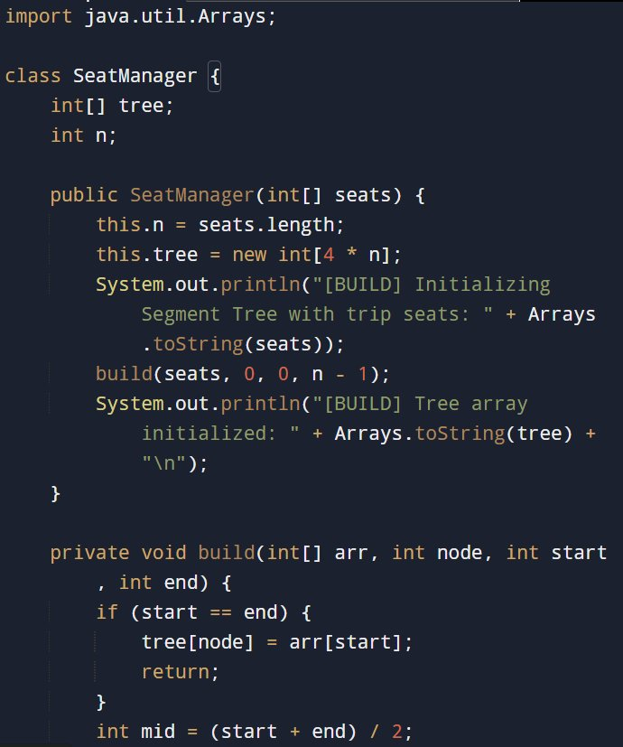
Program Output:
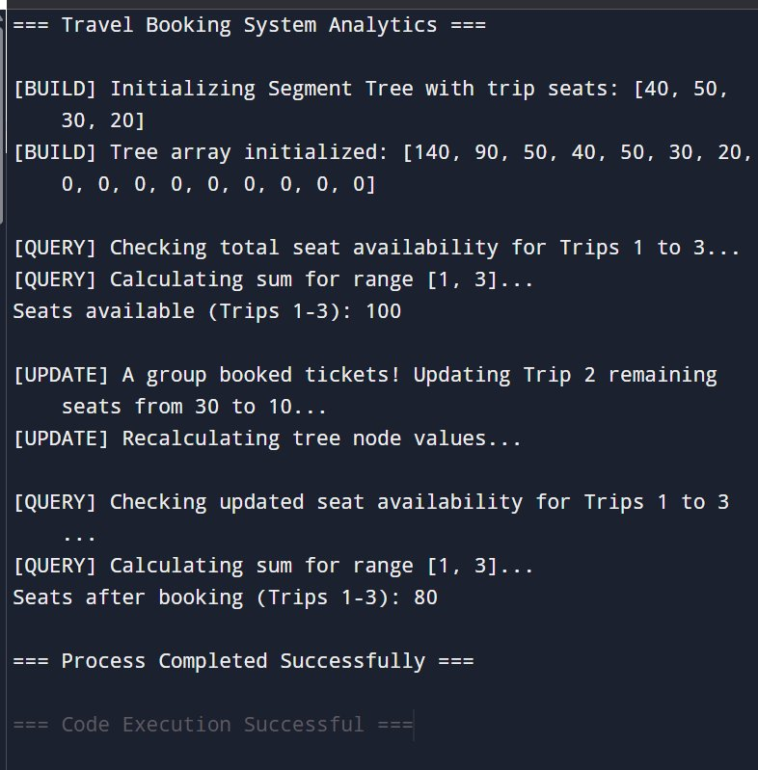
GitHub Link:

Student Signature | Faculty Signature

