
Koneru Lakshmaiah Education Foundation
(Deemed to be University estd. u/s. 3 of the UGC Act, 1956)
Off-Campus: Bachupally-Gandimaisamma Road, Bowrampet, Hyderabad, Telangana - 500 043.
Phone No: 7815926816, www.klh.edu.in
STUDENT CASE STUDY EXECUTION REPORT
Department | FED
Subject | DSA-2
Academic Year | I-III Semester (2025-26)
Faculty Name | BALAIAH GUDIPUDI
Student Name | M. MANASA
Roll Number | 2520030500
Branch | CSE
Course Outcome
Case Study Topic: Graph Algorithms for Transportation Networks
Work Done Summary:
In this case study, we applied graph algorithms to transportation networks to improve connectivity analysis and optimize travel routes. Cities and travel routes were represented as nodes and edges in a graph structure. Breadth‑First Search (BFS) was used to explore connectivity between locations, ensuring that passengers can reach destinations through available routes. Depth‑First Search (DFS) was applied to detect loops in transportation networks, identifying redundant or circular paths that may affect scheduling. Minimum Spanning Tree (MST) algorithms were implemented to design optimal travel networks, minimizing the overall cost of connecting cities while maintaining full connectivity. Together, these graph algorithms demonstrate how transportation systems can be modeled efficiently, enabling smart tourism and optimized travel itinerary planning.
Implementation Details:
- Graph Representation: Cities as nodes, routes as edges.
- BFS: Used to check connectivity (e.g., “Is City A reachable from City B?”).
- DFS: Detects loops or cycles in the network.
- MST (Prim’s/Kruskal’s): Builds the least‑cost travel network connecting all cities.
Result: Screenshots / Output
Code Screenshot:
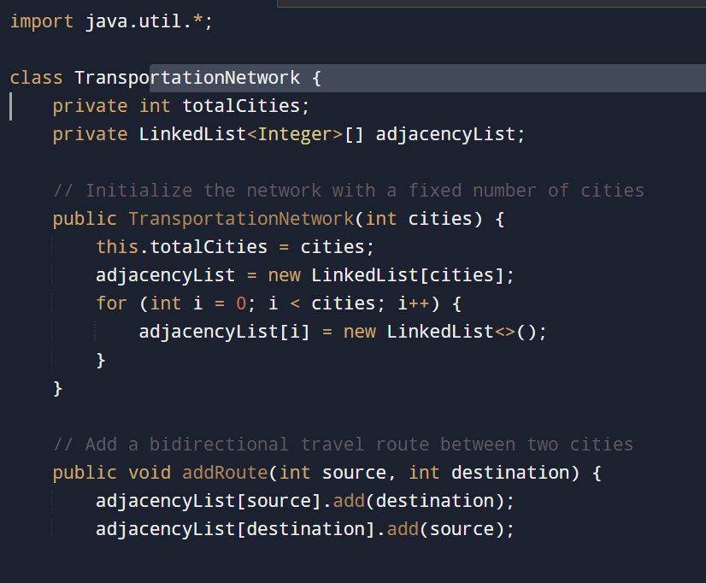
Program Output:
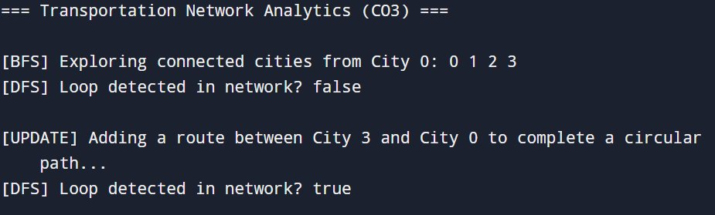
GitHub Link:

Student Signature | Faculty Signature

