A CASE-STUDY BASED REPORT
ON
A Machine Learning Based Case Study for SMS and Email Spam Detection and Classification
submitted in partial fulfilment of the requirements for the Course
MACHINE LEARNING
BACHELOR OF TECHNOLOGY
in
A.Y.: 2026-27
by
Mallavarapu Bala Pranitha Roll No: 2520030051
M. Manasa Roll No: 2520030500
Under the Esteemed guidance of
Dr. G S Raghavendra
Department of Computer Science & Engineering



INDEX
Abstract
Introduction
Background
Motivation for the Project
Overview of the Work Carried Out
Scope and Responsible-Use Statement
Problem Statement
Case-Study Scenario
Central Case-Study Question
Formal Problem Definition
Objectives that Guide the Study
Assumptions and Limitations
Dataset and Exploratory Data Analysis
About the Dataset
Purpose of EDA
Preparation Steps Actually Performed
EDA Exploration - Implementation
Summary of EDA Findings
Algorithm Selection and Implementation
Bag-of-Words and TF-IDF Representations
Why Multinomial Naive Bayes?
Why Support Vector Machine?
Evaluation Results
Influential Words and Error Analysis
Comparison of the Approaches
Conclusion
References
Signature of the Team members

1. Abstract
Short text messages and emails reach users in large numbers, and a considerable share of them is unwanted, promotional, misleading or suspicious. Identifying such messages by reading them one by one is slow and error-prone. This case study, A Machine Learning Based Case Study for SMS and Email Spam Detection and Classification, addresses the problem as a supervised text-classification task in which every message is assigned to one of two classes: Spam or Not Spam. The experiments use the SMS Spam Collection, a labelled corpus of 5,574 messages of which 747 are Spam and 4,827 are Not Spam (ham).
The messages were checked for missing values and for exact duplicates (403 duplicate rows were found and removed, leaving 5,171 unique messages: 4,518 Not Spam and 653 Spam). The text was cleaned and converted into numerical features by two representations, Bag-of-Words and Term Frequency-Inverse Document Frequency (TF-IDF), giving a vocabulary of 7,272 terms. Two classifiers, Multinomial Naive Bayes and a linear Support Vector Machine (SVM), were trained on a stratified 80% training split (4,136 messages) and evaluated on the remaining 20% (1,035 messages), which gives four combinations of representation and classifier.
On the held-out test set all four combinations reach an accuracy between 96.52% and 98.65%. The best test F1-score for the Spam class is 94.40% (Bag-of-Words with SVM), closely followed by Bag-of-Words with Multinomial Naive Bayes (94.21%) and TF-IDF with SVM (93.98%). TF-IDF combined with Multinomial Naive Bayes is the weakest combination (F1 84.07%) because its recall on Spam falls to 72.52%, although it flags no legitimate message as Spam. A five-fold cross-validation confirms that the SVM performs consistently with both representations. The most influential terms are examined: tokens for long digit strings, web addresses and words such as claim, prize, free, txt and reply point towards Spam, whereas everyday conversational words point towards Not Spam.
The work is a supervised learning study on a public benchmark. It is a classification aid and not a guaranteed security or fraud-detection system; a prediction can be wrong and does not establish the intent of a sender. The corpus used for the measurements consists of SMS messages, so the figures reported here describe SMS filtering; email text passes through the same pipeline, but no email corpus was evaluated in this report.
Keywords: spam detection; SMS and email; text classification; natural language processing; Bag-of-Words; TF-IDF; Multinomial Naive Bayes; Support Vector Machine; supervised learning.

2. Introduction

2.1 Background
Electronic messaging through SMS and email is an important part of everyday communication. Along with useful messages, users receive unwanted promotional offers, prize claims, requests to call premium-rate numbers and links to doubtful websites. Such unsolicited messages are called spam. When the volume of incoming messages is large, reading each message to decide whether it is wanted becomes time-consuming, and genuinely important messages can be overlooked among the unwanted ones.
Spam filtering is a text classification problem: a message, which is a piece of free text, is assigned to a predefined category. In this project the two categories are Spam and Not Spam. A labelled dataset supplies examples of both categories, and a supervised machine learning algorithm learns from these examples which patterns of words are typical of each class. Because machine learning algorithms operate on numbers, the raw text cannot be given to a classifier directly. It is first converted into a numerical vector, a step called feature extraction. Two classical ways of doing this are used here: Bag-of-Words, which counts how often each vocabulary term occurs in a message, and TF-IDF, which weights each count by how rare the term is across the whole collection [4].
Two classifiers are studied. Multinomial Naive Bayes is a probabilistic classifier that applies Bayes' theorem with the simplifying assumption that terms occur independently given the class; it has a long history in text and junk-mail filtering [2], [5]. The Support Vector Machine (SVM) looks for the decision boundary that separates the two classes with the largest margin and is well suited to the high-dimensional, sparse vectors that text produces [3].

Supporting literature
Almeida, Gómez Hidalgo and Yamakami [1] introduced the SMS Spam Collection, the dataset used in this project, in a study of SMS spam filtering published at the ACM Symposium on Document Engineering (2011). The collection gathers real SMS messages that were labelled as spam or legitimate (ham) and has become a common benchmark for comparing text classifiers on short messages. Sahami et al. [5] showed earlier that a Bayesian approach can be used to filter junk email, and Joachims [3] argued that SVMs suit text categorization because text produces very many relevant features and sparse examples. McCallum and Nigam [2] compared the multinomial and multi-variate event models of Naive Bayes for text, and the multinomial model is the one used here.
These works support the choice of the dataset and of the two classifier families. They should be distinguished from the present project: the methodology followed here is the one implemented in the project code (cleaning, vectorization, training and evaluation described in Sections 4 and 5), and every number reported in this report was produced by that code and not taken from the cited papers.

2.2 Motivation for the Project
The dataset used in this report contains 5,574 messages, and the real-life stream of messages that a person receives is far larger and never stops. The motivation for the project can be summarised as follows:
- Manual identification of spam messages is time-consuming and does not scale with the number of messages.
- Users need a systematic way to separate unwanted messages from legitimate communication.
- Spam messages contain recognisable patterns and terms (for example offers, prizes, long numbers and links) that can be learned from labelled examples.
- The project gives practical exposure to Natural Language Processing (NLP), feature extraction, supervised learning and text classification on a real problem.
- Comparing two text representations and two classifiers shows how the choice of method influences the result, especially on an imbalanced dataset in which only about one message in eight is Spam.

2.3 Overview of the Work Carried Out
The work follows the pipeline implemented in the project code. The labelled SMS Spam Collection is loaded and checked for missing labels, missing text and duplicate messages; each message is cleaned; the data are split into a training set and a test set with the same proportion of Spam in both; the training text is converted into numerical features by Bag-of-Words and by TF-IDF; Multinomial Naive Bayes and SVM classifiers are trained on each representation; the classifiers are evaluated on the unseen test messages; and the terms that influence the decisions are inspected. The workflow is shown in Figure 1 and summarized in Table 1.
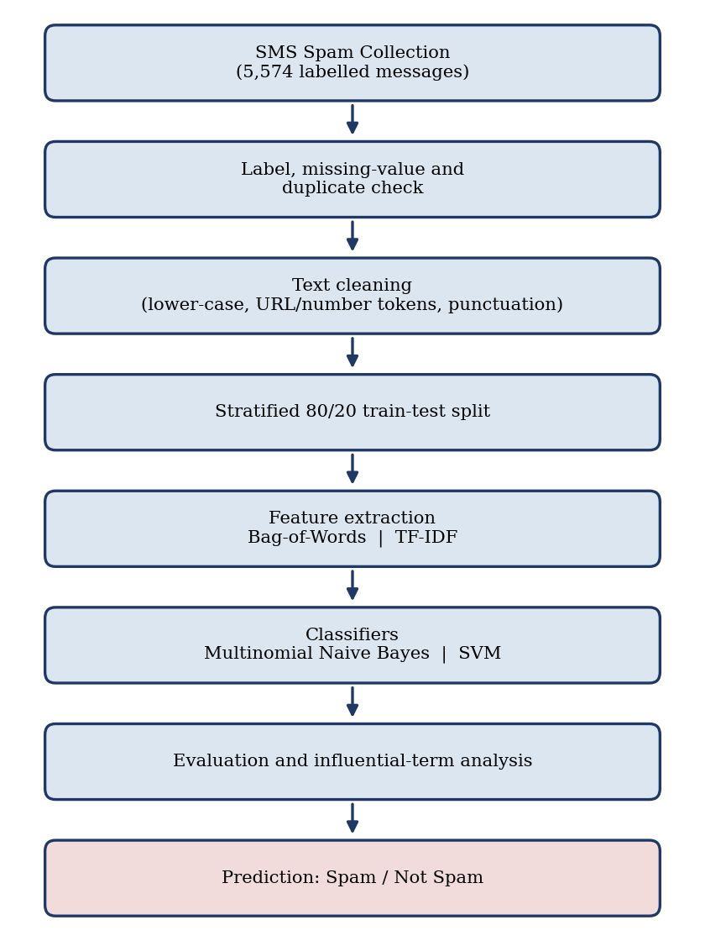
Figure 1: Workflow of the SMS and Email Spam Filter case study (dataset to Spam / Not Spam prediction)
Table 1: Stages of the implemented pipeline
Stage | What is done | Tool used
Data loading | Tab-separated file of 5,574 labelled messages loaded; labels ham / spam | pandas.read_csv
Quality check | Missing labels and text checked; 403 exact duplicate messages removed | isnull, drop_duplicates
Text cleaning | Lower-casing; URLs and long numbers replaced by tokens; punctuation removed | re (regular expressions)
Train-test split | Stratified 80/20 split: 4,136 training and 1,035 test messages | train_test_split
Feature extraction | Text converted to numerical vectors (Bag-of-Words and TF-IDF) | CountVectorizer, TfidfVectorizer
Classification | Multinomial Naive Bayes and linear SVM trained on each representation | MultinomialNB, LinearSVC
Evaluation | Accuracy, precision, recall, F1-score, confusion matrix, 5-fold cross-validation | sklearn.metrics
Interpretation | Influential terms and misclassified messages inspected | Model coefficients, Matplotlib

2.4 Scope and Responsible-Use Statement
The scope of the project is limited to classifying message text into Spam and Not Spam using machine learning and NLP techniques. The system is intended as a classification aid and not as a guaranteed security or fraud-detection system. The following boundaries apply to the whole report:
- The project is supervised: it learns from labelled examples and predicts one of two classes.
- A prediction can be incorrect. A legitimate message should not be treated as malicious only because a model predicts Spam, and a Spam prediction does not establish that the sender is malicious.
- The measurements in this report come from the SMS Spam Collection. They describe SMS filtering on that corpus and should not be read as a guarantee for email or for messages from other sources or periods.
- Real-world integration with a phone or mail client is outside the scope of this work.
- Example messages shown in this report are taken from the public dataset and are used only to illustrate model behaviour.

3. Problem Statement
Users receive a large number of unwanted or suspicious SMS and email messages, which makes manual identification difficult and time-consuming. Each message is free text of variable length, and spam messages deliberately imitate the style of genuine offers or notices. Reading and judging every message by hand does not scale, and simple fixed rules (for example blocking a single word) are easy to evade and can block legitimate messages.
Therefore a machine learning-based system is required that analyses the content of a message and automatically classifies it as Spam or Not Spam. This project builds such a system from labelled examples, using NLP-based text representations (Bag-of-Words and TF-IDF) and two classification approaches (Multinomial Naive Bayes and SVM), and compares them.
Table 2: Existing approach compared with the proposed approach
**** | Existing approach | Proposed approach
Method | Manual reading or fixed keyword rules | Text cleaning, vectorization and a trained classifier
Handling of text patterns | Only the patterns that a person remembers or writes down as rules | Patterns learned automatically from labelled spam and legitimate examples
Adaptability | Rules must be edited by hand when spam changes | Model can be retrained on new labelled data
Output | Subjective decision per message | Spam / Not Spam prediction with measured accuracy, precision, recall and F1-score

3.1 Case-Study Scenario
Consider a user who receives a mixture of legitimate and unwanted messages through SMS or email. The user provides a message to the proposed system. The system processes the text, converts it into numerical features and passes those features to a trained classifier. The classifier returns one of two outcomes: Spam or Not Spam.
For example, a message that offers a free entry to a competition, asks the reader to text a short code to a five-digit number and mentions standard text rates contains several terms (free, text, a long number) that were frequent in the Spam examples seen during training, and it is classified as Spam. A message such as an informal note between friends contains everyday words and is classified as Not Spam.
Case outcome. The system learns from previously labelled examples and applies the learned patterns to new messages. The case remains a classification aid: it does not block senders, does not judge the intent of a sender and does not replace the user's own judgement.

3.2 Central Case-Study Question
The case study is guided by the following central question:
How effectively can machine learning and NLP-based text representations classify SMS and email messages as Spam or Not Spam, and which of the selected approaches provides the more suitable classification performance?

3.3 Formal Problem Definition
Let M = {m₁, m₂, …, mₙ} represent a collection of labelled messages. Each message mᵢ is associated with a class yᵢ ∈ {Spam, Not Spam}. The task is to learn a classification function f(m) that maps the textual content of a new message m to one of the two target classes.
Since machine learning classifiers require numerical input, a feature transformation T(m) is applied to each message. The project considers the Bag-of-Words and TF-IDF representations. The classification task can therefore be expressed as learning f(T(m)) → y, where y is the predicted message class. In the implementation n = 5,171 unique messages, and T(m) is a vector with 7,272 components, one for every term of the training vocabulary.
Table 3: Formal definition of the machine learning task
Element | Definition
Input | Cleaned text of a message, converted by T(m) into a numerical vector (Bag-of-Words counts or TF-IDF weights); 5,171 labelled messages in total
Process | Supervised training of Multinomial Naive Bayes and SVM classifiers on the training split, then prediction on unseen messages
Output | Predicted class for each message: Spam or Not Spam
Goal | Classify new messages correctly, with few legitimate messages marked as Spam and few Spam messages missed
Learning type | Supervised learning, binary text classification

3.4 Objectives that Guide the Study
- To prepare a labelled dataset containing Spam and Not Spam SMS and email messages.
- To preprocess text data so that it can be used effectively for machine learning.
- To transform text into numerical features using Bag-of-Words and TF-IDF techniques.
- To implement Multinomial Naive Bayes and Support Vector Machine classifiers.
- To compare the selected text representations and classification approaches using suitable evaluation metrics.
- To analyse influential words or terms that contribute to the classification decisions.

3.5 Assumptions and Limitations

Assumptions
- The training data is labelled correctly as Spam or Not Spam.
- The message text contains information useful for distinguishing the two classes.
- The preprocessing and feature-extraction process produces usable numerical representations.
- The trained model is applied to new messages that are reasonably related to the training data.

Limitations
- The experiments use one public corpus of 5,574 SMS messages. No email corpus was evaluated, so the reported figures describe SMS filtering and cannot be assumed to hold for email, which has subject lines, headers, HTML content and longer bodies.
- Spam patterns change over time, so a model trained on older data may not recognise newer patterns. The messages in this corpus date from the 2000s.
- The Spam class is the minority (12.63% of the unique messages), so accuracy alone is not informative; precision, recall and F1-score are reported for the Spam class.
- The test set contains only 131 Spam messages, so each missed message changes the recall by about 0.8 percentage points. Small differences between configurations should not be over-interpreted.
- Hyperparameters of the classifiers were left at their default values; no systematic hyperparameter search was performed.
- A classifier can produce false positives and false negatives. The project focuses on text content and does not establish the safety or intent of a sender.
- Real-world integration with SMS or email applications is outside the scope of the present work.

4. Dataset and Exploratory Data Analysis

4.1 About the Dataset
The dataset used in this project is the SMS Spam Collection [1], supplied as a tab-separated file in which every line holds a label (ham or spam) followed by the text of one message. Loading the file gives 5,574 labelled messages: 4,827 Not Spam (ham) messages (86.60%) and 747 Spam messages (13.40%). The file has two fields, label and text, and no other dataset is used [6]. The key facts about the data are listed in Table 4.
Table 4: Summary of the dataset
Item | Value
Source | SMS Spam Collection (public benchmark corpus of labelled SMS messages)
Fields | label (ham / spam) and text (message content)
Total messages in file | 5,574
Not Spam (ham) / Spam in file | 4,827 / 747
Missing labels / missing text | 0 / 0
Exact duplicate messages | 403 (94 of them Spam)
Unique messages used | 5,171 (4,518 Not Spam, 653 Spam)
Share of Spam after de-duplication | 12.63%
Training / test messages | 4,136 / 1,035 (80% / 20%, stratified)
The data are textual: every message is a short string whose length varies from a couple of characters to several hundred. The labels are binary, which makes the task a two-class problem. The classes are imbalanced, because Not Spam messages outnumber Spam messages by about seven to one. This matters for evaluation, as discussed in Section 5.

4.2 Purpose of EDA
Exploratory Data Analysis (EDA) is carried out before modelling in order to understand the structure and quality of the text dataset and to check that it is suitable for the techniques that follow. In this project EDA is used to understand:
- the number of messages in each target class;
- missing message text or labels;
- duplicate messages;
- message length and word-count patterns;
- basic text characteristics of Spam compared with Not Spam messages; and
- the most frequent terms of each class.
Table 5 shows which of these aspects were examined and how.
Table 5: EDA aspects and how they were addressed
EDA aspect | Addressed? | How
Class distribution | Yes | value_counts() on the label column; bar and pie chart (Figure 2)
Missing values | Yes | isnull().sum() on label and text
Duplicates | Yes | duplicated().sum(); duplicates removed
Message length | Yes | Character and word counts per class (Table 8, Figure 3)
Text characteristics | Yes | Share of messages with digits, currency symbols, web addresses and capital letters (Table 9)
Common terms per class | Yes | Most frequent non-stop-words in each class (Figure 4, Table 10)
Feature-space inspection | Yes | Vocabulary size 7,272 after vectorization of the training split

4.3 Preparation Steps Actually Performed
The preparation steps present in the project code are listed in order in Table 6.
Table 6: Preparation steps performed
Step | Action | Result
1. Loading | pd.read_csv(sep="\t", names=["label","text"]) | 5,574 rows, 2 columns
2. Missing-value check | isnull().sum() on label and text | 0 missing labels, 0 missing texts
3. Label check | Labels restricted to ham and spam | Only the two expected labels present
4. Duplicate removal | drop_duplicates() | 403 rows removed; 5,171 remain
5. Text cleaning | Lower-casing, URL and number tokens, punctuation removal (Table 7) | Cleaned text column
6. Train-test split | train_test_split(test_size=0.2, stratify=y, random_state=42) | 4,136 training, 1,035 test
7. Vectorization | CountVectorizer and TfidfVectorizer fitted on training text only | 7,272 terms
Duplicates. The file contains 403 rows that repeat an earlier message exactly. If such a message appeared in both the training and the test split, the classifier would be tested on text it had already seen, which would make the results look better than they are. The duplicates were therefore removed before splitting. 94 of the removed rows were Spam and 309 were Not Spam, which reduces the Spam share slightly from 13.40% to 12.63%.
Text cleaning. Each message is converted to lower case; web addresses are replaced by the token urltoken; digit sequences of five or more digits (typical of short codes and phone numbers) are replaced by the token numtoken; and all characters other than letters, digits, spaces and the currency signs £ and $ are replaced by spaces. Replacing the long numbers and web addresses by tokens lets the classifier learn that "a long number is present", which is a strong signal, instead of treating every different number as a new unseen term. Table 7 shows the effect on a Spam message.
Table 7: Effect of text cleaning on an example Spam message
Version | Text
Original | Free entry in 2 a wkly comp to win FA Cup final tkts 21st May 2005. Text FA to 87121 to receive entry question(std txt rate)T&C's apply 08452810075over18's
Cleaned | free entry in 2 a wkly comp to win fa cup final tkts 21st may 2005 text fa to numtoken to receive entry question std txt rate t c s apply numtoken over18 s
Stop-words, stemming and outliers. Stop-words were not removed from the text used for classification, because words such as to, you and your can themselves carry information about style, and no stemming or lemmatization was applied. Stop-words were ignored only when listing the most frequent terms for the EDA (Table 10). No messages were removed as outliers; the very long messages in the Not Spam class are genuine messages.
The key preparation code is shown below.
df = pd.read_csv("sms.tsv", sep="\t", header=None, names=["label", "text"])
df = df.dropna() # no missing values found
df = df.drop_duplicates() # removes the exact duplicate messages
df["y"] = (df["label"] == "spam").astype(int)

def clean(t):
t = t.lower()
t = re.sub(r"http\S+|www\.\S+", " urltoken ", t)
t = re.sub(r"\d{5,}", " numtoken ", t)
t = re.sub(r"[^a-z0-9£$ ]", " ", t)
return re.sub(r"\s+", " ", t).strip()

df["clean"] = df["text"].map(clean)
X_train, X_test, y_train, y_test = train_test_split(
df["clean"], df["y"], test_size=0.2, stratify=df["y"], random_state=42)

4.4 EDA Exploration - Implementation
The exploration is presented in the order in which it was carried out: class distribution, message length, surface characteristics of the text and the most frequent terms.

Class distribution
After removing duplicates, the dataset has 4,518 Not Spam and 653 Spam messages (Figure 2). Spam makes up 12.63% of the data, so a classifier that always answered "Not Spam" would already reach about 87.4% accuracy while catching no Spam at all. For this reason accuracy is not used alone, and precision, recall and F1-score of the Spam class are reported in Section 5.
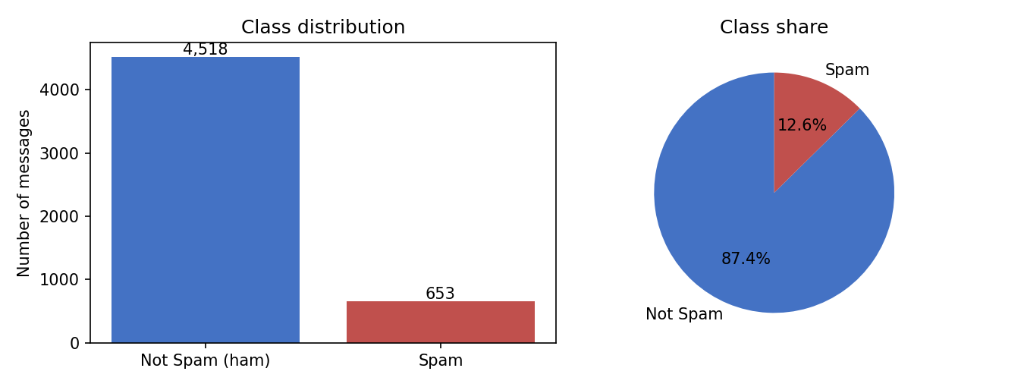
Figure 2: Class distribution of the unique messages (Not Spam vs Spam)

Message length
Spam messages are clearly longer than Not Spam messages. The average Spam message has 137.7 characters and 23.7 words, compared with 70.9 characters and 14.2 words for Not Spam (Table 8). The Not Spam class is spread over a wide range, from a few characters up to 910 characters, whereas Spam messages are concentrated between roughly 100 and 160 characters, close to the length of a single SMS (Figure 3).
Table 8: Message length statistics by class (unique messages)
Measure | Not Spam: characters | Spam: characters | Not Spam: words | Spam: words
Mean | 70.9 | 137.7 | 14.2 | 23.7
Median | 53 | 148 | 11 | 25
Minimum | 2 | 13 | 1 | 2
Maximum | 910 | 223 | 171 | 35
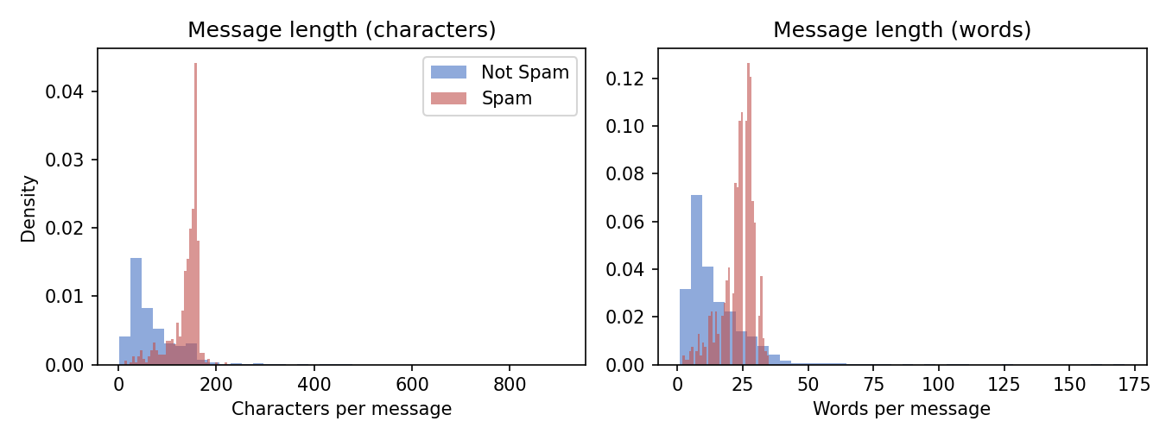
Figure 3: Distribution of message length in characters and words, by class

Surface characteristics of the text
Table 9 compares simple properties of the raw message text. The differences are large: almost every Spam message contains a digit, about a third contain a currency symbol and about one in seven contains a web address, while these are rare in Not Spam messages. Spam messages also contain a higher share of capital letters. These characteristics explain why the cleaning step keeps currency signs and replaces numbers and web addresses by tokens instead of discarding them.
Table 9: Share of messages with selected text characteristics
Characteristic | Not Spam | Spam
Contains at least one digit | 15.8% | 94%
Contains a currency symbol (£ or $) | 0.4% | 33.2%
Contains a web address | 0% | 13.9%
Average share of capital letters in the text | 5.7% | 11%

Most frequent terms
Figure 4 and Table 10 list the ten most frequent terms of each class after cleaning, ignoring common English stop-words. The Spam list is dominated by the token for long numbers and by words of an offer or instruction (free, txt, stop, mobile, claim, reply). The Not Spam list consists of everyday conversational words (just, ok, got, know, like, good). The tokens gt and lt in the Not Spam list come from the characters ">" and "<" written as the HTML entities &gt; and &lt; in the source file, which appear in informal messages.
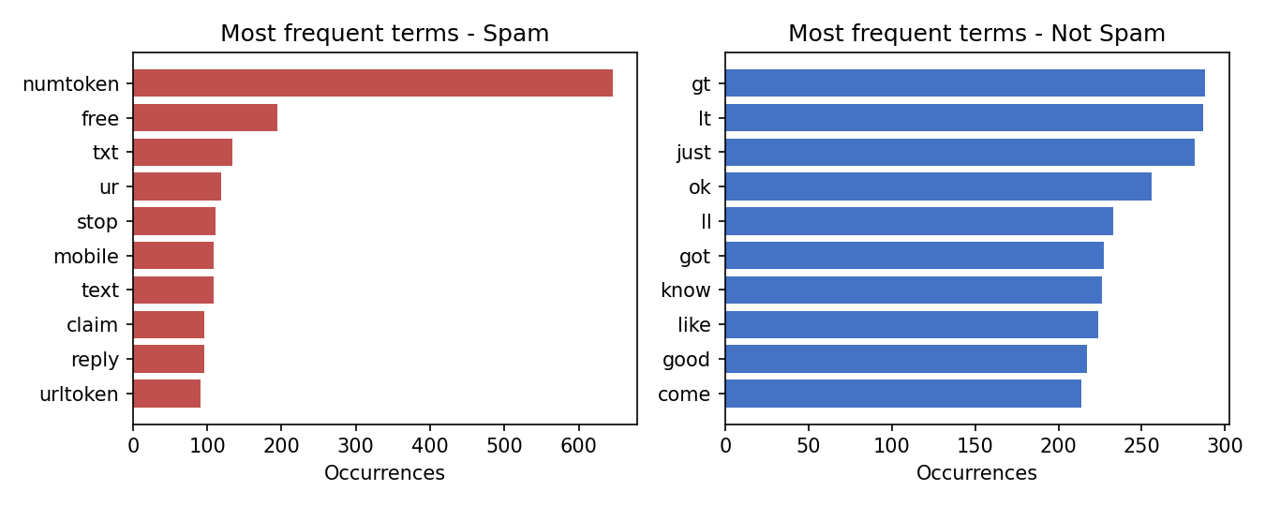
Figure 4: Ten most frequent terms in Spam and Not Spam messages
Table 10: Ten most frequent terms per class (occurrences)
# | Spam term | Count | # | Not Spam term | Count
1 | numtoken | 646 | 1 | gt | 288
2 | free | 195 | 2 | lt | 287
3 | txt | 134 | 3 | just | 282
4 | ur | 119 | 4 | ok | 256
5 | stop | 111 | 5 | ll | 233
6 | mobile | 109 | 6 | got | 227
7 | text | 108 | 7 | know | 226
8 | claim | 96 | 8 | like | 224
9 | reply | 96 | 9 | good | 217
10 | urltoken | 91 | 10 | come | 214

4.5 Summary of EDA Findings
- The SMS Spam Collection has 5,574 labelled messages with no missing labels or texts. 403 exact duplicates were found and removed, leaving 5,171 unique messages.
- The classes are imbalanced: 4,518 Not Spam and 653 Spam messages (12.63% Spam). Accuracy alone is therefore not a sufficient measure.
- Spam messages are longer (mean 137.7 characters) than Not Spam messages (mean 70.9 characters) and are concentrated around the length of one SMS.
- Spam messages are far more likely to contain digits (94% against 15.8%), currency symbols (33.2% against 0.4%) and web addresses (13.9% against 0%).
- The most frequent Spam terms are offer and instruction words (free, txt, stop, mobile, claim, reply), while Not Spam terms are everyday conversational words.
- The data were split 80/20 with the same Spam share in both parts (4,136 training and 1,035 test messages), and vectorization of the training text gives a vocabulary of 7,272 terms.
- The dataset consists of SMS messages only; EDA of email text was not carried out.

5. Algorithm Selection and Implementation
This section describes the two text representations and the two classifiers, how they were implemented, and the results obtained. The project is a supervised binary classification task, so the classifiers are evaluated on messages that were not used for training.

Algorithm followed
- Load the labelled messages and remove duplicates.
- Clean the text of every message.
- Split the data into a stratified training set (80%) and test set (20%).
- Convert the training text into numerical features with Bag-of-Words and with TF-IDF, and transform the test text with the fitted vocabulary.
- Train Multinomial Naive Bayes and SVM on each representation.
- Predict the class of every test message and compute accuracy, precision, recall, F1-score and the confusion matrix.
- Repeat the comparison with five-fold stratified cross-validation as a check of stability.
- Inspect the terms with the largest influence on the decisions and the messages that were misclassified.

Implementation environment
Table 11: Software and libraries used
Item | Details
Programming language | Python 3
Environment | Jupyter-style notebook / script run in a Python environment
Libraries | pandas, NumPy, Matplotlib, scikit-learn [4] (CountVectorizer, TfidfVectorizer, MultinomialNB, LinearSVC, train_test_split, metrics, cross-validation), re
Dataset | SMS Spam Collection, 5,574 messages, 5,171 unique after de-duplication
Random seed | 42 for the split, the cross-validation folds and the SVM

5.1 Bag-of-Words and TF-IDF Representations
Bag-of-Words converts a collection of documents into numerical features based on the occurrence of words. Each distinct term of the training vocabulary becomes one feature, and the value of the feature for a message is the number of times the term occurs in it. The order of the words is ignored, which is why the representation is called a "bag". The vocabulary learned from the 4,136 training messages contains 7,272 terms, so every message becomes a sparse vector with 7,272 components of which only a few are non-zero.
TF-IDF (Term Frequency-Inverse Document Frequency) keeps the same vocabulary but replaces the raw count by a weight that combines how often a term occurs in the message (term frequency) with how rare the term is across the collection (inverse document frequency) [4]. In its usual form the weight of a term t in a message m is tf(t, m) × idf(t), with idf(t) = ln((1 + N) / (1 + df(t))) + 1 in scikit-learn, where N is the number of messages and df(t) the number of messages containing t. Terms that occur in almost every message receive a low weight, and rare, more informative terms receive a higher weight. The resulting vectors are normalised to unit length.
bow = CountVectorizer()
Xtr_b = bow.fit_transform(X_train) # shape (4136, 7272); vocabulary learned on training text only
Xte_b = bow.transform(X_test) # shape (1035, 7272)

tfidf = TfidfVectorizer()
Xtr_t = tfidf.fit_transform(X_train)
Xte_t = tfidf.transform(X_test)

The vectorizers are fitted on the training messages only and then applied to the test messages. This prevents information from the test set from leaking into the vocabulary or the IDF weights. Terms that occur only in the test set are ignored.

5.2 Why Multinomial Naive Bayes?
Multinomial Naive Bayes is a probabilistic classification method commonly used for text classification [2]. For a message with term counts, it computes for each class the prior probability of the class multiplied by the probability of each observed term given that class, assuming that the terms are independent of each other, and it predicts the class with the larger posterior probability. The term probabilities are estimated from the training data with Laplace smoothing (alpha = 1) so that a term never seen in one class does not make the probability zero.
It is selected for this project because it is simple and very fast to train, works naturally with word counts, handles the high-dimensional vocabulary without difficulty and has been applied to junk-mail filtering since the 1990s [5]. Its independence assumption is not true for real language, but in practice the classifier often works well on text.
nb = MultinomialNB() # default smoothing alpha = 1.0
nb.fit(Xtr_b, y_train)
pred_nb = nb.predict(Xte_b)

5.3 Why Support Vector Machine?
A Support Vector Machine is a supervised classification algorithm that identifies a decision boundary between classes. A linear SVM finds the hyperplane that separates Spam from Not Spam with the largest possible margin, so that the messages closest to the boundary (the support vectors) determine its position. Text vectors have a very large number of features and are sparse, a situation in which linear SVMs are known to work well [3], and the learned coefficient of each term shows how strongly the term pushes a message towards Spam or Not Spam.
In this project the linear SVM implementation LinearSVC of scikit-learn is used with default settings, as a second classification approach so that its performance can be compared with Multinomial Naive Bayes on the same two representations.
svm = LinearSVC(random_state=42)
svm.fit(Xtr_t, y_train)
pred_svm = svm.predict(Xte_t)

print(accuracy_score(y_test, pred_svm), precision_score(y_test, pred_svm),
recall_score(y_test, pred_svm), f1_score(y_test, pred_svm))
print(confusion_matrix(y_test, pred_svm))

Table 12: Explanation of the main code elements
Code | Explanation
CountVectorizer().fit_transform | Learns the vocabulary of the training text and returns the matrix of term counts (Bag-of-Words).
TfidfVectorizer().fit_transform | Learns the vocabulary and IDF weights and returns the length-normalised TF-IDF matrix.
MultinomialNB().fit(X, y) | Estimates the class priors and the smoothed term probabilities of each class from the training vectors.
LinearSVC(random_state=42) | Creates a linear SVM; the seed makes the result reproducible.
model.predict(X_test) | Returns 0 (Not Spam) or 1 (Spam) for every test message.
precision_score, recall_score, f1_score | Measure the quality of the Spam predictions (positive class = Spam).
confusion_matrix(y_test, pred) | Counts true and false predictions of both classes.

5.4 Evaluation Results
Because Spam is the minority class and the cost of errors differs, the following measures are computed with Spam as the positive class. TP is the number of Spam messages correctly marked as Spam, FP the number of Not Spam messages wrongly marked as Spam, FN the number of Spam messages that were missed and TN the number of Not Spam messages correctly accepted.
Accuracy = (TP + TN) / (TP + TN + FP + FN); Precision = TP / (TP + FP), the share of Spam predictions that are really Spam; Recall = TP / (TP + FN), the share of real Spam that is found; F1-score = 2 × Precision × Recall / (Precision + Recall).
Table 13 gives the results for the four combinations on the 1,035 test messages (131 Spam and 904 Not Spam), and Figure 5 shows the corresponding confusion matrices.
Table 13: Test-set results of the four combinations (Spam = positive class)
Representation | Classifier | Accuracy | Precision | Recall | F1-score
Bag-of-Words | Multinomial Naive Bayes | 98.55% | 95.31% | 93.13% | 94.21%
Bag-of-Words | SVM (LinearSVC) | 98.65% | 99.16% | 90.08% | 94.40%
TF-IDF | Multinomial Naive Bayes | 96.52% | 100.00% | 72.52% | 84.07%
TF-IDF | SVM (LinearSVC) | 98.55% | 99.15% | 89.31% | 93.98%
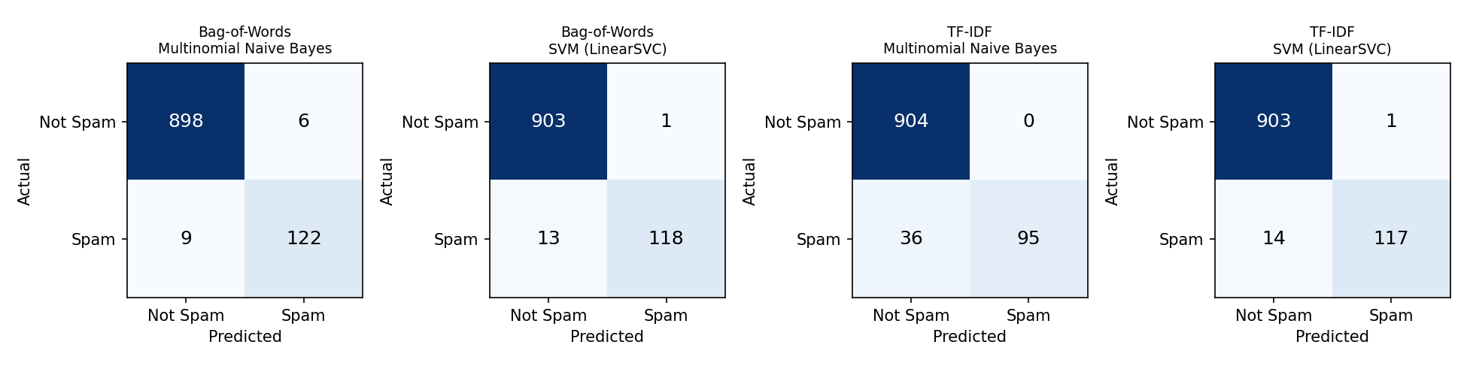
Figure 5: Confusion matrices of the four combinations on the test set
Table 14: Confusion-matrix counts on the test set
Representation | Classifier | TN | FP | FN | TP
Bag-of-Words | Multinomial Naive Bayes | 898 | 6 | 9 | 122
Bag-of-Words | SVM (LinearSVC) | 903 | 1 | 13 | 118
TF-IDF | Multinomial Naive Bayes | 904 | 0 | 36 | 95
TF-IDF | SVM (LinearSVC) | 903 | 1 | 14 | 117
All four combinations classify the large majority of messages correctly. Both SVM configurations and Bag-of-Words with Naive Bayes reach an accuracy of about 98.6% to 98.6%. The two SVM models are very conservative: they wrongly mark only 1 Not Spam message as Spam (precision about 99.2%) but miss 13 and 14 Spam messages respectively. Bag-of-Words with Naive Bayes finds more of the Spam (recall 93.1%) at the price of 6 false alarms. TF-IDF with Naive Bayes never raises a false alarm (precision 100%) but misses 36 of the 131 Spam messages, which lowers its recall to 72.5% and its F1-score to 84.1%.
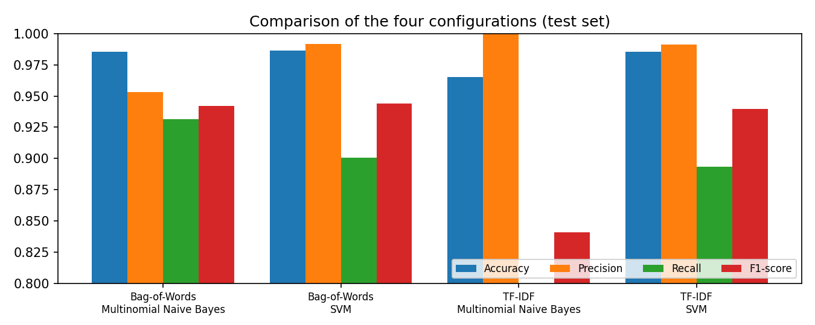
Figure 6: Accuracy, precision, recall and F1-score of the four combinations (test set)
A likely reason for the weaker TF-IDF result with Naive Bayes is that TF-IDF vectors are length-normalised and contain small fractional values instead of counts, so the smoothing term has a relatively large effect and the model leans towards the majority class. This explanation was not tested separately in the project and is given only as a plausible interpretation.

Cross-validation check
A single split with only 131 Spam test messages gives a noisy estimate. As a check, a five-fold stratified cross-validation was run on all 5,171 unique messages, with the vectorizer fitted inside each fold. Table 15 gives the mean and standard deviation of the Spam F1-score over the five folds.
Table 15: Five-fold cross-validation, F1-score of the Spam class
Representation | Classifier | Mean F1 | Std. deviation
Bag-of-Words | Multinomial Naive Bayes | 95.14% | 1.05%
Bag-of-Words | SVM (LinearSVC) | 94.62% | 1.32%
TF-IDF | Multinomial Naive Bayes | 82.55% | 0.38%
TF-IDF | SVM (LinearSVC) | 95.78% | 1.11%
The cross-validated scores agree with the test-set picture: SVM is strong with both representations (F1 about 94.6% to 95.8%), Naive Bayes is strong with Bag-of-Words (95.1%) and clearly weaker with TF-IDF (82.5%). The ordering of the three best combinations differs between the single split and the cross-validation, and the differences between them are about one standard deviation, so the report does not declare one of them the winner.

5.5 Influential Words and Error Analysis
The last objective of the study is to find the terms that contribute most to the decisions. For the linear SVM trained on TF-IDF features, the coefficient of a term is positive if it pushes a message towards Spam and negative if it pushes towards Not Spam (Figure 7). The strongest Spam indicators are the token for long numbers (numtoken, coefficient 5.394), the token for web addresses (urltoken), and the words txt, reply, mobile, text and tones, together with price-like fragments such as 150p. The strongest Not Spam indicators are ordinary personal words such as my, me, liked, yup and place, plus the entity fragments gt and lt.
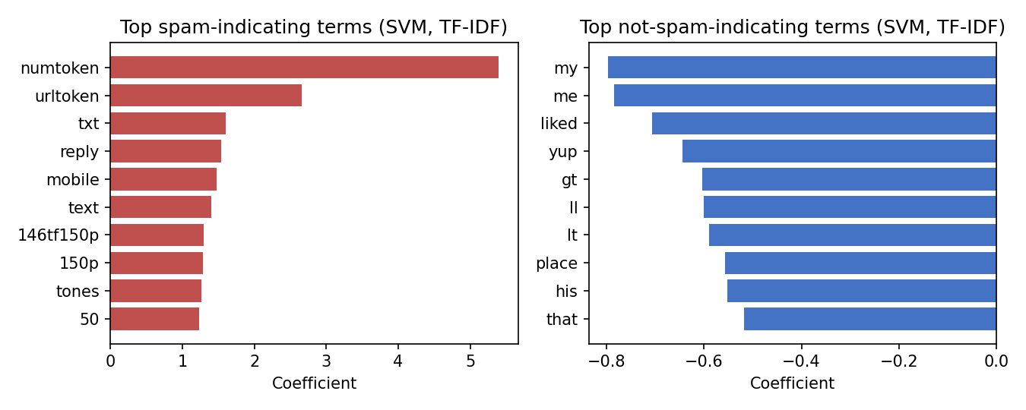
Figure 7: Terms with the largest SVM coefficients (TF-IDF features)
For Multinomial Naive Bayes the corresponding measure is the difference between the log-probability of a term in the Spam class and in the Not Spam class. Among terms that occur at least five times in the training text, the highest values belong to numtoken, claim, prize, 150p, nokia, urltoken, tone, 18, and the lowest to gt, lt, he, lor, da, she. The two classifiers therefore agree on the main signals, and the learned terms match the patterns seen in the EDA: numbers, web addresses, offers and prize language for Spam; informal personal language for Not Spam.

Misclassified messages
The best test-set configuration (Bag-of-Words with SVM) made 14 errors on 1,035 messages. The single false positive is a genuine bank notice that warns customers about e-threats and uses the vocabulary of an alert: "Please protect yourself from e-threats. SIB never asks for sensitive information like Passwords,ATM/SMS PIN th…". Some of the missed Spam messages are short or phrased like a personal message, for example "FreeMsg Hey U, i just got 1 of these video/pic fones, reply WILD to this txt & ill send U my pics, hurry up Im…" and "You will recieve your tone within the next 24hrs. For Terms and conditions please see Channel U Teletext Pg 75…", so they contain few of the typical Spam terms. Such cases show why a prediction should be treated as an aid and not as a final judgement.

5.6 Comparison of the Approaches
Table 16: Comparison of the text representations and classifiers in this project
Aspect | Multinomial Naive Bayes | Support Vector Machine (linear)
Type | Probabilistic classifier based on Bayes' theorem | Margin-based linear classifier
Main idea | Multiplies class prior and per-term probabilities, assuming independent terms | Finds the separating hyperplane with the largest margin
Training | Very fast; counts terms per class | Fast on sparse text; solves an optimisation problem
With Bag-of-Words | F1 94.2% (CV 95.1%); recall 93.1% | F1 94.4% (CV 94.6%); precision 99.2%
With TF-IDF | F1 84.1% (CV 82.5%); recall drops to 72.5% | F1 94.0% (CV 95.8%); stable
Interpretability | Per-term log-probabilities show which words favour Spam | Per-term coefficients show which words favour Spam
Strength in this project | Good recall with Bag-of-Words; simplest model | Very few false alarms; consistent with both representations
The four combinations answer the central question in a nuanced way. Spam can be detected with high accuracy from message text alone, and the linear SVM is the more dependable choice because its quality hardly changes between Bag-of-Words and TF-IDF and it raises very few false alarms. Multinomial Naive Bayes is equally good with Bag-of-Words but sensitive to the representation. Since the differences among the three best combinations are small compared with the variation between folds, they should be regarded as comparable rather than ranked strictly.

6. Conclusion
This case study applied supervised machine learning and NLP to the classification of short messages as Spam or Not Spam. The SMS Spam Collection of 5,574 labelled messages was checked for missing values, 403 duplicates were removed, and the 5,171 unique messages were cleaned and split into 4,136 training and 1,035 test messages. Text was converted into numerical features by Bag-of-Words and TF-IDF, and Multinomial Naive Bayes and a linear SVM were trained on each representation.
On the test set the accuracy of the four combinations lies between 96.5% and 98.6%. The best F1-score for the Spam class was obtained by Bag-of-Words with SVM (94.4%), with Bag-of-Words with Naive Bayes (94.2%) and TF-IDF with SVM (94.0%) very close to it, while TF-IDF with Naive Bayes was weaker (84.1%) because it missed many Spam messages. Cross-validation supports the conclusion that the SVM is the most stable choice and that Naive Bayes depends on the representation. The influential terms (long numbers, web addresses and words such as claim, prize, free, txt and reply for Spam, and everyday personal words for Not Spam) agree with what the EDA showed.
The project is a classification aid and not a guaranteed security system. A prediction can be wrong, as the error analysis shows, and a Spam prediction does not establish that a sender is malicious. The measured results come from one SMS corpus; they do not prove the same performance on email or on newer spam.
Possible future extensions, which were not carried out in this work, include evaluating the pipeline on an email corpus, tuning the hyperparameters of the classifiers, adding character-level or n-gram features, handling the class imbalance explicitly, and building a small interface in which a user can paste a message and see the predicted class.

References
[1] Almeida, T.A.; Gómez Hidalgo, J.M.; Yamakami, A. Contributions to the study of SMS spam filtering: new collection and results. In Proceedings of the 11th ACM Symposium on Document Engineering (DocEng '11), 2011, pp. 259–262.
[2] McCallum, A.; Nigam, K. A comparison of event models for Naive Bayes text classification. In AAAI-98 Workshop on Learning for Text Categorization, 1998.
[3] Joachims, T. Text categorization with support vector machines: learning with many relevant features. In Machine Learning: ECML-98, Lecture Notes in Computer Science 1398, Springer, 1998, pp. 137–142.
[4] Pedregosa, F.; et al. Scikit-learn: Machine Learning in Python. J. Mach. Learn. Res. 2011, 12, 2825–2830.
[5] Sahami, M.; Dumais, S.; Heckerman, D.; Horvitz, E. A Bayesian approach to filtering junk e-mail. In AAAI-98 Workshop on Learning for Text Categorization, 1998.
[6] SMS Spam Collection (tab-separated file of 5,574 labelled SMS messages: 4,827 ham and 747 spam), as used in the project.

