1. Use Case Diagram
The Java system includes patient, doctor, and appointment management, searching, record persistence, and console notification demonstrations. The separate n8n workflow includes file upload, text extraction, Gemini parsing, appointment processing, Google Calendar event creation or replacement, and email delivery through Gmail.
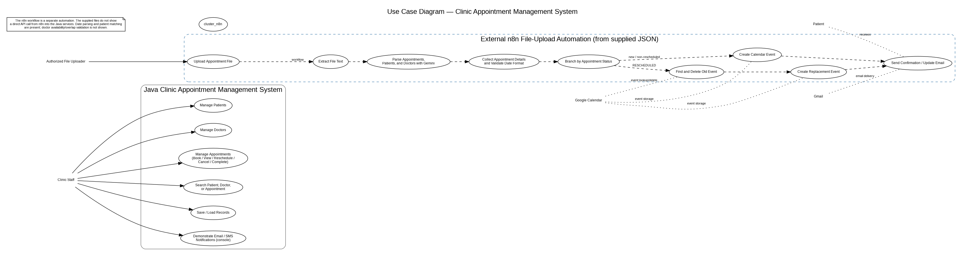

2. Class Diagram
The class diagram represents the supplied Java classes and their principal relationships. Patient and Doctor inherit from Person. EmailNotification and SMSNotification implement Notification. Appointment refers to one Patient and one Doctor, and Doctor maintains a collection of Schedule objects. Service classes manage their domain objects.

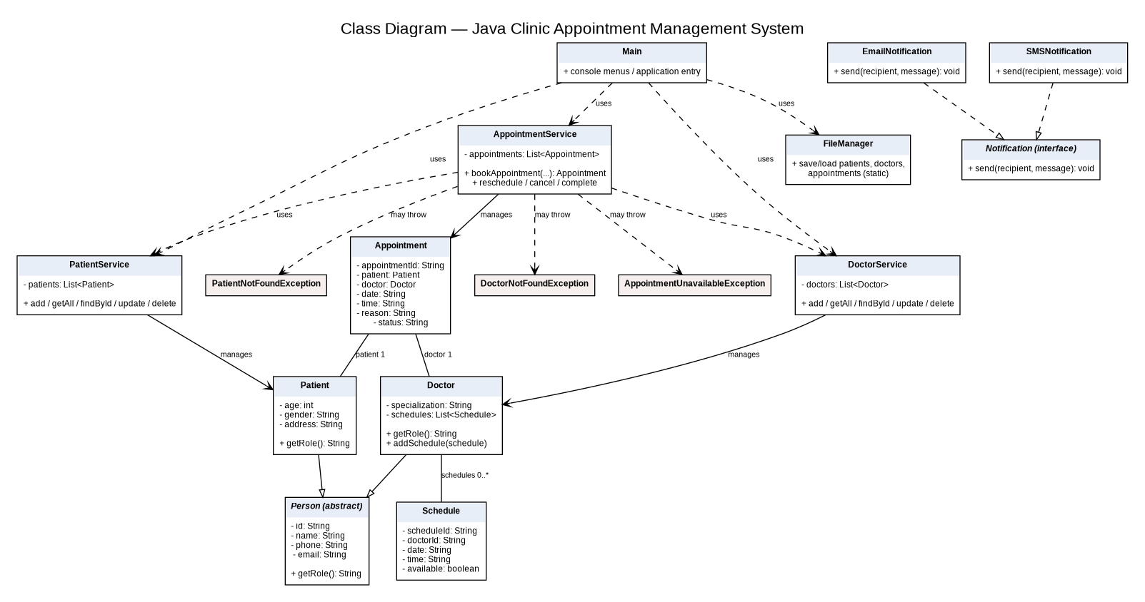

3. Activity Diagram — Appointment File Upload Automation
The workflow follows the revised n8n workflow: form submission, file splitting, text extraction, Gemini parsing, appointment collection, patient lookup, date/time validation, and status branching. The workflow includes normal booking with an email availability check, rescheduling through matching and replacing an existing calendar event, and cancellation through matching an event before conditional deletion and checking email availability before sending a cancellation email.

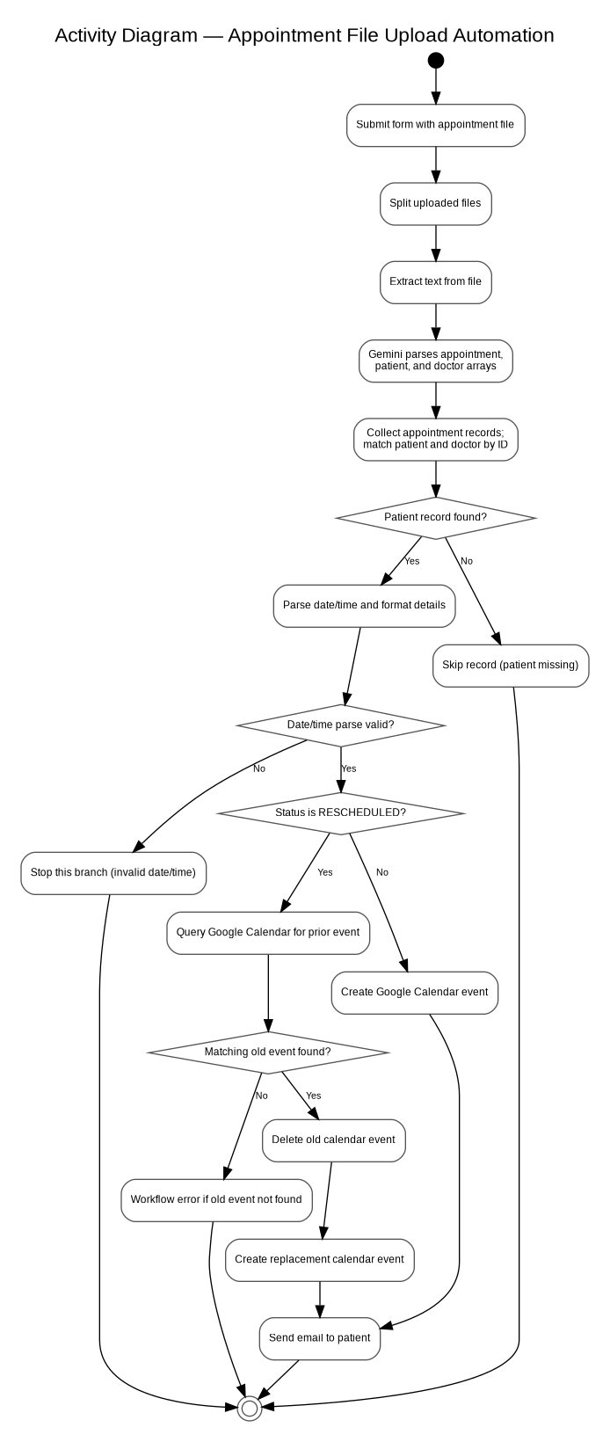

4. Sequence Diagram — File Upload to Calendar Booking
The sequence diagram shows the authorized user submitting a file, n8n extracting its text, Gemini returning structured data, appointment-processing code preparing records, and Google Calendar/Gmail handling event and email operations. The revised workflow includes normal booking, rescheduling, and cancellation branches; event matching and successful execution must be verified in the deployed n8n instance.

CO3 Rubric Alignment and Source-Based Notes

Accuracy and consistency
The activity and sequence diagrams model the supplied n8n workflow. The class diagram models the Java classes in the provided source files. The use case diagram separates the Java application from the external n8n workflow.

Implementation limits shown by the sources
- The n8n workflow accepts an uploaded file, splits uploaded binaries, extracts text, and uses Gemini with a structured output parser to produce appointment, patient, and doctor arrays.
- The appointment-processing code matches appointments to patient records by patient_id and looks up doctor details by doctor_id. It skips an appointment when the patient record is missing, but the supplied code does not skip it when the doctor record is missing.
- The revised workflow parses date/time values and includes separate paths for normal booking, RESCHEDULED appointments, and CANCELLED appointments. Calendar deletion is intended to occur only after a matching event is found.
- The rescheduling path searches Google Calendar for the previous event, deletes the matching event, creates a replacement, and sends an update email.
- The supplied workflow does not visibly check doctor availability or prevent overlapping calendar bookings. Cancellation matching and deletion depend on the returned calendar events and should be tested with a test calendar.
- The Java FileManager saves Java records to text files. The n8n JSON does not show the workflow writing those records into the Java application or calling its services.
- The Java EmailNotification and SMSNotification implementations are console demonstrations. The n8n workflow separately uses Gmail and Google Calendar nodes.

Class relationship summary
- Inheritance: Patient and Doctor extend the abstract Person class.
- Interface realization: EmailNotification and SMSNotification implement Notification.
- Associations: Appointment refers to a Patient and a Doctor; Doctor maintains zero or more Schedule objects.
- Service dependencies: Main uses PatientService, DoctorService, AppointmentService, and FileManager. Services manage collections of their corresponding domain objects.
- The Java appointment conflict check compares an exact doctor/date/time match; it does not check overlapping appointment durations.

