CLINIC APPOINTMENT SYSTEM
PHASE 3 — SYSTEM ANALYSIS AND UML DESIGN
CSC 104 — Object-Oriented Programming
CO3: System Analysis and UML Design

Purpose and System Boundary
This document presents the four UML deliverables required for Phase 3: Use Case, Class, Activity, and Sequence diagrams. It models the complete Clinic Appointment System by showing the Java console-based OOP application and the separate n8n appointment automation. The supplied source materials do not demonstrate a direct Java-to-n8n API integration, so the diagrams do not claim that the two components currently share live data or invoke each other.
The Java application covers patient, doctor, and appointment records, search, conflict checking, text-file persistence, and console-based notification demonstrations. The n8n workflow processes uploaded appointment files, uses Gemini to extract structured data, and interacts with Google Calendar and Gmail for appointment events and email notifications.

1. Use Case Diagram
The use case diagram covers both system components. The Java application supports record management, appointment CRUD/search, exact date-time conflict checking, local persistence, and simulated notifications. The separate automation supports file submission and parsing, calendar event creation/rescheduling/cancellation, and email notification.
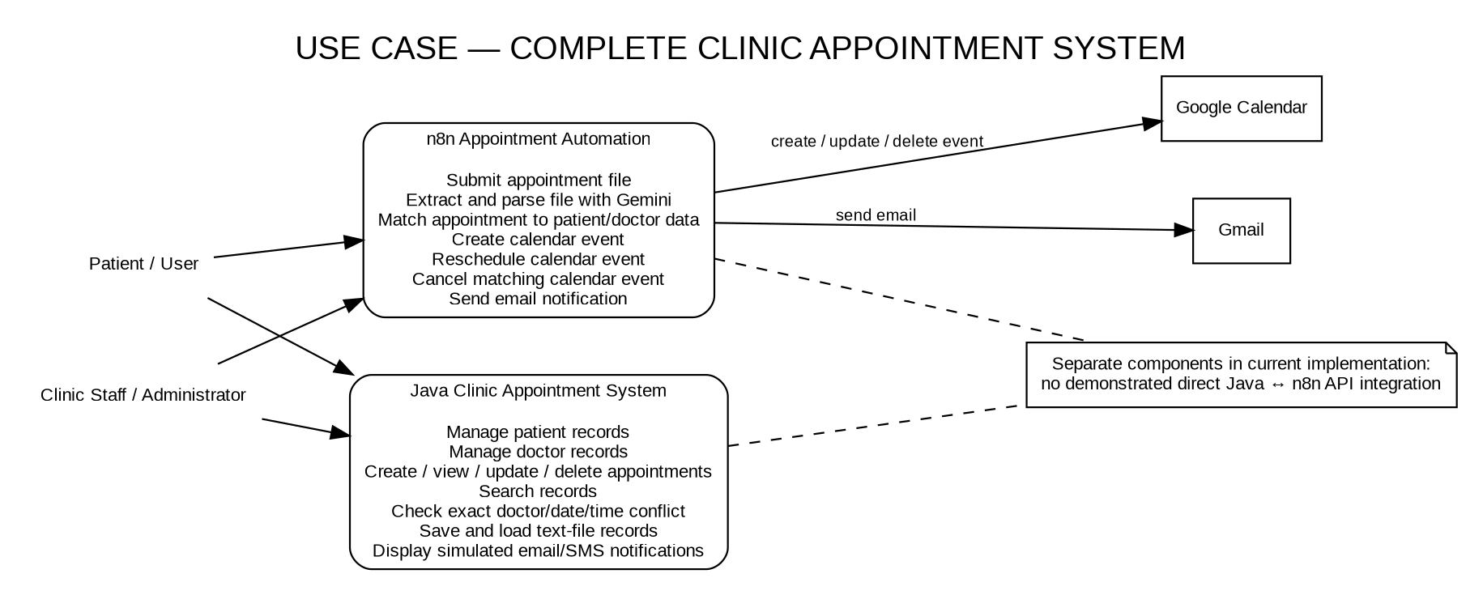

2. Class Diagram
This class diagram models the supplied Java application. Patient and Doctor inherit from the abstract Person class. EmailNotification and SMSNotification implement Notification. Appointment is associated with a Patient and a Doctor, while Doctor maintains Schedule objects. Services manage collections and FileManager provides local text-file persistence. Method labels are summarized to keep the diagram readable; use the actual source code for exact signatures.
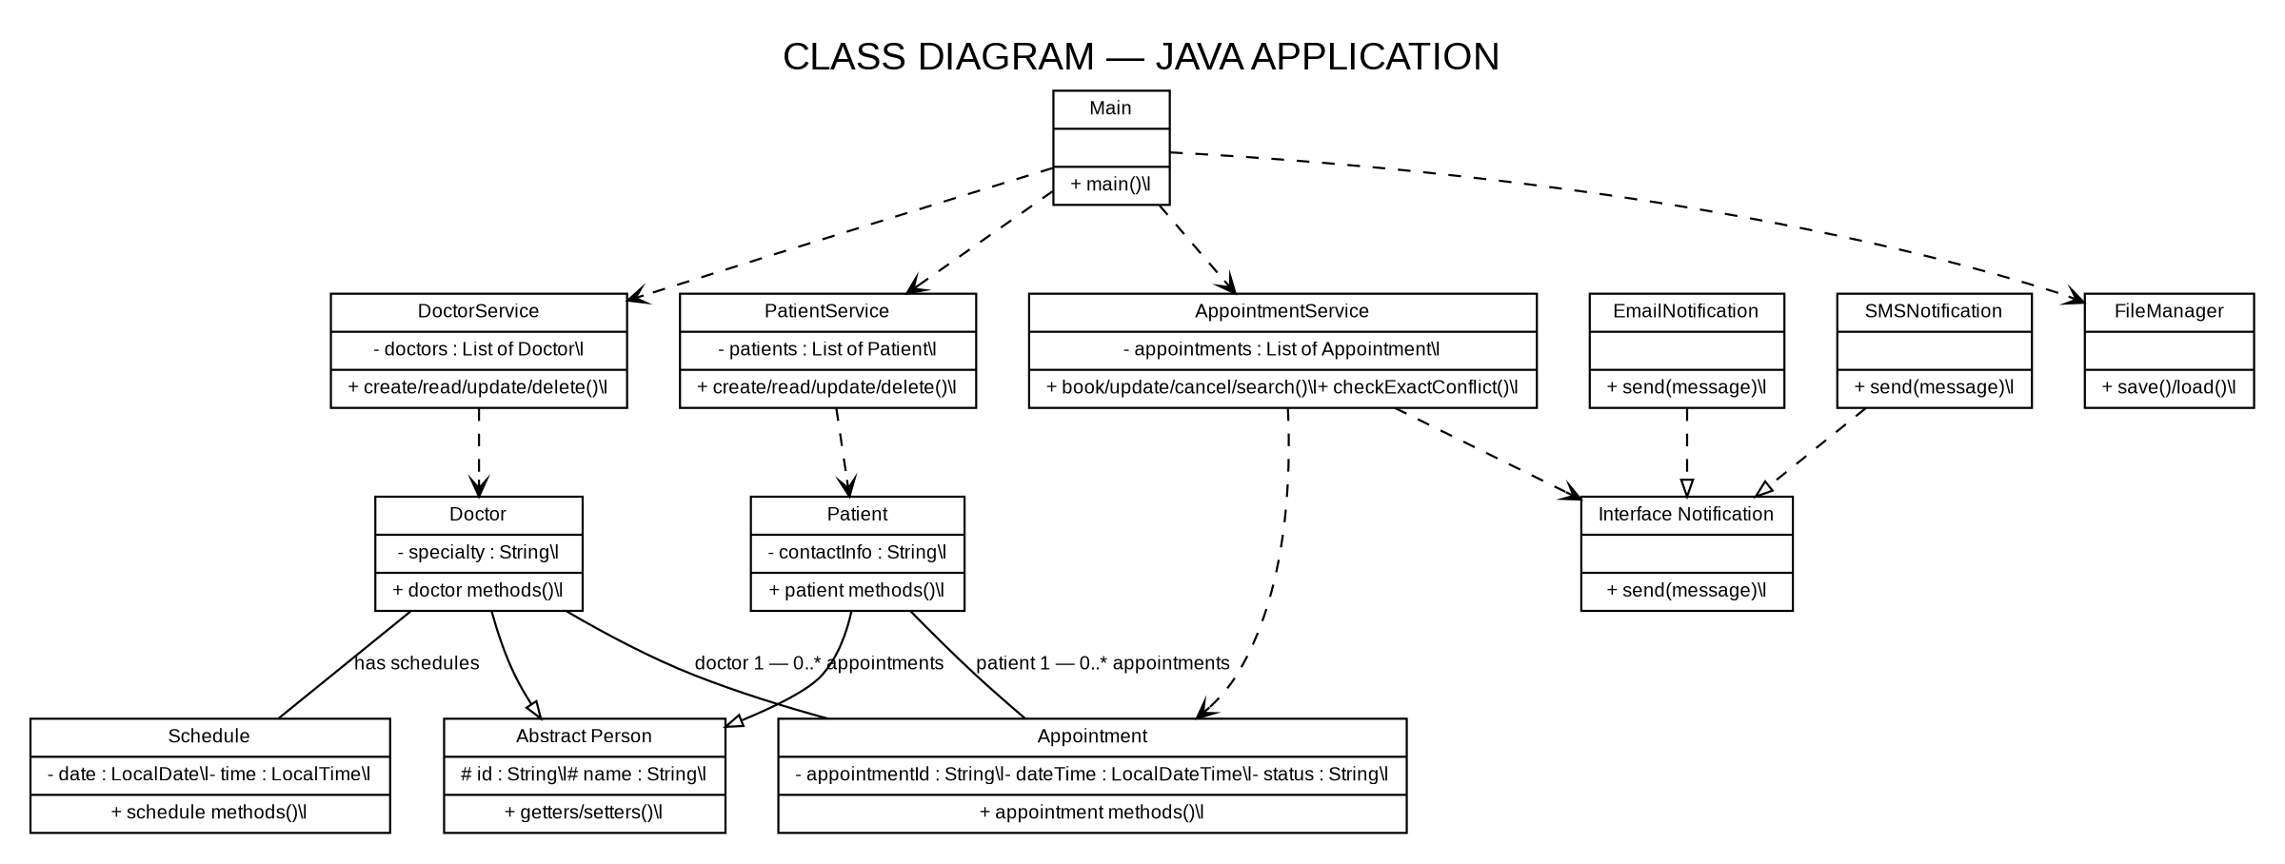

3. Activity Diagram — Appointment Automation
The activity diagram models the n8n workflow from form submission through file extraction, structured parsing, record matching, and status-based calendar actions. Rescheduling searches for a previous event and creates a replacement after a match; cancellation attempts to remove the matching event. Email sending depends on available recipient information. The workflow should be tested with a test calendar before relying on it.
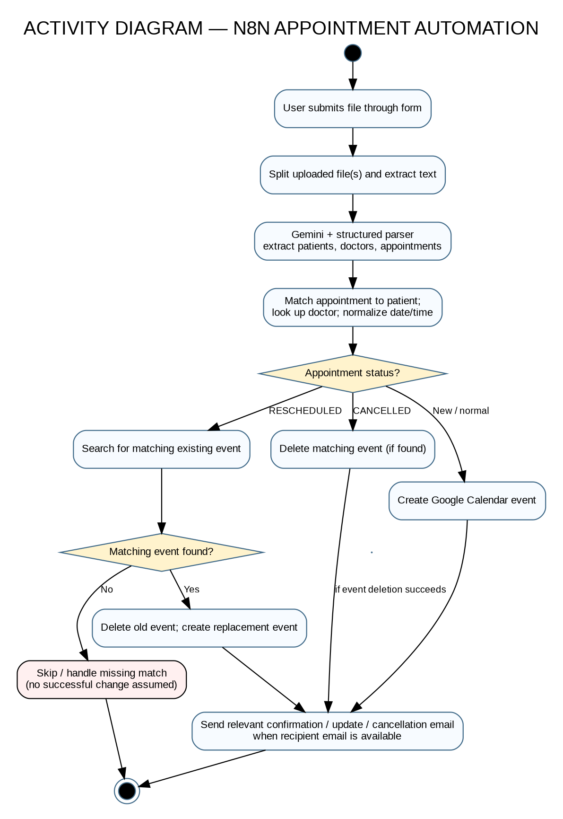

4. Sequence Diagram — File Upload to Calendar Booking
The sequence diagram shows the chronological messages among the user, n8n form trigger, extraction/parser, appointment-processing code, Google Calendar, and Gmail. It intentionally excludes the Java AppointmentService because the supplied n8n workflow does not show a call to the Java application.
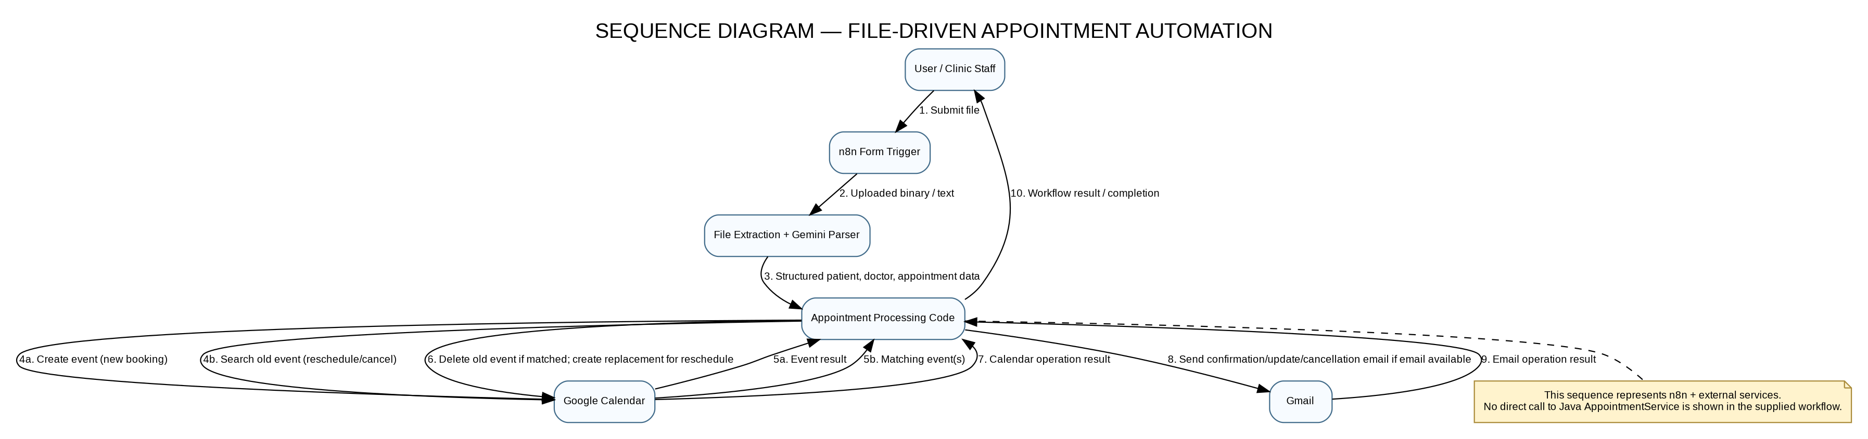

CO3 Rubric Alignment and Implementation Notes
Completeness: All four diagrams required by Phase 3 are included: Use Case, Class, Activity, and Sequence.
Consistency: The class diagram models Java classes; activity and sequence diagrams model n8n automation. The use case diagram shows both as parts of the overall project while distinguishing their current boundary.
Object-oriented design: The class diagram shows inheritance, interface realization, associations, service dependencies, collections, and persistence responsibilities.
Known limitations: The Java conflict check compares an exact doctor/date/time match and does not detect overlapping appointment durations. The Java Schedule availability is not used as booking validation. The n8n workflow does not visibly check doctor availability or prevent overlapping bookings.
Persistence and notifications: Java FileManager persists Java records in text files. Java EmailNotification and SMSNotification are console demonstrations. The n8n workflow separately uses Gmail and Google Calendar.
Automation limitations: Calendar matching/deletion and cancellation behavior should be verified in a test calendar. The workflow does not establish a direct data connection to the Java application.

Phase 3 Submission Checklist
- Use Case Diagram — complete system boundary
- Class Diagram — Java classes and relationships
- Activity Diagram — n8n appointment automation
- Sequence Diagram — interactions with calendar and email services
- Diagram descriptions and source-based implementation notes

