**Project 2 Hadoop PageRank**

**(Due 11:59 pm, February 14th, 2016)**

**Goal**

This assignment provides an illustration of PageRank algorithms and Hadoop. You will then blend these applications by implementing a parallel version of PageRank using the programming interfaces of the Hadoop MapReduce framework.

**Deliverables**

You are required to turn in the following items in a zip file (**username_HadoopPageRank.zip**) in this assignment:

1. The source code of Hadoop PageRank you implemented.
2. Technical report (**username_HadoopPageRank_report.docx**) that contains:
   1. The description of the main steps and data flow in your program.
   2. The output file (**username_HadoopPageRank_output.txt**) which contains the first 10 urls along with their ranks.

**Evaluation**

The point total for this project is 10, where the distribution is as follows:

1. Completeness of your code and output (7 points)
2. Correctness of written report (3 points)

**What is PageRank?**

The web search engine is a typical distributed system on the Internet. It is designed to search for information on the World Wide Web. The search results are generally presented in a list of results and are often called hits. PageRank is a well-known web graph ranking algorithm that helps Internet users sort hits by their importance.   
PageRank calculates a numerical value for each element of a hyperlinked set of webpages, which reflects the probability that a random surfer will access that page. The process of PageRank can be understood as a Markov Chain which requires iterative calculations to converge. An iteration of PageRank calculates the new access probability for each webpage based on values calculated in the previous iteration. The process will repeat until the number of current iterations is bigger than predefined maximum iterations, or the Euclidian distance between rank values in two subsequent iterations is less than a predefined threshold that controls the accuracy of the output results.

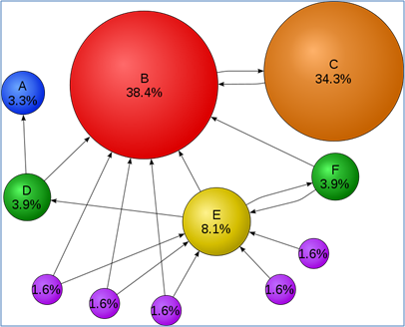  
*Figure 1.* Mathematical PageRank for a simple network in Wikipedia

Figure 1 shows a web graph consisting of 11 vertices {A, B, C, D, E, F, G1, G2, G3, G4, G5}. Each vertex refers to a unique webpage, and the directed edge means there is one link from the source webpage to the target webpage. The percentage on each vertex represents the rank value of each webpage.

**Notes**

You can implement a sequential PageRank that can run on desktops or laptops. But when processing larger input data, like web graphs containing more than a million webpages, you need to run the PageRank application in parallel so that it can aggregate the computing power of multiple compute nodes. Currently, in both industry and academia, the study of large-scale web or social graphs has become increasingly popular. In one published paper, the job execution engines that claim to support large-scale PageRank include: MPI, Hadoop, Dryad, Twister, Pregel.

**Formula**

Eqn.1 is the formula to calculate the rank value for each webpage. We will learn this formula by applying it to the case in Fig.1. There are 11 webpages in Fig.1, which include: {A, B, C, D, E, F, G1, G2, G3, G4, G5}. Assuming the probability distribution for a web surfer accessing all these 11 pages in current iteration is {PR(A), PR(B), PR(C), … PR(G5)}, then the probability for the surfer to access Page B in the next iteration is:   
PR(B) = PR(D)/2 + PR(E)/3 + PR(F)/2 + PR(C) + PR(G1)/2 + PR(G2)/2 + PR(G3)/2   
In a general case, the PageRank value for any page *u* can be expressed as:  
  
Eqn.1: $PR\left(u\right)= \sum_{v∈Set}{\frac{PR\left(v\right)}{L(v)}}$  
  
The vertices seen in the right of the formula contain all the webpages that point to target webpage ‘u’. The L(v) refers to the out degree of each webpage in the vertices set. The initial rank values of each webpage, like PR’(u), can be any double value. After several iteration calculations, the rank values converge to the stationary distribution regardless of what their initial values are.

**Damping factor**

The PageRank theory holds that even an imaginary surfer who is randomly clicking on links will eventually stop clicking. The probability, at any step, that the person will continue is a damping factor **d**. Various studies have tested different damping factors, but it is generally assumed that the damping factor will be around 0.85. The formula considering damping factor is shown in Eqn.2. N refers to the total number of unique urls.

Eqn.2: $PR\left(u\right)=\frac{1-d}{N}+d*\sum_{v∈Set}{\frac{PR\left(v\right)}{L(v)}}$

**Hadoop PageRank DataFlow**

In this project, we have provided a sketch code which contains three MapReduce jobs for you to implement:

1. CreateGraph (done): add one column, 'initial pagerank value', to the input pagerank adjacency matrix (AM). Then pass it to the PageRank program to calculate the pagerank values.
2. **PageRank** (your implementation): take the transformed AM matrix and calculate pagerank values for all pages.
3. Cleanup Results: remove the targetUrls column and output <sourceUrl, pagerank value> as the final result.

The detail dataflow can be seen in Figure 2. Part 1 and Part 3 are given as full solutions in this pipeline; you will implement the 2nd part of the **PageRank** program.

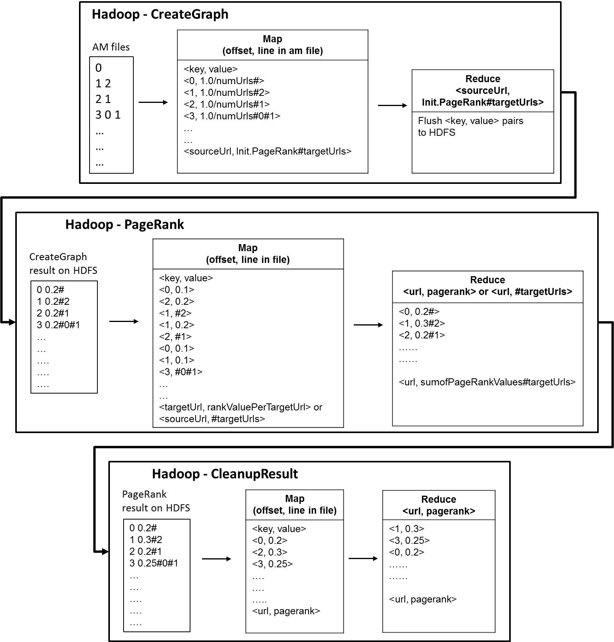

Figure 2. Hadoop PageRank dataflow

Normally for any Hadoop MapReduce program, input data is uploaded and stored in the Hadoop Distributed File System (HDFS) before computation in order to generate <key, value> pairs to the mapper. Initially, the PageRank input data is stored in the format of adjacency matrix as a file(s) in the local file system. Then it will be uploaded to the HDFS and distributed across the compute nodes. Hadoop framework reads the application records from HDFS with the InputFormat interface and generates <key, value> pair input streams. Each Map function produces zero or more intermediate (key, value) pairs by consuming one input (key, value) pair. For this PageRank program, the map function applies the calculation PR(v) / L(V) to each <key, value> pair, where the key is the unique id or name of the webpage and the value contains the current rank value of the webpage and its out link information. Map tasks then generate intermediate (key, value) pairs, whose value is the partial rank value of every webpage. Each reduce task aggregates all the partial values of specific webpages by applying the provided Eqn.2. The aggregated global rank values are written back to HDFS, which in turn is used as input in the next set of iterations, if any. "Hadoop - PageRank" in Figure 2 shows an example for the PageRank data processing.

**Pseudocode for Hadoop PageRank**

You need to complete two files in the provided pacakge inside "indiana/cgl/hadoop/pagerank/": PageRankMap.java and PageRankReduce.java. Code snapshots are shown below.

**PageRankMap.java and PageRankReducer.java**

|  |  |
| --- | --- |
|  | package indiana.cgl.hadoop.pagerank;    import java.io.BufferedWriter;  /* see detail in source code */    public class PageRankMap extends Mapper<LongWritable, Text, LongWritable, Text> {    //each map task handles one line within an adjacency matrix file  // key: file offset  // value: <sourceUrl PageRank#targetUrls>  public void map(LongWritable key, Text value, Context context)  throws IOException, InterruptedException {    int numUrls = context.getConfiguration().getInt("numUrls",1);  String line = value.toString();  //instance an object that records the information for one webpage  RankRecord rrd = new RankRecord(line);  int sourceUrl, targetUrl;  //double rankValueOfSrcUrl;    if (rrd.targetUrlsList.size()<=0){//there is no out degree for this webpage; scatter its rank value to all other urls  double rankValuePerUrl = rrd.rankValue/(double)numUrls;  for (int i=0;i<numUrls;i++){  context.write(new LongWritable(i), new Text(String.valueOf(rankValuePerUrl)));  }  } else {  /*Write your code here*/  } //for  context.write(new LongWritable(rrd.sourceUrl), new Text(sb.toString()));  }  }//map  } |

|  |  |
| --- | --- |
|  | package indiana.cgl.hadoop.pagerank;    import java.io.BufferedWriter;  /* see detail in source code */    public class PageRankReduce extends Reducer<LongWritable, Text, LongWritable, Text>{  public void reduce(LongWritable key, Iterable<Text> values,  Context context) throws IOException, InterruptedException {  double sumOfRankValues = 0.0;  String targetUrlsList = "";    int sourceUrl = (int)key.get();  int numUrls = context.getConfiguration().getInt("numUrls",1);    //hint: each tuple may include rank value tuple or link relation tuple  for (Text value: values){  String[] strArray = value.toString().split("#");  if (strArray.length == 1){  /*Write your code here*/  }  else{  /*Write your code here*/  }  }  sumOfRankValues = 0.85*sumOfRankValues+0.15*(1.0)/(double)numUrls; // calculate using the formula  context.write(key, new Text(sumOfRankValues+targetUrlsList));  }  } |

**Edit**

The sketch code is stored within the provided [VirtualBox image](http://cloudmooc.soic.indiana.edu:10002/mooc-ubuntu1204.ova). Use Eclipse or linux text editor vi/vim to add your code.

$ cd /root/MoocHomeworks/HadoopPageRank/

$ vim src/indiana/cgl/hadoop/pagerank/PageRankMap.java

$ vim src/indiana/cgl/hadoop/pagerank/PageRankReduce.java

**Compile and run your code**

Use the one-click script compileAndExecHadoopPageRank.sh provided below. Standard error messages such as “compile errors, execution errors, etc.” will be redirected on the screen. Debug them based on the returned messages.

$ cd /root/MoocHomeworks/HadoopPageRank/

# usage: ./compileAndExecHadoopPageRank.sh [PageRank Input File][Number of Urls][Number Of Iterations]

$ ./compileAndExecHadoopPageRank.sh PageRankDataGenerator/pagerank5000g50.input.0 5000 1

**View the result**

The result is generated as /root/hbaseMoocAntProject/output/project2.txt.

$ cd /root/MoocHomeworks/HadoopPageRank/

$ cat output/*