**Document Control**

|  |  |
| --- | --- |
| Document Author | Jay K & Anoop G |
| Date | 09/04/2020 |
| Version | 1.0 |
| Classification | Experian Confidential |

**UK&I Solutions**

**Nike: Horizon 3 Infrastructure Remediation -**

**Master Test Plan**

Document Owner

|  |  |
| --- | --- |
| Name | Role |
| Jayakumar Kaniyeri & Anoop Gopalakrishnan | Test Leads |

Approval

Following approval, this document will be base-lined by promoting it to a major version number (e.g. 1.0), recording the names and positions of approvers in the Approval Record and, if applicable, accepting all tracked changes. The Approval Record can be found in the Document Control Appendix at the end of this document.

A soft copy of email approvals will be maintained and stored as a permanent record of acceptance of this document.

Change Control

This document is subject to change control. All requests for change should be referred to the document owner.

The Change History can be found in the Document Control Appendix at the end of this document.

Distribution

|  |  |  |  |
| --- | --- | --- | --- |
| Name | Role | Reason | Departments |
| Mark Griffiths | Project Manager | Approval |  |
| Christopher Payne | Principle Developer | Approval |  |
| Jay Dunkley | Business Analyst | Review |  |
| Padmakrishnan Padmanabhadas | Test Manager | Review |  |

**Contents**

1. Introduction 4

1.1 Document Purpose 4

1.2 References 4

2. Project / Solution Overview 4

3. Project Scope 5

3.1 In Scope 5

3.2 Out of scope 9

4. Test Approach 9

4.1 Deviations from Solutions UK&I Test Strategy 9

5. Testing Scope 9

5.1 Test Types - In Scope 9

5.1.1 Regression Testing 9

5.1.2 Automated Testing 10

5.1.3 Performance Testing 11

5.1.4 Security Testing 11

5.2 Test Types - Out of Scope 11

5.3 Entry and Exit Criteria by Test Type 12

6. Test Environment Requirements 12

6.1 Regression Testing 12

7. Test Data Requirements 13

7.1 Regression Testing 13

8. Test Tool Requirements 13

8.1 Test and Defect Management 13

8.2 Performance Testing 13

9. Defect Management 13

9.1 Defect Workflow 14

9.2 Defect Triage Roles 14

9.3 Defect Priorities 14

9.1 Defect SLAs 15

9.2 Suspension & Resumption Criteria 15

9.2.1 Suspension Criteria: 15

9.2.2 Resumption Criteria: 15

10. Test Management Governance 15

10.1 Test Reporting 15

10.2 Test Closure and Approval Process 16

11. Risks and Issues 16

11.1 Risks 16

11.2 Issues 16

11.3 RACI 16

12. Appendices 17

Appendix A Glossary of terms and abbreviations 17

Appendix B – Defect Workflow 17

Appendix C - Document Control 17

# Introduction

## Document Purpose

The Master Test Plan document is intended to provide its readers with a view of the plan to test the UI applications and webservices which are hosted and aligned for server upgradations as a part of this project. It will also detail any agreed variations of test approach from the Solutions Test Strategy.

## References

Below is the list of all documents that support this Master Test Plan.

|  |  |
| --- | --- |
| Document Title | Version |
| Solutions Test Policy and Strategy | [1.0](http://zoomglobal/departments/TestOffice/Shared%20Documents/Testing%20Policy%20and%20Strategy/Approved/Solutions%20Testing%20Policy%20and%20Strategy%20Document.docx?Web=1) |
| JIRA Projects | <https://jiraglobal.experian.local/browse/SOSOMA> |
| Confluence | <https://confluenceglobal.experian.local/confluence/display/SOLSOFMAI/CIS+Solutions+Software+Maintenance+Home> |
| SharePoint | <http://zoomglobal/projects/SolutionsMaintenance/SitePages/Home.aspx> |

Note: - This document is owned, produced and controlled by the testing team under the governance of the Test Delivery Office.

# Project / Solution Overview

The project is all about migration of existing strategic eSeries, CEMS and SCEMS servers to higher version of Linux, Windows and SQL without making any change in the existing functionalities.

Changes coming under the Linux Server Refresh

* Migrate the solutions applications from Java 8 to Azul Java 11.0.3.
* Refresh Redhat Linux servers with SLES 12.4

Changes coming under the Windows Server refresh

* Replace Windows 2008 servers with Windows 2016 servers.
* Replace SQL 2008 servers with SQL 2016 servers.

# Project Scope

## In Scope

The scope of testing is to perform regression testing on each application/webservices hosted in the servers queued for replacements or upgradations. Below are the main objectives of the programme.

* The legacy RedHat Linux based servers will be migrated to SLES 12.04
* The legacy Windows 2008 based server migration to Windows 2016.
* Existing Oracle Java upgrade to Azul Java.
* Version upgrade of .NET framework.
* Upgradation of SQL Server 2008 to SQL Server 2016.
* Apache Tomcat upgradation.

The list of applications under the Linux servers, Tomcat and Java upgradations are given below.

* Permissions.
* Strategic eSeries Instances listed below.

Application ID Client Name

* 7771 danske-com
* 7789 siemens-commercial
* 7772 lombard
* 7770 o2tran
* 7754 lloyds-auth
* 7774 ee-consumer
* 7792 amex
* 7757 bos-auth
* 7773 danske-con
* 7758 h3groi
* 7756 halifax-auth
* 7794 scxf

The list of applications/Services under the upgradation of Windows 2008 and SQL 2008 are listed below.

* CEMS UI Applications are listed below.
  + CEMS BluePrint
  + CEMS AutotracePlus
  + CEMS BDR
  + CEMS CIS Full
  + CEMS IOL
  + CEMS CitizenViewPlus
  + CEMS Credit Union System
  + CEMS GDFC Services
  + CEMS CIS
  + CEMS NBME CAIS
  + CEMS NBM Full
  + CEMS NBM PFM
  + CEMS Scottish Power
  + CEMS Sulco Services
  + CEMS BDR
* RET05 Services (S)CEMS
  + BureauFileRead_v108
  + getstoredcreditbureau_v102
  + getstoredcreditbureau_v105
  + getstoredcreditbureau_v106
  + SearchCreditBureau_v103
  + SearchCreditBureau_v104
  + authenticateplus_v106
  + authenticateplus_v111
  + authenticateplus_v114
  + bankaccvalidation_v100
  + CoreServices - BankTargetter v101
  + BTOSISReadPort_v101
  + BTOSISReadPort_v103
  + BureauFileRead_v105
  + BusinessTargeter_v101
  + CAISBankAccountPort_v102
  + CoreServices - CaisCreditcard v101
  + CallSEM_v101
  + Cohabiterconnection_v100
  + ConstantReview_v101
  + CVPAddressSearch_v102
  + cvpmoreresults_v102
  + CVPNameAndAddress_v102
  + DelphiGen8 _v100
  + DelphiGen8 _v103
  + DelphiGen8_v106
  + DelphiGen8_v113
  + DelphiGen8_v114
  + DelphiGen8_v115
  + DelphiGen8_v120
  + DelphiGen8_v123
  + CoreServices - Detect v103
  + CoreServices - Detect v105
  + CoreServices - Detect v107
  + detect _v108
  + detect_v110
  + directorsearch_v104
  + experiancallcredittac_v100
  + ExperianOwnershipVerify_V100
  + ExperianPhoneSearch_v100
  + GenerateAutotracePlus_v106
  + GenerateCaseRef_v100
  + GenerateCaseRef_v101
  + GetBIReport_v101
  + getcustaccdetails_v101
  + CoreServices - GetDetectReport v102
  + getdirectorreport_v101
  + ltdcompanysearch_v101
  + CoreServices - LtdCompanySearch v103
  + mortalityfileread_v101
  + nonltdbusinesssearch_v101
  + CoreServices-ReadClientFile_v100
  + CoreServices-ReadClientFile_v101
  + CoreServices-ReadClientFile_v102
  + residencytargeter_v100
  + SanctionsFileRead_v101
  + stdvalidation_v100
  + Verify_v100
  + verify_v102
  + verify_v103
  + verify_v107
  + writeecaps_v100
  + BureauFileRead_v107
  + connection_v100
  + constantreviewretrieval_v101
  + constantreviewretrieval_v102
  + consumerconstantreview_v101
  + IOL2DeleteConstantReview_v101
  + ioldetectteltrace_v100
  + IOLNameAndDOB_v103
  + KparSettings_v101
  + NameAndPostCode_v100
  + callsem_v114
  + CoreServices - Authenticate Plus v104
  + CoreServices - cvptargeter v102
  + CoreServices - DelphiGen8 v107
  + CoreServices - detectbankacctrace v101
  + CoreServices - Directorsearch v102
  + CoreServices - getstoredcreditbureau v103
  + CoreService_Verify_v106
  + WriteInvoice_v100
  + WriteInvoice_v101
  + CISGetCustAccPort_v101
  + CallSemPort_v101
  + CallSemPort_v102
  + ResiDOBAgeretreival_v100
  + DeleteConstantReviewPort_v101
  + GetStoredCreditBureauPort_v106
  + DetectTelNumTracePort_v100
* RET01 Services are listed below.
  + /DataRequestProxy
  + /Delphi/DataVerification
  + /DataRequestProxyV2
  + /experian/wbsv/generic/AVSCV2/v100
  + /experian/wbsv/generic/writeecaps/v101
  + /AuthenticatePlus_v108
  + /BarclaysLocal/ConsumerData
  + /BarclaysLocal/QuotationToFull
  + /BarclaysLocal/SecondPhaseDetect
  + /BarclaysLocal/StandaloneAuthPlus
  + /BILinkSM
  + /CUEHM_DRS
  + /DelphiGen8
  + /DelphiGen8_V110
  + /Detect
  + /GenerateCaseRef
  + /GenericDRS
  + /Hitachi_SOA
  + /Verify
  + /experian/wbsv/BILinkSM/BILinkSMBusinessOwnerSearch/v100
  + /experian/wbsv/BILinkSM/BILinkSMBusinessTargeter/v100
  + /experian/wbsv/BILinkSM/BILinkSMDetect/v100
  + /experian/wbsv/BILinkSM/BILinkSMLtdCompanySearch/v100
  + /experian/wbsv/BILinkSM/BILinkSMNonLtdCompanySearch/v100
  + /experian/wbsv/generic/CAISCardVerification/v100
  + /WebRouter
  + /DelphiSelect
  + /experian/wbsv/generic/authenticateplus/v116
  + /ACDCService
  + /DataSelect
  + /coop
  + /MBNADelphiSelect
* SCEMS products listed below.
  + ConsumerData v1.7
  + QuoteToFullApp v1.0
  + ConsumerData v1.71
  + SecondPhaseDetect v1.11
  + ConsumerData v1.1
  + SecondPhaseDetect v1.1
  + ConsumerData v1.3
  + SecondPhaseAuthPlus v1.0
  + ConsumerData v1.5
  + ConsumerData v1.6
  + Blueprint v1.0
  + BPFDecUpdateProcess v1.0
  + BPFRootLevelProcess v1.0
  + SCEMSAutoTraceGenerateTraceResults v1.0
  + SCEMSAutoTraceNameandVerify v1.0
  + SCEMSAutoTracePersonTrace v1.0
  + SCEMSAutoTracePhoneDetails v1.0
  + DROStrategyWrapper v1.0

## Out of scope

The Strategic eSeries clients attached are out of scope based on the production log analysis of the respective server(s) by the development team.



The CEMS UI Applications below are out of scope as per the input from the SME.

* https://ui.qat.cems.uk.experian.com/DIS/Full/default.aspx
* https://ui.qat.cems.uk.experian.com/EdaBDR/full/default.aspx
* https://ui.qat.cems.uk.experian.com/Hf54cS0t/Blueprint/default.aspx
* https://ui.qat.cems.uk.experian.com/hnmj3wyg/Blueprint/default.aspx
* https://ui.qat.cems.uk.experian.com/NHSE/full/default.aspx
* https://ui.qat.cems.uk.experian.com/npower/full/default.aspx
* https://ui.qat.cems.uk.experian.com/IOL2/full/default.aspx
* https://ui.qat.cems.uk.experian.com/EBDR/full/default.aspx
* https://ui.qat.cems.uk.experian.com/A0gALKsS/Full/default.aspx
* https://ui.qat.cems.uk.experian.com/Bb/full/default.aspx
* https://ui.qat.cems.uk.experian.com/caseworker/full/default.aspx
* https://ui.qat.cems.uk.experian.com/zQv6tNTE/Blueprint/default.aspx

# Test Approach

## Deviations from Solutions UK&I Test Strategy

* Static testing is not in scope since there is no functional requirements.
* System testing is not in scope since there are no functional changes.

# Testing Scope

## Test Types - In Scope

|  |  |
| --- | --- |
| Test Phase | Required |
| Static Testing | Not Required |
| System Testing | Not Required |
| Regression Testing | Mandatory |
| Performance Testing | Mandatory |
| Security Testing | Mandatory |

### Regression Testing

There are two approaches planned for test case design.

1. Use the existing regression suite available in the solution regression repository for the products which are in scope.

* Identify the regression test cases and prepare the test data.
* Get BA reviewed and receive sign off on the Regression coverage.
* Replicate the signed off test suite to JIRA project.

1. The second approach is to create the test cases for the applications which doesn’t have an existing regression suite.

* Strategic eSeries test scenarios are planned to create in Gherkins Format to benefit the BDD automation approach.
* CEMS & SCEMS are planned to create test suites within SOAP UI projects based on webservices and SCEMS products.

### Automated Testing

#### **Approach**

The Experian Automation framework (ETAF) is using for automating the regression test cases for the applications which are under Server refresh scope. The detailed ETAF architecture diagram is given below.

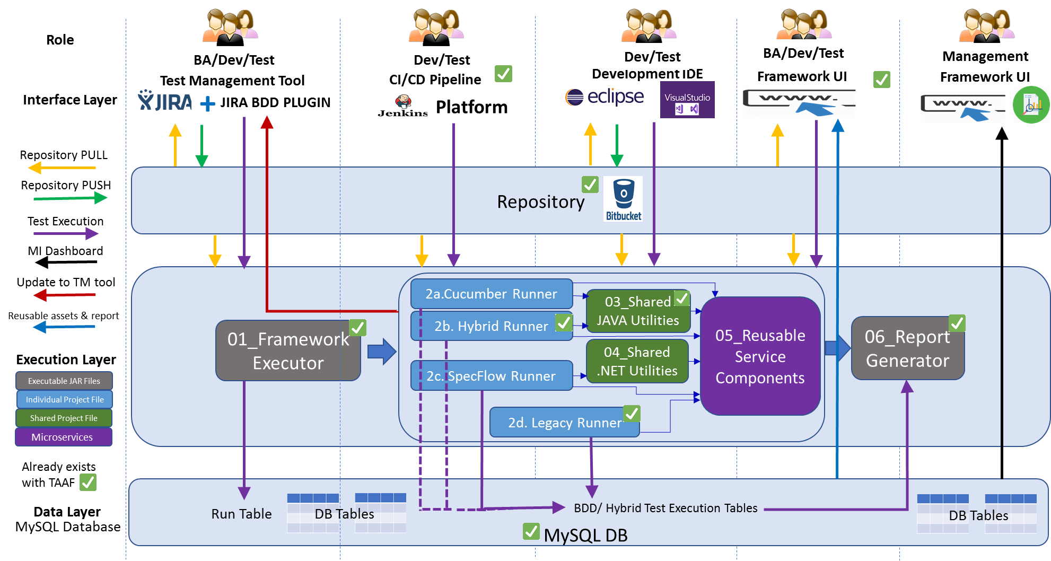

There are two approaches for automating the regression suites for applications under scope.

* First approach is to use the ETAF Hybrid framework to automate existing regression test cases.

In Hybrid Framework approach, team will analyse the existing regression suites and will create Keyword driven tests for the same. The test will upload in the cloud environment and user can run the script from ETAF UI.

* Second approach is to follow the ETAF BDD frameworks Cucumber Runner to automate the applications which doesn’t have a regression suite.

Please find the process flow diagram below for the ETAF BDD Framework. In Nike server remediation project, we are referring the scenarios to create the feature files.

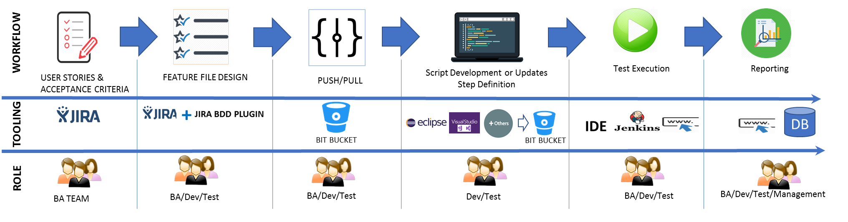



Steps which are following in BDD approach are mentioned below.

* Step1 - Create the Feature files based on the scenarios identified for the webservice or UI application.
* Step2 - Integrate the BDD files to ETAF Cucumber Framework and commit the code into the Bitbucket location.
* Step3 - Execute the scripts from ETAF UI
* Step4 - Work with development team to integrate it with CI / CD pipeline.

#### **Applications in scope**

Refer the Section 5.2 for the applications which are coming under the automation scope.

#### **Version Control**

QA team use bitbucket for storing all automated test scripts and automation framework components. The manual test cases are stored in JIRA.

### Performance Testing

A separate test strategy will be submitted for the Performance Testing explaining the approach and other details to commence performance evaluation.

### Security Testing

Pen test requests must be raised by project team for Strategic eSeries, CEMS & SCEMS and Permissions. This is not in scope for UST QA Team as there are different vendors in place.

## Test Types - Out of Scope

|  |  |
| --- | --- |
| Test Phase | Required |
| Static Testing | Not Required |
| System Testing | Not Required. |

## Entry and Exit Criteria by Test Type

|  |  |  |
| --- | --- | --- |
| Test Type | Entry Criteria | Exit Criteria |
| Regression Testing | * Regression test pack available / created. * Test Environment Readiness. * Satisfactory unit testing report. | * Planned test execution coverage has been completed. * Any Blocker or Critical or Major Defects Resolved. |
| Performance Testing | * NFRs defined * Satisfactory Regression Test Results. * Test Environment Readiness. * Any Blocker or Critical or Major Defects from earlier phases resolved. | * Planned test execution coverage has been completed and meets required NFRs (Scaled for environment) * Any Blocker or Critical or Major Defects Identified by Performance Testing Resolved |

# Test Environment Requirements

## Regression Testing

|  |  |  |
| --- | --- | --- |
| Application Name | Environment | URL |
| Permissions | Dev (Legacy) | <https://ectst027v.ec.experian.com:8280/PermissionsDevProd/>  <https://ectst027v.ec.experian.com:8280/PermissionsDevStag/>  <https://ectst027v.ec.experian.com:8280/PermissionsDevUAT/> |
| Permissions | QAT (Legacy) | <https://ectst027v.ec.experian.com:8230/PermissionsBATStag/>  <https://ectst027v.ec.experian.com:8230/PermissionsBATProd/> |
| CEMS UI | QAT (Legacy) | <https://ui.qat.cems.uk.experian.com/Amr8WguH/Blueprint/default.aspx>  <https://ui.qat.cems.uk.experian.com/autotraceplus/full/default.aspx>  <https://ui.qat.cems.uk.experian.com/BDR/full/default.aspx>  <https://ui.qat.cems.uk.experian.com/CIS/full/default.aspx>  <https://ui.qat.cems.uk.experian.com/investigator/full/default.aspx>  <https://ui.qat.cems.uk.experian.com/citizenviewplus/Full/default.aspx>  <https://ui.qat.cems.uk.experian.com/creditunionsystem/full/default.aspx>  <https://ui.qat.cems.uk.experian.com/gdfcservices/full/default.aspx>  <https://ui.qat.cems.uk.experian.com/CIS/menu/default.aspx>  <https://ui.qat.cems.uk.experian.com/NBMECAIS/full/default.aspx>  <https://ui.qat.cems.uk.experian.com/NBM/full/default.aspx>  <https://ui.qat.cems.uk.experian.com/NBM/PFM/default.aspx>  <https://ui.qat.cems.uk.experian.com/scottishpower/full/default.aspx>  <https://ui.qat.cems.uk.experian.com/sulcoservices/full/default.aspx>  <https://ui.qat.cems.uk.experian.com/BDR/PFM/default.aspx> |
| (S)CEMS | QAT (Legacy) | <http://cems-qat2-ret01:84/>  http://cems-qat2-ret01:82/ |
| (S)CEMS | QAT (New) | http://10.188.42.147/  http://10.188.42.148/ |

# Test Data Requirements

## Regression Testing

There are three approaches towards test data.

1. Get the test data from the regression cases wherever possible.
2. Collect test data from ExPIN databases wherever possible.
3. Obtain exception approval where no test data is available.

**CEMS UI:** We will be using existing test data attached to the regression cases and will fetch from databases based on the needs.

**CEMS APIs & SCEMS:** Find the test data from Splunk logs wherever possible. If no logs are available in Splunk then test data requests can be prepared in the suggested template to share with lead developer to get valid test requests along with test data.

**eSeries:** As the test data is unavailable, QA team will be collecting sample data and requests templates from Dev team.

# Test Tool Requirements

## Test and Defect Management

JIRA Global will be used to manage Tests and Defects. Access to the project will be granted to all necessary project members upon submitting request.

## Performance Testing

This will be detailed in Performance Test Strategy document.

# Defect Management

All defects will be triaged based on the severity and priority. Each defect points will be discussed, and captured evidences can be referred during this meeting to take a decision on the logged defects. Necessary advice from business and BA may require for some defects to confirm validity.

The frequency of the triage is set to daily. However, the triage sessions can be cancelled if there are no defects to triage.

## Defect Workflow

The standard defect workflow diagram is shown in the Appendices this is the forward-looking workflow which has been built into Jira Global.

Defects are initially triaged to check the validity of the defect, and to make sure the appropriate levels of Severity and Priority have been applied. The Defect will then be assigned to the resolver.

Test Lead will own the defect triage process which usually takes the form of a daily conference call or WebEx session between Developers, Project BA and Test Analysts.

## Defect Triage Roles

|  |  |
| --- | --- |
| Role | Responsibility |
| Test Analysts | Submission of Bug Report |
| Test Lead | Convene Defect Triage Meetings |
| Development Lead | Assessment of Bug Report |
| Developers | Clarifications of bug if any |
| Business Analysts | Confirmation of bug |

## Defect Priorities

The importance or urgency of fixing a defect, this will be set by the Tester initially and Test Lead can re-prioritise based on the Defect Triage meetings. During the Defect Triage meeting an assessment as to how disruptive to the testing schedule the continued existence of the defect in the test environment is may drive the priority of the defect.

|  |  |
| --- | --- |
| Priority | Description |
| Blocker | Show Stopper: This prevents business from continuing, e.g.:  Entire System or Key business process is unusable or does not meet the needs of the business  Many users affected and no work-around is available  Loss of data occurs that is not immediately recoverable and prevents the business from continuing |
| Critical | The problem affects selected processing to a significant degree, making it inoperable, causes data loss, or could cause a user to make an incorrect decision or entry, e.g.:  Part of the system or key business process is unusable or does not meet the needs of the business  Few users affected but a work-around is available  Corruption or loss of data occurs that is immediately recoverable and allows the business to continue |
| Major | The problem affects selected processing but has a work-around that allows continued processing and testing. No data loss is suffered, e.g.:  A non- critical incident occurs, typically affecting a single user  The incident affects the ability to provide the best service but there is a workaround |
| Minor | Testing can continue. Includes problems which do not allow testers to perform a minor function or process which does not need a workaround. |
| Trivial | The problem is cosmetic, and/or does not affect further processing and testing, e.g.:  Cosmetic errors  Minor anomalies in documentation  Requests for information or advice |

## Defect SLAs

|  |  |
| --- | --- |
| Priority | SLA |
| Blocker | Fix required within 4 hours |
| Critical | Fix required within 8 hours |
| Major | Fix required next build / patch. |
| Minor | Fix required next build / patch. |
| Trivial | Fix required next build / patch. |

## Suspension & Resumption Criteria

Test Leads may recommend the suspension of testing for any of the following reasons:

### Suspension Criteria:

* A defect is introduced that stops any further testing, e.g. a severity 1 defect is raised for a catastrophic failure of the system functionality and renders the solution unusable and where no acceptable workaround has been identified.
* The number of open defects produces a situation where they cumulatively mean testing has no value at a given point in time.
* The unavailability of dependent systems during test execution that results in all tests being blocked, i.e. no tests can be executed.
* When the entry criterion is not met or being dynamic and undergoing changes for any test stage for testing types in scope.

### Resumption Criteria:

* When the defect is resolved and retest on the fix, or new code, is successful, i.e. the defect has been successfully retested and can be closed.
* When the dependent systems become available again.
* When agreed by the relevant stakeholders of the programme/project.

# Test Management Governance

## Test Reporting

Below is the list of status reports planned throughout the project.

| Name | Purpose | Owner | Distribution |
| --- | --- | --- | --- |
| Weekly Status Report | Update the progress on the current testing  activities. | Test Lead | PM, Dev Lead, BA |
| Test Execution Status | Update the current test execution status. | Test Lead | PM, Dev Lead, BA |
| Defect Report | Update the current test execution status. | Test Lead | PM, Dev Lead, BA |

## Test Closure and Approval Process

A Test Completion report will be produced at the end of the Testing and will summarise all testing up to that point, providing both commentary and statistics of the test results.

The report will also detail defect statistics including commentary on outstanding defects and their planned resolutions.

The approval of this report by the Project Manager is a mandatory requirement to officially close the testing activities.

# Risks and Issues

## Risks

|  |  |  |
| --- | --- | --- |
| **RAID ID** | **Description** | **Mitigating Action** |
| TBC | Due to unavailability of test data for SES, CEMS and SCEMS test team is unable to validate all the business flows. | Work with dev team and product SME to identify the test data. |
| TBC | As there are no documentation available related to business specifications and flows, high chance of missing scenarios. | Consult and review with BA and SMEs for prepared scenarios. |

## Issues

|  |  |  |
| --- | --- | --- |
| **RAID ID** | **Description** | **Mitigating Action** |
| TBC | CEMS QAT environment is not stable and applications are not functioning properly. | Environment issues are planned to fix in the new QAT servers as the legacy one will be discontinued after migration. |

## RACI

Legend:

A – Accountable; R – Responsible; I –   Inform; C – Consult;

TA -Test Analyst; TL – Test Lead; BA – Business Analyst; PM – Project Manager, DL-Development Lead.

| **Role** | **TA** | **TL** | **BA** | **DL** | **PM** |
| --- | --- | --- | --- | --- | --- |
| Test Design | R | A | I | C | C |
| Test Scenario Review | I | A/R | R | C | C |
| Test Execution | R | A/R | I | C | C |
| Automation Test Design | R | A/R | I | C | C |
| Defect Closure | R | A/R | I | C | C |
| QA Signoff | I | R | A | C | C |

# Appendices

## Appendix A Glossary of terms and abbreviations

|  |  |
| --- | --- |
| CEMS | Customer Event Management System |
| SCEMS | Shared Customer Event Management System |
| SES | Strategic eSeries |
|  |  |

## Appendix B – Defect Workflow

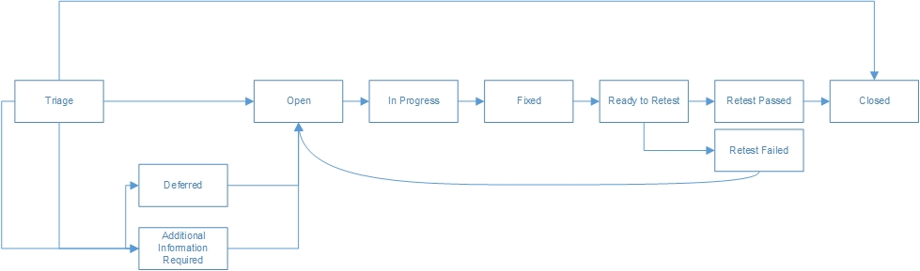

# Appendix C - Document Control

Change History

|  |  |  |  |
| --- | --- | --- | --- |
| Date | Version | Author | Details |
| 20/12/2019 | Draft | Jay K & Anoop G | Initial Draft |
| 09/04/2020 | 1.0 | Jay K & Anoop G | Initial Version & Scope Updated |
|  |  |  |  |

Approval Record

|  |  |  |
| --- | --- | --- |
| Major Version | Approved By | Departments |
|  |  |  |
|  |  |  |
|  |  |  |

Distribution for Current Version

|  |  |  |  |
| --- | --- | --- | --- |
| Name | Role | Departments | Reason |
| Mark Griffiths | Project Manager |  | Approval |
| Christopher Payne | Principle Developer |  | Review |
| Jay Dunkley | Business Analyst |  | Review |
| Padmakrishnan Padmanabhadas | Test Manager |  | Review |