Cover page Lab 5 Project 2A

1. Project Description: For this project the student will take in a paragraph of text and output of many of each specified letter appears in the paragraph. The paragraph uses all upper case letters the asscii values for those letters with be upper case. For the extra credit portion of this this project the student can output the number of time that letter appears by using that many # symbols. The letters to be found are KNIGHTS.
2. Project Design:
   1. Detailed narrative
      1. Take in the paragraph of text and save it onto a string.
      2. Set the count for each of the letters to 0
      3. Get the data address of the first letter
      4. See if the asscii value for the address is null, or one of the letters the researcher wants to find
      5. If null continue onto step viii
      6. If the letter appears add one to that letters counter the continue to step vii
      7. Increase the data address by on byte (character) and go back to step iv
      8. Print how many of each other the letters appears.
   2. Flow chart: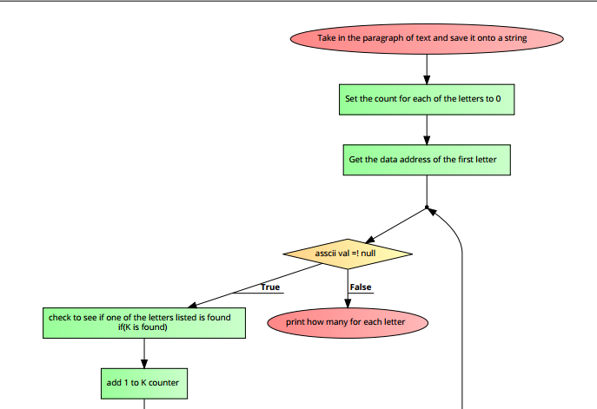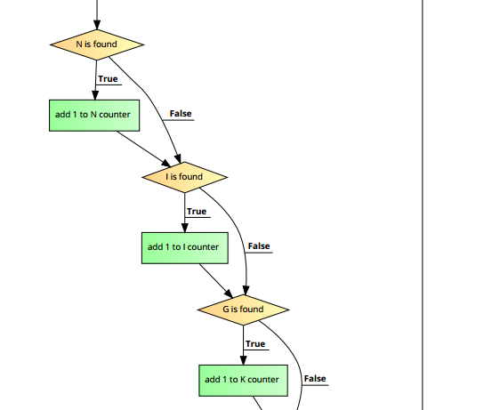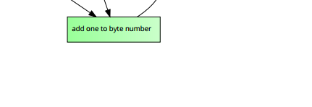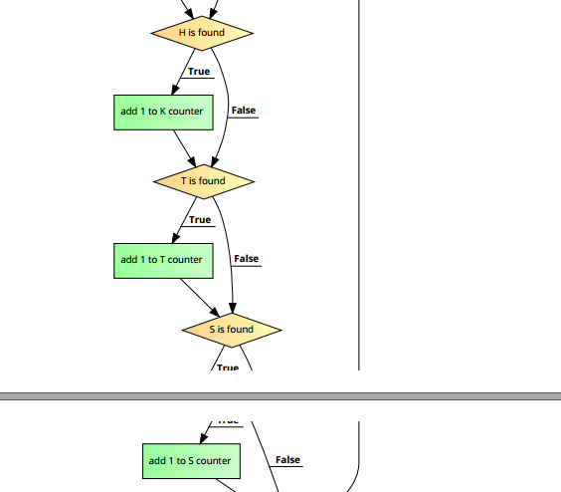
3. Symbol table

|  |  |
| --- | --- |
| $t0 | Where the string input is located |
| $t2 | Char value |
| $t3 | Number of K |
| $t4 | Number of N |
| $t5 | Number of I |
| $t6 | Number of G |
| $t7 | Number of H |
| $s0 | Number of T |
| $s1 | Number of S |
| $v0 | Number 4 to load a string for output, number 1 to print int, number 10 for closing the file |

1. Learning Coverage:
   1. Using the lb function to load a char asscii value onto a register.
   2. Looping through a string of text char by char by adding one to the address for every iteration.
   3. Finding what char, the asscii values equates to.
   4. Finding the number of times, a letter appears in a string of text.
   5. Manipulating strings by understanding how asscii values work.
2. Prototype in c langue:
   1. #include <stdio.h>
   2. #include <string.h>
   3. main() {
   4. char hi[10000] = "THE UCF KNIGHTS ATHLETICS PROGRAMS INCLUDE THE EXTRAMURAL ANDINTRAMURAL SPORTS TEAMS OF THE UNIVERSITY OF CENTRAL FLORIDA INORLANDO, FLORIDA. THESE TEAMS ARE COLLECTIVELY REFERRED TO AS THEKNIGHTS. UCF PARTICIPATES IN THE NATIONAL COLLEGIATE ATHLETICASSOCIATION'S (NCAA) DIVISION I (FBS FOR FOOTBALL) AS A MEMBER OF THE AMERICAN ATHLETIC CONFERENCE (THE AMERICAN).";
   5. int i =0, j=0, k=0, x=0, y=0, z=0, a=0, b=0, c=0;
   6. for (i=0;i<9999;i++){
   7. if (hi[i] == 'K'){
   8. j++;
   9. }
   10. else if (hi[i] == 'N'){
   11. x++;
   12. }
   13. else if (hi[i] == 'I'){
   14. y++;
   15. }
   16. else if (hi[i] == 'G'){
   17. z++;
   18. }
   19. else if (hi[i] == 'H'){
   20. a++;
   21. }
   22. else if (hi[i] == 'T'){
   23. b++;
   24. }
   25. else if (hi[i] == 'S'){
   26. c++;
   27. }
   28. }
   29. printf("The number of K is %d\n",j);
   30. printf("The number of N is %d\n",x);
   31. printf("The number of I is %d\n",y);
   32. printf("The number of G is %d\n",z);
   33. printf("The number of H is %d\n",a);
   34. printf("The number of T is %d\n",b);
   35. printf("The number of S is %d\n",c);
   36. }
3. Test plan: For this project 3 inputs will be tested. First will be the given string, second will be the normal test case of “GO KNIGHTS, CHARGE ON KNIGHTS”, the last test case will be the crazy test case of “sdkfhasdkjfhasdkjfhalksdjhflaksjhdflkasjhdflkaj” which should return nothing for the last case. This is adequate test coverage because it tests base case, a normal case, and an extreme case.
4. Test Results: 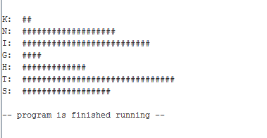

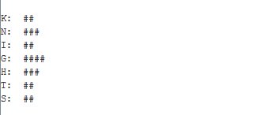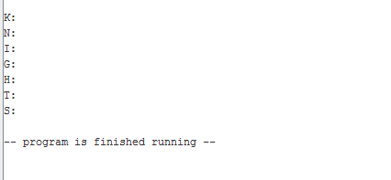

1. References: For this project the researcher used the project 2 part A pdf as a resource. This pdf included the constraints of the project and extra credit assignment. With this pdf the researcher could complete the task at hand.