Lab Report 3

1. Project Description:
   1. This project is used to learn basic math computation in assembly language for the MIPS processor. In this lab the student will use registers to store data values for ints and strings for output and computation. The student will learn how to use loops to use the mathematical diversion operation by using subtraction. Then use “if-else” statements to output specific strings based on if a number is divisible.
2. Program Design:
   1. Save data to variables for output. Output the first string asking for user input. Ask for user input and store in registers. Complete the mathematical computations on the data to find S. Output string saying the variable s in base two is, the output the int s in base ten. Output the string for s in base two then output the number s in base two. Create loops for division by 2 3 5 and 7. Check to see if the number is divisible, if so output is devisable by this number. Else output the remainder from dividing that number then output that remainder.

# Save data to variables -> Output the first string asking for user input -> Ask for user input and store in registers -> Complete the mathematical computations on the data to find S -> Output string saying the variable s in base two is, the output the int s in base ten -> Output the string for s in base two then output the number s in base two-> Divide the number is base ten by the numbers 2 3 5 and 7 in base 10 ->Create if-else statements to tell if the number is divisible, if number is divisible -> output that the number is divisible ,else number is not divisible -> output the remainder

1. Symbol table:

|  |  |
| --- | --- |
| $v0 | This is used for the system commands such as 4, output string. Other uses included 10, for end file, and 1 for output int. |
| $t0-$t7 | These are used as data registers. This could be used to store a number after input or mathematical computation. $t0 is always used as total throughout this program. The value at the end of part 1 execution should be 225 for the number 989104 as input. $t1 for part two will always be the control bit that tells if the number is divisible. |
| $a0 | Use this register for outputting a string. Load the string on this register to output it. |

|  |  |
| --- | --- |
| Exit(1-8): | Used to say to exit a loop when the condition is met. The first are used to exit after multiplication is down, the second is when division is done. |
| J L(1-8) | Telling the code to loop back to top of the loop. This will continue to execute addition for 1-4 and subtraction for 5-8 until this part is skipped when the condition is met. |

1. Learning Coverage:
   1. How to write an algorithm for division is assembly?
   2. How to use if-else statements in assembly using control bits?
   3. How to find remainders in assembly?
   4. How to relate jump statements and control bits for loop to if-else statements?
   5. How to check if a number is divisible by another number.
2. Prototype in C-language:
   1. #include <stdio.h>
   2. Main() {
      1. Int S, A, B, C, D, E, F, x,y;
      2. printf(“Enter your 6 digits of your PID for A, B, C, D, E, and F respectively:\n”);
      3. scanf(“%d, %d, %d, %d, %d, %d”, &A, &B, &C, &D, &E, &F);
      4. S = (A x B) + (18 x C) – (9 x D) – (E x F);
      5. printf(“S_ten = %d”, S);
      6. printf(“S_two = );
      7. for (x=31; x>=0;x--) {
         1. y = s >>x;
         2. if(k &1)
            1. printf(“1”);
         3. else {
            1. printf(“0”);
         4. }
      8. }
      9. x = s%2;
      10. if (x == 0) {
          1. Printf(“the number is divisible by 2”);
      11. }
      12. else() {
          1. Printf(“the remainder of s%2 = %d”, x);
      13. }
      14. x = s%3;
      15. if (x == 0) {
          1. Printf(“the number is divisible by 2”);
      16. }
      17. else() {
          1. Printf(“the remainder of s%2 = %d”, x);
      18. }
      19. x = s%3;
      20. if (x == 0) {
          1. Printf(“the number is divisible by 3”);
      21. }
      22. else() {
          1. Printf(“the remainder of s%3 = %d”, x);
      23. }
      24. x = s%5;
      25. if (x == 0) {
          1. Printf(“the number is divisible by 5”);
      26. }
      27. else() {
          1. Printf(“the remainder of s%5 = %d”, x);
      28. }
      29. x = s%7;
      30. if (x == 0) {
          1. Printf(“the number is divisible by 7”);
      31. }
      32. else() {
          1. Printf(“the remainder of s%7 = %d”, x);
      33. }
   3. }
3. Test plan:
   1. The inputs choices to test this program are 969104 and 3666219. The student chose this because, this is the student’s id number and the other is the sample input. This gives adequate test coverage because this input is approved by the instructor. The expected output has been approved also.
4. Test Results:
   1. 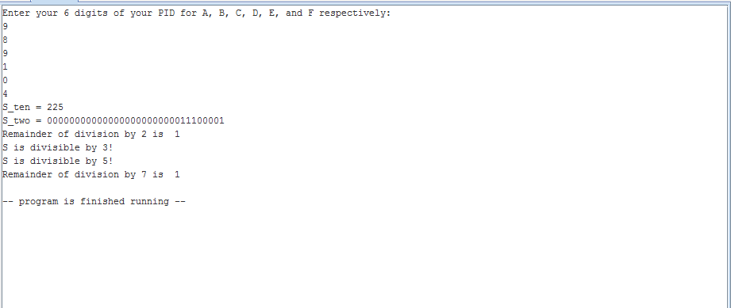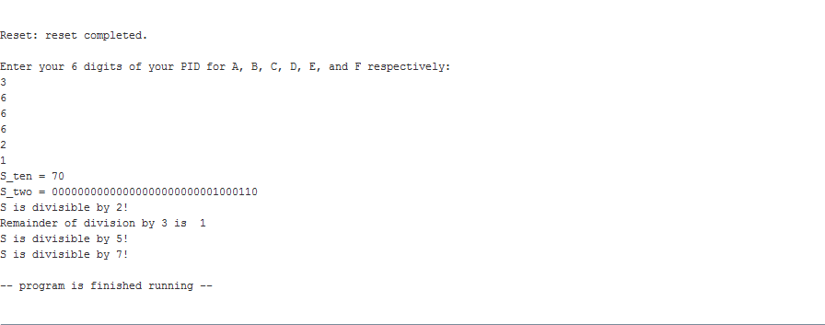
   2. 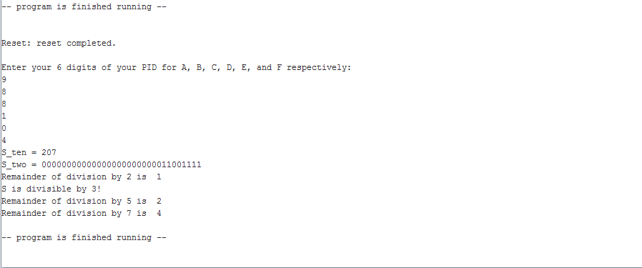
5. References:
   1. For this project the student used the project 1 pdf file to find what the constraints of this project are and sample code to learn how to perform this project’s tasks. This also, sample input and output to know if the code is working as intended.
   2. The grading rubric to tell how the report should be written and it’s formatting.