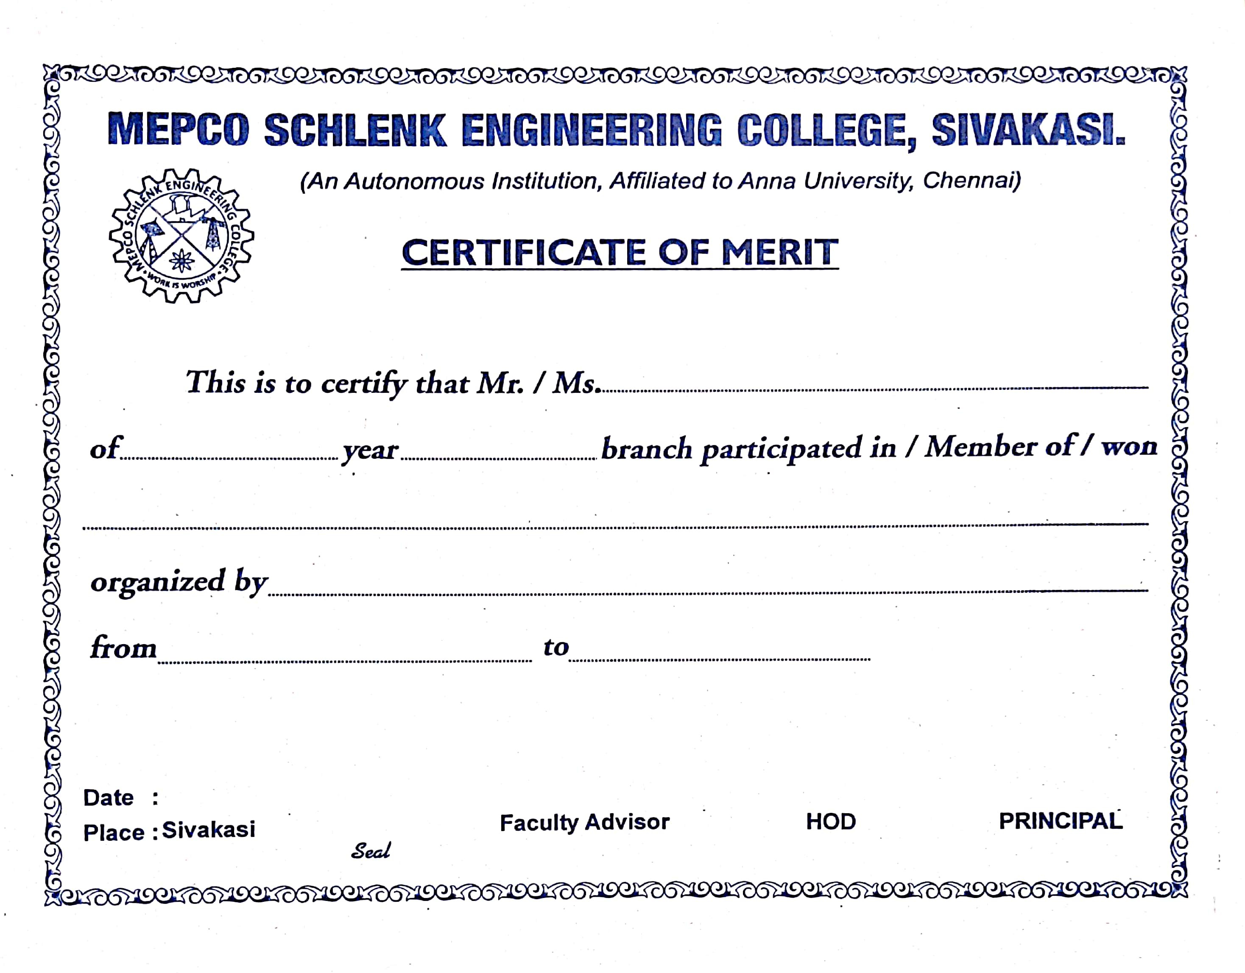

{{name}}

{{br}}
{{year}}

mani
{{role}} {{event}}
{{organizer}}
{{date}}
{{date}}

