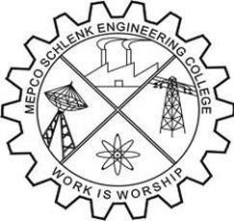
Mepco Schlenk Engineering College, Sivakasi (Autonomous)
National Service Scheme
Department of Artificial Intelligence and Data Science
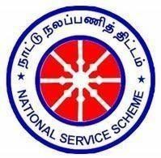
Unit No: 19
PATRON:  Dr.S.Arivazhagan., M.E., Ph.D.,  Principal | PRESIDENT:  Dr.J. Angela Jennifa Sujana.,  M.Tech., Ph.D.,  Professor & Head/AI&DS |  | NSS Program Officer: Dr,A.Shenbagarajan, M.E., Ph.D Dr.N.Arunachelam, M.E., Ph.D
NSS Faculty In-charges:  Dr. P. Manoj Kumar, M.E.,Ph.D Assistant Professor (Sr.G)  Dr. K. Kamala Devi, M.E., Ph.D Assistant Professor  Secretary:  Hariny. M IV-AI&DS  Event Coordinaters: Sudharsan. S III-AI&DS Gokulnath. M II-AI&DS  Software & Multimedia Team: Manikanda Prabu.S, III-AI&DS Ilakiya. P.T II-AI&DS  Executive Committee: Rajeswaran.S, III-AI&DS Prem Nivas. E II-AI&DS  Public Relation Committee:  Sriramachandran.P, III-AI&DS  Devika. R II-AI&DS | SDG:08 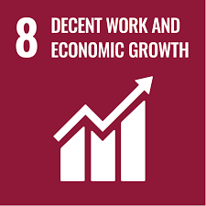  THINK LIKE AN ENTREPRENEUR!    BY  S. SUDHARSAN III AI&DS ‘B’  Date:20.09.2025 (Saturday) Time: 4.00pm to 4.45pm  Venue: AD(05)
Faculty In-charge (Dr. P.Manoj Kumar) (Dr. K.Kamala Devi) |  | President  (Dr.J. Angela Jennifa Sujana)
Copy to: All HoD, Faculty and Students (By Mail) Subject: NSS EVENT – UNIT No.19 (AI&DS)

