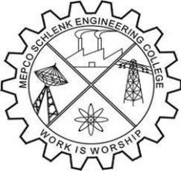
Mepco Schlenk Engineering College, Sivakasi (Autonomous)
National Service Scheme
Department of Artificial Intelligence and Data Science
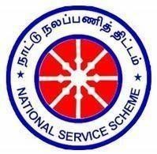
Unit No: 19
PATRON:  Dr.S.Arivazhagan., M.E., Ph.D.,  Principal | PRESIDENT:  Dr.J. Angela Jennifa Sujana.,  M.Tech., Ph.D.,  Professor & Head/AI&DS |  | NSS Program Officer: Dr,A.Shenbagarajan, M.E., Ph.D Dr.N.Arunachelam, M.E., Ph.D
NSS Faculty In-charges:  Dr. P. Manoj Kumar, M.E.,Ph.D Assistant Professor (Sr.G)  Dr. K. Kamala Devi, M.E., Ph.D Assistant Professor  Secretary:  Hariny.M IV-AI&DS  Joint Secretary:  Event Coordinaters: Sudharsan.S, III-AI&DS  Software & Multimedia Team: Samyuktha.G, IV-AI&DS Manikanda Prabu.S, III-AI&DS  Executive Committee: Thinusha Dapni, IV- AI&DS Rajeswaran.S, III-AI&DS  Public Relation Committee:  Vidya.S, IV -AI&DS  Sriramachandran.P, III-AI&DS | SDG:{{no}} {{sdg_image}}  {{title}}  {{main_image}}  BY  {{name}}  {{name2}}  Date: {{date}}  Time: 4:00 to 4:45pm  Venue: {{venue}}
Faculty In-charge (Dr. P.Manoj Kumar) (Dr. K.Kamala Devi) |  | President  (Dr.J. Angela Jennifa Sujana)
Copy to: All HoD, Faculty and Students (By Mail) Subject: NSS EVENT – UNIT No.19 (AI&DS)

