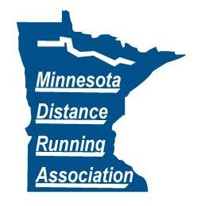41st Year of the Como Park Relays
2 person teams

Date: Every Wednesday in August. Kids race starts at 6:30 p.m. Relay race starts at 6:45 p.m.
Location: At the intersection of Horton Ave. and Lexington Pkwy. In St. Paul. From Hwy 36 go south on Lexington till Horton Ave. From Hwy 94 go north on Lexington till Horton Ave.
Races:
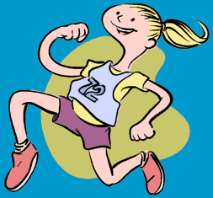
6:30 p.m. kids race ¼ or ½ mile every week
6:45 p.m. 2 person relay
8/6/2014 8 X 1000 meters
8/13/2014 6 X 1 mile
8/20/2014 10 X 1000 meters
8/27/2014 8 X 1 mile
Como
Park
Entry Fee:
50¢ for kids race (14 & under)
$2 per runner – relay race (17 & under)
$3 per runner – relay race (18 & over)
Awards:
Ribbons to all finishers!
8/6/2014 Championship Awards: 17 & under
8/27/2014 Open, Combined ages 80 & over, 90 & over, 100 & over, 110 & over and 120 & over
Results: Can be viewed on www.raceberryjam.com
Facebook: Friend “Como Park Relays” on Facebook to see the relay pictures and keep up to date with all the running excitement
Join the Fun: This series of races (which began in 1974) are a great way to get in shape and improve your fitness. All level of runners are encouraged to compete and have fun. If you do not have a partner, just show up early and we will find you one. Help make the 2014 relays the biggest and best ever! Hey kids, join the fun and get your face painted.
“Serving the Minnesota Running Community”
Como Park Relays Race Director – John Cramer
Phone (651) 489-2252 or breadmanrunner@yahoo.com
www.runmdra.org

