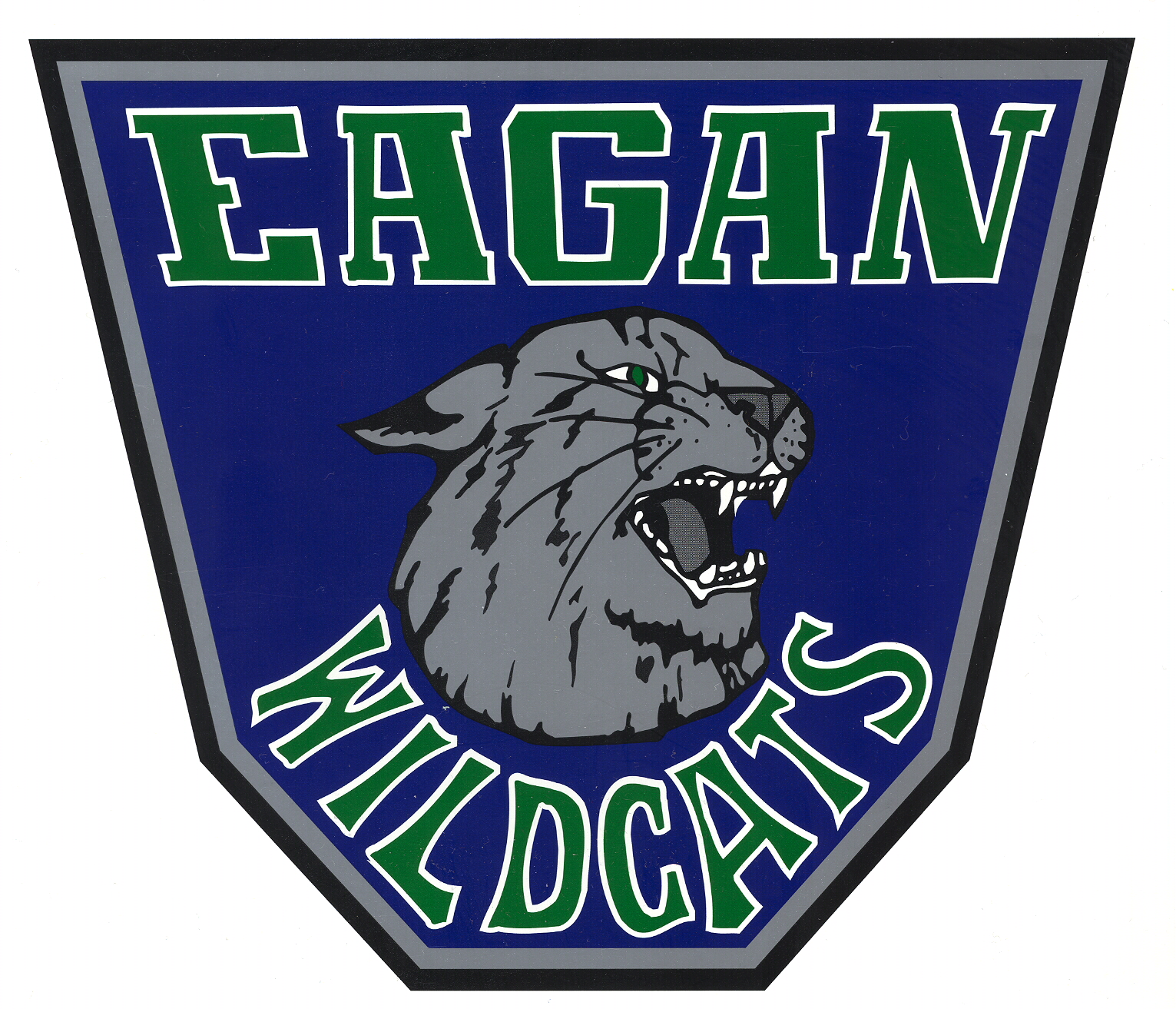
Dakota County Classic
Cross Country Meet

DATE: Friday, August 29, 2014

TIME: 10:00 a.m. Boys’ JV Race 3200 Meters
10:30 a.m. Girls’ JV Race 3200 Meters
11:00 a.m. Boys’ Varsity Race 3200 Meters
11:30 a.m. Girls’ Varsity Race 3200 Meters
12:15 p.m. Awards – EHS Main Gym

SITE: Eagan High School – Athletic Fields North of High School
Parking – EHS Stadium parking lot and Northview Park parking lot

ENTRY FEE: $75 per Varsity team or $150 for boys and girls.
Send to:
ATTN: Rob Graham
4185 Braddock Trail
Eagan, MN 55123

ENTRIES: Varsity - 7 per team with first 5 scoring
JV – Unlimited entries with first 5 scoring

New this year …. Timing will be done using chips and will be handled by Anderson Race Management. Prior to the meet, you will be emailed a formatted spreadsheet that you can add your roster to. Your active roster will then be emailed back to Anderson Race Management and the entry process will be complete. We think this will be easier!

AWARDS: Team –Trophies for each team champion and runners up.
Individual – Boys and Girls JV – Medals 1-12
Boys and Girls Varsity – Medals 1-20

RESULTS: 2013 CHAMPIONS: Boys’ Varsity Apple Valley
Girls’ Varsity Eagan
Boys’ JV Apple Valley
Girls’ JV Lakeville South

QUESTIONS: Please contact Lisa Langenhahn @ lisa.langenhahn@distirict196.org or Rob Graham @ rob.graham@district196.org.

2012 TEAMS: Apple Valley Boys and Girls Nova Classic Academy Boys and Girls Farmington Boys and Girls Simley Boys and Girls
Hastings Boys and Girls Richfield Boys and Girls
New Prague Boys and Girls Lakeville South Boys and Girls
Forest Lake Girls Como Park Boys and Girls
Eastview Girls

