Act/Module 1:
Learning How to Make These Crazy Maps
That Compare Organisms' Full Proteomes
Using Protein Language Models
(i.e. unsupervised learning)
_______________________________________________________________________________________________

Module 1 assignments upload instructions

In this link (https://drive.google.com/drive/folders/1zAMmdEn5TPiUXf3BfgX2NM8STlHpLMwh?usp=sharing) you will find two Google Drive folders:

individual_google_colabs → In here you will find two sub-folders:
- module_1_ipynb: upload your exercises google colab in .pdf format (print to .pdf) → LastName_FirstName_Module_X.pdf
- module_1_ipynb: upload your exercise google colab in .ipynb format → LastName_FirstName_Module_X.ipynb

PLVis_group_project → In here you will upload your PLM comparative visualizations:
- Create a folder with this name LastName1_FirstName1_LastName2_FirstName2 (keep going if there are 3 members)
- Within this folder, upload:
  - 3 separate .html files (or more if you made more comparisons)
  - 1 word or google doc file that includes all your mini-reports.
_______________________________________________________________________________________________
NOTE: If you’re reading this on Canvas, I recommend heading over to the Google Drive version of this document just in case there are any recent updates!

Welcome to Act / Module 1! In preparation for the world of Protein Language Model embeddings, let’s jump right into a couple of exercises with our person-vector representations from the Guess Who game.

[EXERCISE 0] → [HINT: To make life easier, you can work only with the binary features of the dataframe] Take the vector representation of yourself from the “Guess Who” DataFrame. Write a little function that takes as input two such vectors and computes a vector similarity metric or distance between them. You can write it such that the user specifies as additional input to the function which metric to use (e.g. cosine, hamming, etc.). Then compute the “cosine similarity” or “cosine distance” between your vector and every other vector (person) in the dataframe. Then find the person(s) whose vector is most similar to yours according to this metric.

[EXERCISE 1] → [HINT: To make life easier, you can work only with the binary features of the dataframe] Make a 2-D projection of all the person-vectors in the dataframe. You can use a standard Python plotting library (like PyPlot or Seaborn) to make a static scatter plot. You can use any (or ideally all of the following projection algorithms): PCA, tSNE, UMAP.

Video Link: Astronaut on both exercises above. → LINK

[EXERCISE 2] → Making an interactive 2D projection: Make an interactive version of the scatter plot above, using one of the following libraries: Plotly Express or Bokeh. Make it such that when you hover with your Mouse over the points, it shows you the name associated with each point. Find your name and the name of the person closest to you in the 2D projection. Does your nearest neighbor in the 2D projection match your nearest neighbor you found in the first exercise? Discuss your finding with your nearest person or chatbot.

For this new Module you will need a new partner! Your partner will be either the person who is closest to you according to any metric in the large dimensional vector space or the one closest to you in your projection. You all organize yourselves.


Go find your new partner!

Now we begin our transition to the world Protein Language Model embeddings. We are first going to get our hands dirty USING (more accurately, visualizing) protein language model embeddings, while slowly and in parallel - through the next several days - learning a bit more about where these vectors actually come from: that is, how the Transformer model works.***

***NOTE - Expect a big picture level of understanding - this is an APPLIED machine learning class amenable to folks with little to no programming background. These models are really complicated, and one could spend a whole several weeks becoming deeply familiar with and understanding their innards and architecture.***

First, know that there is a rich history of bioinformaticians (CS-type folks who like biology) taking ideas from the field of Natural Language Processing (CS-type folks who study human language), and adapting them to the world of proteins. Repeat this mantra several times: “words and sentences are analogous to amino-acids and proteins”.***

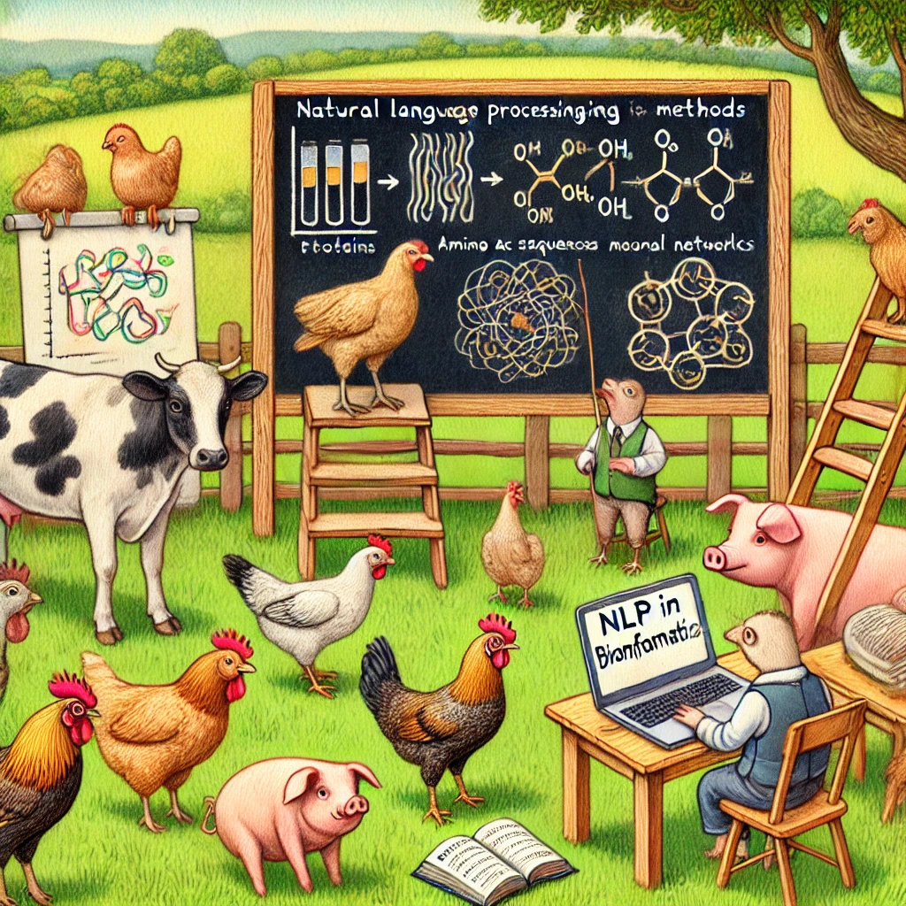
Here is an illustration of cows, chickens, and pigs enthusiastically learning about Natural Language Processing methods in bioinformatics.

*** For the CS-background students among you, or anyone who needs a refresher, check out our Biochemistry Primer notes [LINK] ***

For example, they took this thing called Hidden Markov Models (HMMs) - which were being used by NLP folks to convert sound to text - and applied them to protein sequences. This adaptation was a game-changing idea: HMMs in biology are the foundation of a lot of our understanding of Protein Families. So needless to say, it was a really fruitful idea! (By the way we won’t be going deep into how HMMs work for now. But certainly understanding them is an important exercise for anyone doing bioinformatics! So pick up your favorite chatbot and start learning about HMMs in bioinformatics!)

The adaptation of HMMs to bioinformatics happened in the mid-1990’s (the HMMER software package by Sean Eddy was a milestone). NLP has evolved a ton since then! In the past few years, the latest generation of models from the world of NLP are taking the world by storm. Computational biologists have been quick to adapt one of the most powerful recent models - The Transformer - to feed it protein sequences instead of Wikipedia articles. These are Protein Language Models.

One of my favorite people in this field is called Alexander Rives. I really recommend reading his papers, at least the introductions. He’s the leader of the “ESM” family of protein language models, and one of the heads at an exciting startup called EvolutionaryScale. Check it out!

Remember how we turned each person in "Guess Who" into a vector, a set of numbers representing their characteristics? PLMs do something similar for proteins, converting amino acid sequences into vector embeddings. But here's where things get interesting: our "Guess Who" vectors were straightforward – a '1' might mean "wears glasses." PLM embeddings, on the other hand, are like a secret code. They're generated by a sophisticated "Transformer" model trained on vast quantities of protein data. The individual numbers in these embeddings are not easily translated into human-readable features. They represent the Transformer's own internal understanding of protein structure and function. Think of it as peering into the "mind" of this powerful machine. Even though we can't fully decipher the individual numbers, the fundamental principle remains: similar proteins will have similar "Transformer Devil" embeddings. This allows us to uncover hidden relationships, even without fully understanding the code.

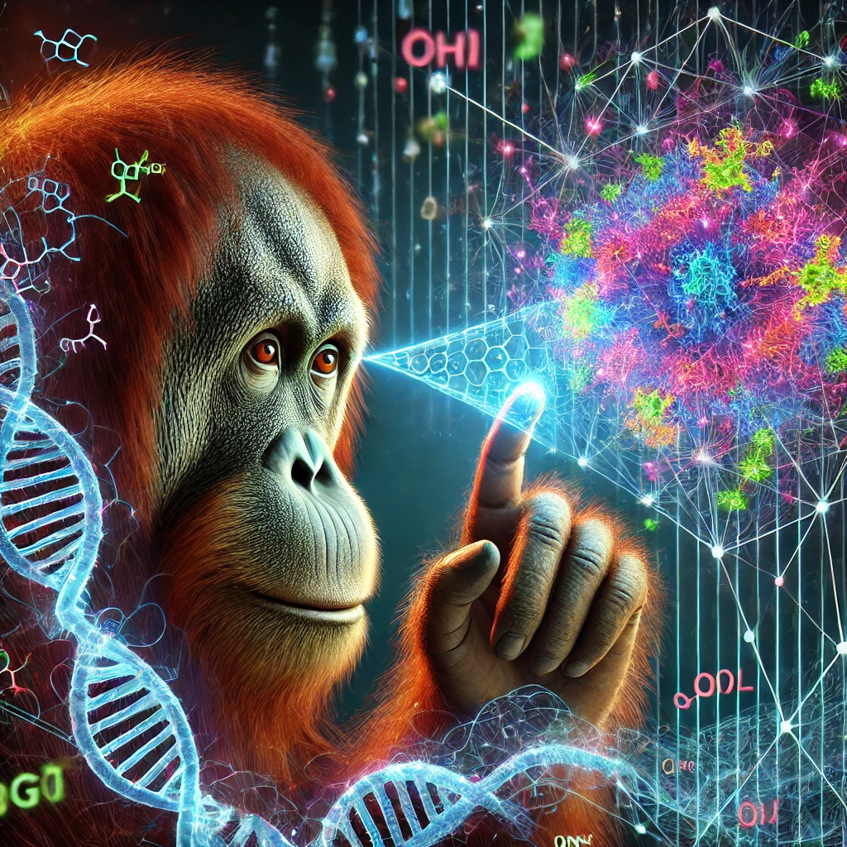
Here is the image of an orangutan curiously peering into the "mind"
of a protein language model (PLM) transformer.

Our next general goal is to get our hands (through Python) on such real-world Protein Language Model embeddings for real-world proteins. But first, we need to learn to navigate the UniProt Database and become familiar with the kind of protein data we can download from it!

[EXERCISE 3]: Becoming familiar with the UniProt Database: Download a full “Reference Proteome” from your favorite organism from the UniProt Database. Learn how to customize the columns of your full proteome table, and make sure you include columns such as Annotation, Length, Sequence, Function [CC], plus any other columns you might find interesting. Download it in either excel or .tsv (tab-separated values) format and import it into your Act/Module 1 Project Google Colab.

USEFUL LINK: Lineage lookup App by Javi. → LINK

[EXERCISE 4]: Proteome summary statistics. Plot a histogram of the protein lengths in your proteome. Also plot a histogram for the Annotation score of all your proteins, which ranges from 1-5. Calculate and display summary statistics (e.g. mean, median, standard deviation, etc.) for protein lengths and annotation scores in the DataFrame. What do you imagine these numbers to be, before you actually calculate them?

[EXERCISE 5]: One more data science / DataFrame manipulation exercise. Write some code that computes, for every sequence in your proteome, the number of cysteine residues in the protein. Store these values in a new column in your DataFrame called “num_cysteines”. Plot the distribution of cysteine residues per protein across the entire proteome.

Video Link: Rabbit Man on the few exercises above→ LINK

Time to get our hands on Protein Language Model (PLM) embeddings. These are pre-trained embeddings, meaning they've been generated by a model that has already learned from a massive amount of protein data (we'll cover the details of pre-training later). There are two general approaches to obtaining embeddings: computing them directly from the amino acid sequence or retrieving pre-computed ones. UniProt offers pre-computed embeddings for the ProtT5 model in .h5 format, making our task much easier. We can simply load these files into Python. Note that for other models like ESM, we would need to compute the embeddings ourselves, but that process isn’t too difficult either.


Make an image of the aztec god quetzalcoatl, the feathered serpent, downloading pre-trained PLM embeddings from UniProt in his brand new laptop computer.

[EXERCISE 6:] Downloading PLM embeddings from UniProt. Learn how to download the embeddings associated to your full proteome table directly from UniProt as an .h5 file. Learn how to load / import .h5 file contents into Google Colab. I recommend loading them as a dictionary!.

Suggested Prompt: “Write Python code that reads a compressed h5 file, decompresses it in-memory, and loads its data into a dictionary. The dictionary should have data (protein) names as keys and their corresponding vectors embeddings as NumPy arrays. Ensure the entire process is handled within a single code cell without writing intermediate files to disk.”

OK, if you’ve been successful in loading the embeddings you should now have a dictionary that lets you fetch for each protein entry the corresponding PLM embedding.

[EXERCISE 7]: → Practicing and learning about dictionaries. Learn about key-value pairs. What are the keys in your dictionary? What are values in your dictionary? Display the first 10 (or a random set of 10) key - value pairs.

Suggested prompt to learn more about Python dictionaries: “I am learning Python and would like to understand dictionaries in depth. Could you provide a concise explanation of what dictionaries are, including their key characteristics and common use cases? Additionally, please offer a few practice problems with solutions to help me apply this knowledge”

[EXERCISE 8:] → Take a look at the embedding dimension, and whether these protein embeddings are dense or sparse. What about the Guess Who embeddings? Were those dense or sparse? Lower or higher dimension?

Suggested prompt to learn about dense vs. sparse vectors: "I'm studying vector representations in machine learning and would like to understand the differences between dense and sparse vectors. Could you explain these concepts, their key characteristics, and common use cases? Additionally, please provide a few practice problems with solutions to help me apply this knowledge.”

Video Link → Beluga Rider on PLM embeddings (Part I) → LINK

[EXERCISE 9:] → Pick a random protein from your full proteome of choice. Get the embedding for that protein. Compute the cosine distance to *every other protein* in the proteome. And find the protein (make sure it’s not the same one) with the shortest distance to your query protein.

Suggested prompt: "I have a Python dictionary where each key maps to a vector (e.g., NumPy arrays). I want to select a specific (random) vector and compute the cosine similarity between this vector and all other vectors in the dictionary. Store the resulting distances in a new dictionary. Could you provide a Python code example that demonstrates how to do this?”

Suggested prompt: “I have a dataframe of proteins, and I also have protein language model embeddings for each protein. I picked one random protein and computed the cosine similarity to all others, and found the one that’s most similar. Assume I have little to no background in biochemistry and protein evolution. Can you explain what it means to find most similar proteins in terms of their sequence, relatedness, protein families? Suggest other prompts to dig deeper and learn more about this.

# [EXERCISE 10:] → Make a 2D projection of all your full proteome embeddings. I recommend using UMAP to make the projection, but you can use any other method. I recommend that, once you generate the 2D coordinates, you store them in a dataframe. Then use this to add two extra columns to the original UniProt dataframe you loaded in your notebook (Exercises 3-5). You can use the merge() function to add the two new columns (‘umap-1’ and ‘umap-2’).

I have a Python dictionary named [NAME] where each key corresponds to a UniProt identifier, and each value is a high-dimensional vector (e.g., 1024 dimensions). Additionally, I have a DataFrame named [NAME] that contains various details about each protein, with an 'Entry' column matching the keys in the dictionary. Could you provide a step-by-step guide, including code, on how to:
- Extract the vectors from [the dictionary] and prepare them for dimensionality reduction.
- Apply UMAP to project these vectors into 2D space.
- Add the resulting UMAP coordinates as new columns ('umap-1' and 'umap-2') to [the uniprot DataFrame].
Please ensure the explanation is suitable for someone with a basic understanding of Python and libraries such as NumPy, pandas, and UMAP.
[EXERCISE 11:] → [OPTIONAL] Cluster your projected protein embeddings using k-means clustering. Pick a fixed number of clusters (e.g. start with 80 clusters).

[EXERCISE 12:] → Making an interactive 2D projection of all your full proteome embeddings. I recommend using UMAP to make the projection, but you can use any other method.

Suggested Prompt: I have a DataFrame that includes UMAP coordinates (umap-1 and umap-2) for various proteins. Each row corresponds to a protein, with columns such as 'Entry' and 'Protein names’ containing relevant information. Could you provide a step-by-step guide, including code, on how to:
- Create an interactive 2D scatter plot using Plotly, plotting 'umap-1' on the x-axis and 'umap-2' on the y-axis.
- Customize the plot so that when hovering over each data point, it displays the 'Entry' and 'Protein names' associated with that point.
Please ensure the explanation is suitable for someone with a basic understanding of Python.

Video Link → Beluga Rider on PLM embeddings (Part II) → LINK

Let's take our exploration of protein language model embeddings to the next level by comparing entire proteomes! You'll prepare data from two (or more) organisms' proteomes, combine their embeddings, and create a unified 2D projection that lets us visualize evolutionary relationships across species. This multi-step process involves carefully merging your datasets before projection - remember, to make meaningful comparisons, we need to project all embeddings together rather than separately. Once your data is prepared, you'll use our visualization notebook to create an interactive map that reveals fascinating patterns in protein space across different organisms
(note: since you need to do this anyway, I added it as an extra exercise).
[EXERCISE 13:] Prepare Your Proteome Data for Visualization Load both proteome dataframes and their corresponding embeddings. Combine the dataframes and embeddings first, then generate a UMAP projection of the combined embeddings (make sure not to project them separately!). Add the resulting UMAP coordinates as new columns to your combined dataframe and save it as a TSV file. This processed file will be used in the visualization notebook we've provided below. Note: Make sure your final dataframe includes both organisms' data and their corresponding UMAP coordinates ('umap-1' and 'umap-2').

Video: Snake Charmer on Proteome Comparisons (Part I: Data Pre-processing) → LINK

Video: Snake Charmer on Proteome Comparisons (Part II: Visualizing two proteomes with DataMatPlot, e.g. Javi’s notebook) → LINK

Video: Snake Charmer on Proteome Comparisons (Part III: exploring the visualization and writing a mini-report) → LINK

Link to Notebook by Javi: Interactive visualization with DataMapPlot → LINK

[But where do these protein language model embeddings come from? The Transformer.]

Video Link: Transformers (how LLMs work) explained visually → LINK

