**Beginner’s guide to Installing & Configuring NAGIOS server**

Nagios server (AKA nagios core) is a very useful, open-source monitoring tool. With the help of Nagios server, we can monitor stats like ram usage, cpu usage, hdd usage along with other parameters of a number of machines/servers on single screen. If something goes wrong , its sends us warning by using sound or sending a mailto configured users or we can even configure Nagios to send a sms to a phone number.

## Pre-requisites

Before we can install Nagios , we need some packages like **httpd, php, gcc, glibc, glibc-comman & GD** on our system.

To install all these packages, run following

$ yum install –y httpd php gcc glibc glibc-comman gd gd-devel make net-snmp

After all the packages are installed, we will now download the Nagios & its plugins source file. As of writing of this tutorial, Nagios 4.2.4  & Plugins 2.1.4 are the latest. You can directly download the files using link below or you can use wget also to get these files

$ wget https://netix.dl.sourceforge.net/project/nagios/nagios-4.x/nagios-4.4.2/nagios-4.4.2.tar.gz

$ wget <https://nagios-plugins.org/download/nagios-plugins-2.2.1.tar.gz>

## ****Installation****

Step 1 – Create  a user & group for Nagios

We will add a user nagios & a group nagcmd

$ useradd nagios

$ passwd nagios (enter a password)

$ groupadd nagcmd

Now, we will add nagios & apache to nagcmd group

$ usermod –G nagcmd nagios

$ usermod –G nagcmd apache

Step2- Extracting Nagios files

We will now extract the nagios & plugins files on our system

$ tar -xvf nagios-4.2.4.tar.gz

$ tar -xvf nagios-plugins-2.1.4.tar.gz

Step 3- Configuring Nagios server

Now that we have extracted the Nagios file, we will now go to the extracted folder & compile those files to install Nagios server

$ cd nagios-4.2.4

$ ./configure –with-command-group=nagcmd

after it’s completed, we will now run make & make install to complete our installation

$ make

$ make install

once these steps are done, we need to install init –scripts, commandmode & also need to install some sample Nagios files

$ make install-init

$ make install-comandmode

$ make install-config

Step4 – Configuring Web-Interface

Once all the above installations are complete, we can now configure web-interface where we will do all the monitoring. To install web-interface, run the following command

$ make install-webconf

Our web-interface is now installed and a default user “nagiosadmin” has been created. We will now assign password to user “nagiosadmin”

$ htpasswd -s -c /usr/local/nagios/etc/htpasswd.users nagiosadmin

Step 5- Setting an email for sending alerts

To set an email to receive alerts , open

$ vi /usr/local/nagios/etc/objects/contacts.cfg

and enter an email address.

(Also Read: Complete monitoring solution : Install OMD (Open Monitoring Distribution))

Step 6- Installing the Nagios Plugins

Now, it’s time to install Nagios plugins

$ cd nagios-plugins-2.1.4/

$ ./configure – -with-nagios-user=nagios –with-nagios-group=nagios

$ make

$ make install

Step 7 – Verify Nagios files

In the last step of Nagios server installation, we will verify Nagios configuration file against a sample configuration file to make sure all the settings are Okay

$ /usr/local/nagios/bin/nagios -v /usr/local/nagios/etc/nagios.cfg

If all the settings made are correct you should not receive any error.

Now restart nagios server & httpd server

$ service nagios restart

$ chkconfig nagios on

$service httpd restart

$ chkconfig httpd on

Step 8- Logging into Web-interface

Open your browser & enter http://localhost/Nagios or http://IP-address/Nagios in your address bar & you will be asked to enter the username & password. Upon entering the credentials, you can now see your Nagios Web-interface.

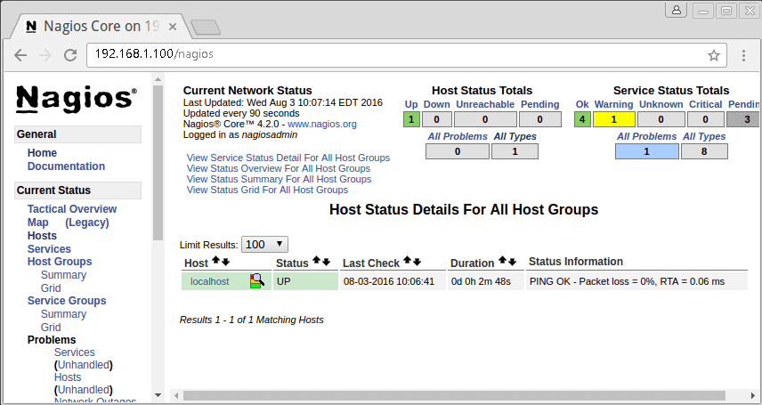

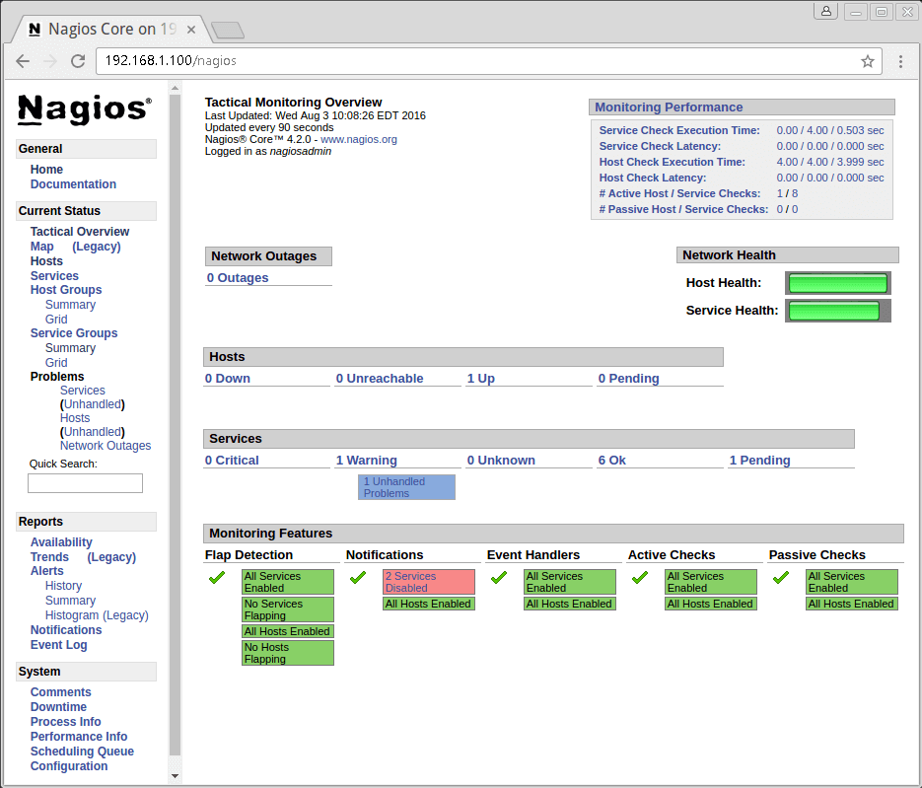

When you see**service overview** page, we can only see services of our localhost . That is because we have not added other host services on Nagios.

# Easy guide to setup Nagios monitoring using SSH (check_by_ssh)

In this tutorial, we will learn to configure nagios monitoring using ssh. SSH is usually installed on almost all the Linux distributions, so no extra packages need to be installed. We only need check_by_ssh plugin, this plugin allows Nagios to execute monitoring plugins and scripts on the remote machine in a secure manner, without having to supply authentication credentials.

So let’s start the configuration for setting up Nagios monitoring using SSH,

## Step 1- Installing & configuring Nagios plugins on Client

Firstly, install the following packages to resolve all dependencies required for installing the plugins ,

**$ yum install -y gcc glibc glibc-common gd gd-devel make net-snmp openssl-devel**

now add a user for Nagios by name “nagios”,

**$ useradd nagios**

**$ passwd nagios**

Next download the Nagios plugins to the system using the following command,

**$ wget https://nagios-plugins.org/download/nagios-plugins-2.2.1.tar.gz**

We will now extract the plugins from the downloaded tar archive,

**$ tar -xvf nagios-plugins-2.2.1.tar.gz**

**$ cd nagios-plugins-2.2.1**

And now we will compile & install the plugins

**$ ./configure –with-nagios-user=nagios**

**$ make**

**$ make install**

After the plugins are installed, we will change the ownership of the plugins folders

**$ chown nagios.nagios /usr/local/nagios**

**$ chown -R nagios.nagios /usr/local/nagios/libexec**

## Step 2- Configure password less login between Nagios server & client

Now, we need to setup password less login between Nagios server & client using the ssh public/private key setup. To create the Public/Private keys, login to nagios server & change the user to nagios,

**$ su nagios**

Than create the keys using the following command,

**$ ssh-keygen**

Press Enter to select default file name & passphrase. Once the keys have been generated, we can locate them in the **‘/home/nagios/.ssh’** folder. Goto that folder,

**$ cd /home/nagios/.ssh**

& copy the public key (it’s named ‘id_rsa.pub’) to client machine using the following command,

**$ ssh-copy-id -i ~/.ssh/id_rsa.pub nagios@client_IP**

Next login to the client machine & goto folder ‘/home/nagios/.ssh’ & make sure that the permissions for the folder ‘authorized_keys’ are 700, so that only ‘nagios’ user can read, write & execute to that folder,

**$ chmod 700 /home/nagios/.ssh/authorized_keys**

## Testing the connection

In order for check_by_ssh to work, we should should be able to login to client machine from nagios server without any authentication. We have already made the necessary changes on both Nagios server & client machine, all we have to do is to test the connection between the two.

To test the connection, ssh into the client machine from Nagios server using the following command,

**$ ssh nagios@client_IP**

& we should be directly able to connect to the client machine, without any username & password.

Once we have successfully tested the tconnection between nagios server & client, we will next check the check_by_ssh plugin connectivity from server to client. So logout from client & log back into the nagios server & execute the following command,

**$ /usr/local/nagios/libexec/check_by_ssh -H client_ip -C uptime**

& we should get following output,

**12:47:01 up 3:04, 2 users, load average: 0.04, 0.07, 0.08**

This shows that check_by_ssh plugin is also working the way its supposed to .

## Configuring check_by_ssh on server

This will be the last step to setup Nagios monitoring using SSH, we now have to define the commands definition to use check_by_ssh for connecting to clients. To do this , we will have to edit **‘commands.cfg’** , its located in**‘/usr/local/nagios/etc’** folder. Open the file,

**$ vim /usr/local/nagios/etc/commands.cfg**

& add the following commands to the file,

**define command{**

**command_name check_remote_disk**

**command_line $USER1$/check_by_ssh -p $ARG1$ \**

**-H $HOSTADDRESS$ -C ‘/usr/lib/nagios/plugins/check_disk \**

**-w $ARG2$ -c $ARG3$ -p $ARG4$’**

**}**

**define command{**

**command_name check_remote_users**

**command_line $USER1$/check_by_ssh -p $ARG1$ \**

**-H $HOSTADDRESS$ -C ‘/usr/lib/nagios/plugins/check_users \**

**-w $ARG2$ -c $ARG3$’**

**}**

**define command{**

**command_name check_remote_load**

**command_line $USER1$/check_by_ssh -p $ARG1$ \**

**-H $HOSTADDRESS$ -C ‘/usr/lib/nagios/plugins/check_load \**

**-w $ARG2$ -c $ARG3$’**

**}**

**define command{**

**command_name check_remote_procs**

**command_line $USER1$/check_by_ssh -p $ARG1$**

**-H $HOSTADDRESS$ -C ‘/usr/lib/nagios/plugins/check_procs \**

**-w $ARG2$ -c $ARG3$ -s $ARG4$’**

**}**

**define command{**

**command_name check_remote_swap**

**command_line $USER1$/check_by_ssh -p $ARG1$ \**

**-H $HOSTADDRESS$ -C ‘/usr/lib/nagios/plugins/check_swap \**

**-w $ARG2$ -c $ARG3$’**

**}**

Depending on how you configured the nagios & plugins, you might need to change the same in commands mentioned above. Now save the file & exit & restart the nagios server to implement the changes,

**$ service nagios restart**

Now visit the nagios monitoring page & you should be able to see the client information. With this we end this tutorial on how to setup Nagios monitoring using SSH, please feel free to send in your queries and suggestions using the comment box below.

**Nagios Server : Adding Linux hosts for monitoring using NRPE**

Configuring Linux Host

Before we begin installtion, we will first install Nagios plugin on host

Installing required packages

Install the following packages to resolve all dependencies required for installing the plugins ,

$ yum install -y gcc glibc glibc-common gd gd-devel make net-snmp openssl-devel

Download the Nagios Plugins

Next, we will download the Nagios plugins from the following url

$ wget https://nagios-plugins.org/download/nagios-plugins-2.1.4.tar.gz

Installing & Configuring the plugin

Before installing Nagios plugin, we need to add a user “nagios”

$ useradd nagios

$ passwd nagios

after creating user, goto the folder with plugins. We will now extract the plugins

$ tar -xvf nagios-plugins-2.1.4.tar.gz

$ cd nagios-plugins-2.1.4

And now we will compile & install the plugins

$ ./configure –with-nagios-user=nagios

$ make

$ make install

Changing the ownership of plugin folder

After the plugins are installed, we will change the ownership of the plugins folders

$ chown nagios.nagios /usr/local/nagios

$ chown -R nagios.nagios /usr/local/nagios/libexec

Downloading & installing NRPE

Now its time we download the plugin, use the link below

$ wget https://sourceforge.net/projects/nagios/files/nrpe-3.x/nrpe-3.2.1/nrpe-3.2.1.tar.gz/download

then, extract the plugin

$ tar –xvf nrpe-3.0.1.tar.gz

$ cd nrpe-3.0.1

next, we compile & install it

$ ./configure

$ make all

$ make install-plugin

$ make install-daemon # Install plugin daemon #

$ make install-daemon-config # Install plugin daemon sample config file #

$ make install-xinetd # Install plugin daemon as a service under xinetd #

Making changes to Config file

Now open config file and add the localhost and IP address of the Nagios Monitoring Server.

$ vi /etc/xinet.d/nrpe

only_from = 127.0.0.1 localhost 192.168.1.100

& in /etc/services file , add following line & save it

$ vi /etc/services

nrpe 5666/tcp NRPE

finally, start xinetd

$ service xinted restart

Note:- xinted is installed on most of the Linux distributions by default, but if that is not the case you install it using

yum install xinetd.

Verifying connectivity from Nagios to host

Now that the plugin has been installed, we will verify connectivity of host from nagios server by following on Nagios server

$ /usr/local/nagios/libexec/check_nrpe -H 192.168.1.115

where, 192.168.1.115 is IP address of Linux host which is to be monitored.

Note:- NRPE config file (/usr/local/nagios/etc/nrpe.cfg) has some of the commands already written on it, you can modify them as per your needs & can test them by directly running these on terminal.

Next, we move on to Nagios & configure it to receive updates from Linux host.

Nagios Server configuration

Download & install NRPE

First, we download & install remote plugin on Nagios server , as we did on Linux host

$ tar -xzvf nrpe-3.0.1.tar.gz

$ cd nrpe-3.0.1

$ ./configure

$ make all

$ make install-daemon

Adding remote Linux host

Create two files named linux_hosts.cfg & linux_services.cfg in folder “/usr/local/nagios/etc/”

$ cd /usr/local/nagios/etc/

$ touch linux_hosts.cfg

$ touch linux_services.cfg

then we will edit nagios.cfg & add the following two files in it

$ vi /usr/local/nagios/etc/nagios.cfg

cfg_file=/usr/local/nagios/etc/linux_hosts.cfg

cfg_file=/usr/local/nagios/etc/linux_services.cfg

Now, we will copy the default templates for hosts & services, present in /usr/local/nagios/etc/objects/ to these files & will edit them as per our need

Firstly , open linux_hosts.cfg & edit it (see screenshot)

$ cd /usr/local/nagios/etc/linux_hosts.cfg

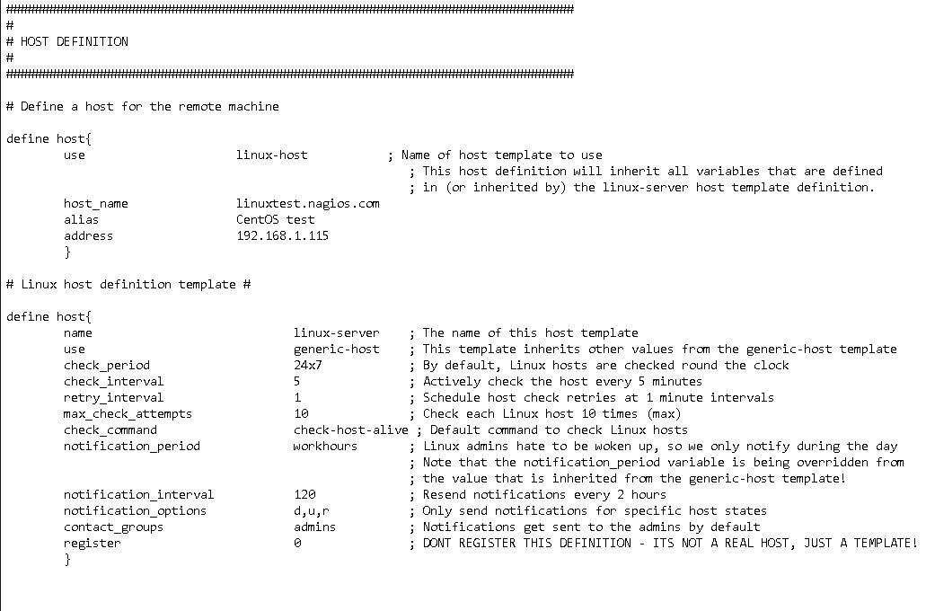

then we will add services in linux_services.cfg (see screenshot)

$ cd /usr/local/nagios/etc/linux_services.cfg

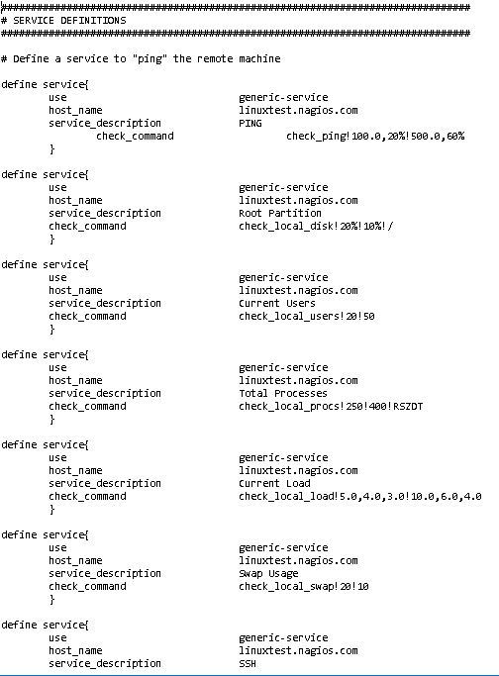

& lastly, we will add NRPE command definition to /usr/local/nagios/etc/objects/commands.cfg

$ vi /usr/local/nagios/etc/objects/commands.cfg

& add the following command definition

###############################################################################

# NRPE CHECK COMMAND

#

# Command to use NRPE to check remote host systems

###############################################################################

define command{

command_name check_nrpe

command_line $USER1$/check_nrpe -H $HOSTADDRESS$ -c $ARG1$

}

Verifying Nagios configuration file

$ /usr/local/nagios/bin/nagios -v /usr/local/nagios/etc/nagios.cfg

If there are any errors, resolve them & then restart the nagios server for changes to take effect.

$ service nagios restart

Open web-console

Open your web-console, by typing your nagios IP address or FQDN in your browser & enter credentials for nagios. Once inside the web-console, goto services page & you should see that services for your Linux hosts have added here for monitoring .

Nagios Server : Adding Windows host to Nagios server for monitoring

To add a Windows host to Nagios server, we need a plugin called **NSclient++**. *NSclient++* acts as a proxy or an intermediary between Nagios server & Windows machine. *NSclient ++*communicates with the help *check_nt* plugin.

Now we will proceed with the steps required to adding Windows host to Nagios server…

### STEP 1 Downloading & installing NSclient++

We can download the latest version of NSclient++ from following link on the windows machine <https://sourceforge.net/projects/nscplus/>

Once you have downloaded the file which is a .msi file, double click on it to run the setup. Hit next on the setup screen, it will then ask you to accept the license agreement , accept & hit next again.

Then choose the typical setup & hit next again. You will be then asked if you would like to install some sample configurations file , leave it as it & hit next.

Now comes the main part of setup, here you will be asked to enter the IP of nagios server (refer to screenshot below)

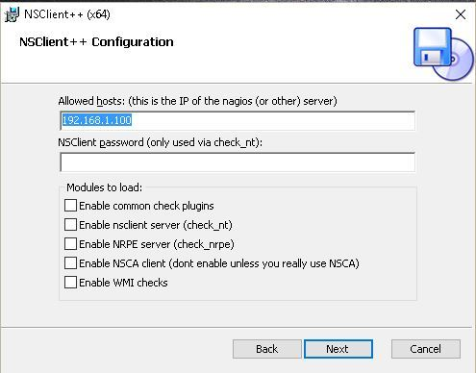

Then click on next & then install to complete the setup. After installation is complete, we need to start NSclient++ by going into you r start menu & selecting “Start NSclient++” (see screenshot)

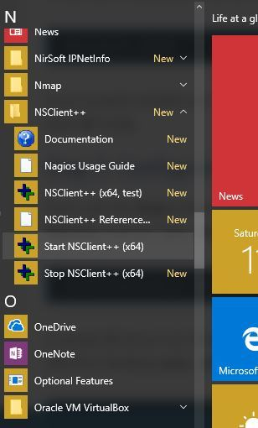

Our installation on Windows hosts is now complete. We will configure our Nagios server for adding windows host.

### STEP 2 Configuring Nagios server

Firstly, open nagios configuration file,

$ vi /usr/local/nagios/etc/nagios.cfg

& uncomment the following line

# Definitions for monitoring a Windows machine

cfg_file=/usr/local/nagios/etc/objects/windows.cfg

/usr/local/nagios/etc/objects/windows.cfg is the file where we will add information about our Windows hosts. Now we will edit the windows.cfg file

$ vi /usr/local/nagios/etc/objects/windows.cfg

A sample host definition is already present in the file, we can either copy it or edit it to point to our windows machine

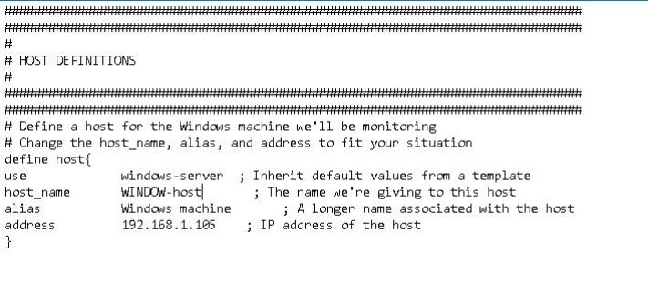

And below *Host Definition* are some *Service Definitions*, if you want to add more services this would be the place to do it. Otherwise just change the host name in these service definitions & you are done

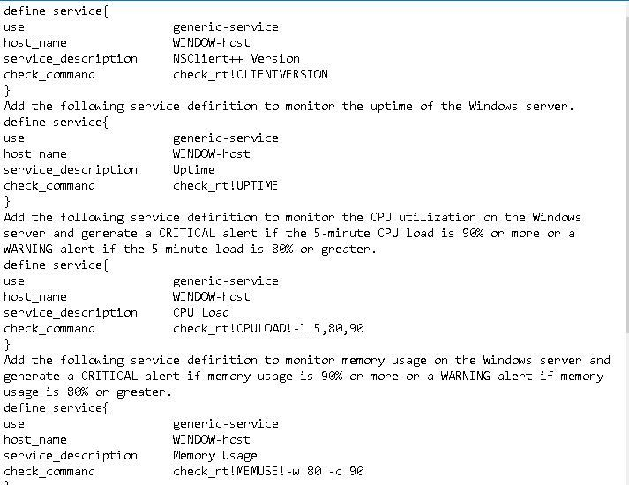

Finally, we will verify the nagios configuration file

$ /usr/local/nagios/bin/nagios -v /usr/local/nagios/etc/nagios.cfg

Output should show no errors & warning found, & then we will restart nagios server for changes to take effect.

$ service nagios restart

STEP 3 Open Web-console

Now we will login to our nagios webcosole & goto services overview. We will now find that all the windows services are also being shown here along with our localhost services.

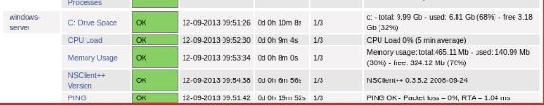

That’s it guys your work is done. In next tutorial we will learn to add Linux machines on nagios server for monitoring.