Part 1 Source Code and Screenshots
This companion MS Word document contains implementation evidence for the selected optimization technique.

A. File Inventory
- src/baseline_quicksort.py
- src/optimized_quicksort.py
- src/input_generators.py
- experiments/run_benchmarks.py
- experiments/plot_results.py
- results/raw_data/benchmark_results.csv
- results/plots/timings_by_distribution.png
- results/plots/speedup_summary.png

B. Baseline Quicksort (Core Snippet)
def deterministic_quicksort(arr):
"""Baseline quicksort with first-element pivot (intentionally vulnerable)."""
if len(arr) <= 1:
return arr
pivot = arr[0]
left = [x for x in arr[1:] if x <= pivot]
right = [x for x in arr[1:] if x > pivot]
return deterministic_quicksort(left) + [pivot] + deterministic_quicksort(right)

C. Optimized Quicksort (Core Snippet)
import random
def _insertion_sort_range(arr, lo, hi):
for i in range(lo + 1, hi + 1):
key = arr[i]
j = i - 1
while j >= lo and arr[j] > key:
arr[j + 1] = arr[j]
j -= 1
arr[j + 1] = key
def _three_way_partition(arr, lo, hi):
pivot_index = random.randint(lo, hi)
arr[lo], arr[pivot_index] = arr[pivot_index], arr[lo]
pivot = arr[lo]
lt = lo
i = lo + 1
gt = hi
while i <= gt:
if arr[i] < pivot:
arr[lt], arr[i] = arr[i], arr[lt]
lt += 1
i += 1
elif arr[i] > pivot:
arr[i], arr[gt] = arr[gt], arr[i]
gt -= 1
else:
i += 1
return lt, gt
def optimized_randomized_quicksort(arr, insertion_threshold=24):
"""
Optimization technique: randomized pivot + three-way partition + small-partition insertion sort
+ tail recursion elimination via explicit stack.
"""
if len(arr) <= 1:
return arr
stack = [(0, len(arr) - 1)]
while stack:
lo, hi = stack.pop()
while lo < hi:
if hi - lo + 1 <= insertion_threshold:
_insertion_sort_range(arr, lo, hi)
break
lt, gt = _three_way_partition(arr, lo, hi)
left_size = lt - lo
right_size = hi - gt
# Process smaller side first to keep stack shallow.
if left_size < right_size:
if gt + 1 < hi:
stack.append((gt + 1, hi))
hi = lt - 1
else:
if lo < lt - 1:
stack.append((lo, lt - 1))
lo = gt + 1
return arr

D. Benchmark Screenshot Figures
Figure A: Timing by distribution
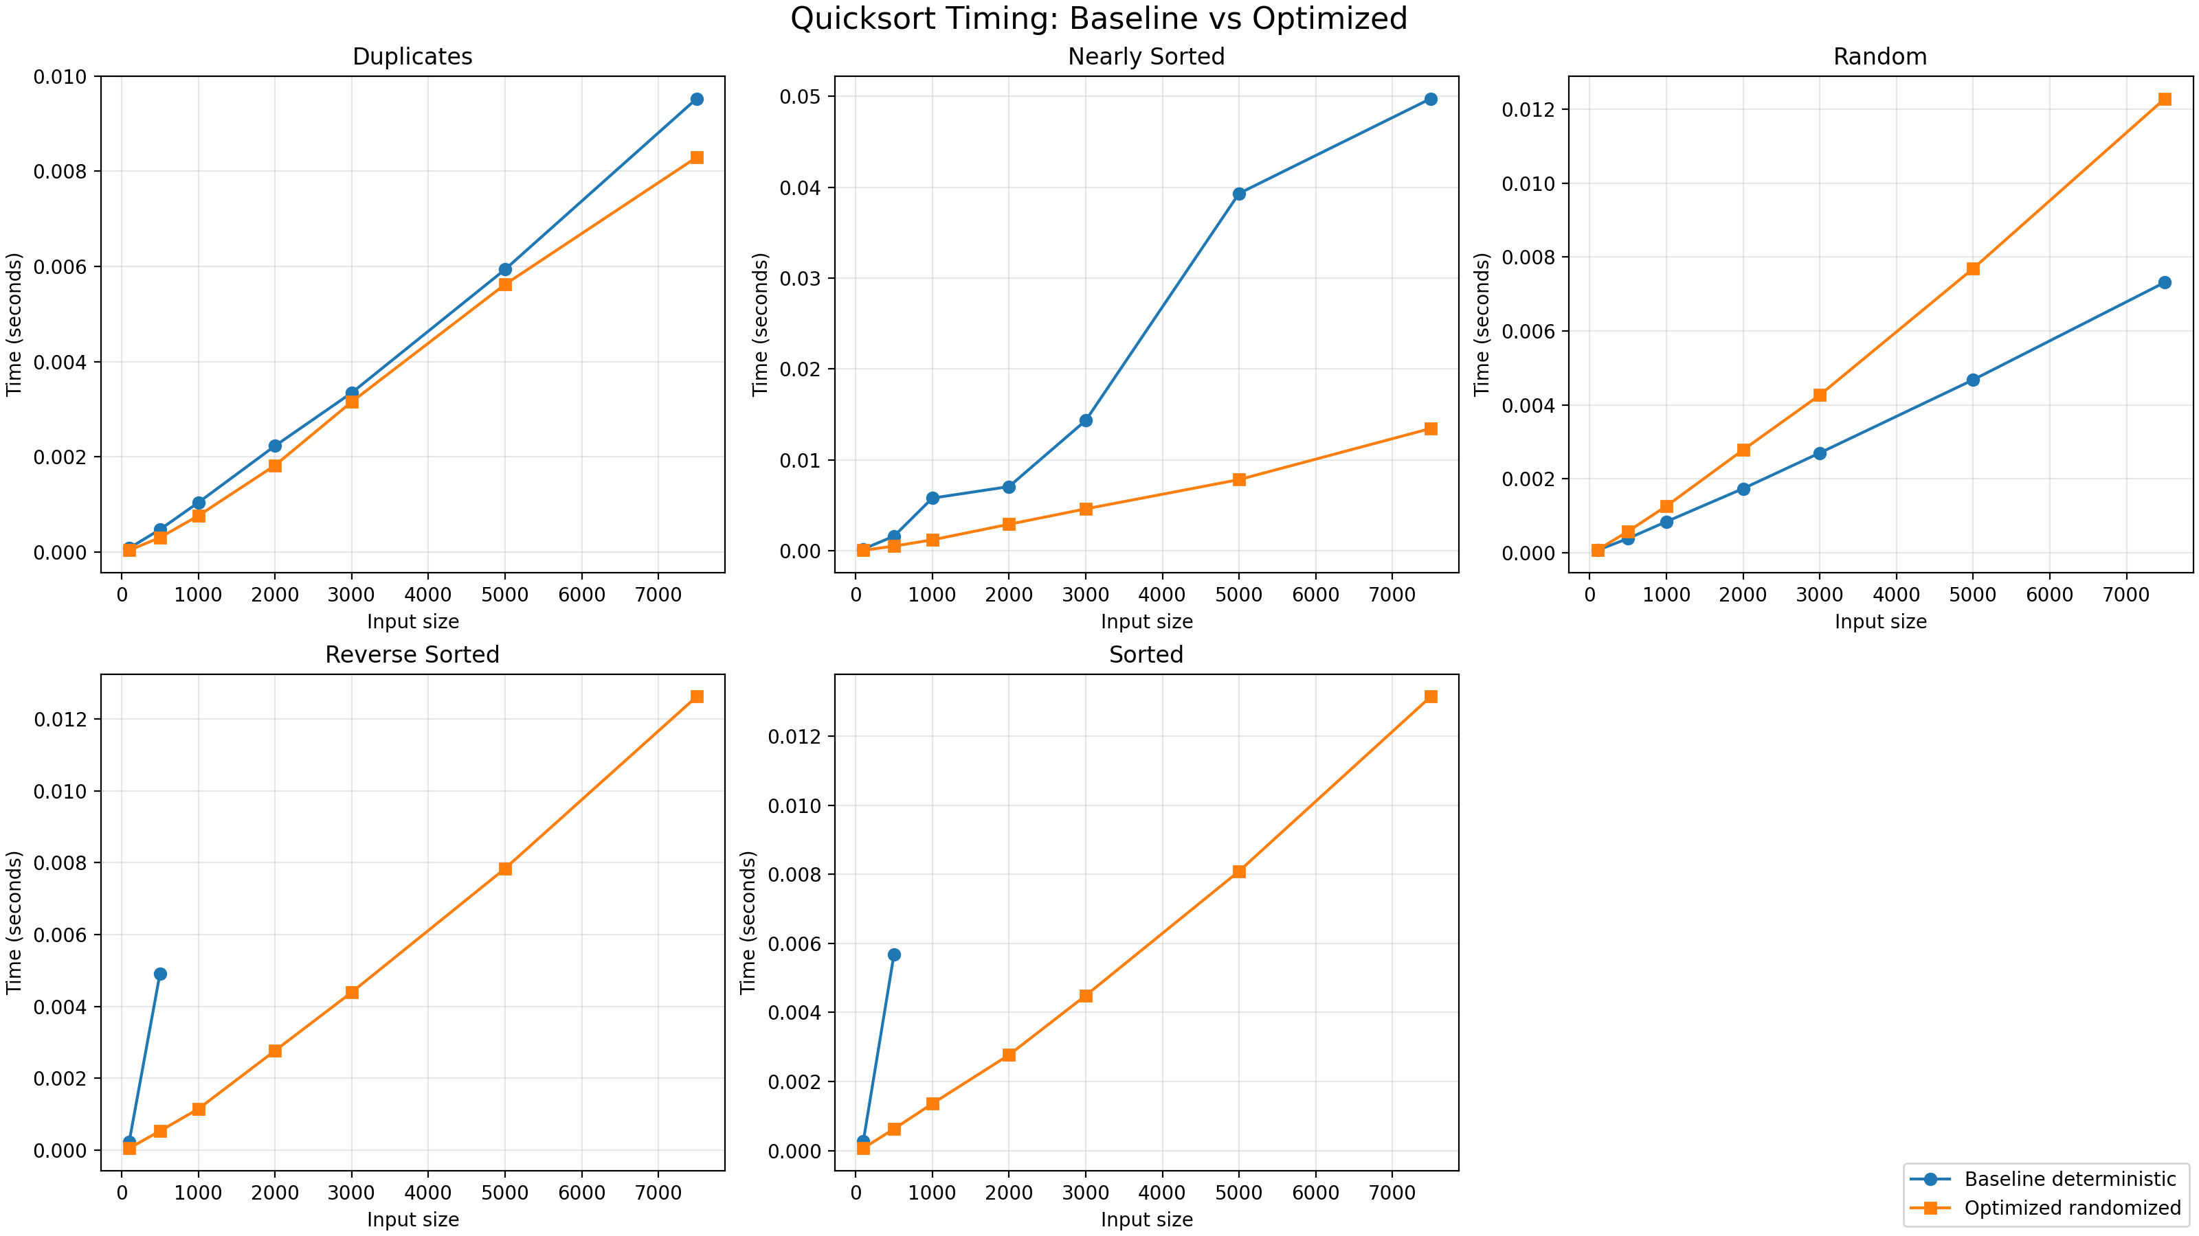
Figure B: Speedup summary
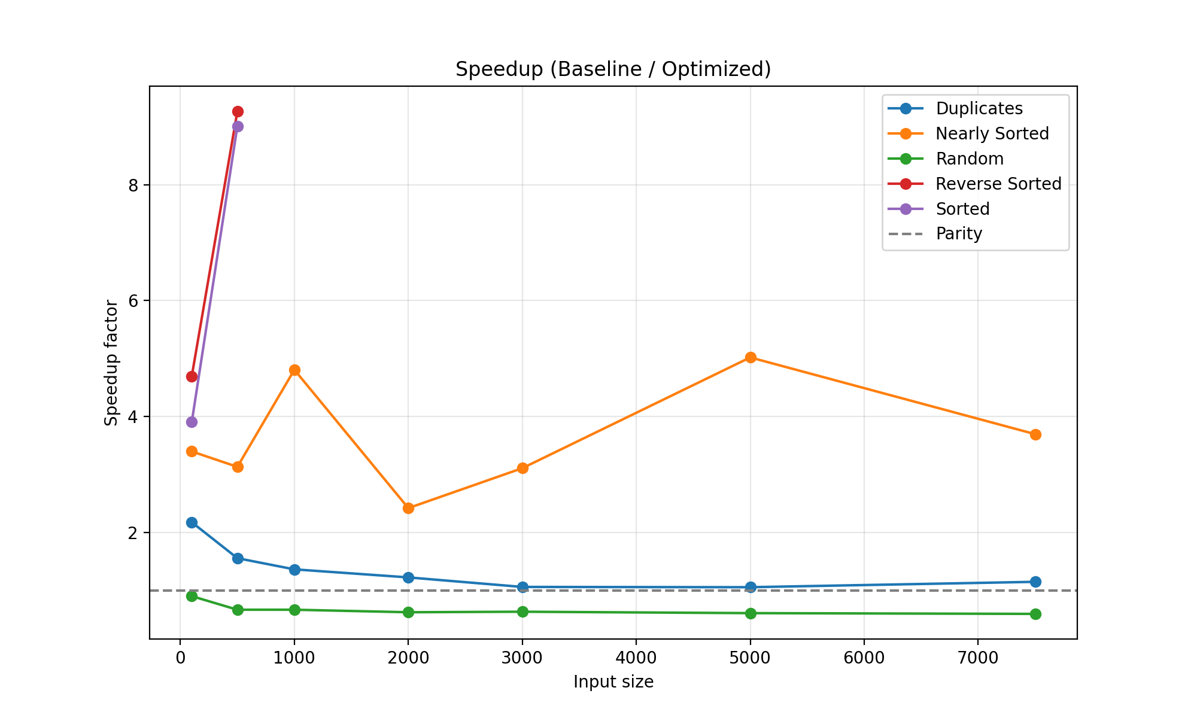

E. Execution Notes
Commands used:
1) PYTHONPATH=. python experiments/run_benchmarks.py
2) python experiments/plot_results.py
The benchmark CSV and PNG outputs are included in this project folder.

