Design Document
_________________________________________

( Fake News Detection )
2019-2020

This document contains the detailed documentation of the Fake News Detection , it’s a Web App to help know news are fake or real , measure quality of article and sort the authors by the quality and reality of article .

Under the supervision of:

Dr/ Mohamed Fawzy Seddiq

Team Members:

Ahmed Mohamed Sayed Abd-Elaziz

Mahmoud Gamal Boraey Seif

Mahmoud Salah Mohamed Mohamed

Mohamed Alaa Mahmoud Mohamed

Ahmed Reda Ragab Gharib

Table of Content

Chapter 1: Project plan ..……………………………......4

1.1 introduction …………………………...……....5
1.1.1 Abstract ……………..………………....5
1.1.2 Objectives …...…...………………….....5
1.1.3 Constraints ………..……………………5
1.2 Application Scenario…………………………...5
1.2 Organization ……………………………….…..6
1.3 Risk Analysis …………………………………..7
1.4 Hardware and software Required ….…………..8
1.5 Document Organization ……………...………..8
1.5.1 Hardware ….………………………….....8
1.3 Software ….....………………………….....8
1.6 Project Schedule ……………………………......8
1.7 Monitoring ………………………………….......8
Chapter 2: Requirements ………………………………....9
2.1 System Requirements ………………………...…10
2.1.1 Functional Requirements ……………......10
2.1.2 Non-Functional Requirements …...….…..11
2.2 User Requirements ………………………….......12
2.3 External Requirements ………………………....13
Chapter 3: Design Diagrams……………………………..14
3.1 Sequence Diagrams ………………………….....15
3.1.1 Login …………………………….….......15
3.1.2 Register …………………………............15
3.1.3 Check News ………………….…............16
3.1.4 View Authors ………………………...…17
3.1.5 Submit Feedback ………………….…....18

4|page

Chapter 1

Project Plan

5|Page

1.1Introduction:
1.1.1 Abstract:
Fake news detection is an application that can be used to determine whether a news is fake or not based on a dataset and specific AI algorithms that we have developed.
The application can be used be either normal users to check whether the news they face in their daily life is fake or not. It can also be used by Organizations and Journalists for business needs.
1.1.2 Objectives:
1. Assemble a trusted dataset that can be depended on for the AI model
2. Build strong AI algorithm that can be both trustworthy and fast
3. Return accurate results for news integrity.
4. Provide more than an option for users to check for news integrity.
5. Display a list of authors and their news integrity score.
6. Each user should have a profile with his news submissions and scheduled submissions
1.1.3 Constrains:
1. Every user should make a login or registrations by inserting his username
, his E-mail and his password.
2. Dataset has to be huge and accurate to cover all the news.
3. Dataset has to be updated periodically.
4. AI algorithm need to be strong to produce accurate results.
5. Need high performance machines to process the AI model and the huge dataset.

1.2 Application Scenario

Steps:

- User have two options to use the website either authenticated or unauthenticated.
- If the user wants to use the website while authenticated, he has to either choose to login or register a new account.
6|Page

- Login page asks for the user to enter his email address and password. Register page asks user to enter his name, email address and password.
- Once authenticated, users can check if a news or fake or not by either copying the news article, author and date then clicking the “Check” button to get the result.
- Users can also copy the link of the news they want to check and our AI will try to fetch the article and check whether it’s fake or not.
- The previous two steps can also be done while a user is not authenticated. However, for authenticated users the submission history is stored and they can see it.
- Authenticated users can access their submission history through the history page.
- The website also has an option for users to check for authors and their trust score based on the news they published through the authors page.
- If a news can’t be found in our dataset and the application is unable to determine whether it’s fake or not a message is shown to the user and the news is saved to the user’s account in “Scheduled” page to check for once the dataset is updated.
- Users have the ability to provide feedback about the application, accuracy and whether they want to report an issue or suggest a feature.

1.3 Organization:
- Documentation: Mohamed Alaa, Ahmed Reda, Ahmed Mohamed, Mahmoud Salah, Mahmoud Gamal.
- App Design: Mohamed Alaa, Ahmed Reda.
- Database and Big Data: Mahmoud Salah.
- App Develop: Mahmoud Gamal, Ahmed Mohamed.

7|Page

1.4 Risk and Contingencies:
Risks | Probability | Impact  1(low ) - 5 (high)
User Cannot handle the web app | 10% | 4
The failure of the server that holds the web app | 10% | 1
Application may be infected by a virus | 5% | 2
Timing problem | 10% | 2
Design of app and development | 10% | 4
Disagree between team members | 5% | 1
Mistake in Coding | 5% | 3
App may be not work | 10% | 4
Unavailable of resources | 15% | 3
The Failure of Big data and Machine Learning Algorithms | 20% | 4

8|Page

1.5 Hardware and software Requirements:
1.4.1 Hardware:
  - PC, laptops.
  - Server.
1.4.2 Software:
- Python web server
- Spark
- Microsoft Word
- Microsoft PowerPoint
1.6 Project Schedule:
- Requirements definition
- App and software design
- Implementation and unit testing
- Integration and app testing
- Operation and maintenance

1.7 Monitoring:
A weekly meeting to review what’s done and what’s next.

9|Page

Chapter 2

Requirements

10|Page

2 System Requirements:

- 2.1 Functional Requirements:

  - DataSets: Multiple datasets are needed for the machine learning model. The datasets are used for fact-checking and fake news detection. The following attributes (at least) need to be covered in the datasets:
    - Author
    - Justification
    - Text
    - Labels (Fake or Not)
    - Author’s Job
  - Machine Learning Libraries to pre-process the datasets: A strong library is required to clean the datasets before running the fake news detection algorithm.
  - Machine Learning Algorithm: A strong machine learning algorithm is required to deliver accurate results for news integrity. The algorithm should use the dataset to build a machine learning model that classifies news as fake or real.
  - Unified Analytics engine for big data (e.g: Spark): The size of the datasets used for the project is considerably huge which makes it hard to be processed
11|Page

  - using only one machine, thus clustering is needed to process the data on multiple machines.
  - Database server and management system: A database is required for storing user profiles and news submissions.

- 2.2 Non-Functional Requirements:

  - Security: A web application firewall is needed to protect against cybersecurity attacks. The web application needs to have strong security to protects users information and privacy.

  - Performance and timing: The machine learning algorithms need to deliver results in a timely manner. The web application also needs to perform quickly.

  - Availability: The application needs to be available for users 24/7. There should be backup databases and backup servers in case of any failure.

  - Reliability: The application needs to be reliable to deliver accurate information regarding news integrity.
12|page

2.2 User Requirements:

- Check for fake news: Users should be able to submit news to check whether they are fake or not through a web interface by submitting the news title, author and text.
- Check for fake news from a link: Users should have an option to fetch news from a link and check whether it’s fake or not.

- Login: Users can login to their profile by entering their email and password.
- Register: Users can register an account by entering their name, email and password.
- Submission History: Users should be able to access a list of their previous submissions in the history page.
- News Scheduling: Users can schedule news for later check if the current dataset can’t return results.
- Feedback: users should be able to provide feedback on the results that the application returns. Or other feedback for bugs and feature suggestions.

13|page

2.3 External Requirements:

- DataSets: Datasets will be built from different external sources such as journals and news websites.

14|page

Chapter 3

Design Diagrams

15|page
- Design Diagrams

- 3.1.2 Register:

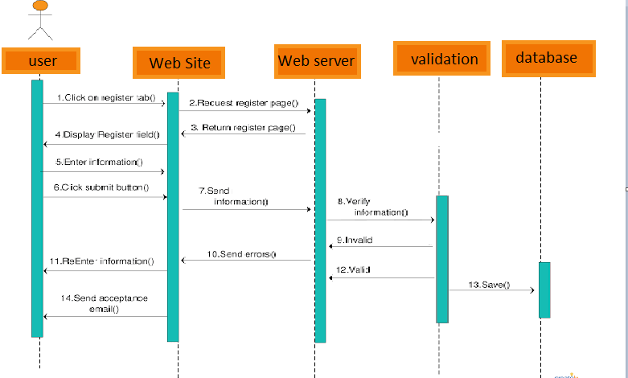

16|page
- 3.1.3 Check news:
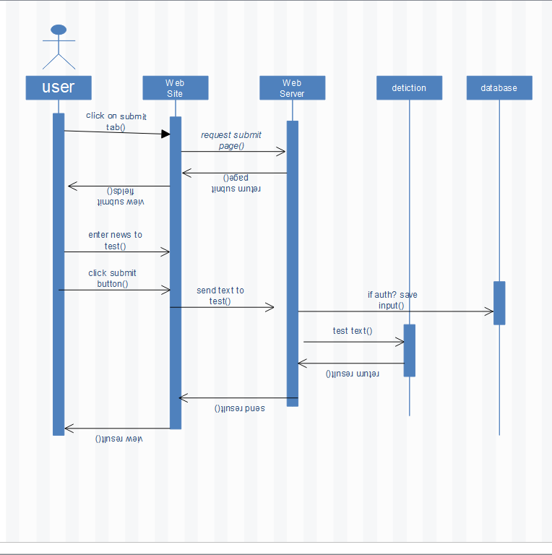

17|page
- 3.1.4 View Authors:
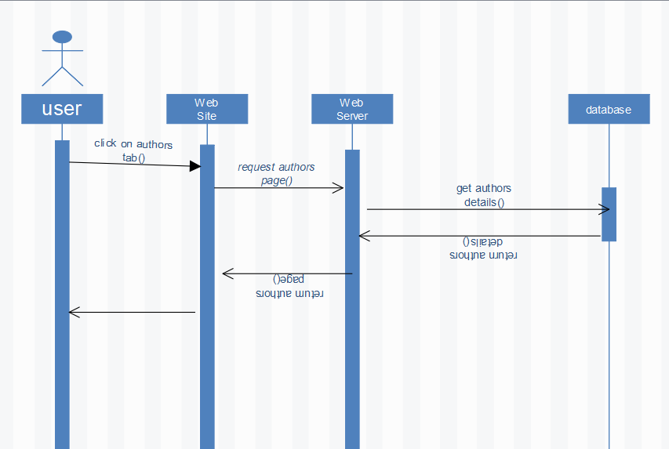

18|page

- 3.1.5 Submit feedback:
