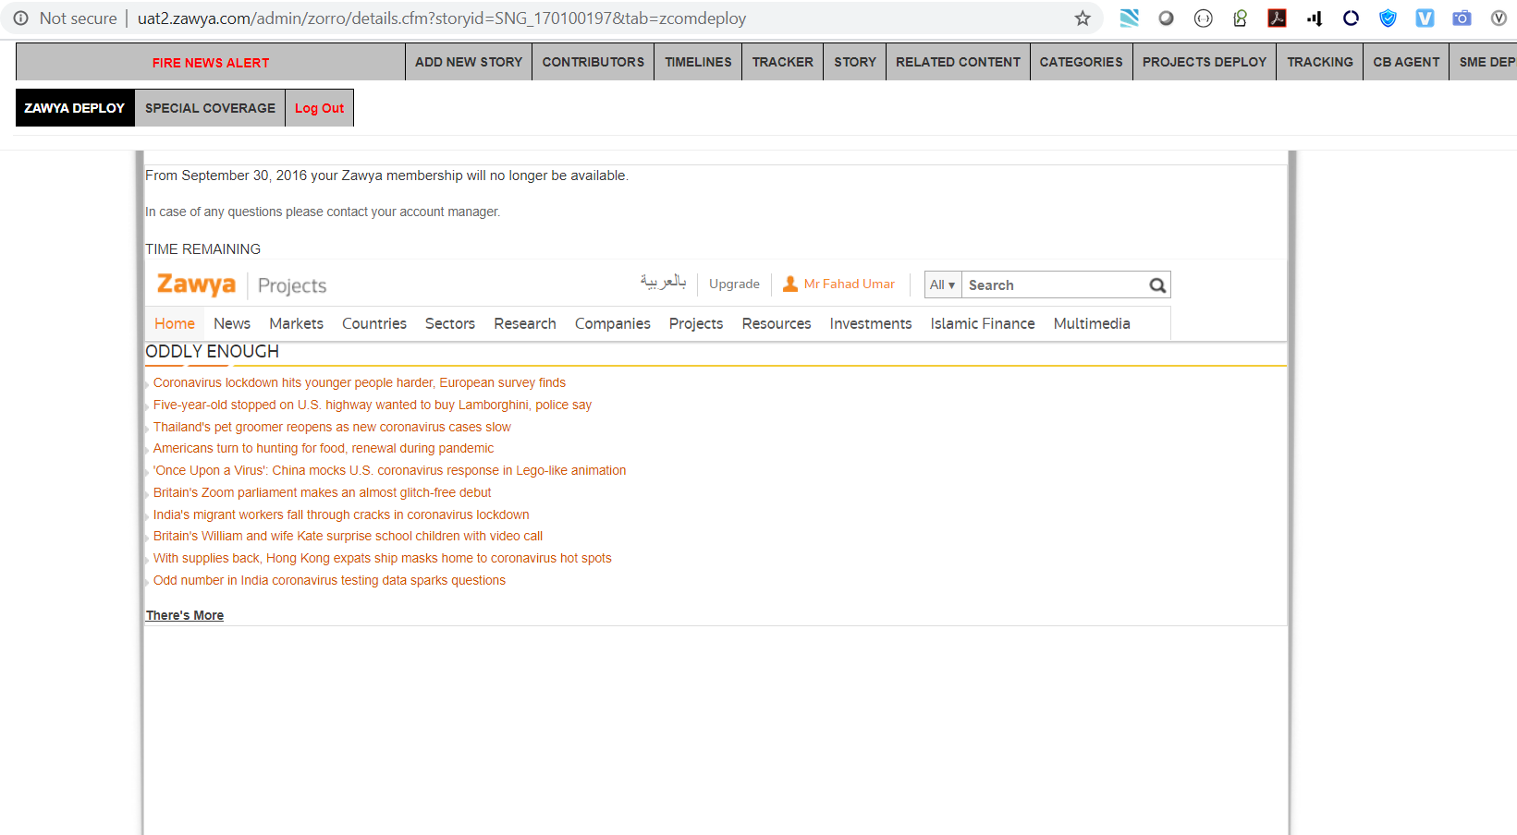

<https://uat2.zawya.com/admin/zorro/details.cfm?storyid=SNG_170100197&tab=zcomdeploy>

