**Custom_RadioButton (Windows form)**

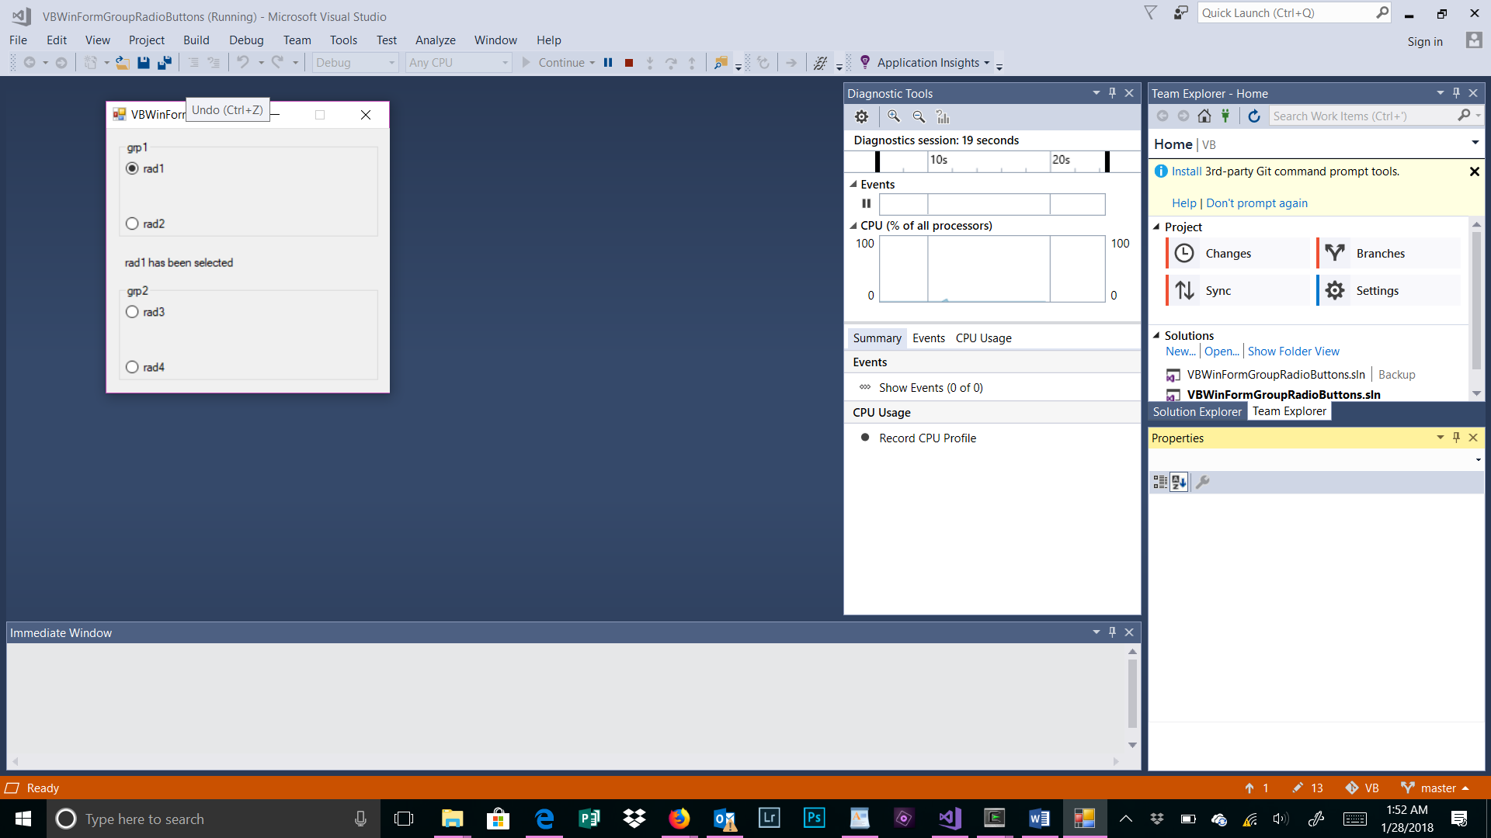

**VB_Sample1 (Visual Basic Windows form)**

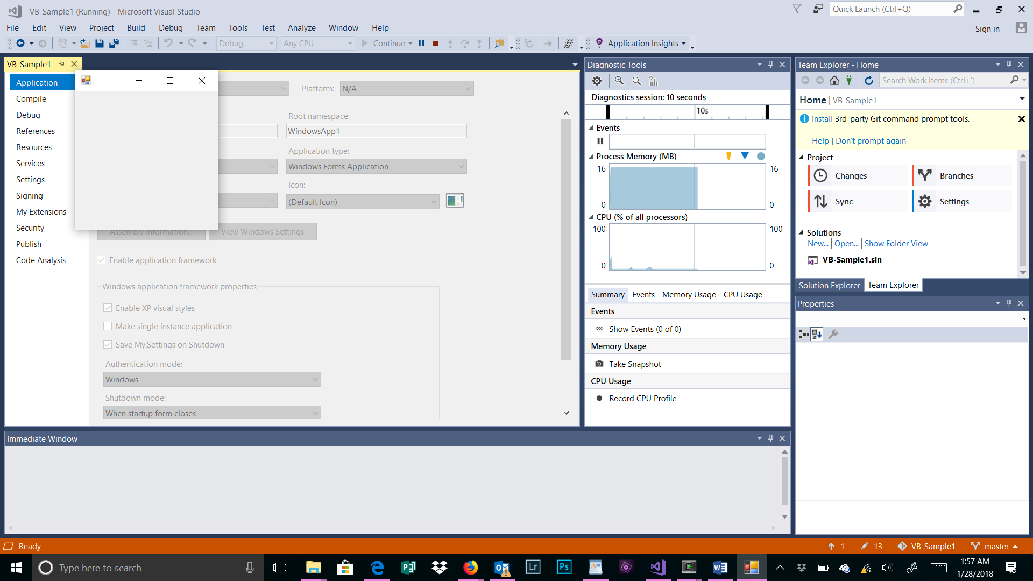

**WinForms1 (C# login Windows form)**

