CREATING SIMPLE SELENIUM BROWSER SCRIPT WITH UI.VISION

1. NAVIGATE TO https://ui.vision/ 1. Add RPA to browser

2. Install XModules

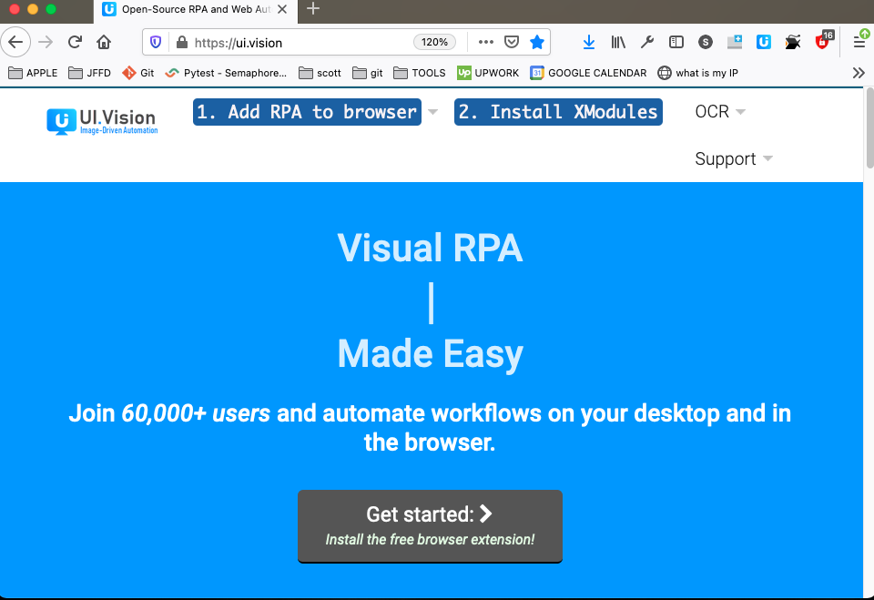

2. Add RPA to browser

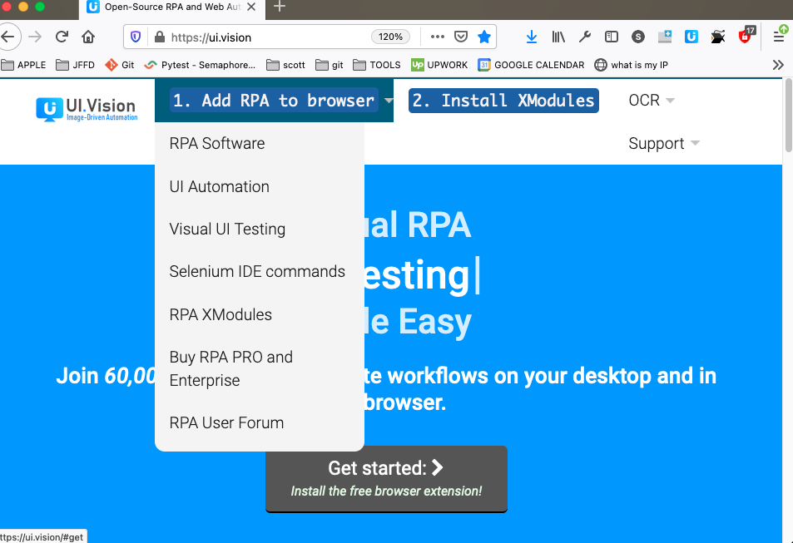

3. Open browser

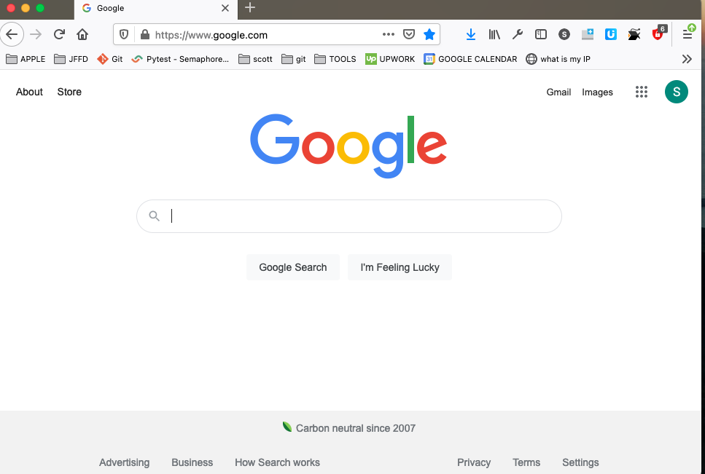

4. Click UI Vision RPA icon on top right of browser

5. Opens new window (Extension (UI.Vision RPA) - UI.Vision RPA 6.1.2

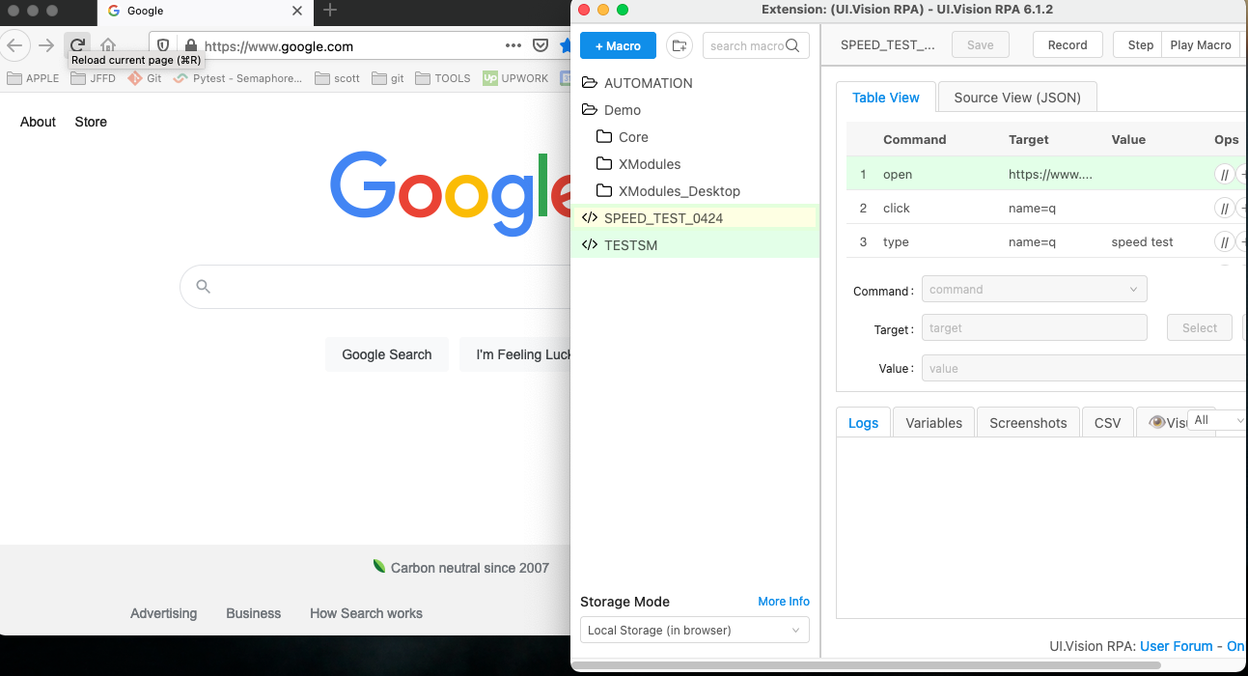

7. Select blue “Macro” button to create new macro & name it

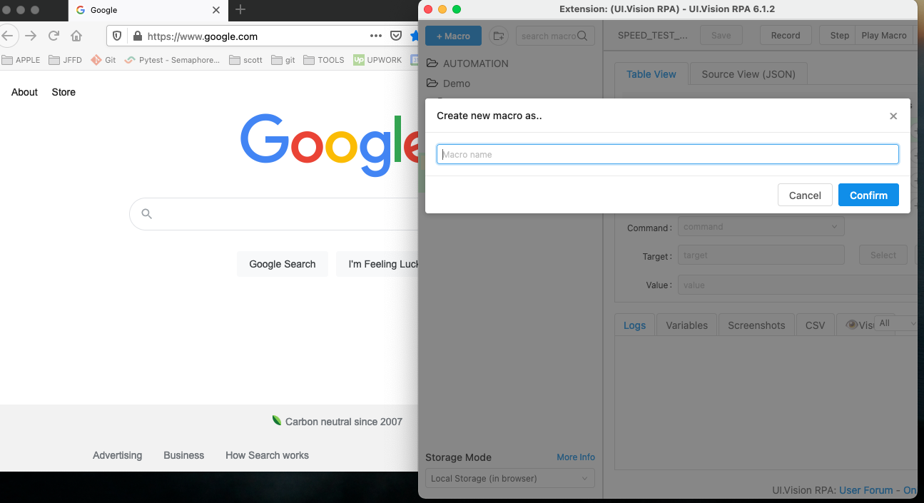

8. Select “Record” button on top of extension

9. Navigate to desired sites on browser

10. When finished recording select “Stop”

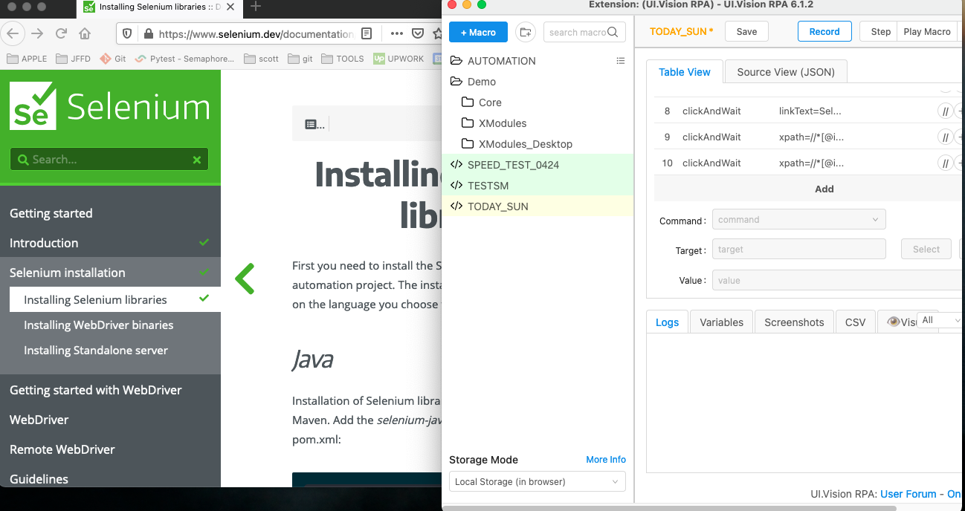

11. Select “Save”

12. Select “Play Macro”

